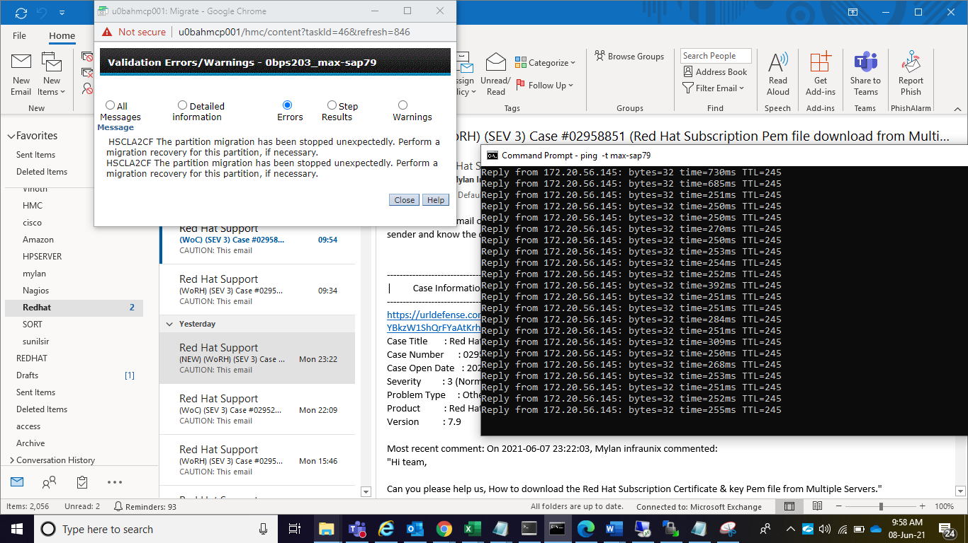

HSCLA2CF The partition migration has been stopped unexpectedly. Perform a migration recovery for this partition, if necessary.
HSCLA2CF The partition migration has been stopped unexpectedly. Perform a migration recovery for this partition, if necessary.

