[‘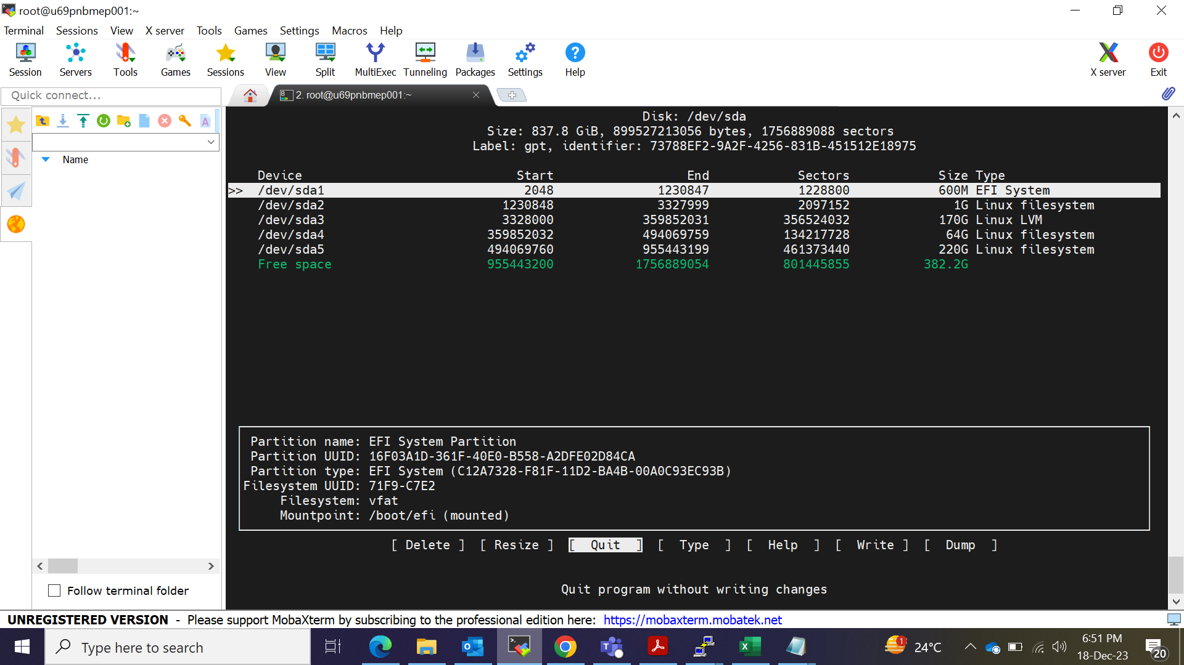

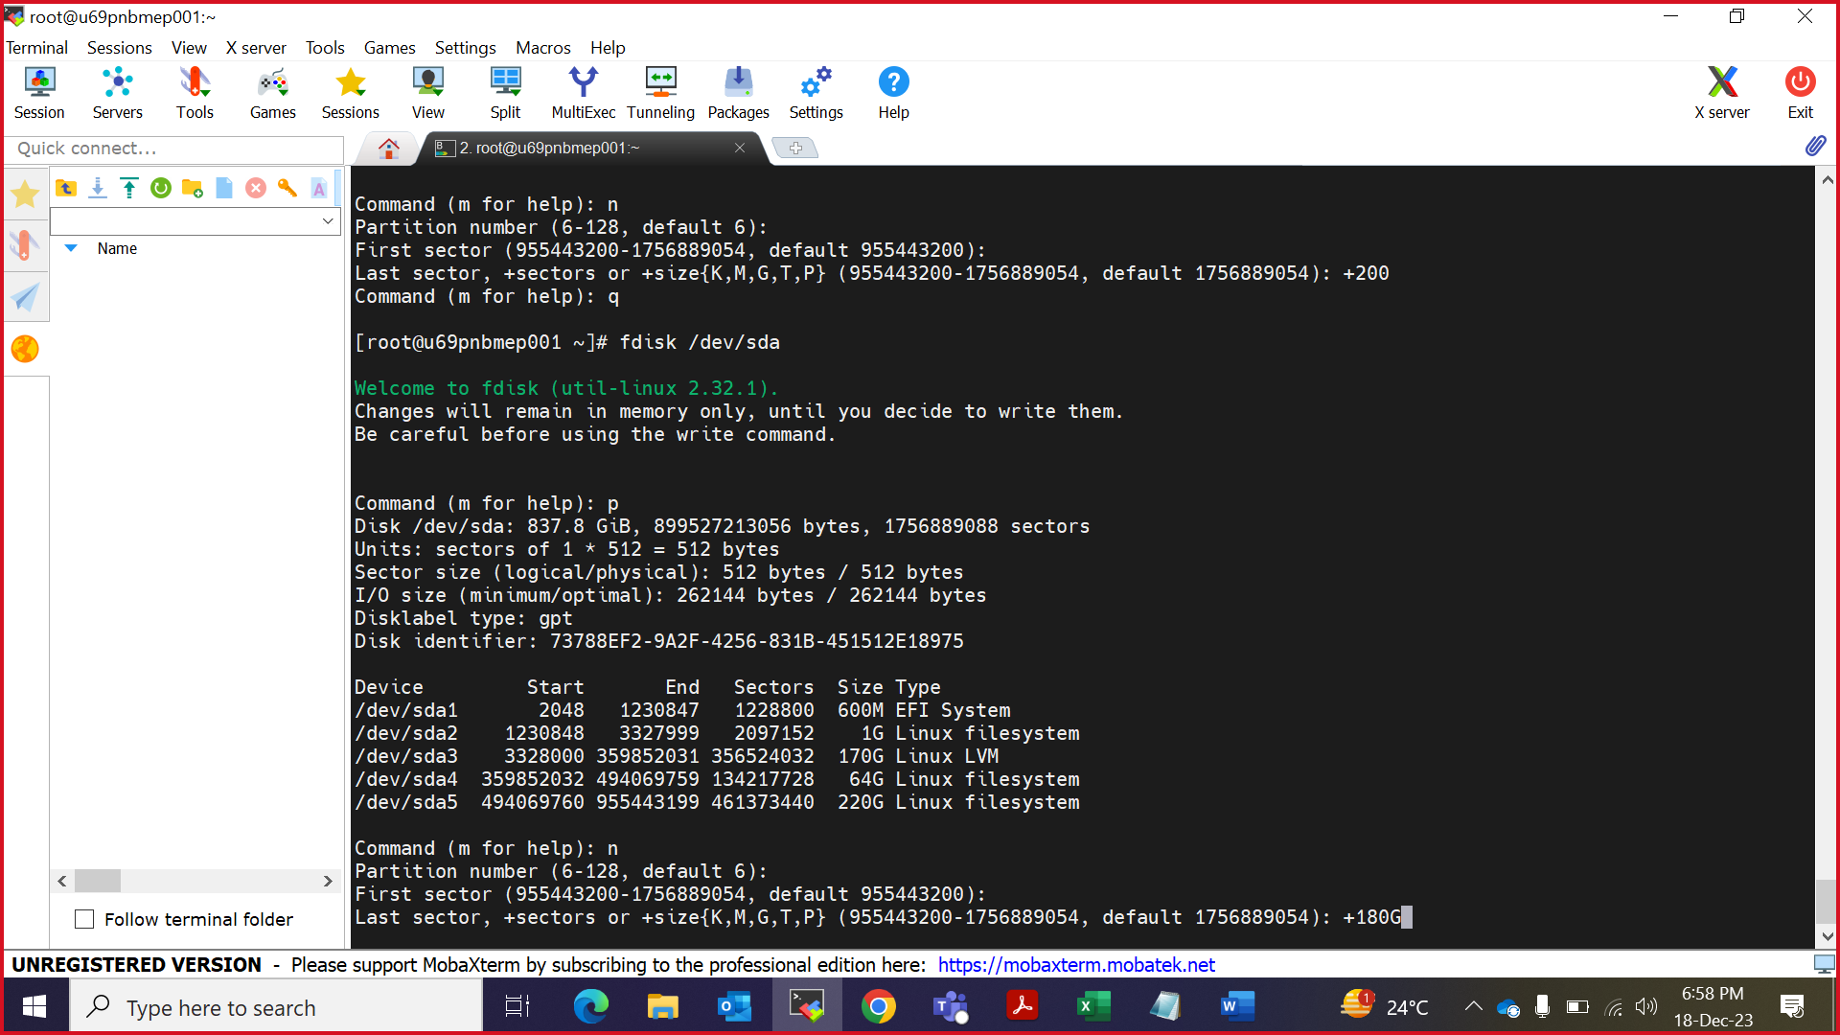

yum install cockpit-leapp
modprobe -r pata_acpi
modprobe -r floppy
yum install leapp cockpit-leapp
systemctl status cockpit.service
yum versionlock clear
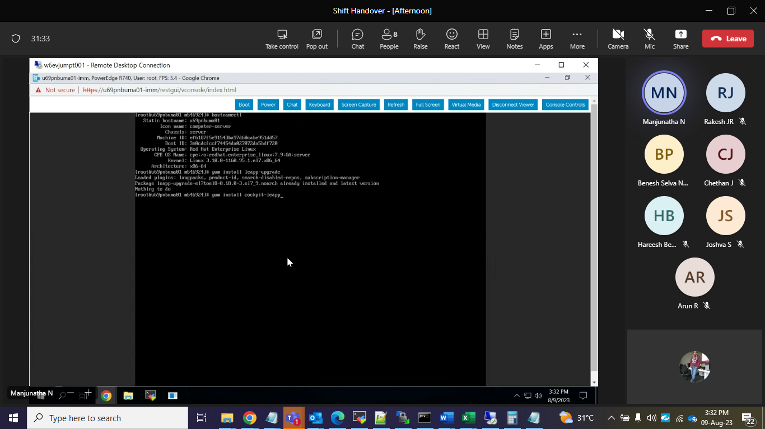
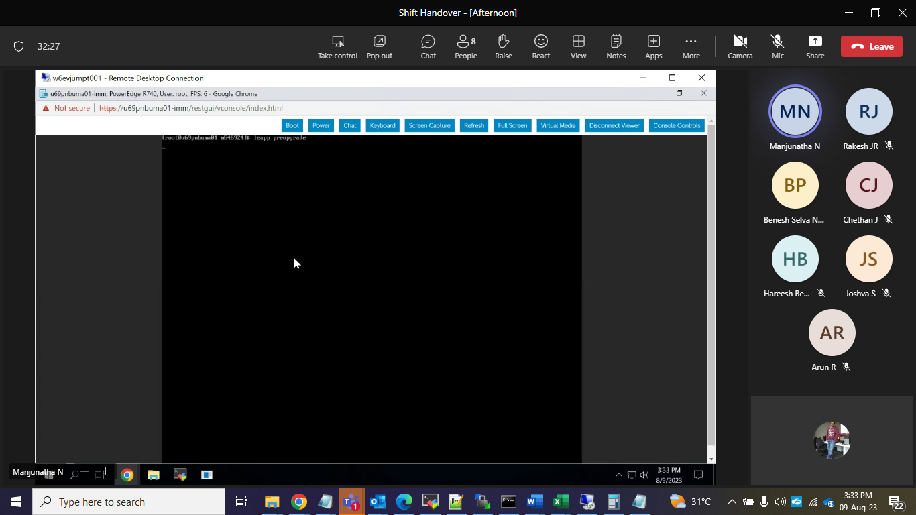
https://u69pnbuma01:9090
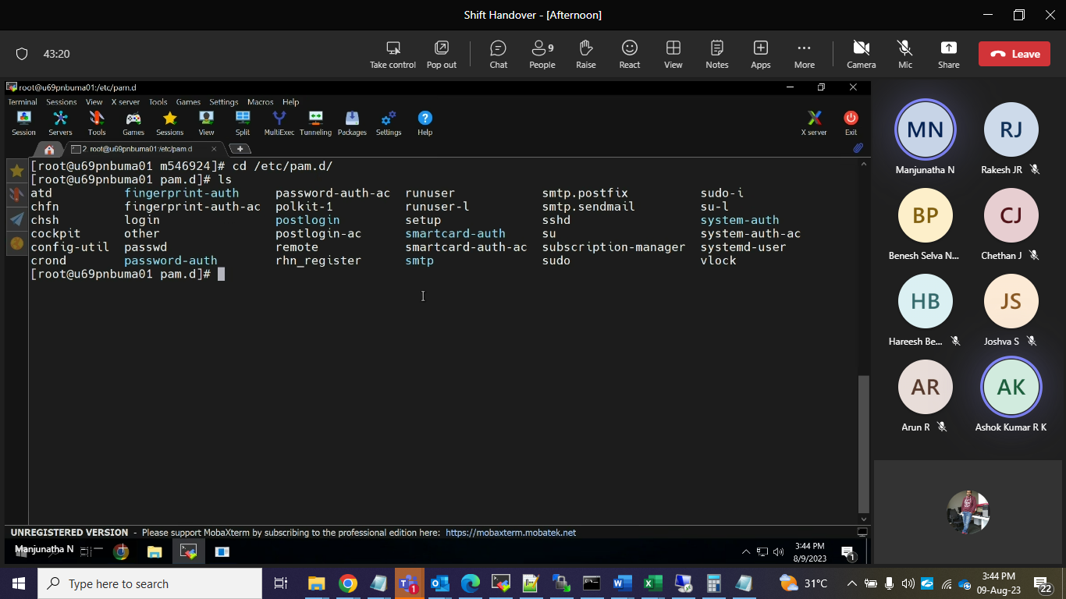
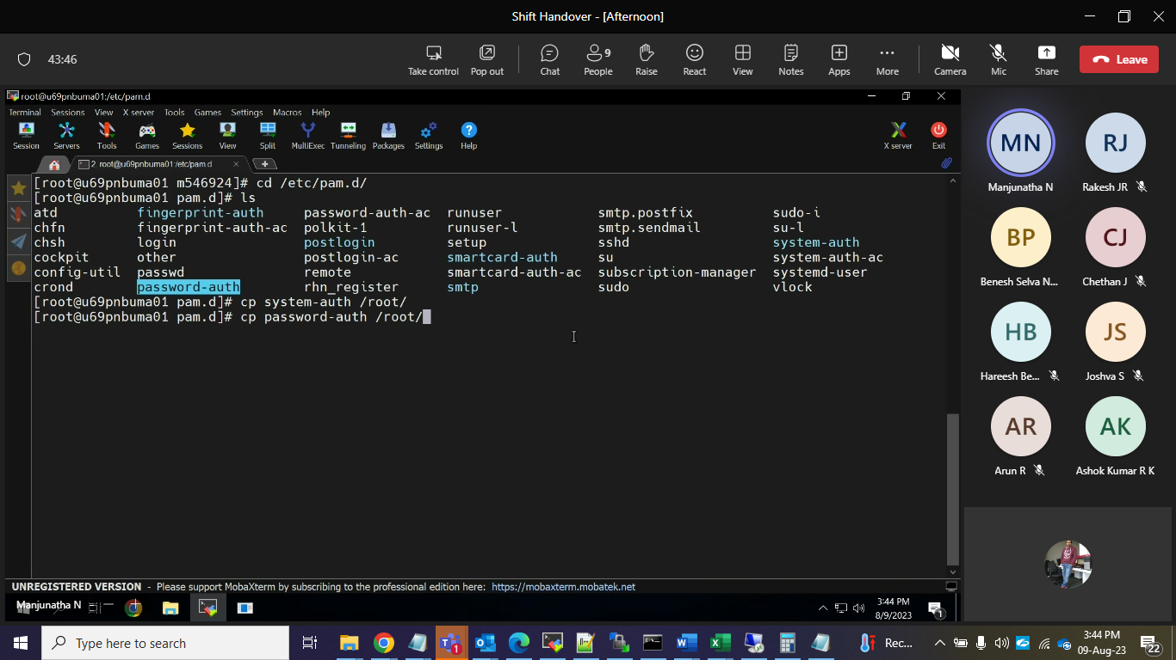
Delete from server copy from working server.
After taking one more session able to login or not
leapp preupgrade
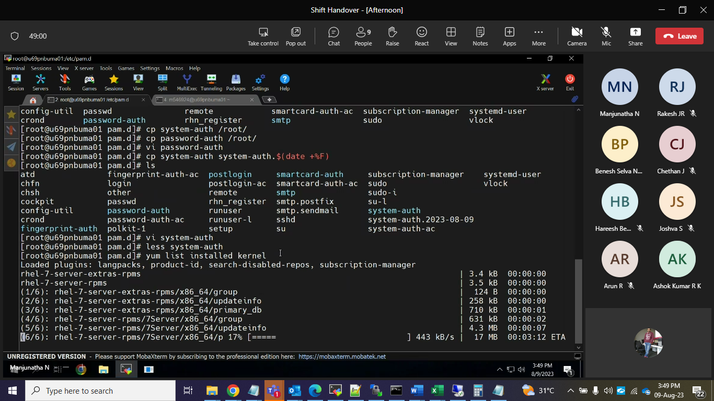
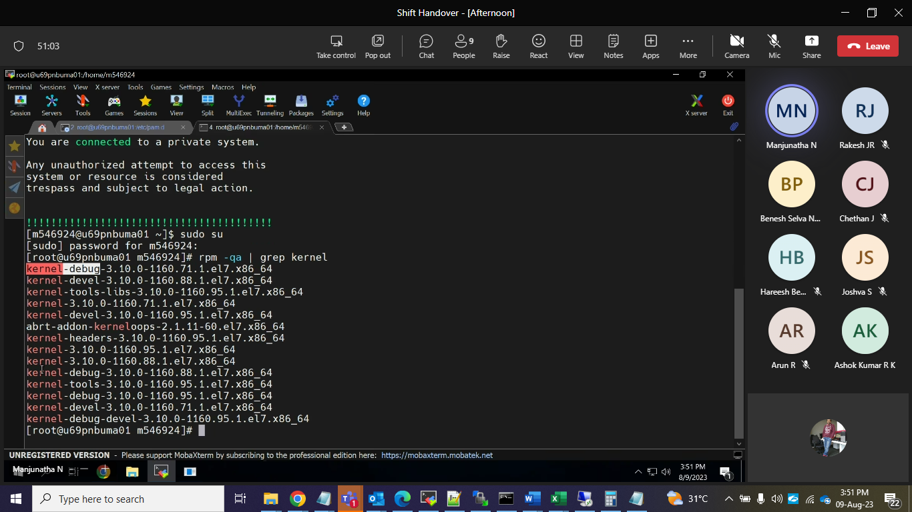

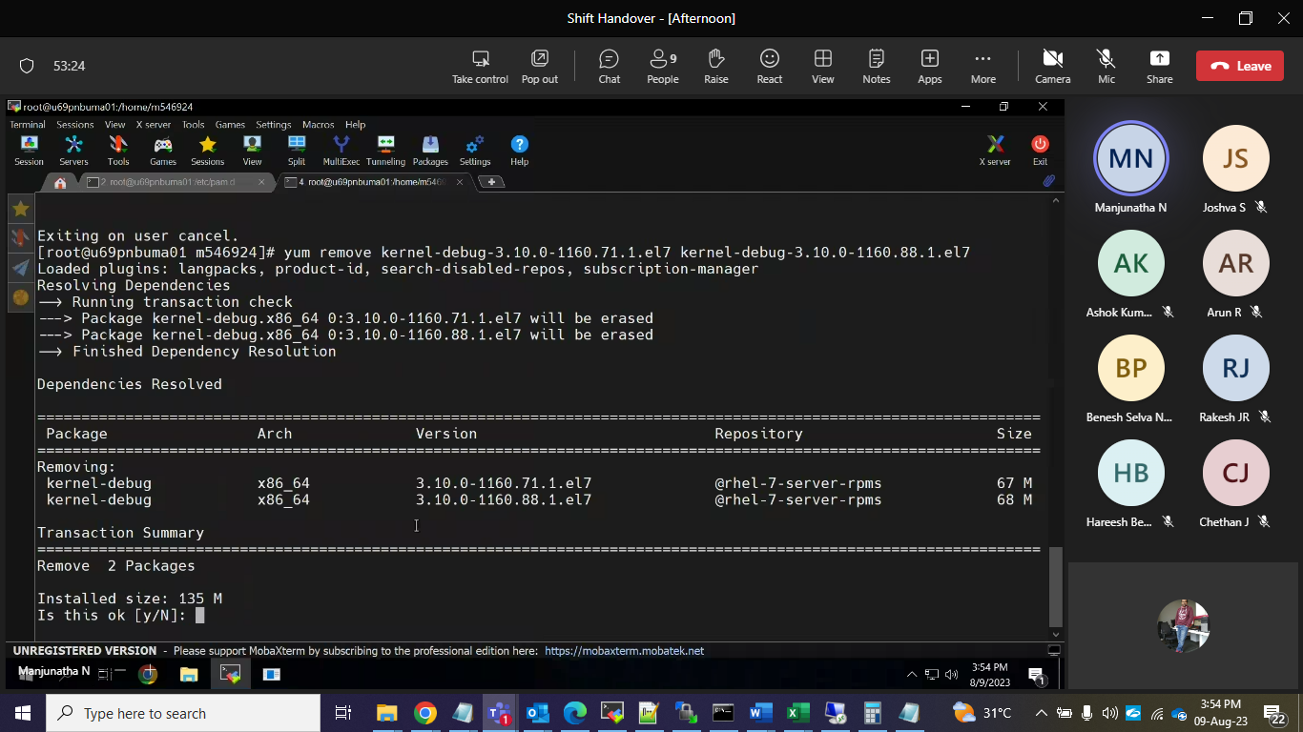

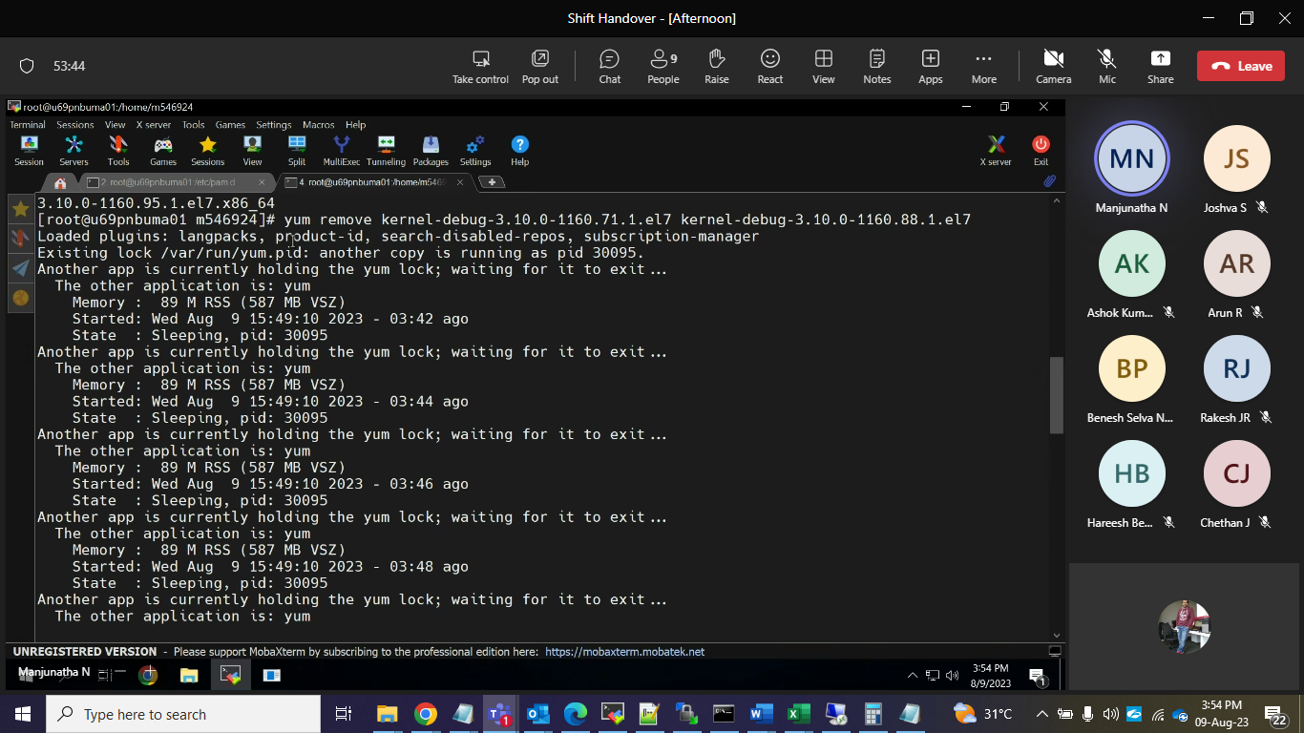

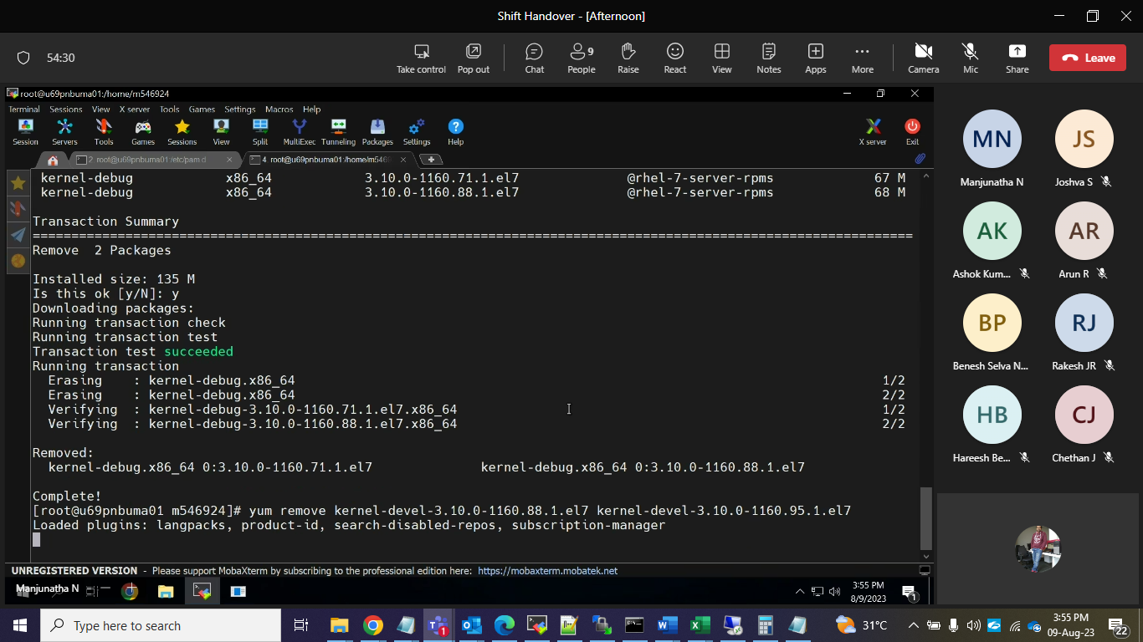
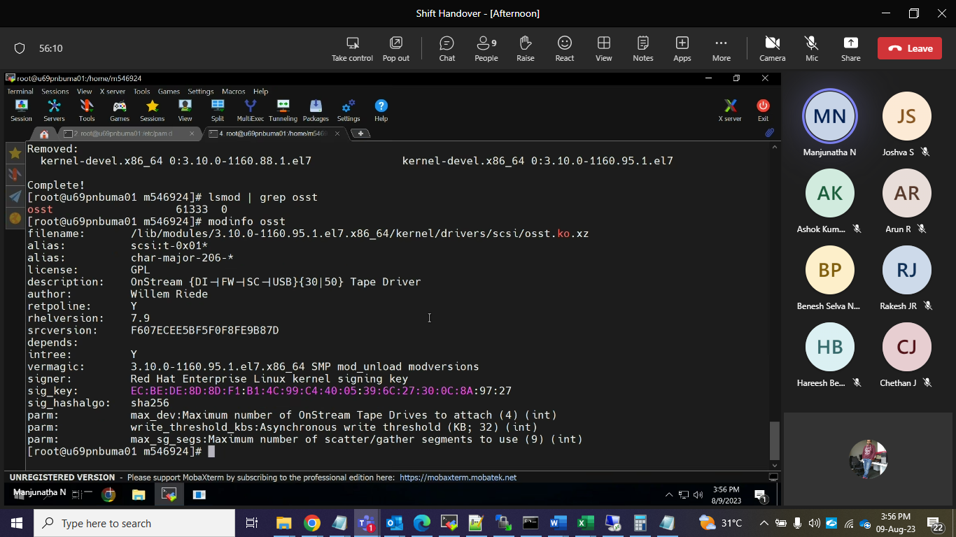
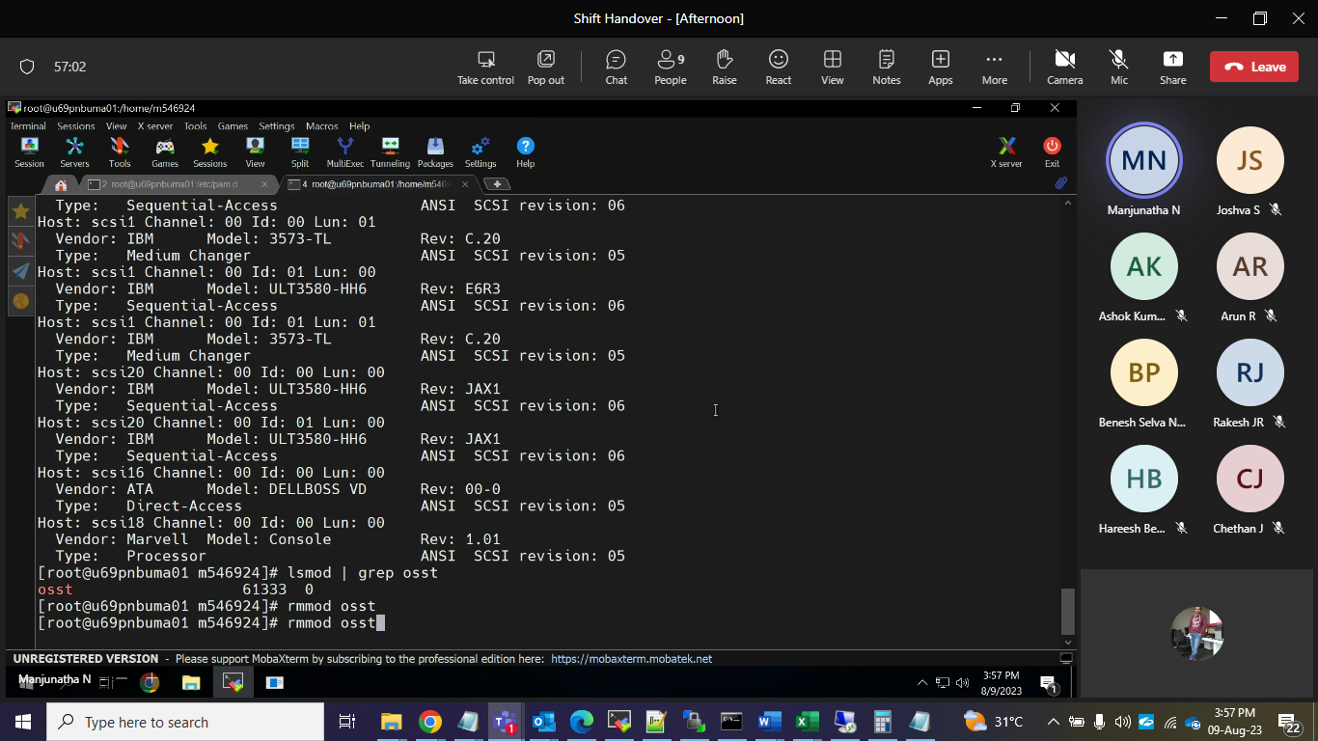
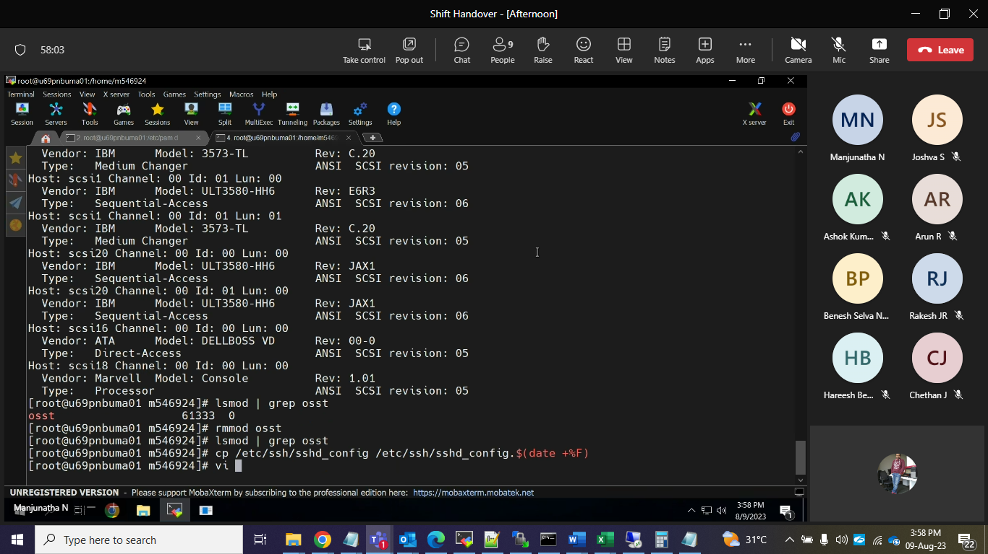

Last 2 lines need to remove
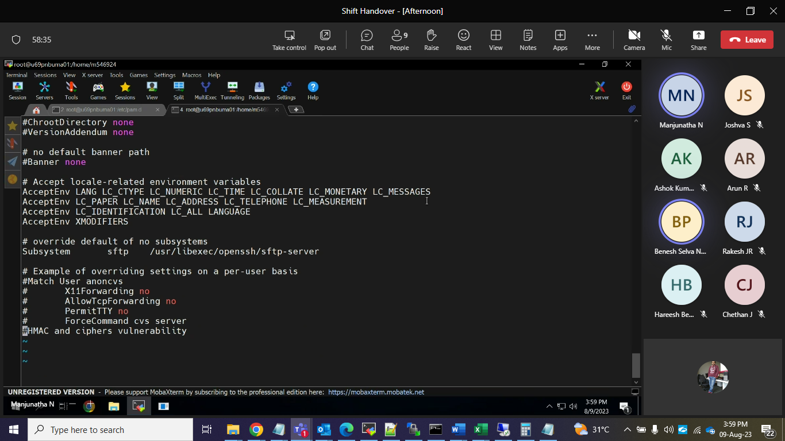

Fix the issues again need to run below command.

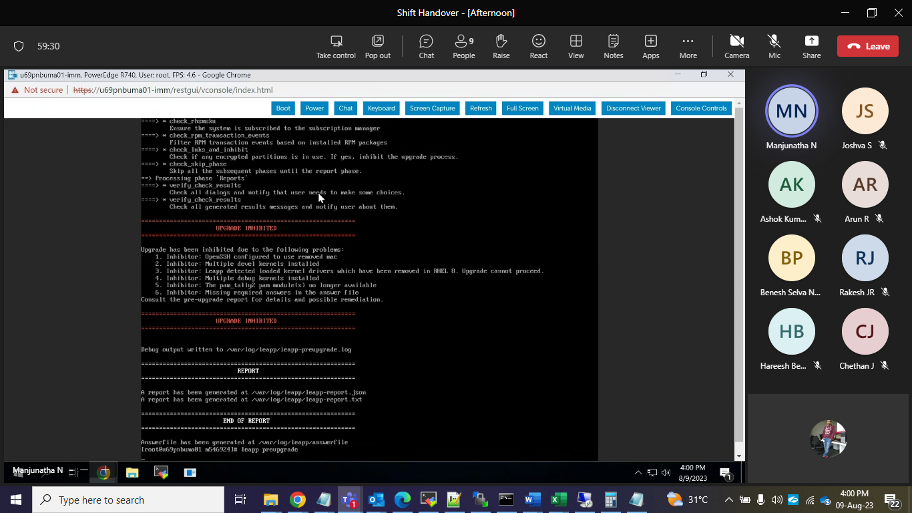
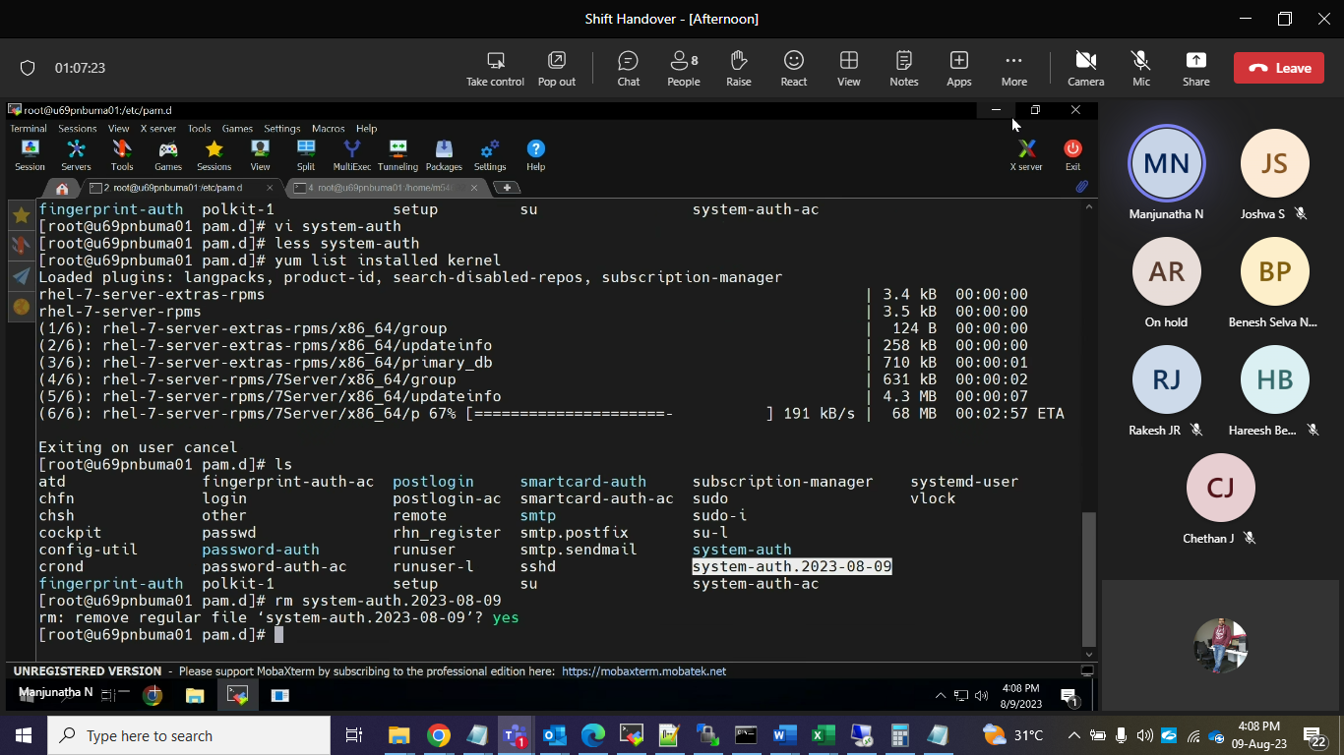

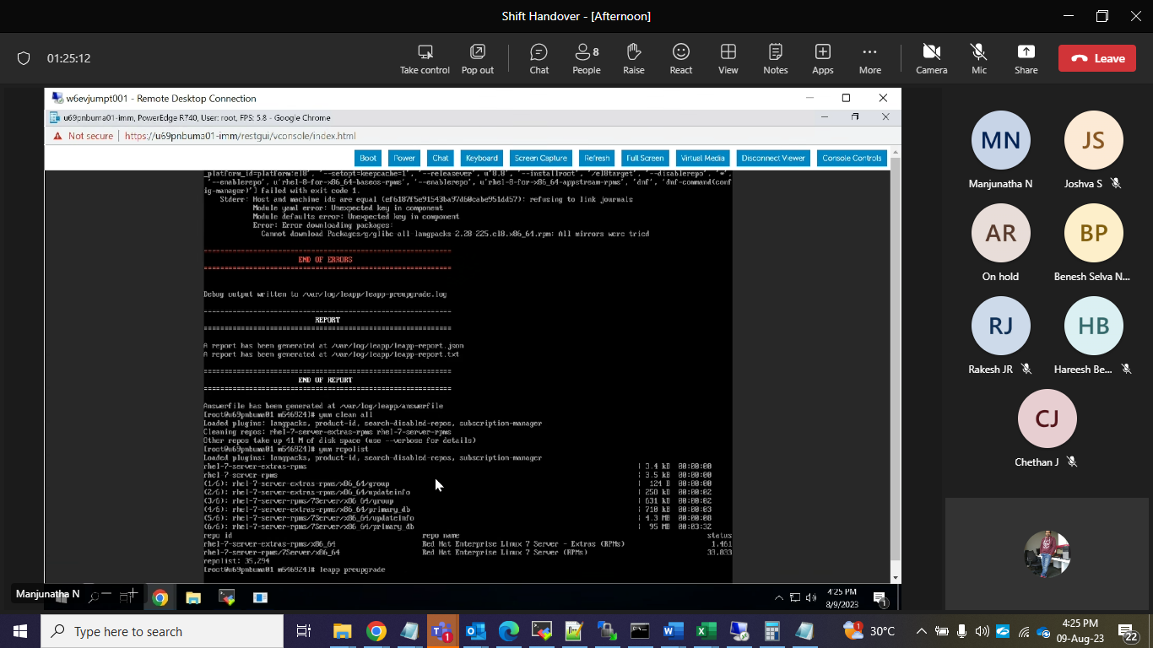

Then do upgrade.
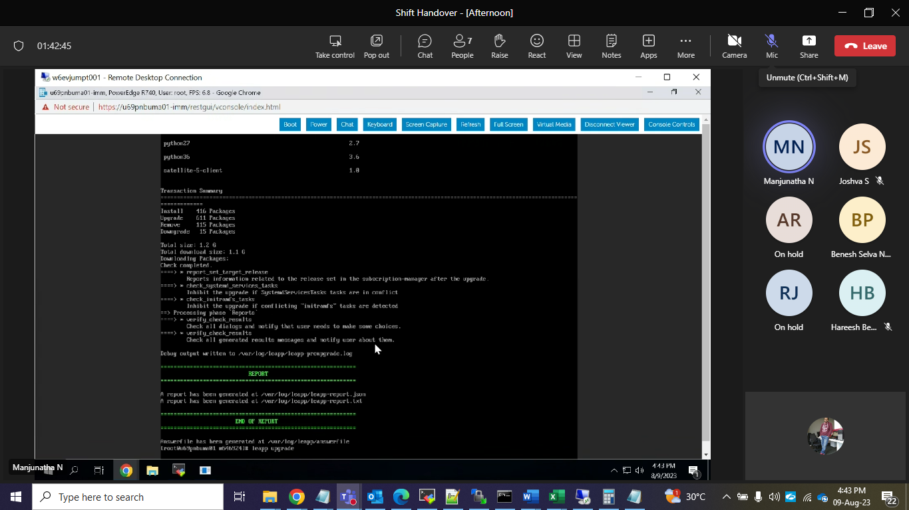
cd /etc/sysconfig/network-scripts/
ls
ls /etc/NetworkManager/system-connections/
nmcli connection migrate
ls /etc/sysconfig/network-scripts/
ls /etc/NetworkManager/system-connections/

dnf config-manager --save --setopt exclude=''
dnf remove leapp-deps-el9 leapp-repository-deps-el9
rm -rf /var/log/leapp /root/tmp_leapp_py3 /var/lib/leapp
ls /boot/vmlinuz-*rescue* /boot/initramfs-*rescue*
ls -l /boot/vmlinuz-*rescue* /boot/initramfs-*rescue*
rm /boot/vmlinuz-*rescue* /boot/initramfs-*rescue*
uname -r
yum list installed kernels
yum list installed kernel
dnf reinstall kernel-core-$(uname -r)
ls -l /boot/vmlinuz-*rescue* /boot/initramfs-*rescue*
lsinitrd /boot/initramfs-*rescue*.img | grep -qm1 "$(uname -r)/kernel/" && echo "OK" || echo "FAIL"
grubby --info $(ls /boot/vmlinuz-*rescue*)
