Table of Contents
1 Purpose 1
2 Responsibility 2
3 References 2
4 Method of File System Agent Installation 2
4.1 Windows Systems 2
4.2 Linux Systems 9
5 Revision history 12

Purpose
This document defines the process of installing file system agent on both windows and Linux systems to be followed in PPDM

Responsibility
Function | Responsibility
Backup Team | - Download the relevant file system agent(Windows and Linux) from PPDM console and install it on respective servers

References
Document Name | Title
NA | NA

Method of File System Agent Installation

Windows Systems
- Login to the PPDM console with administrative privileges
- Download windows file system agent package from PPDM console(SettingsDownloads)

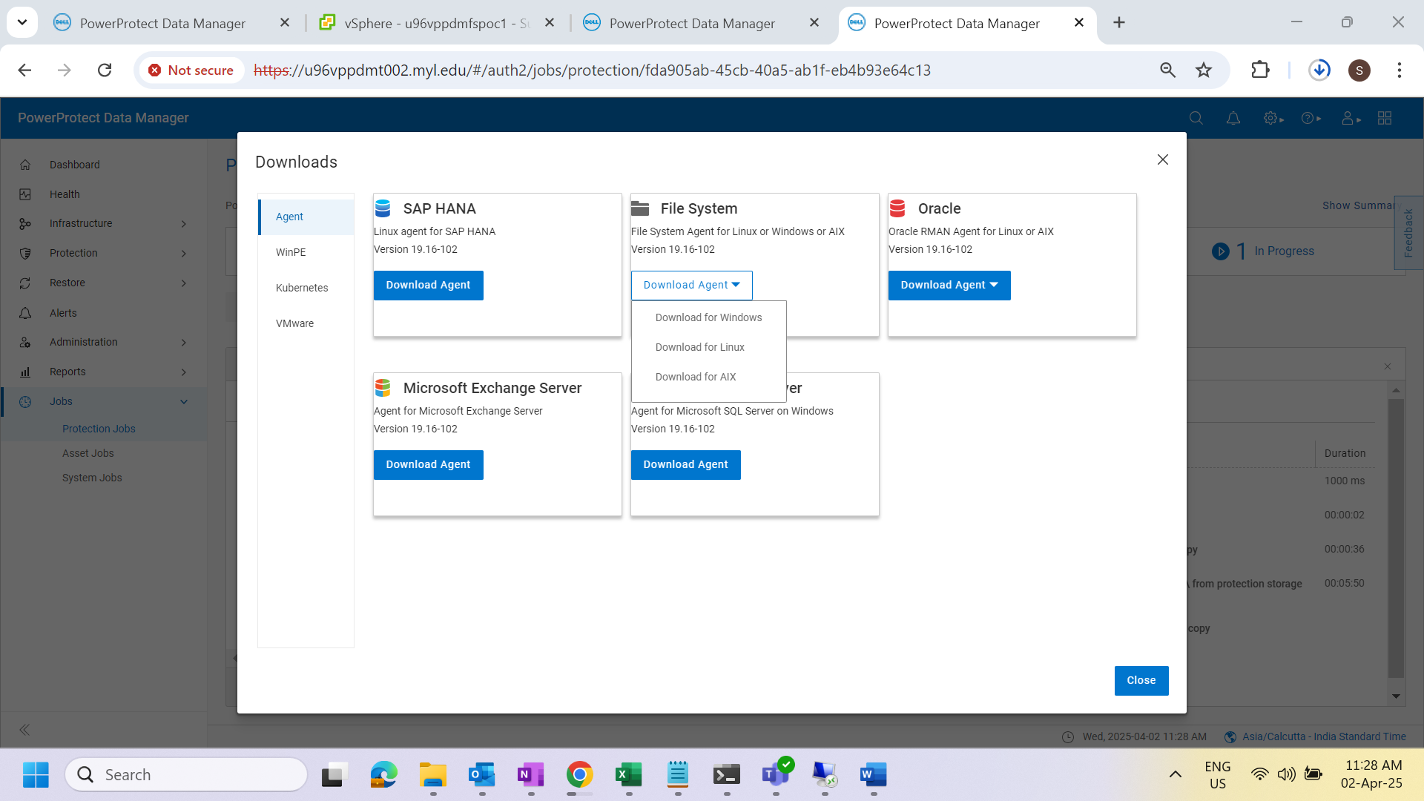

- Login to the relevant windows server with administrative privileges
- Copy the file system agent zip file from local system to respective windows server
- Extract the zip file
- Select the installation binary and run as a administrator
- Agree the license agreement and next to continue
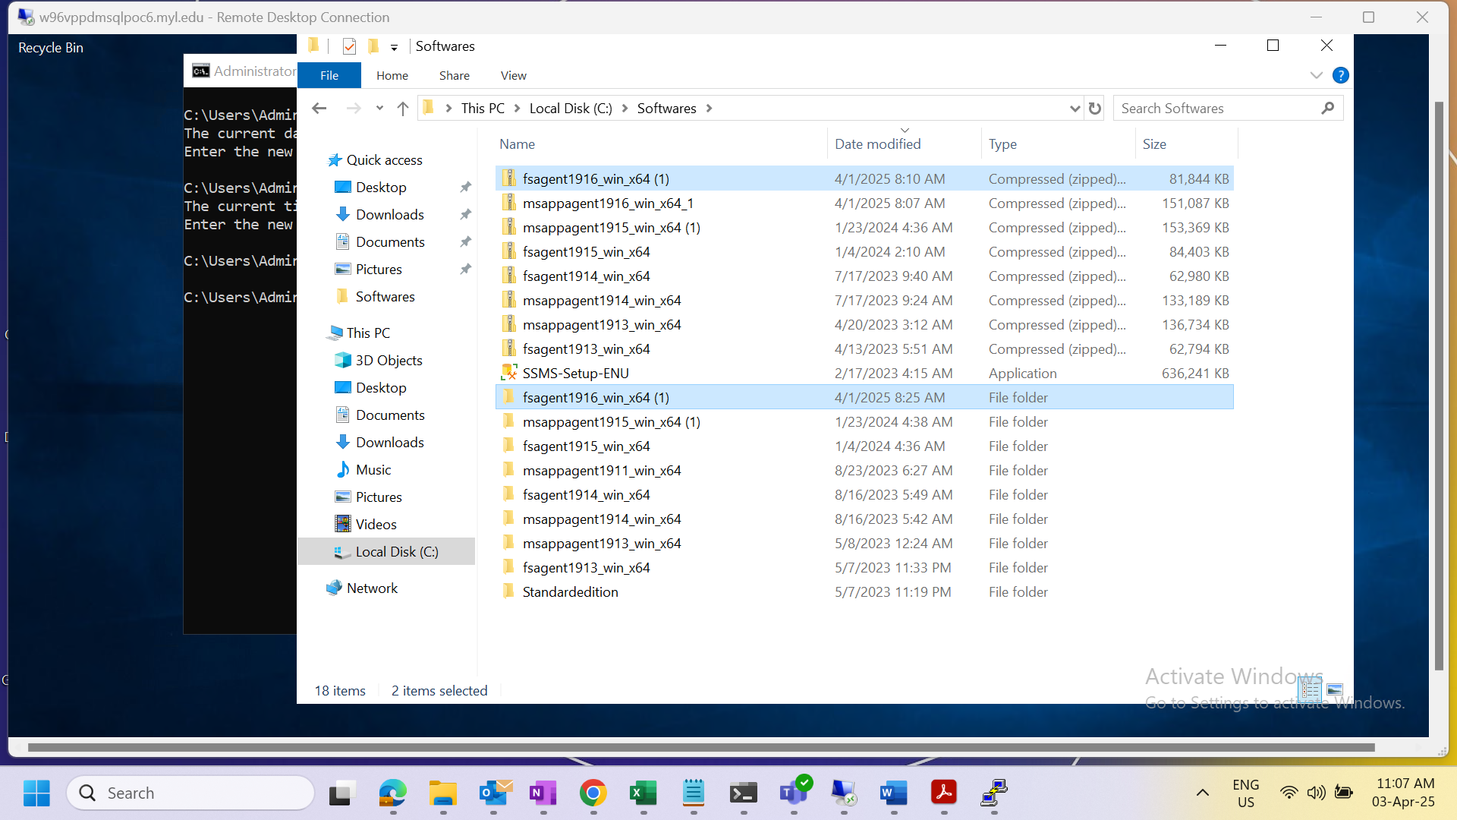
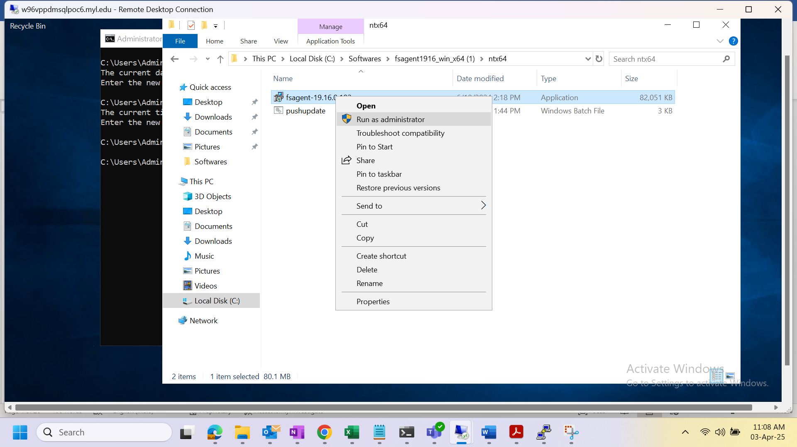

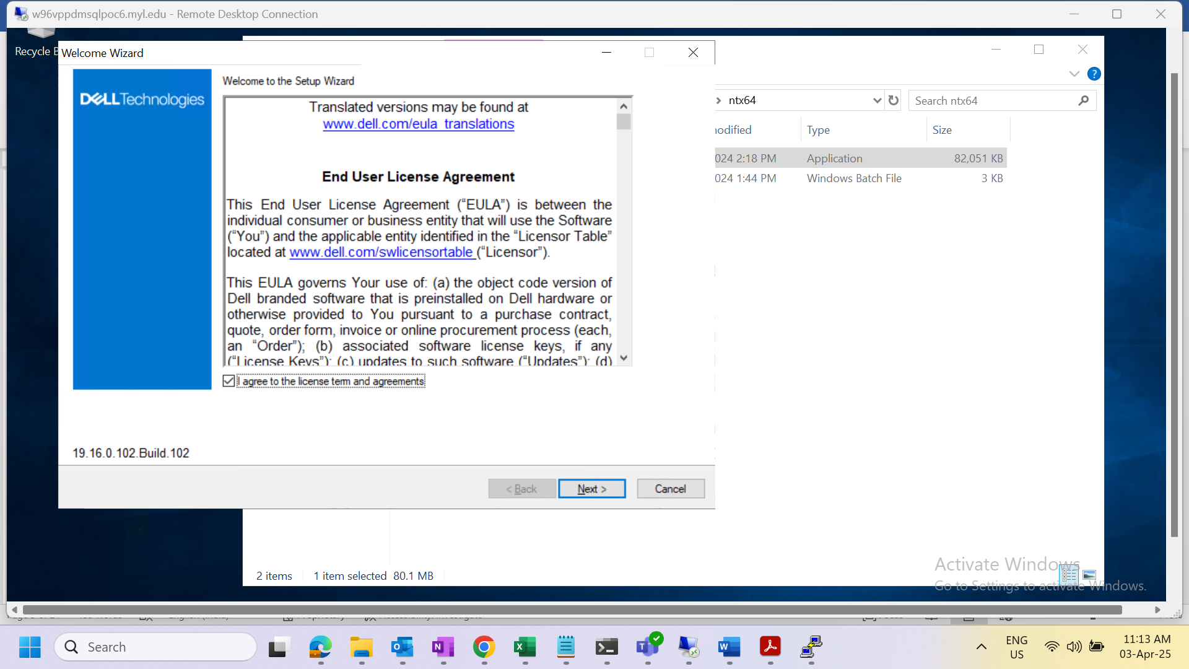

- Change/select the destination folder for this installation and click next to continue

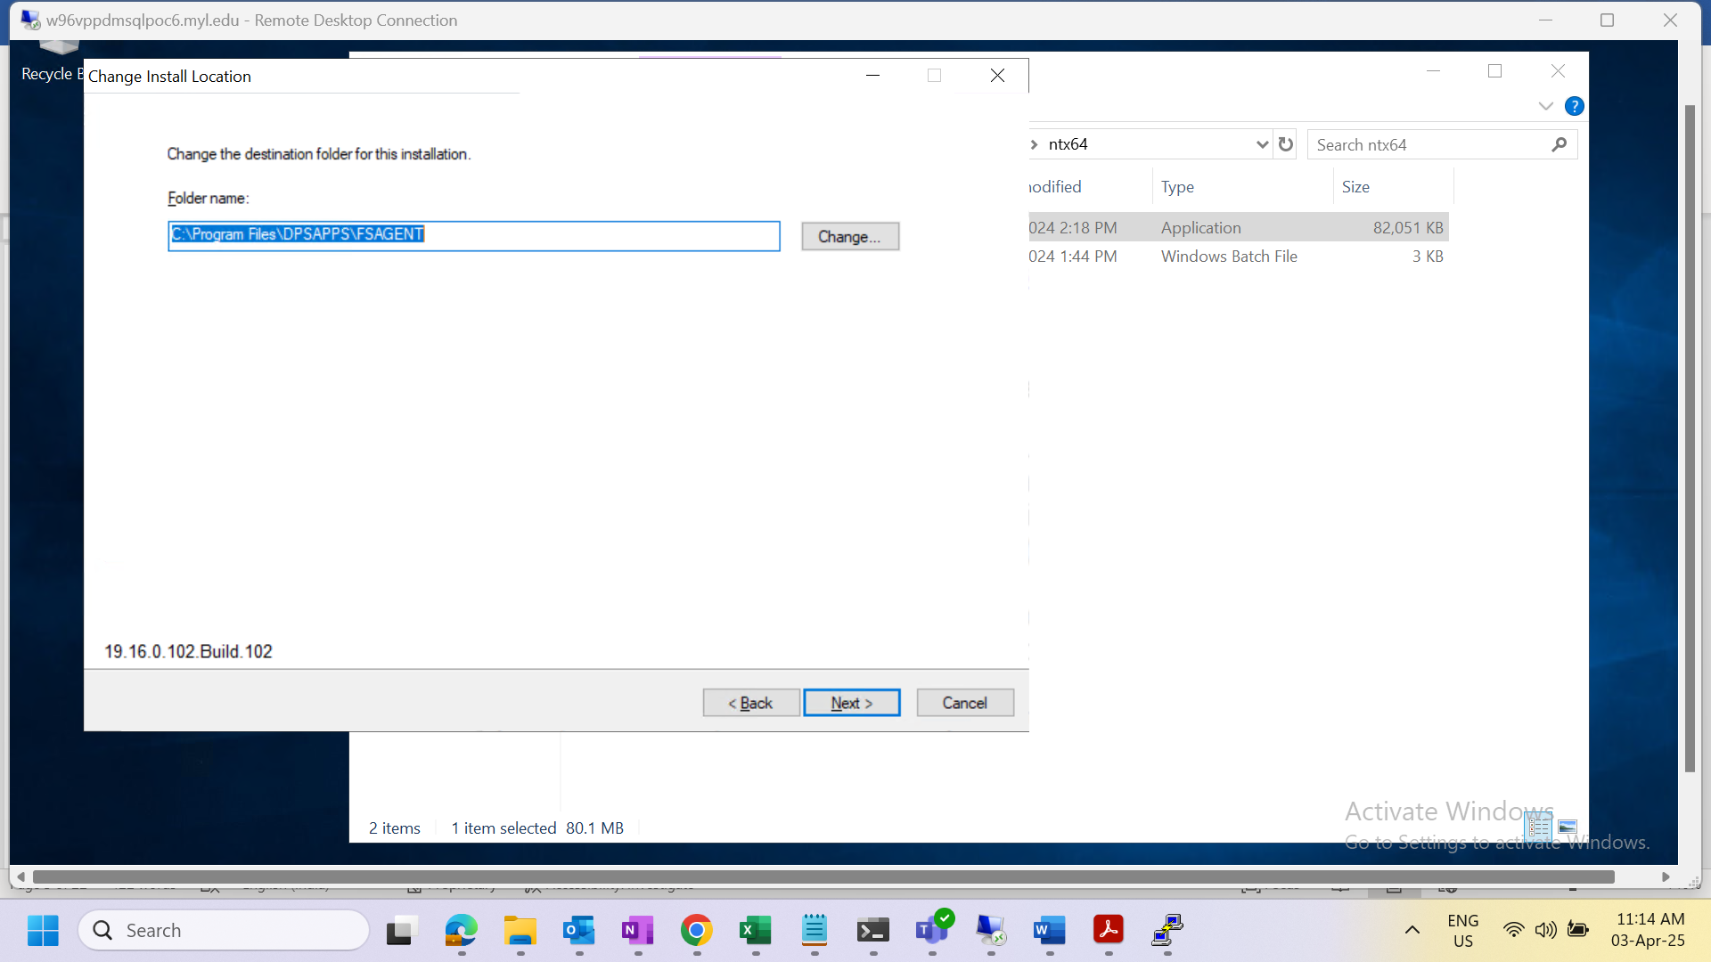

- Specify the PPDM server name and select preferred application host address communication.
- Keep the same windows firewall settings and click install button to begin the installation.

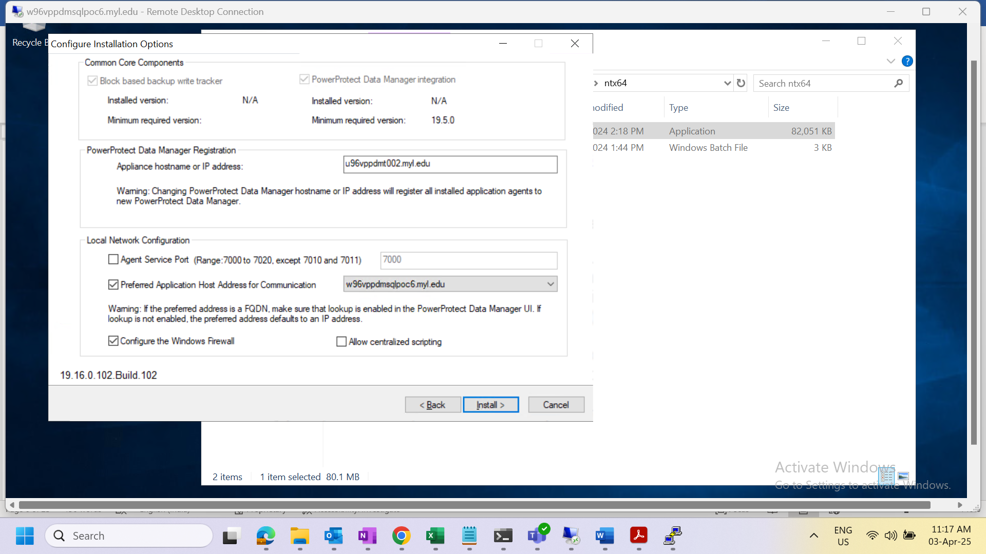
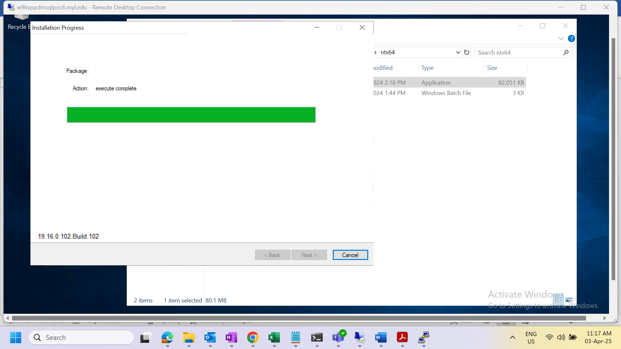

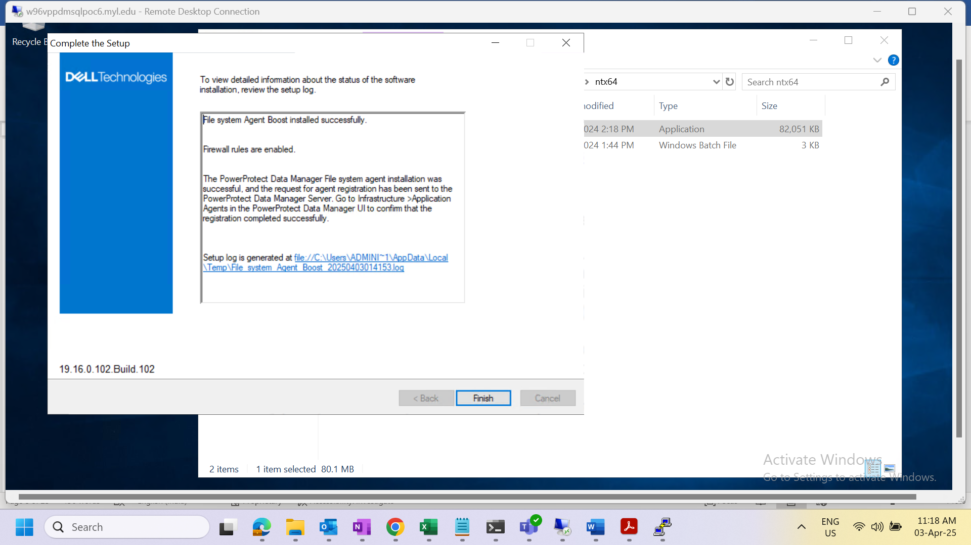

Linux Systems
- Login to the PPDM console with administrative privileges
- Download Linux file system agent package from PPDM console(SettingsDownloads)
- Login to the relevant Linux server with administrative privileges
- Copy the file system agent tar file from local system to respective windows server
- Extract the tar file
- Run the installation binary (./install.sh --skip-driver)
NOTE: For installations on Oracle Linux distributions, run install.sh --skip-driver to skip the block-based backup driver installation. These distributions do not currently support block-based backups. Therefore, all backups performed by the File System agent on these distributions will be file-based backups.
- During the installation provide the inputs for options as
register the client = Y
PPDM server name = <Relevant PPDM Server Name>
Pre-Post script enablement = Y
Preferred FQDN for client host = <Client hostname FQDN>
agent service Port(default 7000) = Y
add the firewall rule = Y

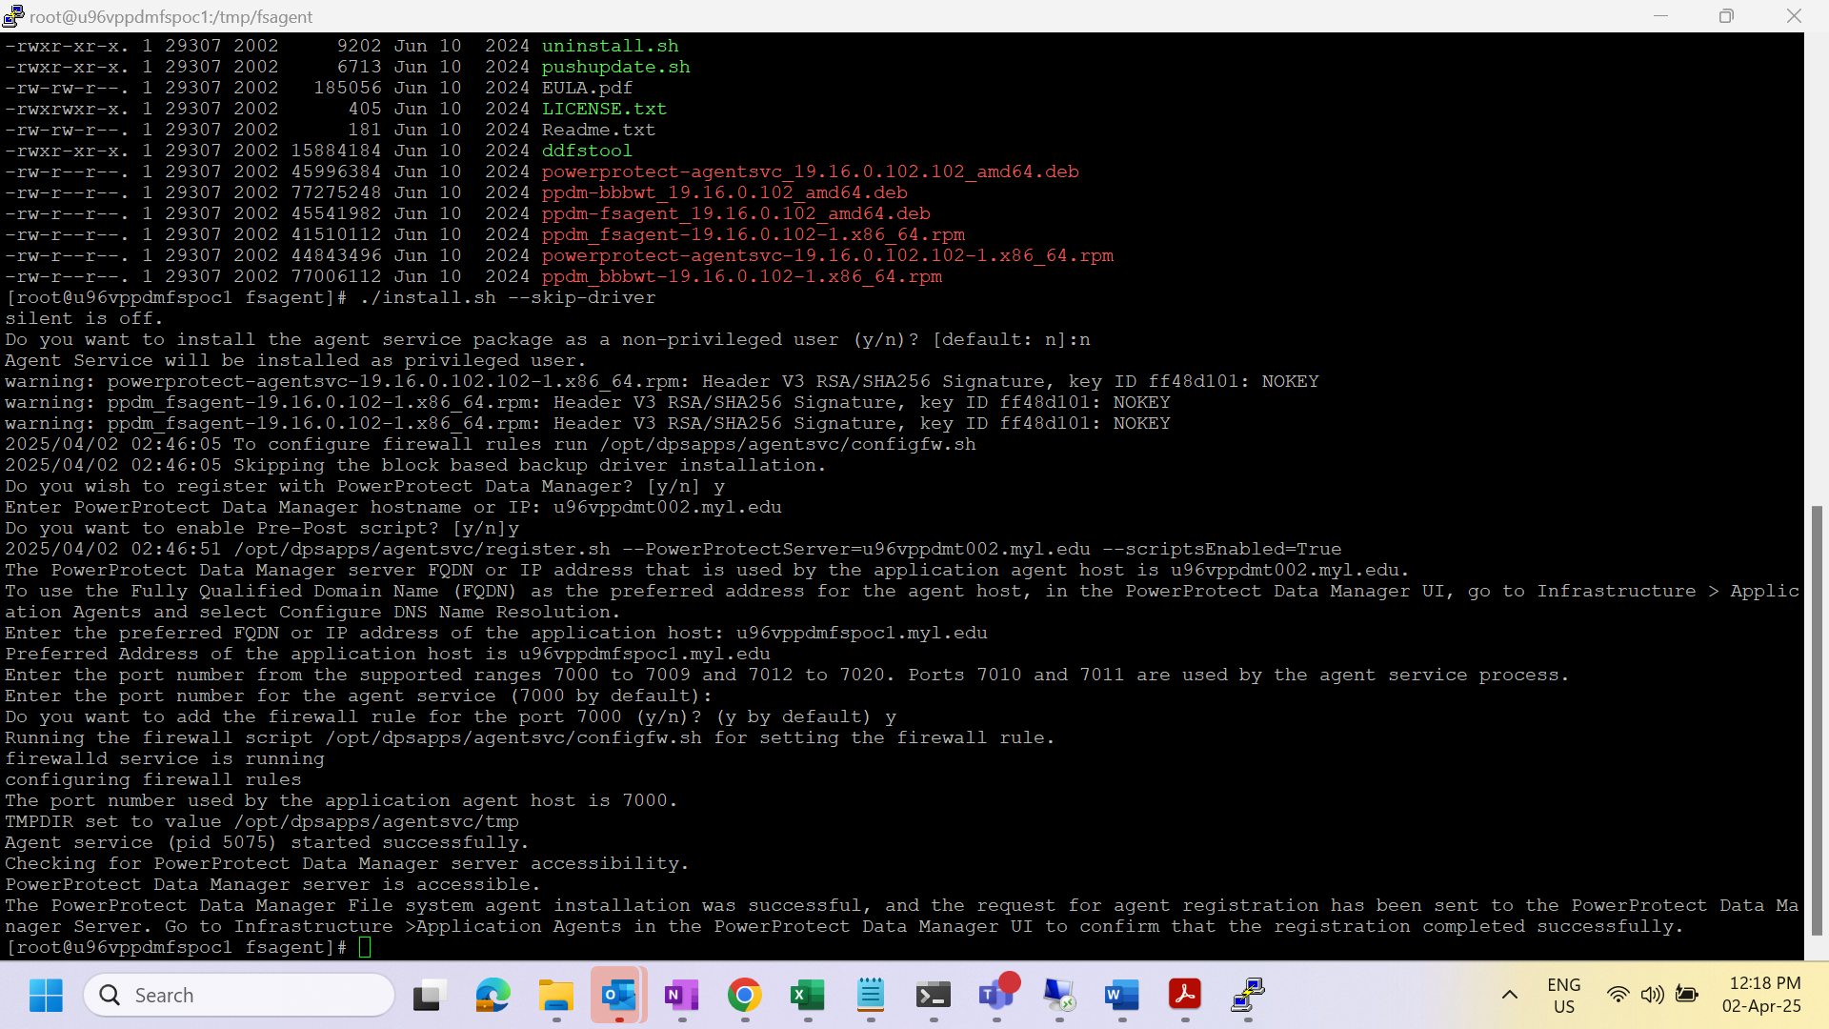

Revision history
Version | Author(s) | Date | Changes Made
1.0 | Suresh E |  | Initial Version

