Power HA 7.1 Build Document

Production_IP:-
##################

10.80.49.65 gbnvpadbs20
10.80.49.64 gbnvpadbs21
10.80.49.68 primdbprod_svc pimdbprod.cpwplc.com

RG Name :- hybris00_rg
ClusterName :- cpw_hybrprod_prod_db
Application Controller name: hyprprod_dbapp
######################################

##### HACMP Details #####
/etc/hosts >> Add both Nodes
10.80.177.71 gbnvradbs29
10.80.177.70 gbnvradbs30
10.80.177.72 primdbstage_svc primdbstage.cpwplc.com
####################

#################################################################################
/etc/cluster/rhosts >> Add to both nodes

[gbnvpadbs20:root:/usr/es/sbin/cluster:] cat /etc/cluster/rhosts
10.80.49.65
10.80.49.64
10.80.49.68
[gbnvpadbs20:root:/usr/es/sbin/cluster:]

[gbnvpadbs21:root:/usr/es/sbin/cluster:] cat /etc/cluster/rhosts
10.80.49.65
10.80.49.64
10.80.49.68
[gbnvpadbs21:root:/usr/es/sbin/cluster:]
#######################################################################################
Add entry to both node for netmon.cf

[gbnvpadbs20:root:/usr/es/sbin/cluster:] cat netmon.cf
!REQD 10.80.49.65 10.80.49.1
[gbnvpadbs20:root:/usr/es/sbin/cluster:]

[gbnvpadbs21:root:/usr/es/sbin/cluster:] cat netmon.cf
!REQD 10.80.49.64 10.80.49.1
[gbnvpadbs21:root:/usr/es/sbin/cluster:]

################################### Do exportvg#########################
[gbnvpadbs20:root:/home/root:] lspv
hdisk0 00c06c8085045986 None
hdisk1 00c06c8079c04a3b oratempvg
hdisk2 00c06c8085045ba8 oraarchvg
hdisk3 00c06c8085045daf oradatavg01
hdisk4 00c06c8085045fab oradatavg02
hdisk5 00c06c80850461c1 oradatavg03
hdisk6 00c06c80850463c6 oradumpvg
hdisk7 00ce5971b873cca9 None
hdisk8 00cd470f7a01e5ee rootvg active
hdisk9 00cd470f8508b1cb orasowvg active
hdisk10 00cd470f8508b345 altinst_rootvg

[gbnvpadbs20:root:/home/root:] lspv
hdisk0 00c06c8085045986 None
hdisk1 00c06c8079c04a3b None
hdisk2 00c06c8085045ba8 None
hdisk3 00c06c8085045daf None
hdisk4 00c06c8085045fab None
hdisk5 00c06c80850461c1 None
hdisk6 00c06c80850463c6 None
hdisk7 00ce5971b873cca9 None
hdisk8 00cd470f7a01e5ee rootvg active
hdisk9 00cd470f8508b1cb orasowvg active
hdisk10 00cd470f8508b345 altinst_rootvg
[gbnvpadbs20:root:/home/root:]
######################################################################

ImportVG with available major number for both Nodes
###############

importvg -V 45 -y oratempvg 00c06c8079c04a3b
importvg -V 46 -y oraarchvg 00c06c8085045ba8
importvg -V 47 -y oradatavg01 00c06c8085045daf
importvg -V 48 -y oradatavg02 00c06c8085045fab
importvg -V 49 -y oradatavg03 00c06c80850461c1
importvg -V 50 -y oradumpvg 00c06c80850463c6

[gbnvpadbs20:root:/home/root:] lspv
hdisk0 00c06c8085045986 None
hdisk1 00c06c8079c04a3b oratempvg concurrent
hdisk2 00c06c8085045ba8 oraarchvg concurrent
hdisk3 00c06c8085045daf oradatavg01 concurrent
hdisk4 00c06c8085045fab oradatavg02 concurrent
hdisk5 00c06c80850461c1 oradatavg03 concurrent
hdisk6 00c06c80850463c6 oradumpvg concurrent
hdisk7 00ce5971b873cca9 None
hdisk8 00cd470f7a01e5ee rootvg active
hdisk9 00cd470f8508b1cb orasowvg active
hdisk10 00cd470f8508b345 altinst_rootvg
[gbnvpadbs20:root:/home/root:]
[gbnvpadbs20:root:/home/root:]

Application Script for Temporary
#####################################

cd /usr/es/sbin/cluster/
mkdir ha_scripts
chmod 777 ha_scripts
cd ha_scripts
touch start_script.sh
touch stop_script.sh
chmod 755 *

##################################################################################

1) Add Cluster Name

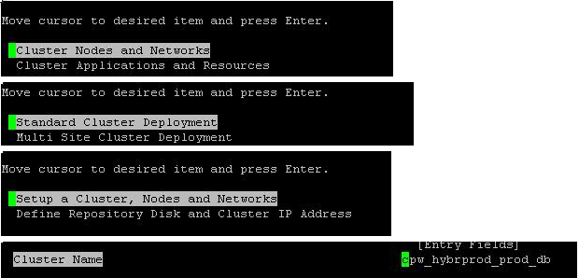
- Define a repository disk on free pv for CAA_VG (Shared Disk)

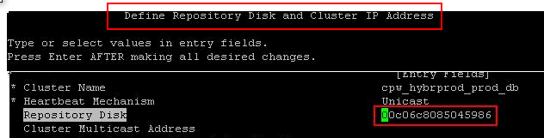
- Then do Verify and Synchronization
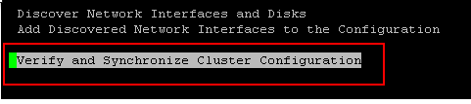
- Add Application Controller Script

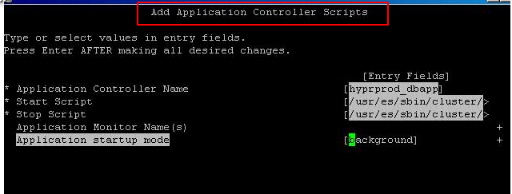
- Add a Service IP
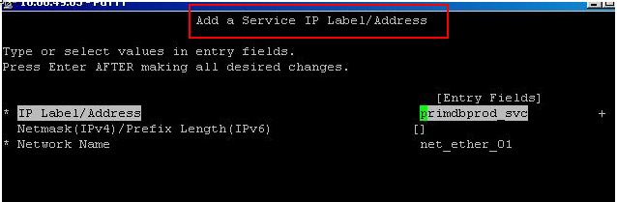
- Add Resource Group
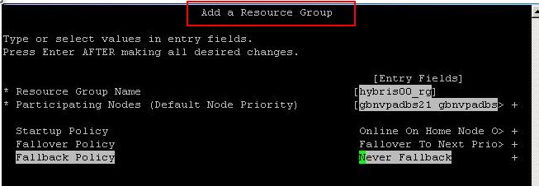
- Add All the VG's to the RG (Application Controllers Name can give any name)
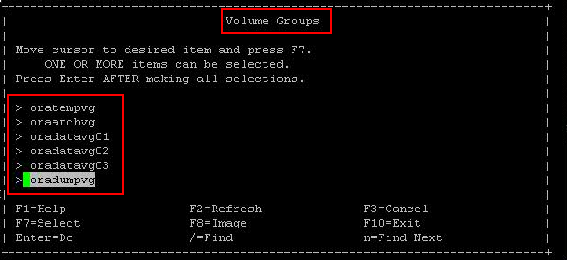
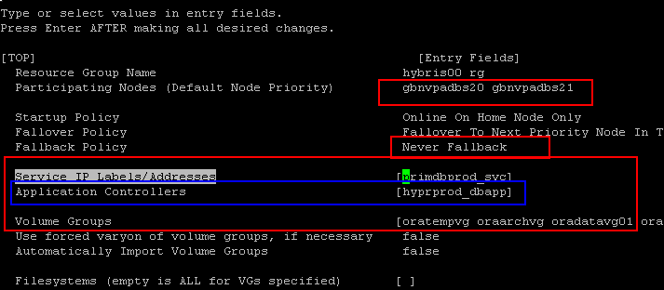
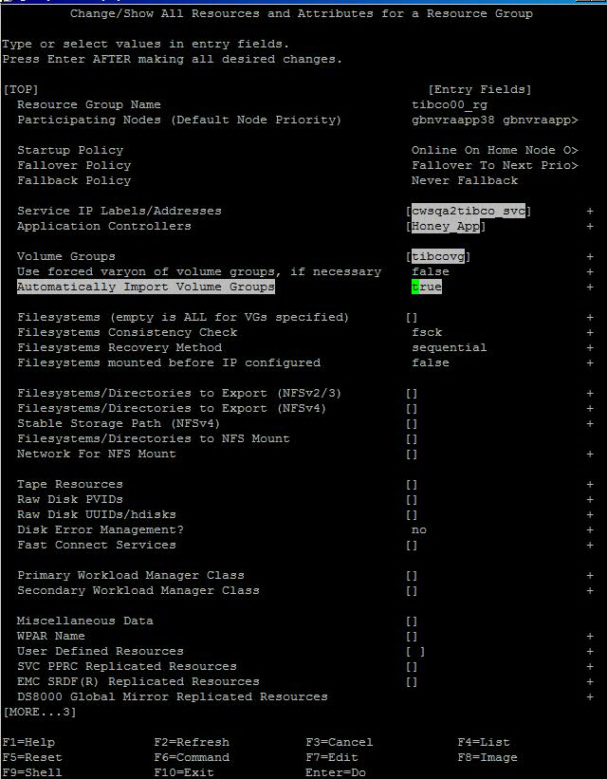

8) Verfy and Synchronize

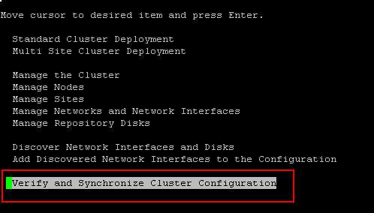

- Start Cluster Services
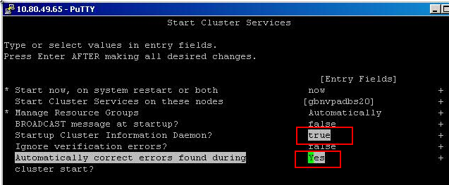

10) Cluster Status

