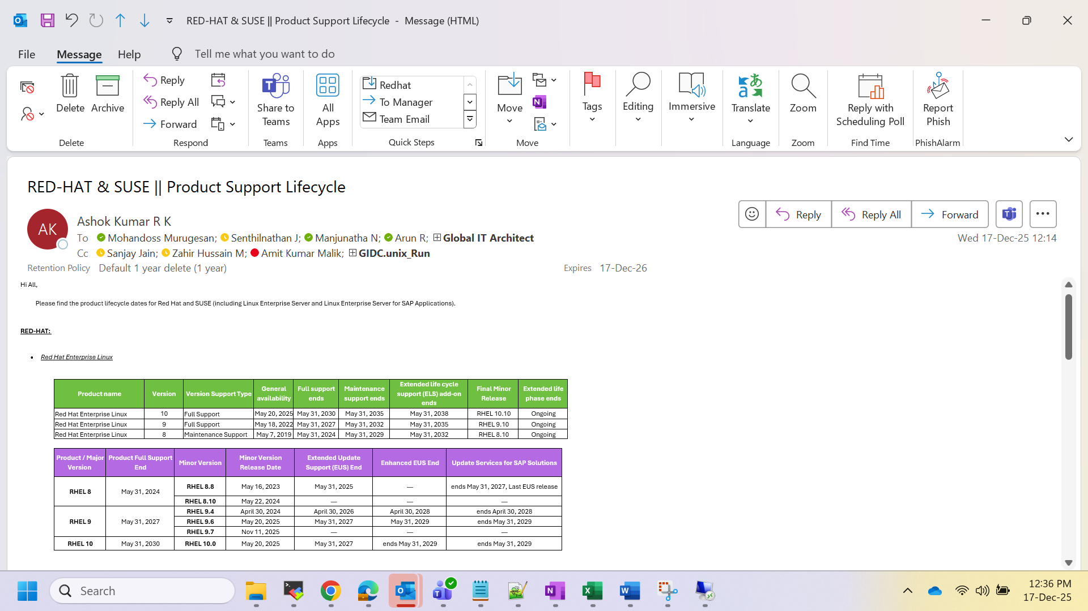

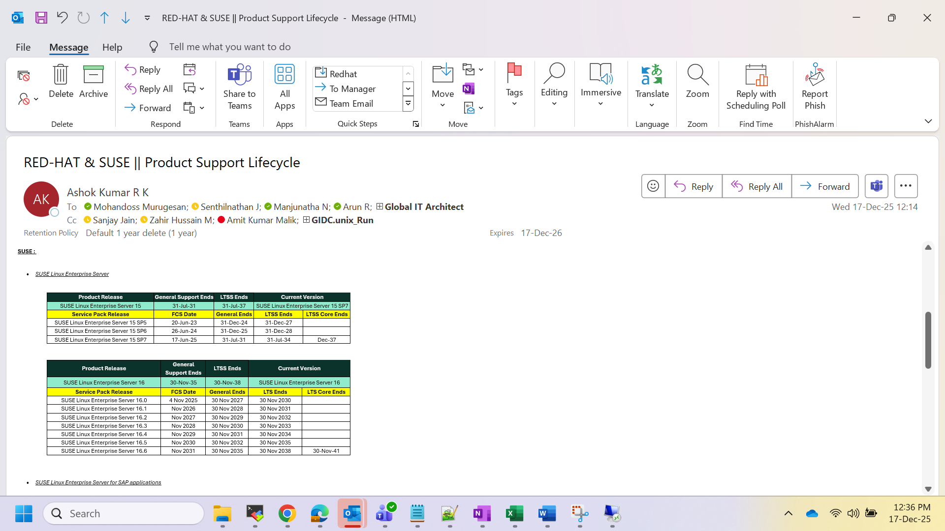

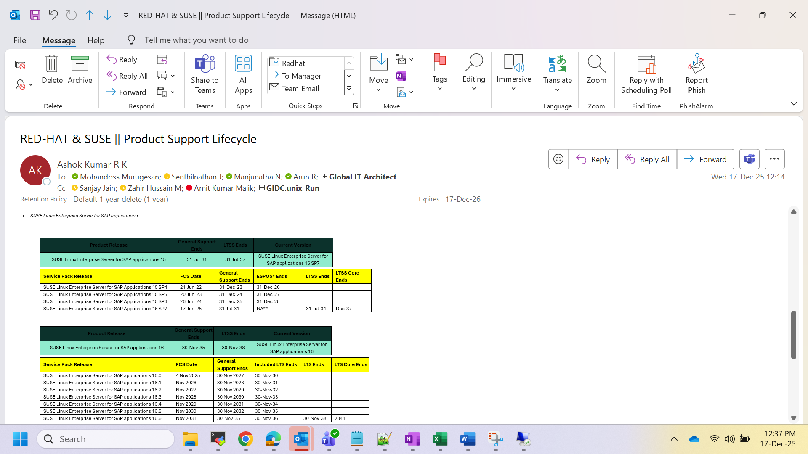

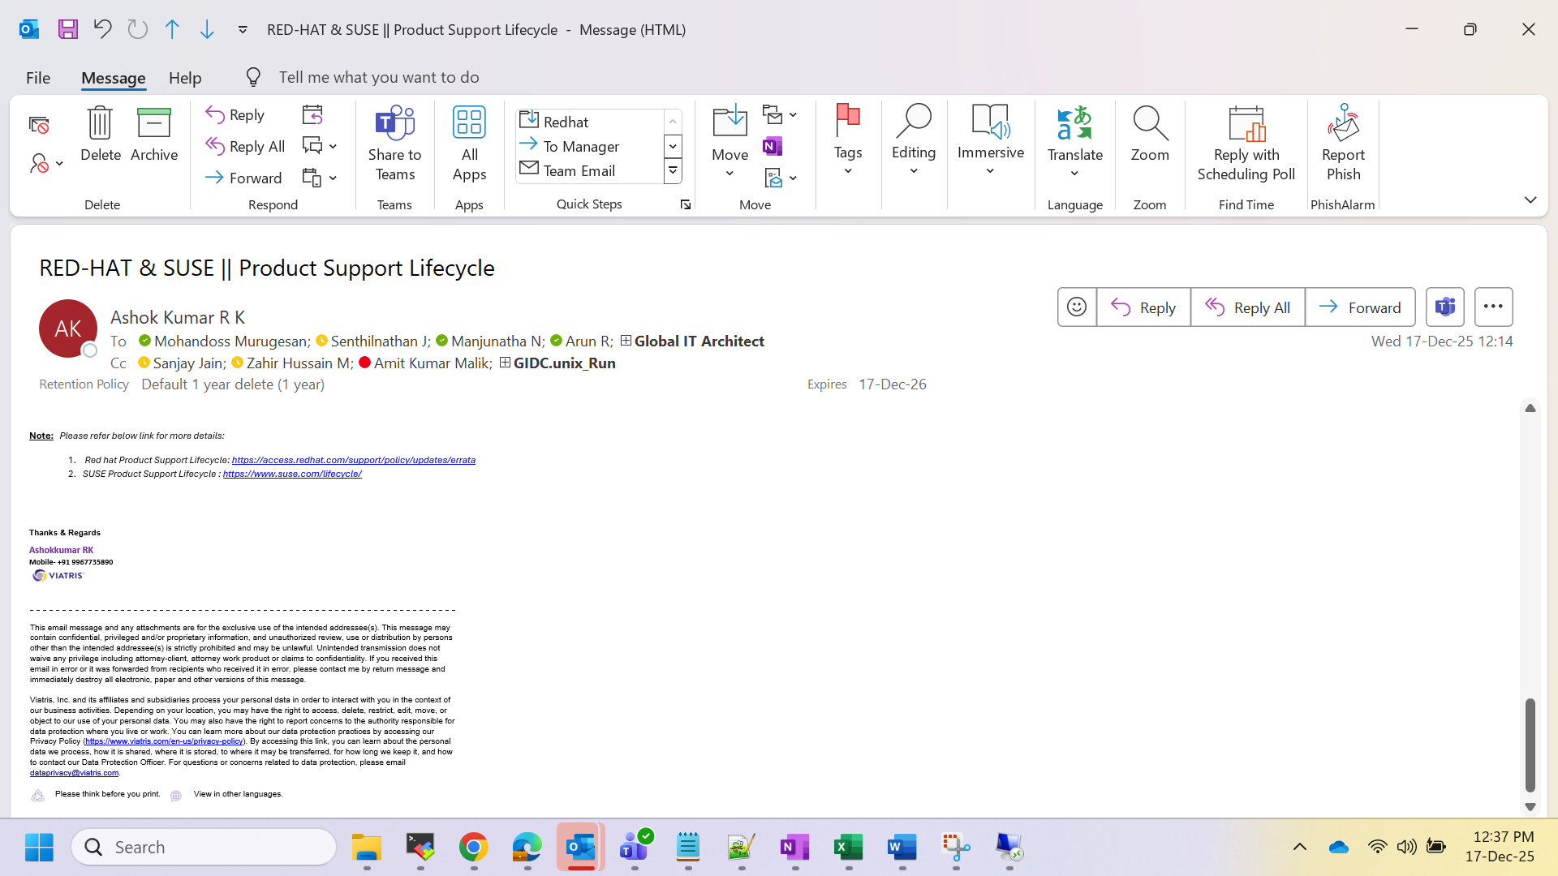

RED-HAT:

- Red Hat Enterprise Linux
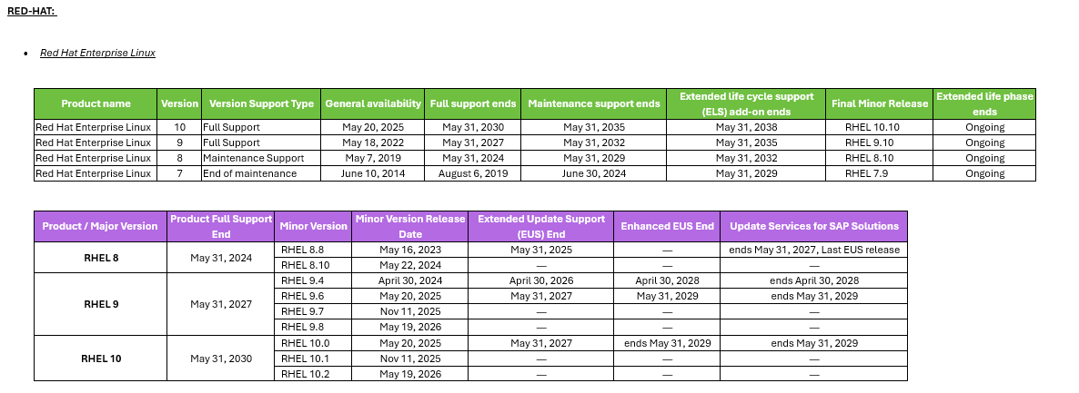
SUSE :

- SUSE Linux Enterprise Server
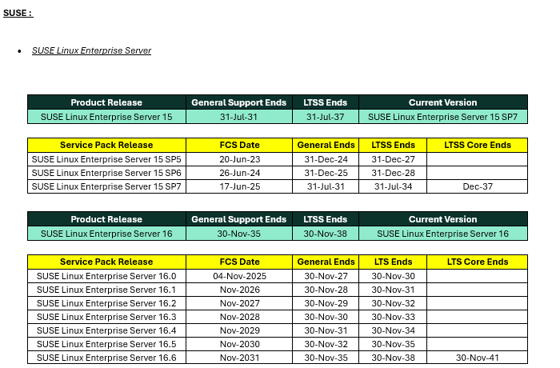

- SUSE Linux Enterprise Server for SAP applications
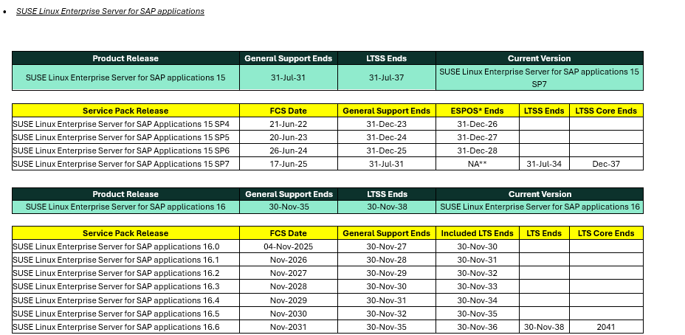

Note: Please refer below link for more details:
- Red hat Product Support Lifecycle:
- https://access.redhat.com/support/policy/updates/errata
- https://access.redhat.com/product-life-cycles
- SUSE Product Support Lifecycle :
- https://www.suse.com/lifecycle/

