ENERGY DEVELOPMENT & CONSERVATION COUNCIL (EDCC)
Trend in Electricity Consumption
Sector-Wise Analysis & Overall Growth Patterns (2022–2025)
★ KEY POINTS — Page 2
- Combined consumption: 165.22 BU (2022) → 203.35 BU (2025) = 23.1% growth
- Agriculture = LARGEST consumer: 98.45 BU (48.4% share)
- Domestic = 71.25 BU (+21.9%) — urbanisation & AC use
- Industrial surged 22.6% in 2022–23 — fastest growing sector
- National demand: 182 → 221 BU (+21.4%)
MAIN FINDING: Electricity consumption increased in EVERY sector, EVERY year (2022–2025) with no decline.
Electricity consumption across agriculture, industrial, and domestic sectors has risen steadily. The data confirms sustained pressure on India's power infrastructure and supports the Chairman's concern regarding sustainable electricity management.
Table 1: Sector-wise Electricity Consumption (Billion Units)
Sector | 2022 | 2023 | 2024 | 2025 | Growth
Agriculture (Largest) | 83.30 | 88.96 | 93.67 | 98.45 | +18.2%
Domestic | 58.44 | 64.20 | 67.80 | 71.25 | +21.9%
Industrial (Fastest ★) | 23.48 | 28.78 | 30.78 | 33.65 | +43.3% ★

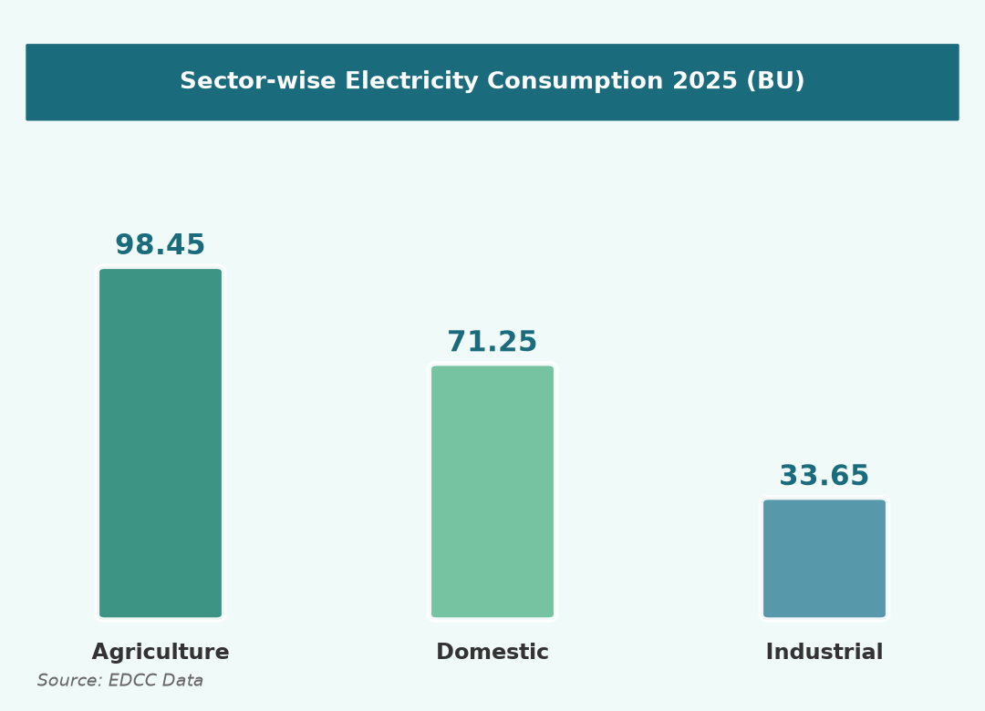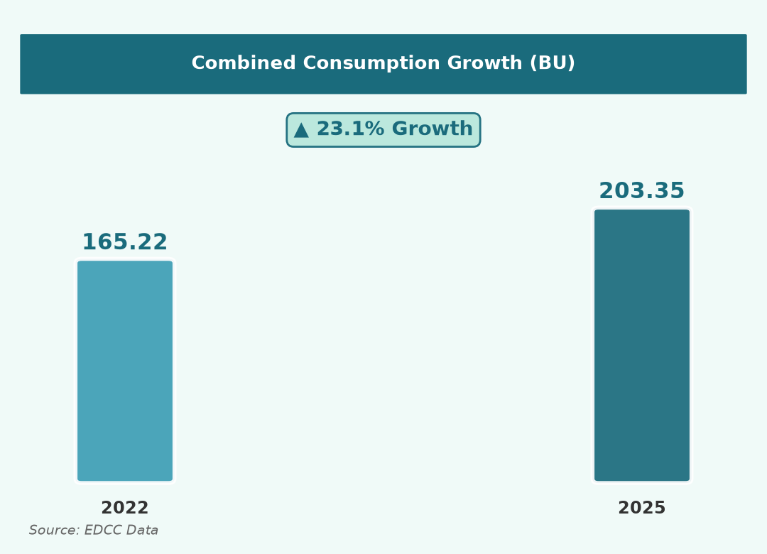
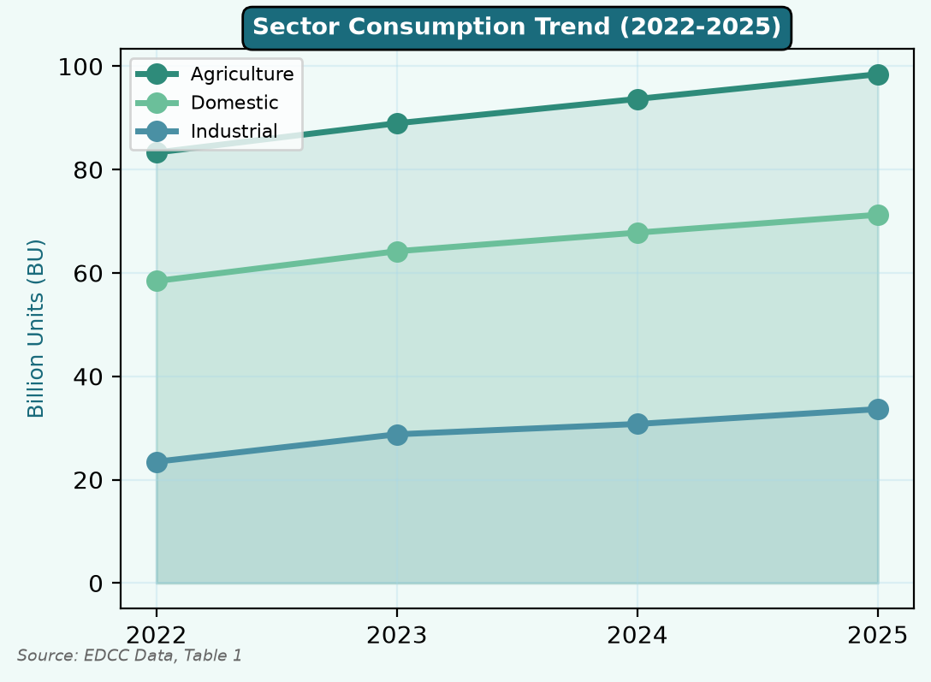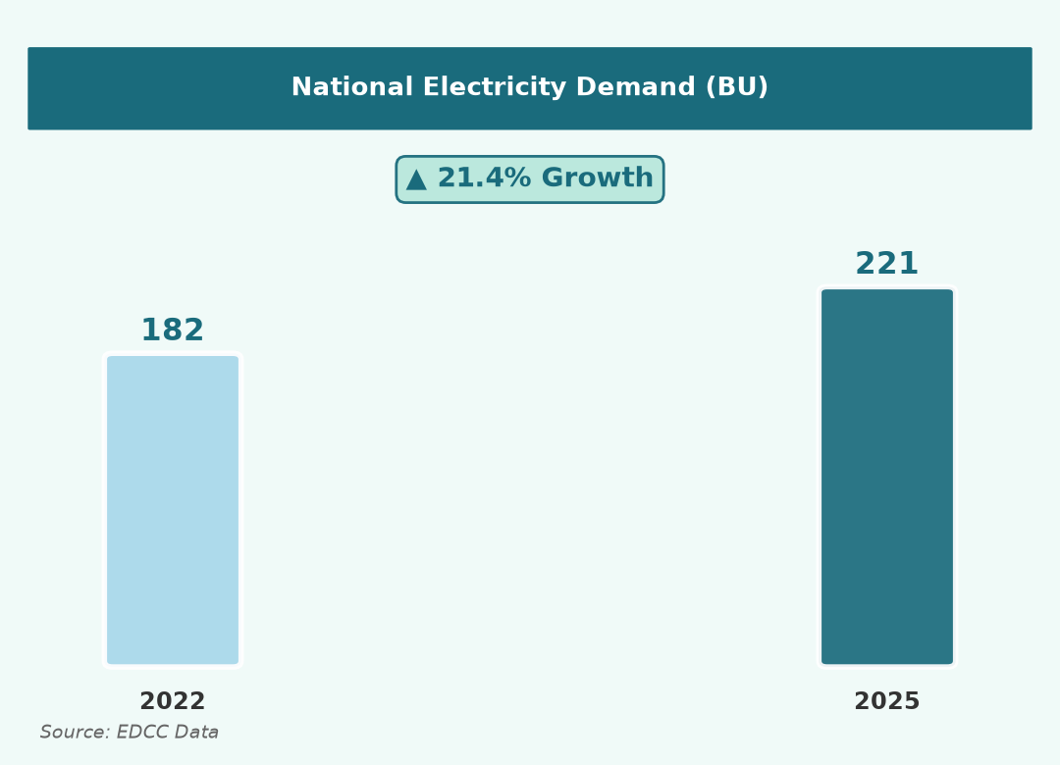
Source: EDCC Data, Table 1 | Page 2 — Jaya

ENERGY DEVELOPMENT & CONSERVATION COUNCIL (EDCC)
Highest Growth Sector Analysis
Identification of Dominant Sector & Key Drivers (2022–2025)
★ KEY POINTS — Page 3
- ★ Industrial sector = HIGHEST GROWTH at 43.3%
- Industrial CAGR = 12.7% | Peak single year = 22.6% (2022–23)
- Industrial share of domestic: 40.2% → 47.2%
- Drivers: industrial expansion | irrigation | urbanisation & ACs
- All sectors contribute to peak electricity demand
★ DOMINANT SECTOR: Industrial sector recorded the HIGHEST GROWTH at 43.3% (2022–2025).
Comparative Growth Analysis (2022–2025)
Measure | Agriculture | Industrial ★ | Domestic
2022 (BU) | 83.30 | 23.48 | 58.44
2025 (BU) | 98.45 | 33.65 | 71.25
Absolute Growth | +15.15 BU | +10.17 BU | +12.81 BU
% Growth | 18.2% | 43.3% ★ | 21.9%
CAGR | 5.8% | 12.7% ★ | 6.7%
Best Single Year | 6.8% | 22.6% ★ | 9.9%

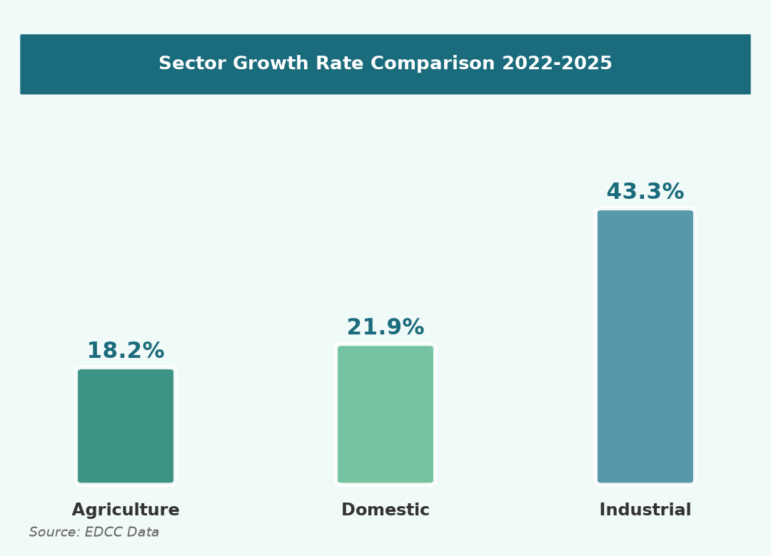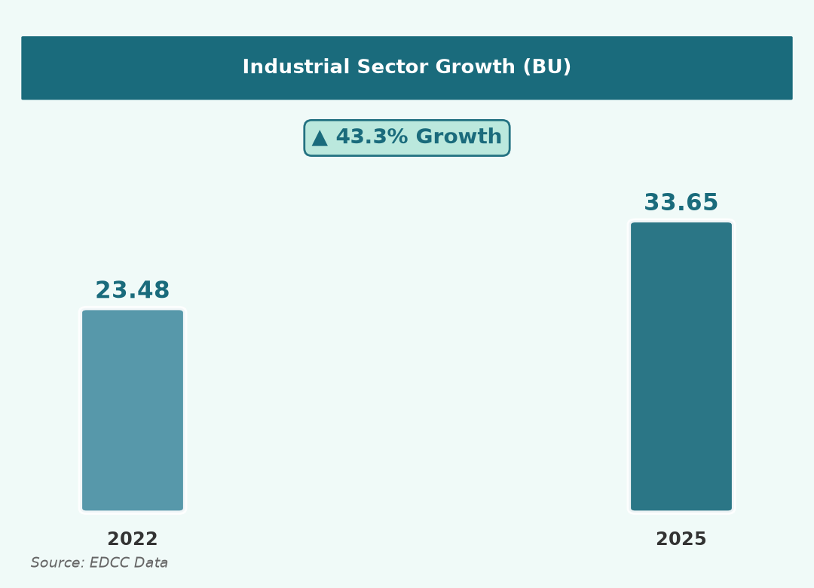
Key Drivers of Sectoral Growth
Sector | Growth | Main Drivers
Industrial ★ | 43.3% | Industrial expansion; 22.6% surge; year-round peak demand
Agriculture | 18.2% | Increased irrigation; largest base; seasonal peak load
Domestic | 21.9% | Rapid urbanisation; higher AC use; steady growth

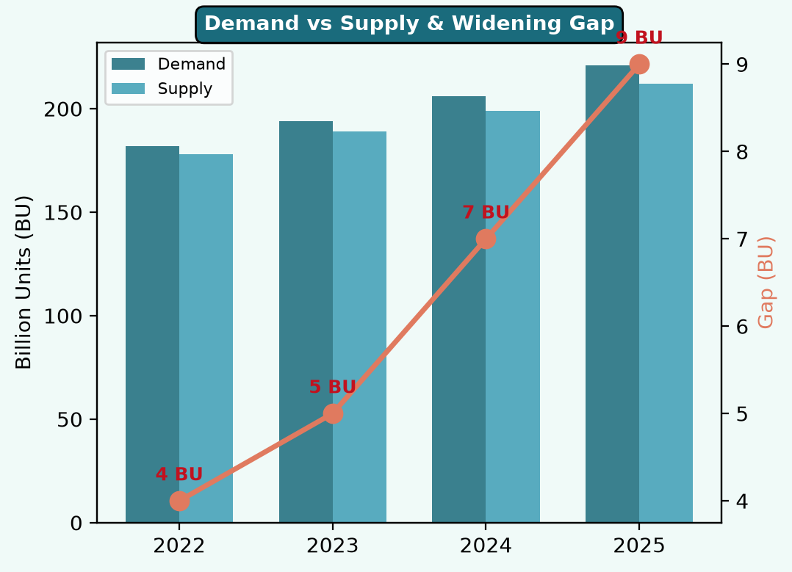
CONCLUSION: Consumption rose every year. Combined growth = 23.1%. Agriculture largest (98.45 BU). Industrial sector HIGHEST GROWTH at 43.3%. Effective energy planning is urgently needed.
Source: EDCC Data, Tables 1 & 2 | Page 3 — Jaya

