ANALYTICAL REPORT
ON ELECTRICITY CONSUMPTION TRENDS
AND SUSTAINABLE ENERGY MANAGEMENT IN INDIA
Prepared for: The Chairman, Energy Development and Conservation Council (EDCC), New Delhi
Prepared by: Secretary, EDCC | Section Contributor: Jaya (Pages 2-3)
Date: August 2026

Introduction
Background, Scope & Report Objectives
★ KEY POINTS — Introduction
- Chairman concerned about steady rise in electricity consumption & pressure on power infrastructure
- Report analyses sector-wise data 2022–2025 from EDCC Tables 1, 2 & 3
- Covers: consumption trends, highest growth sector, demand-supply gap, renewable progress, 3 recommendations
- Drivers: urbanisation, industrial expansion, AC use, agricultural irrigation
- Government promotes: renewable energy, smart grids, energy-efficient appliances, demand-side management
Background and Scope
The Energy Development and Conservation Council (EDCC) has been monitoring India's electricity sector amid sustained economic growth, rapid urbanisation, and rising living standards. Between 2022 and 2025, electricity consumption across agriculture, industrial, and domestic sectors showed a steady upward trajectory, placing increasing pressure on generation capacity, transmission networks, and distribution infrastructure.
Report Objectives
- 1. Analyse trends in electricity consumption from 2022–2025.
- 2. Identify the sector with highest growth and explain reasons.
- 3. Compare electricity demand and supply trends; state concerns.
- 4. Evaluate renewable energy adoption and T&D loss reduction.
- 5. Recommend three practical measures for sustainable electricity management.
Page 1 | EDCC Complete Analytical Report

Trend in Electricity Consumption
Sector-Wise Consumption Analysis (2022–2025)
★ KEY POINTS — Page 2
- Combined consumption: 165.22 BU (2022) → 203.35 BU (2025) = 23.1% growth
- Agriculture = LARGEST consumer: 98.45 BU (48.4% share in 2025)
- Domestic = 71.25 BU (+21.9%) — driven by urbanisation & higher AC use
- Industrial surged 22.6% in 2022–23 — fastest growing sector overall
- National demand aligned: 182 → 221 BU (+21.4%)
MAIN FINDING: Electricity consumption increased in EVERY sector, EVERY year (2022–2025) with no decline.
Table 1: Sector-wise Electricity Consumption (Billion Units)
Sector | 2022 | 2023 | 2024 | 2025 | Growth
Agriculture (Largest) | 83.30 | 88.96 | 93.67 | 98.45 | +18.2%
Domestic | 58.44 | 64.20 | 67.80 | 71.25 | +21.9%
Industrial (Fastest ★) | 23.48 | 28.78 | 30.78 | 33.65 | +43.3% ★

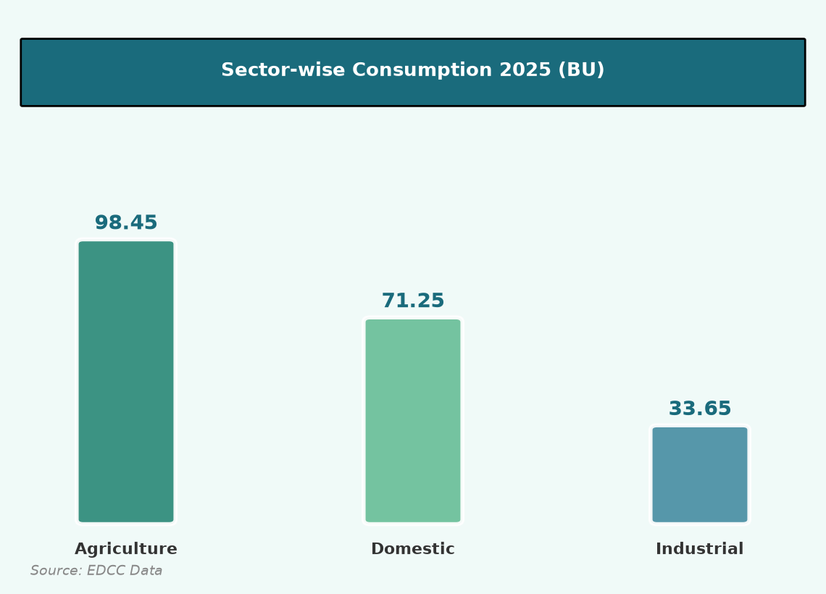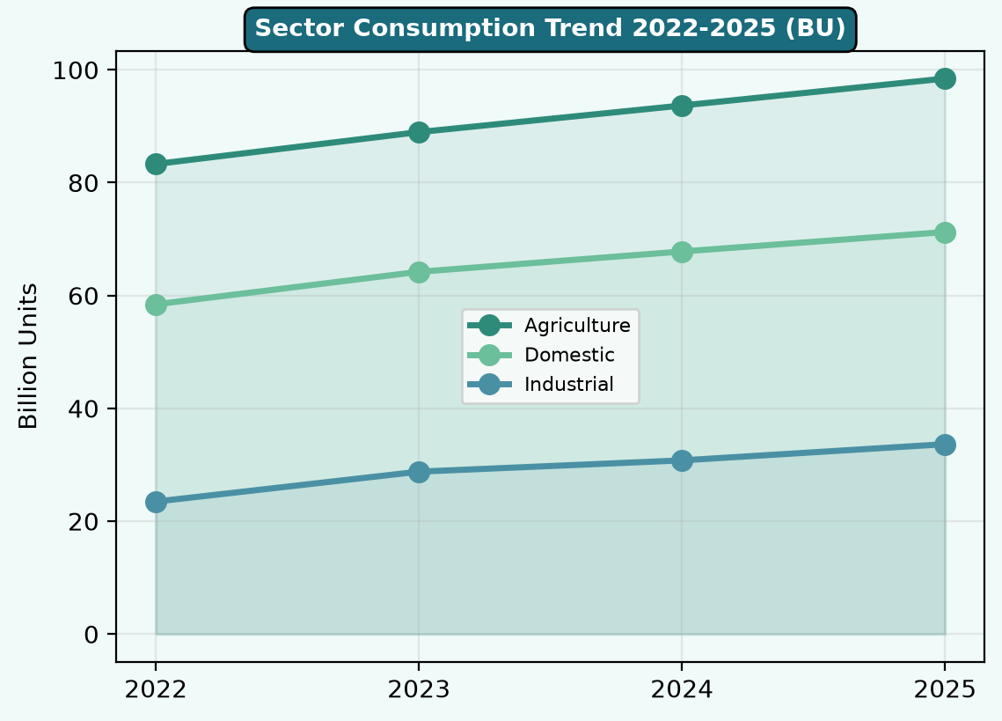
Overall Growth Trends (2022–2025)
Year | Combined (BU) | Annual Increase | YoY Growth
2022 | 165.22 | — | —
2023 | 181.94 | +16.72 | 10.1%
2024 | 192.25 | +10.31 | 5.7%
2025 | 203.35 | +11.10 | 5.8%

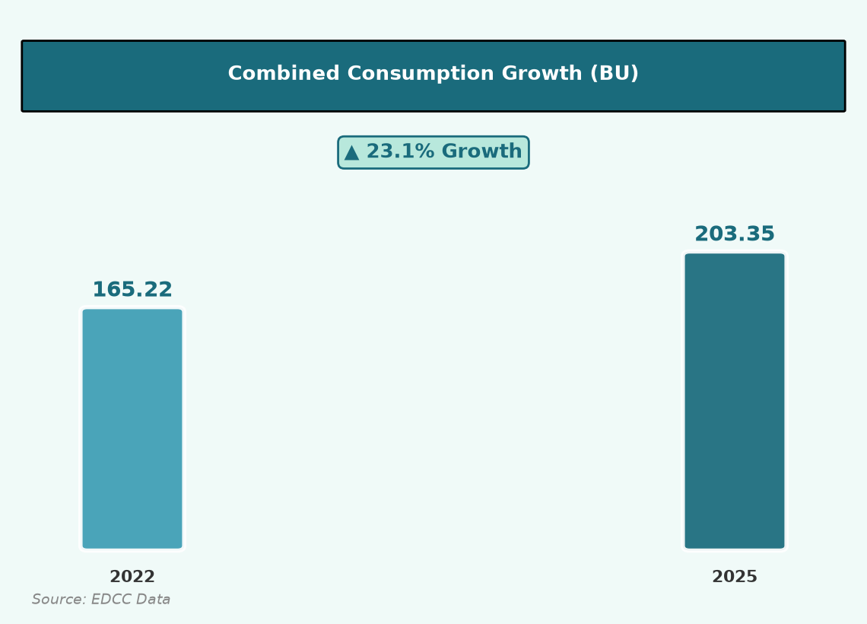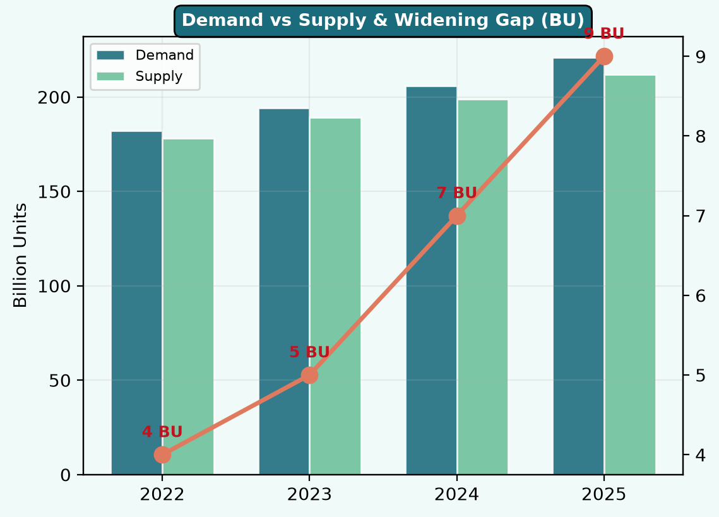
Page 2 | EDCC Complete Analytical Report — Jaya

Highest Growth Sector Analysis
Identification of Dominant Sector & Key Drivers
★ KEY POINTS — Page 3
- ★ INDUSTRIAL SECTOR = HIGHEST GROWTH at 43.3%
- Industrial CAGR = 12.7% | Peak single year = 22.6% (2022–23)
- Industrial share of domestic consumption: 40.2% → 47.2%
- Drivers: industrial expansion | irrigation | urbanisation & ACs
- All sectors contribute to peak demand alongside cooling requirements
★ DOMINANT SECTOR: Industrial sector recorded HIGHEST GROWTH at 43.3% during 2022–2025.
Comparative Growth Analysis
Measure | Agriculture | Industrial ★ | Domestic
2022 (BU) | 83.30 | 23.48 | 58.44
2025 (BU) | 98.45 | 33.65 | 71.25
% Growth | 18.2% | 43.3% ★ | 21.9%
CAGR | 5.8% | 12.7% ★ | 6.7%
Best Single Year | 6.8% | 22.6% ★ | 9.9%

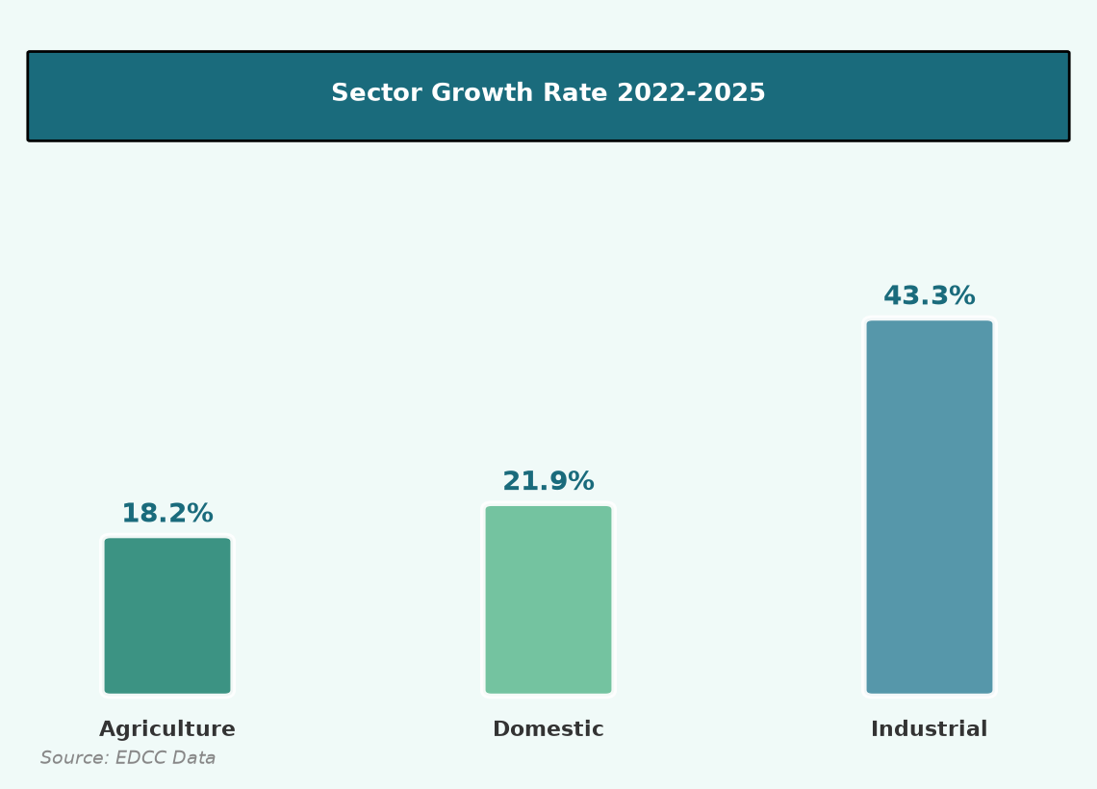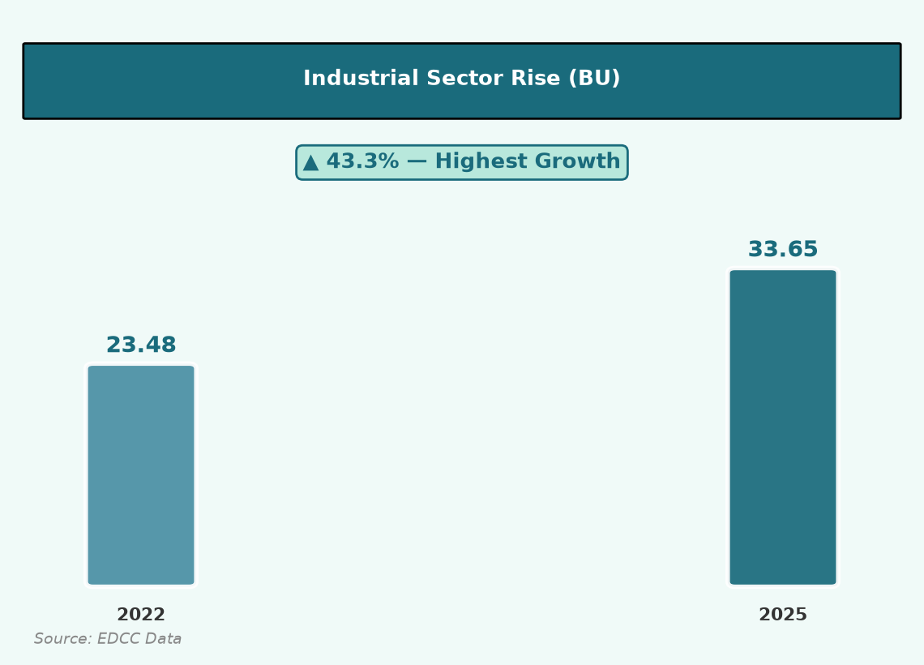
Key Drivers of Sectoral Growth
Sector | Growth | Main Drivers (EDCC Briefing)
Industrial ★ | 43.3% | Industrial expansion; continuous peak demand; 22.6% surge 2022–23
Agriculture | 18.2% | Increased agricultural irrigation; largest base (+15.15 BU)
Domestic | 21.9% | Rapid urbanisation; higher use of air conditioners

Page 3 | EDCC Complete Analytical Report — Jaya

Electricity Demand and Supply Dynamics
Comparison of Demand and Supply Trends (2022–2025)
★ KEY POINTS — Page 4
- Total demand grew: 182 → 221 BU (+21.4%)
- Total supply grew: 178 → 212 BU (+19.1%)
- ★ Demand-Supply GAP WIDENED: 4 BU → 9 BU (more than doubled)
- Gap as % of demand: 2.2% → 4.1% — supply falling behind demand
- Risk: load shedding, voltage instability, costly short-term power purchases
CRITICAL CONCERN: Supply is not keeping pace with demand — gap widens by 1-2 BU every year.
Table 2: Electricity Demand and Supply (Billion Units)
Year | Demand (BU) | Supply (BU) | Gap (BU) | Gap %
2022 | 182 | 178 | 4 | 2.2%
2023 | 194 | 189 | 5 | 2.6%
2024 | 206 | 199 | 7 | 3.4%
2025 | 221 | 212 | 9 ★ | 4.1% ★

Although supply has grown in absolute terms, the demand-supply gap has more than doubled from 4 BU to 9 BU. Each year, unmet demand increased by 1–2 BU, indicating incremental generation and transmission capacity additions are falling short of demand growth.
Critical Concerns in the Power Sector
- Managing peak demand during summer and extreme weather periods
- Financial health of DISCOMs limiting infrastructure investment
- Continued dependence on coal for round-the-clock baseload supply
- Integration challenges of variable renewable energy sources
- Widening demand-supply gap threatening energy security
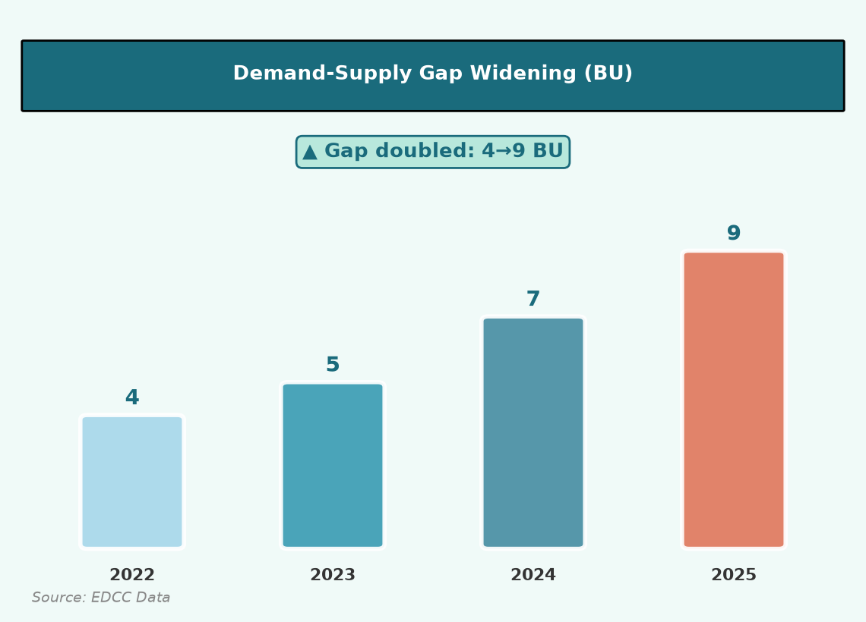
Page 4 | EDCC Complete Analytical Report

Renewable Energy and Infrastructure Efficiency
Progress in RE Adoption & T&D Loss Reduction (2022–2025)
★ KEY POINTS — Page 5
- Renewable energy share: 24% → 35% (+11 percentage points in 4 years)
- T&D losses reduced: 18% → 15% (-3 percentage points)
- Government targets AT&C losses of 12–15% under RDSS scheme
- RE growth must be matched by storage, transmission & grid modernisation
- Reducing losses = more electricity reaches paying consumers without new generation
Table 3: Renewable Energy and Transmission Losses
Indicator | 2022 | 2023 | 2024 | 2025 | Change
Renewable Energy Share (%) | 24 | 27 | 31 | 35 | +11 pp ★
T&D Losses (%) | 18 | 17 | 16 | 15 | -3 pp ★

India has made significant progress in renewable energy adoption, with share rising from 24% to 35%. T&D losses declined steadily from 18% to 15%, showing improvement in distribution efficiency. However, further reduction is needed to reach international benchmarks and RDSS targets of 12–15%.
The challenge is shifting from capacity creation to efficient and reliable demand management — ensuring electricity is available when and where needed, especially during peak periods when solar generation is unavailable.
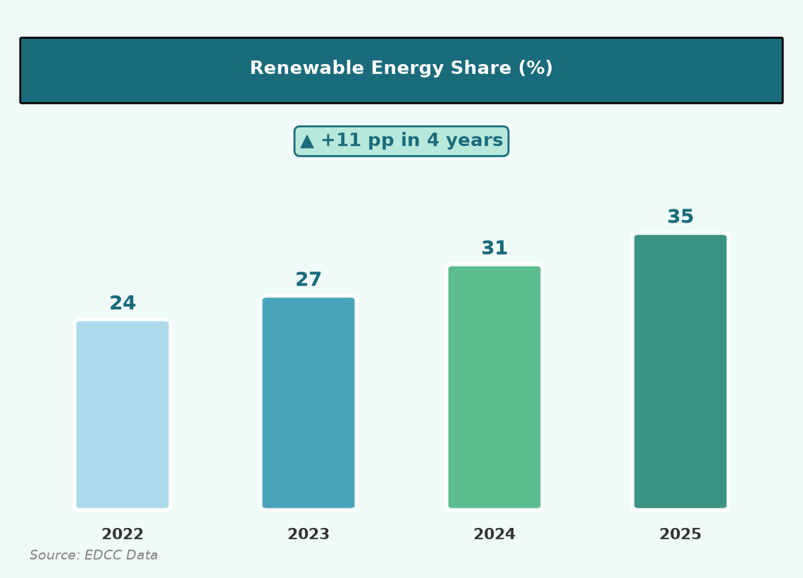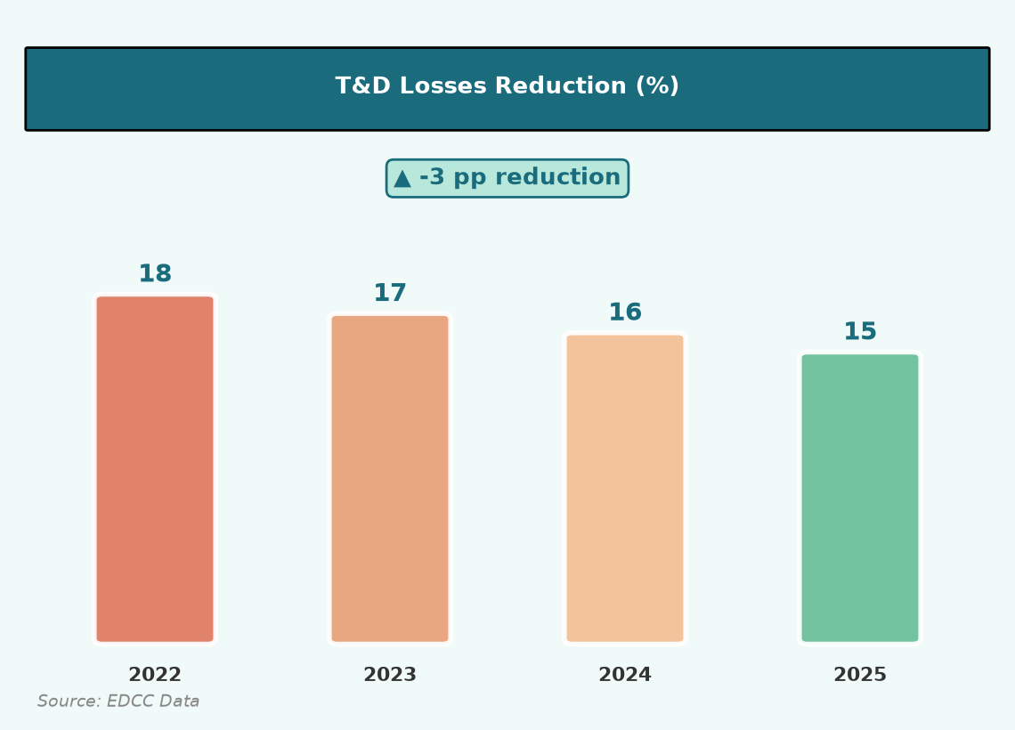
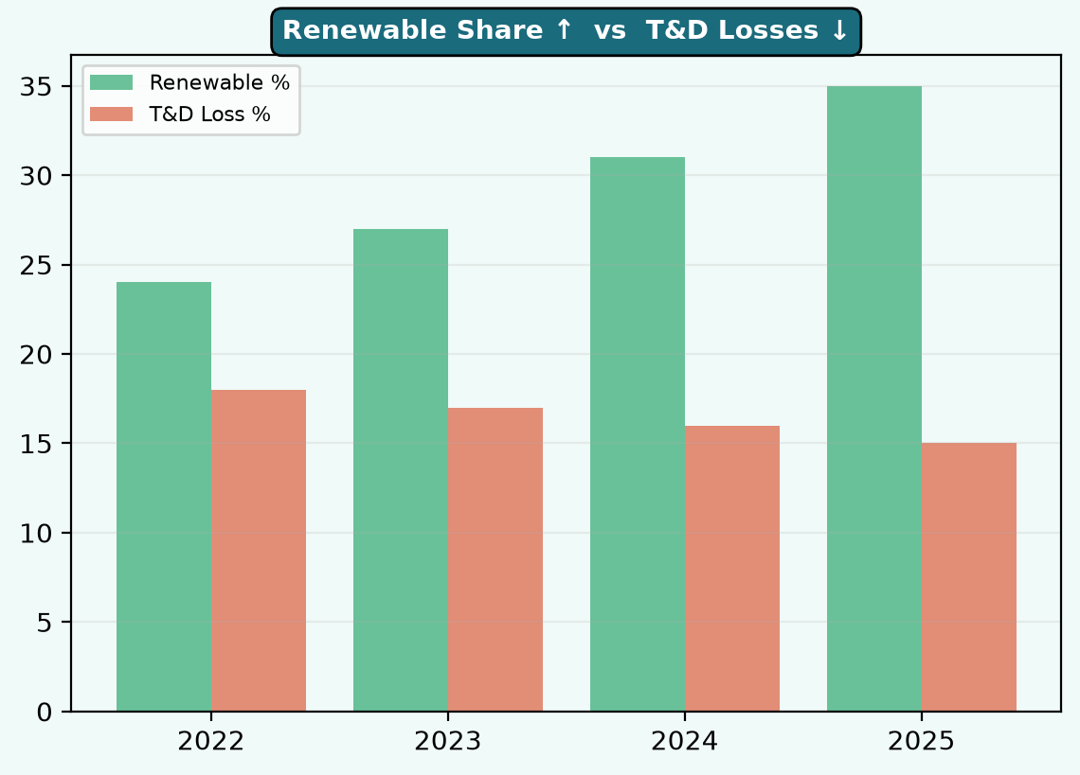
Page 5 | EDCC Complete Analytical Report

Practical Measure 1: Demand-Side Management (DSM) & Peak Load Shaping
Implementation Strategy & Projected Impact
★ KEY POINTS — Measure 1
- Implement Time-of-Day (ToD) tariffs for industrial and commercial consumers
- Peak demand reduction of 8–12 GW during summer
Implementation Strategy
- Implement Time-of-Day (ToD) tariffs for industrial and commercial consumers
- Mandatory demand response for large consumers (>1 MW) during peak hours
- Agricultural feeder scheduling aligned with solar daytime generation
- Accelerated BEE star-rating standards for ACs, refrigerators and pumps
- Public awareness campaigns on energy conservation during summer
Projected Impact and Analysis
- Peak demand reduction of 8–12 GW during summer
- Estimated savings of ₹5,000–8,000 crore annually
- Reduced need for expensive peaking plants
- Improved grid stability and lower load shedding

Page 6 | EDCC Complete Analytical Report

Practical Measure 2: Renewable Energy & Storage Corridor Development
Implementation Strategy & Projected Impact
★ KEY POINTS — Measure 2
- Establish 5–7 RE corridors connecting high-generation to high-demand states
- Integrate 50–70 GW additional solar and wind capacity
Implementation Strategy
- Establish 5–7 RE corridors connecting high-generation to high-demand states
- Co-located battery storage (BESS) and pumped hydro at corridor endpoints
- Green Energy Open Access reforms for cross-state renewable procurement
- Hybrid wind-solar projects with storage for dispatchable clean power
- Central assistance through Green Energy Corridor Phase-II
Projected Impact and Analysis
- Integrate 50–70 GW additional solar and wind capacity
- Add 40–60 BU reliable renewable supply annually
- Reduce CO₂ emissions by 30–40 million tonnes per year
- Partially offset the current 9 BU demand-supply gap

Page 7 | EDCC Complete Analytical Report

Practical Measure 3: DISCOM Modernisation & Loss Reduction
Implementation Strategy & Projected Impact
★ KEY POINTS — Measure 3
- Universal smart metering for all consumers by 2028
- T&D losses reduced from 15% to 11–12% by 2028
Implementation Strategy
- Universal smart metering for all consumers by 2028
- Feeder segregation (agricultural vs non-agricultural) in all states
- Distribution transformer monitoring and GIS mapping of networks
- Strict enforcement against electricity theft with tamper-proof meters
- Performance-linked central grants tied to verifiable AT&C loss reduction
Projected Impact and Analysis
- T&D losses reduced from 15% to 11–12% by 2028
- Recover 8–10 BU of electricity without new generation plants
- DISCOM revenue improvement of ₹15,000–20,000 crore
- Better infrastructure investment capacity for DISCOMs

Page 8 | EDCC Complete Analytical Report

Conclusion and Recommendations
Summary of Key Findings & Final Recommendations
★ KEY POINTS — Conclusion
- Consumption rose in all 3 sectors every year: combined growth 23.1%
- Agriculture largest (98.45 BU) | Industrial highest growth (43.3% ★)
- Demand-supply gap widened: 4 → 9 BU — critical concern
- Renewable share up 24→35% | T&D losses down 18→15% — progress but more needed
- 3 measures: DSM + RE Corridors + DISCOM Modernisation
Summary of Key Findings
- Electricity consumption increased steadily across all sectors (2022–2025).
- Agriculture remains the largest consumer at 98.45 BU (48.4% share).
- Industrial sector recorded the highest growth at 43.3%, driven by industrial expansion.
- Domestic consumption grew 21.9% due to urbanisation and higher AC use.
- Demand-supply gap widened from 4 BU to 9 BU — supply falling behind demand.
- Renewable energy share rose from 24% to 35%; T&D losses fell from 18% to 15%.
Final Recommendations
# | Measure | Primary Objective
1 | Demand-Side Management & Peak Load Shaping | Reduce peak demand; moderate consumption growth
2 | RE & Storage Corridor Development | Integrate renewables with storage for reliable clean power
3 | DISCOM Modernisation & Loss Reduction | Recover lost electricity; strengthen distribution

The EDCC recommends prompt coordination with Ministry of Power, MNRE, and state governments to implement these measures and address the Chairman's concerns over rising consumption and infrastructure pressure.
Page 9 | EDCC Complete Analytical Report

References and Appendices
Sources & Data Appendix
1. Energy Development and Conservation Council (EDCC). (2026). Sector-wise Electricity Consumption Data, 2022–2025. Internal Council Tables 1–3.
2. Central Electricity Authority. (2024). Load Generation Balance Report 2024-25. Ministry of Power, Government of India. https://cea.nic.in/l-g-b-r-report/
3. Press Information Bureau. (2025). India's Energy Landscape: Powering Growth with Sustainable Energy. Government of India. https://static.pib.gov.in/
4. Ministry of Statistics and Programme Implementation. (2025). Energy Statistics India 2025. https://mospi.gov.in/
5. Bureau of Energy Efficiency. (2024). Impact of Energy Efficiency Measures for the Year 2022-23. Ministry of Power. https://beeindia.gov.in/
6. Government of India. (2022). Revamped Distribution Sector Scheme (RDSS) Guidelines. Ministry of Power.
Appendix A: Key Calculations
Calculation | Result
Agriculture growth 2022–2025 | (98.45-83.30)/83.30 = 18.2%
Industrial growth 2022–2025 | (33.65-23.48)/23.48 = 43.3% ★ Highest
Combined CAGR | 7.1%
Demand-supply gap 2025 | 221-212 = 9 BU (4.1% of demand)
Renewable share change | 35%-24% = +11 percentage points
T&D loss reduction | 18%-15% = -3 percentage points

Page 10 | EDCC Complete Analytical Report — End

