AWS Retail Brokerage Project
Copy-Paste Safe Git Bash Implementation Guide
Student lab manual with reliable Git Bash commands, validation checkpoints, and troubleshooting

How to use this guide
This revised guide fixes the command-copying issue by using Git Bash friendly command blocks and helper shell scripts. Students should copy from the DOCX or from the companion .sh file, not from a PDF. Long AWS commands are converted into script files where possible.
Rule | Reason
Use Git Bash only | The commands use Bash variables, source, grep, awk, wc, and shell scripts.
Run from project root | Commands assume folders such as src, infra, generated_data, and tests are visible.
Use forward slash / paths | Git Bash expects infra/cloudformation/template.yaml, not Windows backslash paths.
Use file:// for validate-template | Without file://, AWS CLI treats the file path as template content and fails.
Create helper .sh files | This avoids copy-paste errors caused by Word wrapping and long commands.
Run source set-env.sh in every new terminal | Exported variables vanish when the terminal closes.

Project architecture reference
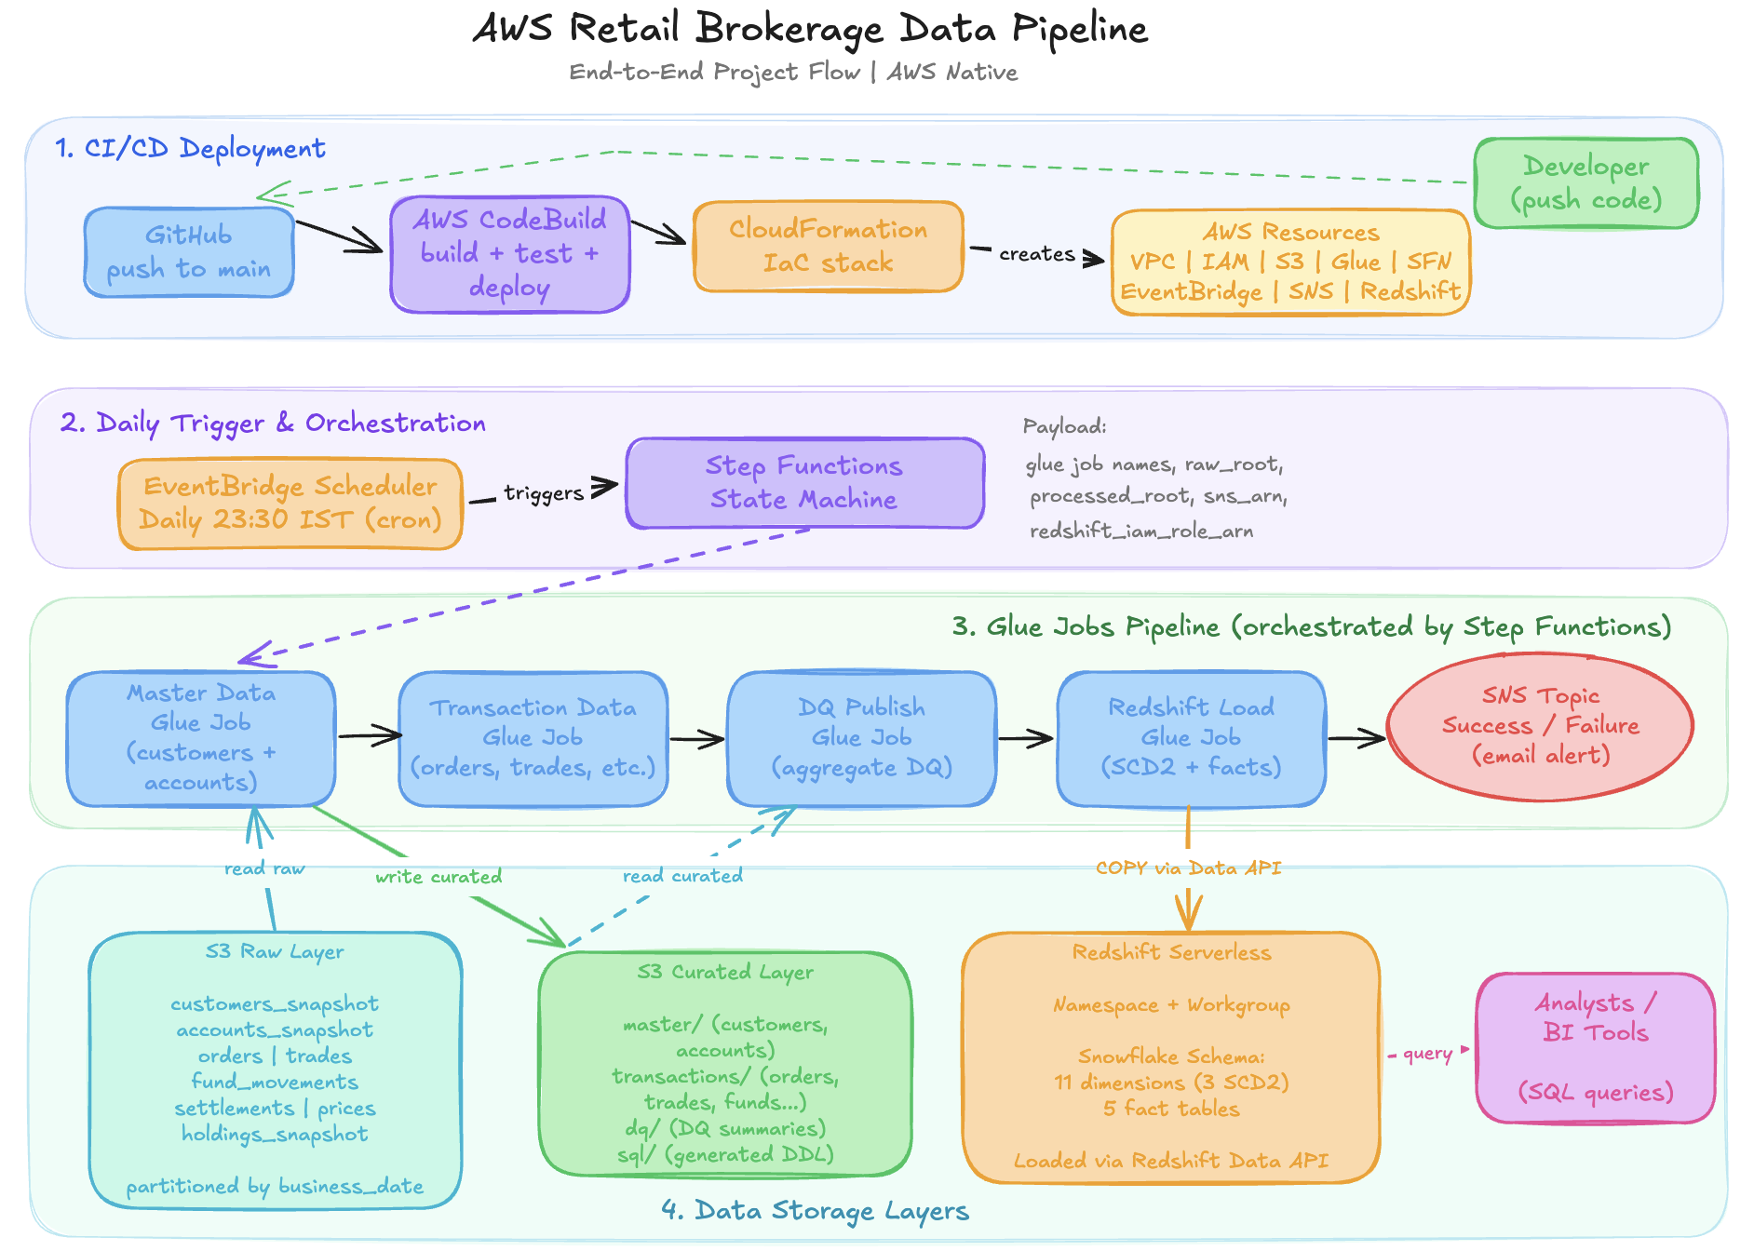
Architecture summary: local/GitHub project -> CloudFormation -> S3 raw and artifact buckets -> Glue ETL and Glue Data Quality -> S3 curated -> Redshift Serverless -> analytics queries. Step Functions orchestrates jobs; EventBridge schedules daily runs; SNS sends notifications.

Final warehouse data model reference
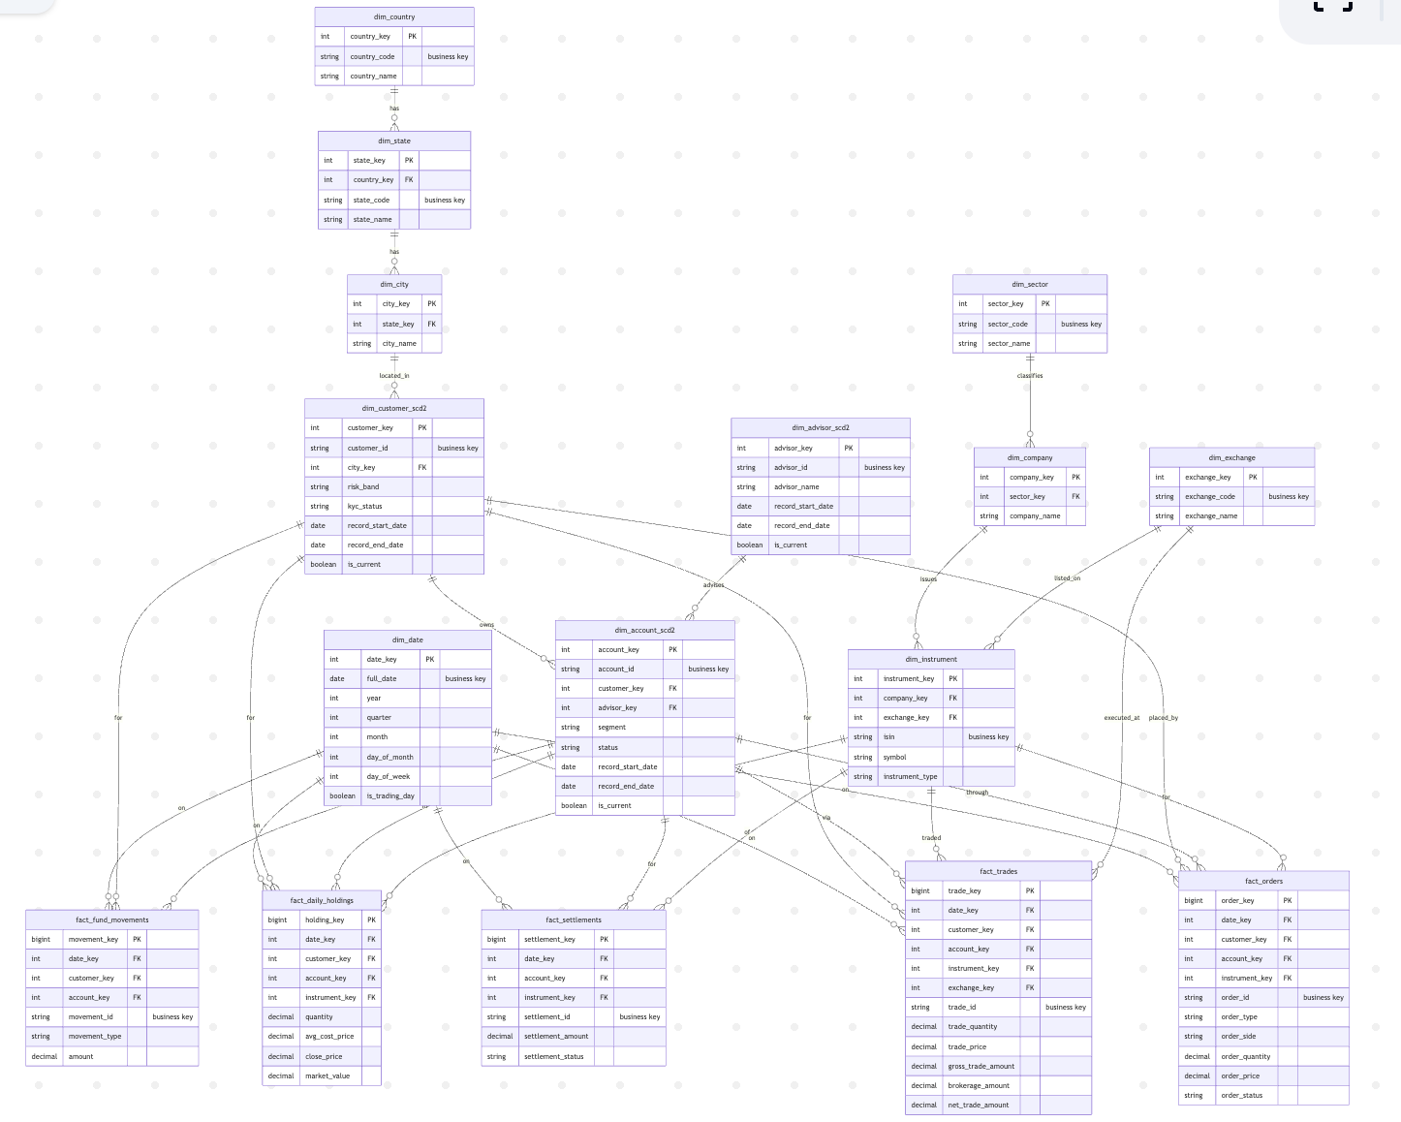
The final Redshift layer contains dimensions, SCD Type 2 dimensions, and fact tables for orders, trades, settlements, fund movements, and daily holdings.

Implementation flow
Step | Goal | Main output
1 | Basic system checks | Git Bash, Python, pip, AWS CLI are available
2 | Local Python setup | .venv created and tests pass
3 | Generate sample data | Raw and reference CSV files created
4 | AWS CLI setup | aws sts get-caller-identity works
5 | Environment file | set-env.sh created
6 | CloudFormation deployment | AWS resources created
7 | Upload project assets | Scripts and raw data uploaded to S3
8 | Master Glue job | Curated customers and accounts created
9 | Transaction Glue job | Curated transaction datasets created
10 | DQ Glue job | DQ summary outputs created
11 | Redshift load job | Warehouse tables loaded
12 | Step Functions full run | End-to-end orchestration validated
13 | Redshift validation | SQL queries return counts and metrics
14 | Cleanup | AWS resources deleted after demo

Step 1 - Basic system checks
Run these in Git Bash to confirm the required tools are available.
git --version
python --version
pip --version
aws --version
pwd
ls

Common errors and fixes
Error / Symptom | Fix
git: command not found | Install Git for Windows and reopen Git Bash.
aws: command not found | Install AWS CLI v2 and reopen Git Bash.
python shows Anaconda path | It can still work, but for class consistency use normal Python 3.11 or ensure .venv is active.
Not inside project folder | Use cd to move into retail_brokerage_project before running project commands.

Step 2 - Local Python setup
Create the project virtual environment, install dependencies, install tzdata for Windows timezone support, and run tests.
python -m venv .venv
source .venv/Scripts/activate
python -m pip install --upgrade pip
pip install -r requirements.txt
python -m pip install tzdata
pytest tests/unit -v

Common errors and fixes
Error / Symptom | Fix
source .venv/Scripts/activate fails | Check that .venv was created. Run ls -la and confirm .venv exists.
No module named tzdata / Asia/Kolkata error | Run python -m pip install tzdata inside the active virtual environment.
pytest not found | Run pip install -r requirements.txt again after activating .venv.
Tests fail due to wrong folder | Run pwd and ls; you must be in retail_brokerage_project.

Step 3 - Generate sample brokerage data
Generate three business dates of raw brokerage CSV files and verify the outputs.
source .venv/Scripts/activate
python -m src.data_generator.generate_brokerage_data --output-root generated_data --start-date 2026-04-19 --days 3 --customers 500 --accounts 800 --instruments 120 --orders-per-day 3500
ls generated_data/raw
ls generated_data/raw/business_date=2026-04-19
find generated_data/raw -name "*.csv" | wc -l
head -5 generated_data/raw/business_date=2026-04-19/customers_snapshot.csv
head -5 generated_data/raw/business_date=2026-04-19/orders.csv

Common errors and fixes
Error / Symptom | Fix
No module named src | You are not in the project root. cd into retail_brokerage_project.
ZoneInfoNotFoundError Asia/Kolkata | Install tzdata: python -m pip install tzdata.
generated_data/raw missing | Run the generator command again and check write permissions.
CSV count is not 24 | Regenerate data with --days 3 and verify there are 8 files per business date.

Step 4 - Configure AWS CLI
Configure AWS credentials and verify the current AWS account.
aws configure
aws sts get-caller-identity

Common errors and fixes
Error / Symptom | Fix
Unable to locate credentials | Run aws configure and enter the access key, secret key, region ap-south-1, output json.
Wrong AWS account | Run aws configure again or check AWS profiles.
AccessDenied later in deployment | The IAM user does not have enough permissions for this lab. Use a sandbox/admin lab user.
Do not use root keys | Create an IAM user access key for the project and delete it after the lab if not needed.

Step 5 - Create set-env.sh
This file stores variables used by all AWS commands. Replace CHANGE_ME_EMAIL with your actual email. Run source set-env.sh whenever you open a new Git Bash terminal.
cat > set-env.sh <<'EOF'
export AWS_REGION=ap-south-1
export PROJECT_NAME=retail-brokerage-pipeline
export ENVIRONMENT_NAME=dev
export STACK_NAME=${PROJECT_NAME}-${ENVIRONMENT_NAME}

export ACCOUNT_ID=$(aws sts get-caller-identity --query Account --output text)

export ARTIFACT_BUCKET_NAME=${PROJECT_NAME}-${ENVIRONMENT_NAME}-${ACCOUNT_ID}-${AWS_REGION}-artifacts
export RAW_DATA_BUCKET_NAME=${PROJECT_NAME}-${ENVIRONMENT_NAME}-${ACCOUNT_ID}-${AWS_REGION}-raw
export CURATED_DATA_BUCKET_NAME=${PROJECT_NAME}-${ENVIRONMENT_NAME}-${ACCOUNT_ID}-${AWS_REGION}-curated

export NOTIFICATION_EMAIL=CHANGE_ME_EMAIL

export REDSHIFT_ADMIN_USERNAME=adminuser
export REDSHIFT_DATABASE_NAME=brokerage
export REDSHIFT_ADMIN_PASSWORD='ChangeThisPassword123!'

export ALLOWED_INGRESS_CIDR=0.0.0.0/0
export DAILY_SCHEDULE_EXPRESSION="cron(30 23 * * ? *)"

if [[ "$NOTIFICATION_EMAIL" == "CHANGE_ME_EMAIL" ]]; then
echo "ERROR: Open set-env.sh and replace CHANGE_ME_EMAIL with your real email."
return 1 2>/dev/null || exit 1
fi
EOF

code set-env.sh
source set-env.sh
printenv | grep -E 'AWS_REGION|PROJECT_NAME|ENVIRONMENT_NAME|STACK_NAME|ARTIFACT_BUCKET_NAME|RAW_DATA_BUCKET_NAME|CURATED_DATA_BUCKET_NAME|NOTIFICATION_EMAIL|REDSHIFT_ADMIN_USERNAME|REDSHIFT_DATABASE_NAME|ALLOWED_INGRESS_CIDR|DAILY_SCHEDULE_EXPRESSION'

Common errors and fixes
Error / Symptom | Fix
ERROR: replace CHANGE_ME_EMAIL | Open set-env.sh, replace CHANGE_ME_EMAIL with your email, save, then run source set-env.sh.
Variables are blank | Run source set-env.sh again. Environment variables are terminal-session specific.
aws sts get-caller-identity fails inside set-env.sh | AWS CLI is not configured or credentials are invalid. Run aws configure.
Bucket names too long or invalid | Use lowercase project name with hyphens only. Do not use underscores.

Step 6 - Validate CloudFormation template
Use file:// before the template path. This is the exact fix for the unsupported structure error.
source set-env.sh
aws cloudformation validate-template --region "$AWS_REGION" --template-body file://infra/cloudformation/template.yaml

Common errors and fixes
Error / Symptom | Fix
Template format error: unsupported structure | You forgot file://. Use --template-body file://infra/cloudformation/template.yaml.
Unable to get file | Run pwd and ls. You must be in the project root.
Used infra\cloudformation\template.yaml | In Git Bash use forward slashes: infra/cloudformation/template.yaml.
AccessDenied | IAM user lacks CloudFormation permissions.

Step 7 - Deploy AWS infrastructure with deploy-stack.sh
Instead of pasting one huge AWS deploy command, create a script and run it. This is safer for Word copy-paste and easier to teach.
cat > deploy-stack.sh <<'EOF'
#!/usr/bin/env bash
set -euo pipefail
source set-env.sh
aws cloudformation validate-template --region "$AWS_REGION" --template-body file://infra/cloudformation/template.yaml
aws cloudformation deploy \
--region "$AWS_REGION" \
--template-file infra/cloudformation/template.yaml \
--stack-name "$STACK_NAME" \
--capabilities CAPABILITY_NAMED_IAM \
--parameter-overrides \
ProjectName="$PROJECT_NAME" \
EnvironmentName="$ENVIRONMENT_NAME" \
ArtifactBucketName="$ARTIFACT_BUCKET_NAME" \
RawDataBucketName="$RAW_DATA_BUCKET_NAME" \
CuratedDataBucketName="$CURATED_DATA_BUCKET_NAME" \
NotificationEmail="$NOTIFICATION_EMAIL" \
AllowedIngressCidr="$ALLOWED_INGRESS_CIDR" \
DailyScheduleExpression="$DAILY_SCHEDULE_EXPRESSION" \
RedshiftAdminUsername="$REDSHIFT_ADMIN_USERNAME" \
RedshiftDatabaseName="$REDSHIFT_DATABASE_NAME" \
RedshiftAdminPassword="$REDSHIFT_ADMIN_PASSWORD"
aws cloudformation describe-stacks --region "$AWS_REGION" --stack-name "$STACK_NAME" --query "Stacks[0].StackStatus" --output text
aws cloudformation describe-stacks --region "$AWS_REGION" --stack-name "$STACK_NAME" --query "Stacks[0].Outputs[*].[OutputKey,OutputValue]" --output table
EOF
chmod +x deploy-stack.sh
./deploy-stack.sh

Common errors and fixes
Error / Symptom | Fix
InsufficientCapabilities | Ensure deploy command contains --capabilities CAPABILITY_NAMED_IAM.
BucketAlreadyExists | Change bucket names in set-env.sh by adding initials or a suffix, source it again, rerun deploy.
ROLLBACK_COMPLETE | Check stack events, delete failed stack, fix issue, redeploy.
AccessDenied for IAM/Redshift/Glue | Use a lab IAM user with required permissions or AdministratorAccess in a sandbox account.
Invalid CIDR | Use 0.0.0.0/0 for demo or your-ip/32 for safer access.
SNS email not confirmed | Open email from AWS Notification and click Confirm subscription.

Step 8 - Load CloudFormation outputs
These output variables are needed for Step Functions, Redshift validation, and later commands. Source this file, do not just execute it, because we want variables to remain in the current terminal.
cat > load-outputs.sh <<'EOF'
#!/usr/bin/env bash
set -euo pipefail
source set-env.sh
export STEP_FUNCTION_ARN=$(aws cloudformation describe-stacks --region "$AWS_REGION" --stack-name "$STACK_NAME" --query "Stacks[0].Outputs[?OutputKey=='StepFunctionArn'].OutputValue" --output text)
export SNS_TOPIC_ARN=$(aws cloudformation describe-stacks --region "$AWS_REGION" --stack-name "$STACK_NAME" --query "Stacks[0].Outputs[?OutputKey=='NotificationTopicArn'].OutputValue" --output text)
export REDSHIFT_WORKGROUP_NAME=$(aws cloudformation describe-stacks --region "$AWS_REGION" --stack-name "$STACK_NAME" --query "Stacks[0].Outputs[?OutputKey=='RedshiftWorkgroupName'].OutputValue" --output text)
export REDSHIFT_NAMESPACE_NAME=$(aws cloudformation describe-stacks --region "$AWS_REGION" --stack-name "$STACK_NAME" --query "Stacks[0].Outputs[?OutputKey=='RedshiftNamespaceName'].OutputValue" --output text)
export REDSHIFT_COPY_ROLE_ARN=$(aws cloudformation describe-stacks --region "$AWS_REGION" --stack-name "$STACK_NAME" --query "Stacks[0].Outputs[?OutputKey=='RedshiftCopyRoleArn'].OutputValue" --output text)
export REDSHIFT_SECRET_ARN=$(aws secretsmanager describe-secret --region "$AWS_REGION" --secret-id "${PROJECT_NAME}-${ENVIRONMENT_NAME}-redshift-admin" --query ARN --output text)
echo "STEP_FUNCTION_ARN=$STEP_FUNCTION_ARN"
echo "SNS_TOPIC_ARN=$SNS_TOPIC_ARN"
echo "REDSHIFT_WORKGROUP_NAME=$REDSHIFT_WORKGROUP_NAME"
echo "REDSHIFT_NAMESPACE_NAME=$REDSHIFT_NAMESPACE_NAME"
echo "REDSHIFT_COPY_ROLE_ARN=$REDSHIFT_COPY_ROLE_ARN"
echo "REDSHIFT_SECRET_ARN=$REDSHIFT_SECRET_ARN"
EOF
source load-outputs.sh

Common errors and fixes
Error / Symptom | Fix
Output variable is None or blank | CloudFormation stack may not be CREATE_COMPLETE. Check stack status.
Secret not found | Confirm stack created the secret named project-env-redshift-admin.
Variables disappear | Use source load-outputs.sh, not ./load-outputs.sh, when you need variables in the current terminal.
Query returns empty | Check exact OutputKey names in CloudFormation outputs.

Step 9 - Upload project assets and data to S3
Upload Glue scripts to the artifact bucket and raw/reference data to the raw bucket. Curated bucket should be empty before Glue jobs run.
cat > upload-assets.sh <<'EOF'
#!/usr/bin/env bash
set -euo pipefail
source set-env.sh
aws s3 sync src s3://${ARTIFACT_BUCKET_NAME}/src --region "$AWS_REGION"
aws s3 sync generated_data/raw s3://${RAW_DATA_BUCKET_NAME}/raw --region "$AWS_REGION"
aws s3 sync generated_data/reference s3://${RAW_DATA_BUCKET_NAME}/reference --region "$AWS_REGION"
aws s3api put-object --bucket "$ARTIFACT_BUCKET_NAME" --key temporary/ --region "$AWS_REGION"
aws s3 ls s3://${ARTIFACT_BUCKET_NAME}/src/glue/jobs/ --region "$AWS_REGION"
aws s3 ls s3://${RAW_DATA_BUCKET_NAME}/raw/business_date=2026-04-19/ --region "$AWS_REGION"
aws s3 ls s3://${RAW_DATA_BUCKET_NAME}/reference/ --region "$AWS_REGION"
EOF
chmod +x upload-assets.sh
./upload-assets.sh

Common errors and fixes
Error / Symptom | Fix
NoSuchBucket | CloudFormation did not create buckets or variable is wrong. Run source set-env.sh and aws s3 ls.
Skipping file generated_data/raw does not exist | Generate data first or run from project root.
Glue script not found later | Re-run aws s3 sync src s3://${ARTIFACT_BUCKET_NAME}/src.
AccessDenied | IAM user lacks S3 permissions.
Raw CSV count wrong | Check generated_data/raw and re-run generator.

Step 10 - Create Glue wait helper
This helper monitors any Glue job until it succeeds or fails. Create it once and reuse it for all four Glue jobs.
cat > wait-glue-job.sh <<'EOF'
#!/usr/bin/env bash
set -euo pipefail
source set-env.sh
JOB_NAME="$1"
RUN_ID="$2"
while true; do
STATUS=$(aws glue get-job-run --region "$AWS_REGION" --job-name "$JOB_NAME" --run-id "$RUN_ID" --query "JobRun.JobRunState" --output text)
echo "$(date) - $JOB_NAME - $RUN_ID - $STATUS"
if [[ "$STATUS" == "SUCCEEDED" || "$STATUS" == "FAILED" || "$STATUS" == "STOPPED" || "$STATUS" == "TIMEOUT" ]]; then
break
fi
sleep 30
done
if [[ "$STATUS" != "SUCCEEDED" ]]; then
echo "Glue job did not succeed. Fetching details..."
aws glue get-job-run --region "$AWS_REGION" --job-name "$JOB_NAME" --run-id "$RUN_ID"
exit 1
fi
EOF
chmod +x wait-glue-job.sh

Step 11 - Run master data Glue job
Processes customers_snapshot.csv and accounts_snapshot.csv into curated master folders.
source set-env.sh
export BUSINESS_DATE=2026-04-19
export MASTER_JOB_NAME=${PROJECT_NAME}-${ENVIRONMENT_NAME}-master-job
export GLUE_ARGS=$(printf '{"--business_date":"%s"}' "$BUSINESS_DATE")
export MASTER_JOB_RUN_ID=$(aws glue start-job-run --region "$AWS_REGION" --job-name "$MASTER_JOB_NAME" --arguments "$GLUE_ARGS" --query JobRunId --output text)
echo "MASTER_JOB_RUN_ID=$MASTER_JOB_RUN_ID"
./wait-glue-job.sh "$MASTER_JOB_NAME" "$MASTER_JOB_RUN_ID"
aws s3 ls s3://${CURATED_DATA_BUCKET_NAME}/curated/business_date=${BUSINESS_DATE}/master/ --region "$AWS_REGION"

Common errors and fixes
Error / Symptom | Fix
Script not found | Re-run upload-assets.sh and verify s3://${ARTIFACT_BUCKET_NAME}/src/glue/jobs/.
Path does not exist | Verify raw data is uploaded for the selected BUSINESS_DATE.
AccessDenied | Glue execution role or S3 permissions issue. Check CloudFormation roles and bucket access.
Column mismatch / AnalysisException | Regenerate sample data and re-upload raw/reference folders.
Job FAILED | Open Glue job run logs in CloudWatch /aws-glue/jobs/error and check ErrorMessage from get-job-run.

Step 12 - Run transaction data Glue job
Processes orders, trades, fund movements, settlements, prices, and holdings into curated transaction folders.
source set-env.sh
export BUSINESS_DATE=2026-04-19
export TRANSACTION_JOB_NAME=${PROJECT_NAME}-${ENVIRONMENT_NAME}-transaction-job
export GLUE_ARGS=$(printf '{"--business_date":"%s"}' "$BUSINESS_DATE")
export TRANSACTION_JOB_RUN_ID=$(aws glue start-job-run --region "$AWS_REGION" --job-name "$TRANSACTION_JOB_NAME" --arguments "$GLUE_ARGS" --query JobRunId --output text)
echo "TRANSACTION_JOB_RUN_ID=$TRANSACTION_JOB_RUN_ID"
./wait-glue-job.sh "$TRANSACTION_JOB_NAME" "$TRANSACTION_JOB_RUN_ID"
aws s3 ls s3://${CURATED_DATA_BUCKET_NAME}/curated/business_date=${BUSINESS_DATE}/transactions/ --region "$AWS_REGION"

Common errors and fixes
Error / Symptom | Fix
Script not found | Re-run upload-assets.sh and verify s3://${ARTIFACT_BUCKET_NAME}/src/glue/jobs/.
Path does not exist | Verify raw data is uploaded for the selected BUSINESS_DATE.
AccessDenied | Glue execution role or S3 permissions issue. Check CloudFormation roles and bucket access.
Column mismatch / AnalysisException | Regenerate sample data and re-upload raw/reference folders.
Job FAILED | Open Glue job run logs in CloudWatch /aws-glue/jobs/error and check ErrorMessage from get-job-run.

Step 13 - Run DQ publish Glue job
Publishes data quality summary for curated datasets.
source set-env.sh
export BUSINESS_DATE=2026-04-19
export DQ_JOB_NAME=${PROJECT_NAME}-${ENVIRONMENT_NAME}-dq-job
export GLUE_ARGS=$(printf '{"--business_date":"%s"}' "$BUSINESS_DATE")
export DQ_JOB_RUN_ID=$(aws glue start-job-run --region "$AWS_REGION" --job-name "$DQ_JOB_NAME" --arguments "$GLUE_ARGS" --query JobRunId --output text)
echo "DQ_JOB_RUN_ID=$DQ_JOB_RUN_ID"
./wait-glue-job.sh "$DQ_JOB_NAME" "$DQ_JOB_RUN_ID"
aws s3 ls s3://${CURATED_DATA_BUCKET_NAME}/curated/business_date=${BUSINESS_DATE}/dq/dq_publish_summary/ --region "$AWS_REGION"

Common errors and fixes
Error / Symptom | Fix
Script not found | Re-run upload-assets.sh and verify s3://${ARTIFACT_BUCKET_NAME}/src/glue/jobs/.
Path does not exist | Verify raw data is uploaded for the selected BUSINESS_DATE.
AccessDenied | Glue execution role or S3 permissions issue. Check CloudFormation roles and bucket access.
Column mismatch / AnalysisException | Regenerate sample data and re-upload raw/reference folders.
Job FAILED | Open Glue job run logs in CloudWatch /aws-glue/jobs/error and check ErrorMessage from get-job-run.

Step 14 - Run Redshift load Glue job
Loads curated S3 data into Redshift Serverless warehouse tables.
source set-env.sh
export BUSINESS_DATE=2026-04-19
export REDSHIFT_LOAD_JOB_NAME=${PROJECT_NAME}-${ENVIRONMENT_NAME}-redshift-load-job
export GLUE_ARGS=$(printf '{"--business_date":"%s"}' "$BUSINESS_DATE")
export REDSHIFT_LOAD_JOB_RUN_ID=$(aws glue start-job-run --region "$AWS_REGION" --job-name "$REDSHIFT_LOAD_JOB_NAME" --arguments "$GLUE_ARGS" --query JobRunId --output text)
echo "REDSHIFT_LOAD_JOB_RUN_ID=$REDSHIFT_LOAD_JOB_RUN_ID"
./wait-glue-job.sh "$REDSHIFT_LOAD_JOB_NAME" "$REDSHIFT_LOAD_JOB_RUN_ID"
aws s3 ls s3://${CURATED_DATA_BUCKET_NAME}/curated/business_date=${BUSINESS_DATE}/sql/ --region "$AWS_REGION"

Common errors and fixes
Error / Symptom | Fix
Script not found | Re-run upload-assets.sh and verify s3://${ARTIFACT_BUCKET_NAME}/src/glue/jobs/.
Path does not exist | Verify raw data is uploaded for the selected BUSINESS_DATE.
AccessDenied | Glue execution role or S3 permissions issue. Check CloudFormation roles and bucket access.
Column mismatch / AnalysisException | Regenerate sample data and re-upload raw/reference folders.
Job FAILED | Open Glue job run logs in CloudWatch /aws-glue/jobs/error and check ErrorMessage from get-job-run.

Step 15 - Run full Step Functions pipeline
After testing manual jobs for 2026-04-19, run the full orchestrated pipeline for another business date such as 2026-04-20. The input JSON is written to a file to avoid JSON quoting errors.
source load-outputs.sh
export BUSINESS_DATE=2026-04-20
cat > sfn-input.json <<EOF
{
"business_date": "$BUSINESS_DATE",
"sns_topic_arn": "$SNS_TOPIC_ARN",
"master_job_name": "${PROJECT_NAME}-${ENVIRONMENT_NAME}-master-job",
"transaction_job_name": "${PROJECT_NAME}-${ENVIRONMENT_NAME}-transaction-job",
"dq_job_name": "${PROJECT_NAME}-${ENVIRONMENT_NAME}-dq-job",
"redshift_load_job_name": "${PROJECT_NAME}-${ENVIRONMENT_NAME}-redshift-load-job",
"raw_root": "s3://${RAW_DATA_BUCKET_NAME}/raw",
"processed_root": "s3://${CURATED_DATA_BUCKET_NAME}",
"curated_bucket_name": "$CURATED_DATA_BUCKET_NAME",
"redshift_iam_role_arn": "$REDSHIFT_COPY_ROLE_ARN",
"redshift_workgroup_name": "$REDSHIFT_WORKGROUP_NAME",
"redshift_database_name": "$REDSHIFT_DATABASE_NAME"
}
EOF
export EXECUTION_ARN=$(aws stepfunctions start-execution --region "$AWS_REGION" --state-machine-arn "$STEP_FUNCTION_ARN" --input file://sfn-input.json --query executionArn --output text)
echo "EXECUTION_ARN=$EXECUTION_ARN"
while true; do
STATUS=$(aws stepfunctions describe-execution --region "$AWS_REGION" --execution-arn "$EXECUTION_ARN" --query status --output text)
echo "$(date) - Step Functions status: $STATUS"
if [[ "$STATUS" == "SUCCEEDED" || "$STATUS" == "FAILED" || "$STATUS" == "TIMED_OUT" || "$STATUS" == "ABORTED" ]]; then
break
fi
sleep 30
done
aws stepfunctions describe-execution --region "$AWS_REGION" --execution-arn "$EXECUTION_ARN" --query '{status:status,startDate:startDate,stopDate:stopDate}' --output table

Common errors and fixes
Error / Symptom | Fix
The JSONPath could not be found in input | Use the full sfn-input.json block above; do not send only business_date.
Execution FAILED | Open Step Functions execution graph, click the failed state, then open the linked Glue run logs.
SNS email not received | Confirm SNS subscription email first.
Business date data missing | Upload raw data for that business_date to S3.
Redshift load failed inside Step Functions | Run the Redshift load job manually first and inspect Glue logs.

Step 16 - Validate Redshift with Data API
This script runs basic count and business metric queries using Redshift Data API. You can also validate from Redshift Query Editor v2 in the AWS Console.
source load-outputs.sh
cat > redshift-validation.sh <<'EOF'
#!/usr/bin/env bash
set -euo pipefail
source load-outputs.sh
run_sql() {
local SQL="$1"
local ID
ID=$(aws redshift-data execute-statement --region "$AWS_REGION" --workgroup-name "$REDSHIFT_WORKGROUP_NAME" --database "$REDSHIFT_DATABASE_NAME" --secret-arn "$REDSHIFT_SECRET_ARN" --sql "$SQL" --query Id --output text)
echo "SQL_ID=$ID"
while true; do
local STATUS
STATUS=$(aws redshift-data describe-statement --region "$AWS_REGION" --id "$ID" --query Status --output text)
echo "SQL status: $STATUS"
if [[ "$STATUS" == "FINISHED" || "$STATUS" == "FAILED" || "$STATUS" == "ABORTED" ]]; then
break
fi
sleep 5
done
aws redshift-data describe-statement --region "$AWS_REGION" --id "$ID" --query '{Status:Status,Error:Error}' --output table
aws redshift-data get-statement-result --region "$AWS_REGION" --id "$ID" --output table || true
}
run_sql "select count(*) as dim_customer_count from brokerage_dw.dim_customer_scd2;"
run_sql "select count(*) as fact_orders_count from brokerage_dw.fact_orders;"
run_sql "select count(*) as fact_trades_count from brokerage_dw.fact_trades;"
run_sql "select business_date, count(*) as trade_count from brokerage_dw.fact_trades group by business_date order by business_date;"
run_sql "select business_date, sum(gross_trade_amount) as gross_volume, sum(brokerage_fee) as brokerage_revenue from brokerage_dw.fact_trades group by business_date order by business_date;"
EOF
chmod +x redshift-validation.sh
./redshift-validation.sh

Common errors and fixes
Error / Symptom | Fix
Schema brokerage_dw does not exist | Redshift load job did not run or failed before creating schema.
Relation fact_trades does not exist | Redshift DDL/load did not complete. Check redshift load Glue job logs.
Redshift workgroup not available | Wait for workgroup status AVAILABLE.
SecretArn error | Run source load-outputs.sh and confirm REDSHIFT_SECRET_ARN is printed.
COPY from S3 failed | Check Redshift COPY IAM role and curated S3 output paths.

Step 17 - Cleanup after demo
Run cleanup only after the class/demo is completed. This deletes project S3 objects and CloudFormation resources. It helps avoid Redshift Serverless and Glue-related charges.
cat > cleanup-project.sh <<'EOF'
#!/usr/bin/env bash
set -euo pipefail
source set-env.sh
echo "Emptying project S3 buckets..."
aws s3 rm s3://${ARTIFACT_BUCKET_NAME} --recursive --region "$AWS_REGION" || true
aws s3 rm s3://${RAW_DATA_BUCKET_NAME} --recursive --region "$AWS_REGION" || true
aws s3 rm s3://${CURATED_DATA_BUCKET_NAME} --recursive --region "$AWS_REGION" || true
echo "Deleting CloudFormation stack: $STACK_NAME"
aws cloudformation delete-stack --region "$AWS_REGION" --stack-name "$STACK_NAME"
aws cloudformation wait stack-delete-complete --region "$AWS_REGION" --stack-name "$STACK_NAME"
echo "Cleanup completed."
EOF
chmod +x cleanup-project.sh
# Run only when class/demo is fully done:
# ./cleanup-project.sh

Common errors and fixes
Error / Symptom | Fix
Stack delete fails because buckets are not empty | Run the aws s3 rm commands again, then delete stack.
Deletion takes long | Redshift Serverless and networking resources may take several minutes.
AccessDenied while deleting | Use the same IAM user/role that deployed the stack or an admin lab user.
Need to keep data for next class | Do not run cleanup; but remember resources may create AWS charges.

Quick troubleshooting map
Where it fails | First thing to check | Command / place
Local setup | Are you in project root? | pwd; ls
Data generation | tzdata and .venv | python -m pip install tzdata
AWS login | Current account | aws sts get-caller-identity
Template validation | file:// prefix | aws cloudformation validate-template --template-body file://infra/cloudformation/template.yaml
Deployment | Stack events | aws cloudformation describe-stack-events --stack-name "$STACK_NAME"
S3 upload | Bucket and local folders | aws s3 ls; ls generated_data/raw
Glue jobs | Script path and raw paths | aws s3 ls s3://${ARTIFACT_BUCKET_NAME}/src/glue/jobs/
Glue job failure | CloudWatch logs | AWS Glue -> job -> Runs -> View logs
Step Functions | Failed state in graph | AWS Step Functions execution details
Redshift load | Glue logs and Redshift Data API | redshift-load-job logs
Cleanup | Buckets empty | aws s3 rm s3://bucket --recursive

Copy-paste quality checklist for students
Check | Expected
Command prompt shows (.venv) | Virtual environment is active for local Python steps.
pwd shows retail_brokerage_project | You are in the correct folder.
source set-env.sh works | No CHANGE_ME_EMAIL error.
validate-template uses file:// | No unsupported structure error.
deploy-stack.sh completes | Stack status CREATE_COMPLETE.
upload-assets.sh completes | S3 has Glue scripts and raw data.
Master job succeeds | Curated master folder exists.
Transaction job succeeds | Curated transactions folder exists.
DQ job succeeds | dq_publish_summary folder exists.
Redshift load succeeds | Redshift warehouse tables have counts.
Cleanup done after demo | Stack deleted and buckets emptied.

Important note for instructors
For live class, keep this DOCX for explanation, but ask students to copy commands from the companion .sh file when possible. The companion file is plain text, so it avoids Word/PDF formatting problems entirely.

