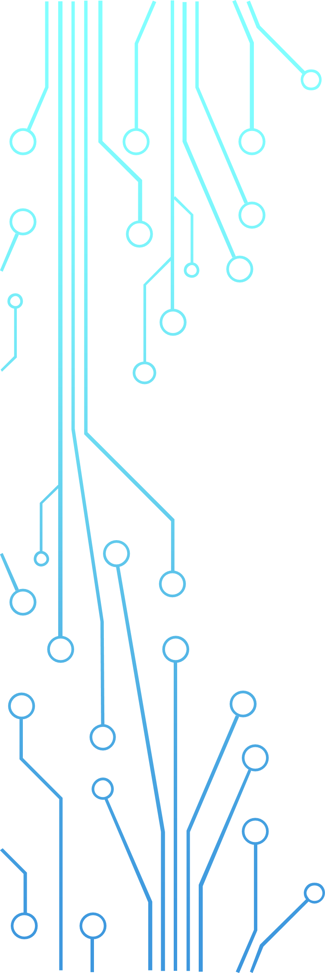GESTOBOT

HAND GESTURES CONTROLLED ROBOT

# INTRODUCTION TO ROBOTICS

* **Robotics** is the interdisciplinary study and practice of the design, construction, operation, and use of robots.
* The goal of most robotics is to design machines that can help and assist humans.
* Many robots are built to do jobs that are hazardous to people, such as finding survivors in unstable ruins, and exploring space, mines and shipwrecks.
* Others replace people in jobs that are boring, repetitive, or unpleasant, such as cleaning, monitoring, transporting, and assembling.
* Today, robotics is a rapidly growing field, as technological advances continue; researching, designing, and building new robots serve various practical purposes.

# GESTURE RECOGNITION

* **Gesture recognition** is an area of research and development in computer science and language technology concerned with the recognition and interpretation of human gestures. A subdiscipline of computer vision, it employs mathematical algorithms to interpret gestures. • Gesture recognition offers a path for computers to begin to better understand and interpret human body language, previously not possible through text or unenhanced graphical (GUI) user interfaces.
* Gestures can originate from any bodily motion or state, but commonly originate from the face or hand. One area of the field is emotion recognition derived from facial expressions and hand gestures. Users can make simple gestures to control or interact with devices without physically touching them.

# HAND GESTURES CONTROLLED ROBOT

* A Gesture Controlled robot is a robot which can be controlled by hand gestures.
* You just need to have a small transmitting device in your hand, which includes an acceleration meter to transmit an appropriate command to the robot so that it can do whatever we want.

# REAL LIFE IMAGES

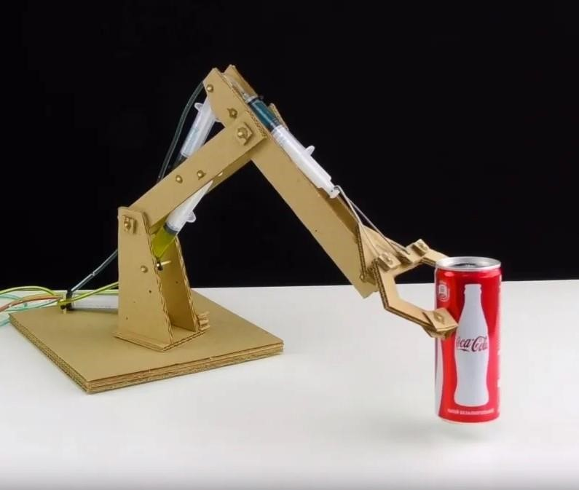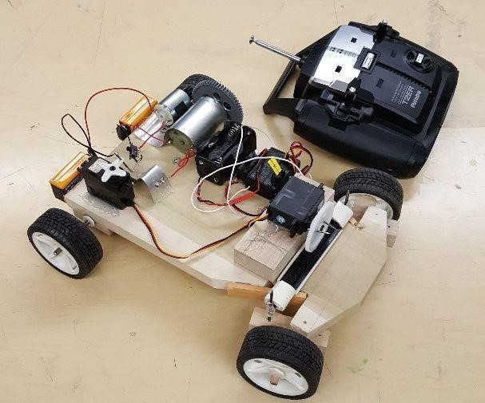

# OBJECTIVE OF THE PROJECT

* The basic objective of the project is to integrate two major components.
* **The Transmitter**, which provides gesture signals to the receiver.
* **The Receiver,** basically a robotic claw with a rover which receives the gesture signals sent by the transmitter.
* The receiver interprets the signals obtained from the transmitter and performs actions as programmed.
* The actions performed by the Receiver include **locomotion** and **claw control**.

# HARDWARE COMPONENTS

* Arduino NANO/UNO
* Accelerometer – ADXL335
* Motor Driver Board – L298 Module
* Encoder – HT12E and Decoder – HT12D
* RF Transmitter and Receiver – NRF24L01
* Chassis (DC Motors(4), Servo Motors(6), Wheels, Plain Wooden Board, 9V DC Batteries)
* Robotic Claw

# WORKING MECHANISM

* Our gesture-controlled robot works based on accelerometer outputs, which correspond to hand movements and sends that data to a comparator which assigns specific voltage level to the movements.
* This information is transferred to an encoder which encodes it before RF transmission.
* On the other end, the information is received wirelessly via RF (Radio Frequency).
* These decisions are sent to the motor driver and robotic claw, which triggers the motors in specific configurations to make the robot move in different directions.

# BUDGET

* Arduino NANO/UNO → 200 - 300 INR
* Accelerometer – ADXL335 → 400 INR
* Motor Driver Board – L298 Module → 150 INR
* Encoder – HT12E and Decoder – HT12D → 200 INR (Both)
* RF Transmitter and Receiver – NRF24L01 → 250 INR (Each)
* Chassis (DC Motors(4), Servo Motors(6), Wheels, Plain Wooden Board, 9V DC Batteries) → 500 INR
* Robotic Claw → 450 INR

# REAL WORLD APPLICATIONS

* Medical Applications - Advanced analytic systems that recognize gestures could be installed in hospitals and houses to detect and cure life-threatening diseases such as strokes and heart attacks.
* The majority of today's computer games are played on game consoles, arcade machines, or desktops, and they all require several input devices. Hand gesture recognition has the potential to engage players in previously unimagined ways in the gaming environment.
* Automation systems - Gesture recognition can be utilized in a variety of settings, including residences, workplaces, shipping containers, and more, to improve usability and save money on general and specific input devices such as remote controls, car entertainment systems with buttons, and other similar devices.

# FUTURE SCOPE

* In future we can design a wireless robot which can sense hand gesture by using wireless technologies.
* It can be used in military applications as a robotic vehicle which can be handled by a soldier to avoid casualties.
* Our system has shown the possibility that interaction with machines through gestures is a feasible task and the set of detected gestures could be enhanced to more commands by implementing a more complex model of an advanced vehicle for not only in limited space while also in the broader area as in the roads too.
* In the future, service robot executing many different tasks from private movement to a fullfledged advanced automotive that can make disabled to able in all sense.

## GROUP NO. 5

* Jayakanth M V → 2023BEE017
* Jaisurya Vetrivel S S → 2023BEE016
* Amanjot Singh → 2023BEE005
* Belana Biswajeet Patro → 2023BEE011