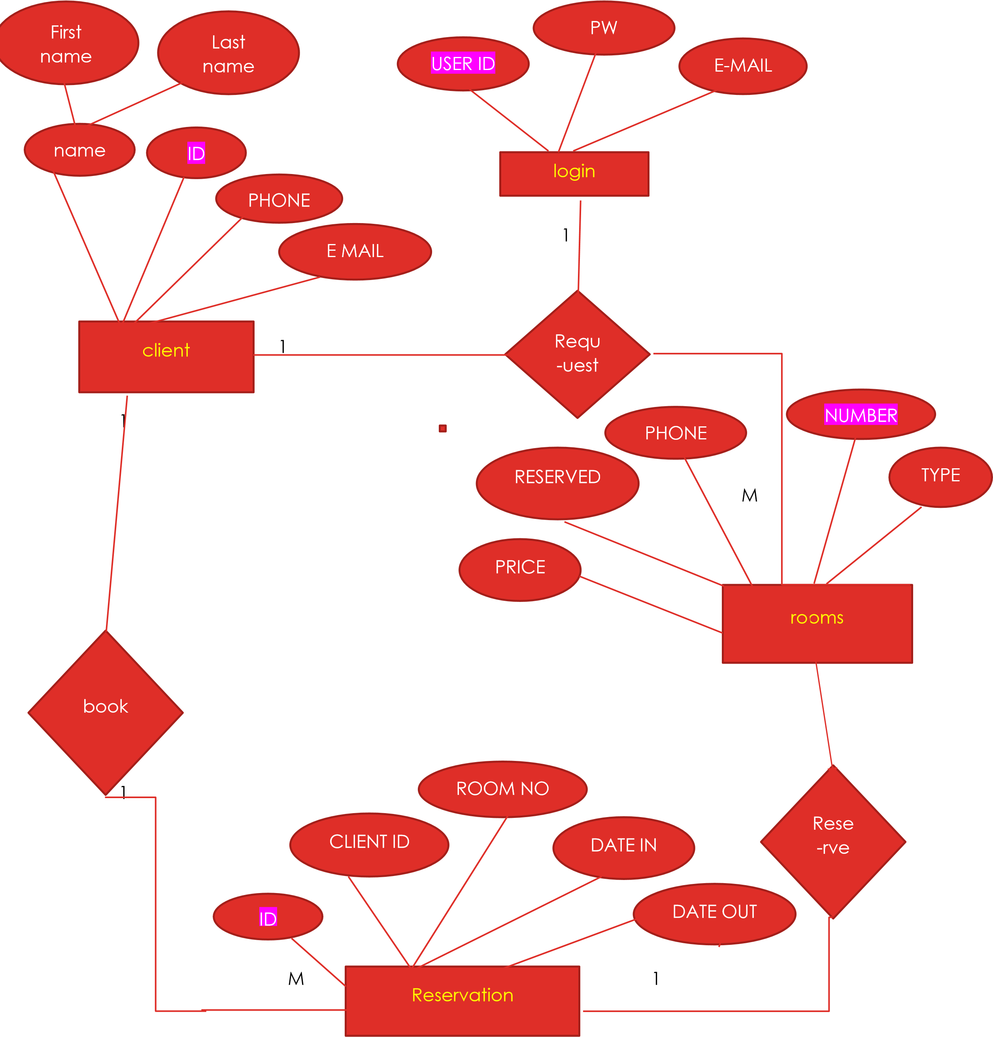

ER DIAGRAM FOR OUR HOTEL RESERVATION MANAGEMENT SYSTEM