5/30/2023

DEA Assignment

Report

Table of Contents

1. Student Profile. 3

2. Introduction. 4

2.1. Introduction Our System. 4

2.2. Functionally and features. 5

2.3. Benefits of Implementing our hotel reservation management system. 6

2.4. case study for our system. 7

2.5. Implementation and Integration. 8

2.6. conclusion. 9

3. Web scenario. 10

3.1. Objectives for Our Hotel Reservation System. 10

3.2. The actors in our reservation management system can include. 11

3.3. User Role. 11

3.4. Main Flow. 11

3.5. Alternative flow. 12

3.6. User interface design. 12

3.7. Step-by-step process on our website for web scenario. 13

3.8. Website Map. 14

15

16

3. UML diagrams 18

3.1 ER Diagram 18

3.2 Class Diagram. 19

4. MVC. 20

4.1. Our web system designed by using MCV architecture. 20

4.2. Our login system was designed by using MVC architecture. 21

**5.** Code Segment. 23

5.1 Header.jsp and footer.jsp 23

5.2.signup.jsp 24

5.3. login.jsp 25

5.4. loginbean.jsp 26

5.5.Client.jsp 28

5.6. clientupdate.jsp 31

5.7. clientdelete.jsp 33

5.8. room.jsp 34

5.9.Roomsupdate.jsp 37

5.10.Roomsdelete.jsp 39

Bibliography 40

# Student Profile.

|  |  |  |
| --- | --- | --- |
| Student ID. | Student Name. | Signature. |
| 25180 | PGJ Lakshani. |  |
| 25011 | HHN Peiris. |  |
| 25337 | HV Wickramanayaka. |  |
| 25105 | KMHG Dhanawardana. |  |
| 25491 | VASR Hirushan. |  |
| 25422 | WRS Waduwawala. |  |

# Introduction.

## 2.1. Introduction Our System.

We are proud to introduce our comprehensive hotel reservation management system, (Name), designed to revolutionize the way hotels manage their bookings and reservations. Our system incorporates a wide range of functionalities to streamline and automate the entire process, ensuring a seamless and efficient workflow for hotel staff.

One of the key features of our system is guest information management, which allows hotels to capture and store detailed guest information securely. This enables personalized service and facilitates effective communication throughout the guest's stay. Additionally, our system includes robust room availability tracking, providing real-time updates on room availability and enabling efficient allocation of rooms to incoming guests. This minimizes the risk of double bookings and optimizes room utilization, ultimately maximizing occupancy rates.

Our online booking processing feature offers a user-friendly interface, making it convenient for guests to browse available rooms, select their preferences, and complete the reservation process smoothly. The system also ensures secure payment handling, instilling confidence in guests during their transactions. Furthermore, our system enhances the guest experience through multimedia presentations, showcasing room features and amenities through captivating photographs. This visual representation empowers guests to make informed decisions based on their preferences, leading to heightened satisfaction.

In addition to its operational functionalities, our system provides powerful reporting and analytics capabilities. Hotels can gain valuable insights through comprehensive reports and analytics, facilitating data-driven decision-making and optimizing various aspects of hotel operations. This helps hotels identify trends, evaluate performance, and make informed decisions to enhance overall efficiency and guest satisfaction.

our hotel reservation management system, (Name), offers a comprehensive solution to simplify the reservation process, improve operational efficiency, and enhance customer satisfaction in the hospitality industry. With features like guest information management, real-time room availability updates, online booking processing, secure payment handling, multimedia presentations, and robust reporting capabilities, our system empowers hotels to achieve optimal performance, maximize occupancy rates, and deliver exceptional guest experiences.

## 2.2. Functionally and features.

The hotel reservation management system offers a range of essential functionalities and features to streamline the booking process and enhance guest experience. Firstly, it includes guest information management, allowing hotel staff to capture and store detailed client information securely. This enables personalized service and facilitates efficient communication with guests throughout their stay. Secondly, the system provides real-time room availability tracking, ensuring accurate updates on room availability and enabling efficient allocation of rooms to incoming guests. This helps optimize room utilization and minimize the chances of double bookings.

Furthermore, the system offers online booking processing with a user-friendly interface, making it convenient for guests to browse available rooms, select their preferences, and complete the reservation process seamlessly. It also ensures secure payment handling, providing guests with confidence in their transactions. Additionally, the system facilitates a multimedia presentation of rooms, showcasing their features and amenities through photographs. This visual representation enables guests to make informed decisions based on their preferences, enhancing their overall satisfaction.

Moreover, the system utilizes a database for efficient retrieval of information as needed. Hotel staff can access the database to retrieve guest details, reservation history, and other necessary information for providing personalized services and addressing specific guest requirements promptly. The availability of comprehensive data within the system enhances operational efficiency and supports data-driven decision-making processes.

Overall, the hotel reservation management system's functionalities and features, such as guest information management, room availability tracking, online booking processing, multimedia presentation, and database access, work together to streamline the reservation process, improve efficiency, and enhance the guest experience. By leveraging these capabilities, hotels can optimize their operations, increase guest satisfaction, and achieve higher levels of efficiency and revenue.

## 2.3. Benefits of Implementing our hotel reservation management system.

Implementing a hotel reservation management system offers numerous benefits that positively impact hotel operations and guest experiences. Firstly, the system streamlines the reservation process by providing efficient handling and room allocation. Hotel staff can manage reservations seamlessly, ensuring that guests are assigned rooms quickly and accurately. Real-time availability updates and integration with online booking platforms enable hotels to maximize occupancy rates by capturing bookings promptly and avoiding overbooking.

One of the significant advantages of the system is the enhanced guest experience it provides. Guests can easily select their preferred rooms based on availability, room features, and amenities. The system offers a user-friendly interface that simplifies the booking process, allowing guests to make informed decisions. This convenience and access to detailed room information contribute to an overall improved guest experience and higher satisfaction levels.

By automating various tasks and reducing manual errors, the hotel reservation management system improves efficiency. Manual processes are prone to errors, such as double bookings or incorrect room assignments, which can result in guest dissatisfaction. Automation minimizes these errors and ensures a smooth workflow, allowing staff to focus on providing excellent customer service rather than manual administrative tasks.

Moreover, the system provides decision-making support through valuable insights derived from reports and analytics. Hotels can access data on reservation patterns, guest preferences, and revenue generation. These insights enable informed decision-making related to pricing strategies, marketing campaigns, and resource allocation. By utilizing data-driven approaches, hotels can optimize their operations, identify areas for improvement, and enhance overall performance.

implementing a hotel reservation management system offers a multitude of benefits. It streamlines the reservation process, maximizes occupancy rates, enhances the guest experience, improves efficiency through automation, and provides decision-making support through valuable insights. By leveraging these advantages, hotels can optimize their operations, boost guest satisfaction, and drive business success in the competitive hospitality industry.

## 2.4. case study for our system.

Hotel X, a prominent luxury hotel chain, implemented our hotel reservation management system, (name), to streamline their reservation process and enhance guest experiences. The successful implementation of the system resulted in significant benefits, including increased occupancy rates and improved guest satisfaction.

By utilizing (Name of the System), Hotel X experienced a remarkable boost in occupancy rates. The real-time availability updates and seamless integration with online booking platforms allowed them to capture bookings promptly, ensuring that rooms were efficiently allocated. This optimization of room utilization led to increased occupancy rates and minimized the chances of overbooking.

Additionally, the hotel witnessed a notable improvement in guest satisfaction. The user-friendly interface of (Name of the System) facilitated an easy selection of rooms based on availability, room features, and amenities. Guests appreciated the convenience and transparency offered, leading to higher satisfaction levels. Moreover, the multimedia presentation feature showcasing room features and amenities through captivating photographs added to the overall appeal and positive guest experience.

Hotel X's staff provided positive feedback on the implementation of (Name of the System). They highlighted how the system enhanced their workflow by automating various tasks and reducing manual errors. The efficient handling of reservations and accurate room allocations saved valuable time and eliminated the risk of double bookings. The staff appreciated the system's intuitive interface, which made their work more seamless and efficient.

Case Study: Hotel Y's Experience with (Name)

Hotel Y, a boutique hotel known for its exceptional service, implemented (Name of the System) to improve its reservation management and guest experience. The system had a significant positive impact on their operations and revenue management, driving data-driven decision-making processes.

The implementation of (Name of the System) revolutionized Hotel Y's reservation management. The system provided real-time updates on room availability, ensuring accurate information for both staff and guests. This enabled the efficient allocation of rooms, reducing the chances of overbooking and enhancing overall operational efficiency. The system's seamless integration with online booking platforms facilitated a smooth and convenient booking process for guests, further contributing to an improved guest experience.

Hotel Y also experienced notable improvements in revenue management. (Name of the System) provided valuable insights through comprehensive reports and analytics. Hotel Y's management team could access data on reservation patterns, guest preferences, and revenue generation, enabling them to make data-driven decisions. This data-driven approach allowed them to optimize pricing strategies, identify peak seasons, and allocate resources effectively.

The implementation of (Name of the System) at Hotel Y brought significant improvements to reservation management and guest experiences. The system streamlined operations, improved revenue management through data-driven decision-making, and enhanced overall efficiency. The positive outcomes showcased the system's capability to drive business success and elevate the guest experience in the competitive hospitality industry.

## 2.5. Implementation and Integration.

Our hotel reservation management system, (Name of the System), offers a seamless implementation and integration process, ensuring a smooth transition for hotels. The implementation process involves careful considerations and steps to ensure the system is effectively integrated into the existing hotel management framework.

During the implementation process, we collaborate closely with the hotel's management team to understand their specific requirements and tailor the system accordingly. Considerations include the hotel's size, number of rooms, and specific needs such as multi-location management or integration with other systems. This initial assessment enables us to design a customized implementation plan that aligns with the hotel's goals and operational workflow.

Integration with existing hotel management systems is a crucial aspect of the implementation process. We work closely with the hotel's IT team to seamlessly integrate our system with their existing infrastructure. This ensures a cohesive and efficient flow of data between different systems, such as the property management system (PMS) and the central reservation system (CRS), to avoid data silos and enable real-time information sharing.

To ensure a successful implementation, we provide comprehensive staff training programs. Our training sessions are designed to familiarize hotel staff with the features and functionalities of (Name of the System). This empowers them to efficiently handle reservations, manage guest details, and leverage the system's reporting and analytics capabilities. Our training programs are conducted on-site or remotely, depending on the hotel's preference, and can be customized to meet specific training needs.

Cost considerations and return on investment (ROI) analysis are crucial factors for any hotel considering the implementation of a reservation management system. We provide transparent pricing models and work closely with hotels to evaluate the financial impact and potential return on investment. By streamlining operations, optimizing room allocation, and enhancing guest experiences, (Name of the System) offers significant cost-saving opportunities and revenue-generating potential, ensuring a favorable ROI over time.

our hotel reservation management system, (Name of the System), offers a well-structured implementation process with careful considerations of the hotel's specific requirements. We seamlessly integrate the system with existing hotel management systems, provide comprehensive staff training programs, and work closely with hotels to evaluate cost considerations and return on investment. With our expertise and support, hotels can successfully implement our system, optimize their operations, and achieve long-term success in the dynamic hospitality industry.

## 2.6. conclusion.

In conclusion, our hotel reservation management system, (Name of the System), is a comprehensive solution that brings numerous benefits to hotels in streamlining their reservation processes and enhancing guest experiences. By incorporating functionalities such as guest information management, real-time room availability tracking, online booking processing, secure payment handling, multimedia presentations, and robust reporting and analytics, our system empowers hotels to optimize their operations and achieve higher levels of efficiency.

Through the implementation of (Name), hotels can experience increased occupancy rates, as real-time availability updates and integration with online booking platforms enable them to capture bookings promptly and allocate rooms efficiently. This leads to a maximized utilization of available rooms and a reduction in the risk of overbooking.

Furthermore, the guest experience is significantly enhanced by our system. Guests can easily browse available rooms, select their preferences, and access detailed room features and amenities through multimedia presentations. This transparency and convenience contribute to higher guest satisfaction levels, leading to repeat bookings and positive word-of-mouth recommendations.

Our system also brings efficiency improvements by automating various tasks and reducing manual errors. The streamlined reservation process and accurate room allocation save time and eliminate the risk of double bookings, enabling hotel staff to focus on providing exceptional customer service.

Additionally, (Name) provides valuable insights through reports and analytics, enabling data-driven decision-making. Hotel managers can access data on reservation patterns, guest preferences, and revenue generation, facilitating informed decisions regarding pricing strategies, marketing campaigns, and resource allocation.

Considering cost considerations and return on investment, our system offers transparent pricing models and demonstrates its potential to generate cost savings and revenue opportunities over time.

In summary, our hotel reservation management system, (Name of the System), offers hotels a comprehensive solution to optimize their reservation processes, increase occupancy rates, enhance guest experiences, improve efficiency, and support data-driven decision-making. By implementing our system, hotels can achieve operational excellence, elevate guest satisfaction, and drive business success in the competitive hospitality industry.

# 3. Web scenario.

## 3.1. Objectives for Our Hotel Reservation System.

Staff Convenience: The primary objective of our hotel reservation system is to enhance staff convenience by streamlining and automating the reservation process. The system should be user-friendly, intuitive, and equipped with features that enable staff members to efficiently manage reservations, check availability, and process bookings, saving them time and effort.

User Convenience: Our hotel reservation system aims to provide a seamless and user-friendly experience for guests. The system should enable users to easily search for available rooms, view room details, select desired amenities, and make reservations with minimal steps. We aim to enhance customer satisfaction and encourage repeat bookings by offering a convenient and efficient booking process.

Data Security: Ensuring the security and privacy of guest information is a critical objective of our reservation system. Robust security measures should be implemented to safeguard personal data, including credit card details and contact information. The system should adhere to industry-standard security protocols and comply with relevant data protection regulations to instill confidence in our guests and protect their sensitive information.

Time Efficiency: Our reservation system aims to reduce the time required for both staff and guests to complete the reservation process

Accuracy and Correctively: The system's objective is to ensure accuracy and correctness in managing reservations and associated data. It should have built-in validation checks to prevent errors and inconsistencies. Any updates or modifications to reservations, including changes in room types or dates, should be accurately reflected across the system in real time. This objective ensures that both staff and guests have confidence in the system's reliability and accuracy.

By focusing on these objectives, our hotel reservation system will enhance staff efficiency, provide a seamless booking experience for guests, prioritize data security, optimize time management, and maintain accuracy and correctness throughout the reservation process. These goals collectively contribute to a positive guest experience and efficient hotel operations.

## 3.2. The actors in our reservation management system can include.

Hotel Staff: The hotel staff members are responsible for managing the reservation system. This includes receptionists, reservation agents, and administrators who handle tasks such as updating availability, allocating rooms, processing payments, and managing guest information.

Administrators: Administrators have higher-level access to the reservation management system. They are responsible for configuring system settings, managing user accounts, generating reports, and performing system maintenance tasks.

## 3.3. User Role.

Front Desk Staff: These users have the role of managing client data and handling reservations on behalf of the hotel. Their responsibilities include adding, removing, and updating client information in the system. They have the authority to book rooms for clients based on availability and guest preferences. Additionally, they are expected to efficiently complete the reservation process to ensure a smooth experience for the clients.

System Administrators: System administrators have elevated privileges and are responsible for managing the overall reservation management system. They have the authority to configure system settings, maintain data integrity, and oversee user accounts. Administrators also handle system updates, backups, and security measures to ensure the smooth operation and reliability of the system.

## 3.4. Main Flow.

Guest Registration: The guest arrives at the hotel or contacts the front desk staff to make a reservation. The staff collects relevant guest information, such as name, contact details, and any specific preferences or requirements.

Room Availability Check: The staff checks the system to determine the availability of rooms based on the guest's desired dates and room preferences. The system displays a list of available rooms meeting the specified criteria.

Room Selection: The staff presents the available room options to the guest, along with relevant details such as room type, amenities, and rates. The guest chooses a room based on their preferences and budget. And staff can show to photograph in available rooms for client convenience using this system.

Reservation Confirmation: The staff enters the guest's chosen room and reservation details into the system. The system verifies the availability of the selected room and confirms the reservation. If the room is not available, the staff suggests alternative options.

Reservation Confirmation: The system generates a reservation confirmation, which includes the reservation details, room information, dates, and any additional services or requests. The staff provides the confirmation to the guest either electronically or in a printed format.

Room Allocation: The staff allocates the confirmed room to the guest and updates the system with the assigned room number. The system reflects the room as occupied for the specified dates, ensuring that it is not double-booked.

Throughout the main flow, the reservation management system plays a crucial role in facilitating and tracking the reservation process, ensuring accuracy, efficiency, and a seamless experience for both staff and guests.

## 3.5. Alternative flow.

Room Unavailability: If the desired room type or specific room requested by the guest is not available, the system should provide alternative options. The staff can present available rooms of a different type or suggest alternative dates to accommodate the client needs.

Room Upgrade Requests: If a guest requests an upgrade to a higher room category or a room with additional amenities, the system should allow the staff to check the availability of the requested room type. If available, the staff can update the reservation with the upgraded room and adjust the charges accordingly.

Special Requests or Accommodations: If a guest has specific requests or requires special accommodations, such as extra beds, accessible rooms, or specific room locations, the system should allow the staff to note and fulfill these requirements.

## 3.6. User interface design.

Home Page:

Upon accessing the system, users are welcomed by a visually appealing home page. The UI design showcases an elegant and modern aesthetic, with a harmonious color scheme that reflects our hotel's brand identity. A clean layout with strategically placed elements allows users to easily navigate through the page and access essential information.

*Client Details Page:

*Rooms Page:

*Gallery Page:

The Gallery page showcases an extensive collection of captivating images that depict our hotel's unique features, rooms, amenities, and surroundings. The UI design employs a visually engaging grid or carousel layout, allowing users to explore the gallery effortlessly. Interactive features, such as image zoom and swipe functionalities, enable users to delve deeper into the visual representation of our hotel.

Throughout the system, our UI design maintains consistency in branding elements, typography, and navigation elements, ensuring a cohesive and harmonious user experience. Attention to detail, such as sufficient white space, clear typography, and appropriate use of icons and visual cues, contributes to an aesthetically pleasing and user-friendly interface.

Our Hotel Reservation Management System's UI design aims to simplify the booking process, provide a delightful user experience, and evoke a sense of trust and confidence in our hotel brand.

## 3.7. Step-by-step process on our website for web scenario.

* Below is the front page of our website where staff can sign or register for this. And after sign in user can go to the rooms or, client or reservation page.
  + - * If the user only inputs a username and clicks the login button, show an alert box “Enter your password login”.
      * Same as if a user enters the wrong password, show a “wrong username or password “alert box.
      * If the user only inputs the password and clicks the login button, show a “enter your username to login” alert box.
      * When the user includes a valid username or password and clicks the login button display” successfully connected” and goes to the home page.

The home page has other pages link and users can click and these pages. These pages are

* Gallery page
* Rooms page
* Client details page

## 3.8. Website Map.

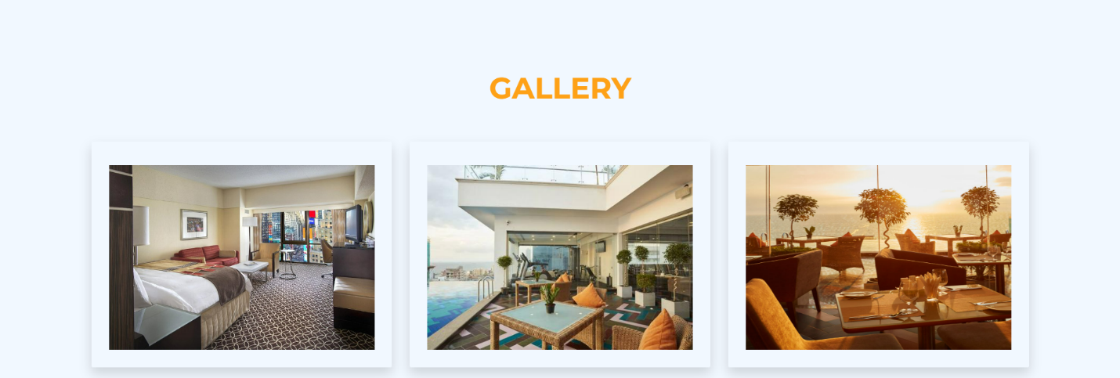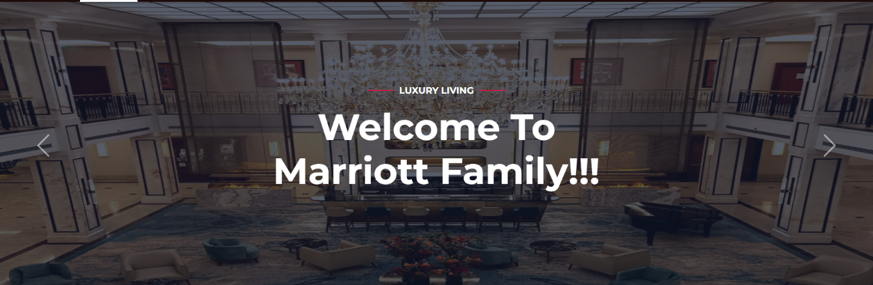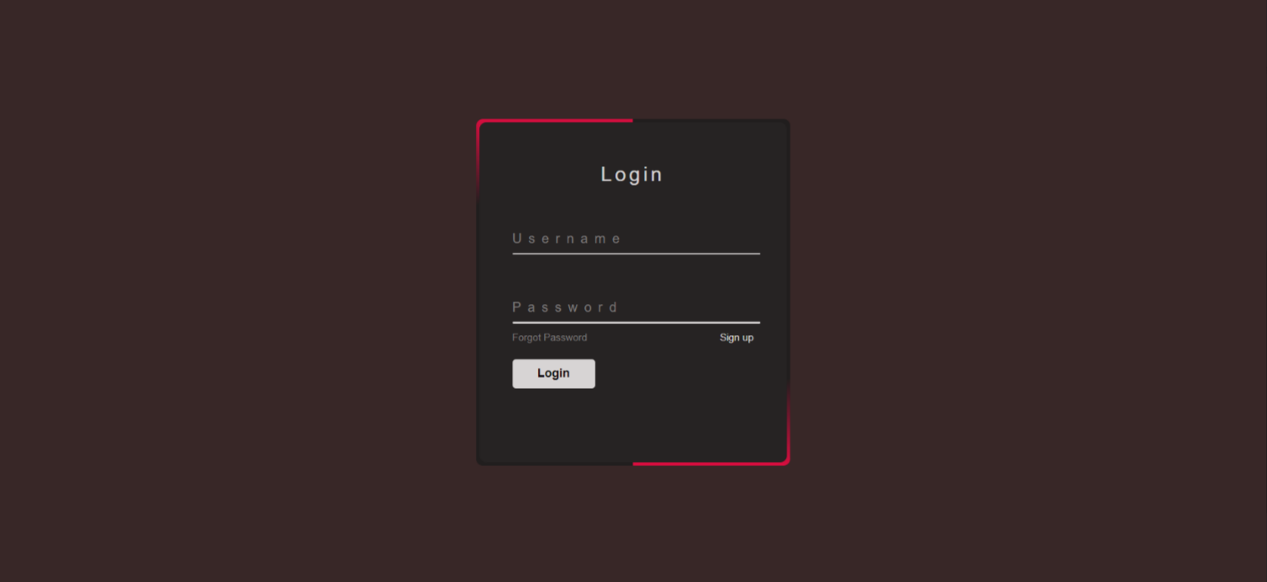

# 

# 

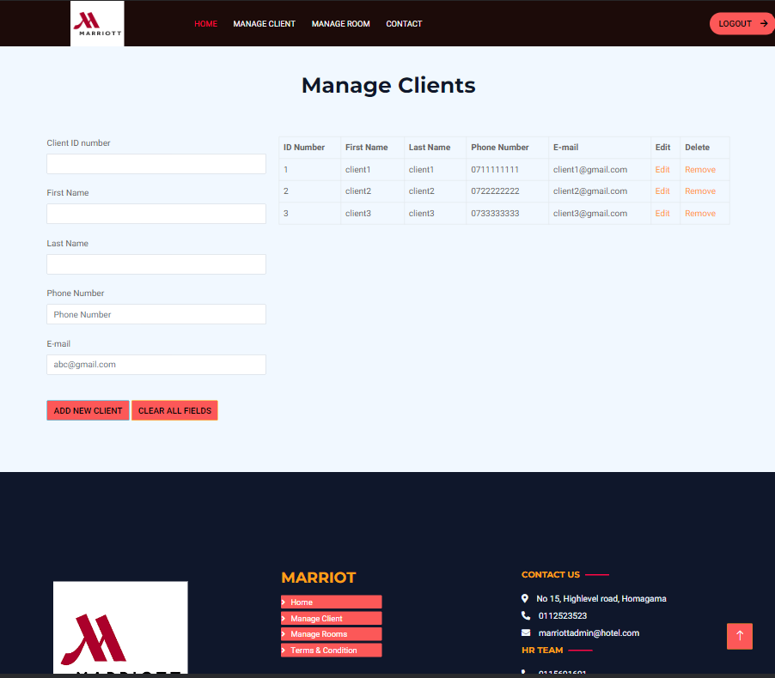

# UML diagrams

## ER Diagram

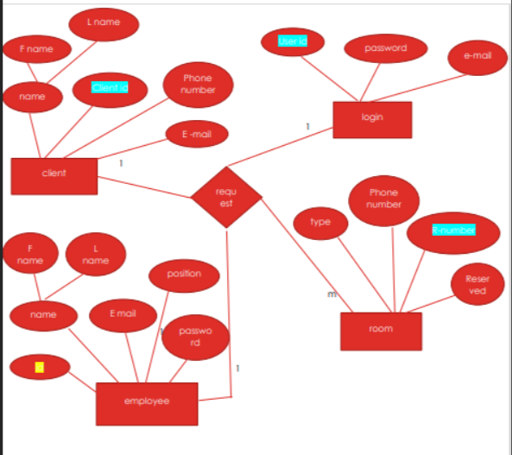

## Class Diagram.

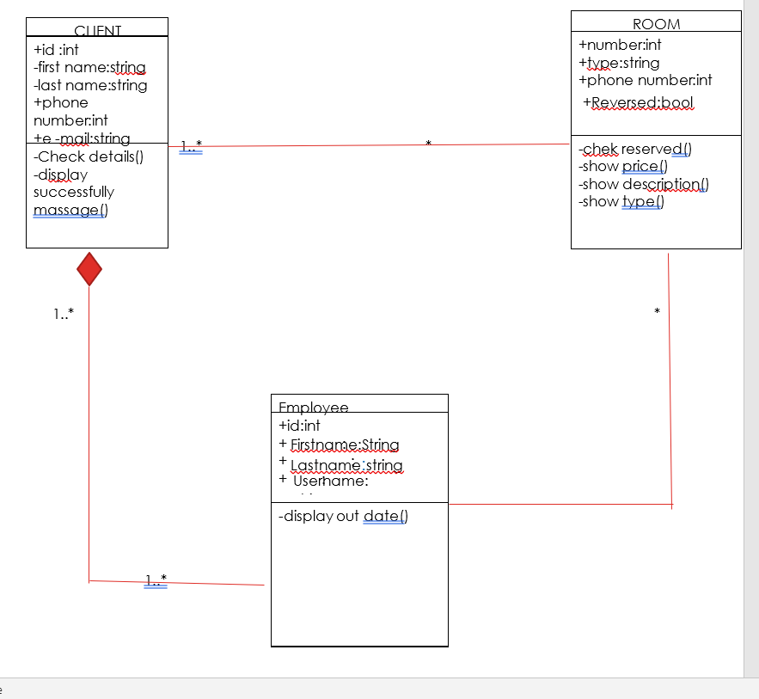

# MVC.

## 4.1. Our web system designed by using MCV architecture.

Our hotel reservation management system has been meticulously designed using the Model-View-Controller (MVC) architecture. This architecture provides a structured and modular approach to system development, ensuring separation of concerns and promoting maintainability, scalability, and flexibility.

In our system's design, the Model represents the data and business logic. It encompasses the core functionality of the reservation management system, such as guest information management, room availability tracking, and payment handling. The Model encapsulates the data structures and algorithms required to perform these operations efficiently.

The View layer focuses on the presentation and user interface aspects of the system. It handles the visual representation of information, allowing users to interact with the system through an intuitive and user-friendly interface. The View layer in our hotel reservation management system showcases room availability, facilitates online booking processing, and presents multimedia features to guests, ensuring a seamless and engaging user experience.

The Controller acts as the intermediary between the Model and the View. It receives user input from the View and communicates with the Model to perform the necessary operations. The Controller ensures that the system responds to user actions appropriately, updating the Model and updating the View accordingly. In our hotel reservation management system, the Controller handles tasks such as assigning rooms, managing reservations, and processing payment transactions.

The MVC architecture used in our hotel reservation management system allows for modular development and easy integration of new features or enhancements. The separation of concerns between the Model, View, and Controller enables developers to work on different components independently, promoting code reusability and maintainability.

Furthermore, the MVC architecture facilitates scalability, as each component can be scaled independently based on specific requirements. For example, if the system needs to handle a larger volume of reservations, the Model and Controller components can be optimized and scaled without impacting the View layer.

our hotel reservation management system follows the MVC architecture to ensure a well-structured, modular, and maintainable design. By leveraging this architecture, we have created a system that effectively manages hotel reservations, enhances the guest experience, and provides a solid foundation for future enhancements and scalability.

# 4.2. Our login system was designed by using MVC architecture.

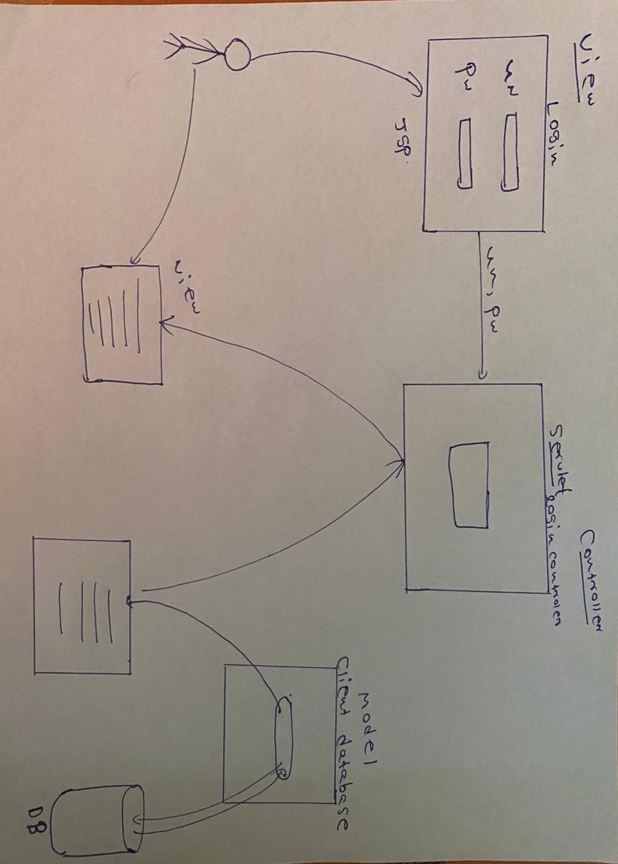

In our login system, we have implemented the Model-View-Controller (MVC) architecture to ensure a well-structured and modular design. Let's break down the roles of the Model, View, and Controller components in our system:

Model: The Model component in our system represents the data and business logic. In this case, it includes the client database where user information, such as usernames and passwords, is stored. The Model is responsible for validating user credentials by searching the database for a matching username and password combination. It ensures the integrity and security of user data and performs the necessary operations to authenticate user login attempts.

View: The View component is the user interface that users interact with to enter their login credentials. In our system, the login page serves as the View. It presents the username and password fields, allowing users to input their login information. The View is responsible for capturing user input and forwarding it to the Controller for further processing.

Controller: The Controller component handles the logic and flow of the system. In our case, the Controller is created using a servlet, a Java-based server-side component. When a user submits their login credentials from the View (login page), the Controller receives this data. It then interacts with the Model to validate the user's credentials by querying the client database. Based on the validation result, the Controller determines the next step in the login process. If the credentials are valid, it redirects the user to the next page, typically the user's dashboard or a designated landing page. If the credentials are invalid, appropriate error messages can be displayed to the user.

By using the MVC architecture in our login system, we ensure a clear separation of concerns and maintainability. The Model handles the data and business logic, the View presents the user interface, and the Controller manages the flow and interactions between the Model and the View. This design approach allows for modularity, scalability, and easier maintenance and enhancement of the system in the future.

# Code Segment.

## Header.jsp and footer.jsp

header. jsp and footer.jsp pages are formed separately as 2 jsp pages in order to avoid repeating the same code in every page lengthening the size of the code. The header and footer are connected to every page by the below code.





** 5.2.signup.jsp

* This handles the insertion of employee data into the employee table “DBmarriott” MySQL database. It retrieves the employee data from the request parameters, such as id, firstName, lastName, username, passwordInput, position, and email.
* If the update operation is successful (rowsAffected > 0), it redirects the user to the "login.jsp" page and if the update operation fails, it prints a message indicating the failure.
* login.jsp and signup.jsp are connected to the same database table “employee”. Only already inserted ids(in the database table “employee”) can be login through the login page. New users can sign up then login since then their ids get inserted in the database table.

## 5.3. login.jsp

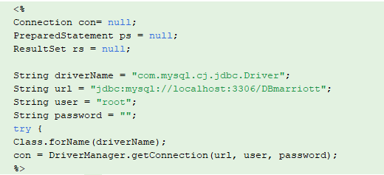

* This code sets up the database connection using JDBC and initializes variables for the driver name, URL, username, and password.
* login.jsp is connected to the loginbean.jsp. When the login button is clicked it connects to the loginbean.jsp .
* login.jsp" is the presentation layer or the user interface of the login functionality.
* It displays the login form to the user, collects the username and password input, and submits the form to the server for processing.
* This login.jsp JSP file contains , JavaScript, and JSP tags to create the login form and handle user interactions.

## 5.4. loginbean.jsp

* "loginbean.jsp" is the server-side logic for processing the login functionality.
* It handles the authentication and validation of user credentials against a database.
* It interacts with the database to retrieve user information and validate the credentials.
* It sets session attributes or redirects the user to different pages based on the login outcome (success or failure).

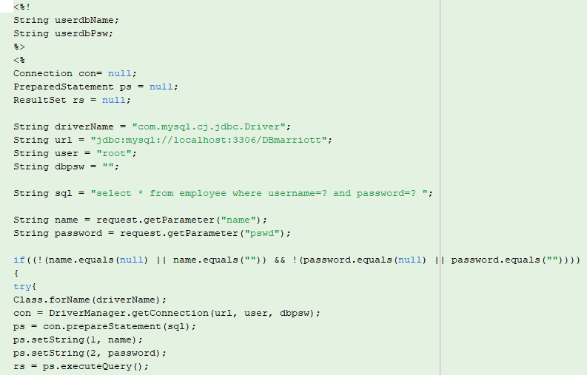

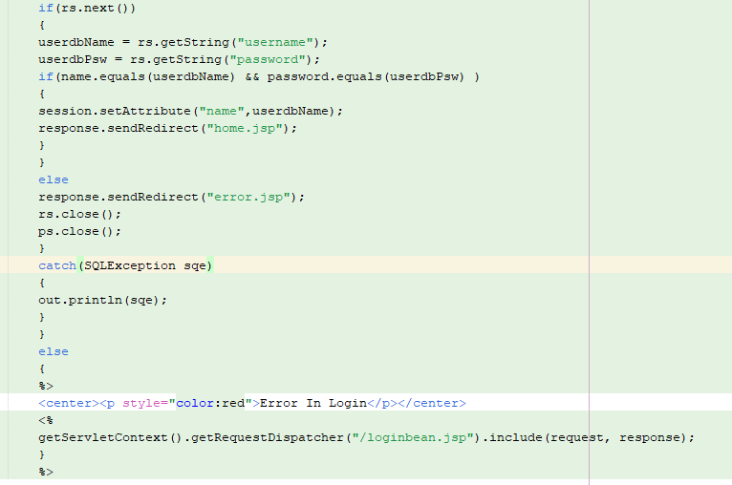

* This code declares and initializes variables for the username (userdbName) and password It defines an SQL query to select records from the "employee" table based on the provided username and password. Also it retrieves the username and password parameters from the request .MoreoverIt checks if the provided username and password are not empty or null.
* If the conditions are met, it connects to the database, constructs the SQL statement, sets the parameters, and runs the query. If the result set contains any rows, it obtains the username and password from the result set and compares them to the credentials provided.
* If the credentials are correct, it stores the username in the session and redirects the user to the "home.jsp" page and if the credentials do not match, the user is redirected to the "error.jsp" page Also if the entered username or password is empty or null, an error message is displayed.

## 5.5.Client.jsp

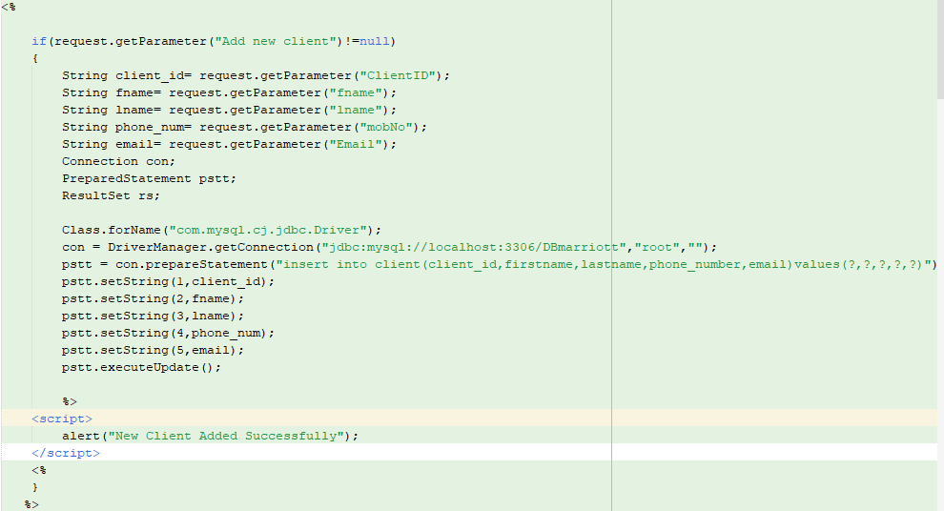

The Manage Client Page is connected to the database from this code. This JSP code block handles the addition of a new client to the MYSQL database "DBmarriott" .

* It checks if a parameter named "Add new client" is present in the request and If the parameter is found, it retrieves the relevant data from other request parameters such as "ClientID", "fname", "lname", "mobNo", and "Email".
* This establishes a database connection using JDBC (Java Database Connectivity) with the MySQL database "DBmarriott" on the local host.
* SQL INSERT statement inserts the client data into the "client" table in the database with columns: "client_id", "firstname", "lastname", "phone_number", and "email" and this sets the parameter values for the prepared statement using the retrieved data.
* It executes the INSERT statement using the ‘executeUpdate()’ method, which inserts the new client record into the database. If the insertion is successful, it displays a JavaScript alert message to indicate that the new client was added successfully.

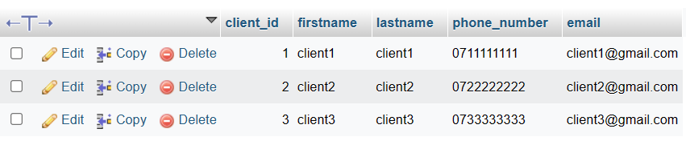

When a new client is added, it shows in the client table in the database as above.

This code retrieves data from the "client" table in the "DBmarriott" database and displays it in an HTML table format as below.

In the above code, it establishes a database connection using JDBC (Java Database Connectivity) with the MySQL database "DBmarriott" on the local host and SQL SELECT query string to retrieve all records from the "client" table.

It retrieves the values of columns "client_id", "firstname", "lastname", "phone_number", and "email" using getString() method and stores them in respective variables.

Also this code provides links to edit or remove the client record using the client ID. The client ID is passed as a query parameter in the URLs of the edit and remove links.

## 5.6. clientupdate.jsp

* When the Edit link is clicked in any row of the table on the Manage Client page and directed to Clientupdate.jsp , this code handles handle the update of client details in the MySQL database. It is triggered when the Update button is clicked.
* It checks if a parameter named "Update" is present in the request and the parameter is found, it retrieves the updated client details from other request parameters such as "ClientID", "fname", "lname", "mobNo", and "Email". It also establishes a database connection using JDBC.
* SQL UPDATE statement updates the client details in the "client" table. The statement sets the values of the "firstname", "lastname", "phone_number", and "email" columns based on the client ID.
* If the update is successful, it displays a JavaScript alert message to indicate that the client details were updated successfully.
* This code is to retrieve the pre-inserted client details in order to update/ edit the details. It It appears to retrieve client information from the "client" table in the MySQL database based on the "id" parameter passed in the request. In Client.jsp, the client_id is passed as the “id” in the link to Clientupdate.jsp however in here It retrieves the value of the "id" parameter from the request using request.getParameter("id") and assigns it to the variable client_id to retrieve the specific record.

* This generates an HTML form with input fields for each client attribute, pre-filling the fields with the retrieved values using embedded Java code (<%= %>) to output the values dynamically.

**5.7. clientdelete.jsp

This code handles the deletion of a client record from the MySQL database. The client _id is passed as a query parameter.

## 5.8. room.jsp

The Manage Rooms Page is connected to the database from this code. This JSP code block handles the addition of a new room to the rooms table in MYSQL database "DBmarriott" .

* When the form in the Manage Rooms is submitted by “ Add new room” button it checks the request parameter and retrieves the values of request parameters "RoomNo," "TypeID," "mobNo," and "Reserved."
* This establishes a connection to a MySQL database using the JDBC driver and establishes a connection to a MySQL database using the JDBC driver. SQL statement inserts the room details into the "rooms" table in "DBmarriott" database and also this code sets the values for the SQL statement using the retrieved request parameters.
* ‘executeUpdate()’ method executes the SQL statement. After successfully inserting the data into the table, it displays a JavaScript alert message saying "Room Adddeddddd”.

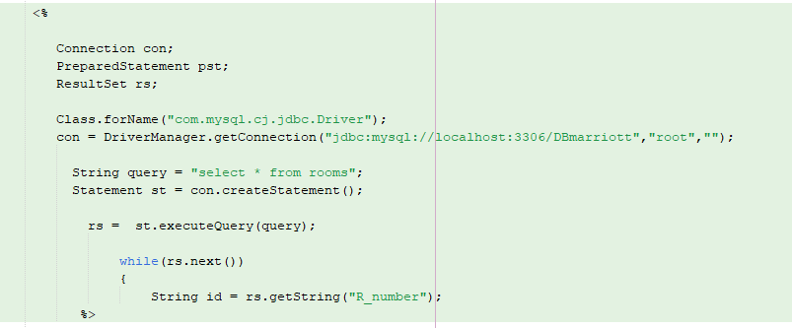

This code retrieves data from the "rooms" table in the MySQL database and displays it in an HTML table format.

* It establishes a database connection using the same JDBC driver and connection URL as in the previous code and then it establishes a database connection using the same JDBC driver and connection URL as in the previous code.
* After creating a Statement object (st) from the database connection, it executes the query using the executeQuery() method of the Statement object and assigns the result to the ResultSet variable (rs).
* It generates an html table row (<tr>) with the retrieved values using embedded Java code (<%= %>) to output the values dynamically.
* It includes two hyperlinks in the table row, "Edit" and "Remove," which link to separate JSP files (Roomsupdate.jsp and Roomsdelete.jsp) passing the room ID (id) as a query parameter.

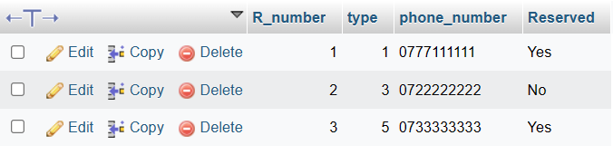

When a new room is added , it shows as above in the rooms table in the database.

This is the list of added rooms and this table is displayed on the Manage Room page. It gets updated when new room is added or details were edited or an existing room record is deleted.

## 5.9.Roomsupdate.jsp

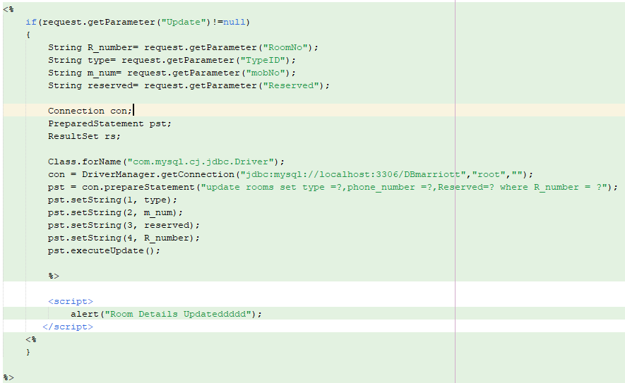

* 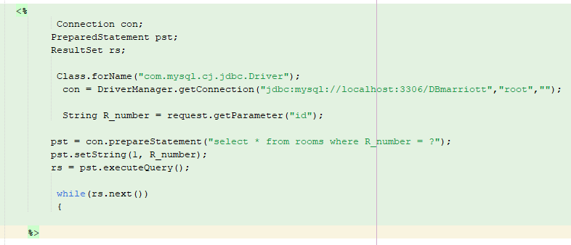This is similar to the Clientupdate.jsp . Here this handles the update functionality for the room details. When the room record is edited and clicked the Update button , it retrieves the updated values for the room details from the request parameters , "RoomNo," "TypeID," "mobNo," and "Reserved." It sets the values for the SQL statement using the updated request parameters and it executes the SQL statement using pst.executeUpdate() to update the data in the database table.
* Similar to Clientupdate.jsp , this code is to retrieve the pre-inserted room details in order to update/ edit the details. It appears to retrieve room details from the "rooms" table in the MySQL database based on the "id" parameter passed in the request. In Room.jsp, the R_number is passed as the “id” in the link to Roomupdate.jsp then in here it retrieves the value of the "id" parameter from the request using request.getParameter("id") and assigns it to the variable R_number to retrieve the specific record.
* This generates an HTML form with input fields for each client attribute, pre-filling the fields with the retrieved values using embedded Java code (<%= %>) to output the values dynamically. It helps to display the existing details related to each record before editing, then the user can edit the existing details.

## 5.10.Roomsdelete.jsp

This code handles the deletion of the records of rooms.

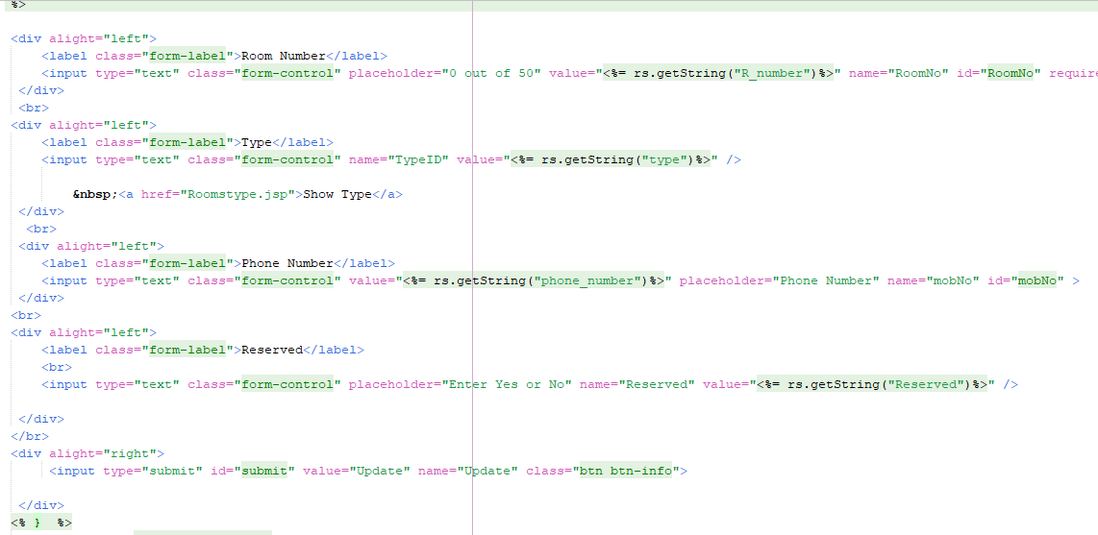

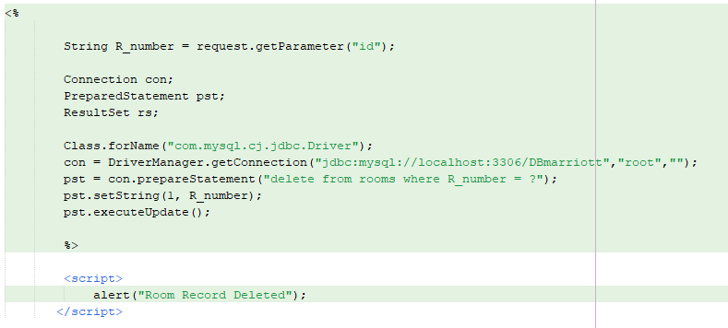

# GitHub Link.

Link:

# Bibliography

Ros, F., 2023. *code-projects.* [Online]   
Available at: https://code-projects.org/hotel-site-using-html-javascript-css/

Sewvandii, 2022. *Github.* [Online]   
Available at: https://github.com/topics/hotel-management-system?l=html