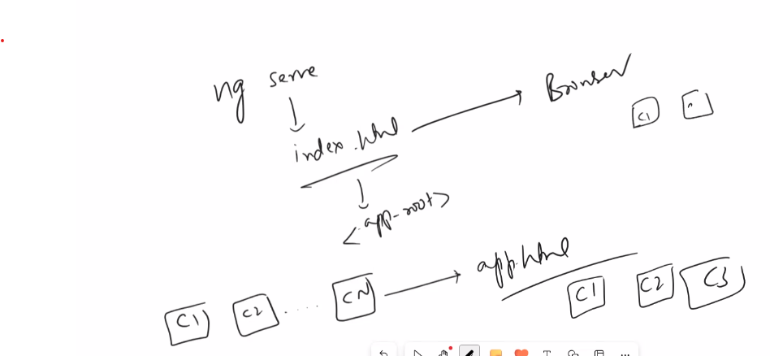

GIT STAGE COMMIT AND PUSH
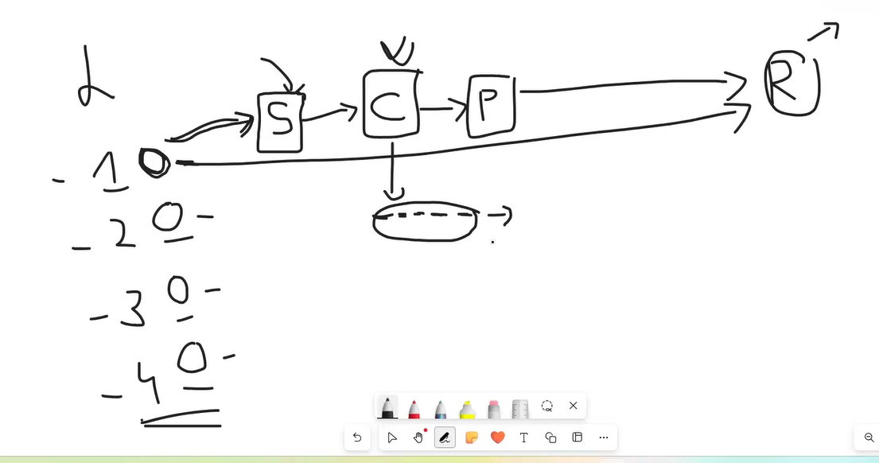
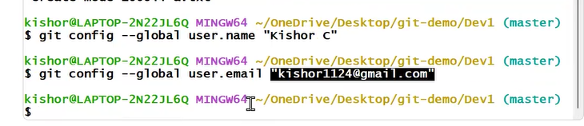
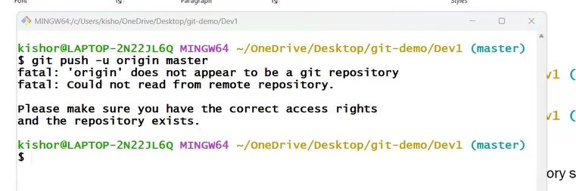
…or create a new repository on the command line
echo "# 20251123-gitbasics" >> README.md
git init
git add README.md
git commit -m "first commit"
git branch -M main
git remote add origin https://github.com/jayashankartx/20251123-gitbasics.git
git push -u origin main

…or push an existing repository from the command line
git remote add origin https://github.com/jayashankartx/20251123-gitbasics.git
git branch -M main
git push -u origin main

git push -u origin master
info: please complete authentication in your browser...
Enumerating objects: 93, done.
Counting objects: 100% (93/93), done.
Delta compression using up to 14 threads
Compressing objects: 100% (88/88), done.
Writing objects: 100% (93/93), 163.86 KiB | 4.82 MiB/s, done.
Total 93 (delta 19), reused 0 (delta 0), pack-reused 0 (from 0)
remote: Resolving deltas: 100% (19/19), done.
To https://github.com/jayashankartx/20251123-jfsd.git
* [new branch] master -> master
branch 'master' set up to track 'origin/master'.

Git Branch
git pull

Can we merge again?

