Assignment 3 (WQUPC)

**Name**: Jayashanker Padishala

**NUID:** 001097220

**Step1: Please find the attachment of the Unit-testcase passed.**

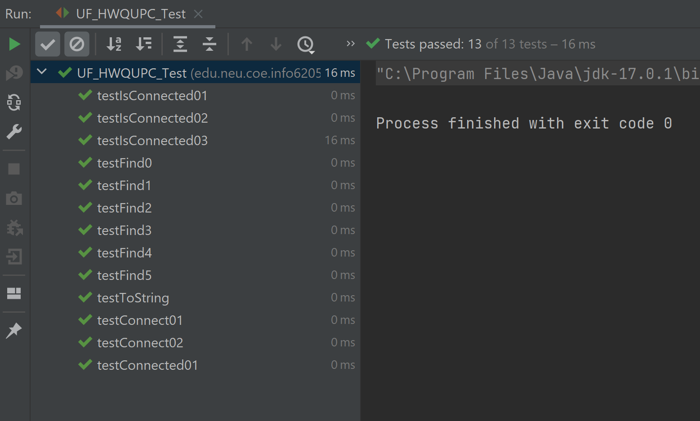

**Step2:**

**Attached the code file.**

**The generated data of the program is saved to result.txt and in the excel file.**

**Step 3:**

**As per the generated data (which is run on 100000 testcases), we can observe that it follows the linear pattern.**