a) To construct a binary Search tree.
b) To traverse the tree using all the methods i.e., in-order,
preorder and post order
c) To display the elements in the tree.

BFS:

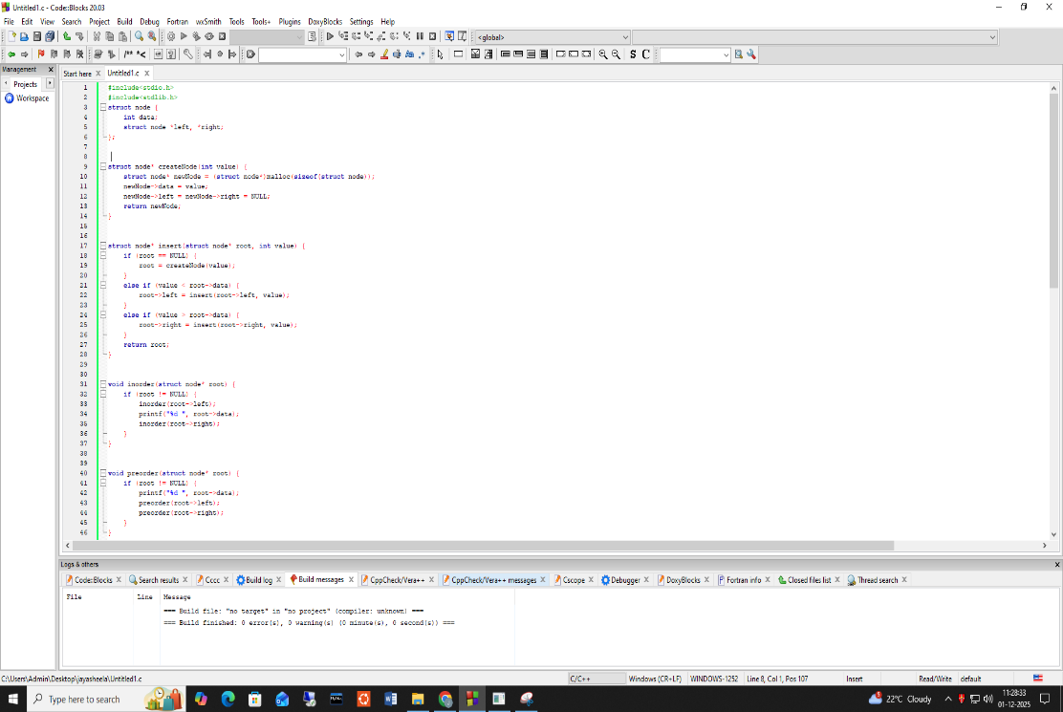
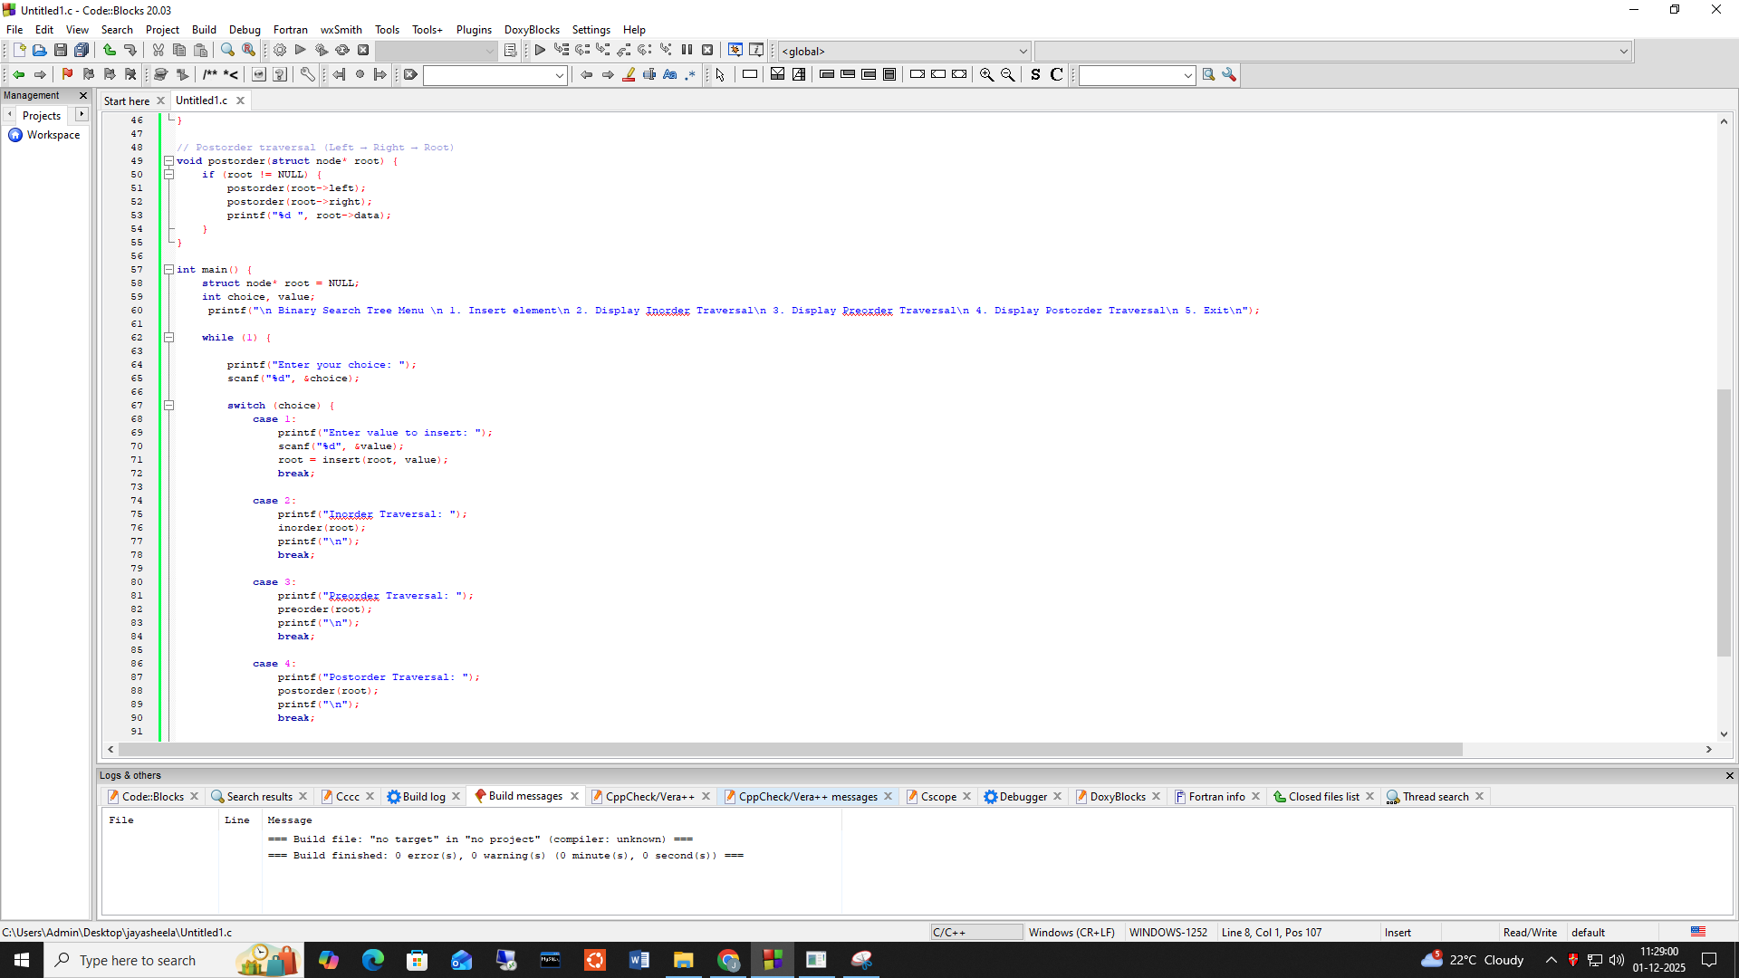

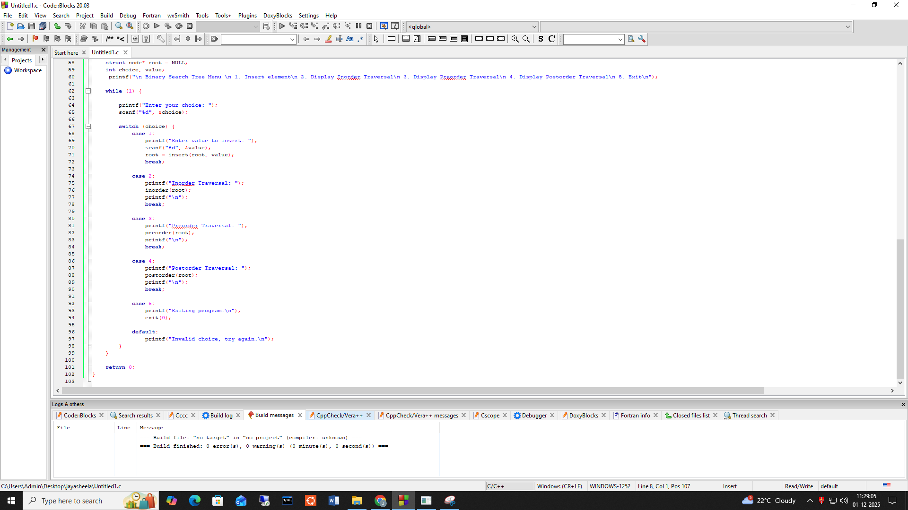
Output:
