Graph Traversal Programs (BFS and DFS)
A) Program to Traverse a Graph Using BFS (Adjacency List)
Program Code:

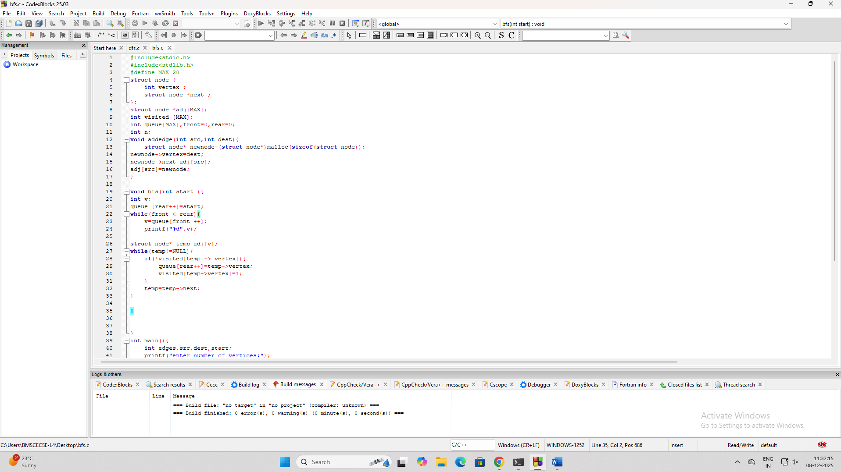

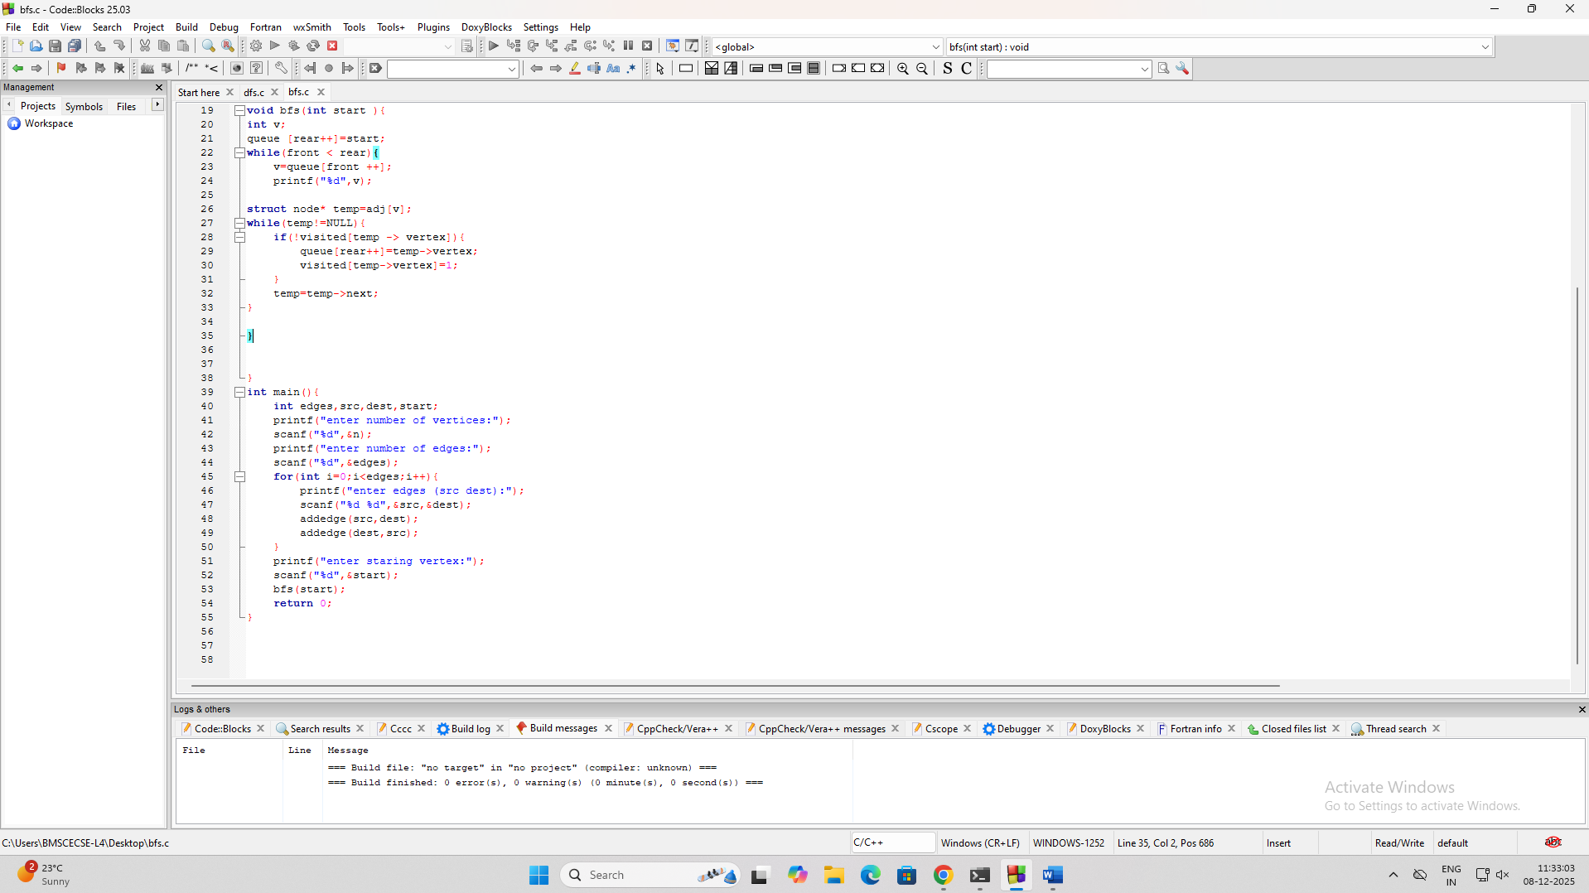

#include<stdio.h>
#include<stdlib.h>
#define MAX 20
struct node {
int vertex ;
struct node *next ;
};
struct node *adj[MAX];
int visited [MAX];
int queue[MAX],front=0,rear=0;
int n;
void addedge(int src,int dest){
struct node* newnode=(struct node*)malloc(sizeof(struct node));
newnode->vertex=dest;
newnode->next=adj[src];
adj[src]=newnode;
}

void bfs(int start ){
int v;
queue [rear++]=start;
while(front < rear){
v=queue[front ++];
printf("%d",v);

struct node* temp=adj[v];
while(temp!=NULL){
if(!visited[temp -> vertex]){
queue[rear++]=temp->vertex;
visited[temp->vertex]=1;
}
temp=temp->next;
}

}

}
int main(){
int edges,src,dest,start;
printf("enter number of vertices:");
scanf("%d",&n);
printf("enter number of edges:");
scanf("%d",&edges);
for(int i=0;i<edges;i++){
printf("enter edges (src dest):");
scanf("%d %d",&src,&dest);
addedge(src,dest);
addedge(dest,src);
}
printf("enter staring vertex:");
scanf("%d",&start);
bfs(start);
return 0;
}

Output:
