Program to Check Whether Graph is Connected Using DFS (Adjacency List)
Program Code:

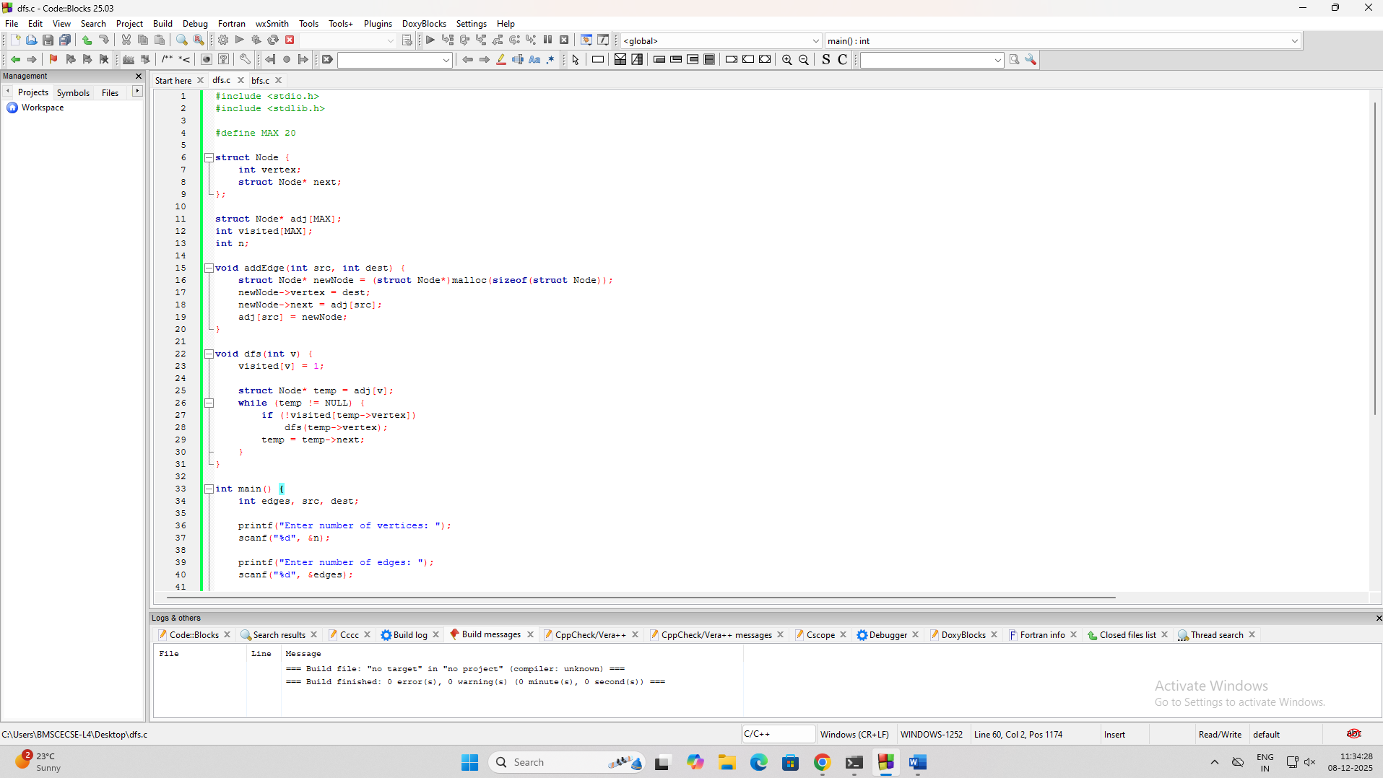

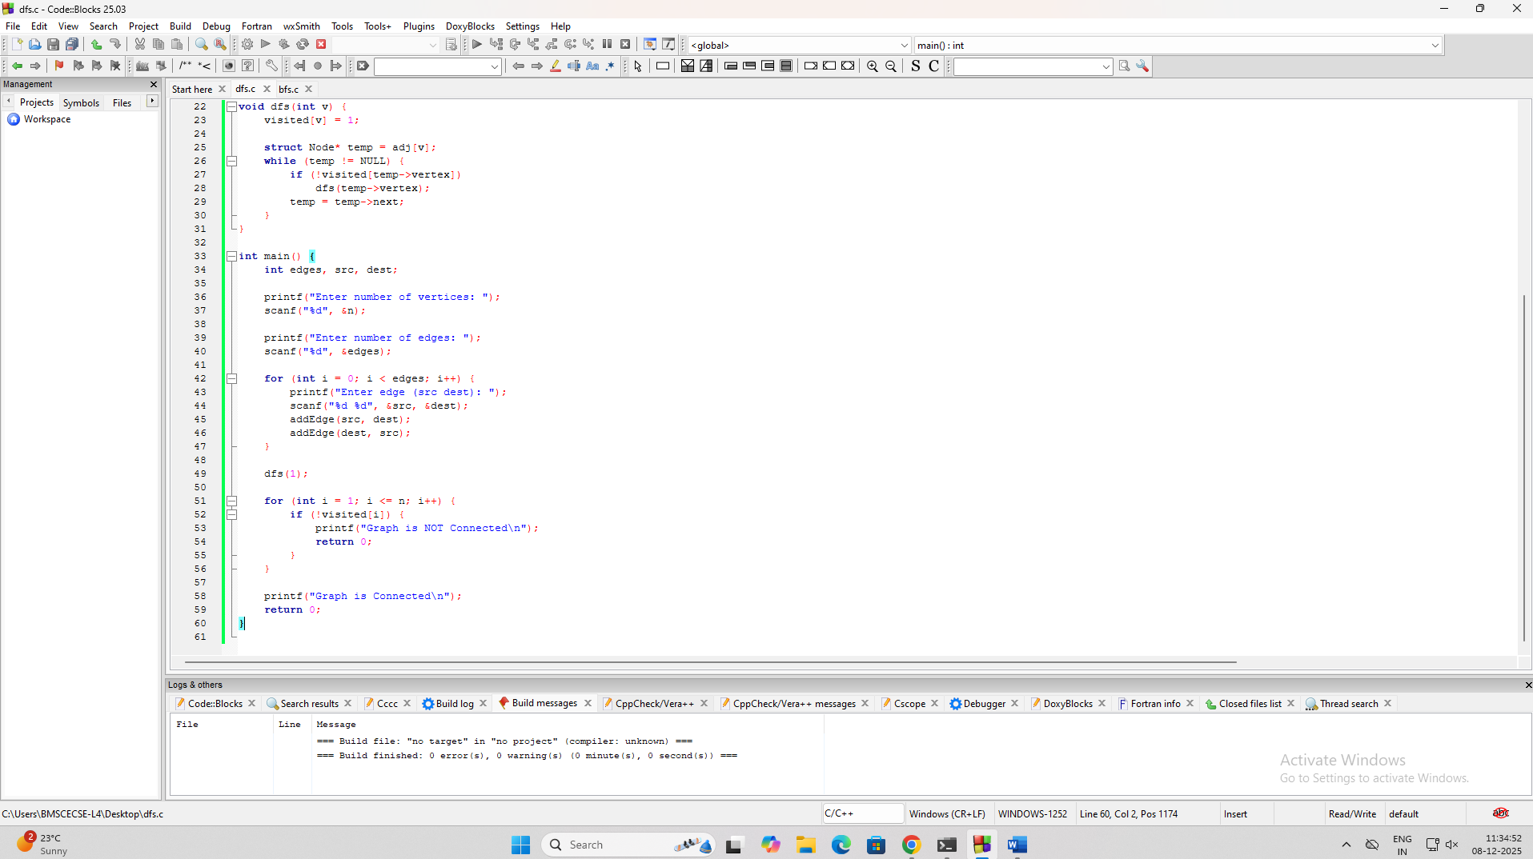

Code:
#include <stdio.h>
#include <stdlib.h>

#define MAX 20

struct Node {
int vertex;
struct Node* next;
};

struct Node* adj[MAX];
int visited[MAX];
int n;

void addEdge(int src, int dest) {
struct Node* newNode = (struct Node*)malloc(sizeof(struct Node));
newNode->vertex = dest;
newNode->next = adj[src];
adj[src] = newNode;
}

void dfs(int v) {
visited[v] = 1;

struct Node* temp = adj[v];
while (temp != NULL) {
if (!visited[temp->vertex])
dfs(temp->vertex);
temp = temp->next;
}
}

int main() {
int edges, src, dest;

printf("Enter number of vertices: ");
scanf("%d", &n);

printf("Enter number of edges: ");
scanf("%d", &edges);

for (int i = 0; i < edges; i++) {
printf("Enter edge (src dest): ");
scanf("%d %d", &src, &dest);
addEdge(src, dest);
addEdge(dest, src);
}

dfs(1);

for (int i = 1; i <= n; i++) {
if (!visited[i]) {
printf("Graph is NOT Connected\n");
return 0;
}
}

printf("Graph is Connected\n");
return 0;
}
Output:

