Zee Music Analysis Report
Requirements – Dashboard Page 1:-
1.Identify the artist with the highest number of streams.
The clustered bar chart displays the top 10 artists based on total streams. Velvet Signals has the highest number of streams, followed by Isla Bennett and Neon Avenue. Zara Khan and Oliver James have the lowest streaming activity among the displayed artists. This indicates that Velvet Signals is the most-streamed artist in the dataset.
2.Display the top 10 artists based on total revenue.
EVALUATE
TOPN (10, SUMMARIZECOLUMNS ('Artist' [ArtistName], "Total Revenue", SUM ('Music_Streams' [RevenueUSD])), [Total Revenue], DESC) ORDER BY [Total Revenue] DESC
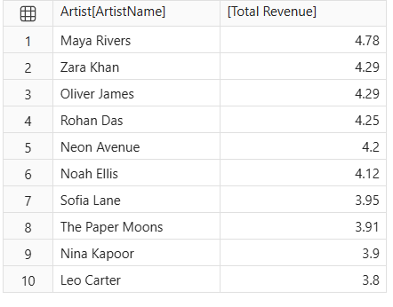
3.Compare the revenue generated by different genres.
EVALUATE
SUMMARIZECOLUMNS ('Artist' [PrimaryGenre], "Total Revenue", SUM ('Music_Streams' [RevenueUSD])) ORDER BY[Total Revenue] DESC
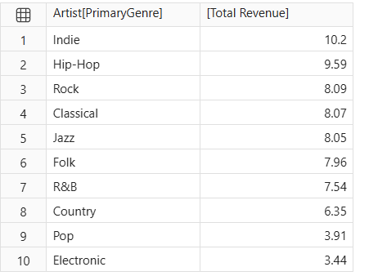

4.Identify the album with the highest listening activity.
EVALUATE
TOPN(1,SUMMARIZECOLUMNS('Album' [AlbumName], "Total Listening Activity", SUM('Music_Streams'[StreamCount])), [Total Listening Activity], DESC)ORDER BY [Total Listening Activity] DESC
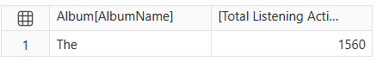
5.Analyse monthly stream trends.
The line chart shows that January recorded the highest streams (1,553), while May recorded the lowest streams (1,091). Streaming activity decreased from January to February and fluctuated throughout the remaining months. A noticeable increase occurred in June and August. Overall, the chart shows that monthly streaming activity varies, with January performing the best and May recording the lowest performance.
6.Compare revenue between 2024 and 2025.
- The clustered column chart shows revenue generated by different music genres in 2024 and2025.
- In 2024, India genre generated the highest revenue, approximately 5.3.
- In 2025, India genre also recorded the highest revenue, approximately 4.5.
- Electronic and Pop genres generated comparatively lower revenue in both years.
- Overall, 2024 generated slightly higher revenue than 2025.

Requirements – Dashboard Page 2 :-
1.Determine which subscription type generates the highest total revenue.
The bar chart compares the revenue generated by Free, Premium, Family and Student subscriptions. It helps identify which subscription type generates the highest revenue. Longer bars represent higher revenue. This comparison helps understand the revenue contribution of each subscription category.
2.Compare the average revenue per record for each subscription type.
EVALUATE
SUMMARIZECOLUMNS('Music_Streams'[SubscriptionType], "Total Revenue", SUM('Music_Streams'[RevenueUSD]), "Total Records", COUNTROWS('Music_Streams'),"Average Revenue Per Record", AVERAGE('Music_Streams'[RevenueUSD]))ORDER BY [Average Revenue Per Record] DESC
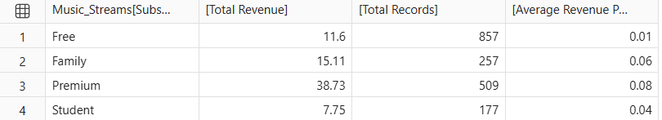
3.Identify which device accounts for the most streaming activity.
The donut chart displays the distribution of streaming records across different devices. Each section represents a device category. The largest section indicates the device with the highest number of streaming records. It helps understand listeners' device preferences.
4.Compare listening behaviour across countries.
The table provides country-wise information about subscription type, total streams, listening minutes, skips and revenue. It helps compare listening behaviour across different countries. It also helps identify differences in streaming activity and revenue between countries.
5.Find which playlist source has the highest number of streams.
EVALUATE
TOPN(1,SUMMARIZECOLUMNS('Music_Streams' [PlaylistSource], "TotalStreams",SUM('Music_Streams'[StreamCount]) ),[Total Streams], DESC) ORDER BY [Total Streams] DESC
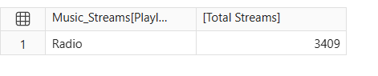
6.Compare completed and not-completed records.
The stacked bar chart compares completed and not-completed streaming records across subscription types. Different colours represent the completion status. It helps understand which subscription types have more completed streams. It also shows differences in listening behavior.
7.Analyse the relationship between SkipCount and Rating.
EVALUATE
SUMMARIZECOLUMNS('Music_Streams'[Rating],"Total Skips",SUM('Music_Streams'[SkipCount]),"Average Skip Count",AVERAGE('Music_Streams'[SkipCount]))ORDER BY 'Music_Streams'[Rating] ASC
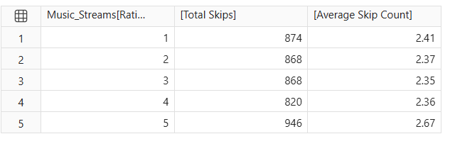
8.Compare revenue growth with the previous year.
EVALUATE
SUMMARIZECOLUMNS( 'Date'[Year],"Total Revenue",SUM('Music_Streams'[RevenueUSD]),"Previous Year Revenue",CALCULATE(SUM('Music_Streams'[RevenueUSD]), DATEADD('Date'[Date], -1, YEAR)))ORDER BY 'Date'[Year] ASC
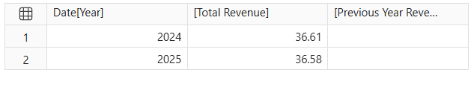
9.Identify artists or albums with high streams but relatively low revenue.
EVALUATE
SUMMARIZECOLUMNS('Artist'[ArtistName],'Album'[AlbumName],"Total Streams",SUM('Music_Streams'[StreamCount]),"Total Revenue",SUM('Music_Streams'[RevenueUSD]))ORDER BY [Total Streams] DESC
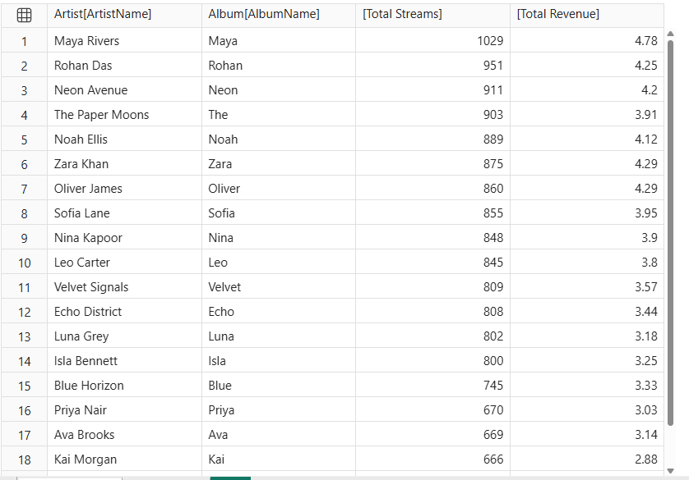

DAX Queries

1.Display 10 artists with the lowest no.of social media followers.
EVALUATE
TOPN(10,SELECTCOLUMNS ('Artist', “Artist Name", 'Artist'[ArtistName], "Social Media Followers",'Artist' [SocialFollowers]), [Social Media Followers], ASC) ORDER BY [Social Media Followers] ASC
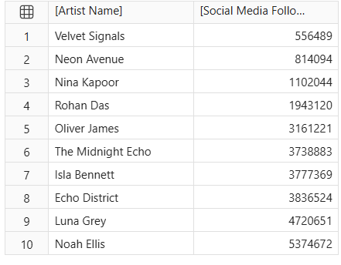

2.Display the 5 oldest albums based on their release dates.
EVALUATE
TOPN (5, SELECTCOLUMNS ('Album', "Album Name", 'Album' [AlbumName], "Release Date", 'Album' [ReleaseDate]), [Release Date], ASC) ORDER BY [Release Date] ASC
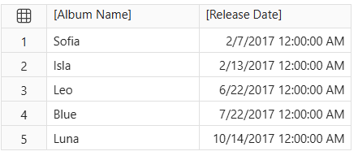
3.Display totalno.of streaming records,avg listening minutes,maximum rating and minimum rating in a single row.
EVALUATE
ROW ("Total Streaming Records", COUNTROWS ('Music_Streams'), "Average Listening Minutes",AVERAGE(Music_Streams [MinutesListened]), "Maximum Rating", MAX (Music_Streams [Rating]), "Minimum Rating", MIN(Music_Streams[Rating]))

4.Display the total revenue and average rating for each PlaylistSource.
EVALUATE
SUMMARIZECOLUMNS ( Music_Streams [PlaylistSource], "Total Revenue",SUM('Music_Streams' [RevenueUSD]), "Average Rating",AVERAGE('Music_Streams'[Rating]))
ORDER BY[Total Revenue] DESC
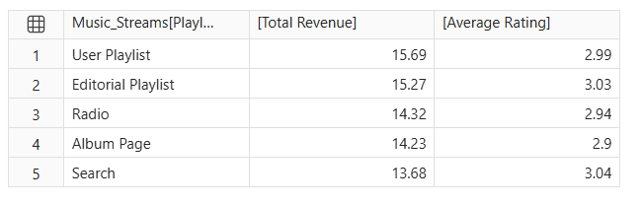

5.Dislay the 5 tracks with the highest total StreamCount,along with their total streams.
EVALUATE
TopN (5,SUMMARIZECOLUMNS ('Music_Streams' [TrackName], "Total Streams",SUM('Music_Streams' [StreamCount])), [Total Streams], DESC) ORDER BY [Total Streams] DESC
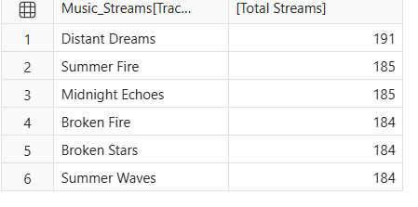
6.Display each PrimaryGenre and the no.of unique artists belonging to that genre.
EVALUATE
SUMMARIZECOLUMNS ('Artist'[PrimaryGenre], "Unique Artists",DISTINCTCOUNT('Artist' [ArtistKey])) ORDER BY[Unique Artists] DESC
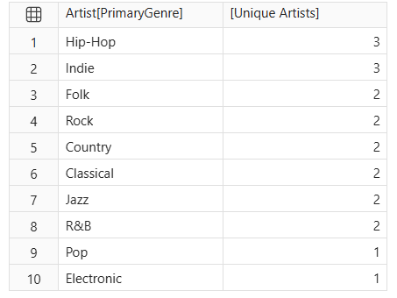

7.Display the total revenue generated from listeners in each ListenerCountry.
EVALUATE
SUMMARIZECOLUMNS( 'Music_Streams' [ListenerCountry], "Total Revenue",SUM ('Music_Streams'[RevenueUSD])) ORDER BY [Total Revenue] DESC
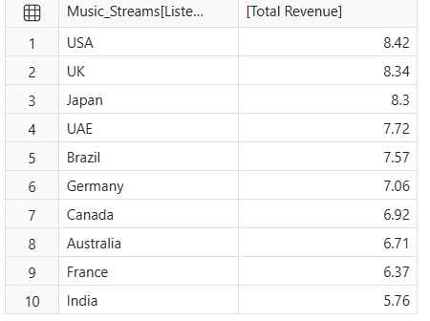
8. Display the 5 countries with the highest no.of unique listeners.
EVALUATE
TOPN (5, SUMMARIZECOLUMNS ('Music_Streams' [ListenerCountry], "Unique Listeners", DISTINCTCOUNT ('Music_Streams' [ListenerID])), [Unique Listeners], DESC) ORDER BY [Unique Listeners] DESC
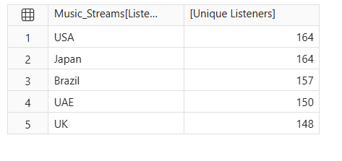
9.Display each PlaylistSource and its average SkipCount.
EVALUATE
SUMMARIZECOLUMNS ( 'Music_Streams'[PlaylistSource], "Average Skip Count",
AVERAGE('Music_Streams' [SkipCount]))ORDER BY [Average Skip Count] DESC
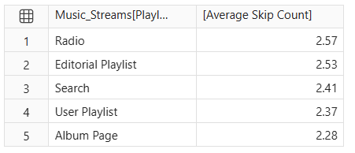

10.Display the 5 albums with the highest ProductionCostUSD.
EVALUATE
TOPN (5, SELECTCOLUMNS ( 'Album', "Album Name", 'Album'[AlbumName],
"Production Cost USD", 'Album' [ProductionCostUSD]), [Production Cost USD], DESC)
ORDER BY [Production Cost USD] DESC
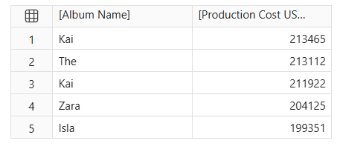
11. Display the total revenue generated in each year using the Date table.
EVALUATE
SUMMARIZECOLUMNS ( 'Date'[Year], "Total Revenue", SUM ('Music_Streams '[RevenueUSD])) ORDER BY 'Date'[Year] ASC
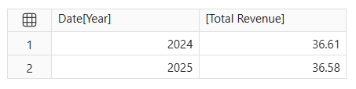
12..Displaytotal skips for every combination of Device and PlaylistSource.
EVALUATE
SUMMARIZECOLUMNS ('Music_Streams' [Device], 'Music_Streams'[PlaylistSource], "Total Skips", SUM('Music_Streams'[SkipCount])) ORDER BY [Total Skips] DESC
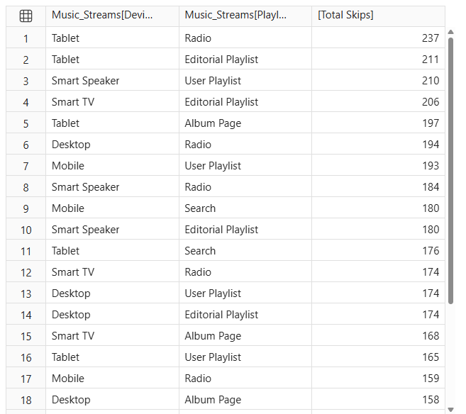

13.Display each ArtistType and its average no.of social followers.
EVALUATE
SUMMARIZECOLUMNS ('Artist' [ArtistType], "Average Social Media Followers", AVERAGE('Artist'[SocialFollowers])) ORDER BY [Average Social Media Followers] DESC
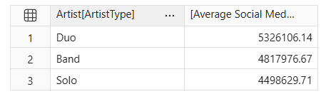
14.Display each ListenerCountry,its total revenue,no.of streaming records and average revenue per record.
EVALUATE
SUMMARIZECOLUMNS ( 'Music_Streams' [ListenerCountry], "Total Revenue", SUM('Music_Streams' [RevenueUSD]),"Streaming Records", COUNTROWS ('Music_Streams'), "Average Revenue Per Record", AVERAGE('Music_Streams' [RevenueUSD])) ORDER BY [Total Revenue] DESC
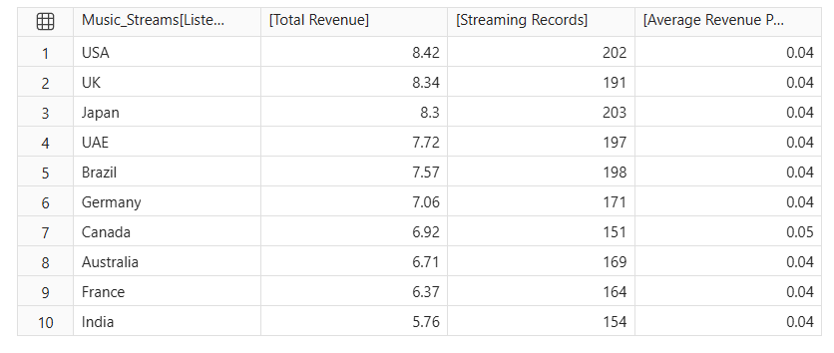

15.Display the no.of unique listeners and average listening minutes for every combination of SubscriptionType and Device.
EVALUATE
SUMMARIZECOLUMNS ( 'Music_Streams' [SubscriptionType], 'Music_Streams' [Device], "Unique Listeners", DISTINCTCOUNT ('Music_Streams' [ListenerID]), "Average Listening Minutes", AVERAGE('Music_Streams'[MinutesListened]))ORDER BY [Unique Listeners] DESC



