APPLICATION PROJECT REPORT

JOB PORTAL WEB APPLICATION USING NEXT.JS

A Project Report Submitted in Partial Fulfillment
of the Requirements for Academic Evaluation

Submitted by

Student Name: sarathy s
Register Number: 25cap109
Department: Master of Computer Applications
Guide: Ms. N. Sneha

Institution: Karpagam Academy of Higher Education
Academic Year: 2025 - 2026

Guide Signature: Ms. N. Sneha
Head of Department: _____________________

CERTIFICATE
This is to certify that the project report entitled "Job Portal Web Application Using Next.js" is a bona fide work carried out by sarathy s (Reg. No. 25cap109) in partial fulfillment of academic requirements. The work has been completed under the guidance of Ms. N. Sneha in the Department of Master of Computer Applications, Karpagam Academy of Higher Education.

Guide Signature (Ms. N. Sneha)
Head of Department

DECLARATION
I hereby declare that this project report titled "Job Portal Web Application Using Next.js" is my original work and has not been submitted to any other institution for any award.
Name: sarathy s
Register Number: 25cap109
Department: Master of Computer Applications

Student Signature (sarathy s)

ACKNOWLEDGEMENT
I express my sincere gratitude to all faculty members, guide, and institution for their support and encouragement in completing this project successfully.

TABLE OF CONTENTS
Right-click and Update Field to populate Table of Contents
Contents Preview
Chapter 1. Introduction
Chapter 2. System Analysis
Chapter 3. System Design
Conclusion

APPLICATION PROJECT DOCUMENTATION

Project Title: Job Portal Web Application Using Next.js

Chapter 1. Introduction

1.1 Overview
The Job Portal project is a web application that helps candidates discover relevant jobs, review detailed job information, save interesting opportunities, and submit job applications using a structured form. The system is built with Next.js and React for the frontend and API routes, with json-server and a local JSON file for persistent data.

1.2 Background
Digital recruitment platforms are now the standard channel for companies and applicants. Most production platforms are large and complex, which makes them difficult for academic learning and incremental implementation. This project focuses on a clear, modular, and educational architecture while still covering core recruitment workflows: registration, login, job exploration, shortlist management, and application submission.

The current state of practice in this domain includes secure authentication, scalable search, application tracking dashboards, and workflow automation. This project implements the foundational version of these capabilities in a manageable scope suitable for academic evaluation.

1.3 The Problem
Students and entry-level developers need a practical project that demonstrates complete software lifecycle concepts in one application. Existing sample applications often fail to include both user management and end-to-end transactional flow. Specifically, the common gaps are:
1. No persistent application submission workflow.
2. No link between authentication and protected screens.
3. No clear system analysis artifacts such as DFD, ERD, and scheduling charts.

1.4 The Proposed Solution
The proposed solution is a modular job portal application with integrated API routes, persistent JSON storage, and an application form workflow. Key contributions are:
1. A complete flow from authentication to job application submission.
2. Structured project architecture with reusable components and protected pages.
3. Persistent application storage in db.json using an application entity with timestamp and status.
4. Strong documentation artifacts: DFD levels, ERD, class/use-case/activity/sequence/state models, and data dictionary.

Novel aspects and differences from basic demo portals:
1. Application submission is stored as structured records, not just alerts.
2. Feature set is aligned with formal SRS and system design deliverables.
3. The solution provides both implementation and documentation readiness for academic review.

1.5 Objectives or Anticipation of Conclusions
If implemented successfully, the project will achieve:
1. Functional user onboarding and login for job seekers.
2. Efficient job discovery through search and filtering.
3. Reliable application submission with required details.
4. Consistent user experience across dashboard, job details, saved jobs, and profile.
5. A complete software engineering document set suitable for evaluation and viva.

Chapter 2. System Analysis

2.1 Identification of Need
The system is needed to solve the following practical and educational needs:
1. Centralized access to job opportunities for users.
2. Structured mechanism to apply with essential applicant details.
3. Persistent record of submitted applications for tracking and future admin workflows.
4. A complete academic model project demonstrating requirements, analysis, design, and testing.

2.2 Feasibility Study
The project is feasible across multiple dimensions.

1. Technical Feasibility:
The stack (Next.js, React, json-server, local JSON database) is lightweight, stable, and well-supported. Required development tools are available and suitable for rapid implementation.

2. Operational Feasibility:
Users can interact with familiar web interfaces for signup, login, browsing jobs, and applying. System behavior is simple to understand and operate.

3. Economic Feasibility:
The project uses open-source tools and does not require paid infrastructure for local deployment. Cost of implementation is minimal.

4. Schedule Feasibility:
The project can be delivered within a short academic timeline using phased implementation and testing.

5. Legal and Ethical Feasibility:
The application handles user profile and application data for educational purposes. Deployment-level legal controls can be added in future versions.

2.3 Project Planning and Scheduling

2.3.1 Work Breakdown Structure
1. Requirement analysis and documentation.
2. UI design and component setup.
3. Authentication implementation.
4. Dashboard and filtering implementation.
5. Job detail and saved jobs workflow.
6. Application form and persistence.
7. Testing and validation.
8. Final report preparation.

2.3.2 PERT Chart
Diagram
Figure: PROJECT_DOCUMENTATION_DIAGRAMS-1

2.3.3 Gantt Chart
Diagram
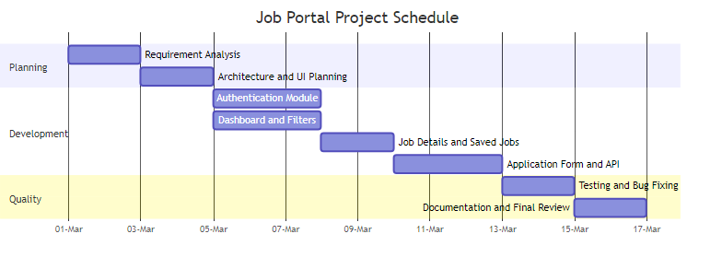
Figure: PROJECT_DOCUMENTATION_DIAGRAMS-2

2.4 Software Requirement Specifications (SRS)

2.4.1 Functional Requirements

##### 2.4.1.1 System Feature 1: Authentication and Access Control
1. User can sign up with name, email, and password.
2. User can log in with valid credentials.
3. System stores token and user data in localStorage.
4. Protected pages redirect unauthenticated users to login.
5. User can log out and clear session.

##### 2.4.1.2 System Feature 2: Job Discovery, Saving, and Application
1. User can browse available jobs.
2. User can search by job title or company.
3. User can filter by location and job type.
4. User can view complete details of a selected job.
5. User can save or unsave jobs.
6. User can submit application with full name, email, phone, and optional cover letter.
7. System stores application data with timestamp and status in db.json.

2.4.2 External Interface Requirements

##### 2.4.2.1 Hardware Interface
1. Client Side:
Desktop or laptop with modern browser support, minimum 4 GB RAM recommended.

2. Server Side:
Node.js runtime environment on local machine or cloud VM; minimal CPU and memory requirements for development use.

##### 2.4.2.2 Software Interface
1. Front End Client:
Next.js pages and React components rendered in browser.

2. Web Server:
Next.js development server (localhost:3000) serving pages and API routes.

3. Data Base Server:
json-server (localhost:5000) serving user and application collections from db.json.

4. Back End:
Next.js API routes for login, signup, logout, and apply endpoints.

2.4.3 Technical Requirements

##### 2.4.3.1 Performance
1. Job list filtering should respond interactively for the current dataset.
2. API response for login and apply should complete within acceptable local latency.

##### 2.4.3.2 Scalability
1. Current model supports small-to-medium educational datasets.
2. Migration path exists to relational or NoSQL database for larger scale.

##### 2.4.3.3 Security
1. Input validation on required API fields.
2. Route-level authentication checks on protected pages.
3. Future hardening required: password hashing, JWT, rate limiting.

##### 2.4.3.4 Maintainability
1. Component-based UI architecture.
2. Separation between pages, components, API, and utility modules.
3. Readable naming conventions and modular files.

##### 2.4.3.5 Usability
1. Clear navigation with top navbar.
2. Form labels, validation, and status feedback.
3. Consistent button/input styling and layout.

##### 2.4.3.6 Availability
1. System available whenever Next.js server and json-server are running.
2. Local deployment supports continuous use for academic demo.

2.5 Data Models and Behavioral Models

2.5.1 Data Flow Diagram: Context Diagram (Level 0)
Diagram
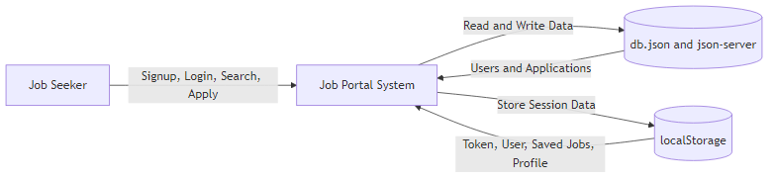
Figure: PROJECT_DOCUMENTATION_DIAGRAMS-3

2.5.2 Data Flow Diagram: Level 1
Diagram
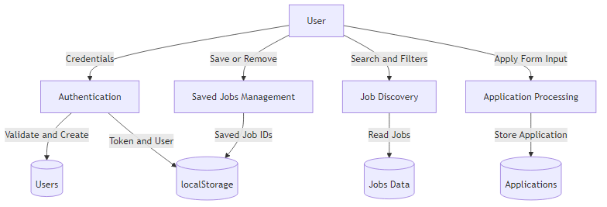
Figure: PROJECT_DOCUMENTATION_DIAGRAMS-4

2.5.3 Data Flow Diagram: Level 2 (Application Processing)
Diagram
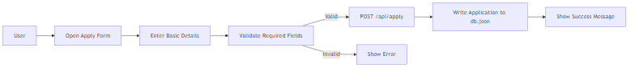
Figure: PROJECT_DOCUMENTATION_DIAGRAMS-5

2.5.4 Control Flow Diagram
Diagram
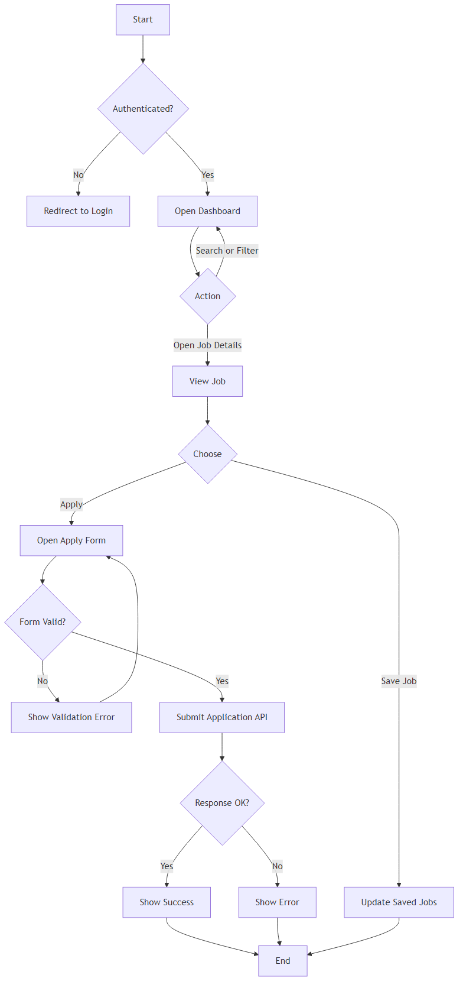
Figure: PROJECT_DOCUMENTATION_DIAGRAMS-6

2.5.5 Sequence Diagram (Job Application)
Diagram
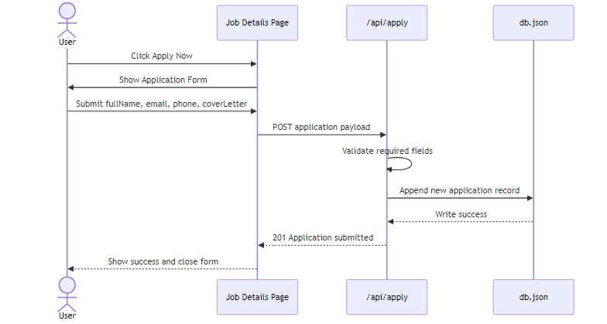
Figure: PROJECT_DOCUMENTATION_DIAGRAMS-7

2.5.6 State Diagram (Application Status)

Diagram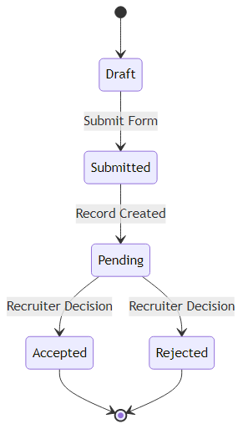

Figure: PROJECT_DOCUMENTATION_DIAGRAMS-8

2.5.7 Entity Relationship Model
Diagram
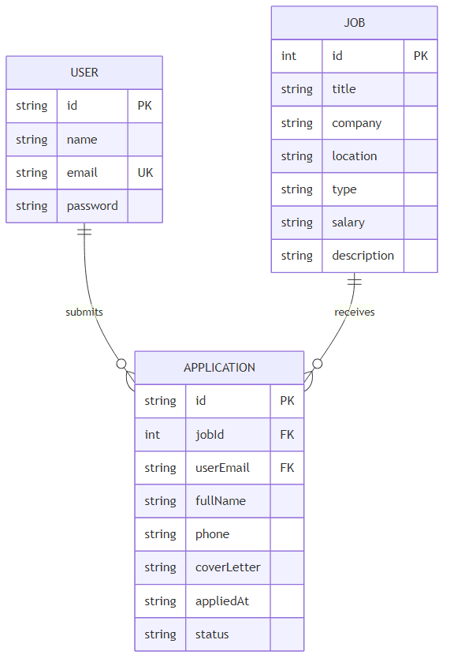
Figure: PROJECT_DOCUMENTATION_DIAGRAMS-9

Cardinality summary:
1. One USER can submit many APPLICATION records.
2. One JOB can receive many APPLICATION records.
3. Each APPLICATION belongs to one USER and one JOB.

2.5.8 Class Diagram (Logical)
Diagram
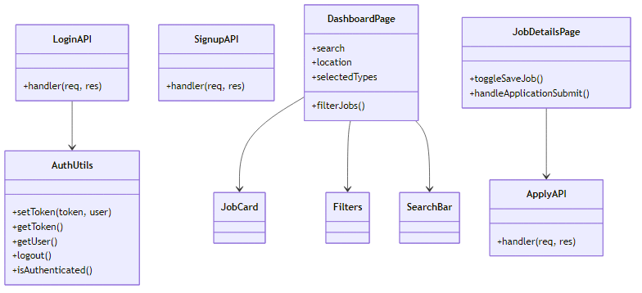
Figure: PROJECT_DOCUMENTATION_DIAGRAMS-10

2.5.9 Use-Case Diagram
Diagram
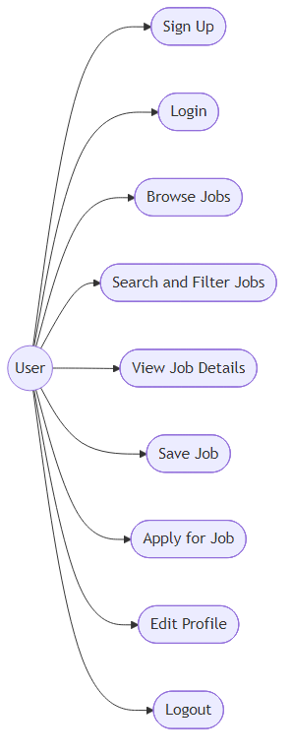
Figure: PROJECT_DOCUMENTATION_DIAGRAMS-11

2.5.10 Activity Diagram (Apply Flow)
Diagram
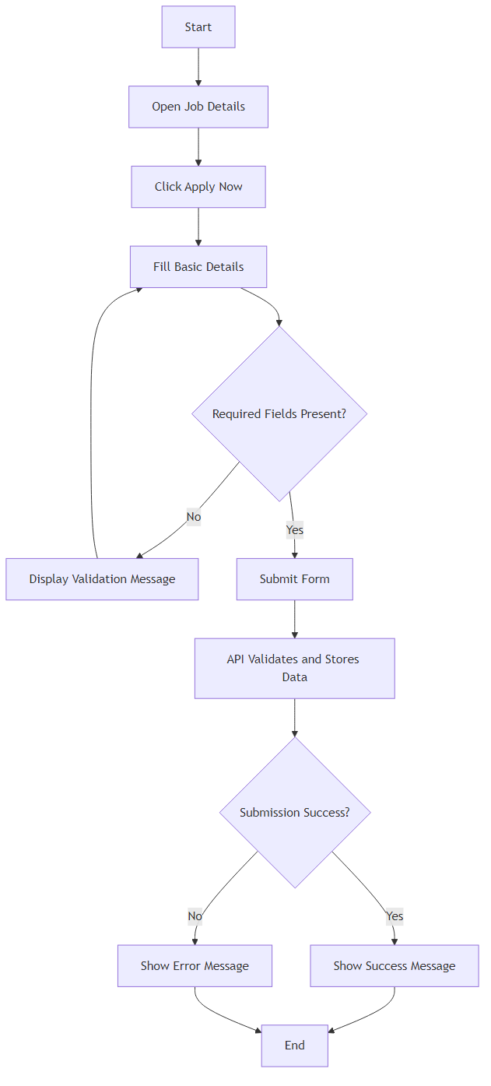
Figure: PROJECT_DOCUMENTATION_DIAGRAMS-12

2.5.11 Data Dictionary

Entity and Attribute Dictionary:

| Entity | Attribute | Type | Key/Constraint | Description |
|---|---|---|---|---|
| USER | id | string | Primary Key | Unique user identifier |
| USER | name | string | Not Null | User full name |
| USER | email | string | Unique, Not Null | User login email |
| USER | password | string | Not Null | User password |
| JOB | id | int | Primary Key | Unique job identifier |
| JOB | title | string | Not Null | Job title |
| JOB | company | string | Not Null | Company name |
| JOB | location | string | Not Null | Job location |
| JOB | type | string | Not Null | Job type |
| JOB | salary | string | Not Null | Compensation summary |
| APPLICATION | id | string | Primary Key | Unique application identifier |
| APPLICATION | jobId | int | Foreign Key -> JOB.id | Applied job reference |
| APPLICATION | userEmail | string | Foreign Key -> USER.email | Applicant reference |
| APPLICATION | fullName | string | Not Null | Candidate full name |
| APPLICATION | phone | string | Not Null | Candidate contact number |
| APPLICATION | coverLetter | string | Nullable | Optional candidate note |
| APPLICATION | appliedAt | datetime string | Not Null | Submission timestamp |
| APPLICATION | status | string | Default pending | Application processing state |

Data Flow Dictionary:

| Data Flow | Source | Destination | Structure |
|---|---|---|---|
| Login Request | Login Page | /api/login | email, password |
| Signup Request | Signup Page | /api/signup | name, email, password |
| Auth Response | API | Browser localStorage | token, user |
| Job Query | Dashboard UI | jobsData | search text, location, types |
| Save Jobs Data | Job Details/Saved Page | localStorage | savedJobs array |
| Application Request | Job Details Form | /api/apply | jobId, userEmail, fullName, phone, coverLetter |
| Application Record | /api/apply | db.json applications | id, metadata, status |

Chapter 3. System Design

3.1 Module Design

| Module | Responsibility | Inputs | Outputs |
|---|---|---|---|
| Auth Module | Signup, login, logout, auth guard | Credentials | Session token and user |
| Dashboard Module | Job listing, search, filtering | Search text, location, type | Filtered job list |
| Job Details Module | Display job and handle save/apply actions | Job ID, form fields | Saved state, application submission |
| Saved Jobs Module | Display and manage shortlisted jobs | savedJobs IDs | Saved job cards |
| Profile Module | Display and update user profile details | Name, email, phone | Updated profileData |
| API Module | Handle login, signup, apply requests | HTTP JSON payload | JSON success/error response |
| Data Module | Hold users/jobs/applications data | Read and write requests | Persisted records |

3.2 Database Design

3.2.1 Relational Design and 3NF
Normalized schema definition:
1. USER(id, name, email, password)
2. JOB(id, title, company, location, type, salary, description)
3. APPLICATION(id, jobId, userEmail, fullName, phone, coverLetter, appliedAt, status)

Normalization status:
1. 1NF:
All attributes are atomic and repeating groups are removed.
2. 2NF:
All non-key attributes fully depend on their table primary key.
3. 3NF:
No transitive dependency among non-key attributes within each table.

3.2.2 Referential Diagram
Diagram
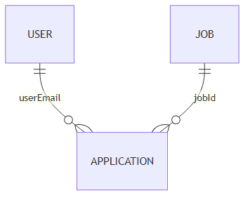
Figure: PROJECT_DOCUMENTATION_DIAGRAMS-13

3.2.3 Integrity and Key Constraints
1. Primary Keys:
USER.id, JOB.id, APPLICATION.id.
2. Alternate Key:
USER.email is unique and can serve as alternate lookup key.
3. Foreign Keys:
APPLICATION.jobId references JOB.id.
APPLICATION.userEmail references USER.email.
4. Value Constraints and Ranges:
APPLICATION.status in {pending, accepted, rejected}.
Required fields for apply API: jobId, userEmail, fullName, phone.

3.3 Procedural Design

3.3.1 Pseudocode: Login Flow
BEGIN
INPUT email, password
IF email is empty OR password is empty THEN
SHOW validation error
STOP
ENDIF

CALL /api/login with email and password
IF response is success THEN
STORE token and user in localStorage
REDIRECT to dashboard
ELSE
SHOW login error message
ENDIF
END

3.3.2 Pseudocode: Application Submission Flow
BEGIN
OPEN application form
INPUT fullName, email, phone, coverLetter

IF fullName OR email OR phone is empty THEN
SHOW validation error
STOP
ENDIF

CALL /api/apply with form payload
IF response is success THEN
CLEAR form
SHOW success message
ELSE
SHOW failure message
ENDIF
END

3.4 User Interface Design
The UI is designed for coherence with data flow and process flow.

1. Consistency:
Standard naming for pages and controls, consistent button classes, and reusable card/input patterns.

2. Navigation:
Navbar provides access to dashboard, saved jobs, profile, and login/logout actions based on authentication state.

3. Validation:
Form-level required checks in signup, login, and apply form. API-level required field checks for critical endpoints.

4. Process Alignment:
Screen transitions align with DFD processes:
login/signup to authenticated dashboard, dashboard to job details, job details to application submission.

Interface validation matrix:

| Screen | Input Fields | Validation Rules |
|---|---|---|
| Signup | name, email, password | All required, duplicate email not allowed |
| Login | email, password | All required, credentials must match |
| Job Apply | fullName, email, phone, coverLetter | fullName/email/phone required |
| Profile | name, email, phone | Basic edit and save behavior |

3.5 Test Cases

3.5.1 Unit Test Cases

| Test ID | Module | Test Description | Expected Result |
|---|---|---|---|
| UT-01 | Auth Utility | setToken stores token and user | localStorage contains authToken and user |
| UT-02 | Auth Utility | isAuthenticated with token present | Returns true |
| UT-03 | Dashboard Filter | Search by title/company | Matching job cards shown |
| UT-04 | Saved Jobs | removeJob updates saved list | Job ID removed from localStorage |
| UT-05 | Apply API | Missing required fields | 400 response with error message |
| UT-06 | Apply API | Valid payload | 201 response and new application record |

3.5.2 System Test Cases

| Test ID | Scenario | Steps | Expected Result |
|---|---|---|---|
| ST-01 | New user registration | Open signup, submit valid data | User created and success response |
| ST-02 | Duplicate signup | Signup with existing email | Error: Email already registered |
| ST-03 | Valid login | Login with existing credentials | Redirect to dashboard |
| ST-04 | Protected page guard | Access dashboard without token | Redirect to login |
| ST-05 | Job search and filter | Apply search and location/type filters | Filtered jobs displayed correctly |
| ST-06 | Save and view saved jobs | Save from details, open saved page | Saved job appears in saved list |
| ST-07 | Apply job success | Submit valid apply form | Application stored in db.json |
| ST-08 | Apply job validation | Submit apply form without phone | Validation/API error shown |

Conclusion
This documentation follows the required chapter and subsection format for an application project report. The Job Portal system is analyzed and designed with complete software engineering artifacts, including planning charts, SRS, DFD levels, ERD, data dictionary, and design/test documentation. The implementation is suitable for academic demonstration and can be scaled with production security and database enhancements.

