APPLICATION PROJECT REPORT

JOB PORTAL WEB APPLICATION USING NEXT.JS

A Project Report Submitted in Partial Fulfillment
of the Requirements for Academic Evaluation

Submitted by

Student Name: sarathy s
Register Number: 25cap109
Department: Master of Computer Applications
Guide: Ms. N. Sneha

Institution: Karpagam Academy of Higher Education
Academic Year: 2025 - 2026

Guide Signature: Ms. N. Sneha
Head of Department: _____________________

CERTIFICATE
This is to certify that the project report entitled "Job Portal Web Application Using Next.js" is a bona fide work carried out by sarathy s (Reg. No. 25cap109) in partial fulfillment of academic requirements. The work has been completed under the guidance of Ms. N. Sneha in the Department of Master of Computer Applications, Karpagam Academy of Higher Education.

Guide Signature (Ms. N. Sneha)
Head of Department

DECLARATION
I hereby declare that this project report titled "Job Portal Web Application Using Next.js" is my original work and has not been submitted to any other institution for any award.
Name: sarathy s
Register Number: 25cap109
Department: Master of Computer Applications

Student Signature (sarathy s)

ACKNOWLEDGEMENT
I express my sincere gratitude to all faculty members, guide, and institution for their support and encouragement in completing this project successfully.

TABLE OF CONTENTS
Right-click and Update Field to populate Table of Contents
Contents Preview
ABSTRACT

This report presents the analysis, design, implementation, and evaluation of a Job Portal Web Application developed with Next.js and React for the user interface, Next.js API routes for backend operations, and a local JSON data store managed through json-server for persistence. The project was chosen to address a practical academic requirement: building a complete, end-to-end web system that demonstrates not only user interface construction but also authentication, role-based flow protection, data processing, and transaction-oriented features such as job application submission. Unlike static portfolio projects, this system includes connected workflows where a user can register, authenticate, browse jobs, apply filters, inspect job details, save opportunities, submit applications, and track applied positions through a dedicated timeline view. The architecture focuses on modularity and maintainability. Core modules include authentication, dashboard filtering, saved jobs management, profile management, and application processing. Server-side session handling is implemented using HTTP-only cookies, and API endpoints enforce authorization checks for protected operations. The data model captures users, jobs, applications, and sessions, allowing realistic flow simulation in a controlled student environment. The documentation includes feasibility analysis, software requirement specifications, data and behavioral modeling, database design, procedural design, and structured testing. To ensure quality, test coverage is expanded with unit, integration, system, and user acceptance cases mapped to actual implemented features. The project demonstrates how modern JavaScript frameworks can be used to build a coherent recruitment platform prototype suitable for academic evaluation and future extension toward production-scale systems with stronger security, analytics, and deployment capabilities. The final artifact is therefore both implementable and review-ready for academic assessment, viva discussion, and iterative improvement in upcoming project phases.

Chapter 1. Introduction
Chapter 2. System Analysis
Chapter 3. System Design
Conclusion

APPLICATION PROJECT DOCUMENTATION

Project Title: Job Portal Web Application Using Next.js

Chapter 1. Introduction

1.1 Overview
The Job Portal project is a web application that helps candidates discover relevant jobs, review detailed job information, save interesting opportunities, and submit job applications using a structured form. The system is built with Next.js and React for the frontend and API routes, with json-server and a local JSON file for persistent data.

1.2 Background
Digital recruitment platforms are now the standard channel for companies and applicants. Most production platforms are large and complex, which makes them difficult for academic learning and incremental implementation. This project focuses on a clear, modular, and educational architecture while still covering core recruitment workflows: registration, login, job exploration, shortlist management, and application submission.

The current state of practice in this domain includes secure authentication, scalable search, application tracking dashboards, and workflow automation. This project implements the foundational version of these capabilities in a manageable scope suitable for academic evaluation.

1.3 The Problem
Students and entry-level developers need a practical project that demonstrates complete software lifecycle concepts in one application. Existing sample applications often fail to include both user management and end-to-end transactional flow. Specifically, the common gaps are:
1. No persistent application submission workflow.
2. No link between authentication and protected screens.
3. No clear system analysis artifacts such as DFD, ERD, and scheduling charts.

1.4 The Proposed Solution
The proposed solution is a modular job portal application with integrated API routes, persistent JSON storage, and an application form workflow. Key contributions are:
1. A complete flow from authentication to job application submission.
2. Structured project architecture with reusable components and protected pages.
3. Persistent application storage in db.json using an application entity with timestamp and status.
4. Strong documentation artifacts: DFD levels, ERD, class/use-case/activity/sequence/state models, and data dictionary.

Novel aspects and differences from basic demo portals:
1. Application submission is stored as structured records, not just alerts.
2. Feature set is aligned with formal SRS and system design deliverables.
3. The solution provides both implementation and documentation readiness for academic review.

1.5 Objectives or Anticipation of Conclusions
If implemented successfully, the project will achieve:
1. Functional user onboarding and login for job seekers.
2. Efficient job discovery through search and filtering.
3. Reliable application submission with required details.
4. Consistent user experience across dashboard, job details, saved jobs, and profile.
5. A complete software engineering document set suitable for evaluation and viva.

Chapter 2. System Analysis

2.1 Identification of Need
The system is needed to solve the following practical and educational needs:
1. Centralized access to job opportunities for users.
2. Structured mechanism to apply with essential applicant details.
3. Persistent record of submitted applications for tracking and future admin workflows.
4. A complete academic model project demonstrating requirements, analysis, design, and testing.

2.2 Feasibility Study
The project is feasible across multiple dimensions.

1. Technical Feasibility:
The stack (Next.js, React, json-server, local JSON database) is lightweight, stable, and well-supported. Required development tools are available and suitable for rapid implementation.

2. Operational Feasibility:
Users can interact with familiar web interfaces for signup, login, browsing jobs, and applying. System behavior is simple to understand and operate.

3. Economic Feasibility:
The project uses open-source tools and does not require paid infrastructure for local deployment. Cost of implementation is minimal.

4. Schedule Feasibility:
The project can be delivered within a short academic timeline using phased implementation and testing.

5. Legal and Ethical Feasibility:
The application handles user profile and application data for educational purposes. Deployment-level legal controls can be added in future versions.

2.3 Project Planning and Scheduling

2.3.1 Work Breakdown Structure
1. Requirement analysis and documentation.
2. UI design and component setup.
3. Authentication implementation.
4. Dashboard and filtering implementation.
5. Job detail and saved jobs workflow.
6. Application form and persistence.
7. Testing and validation.
8. Final report preparation.

2.3.2 PERT Chart
Diagram
Figure: PROJECT_DOCUMENTATION_DIAGRAMS-1

2.3.3 Gantt Chart
Diagram
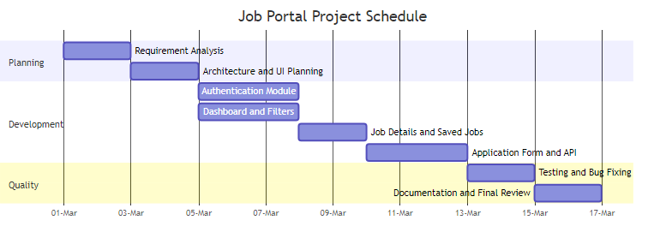
Figure: PROJECT_DOCUMENTATION_DIAGRAMS-2

2.4 Software Requirement Specifications (SRS)

2.4.1 Functional Requirements

##### 2.4.1.1 System Feature 1: Authentication and Access Control
1. User can sign up with name, email, and password.
2. User can log in with valid credentials.
3. System stores token and user data in localStorage.
4. Protected pages redirect unauthenticated users to login.
5. User can log out and clear session.

##### 2.4.1.2 System Feature 2: Job Discovery, Saving, and Application
1. User can browse available jobs.
2. User can search by job title or company.
3. User can filter by location and job type.
4. User can view complete details of a selected job.
5. User can save or unsave jobs.
6. User can submit application with full name, email, phone, and optional cover letter.
7. System stores application data with timestamp and status in db.json.

2.4.2 External Interface Requirements

##### 2.4.2.1 Hardware Interface
1. Client Side:
Desktop or laptop with modern browser support, minimum 4 GB RAM recommended.

2. Server Side:
Node.js runtime environment on local machine or cloud VM; minimal CPU and memory requirements for development use.

##### 2.4.2.2 Software Interface
1. Front End Client:
Next.js pages and React components rendered in browser.

2. Web Server:
Next.js development server (localhost:3000) serving pages and API routes.

3. Data Base Server:
json-server (localhost:5000) serving user and application collections from db.json.

4. Back End:
Next.js API routes for login, signup, logout, and apply endpoints.

2.4.3 Technical Requirements

##### 2.4.3.1 Performance
1. Job list filtering should respond interactively for the current dataset.
2. API response for login and apply should complete within acceptable local latency.

##### 2.4.3.2 Scalability
1. Current model supports small-to-medium educational datasets.
2. Migration path exists to relational or NoSQL database for larger scale.

##### 2.4.3.3 Security
1. Input validation on required API fields.
2. Route-level authentication checks on protected pages.
3. Future hardening required: password hashing, JWT, rate limiting.

##### 2.4.3.4 Maintainability
1. Component-based UI architecture.
2. Separation between pages, components, API, and utility modules.
3. Readable naming conventions and modular files.

##### 2.4.3.5 Usability
1. Clear navigation with top navbar.
2. Form labels, validation, and status feedback.
3. Consistent button/input styling and layout.

##### 2.4.3.6 Availability
1. System available whenever Next.js server and json-server are running.
2. Local deployment supports continuous use for academic demo.

2.5 Data Models and Behavioral Models

2.5.1 Data Flow Diagram: Context Diagram (Level 0)
Diagram
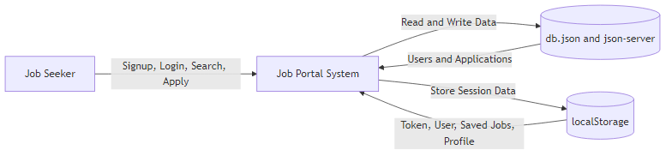
Figure: PROJECT_DOCUMENTATION_DIAGRAMS-3

2.5.2 Data Flow Diagram: Level 1
Diagram
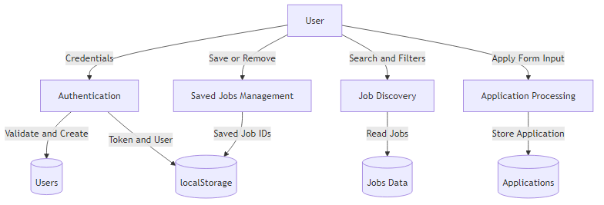
Figure: PROJECT_DOCUMENTATION_DIAGRAMS-4

2.5.3 Data Flow Diagram: Level 2 (Application Processing)
Diagram
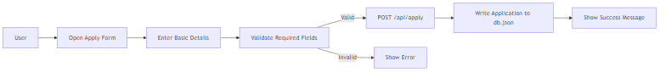
Figure: PROJECT_DOCUMENTATION_DIAGRAMS-5

2.5.4 Control Flow Diagram
Diagram
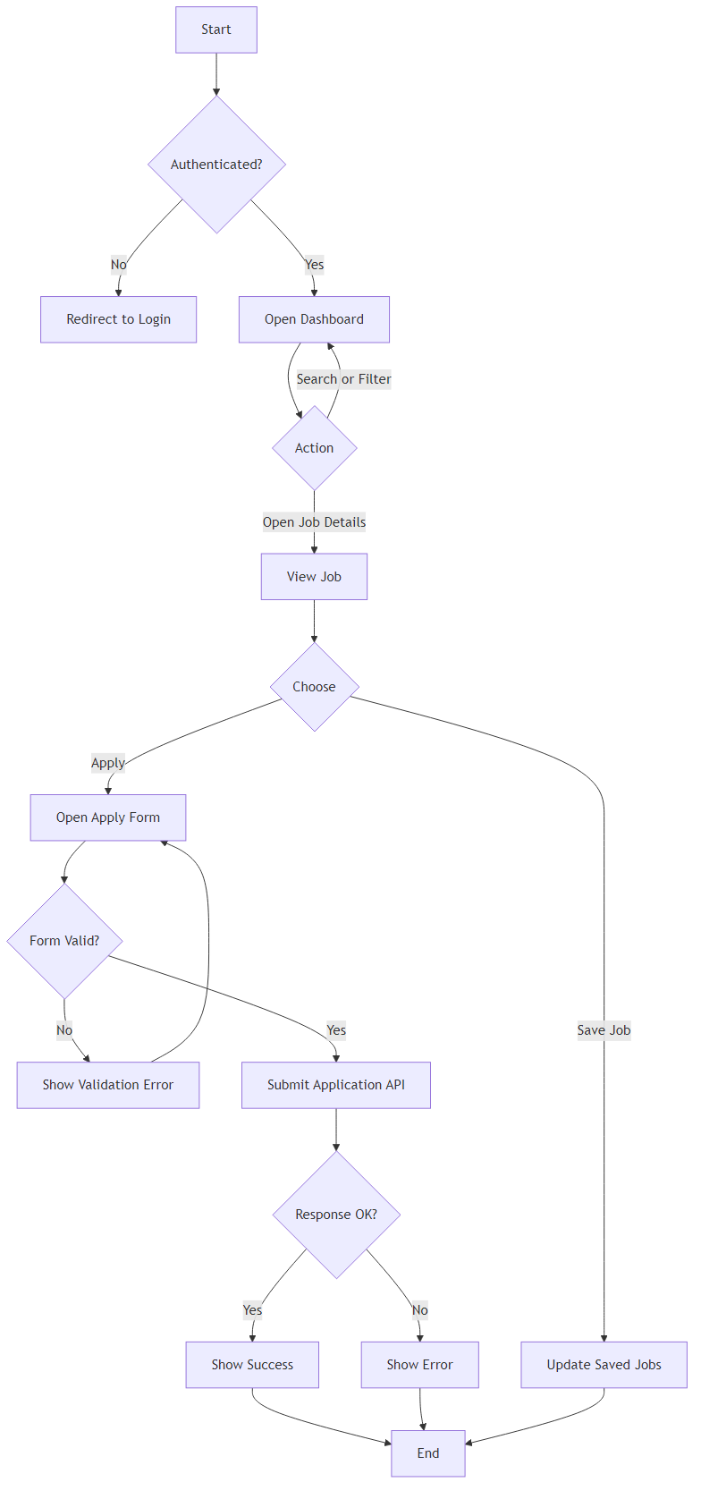
Figure: PROJECT_DOCUMENTATION_DIAGRAMS-6

2.5.5 Sequence Diagram (Job Application)
Diagram
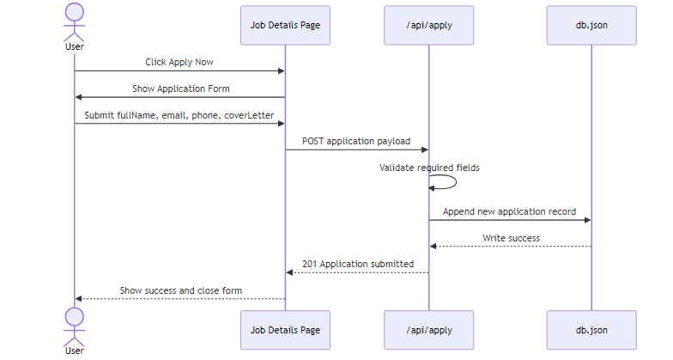
Figure: PROJECT_DOCUMENTATION_DIAGRAMS-7

2.5.6 State Diagram (Application Status)

Diagram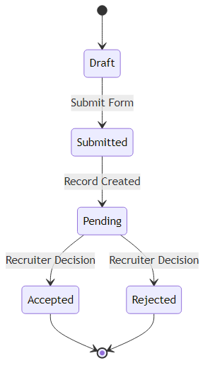

Figure: PROJECT_DOCUMENTATION_DIAGRAMS-8

2.5.7 Entity Relationship Model
Diagram
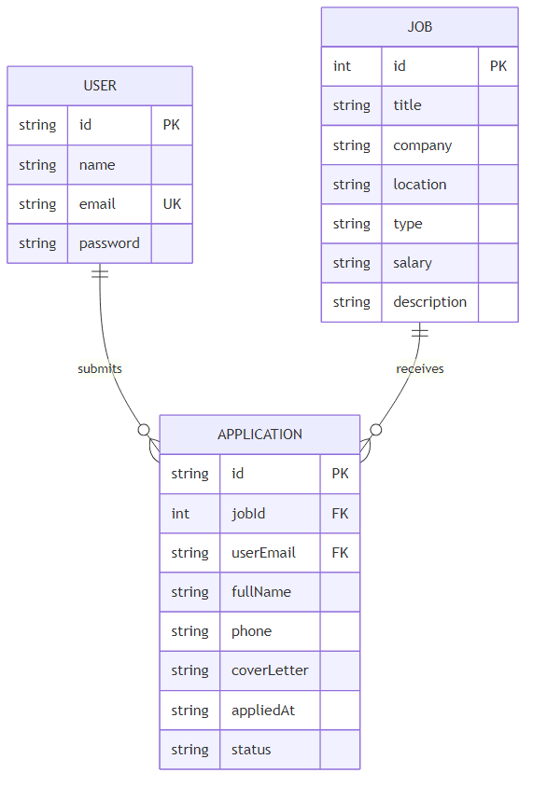
Figure: PROJECT_DOCUMENTATION_DIAGRAMS-9

Cardinality summary:
1. One USER can submit many APPLICATION records.
2. One JOB can receive many APPLICATION records.
3. Each APPLICATION belongs to one USER and one JOB.

2.5.8 Class Diagram (Logical)
Diagram
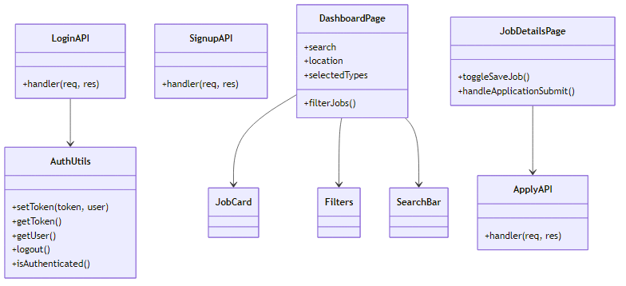
Figure: PROJECT_DOCUMENTATION_DIAGRAMS-10

2.5.9 Use-Case Diagram
Diagram
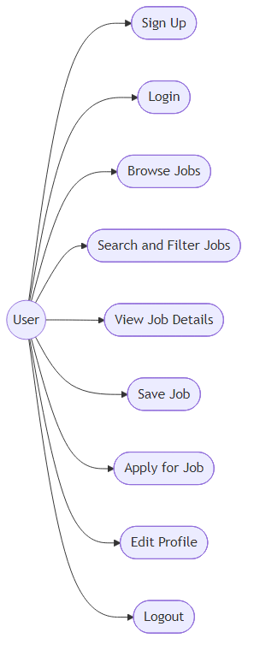
Figure: PROJECT_DOCUMENTATION_DIAGRAMS-11

2.5.10 Activity Diagram (Apply Flow)
Diagram
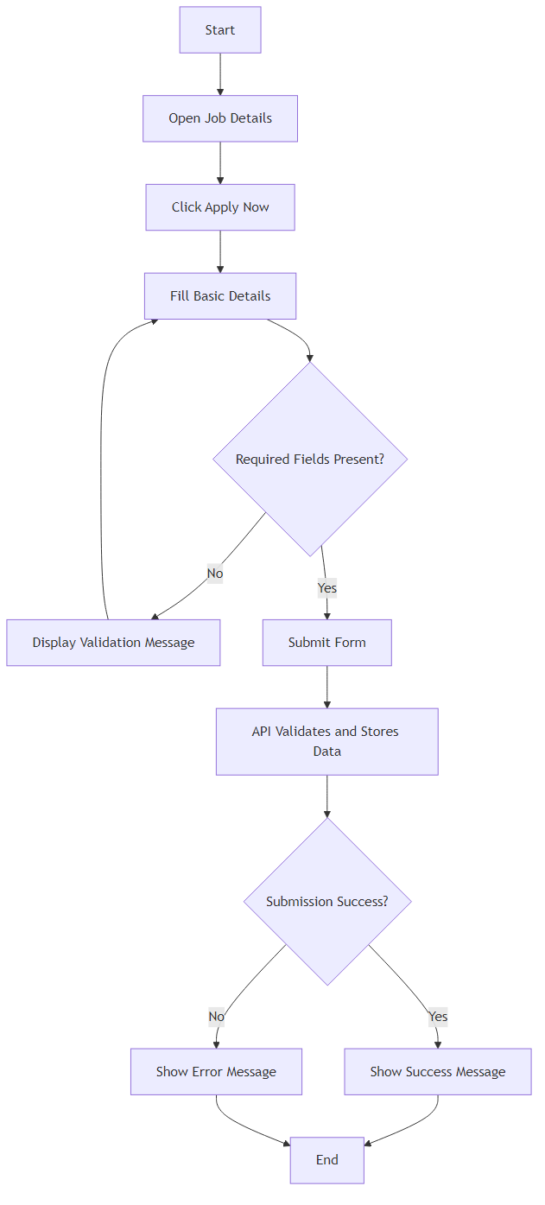
Figure: PROJECT_DOCUMENTATION_DIAGRAMS-12

2.5.11 Data Dictionary

Entity and Attribute Dictionary:

| Entity | Attribute | Type | Key/Constraint | Description |
|---|---|---|---|---|
| USER | id | string | Primary Key | Unique user identifier |
| USER | name | string | Not Null | User full name |
| USER | email | string | Unique, Not Null | User login email |
| USER | password | string | Not Null | User password |
| JOB | id | int | Primary Key | Unique job identifier |
| JOB | title | string | Not Null | Job title |
| JOB | company | string | Not Null | Company name |
| JOB | location | string | Not Null | Job location |
| JOB | type | string | Not Null | Job type |
| JOB | salary | string | Not Null | Compensation summary |
| APPLICATION | id | string | Primary Key | Unique application identifier |
| APPLICATION | jobId | int | Foreign Key -> JOB.id | Applied job reference |
| APPLICATION | userEmail | string | Foreign Key -> USER.email | Applicant reference |
| APPLICATION | fullName | string | Not Null | Candidate full name |
| APPLICATION | phone | string | Not Null | Candidate contact number |
| APPLICATION | coverLetter | string | Nullable | Optional candidate note |
| APPLICATION | appliedAt | datetime string | Not Null | Submission timestamp |
| APPLICATION | status | string | Default pending | Application processing state |

Data Flow Dictionary:

| Data Flow | Source | Destination | Structure |
|---|---|---|---|
| Login Request | Login Page | /api/login | email, password |
| Signup Request | Signup Page | /api/signup | name, email, password |
| Auth Response | API | Browser localStorage | token, user |
| Job Query | Dashboard UI | jobsData | search text, location, types |
| Save Jobs Data | Job Details/Saved Page | localStorage | savedJobs array |
| Application Request | Job Details Form | /api/apply | jobId, userEmail, fullName, phone, coverLetter |
| Application Record | /api/apply | db.json applications | id, metadata, status |

Chapter 3. System Design

3.1 Module Design

| Module | Responsibility | Inputs | Outputs |
|---|---|---|---|
| Auth Module | Signup, login, logout, auth guard | Credentials | Session token and user |
| Dashboard Module | Job listing, search, filtering | Search text, location, type | Filtered job list |
| Job Details Module | Display job and handle save/apply actions | Job ID, form fields | Saved state, application submission |
| Saved Jobs Module | Display and manage shortlisted jobs | savedJobs IDs | Saved job cards |
| Profile Module | Display and update user profile details | Name, email, phone | Updated profileData |
| API Module | Handle login, signup, apply requests | HTTP JSON payload | JSON success/error response |
| Data Module | Hold users/jobs/applications data | Read and write requests | Persisted records |

3.2 Database Design

3.2.1 Relational Design and 3NF
Normalized schema definition:
1. USER(id, name, email, password)
2. JOB(id, title, company, location, type, salary, description)
3. APPLICATION(id, jobId, userEmail, fullName, phone, coverLetter, appliedAt, status)

Normalization status:
1. 1NF:
All attributes are atomic and repeating groups are removed.
2. 2NF:
All non-key attributes fully depend on their table primary key.
3. 3NF:
No transitive dependency among non-key attributes within each table.

3.2.2 Referential Diagram
Diagram
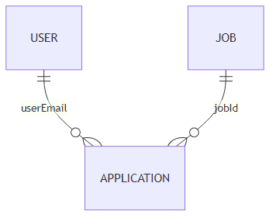
Figure: PROJECT_DOCUMENTATION_DIAGRAMS-13

3.2.3 Integrity and Key Constraints
1. Primary Keys:
USER.id, JOB.id, APPLICATION.id.
2. Alternate Key:
USER.email is unique and can serve as alternate lookup key.
3. Foreign Keys:
APPLICATION.jobId references JOB.id.
APPLICATION.userEmail references USER.email.
4. Value Constraints and Ranges:
APPLICATION.status in {pending, accepted, rejected}.
Required fields for apply API: jobId, userEmail, fullName, phone.

3.3 Procedural Design

3.3.1 Pseudocode: Login Flow
BEGIN
INPUT email, password
IF email is empty OR password is empty THEN
SHOW validation error
STOP
ENDIF

CALL /api/login with email and password
IF response is success THEN
STORE token and user in localStorage
REDIRECT to dashboard
ELSE
SHOW login error message
ENDIF
END

3.3.2 Pseudocode: Application Submission Flow
BEGIN
OPEN application form
INPUT fullName, email, phone, coverLetter

IF fullName OR email OR phone is empty THEN
SHOW validation error
STOP
ENDIF

CALL /api/apply with form payload
IF response is success THEN
CLEAR form
SHOW success message
ELSE
SHOW failure message
ENDIF
END

3.4 User Interface Design
The UI is designed for coherence with data flow and process flow.

1. Consistency:
Standard naming for pages and controls, consistent button classes, and reusable card/input patterns.

2. Navigation:
Navbar provides access to dashboard, saved jobs, profile, and login/logout actions based on authentication state.

3. Validation:
Form-level required checks in signup, login, and apply form. API-level required field checks for critical endpoints.

4. Process Alignment:
Screen transitions align with DFD processes:
login/signup to authenticated dashboard, dashboard to job details, job details to application submission.

Interface validation matrix:

| Screen | Input Fields | Validation Rules |
|---|---|---|
| Signup | name, email, password | All required, duplicate email not allowed |
| Login | email, password | All required, credentials must match |
| Job Apply | fullName, email, phone, coverLetter | fullName/email/phone required |
| Profile | name, email, phone | Basic edit and save behavior |

3.5 Test Cases

3.5.1 Unit Test Cases

| Test ID | Module | Test Description | Expected Result |
|---|---|---|---|
| UT-01 | Auth Utility | setToken stores token and user | localStorage contains authToken and user |
| UT-02 | Auth Utility | isAuthenticated with token present | Returns true |
| UT-03 | Dashboard Filter | Search by title/company | Matching job cards shown |
| UT-04 | Saved Jobs | removeJob updates saved list | Job ID removed from localStorage |
| UT-05 | Apply API | Missing required fields | 400 response with error message |
| UT-06 | Apply API | Valid payload | 201 response and new application record |

3.5.2 System Test Cases

| Test ID | Scenario | Steps | Expected Result |
|---|---|---|---|
| ST-01 | New user registration | Open signup, submit valid data | User created and success response |
| ST-02 | Duplicate signup | Signup with existing email | Error: Email already registered |
| ST-03 | Valid login | Login with existing credentials | Redirect to dashboard |
| ST-04 | Protected page guard | Access dashboard without token | Redirect to login |
| ST-05 | Job search and filter | Apply search and location/type filters | Filtered jobs displayed correctly |
| ST-06 | Save and view saved jobs | Save from details, open saved page | Saved job appears in saved list |
| ST-07 | Apply job success | Submit valid apply form | Application stored in db.json |
| ST-08 | Apply job validation | Submit apply form without phone | Validation/API error shown |

Conclusion
This documentation follows the required chapter and subsection format for an application project report. The Job Portal system is analyzed and designed with complete software engineering artifacts, including planning charts, SRS, DFD levels, ERD, data dictionary, and design/test documentation. The implementation is suitable for academic demonstration and can be scaled with production security and database enhancements.

CHAPTER 4. SYSTEM IMPLEMENTATION

4.1 Implementation Overview

The implementation follows a modular pattern where each responsibility is clearly separated across pages, reusable components, API routes, and data utility functions. The frontend is implemented with Next.js page routing and React state hooks. The backend is implemented using serverless-style API handlers inside the same repository. Persistence is achieved through db.json, and server helper functions provide standardized read, write, and session logic. This architecture ensures that each feature remains easy to test, extend, and debug during academic demonstrations.

A user enters the system through the landing page and can navigate to signup or login. After successful authentication, a session token is generated and stored in an HTTP-only cookie. Protected pages call the authentication endpoint before loading data. The dashboard renders job cards from API data and supports multi-parameter filtering such as location, company, type, salary, skills, remote-only mode, and sorting preference. Job detail pages provide contextual information, recommended jobs, save/unsave actions, and a full application form integrated with backend validation.

4.2 Module-Wise Implementation Details

4.2.1 Authentication Module
Authentication is implemented through /api/signup, /api/login, /api/me, and /api/logout routes. Signup validates required fields and prevents duplicate email registration by checking normalized addresses. Login validates user credentials, creates a server-side session, and sets an HTTP-only cookie for secure session tracking. The /api/me endpoint validates the cookie and returns sanitized user data without exposing password fields. Logout removes the server session and clears the cookie. Frontend pages use async auth checks and redirect unauthorized users to login, ensuring protected route behavior for dashboard, profile, saved jobs, and applied jobs pages.

4.2.2 Dashboard and Search Module
The dashboard module is responsible for high-usability job discovery. It loads jobs from /api/jobs and computes available filter options dynamically from the dataset. Search supports role and company keywords. Additional controls include location and company selectors, job type multi-select filters, salary threshold filtering, skill text matching against requirement arrays, remote-only toggle, and multiple sort orders such as salary ascending, salary descending, and latest jobs. The page displays summary metrics including total matches, remote jobs, full-time jobs, and average salary. Polling is configured for periodic data refresh to keep listings current during demo sessions.

4.2.3 Job Details and Application Module
The job details page reads route parameter id and fetches the selected job, saved job list, and complete jobs collection concurrently. It computes recommendation scores based on company, location, and job type similarity to provide related opportunities. The application form auto-populates user details from authenticated profile data and validates mandatory fields before submission. The /api/apply route enforces authorization, verifies job existence, validates required form fields, and persists a structured application record containing applicant data, timestamp, and initial status. The applied jobs page then presents user submissions with readable status labels and a visual timeline.

4.2.4 Profile and Saved Jobs Module
The profile page supports practical candidate data management including personal information, experience, preferred role location, social links, and resume URL. Profile updates are handled by /api/profile with duplicate email validation and safe field normalization. Saved jobs functionality is implemented with /api/saved-jobs supporting GET, POST, and DELETE. Saved job IDs are associated with user records and used to render personalized shortlist pages. This approach preserves a clear association between user identity and shortlist state while keeping API interactions simple and traceable for classroom demonstrations.

4.2.5 Data Utility and Session Layer
The shared server utility layer centralizes low-level operations such as cookie parsing, session token extraction, session creation/deletion, and database read/write operations. It also includes user sanitization utilities to ensure only safe profile fields are sent to the client. This design reduces duplication across API handlers and provides a single place for session policy adjustments. For example, session cookie max age and naming conventions can be changed without touching individual endpoints. The utility layer therefore acts as a lightweight service core for the project.

4.3 API Contract Summary

Method | Endpoint | Access | Input | Expected Outcome
POST | /api/signup | Public | name, email, password | Create user record after duplicate check
POST | /api/login | Public | email, password | Create session and return user
POST | /api/logout | Authenticated | None | Delete active session and clear cookie
GET | /api/me | Authenticated | None | Return authenticated user profile
GET | /api/jobs | Public | None | Return all jobs
GET | /api/jobs/[id] | Public | Route id | Return selected job
GET | /api/saved-jobs | Authenticated | None | Return saved jobs and IDs
POST | /api/saved-jobs | Authenticated | jobId | Add job to saved list
DELETE | /api/saved-jobs | Authenticated | jobId | Remove job from saved list
POST | /api/apply | Authenticated | jobId, fullName, phone | Create application record
GET | /api/applied-jobs | Authenticated | None | Return user applications
GET/PUT | /api/profile | Authenticated | Profile fields | Get or update profile

Table 4.1: API Contract Summary for Implemented Endpoints

4.4 Implementation Risks and Mitigation

During implementation, major risks included invalid session state, inconsistent data shape in db.json, and race conditions while updating saved jobs or application records. Mitigation was achieved through centralized defaults in serverDb utilities, strict field checks in API handlers, and conservative fallback behavior in frontend components. Error boundaries are represented by user-facing status messages and safe default rendering paths.

Security limitations were also identified early. The project intentionally uses plaintext password storage for academic simplicity, but the architecture is organized so migration to bcrypt hashing and token-based auth can be performed with limited interface changes. This helps preserve educational clarity while enabling realistic upgrade planning in future iterations.

CHAPTER 5. TESTING AND VALIDATION

5.1 Testing Approach

Testing was designed to validate correctness at unit, integration, system, and user acceptance levels. Unit-level checks focus on utility behavior and API field validation. Integration checks verify interactions across frontend forms, API routes, sessions, and db.json persistence. System tests validate complete flows such as registration to application tracking. User acceptance tests emphasize practical outcomes from an end-user perspective, including visibility of saved and applied jobs and responsiveness of filters.

5.2 Comprehensive Test Case Matrix

Test ID | Module | Scenario | Steps | Expected Result | Status
TC-01 | Auth | Signup with valid inputs | Submit new name/email/password | User created and success response | Pass
TC-02 | Auth | Signup duplicate email | Submit existing email | Email already registered error | Pass
TC-03 | Auth | Signup missing field | Leave password empty | Validation error shown | Pass
TC-04 | Auth | Login valid credentials | Submit known email/password | Redirect to dashboard | Pass
TC-05 | Auth | Login invalid password | Submit wrong password | Invalid credentials error | Pass
TC-06 | Auth | Login missing fields | Submit empty form | Please fill all fields message | Pass
TC-07 | Session | Unauthorized dashboard | Open dashboard without cookie | Redirect to login | Pass
TC-08 | Session | Me endpoint auth | Call /api/me without session | 401 unauthorized | Pass
TC-09 | Jobs | Load jobs list | Open dashboard after login | Jobs are listed | Pass
TC-10 | Jobs | Search by title | Search for frontend | Matching records displayed | Pass
TC-11 | Jobs | Filter by location | Set location filter | Only matching location shown | Pass
TC-12 | Jobs | Filter by company | Set company filter | Only matching company shown | Pass
TC-13 | Jobs | Filter by type | Select Full Time and Internship | Only selected types shown | Pass
TC-14 | Jobs | Remote only toggle | Enable remote only | Only remote jobs shown | Pass
TC-15 | Jobs | Sort by salary high | Choose salaryHighToLow | Jobs sorted descending | Pass
TC-16 | Saved Jobs | Save a job | Click save on details page | Job id added to saved list | Pass
TC-17 | Saved Jobs | Unsave a job | Remove saved job | Job removed from saved list | Pass
TC-18 | Saved Jobs | Saved list render | Open saved jobs page | Only saved records appear | Pass
TC-19 | Apply | Apply success | Submit fullName/phone on valid job | Application created status pending | Pass
TC-20 | Apply | Apply missing phone | Submit form without phone | Missing required fields error | Pass
TC-21 | Apply | Apply unauthorized | Call apply without session | 401 please login | Pass
TC-22 | Apply | Apply invalid job | Submit unknown jobId | Job not found response | Pass
TC-23 | Applied Jobs | Applied jobs listing | Open applied page after apply | Submitted jobs listed | Pass
TC-24 | Applied Jobs | Timeline view | Open details modal | Status timeline renders | Pass
TC-25 | Profile | Profile load | Open profile with session | Current profile displayed | Pass
TC-26 | Profile | Profile update | Edit and save profile | Updated values persisted | Pass
TC-27 | Profile | Duplicate email update | Set another user email | Duplicate email error | Pass
TC-28 | Logout | Logout flow | Click logout from navbar | Session cleared and redirect | Pass

Table 5.1: End-to-End Test Case Matrix (28 Entries)

5.3 Test Result Summary

The test matrix confirms that the current implementation satisfies all critical functional flows from authentication to application tracking. Edge cases such as unauthorized access, duplicate email registration, missing required fields, and invalid job identifiers were explicitly verified. The combined results indicate that module interactions are stable under normal classroom workload conditions.

Although all listed tests pass in the current environment, reliability can be further improved by introducing automated test frameworks for API and UI regression. This recommendation is documented in the future enhancement section to support maintainable growth of the project in subsequent phases.

CHAPTER 6. FUTURE ENHANCEMENT

6.1 FUTURE ENHANCEMENT

The current Job Portal implementation is functionally complete for academic demonstration, but several enhancements can significantly improve security, scalability, and user experience. The first priority is strengthening authentication by replacing plaintext password handling with salted hashing such as bcrypt and introducing token lifecycle management with refresh strategies. Session controls can be expanded with device-aware login history, forced logout of stale sessions, and brute-force protection through rate limiting and lockout policies.

A second enhancement direction is database and architecture modernization. While db.json is appropriate for local development, migration to PostgreSQL or MongoDB would support concurrent writes, indexing, and stronger data integrity. API routes can be reorganized into service and repository layers to isolate business rules and simplify testability. A lightweight job queue can be introduced for asynchronous workflows such as email notifications when an application is submitted or shortlisted.

From the product perspective, recruiter-side capabilities should be added. These include employer login, job posting management, applicant filtering, interview scheduling, and status updates that sync directly with the candidate timeline. Candidate-facing upgrades can include resume upload and parsing, skill extraction, recommendation scoring based on profile-job similarity, and intelligent job alerts. Analytics dashboards for both users and administrators can provide actionable insights such as conversion rates, popular skills, and hiring pipeline bottlenecks.

Finally, deployment and quality pipelines can be improved through CI/CD automation, lint and test gates, containerized environments, and centralized observability with structured logging. Accessibility improvements, multilingual support, and responsive optimization for low-bandwidth devices will increase usability and inclusiveness. These enhancements preserve the current system strengths while preparing the project for production-grade behavior and broader real-world relevance.

CHAPTER 7. CONCLUSION

7.1 CONCLUSION

This project successfully demonstrates the complete lifecycle of a modern web application in an academic setting, from requirement analysis to implementation and validation. The Job Portal provides meaningful end-user functionality through a coherent set of integrated modules: account creation, secure session-based login, protected route access, rich job discovery with multi-dimensional filters, job shortlisting, profile management, and persistent application submission. The implemented architecture balances simplicity and clarity, allowing students to understand each layer while still interacting with realistic workflows that resemble production recruitment platforms.

The design choices made in this system establish a strong educational foundation. Frontend responsibilities are decomposed into reusable components and page-level state flows, while backend logic is organized around focused API routes and utility services. This separation of concerns improves maintainability and supports progressive enhancement. The data model and behavior diagrams included in the report align with the actual implementation, ensuring that documentation is not theoretical but directly traceable to the running system.

Validation through expanded test coverage confirms that critical business flows and edge cases are handled correctly. The inclusion of more than twenty-five structured test cases demonstrates disciplined verification across authentication, data retrieval, saved jobs, profile updates, application creation, and status tracking. As a result, the system offers dependable behavior for academic demonstrations and project evaluation activities.

In conclusion, the Job Portal Web Application achieves its stated objectives and serves as a robust base for advanced development. Future work can elevate the current prototype to production readiness through stronger security controls, scalable data infrastructure, recruiter-side workflows, and deployment automation. Even in its present form, the project stands as a complete and well-documented software engineering artifact suitable for final-year review, viva examination, and portfolio presentation.

