**Figures**

**Figure 1: Alignment of *MIZ1* Gene Homologs Post-Trimming**

This alignment shows the homologs of the *MIZ1* gene after trimming poorly aligned sequences. The black box highlights species within the *Triticum* genus, displaying a similar alignment pattern. Similarly, the red box highlights species from the *Arabidopsis* genus, which also exhibit a consistent alignment pattern. Different colors in the sequence represent conserved and variable regions across the aligned species.

**Figure 2: Phylogenetic tree of the *MIZ1* gene across Embryophytes**

This phylogenetic tree represents the *MIZ1* gene across various species of embryophytes. The tree uses different colors to denote major plant groups: red for Angiosperms, blue for Gymnosperms, light blue for Ferns, yellow for Lycophytes, green for Mosses, and grey for Hornworts. The visual structure of the tree illustrates evolutionary relationships and lineage diversifications within these plant groups.

**Figure 3: Phylogenetic tree of the *MIZ1* gene, displaying three paralogs and their evolutionary relationships across plant lineages.** The phylogenetic tree illustrates three distinct paralogs of the *MIZ1* gene, with the first paralog showing the evolutionary progression of land plants from Bryophytes to Angiosperms. The second and third paralogs highlight missing phyla within the tree. The different plant groups—Angiosperms, Gymnosperms, Ferns, Lycophytes, Mosses, and Hornworts—are color-coded for visual clarity, emphasizing the evolutionary relationships between these groups.

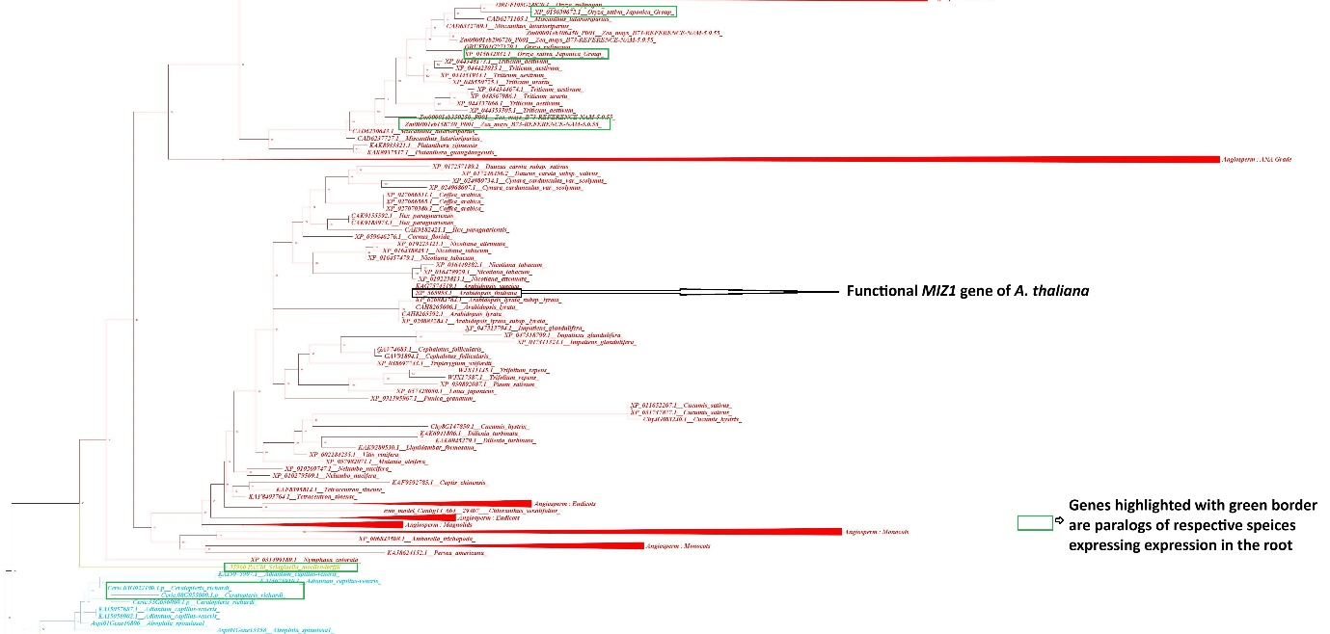

**Figure 4: Phylogenetic tree of the third paralog of the *MIZ1* gene, including functional *MIZ1* of *A. thaliana* and root-expressing paralogs in other species.**The phylogenetic tree shows the positioning of the functional *MIZ1* gene of *Arabidopsis thaliana* within the third paralog. The green-highlighted boxes indicate paralogs in different species that exhibit gene expression in the roots. This figure includes species from various plant lineages and demonstrates the evolutionary relationships among these *MIZ1* paralogs

**Figure 5: Synteny analysis of the *MIZ1* gene and associated conserved genes across different plant species.** The heatmap represents the presence or absence of *MIZ1* and its associated conserved genes, such as Glycosyltransferase family 61, Heat stress transcription factor B-3, and ATP-binding cassette A1, across various plant species. Each gray box indicates the presence of the gene in the corresponding species, while the white gaps represent the absence of the gene. The species listed include a range from non-vascular plants like *Selaginella moellendorffii* to angiosperms

**Figure 6: Phylogenetic Tree Representing *MIZ1* Gene Duplication**

This phylogenetic tree illustrates the second gene duplication event in liverworts, with the *MIZ1* gene subsequently evolving across other plant phyla. The spheres represent points of gene duplication, with different color branches indicating the respective clades for the second (red) and third (purple) paralogs, and their evolutionary distribution across various plant groups

**Figure 7: Phylogenetic Tree Representing the Second Duplication Event in Hornwort**

This phylogenetic tree shows the second duplication of the *MIZ1* gene in hornwort, with subsequent evolutionary developments across various phyla. It also highlights the loss of a few phyla during the evolutionary process. The spheres mark gene duplication points, with branches colored to indicate the second paralog (red) and the third paralog (purple).

**Figure 8: Phylogenetic Tree Representing the Second Duplication Event in Liverwort or Moss**

This phylogenetic tree illustrates the second gene duplication of the *MIZ1* gene, which likely occurred in either liverwort or moss, with the gene subsequently evolving across other phyla. The spheres indicate points of gene duplication, and the tree is color-coded, with the second paralog shown in red and the third paralog in purple

**Figure 9: Phylogenetic Tree Representing the Second Duplication in Liverwort or Moss.**

This phylogenetic tree depicts the second duplication of the *MIZ1* gene, occurring in either liverwort or moss, and shows the evolutionary trajectory where the gene is lost in the lycophyte group. The spheres mark points of gene duplication, with the second paralog highlighted in red and the third paralog in purple.

**Figure 10: Expression Rank of the First Paralog of *MIZ1* Gene Across Various Species.** This figure displays the expression patterns of the first paralog of the *MIZ1* gene across multiple species. The heatmap indicates the highest expression in blue, with cells outlined in red marking root expression under abiotic stress conditions. The species analyzed include a range of plant groups, showing different levels of gene expression in various plant parts, including roots, leaves, and reproductive structures.

**Figure 11: Normalized Gene Expression of the First *MIZ1* gene Paralog in Various Plant Tissues and Organs**

This bar graph illustrates the normalized gene expression levels of the first paralog of the *MIZ1* gene across different plant tissues and organs. The highest expression is observed in the root, followed by the leaf, flower, and stem. Other tissues, such as the fruit, endosperm, shoot system, archegonia, female reproductive part, sporophyte, and male reproductive part, show progressively lower levels of expression.

Figure 12: **Normalized Gene Expression Levels of the First *MIZ1* Paralog Across Various Plant Tissues and Organs in Flowering and Non-Flowering Plants**

This bar graph shows the normalized gene expression levels of the first *MIZ1* paralog across different plant tissues and organs, comparing flowering (green) and non-flowering plants (orange). The highest expression levels are observed in the root tissues of non-flowering plants while flowering plants show higher expression in the flower and root.

Figure 13: **Expression Rank of the Second *MIZ1* Paralog Across Various Plant Species and Tissues**

This heatmap shows the expression levels of the second *MIZ1* paralog across different species and plant tissues. The highest expression is observed in tissues such as roots, leaves, and reproductive parts, with red-bordered cells indicating root expression under abiotic stress conditions. The expression is ranked from highest to least, with varying levels across different tissues like stems, seeds, and flowers.

Figure 14: **Normalized Gene Expression in Second Paralog Across Different Plant Tissues and Organs**

This bar chart displays the normalized gene expression levels of the second *MIZ1* paralog across various plant tissues and organs. The highest expression is observed in the flower, followed by the root and leaf, while lower expression is noted in tissues such as seeds, fruit, and sporophytes at 24 hours.

Figure 15: **Normalized Gene Expression Levels Across Second Paralog in Flowering and Non-flowering Plants**

This bar chart illustrates the normalized gene expression levels of the second *MIZ1* paralog across different plant tissues and organs, distinguishing between flowering and non-flowering plants. The chart shows significant expression in the roots and flower for flowering plants, while non-flowering plants exhibit higher expression in the root, leaf, and sporophyte at different time intervals.

Figure 16: : **Expression Rank of the Second *MIZ1* Paralog Across Various Plant Species and Tissues**

This heatmap shows the expression levels of the third paralog of the *MIZ1* gene across various plant species, with root expression highlighted in red when observed under abiotic stress conditions. The chart categorizes expression levels from the highest to the least, illustrating how the *MIZ1* gene is expressed in different plant tissues such as roots, stems, leaves, and reproductive parts.

Figure 17: **Normalized Gene Expression in the Third Paralog Across Plant Tissues and Organs**

This bar graph illustrates the normalized expression levels of the third paralog of the *MIZ1* gene across various plant tissues and organs. The highest expression is observed in the root, followed by the leaf, flower, and stem, with lower expression in reproductive parts, seeds, and endosperm.

Figure 18: **Normalized Gene Expression Levels Across Third Paralog in Flowering and Non-Flowering Plants**

This bar graph depicts the normalized expression levels of the third paralog of the *MIZ1* gene across various tissues and organs in both flowering and non-flowering plants. The data show higher expression in roots and leaves in non-flowering and while flowering plants exhibit higher expression in the root, flower..