Machine Learning with Enron Dataset

Enron company which touched new heights in bussiness in the year 2000,went bankrupt in the year 2002.Enron scandal is one of the biggest one in the US history.Enron dataset contains financial features and email details of the enron employees.My task is to identify POI's in the dataset.The dataset is highly imbalanced as the number of POI's is only 18 aganist the total number of employees 146 in the dataset.

Exploraroty Data Analysis:
Number of Data Points:146
Number of POI's:18
Number of non-POI's:128
Number of features originally present in the dataset:20
Number of New features created:4
Number of New features used in final analysis:2
Feature with the highest number of missing values:loan_advances

I have filled missing values NaN's with 0's.I tried filling with mean,median,mode and most frquent strategy from Imputer class but model performance was poor with precision below 0.2 and recall around 0.1

I have created correlation matrix as seaborn heatmap.This helps me to look in to correlated features to be used in final analysis.

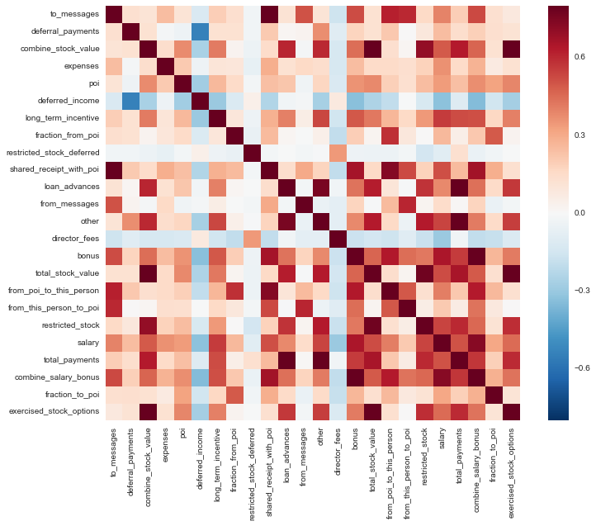

Outlier Investigation:
Biggest outlier in the dataset TOTAL which is a spreadsheet quirk is removed from the dataset.

Feature Engineering:

Rationale behind creating new features:

1.combine_salary_bonus:
salary and bonus features are correlated so they are combined to form a new feature combine_salary_bonus.

combine_salary_bonus=(salary+bonus)/2

2.combine_stock_value:
exercised_stock_options and total_stock_value are correlated so they are combined to form a new feature combine_stock_value.

combine_stock_value=(exercised_stock_options+total_stock_value)/2

3.fraction_to_poi:
If a person sends most of the messages to POI,then he can be considered as a potential POI.
fraction_to_poi is derived from the number of e-mails sent to poi from the total number of e-mails received.If the fraction is high,then most probably this person will be a POI.

fraction_to_poi=from_this_person_to_poi/from_messages

4.fraction_from_poi:
fraction_from_poi is derived from the number of e-mails received from poi from the total number of e-mails sent.
fraction_from_poi=from_poi_to_this_person/to_messages

I used SelectKBest to find the scores of all features.I have tabulated the results below.

Features | K-Scores
exercised_stock_options | 25.0975
total_stock_value | 24.4670
combine_stock_value | 23.8220
combine_salary_bonus | 22.7503
bonus | 21.0600
salary | 18.5750
fraction_to_poi | 16.6417
deferred_income | 11.5955
long_term_incentive | 10.0724
restricted_stock | 9.3467
total_payments | 8.8667
shared_receipt_with_poi | 8.7465
loan_advances | 7.2427
expenses | 6.2342
from_poi_to_this_person | 5.3449
other | 4.2050
fraction_from_poi | 3.2108
from_this_person_to_poi | 2.4265
director_fees | 2.1077
to_messages | 1.6988
deferral_payments | 0.2171
from_messages | 0.1642
restricted_stock_deferred | 0.0650

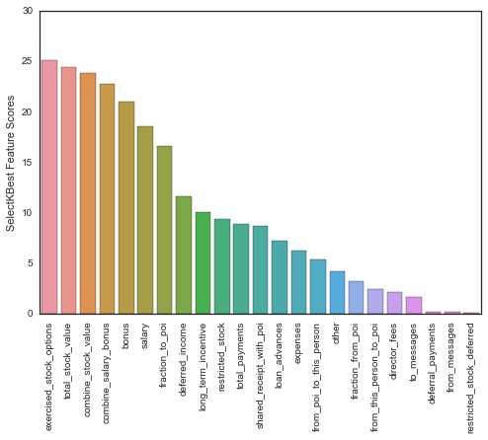
Let us look at the precision and recall before and after engineering new features.
 | Precision | Recall
Before | 0.3673 | 0.2290
After using all new features | 0.4365 | 0.3005
Using only fraction_to_poi,combine_salary_bonus,combine_stock_value | 0.4420 | 0.3165
Using only combine_salary_bonus,combine_stock_value | 0.4828 | 0.3010
Using only combine_stock_value | 0.5421 | 0.3285
Using only combine_salary_bonus | 0.4561 | 0.2805
Using only combine_stock_value,fraction_to_poi | 0.4163 | 0.2910
Using only combine_salary_bonus,fraction_to_poi | 0.4537 | 0.2670

This confirms that the new features added to the model has improved its performance.

Pipelines:
Feature rescaling,pca and feature selection using SelectKBest is done using pipelines.This prevents information leakage.Pipelien object is sent to GridSearchCv object for finding best estimators.
SVM and K Means clustering algorithm performance varies with respect to scaled features.

Algorithm Selection and Parameter Tuning:

I have tried the following algorithm and parameters are tuned to achieve better results.GridSearchcv is used to pick best parameters for the classfiers.Tuning parameters is an important aspect to achieve better prediction results.

Algorithm | Parameters Tuned
Naive Bayes | None
DecisionTreeClassifier | max_depth,max_leaf_nodes,min_samples_leaf,min_samples_split
AdaBoostClassifier | Parameters of DT with n_estimators and learning_rate
K Nearest Neighbours | n_neighbours
SVM | C,gamma

Evaluation Metrics:

Since accuracy is not a correct metric for evaluating imbalanced data,we will look at results got from running tester.py script on the classifier file.
Precision is selectivity,it shows the ability of the model to select POI from non-POI.
Recall is sensitivity,it shows the ability of the model that the selected person is Real POI.

Precision=TP/(TP+FP)
Recall=TP/(TP+FN)
F1-score=2.(Precison*Recall/Precision+Recall)

where
TP-True Positive
FP-False Positive
FN-False Negative

Algorithm | Precision | Recall | F1-score
Naive Bayes | 0.3943 | 0.3505 | 0.3711
DecisionTreeClassifier | 0.3705 | 0.2245 | 0.2796
AdaBoostClassifier with DecisionTreeClassifier | 0.4166 | 0.2785 | 0.3383
KNearestNeighbours | 0.3372 | 0.1895 | 0.2426
SVM | 0.2929 | 0.7650 | 0.4237
RandomForestClassifier | 0.4710 | 0.1260 | 0.1988
AdaBoostClassifier with RandomForestClassifier | 0.4032 | 0.2030 | 0.2700
Gradient Tree Boosting | 0.3929 | 0.2770 | 0.3249

I have chosen GaussianNB for final analysis as its performance is better than other classfiers.

Cross-Validation technique:

I have used train_test_split() to split data in to training and testing data.This is important to prevent overfitting of models since the same data used for training and testing will predict badly on unforseen data.I have chosen StratifiedShuffleSplit as cross validation technique to get details about evaluation metrics like precision,recall and F1-score.StratifiedShuffleSplit is chosen as this an imbalanced dataset. StratifiedShuffleSplit creates splits by preserving the same percentage for each target class as in the complete set. StratifiedShuffleSplit performs the process of shuffling and splitting for as many times as the argument n_splits. Each fold will be randomly shuffled and split into test and train groups, keeping the label ratio constant.

