­­­­

CLOUD NATIVE DEVELOPMENT-PROJECT CASE STUDY

by

JAYASHREE T (JT00740380@TechMahindra.com)

Node -JS pipeline

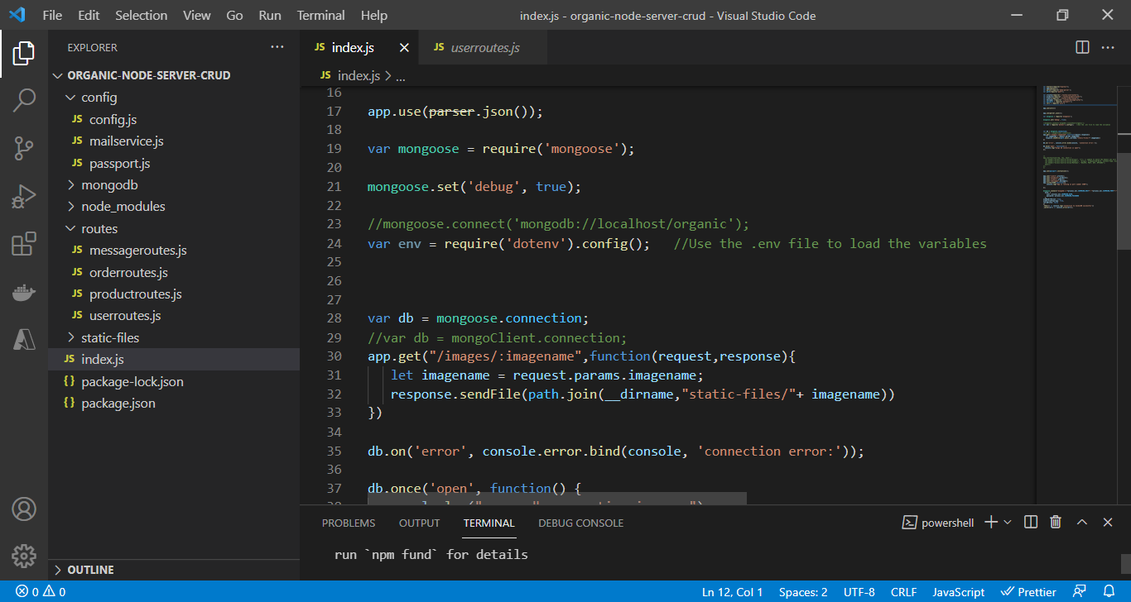

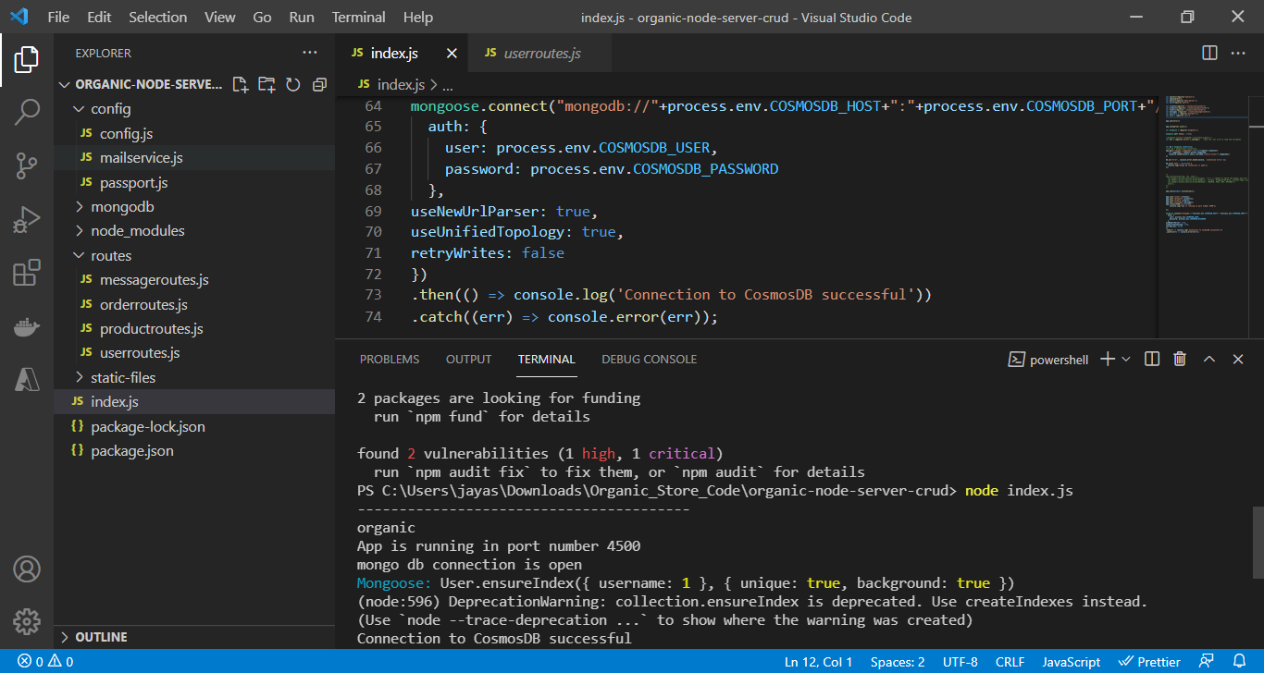

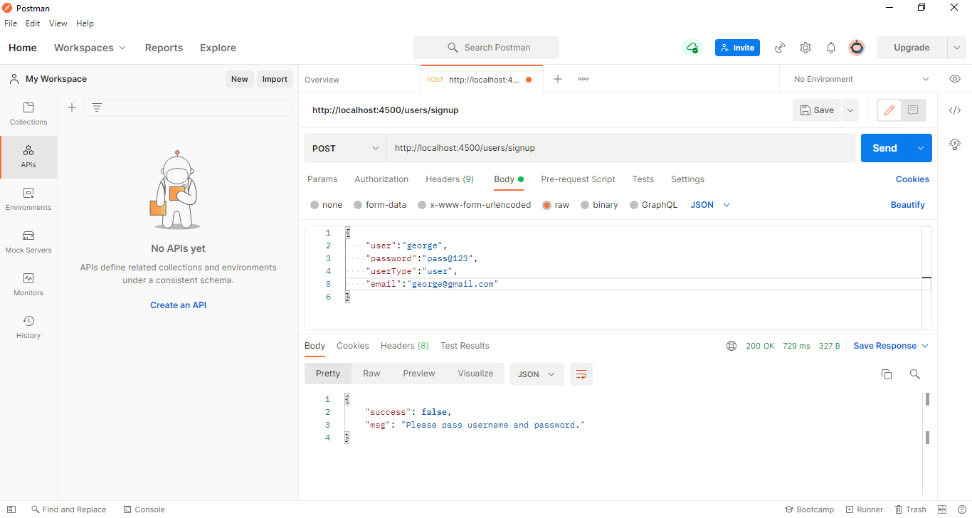

Agent creation

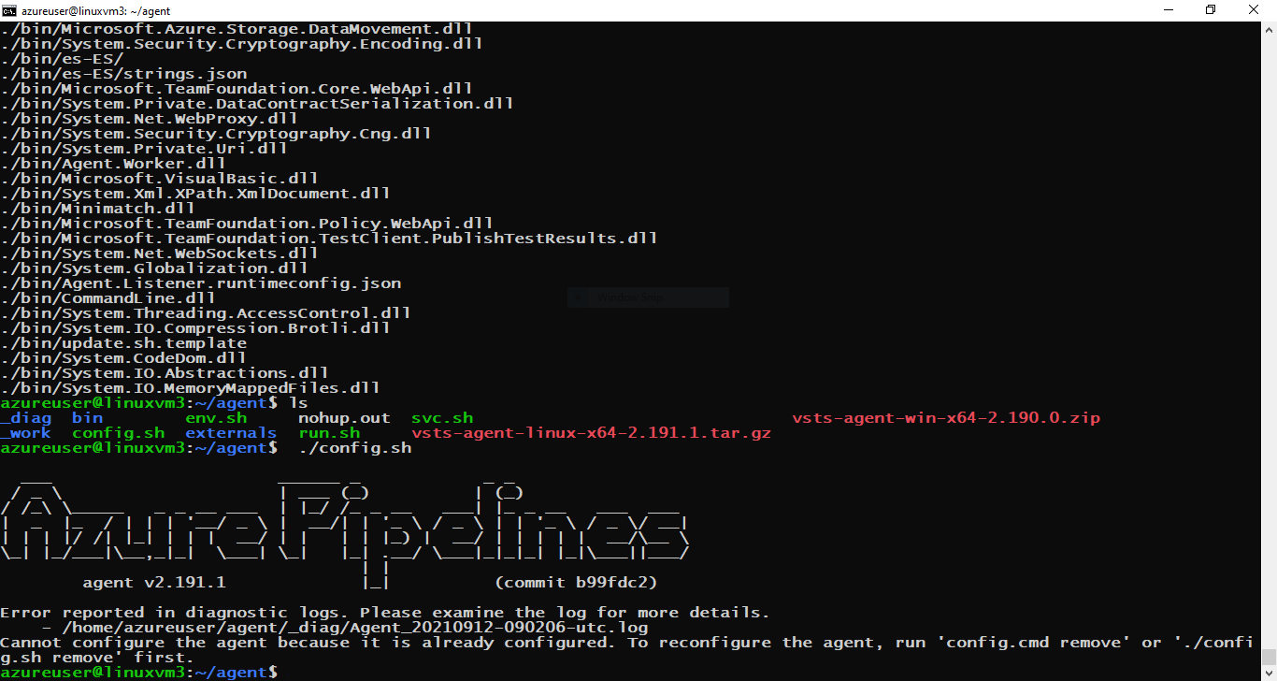

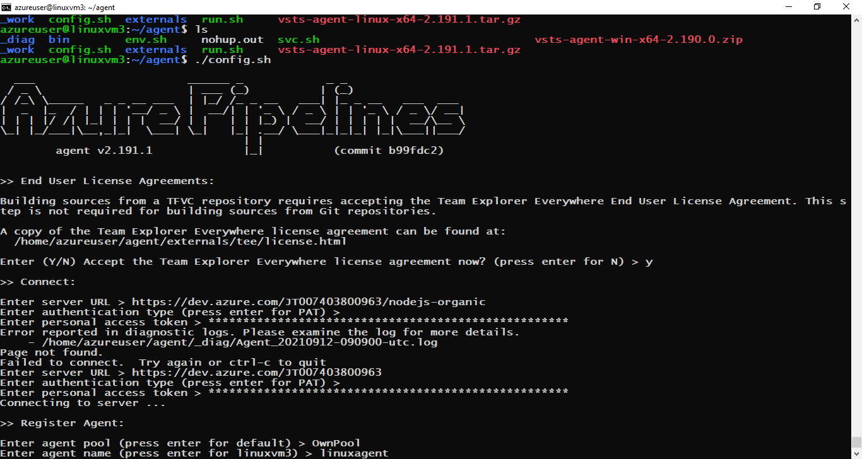

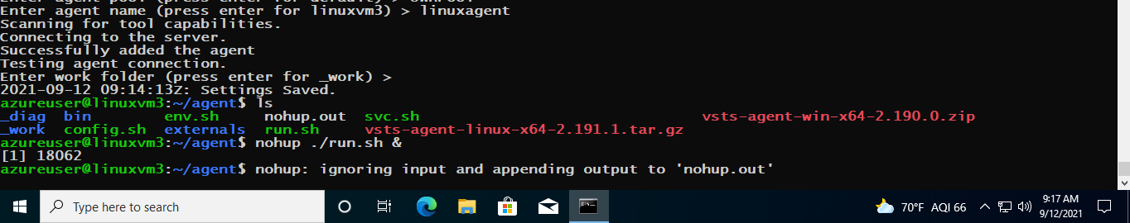

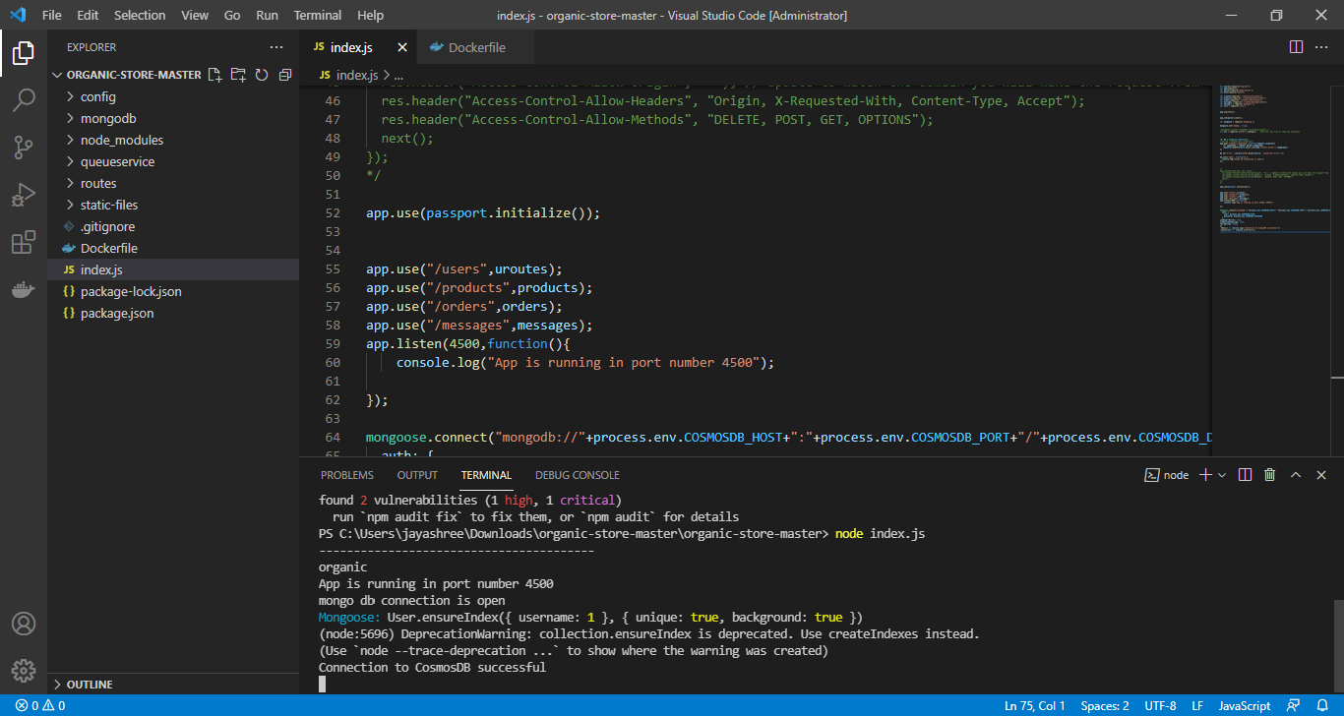

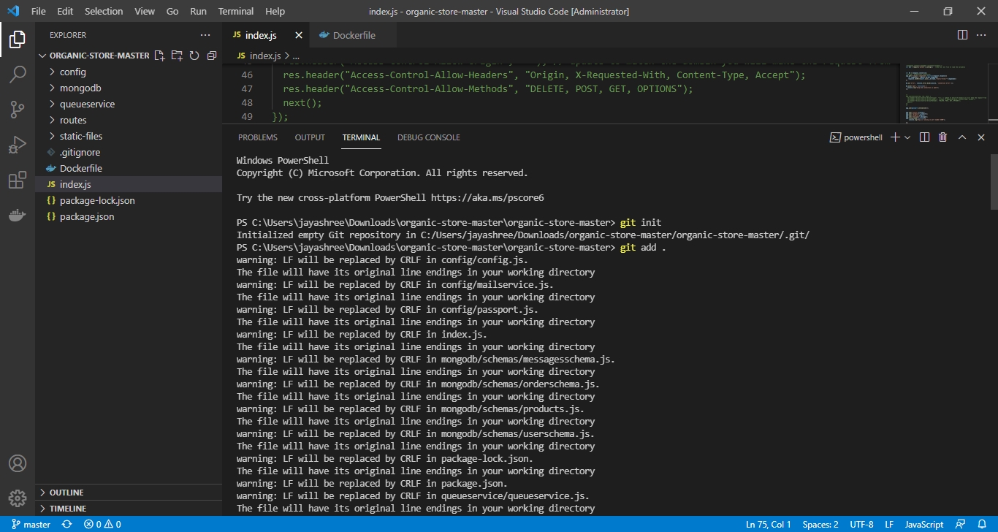

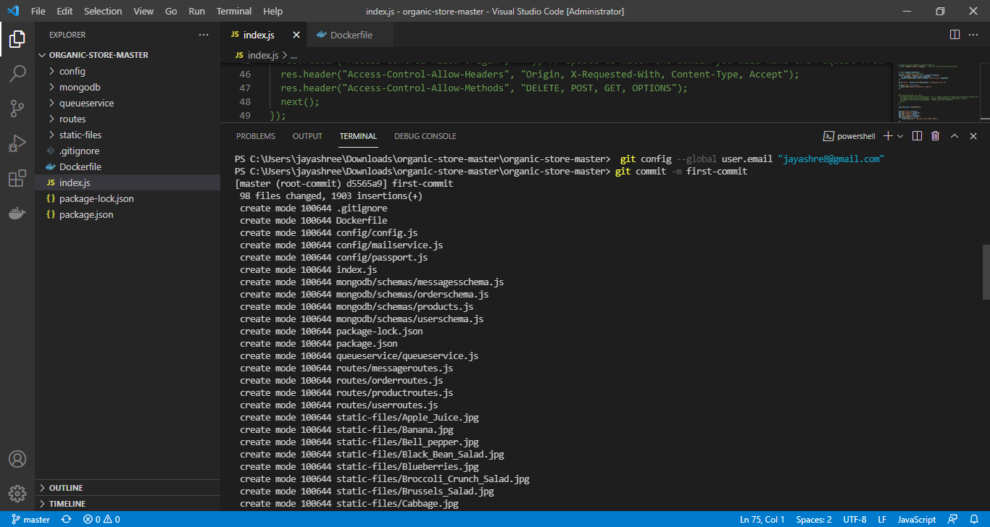

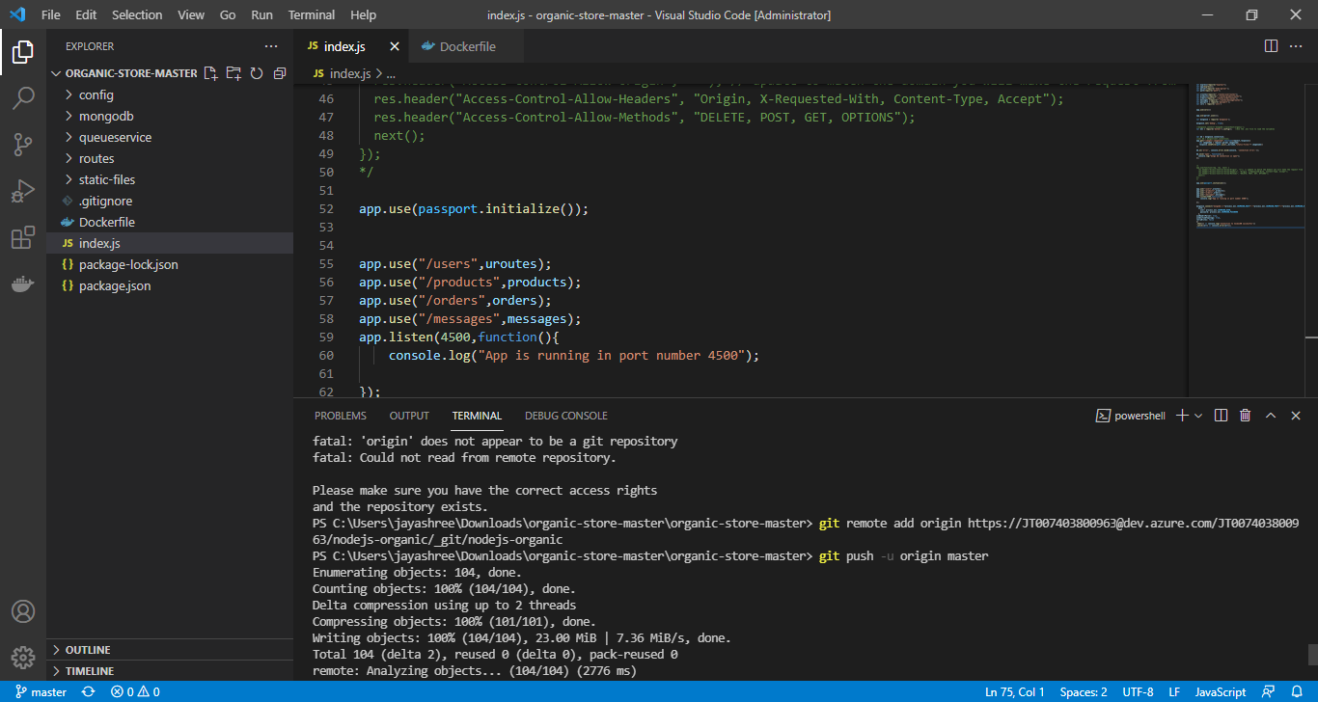

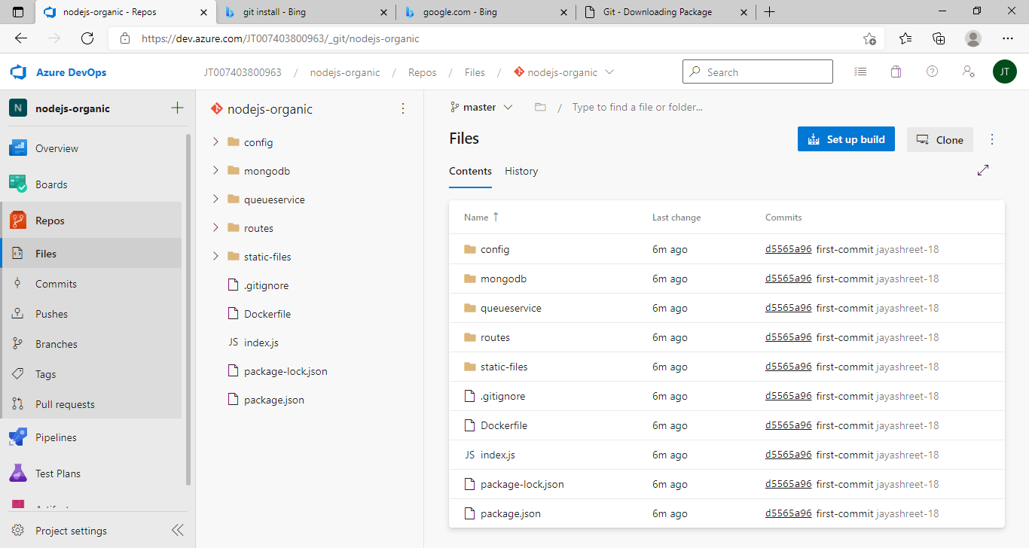

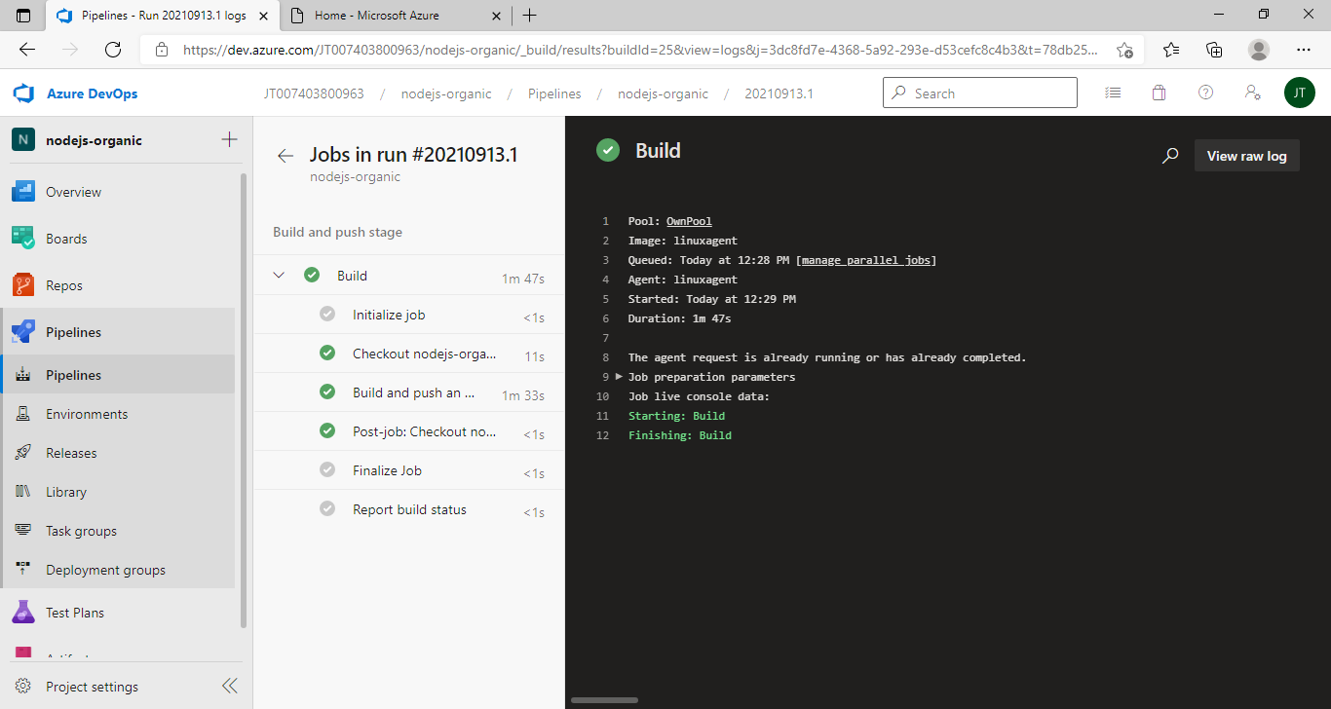

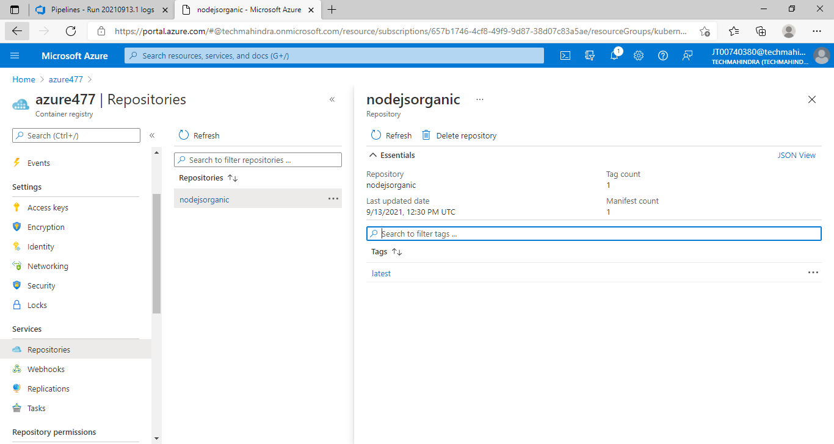

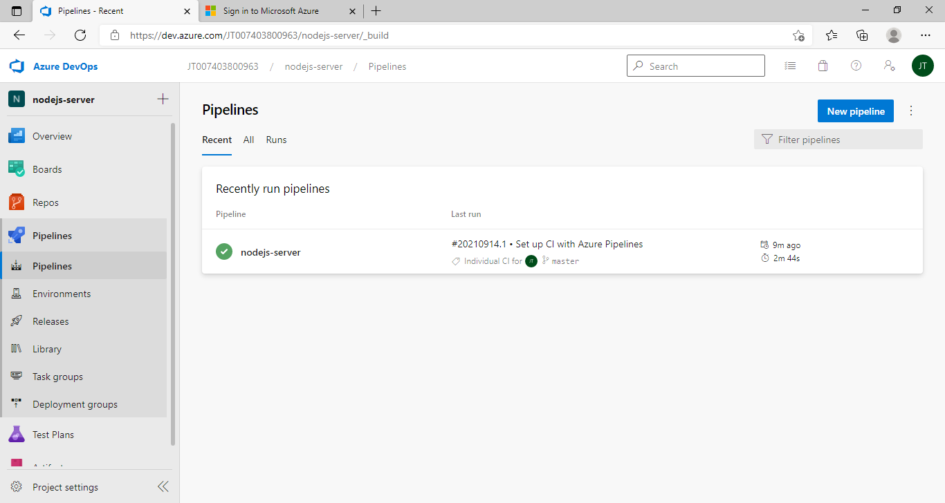

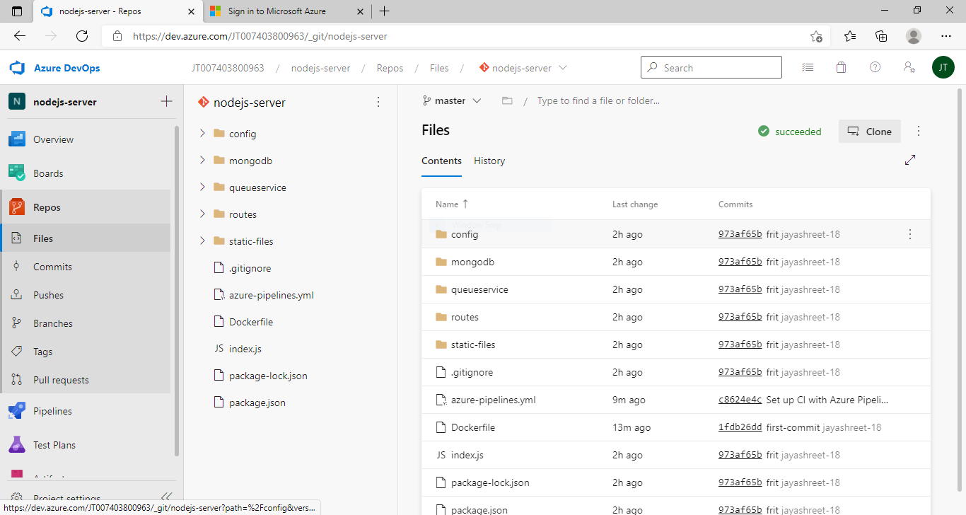

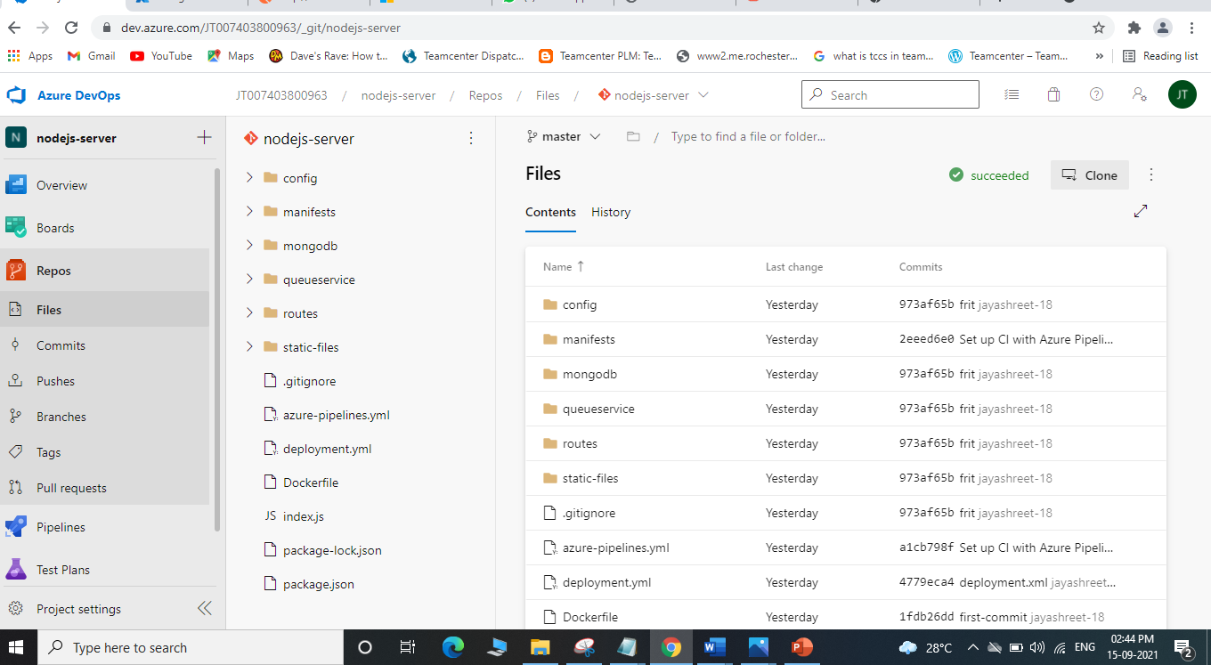

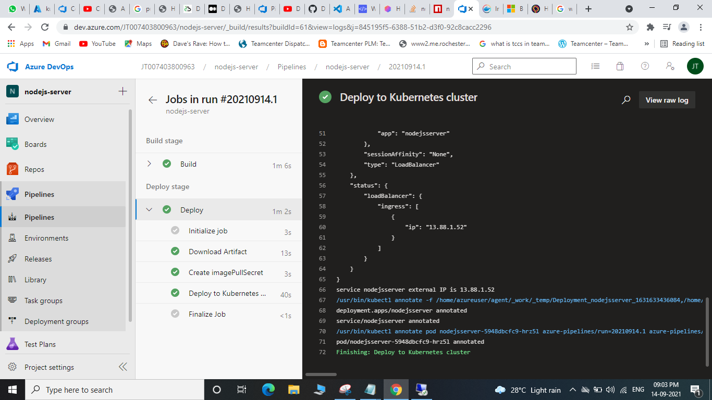

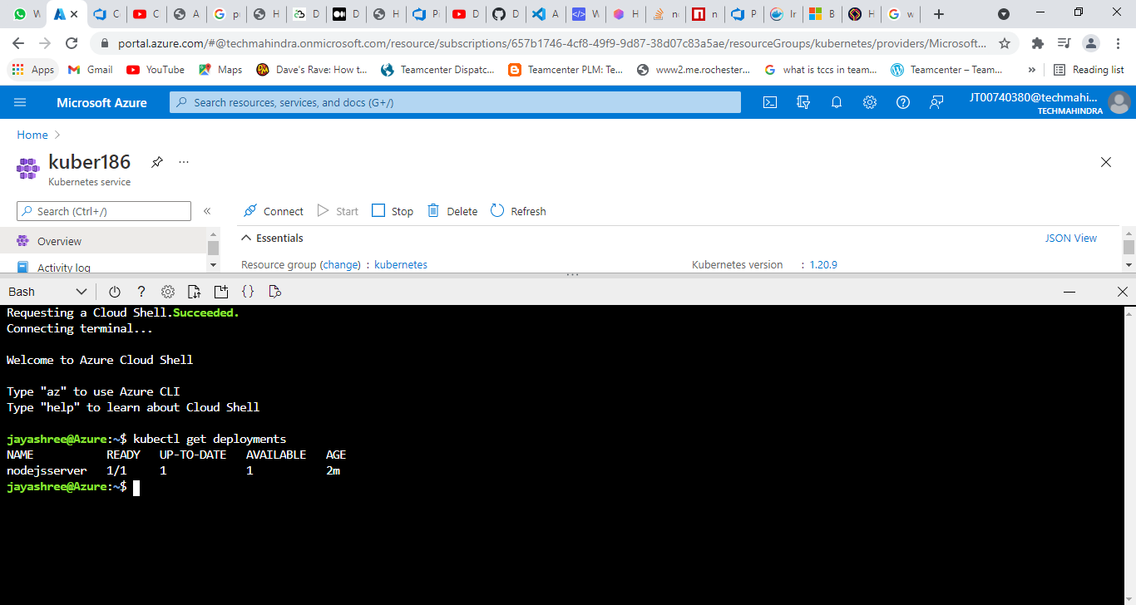

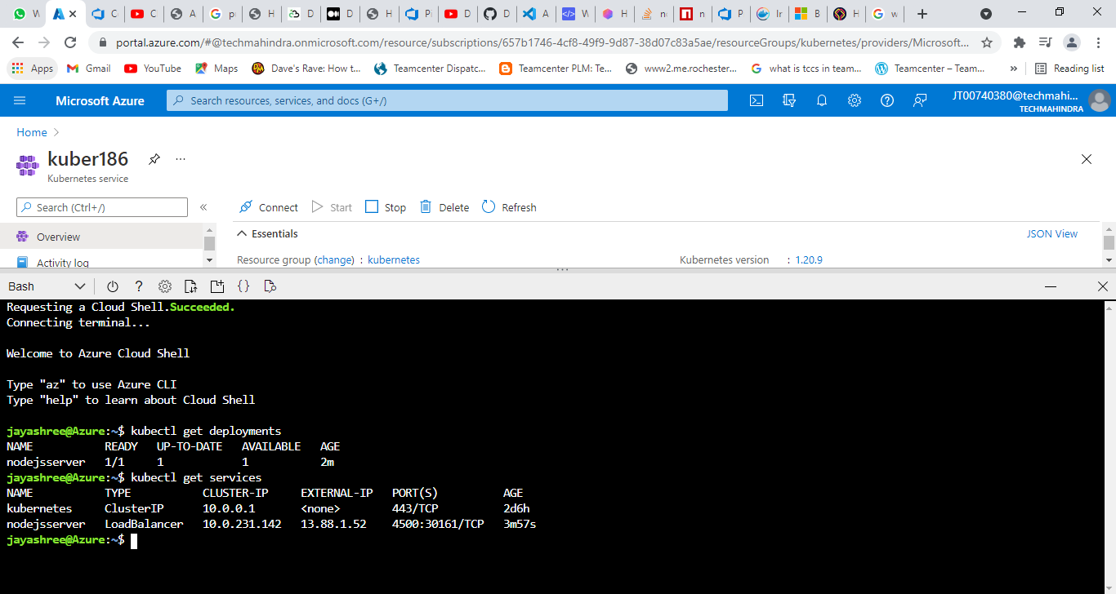

ANGULAR PIPELINE

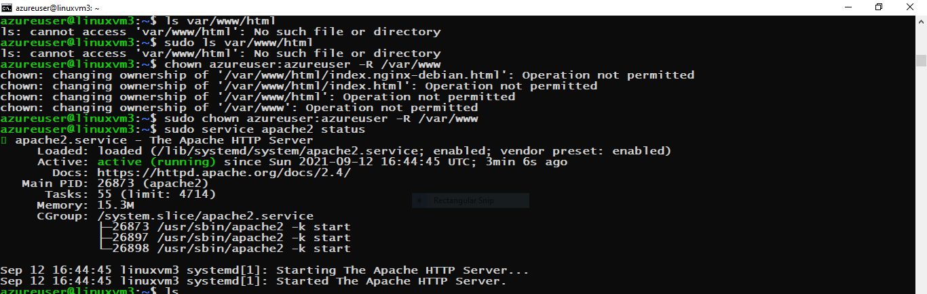

CLOUD STORAGE IMAGES UPLOAD

