HOME ENERGY AUDIT [2]
Energy and Carbon Audit of a Shared Student-Hostel Room in Hong Kong
Room 1003B, 10/F, Hall 13, CityU Lee Shau Kee Student Residence Village, Ma On Shan, New Territories, Hong Kong
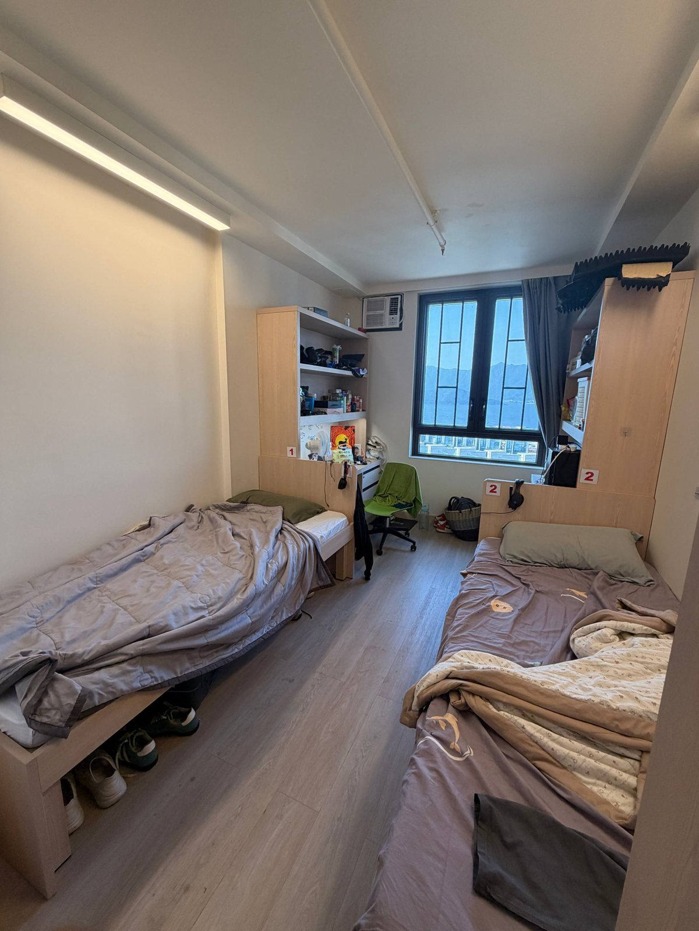
Room 1003B - the audited home (twin room, 15 m², window facing NW)

Course | SEE8115
Prepared by | Jayash Sahu
Student ID | ________________
Instructor | ________________
Audit period | 1 January 2026 - 11 October 2026 (data collection and site survey)
Report date | 11 October 2026
Report reference | SEE8115-HEA-2026-01
Methods | EMSD Code of Practice for Building Energy Audit (EAC 2018); EPD/EMSD Guidelines to Account for and Report on GHG Emissions and Removals for Buildings in Hong Kong (2010)

Contents
Executive summary 5
1 Introduction 7
1.1 Background 7
1.2 Objectives 7
1.3 Administrative information 7
1.4 Scope of the audit (EAC §8.1(a)) 7
1.5 Regulatory and methodological basis 8
2 Audit methodology 9
2.1 The six EAC steps applied to a home 9
2.2 Calculation methods 9
2.3 Data sources and data quality 9
2.4 Tools and deliverables 10
3 Audit boundary and reporting period 11
3.1 Reporting entity and physical boundary 11
3.2 Operational boundary 11
3.3 Reporting period 12
4 Site and building characteristics (EAC §8.1(b)) 13
4.1 Location and climate 13
4.2 The building 13
4.3 The audited room 13
4.4 Occupancy profile 14
4.5 Shared facilities 14
5 Equipment inventory and operating characteristics 15
5.1 Air-conditioning (EAC §8.1(e)) 15
5.2 Lighting (EAC §8.1(f)) 16
5.3 Plug loads and the desk fan 16
5.4 Water heating and washroom ventilation 17
5.5 Kitchen and laundry appliances 17
6 Energy consumption analysis (EAC §8.1(d), (g)) 18
6.1 Room air-conditioning baseline: two independent methods 18
6.2 Shower hot water 19
6.3 Annual consumption and end-use breakdown 19
6.4 Breakdown by EAC installation category (EAC §8.1(g)(iv)) 20
6.5 Monthly profile and monthly EUI (EAC §8.1(g)(iii)) 21
6.6 Energy Utilisation Index and benchmarks 22
6.7 Energy used outside the room (EAC §8.1(h)) 23
7 Greenhouse-gas inventory 24
7.1 Emission factors 24
7.2 Scope 1 - direct emissions 24
7.3 Scope 2 - purchased electricity 24
7.4 Scope 3 - water, sewage and paper 25
7.5 Inventory summary 25
7.6 Daily-activity extension (reported separately) 26
8 Walk-through findings (EAC §7.4.5, §8.1(i)) 27
9 Energy Management Opportunities (EAC §6.2, §7.4-7.5) 28
9.1 Category I - housekeeping (no cost) 29
9.2 Category II - low-cost operational changes 29
9.3 Category III - capital measures and cost-benefit with service life (EAC §7.5.4) 30
9.4 Energy recovery and renewable energy (EAC §7.4.4(c)-(d), §8.1(l)(iii)) 30
10 Recommendations, implementation and M&V (EAC §7.6) 32
10.1 Implementation plan 32
10.2 Measurement and verification plan (EAC §7.5.3, §7.6.3) 32
10.3 Communication with hall management (EAC §7.4.3) 32
10.4 Further studies (EAC §7.6.5) 32
11 Uncertainty, limitations and sensitivity 34
11.1 Limitations 35
12 Conclusions and lessons for the corporate carbon audit 36
12.1 Conclusions 36
12.2 Lessons for the corporate carbon audit 36
References 37
Appendix A - Questionnaire responses (summary) 39
Appendix B - Photo log 40
Appendix C - Input data register 42
Appendix D - Executive summary in EE-EAes structure 45
Appendix E - Completed Penn State Home Energy Audit Tool 46
Appendix F - Deliverables and reproducibility 47
After editing the report in Word, right-click the contents list and choose Update Field to refresh the page numbers.

Abbreviations
Term | Meaning
AC | Air-conditioning / air-conditioner
BEC / BEEO | Building Energy Code / Buildings Energy Efficiency Ordinance (Cap. 610)
CBSI | Central building services installation (EAC term)
CLP | CLP Power Hong Kong Ltd, the electricity supplier to Ma On Shan
CO₂e | Carbon dioxide equivalent
CSPF / EER | Cooling seasonal performance factor / energy efficiency ratio (rated capacity ÷ rated input)
DSD / WSD | Drainage Services Department / Water Supplies Department
EAC | Code of Practice for Building Energy Audit (EMSD, 2018 edition)
EE-EAes | EMSD technical form: Executive Summary of an Energy Audit Report
EMO | Energy Management Opportunity (Category I, II or III)
EMSD / EPD / EEB | Electrical and Mechanical Services Department / Environmental Protection Department / Environment and Ecology Bureau
EUI | Energy Utilisation Index (MJ/m²/yr; kWh/m²/yr = MJ/m²/yr ÷ 3.6)
FiT | Feed-in Tariff (CLP renewable-energy scheme)
GHG / GWP | Greenhouse gas / global warming potential
HKO | Hong Kong Observatory
LPD | Lighting power density (W/m²)
M&V | Measurement and verification of savings
MiC | Modular integrated construction
RF | Radiative forcing uplift for aviation emissions
SRO | CityU Student Residence Office (hall management)
WELS | Water Efficiency Labelling Scheme (WSD)

Executive summary
This report presents a systematic energy and carbon audit of the auditor's home: Room 1003B, 10/F, a 15 m² twin room in Hall 13, CityU Lee Shau Kee Student Residence Village (Ma On Shan, New Territories, Hong Kong), together with the household's share of the shared washroom, floor kitchen and hall laundry. The audit follows the six steps of the EMSD Code of Practice for Building Energy Audit (EAC 2018) [1] and quantifies greenhouse-gas emissions with the EPD/EMSD Guidelines for buildings in Hong Kong [2]. Its purpose is to establish a baseline, explain the consumption pattern and identify Energy Management Opportunities (EMOs) before progressing to a corporate carbon audit.
Table ES.1: Key results (typical 12-month baseline year)
Indicator | Result
Household electricity (room + allocated shared services) | 2,586 kWh/yr (1,293 kWh per person)
Electricity used inside the 15 m² room | 1,220 kWh/yr (47.2% of household); 52.8% is used in shared facilities
Room air-conditioning baseline (Octopus spend) | 811 kWh/yr; independent energy-label check 884 kWh/yr (+9.1%)
Energy Utilisation Index of the room (EAC §8.1(g)(ii)) | 292.7 MJ/m²/yr (81.3 kWh/m²/yr), 1.18 × a typical Hong Kong home
Largest end-uses | Air-conditioning 34.4%, shower hot water 24.5%, cooking 12.1%
GHG emissions - CLP factor 0.34 kg/kWh | 939 kg CO₂e/yr (470 kg per person)
GHG emissions - territory default 0.7 kg/kWh | 1,870 kg CO₂e/yr (935 kg per person)
Scope split (CLP basis) | Scope 1 16 kg; Scope 2 879 kg (93.6%); Scope 3 43 kg
Auditor's wider footprint (travel and diet added) | 5.1 t CO₂e/yr - home energy and water are only 9%
EMOs identified | 18 (8 Category I, 6 Category II, 4 Category III)
No-cost Category I package | 503 kWh/yr (19.5%) and 171 kg CO₂e/yr saved

Main findings
- Operation, not equipment, drives use. The room AC (Midea MW-12CRF8E) and the kitchen appliances already carry Grade 1 HK Energy Labels. Energy is driven by all-night AC operation at 25 °C, a washroom exhaust fan that runs 24 hours a day and a kitchen AC that residents leave on for 8 h or more.
- More than half of the "home" is outside the room. 52.8% of the household's electricity is used in shared facilities that students do not control. The largest shares are shower water heating with a 24.4 kW instantaneous heater, the washroom fan and the kitchen.
- Hot water is seasonal. Shower energy is 2.12 times higher in January than in July because the cold-water inlet falls from about 29 °C to 16.5 °C [8].
- Lighting is already efficient. It is all-LED, and the room's lighting power density of 4.0 W/m² is within the BEC 2021 dormitory limit of 6.2 W/m² [24].
- The emission factor doubles the answer. Scope 2 is 93.6% of the inventory, and the CLP-specific factor (0.34) and the territory-wide default (0.7) differ by a factor of two, so both are reported as the Guidelines require [2], [5].
Recommendations
- Implement the eight Category I measures now:
  - raise the AC set-point to 26 °C with the fan on;
  - use the AC timer to stop 2 h before waking;
  - clean the AC filter fortnightly;
  - use task lighting;
  - take 4-minute showers at 38 °C;
  - use laptop power management;
  - cook efficiently.
Together they save about 503 kWh/yr at no cost, including HK$231 a year of Octopus AC charges.
- Ask the Student Residence Office to implement four low-cost Category II measures:
  - an exhaust-fan run-on/humidistat control;
  - a kitchen-AC timer with the set-point fixed at 25.5 °C;
  - a night set-back for the water dispenser;
  - WELS Grade 1 showerheads.
They save about 1,118 kWh/yr at the facility level, with paybacks of 0.6 to 3.2 years.
- Treat central heat-pump water heating and more rooftop PV as Category III feasibility studies. Replacing the window AC is not viable: its payback of 20.9 years exceeds the 12-year service life.
- Buy a plug-in power meter (about HK$120, within the HK$200 budget) and keep weekly Octopus readings so that the savings can be verified (EAC §7.6.3).
Table ES.2: Items required in an executive summary by EAC §8.2
EAC §8.1 item | Summary | Section
(b) Building characteristics | Student-hostel room, 10/F, 15 m², 2 occupants (7.5 m²/person), occupied 103 h/week; MiC building opened 2024 | 4
(e)(i) AC cooling capacity and condenser cooling | Window unit 3.34 kW (11,400 Btu/h), air-cooled, inverter, R32; kitchen split unit 7.0 kW, air-cooled, R410A | 5.1
(e)(ii) Heat pump heating capacity | Not applicable (no space heating; cooling-only units) | 5.1
(f) Total lighting power | 60 W in the room (4.0 W/m²) | 5.2
(g)(ii) EUI | 292.7 MJ/m²/yr (room); past 2nd/3rd 12-month periods not applicable | 6.6
(g)(iii) Monthly EUI | 16.1-32.2 MJ/m²/month (cool vs hot months) | 6.5
(g)(iv) Breakdown | Room: AC 73.7%, lighting 9.6%, others 16.8%, lift & escalator 0% | 6.4
(h) Supply from shared services | 52.8% of household electricity | 6.7
(l)(i) EMO categories | 8 Category I, 6 Category II, 4 Category III | 9
(m) Administrative information | Cover page and Table 1.1 | 1

1 Introduction

1.1 Background
Buildings account for about 90% of Hong Kong's electricity consumption [30]. Electricity generation produced 61% of the territory's greenhouse-gas emissions in 2023, when per-capita emissions were about 4.58 t CO₂e [10]. Hong Kong's Climate Action Plan 2050 targets carbon neutrality before 2050. It also aims to cut electricity use in residential buildings by 20-30% from 2015 levels by 2050, with half of that reduction by 2035 [31]. Homes are therefore a useful place to practise the audit discipline that the Buildings Energy Efficiency Ordinance (Cap. 610) requires of commercial buildings. A home is small enough to inventory completely, yet it already raises the problems of a corporate audit: boundaries, shared services, missing meters and choice of emission factors.

1.2 Objectives
- Establish an energy baseline for the home (annual and monthly, by end-use and by space).
- Identify consumption patterns: seasonal, behavioural and spatial (room versus shared facilities).
- Quantify Scope 1, 2 and 3 greenhouse-gas emissions using the Hong Kong building guidelines [2].
- Identify, categorise (Category I/II/III) and cost Energy Management Opportunities [1].
- Draw lessons for the forthcoming corporate carbon audit.

1.3 Administrative information
Table 1.1: Administrative information (EAC §8.1(m))
Building | Hall 13, CityU Lee Shau Kee Student Residence Village (opened Q3 2024) [15]
Audited unit | Room 1003B, 10/F - twin room, 2 occupants
Address / location | Ma On Shan, New Territories, Hong Kong; 22°26'0" N, 114°14'32" E (44 m elevation, phone compass)
Electricity supplier | CLP Power Hong Kong Ltd (room AC pre-paid by Octopus card)
Auditor | Jayash Sahu (SEE8115); occupant of the room
Audit commenced / completed | 01/01/2026 / 11/10/2026
Energy bill reference month | September 2026: 1-30 September 2026 (no utility bill; Octopus pre-paid AC). Completion is within the 6 months that EAC §8.1(m) allows
Registered Energy Assessor | Not applicable: voluntary student audit, not submitted under Cap. 610
Previous energy audit (§8.1(k)) | None; this is the first audit of the room
Report reference | SEE8115-HEA-2026-01

1.4 Scope of the audit (EAC §8.1(a))
Installations audited:
- room window AC, LED lighting, desk fan, laptops and phone chargers;
- shared washroom instantaneous water heater, exhaust fan and sensor lighting;
- shared-kitchen refrigerators, water dispenser, split AC, lighting, induction hobs and microwave;
- hall laundry washer and dryer.
Not audited:
- hall common services: lifts, corridors, lobbies and central plant;
- the building envelope beyond the room's window;
- other residents' personal use.
Assumptions and estimating methods (detailed in Section 2 and Appendix C):
- room AC energy is taken from the reported Octopus spend divided by the CLP 2026 average tariff, and checked against the HK Energy Label;
- other loads are rated power × reported hours;
- shower energy is calculated from first principles;
- shared fixed loads are allocated per user;
- the roommate's personal loads are assumed equal to the auditor's.

1.5 Regulatory and methodological basis
The EAC 2018 [1] defines the audit steps (§7), the EMO categories (§6.2) and the content of an audit report (§8). Under Cap. 610, energy audits are mandatory only for commercial buildings and the commercial portions of composite buildings; the EE-EAes form lists only these building types [3]. A student hostel is not a prescribed building, so this audit applies the Code voluntarily. Emissions follow the EPD/EMSD Guidelines [2], which require Scope 1 and 2 reporting, make Scope 3 optional, and require electricity to be reported with both the territory-wide default and the power company's own factor.
The course's Penn State Home Energy Audit Tool [4] was used as the room-by-room data-collection template; a completed copy accompanies this report. Equipment efficiency is assessed against the EMSD Mandatory Energy Efficiency Labelling Scheme [9] and lighting against the Building Energy Code [24].

2 Audit methodology

2.1 The six EAC steps applied to a home
Table 2.1: How each EAC 2018 step was carried out
EAC step | Requirement | How it was applied in this audit
1 Building information (§7.2) | Inventories, drawings, operating records, 36-month energy data | 48-question occupant questionnaire; 26 photographs of nameplates, labels and spaces; CityU building information [15]; HKO climate normals [8]
2 Review of energy-consuming equipment (§7.3) | Site inspection; record equipment characteristics (§7.3.1); calculate power and energy from ratings and operating records, or measure (§7.3.2) | Walk-through of room, washroom and kitchen; equipment inventory (Table 5.1); Octopus AC spend; label-based and first-principles calculations
3 Identify EMOs (§7.4) | Evaluate AC, LPD, EUI; maintenance, set-points, behaviour, schedules | Benchmarks (EUI, LPD, water, per-capita use); 12 walk-through findings (Section 8)
4 Cost-benefit (§7.5) | Savings, costs, service life, energy price | HK$1.406/kWh; indicative costs; simple payback compared with service life
5 Recommendations (§7.6) | Implementation, M&V, further studies | Action plan, metering plan and memo to hall management (Section 10)
6 Report (§7.7, §8) | Report and executive summary | This report; Excel workbook (live formulas); completed Penn State tool; EE-EAes summary

2.2 Calculation methods
(1) Appliance energy: E = P × LF × h × d × n ÷ 1000 (kWh/yr). P is rated power (W), LF the load factor, h hours per day, d days per year and n the quantity.
(2) AC, top-down: E = Σ (monthly Octopus spend) ÷ tariff. The spend is HK$140 in May-Oct and HK$50 in Nov-Apr; the tariff is HK$1.406/kWh (CLP 2026 average net tariff) [6].
(3) AC, bottom-up: E = (label kWh ÷ 1,200 h) × Σ operating hours. The HK label states annual consumption for 1,200 h of operation [9].
(4) Shower water heating: E = V × cₚ × (T_shower − T_inlet) ÷ (3,600 × η). V is litres (1 L = 1 kg) and cₚ = 4.186 kJ/kg·K; T_inlet is the HKO monthly mean air temperature.
(5) Allocation: E_household = Σ E_item × share. Room items count at 1; washroom fixed loads at 2/4; kitchen fixed loads at 2/32; showers, cooking and laundry at the household's own use.
(6) Energy Utilisation Index: EUI = E × 3.6 ÷ A (MJ/m²/yr) [1], [3].
(7) GHG emissions: activity × emission factor. Scope 2 uses both 0.34 (CLP 2025) [5] and 0.7 kg CO₂e/kWh [2]. Water and sewage use the utility's kWh per m³ × 0.7 (Guideline Tables 8 and 9) [2], [11], [12].

2.3 Data sources and data quality
The workbook holds 104 inputs, each tagged with its source and a data-quality class. In descending order of reliability:
- nameplate or energy-label values photographed on site: 10;
- values reported by the occupant in the questionnaire: 33;
- published Hong Kong or international data: 30;
- derived values: 3;
- typical values assumed where nothing better existed: 28.
Assumed values are highlighted in yellow in the workbook and tested in the sensitivity analysis (Section 11). The most influential assumption is the Octopus AC tariff: CityU does not publish its hall AC rate, so the CLP average tariff is used and cross-checked against comparable university hostels (HK$1.20-2.31/kWh [25]).

2.4 Tools and deliverables
- Home_Energy_Carbon_Audit_Workbook.xlsx - 15 sheets with 1,150 live formulas, including inputs, AC baseline, hot water, inventory, monthly profile, breakdown, GHG inventory, EMO register, sensitivity, EE-EAes summary and entry guide.
- 1_SEE6115-8115_Home Energy Audit Tool_COMPLETED.xlsx - the course's Penn State tool completed for the room, washroom, kitchen and laundry, with all navigation buttons and drop-downs preserved.
- EE-EAes structure - the executive summary is presented in the EMSD form's structure, with a cell-by-cell entry guide for the official macro-enabled form.

3 Audit boundary and reporting period

3.1 Reporting entity and physical boundary
The reporting entity is the household of Room 1003B: the auditor and one roommate. The Guidelines ask the reporting entity to define the physical boundary within which emissions are counted [2]. In a student hostel, the "home" is not only the room: daily life also depends on a washroom shared by four residents, a floor kitchen used by 32 residents, and hall laundry machines. The boundary therefore combines three kinds of item, shown in Figure 3.1:
- the room in full;
- per-capita shares of the fixed loads in the shared spaces (fans, lights, refrigerators, water dispenser, kitchen AC);
- usage-based items attributed directly (showers, cooking, laundry).
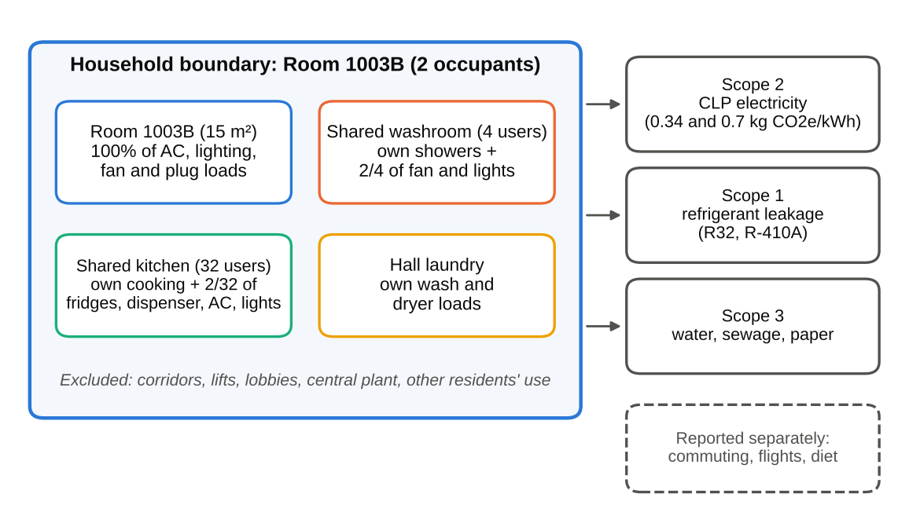
Figure 3.1: Physical and operational boundary of the audit
Per-capita allocation was chosen because every resident has equal access to the shared spaces. Allocating the kitchen over the 20 active users rather than all 32 residents raises the household total by only 4.1% (Section 11). Hall common services (lifts, corridors, lobbies, pumps, central plant and rooftop PV) are outside the boundary because the household cannot influence them and has no data on them.

3.2 Operational boundary
- Scope 1 - direct: no fuel is burnt within the boundary; cooking and water heating are all-electric (Guideline Table 1 is nil). Fugitive refrigerant from the room AC (R32) and the kitchen AC (R-410A) is estimated by a screening method (Section 7.2).
- Scope 2 - energy indirect: electricity purchased from CLP Power for all items in the boundary (Guideline Table 5). No Towngas is used (Table 6 is nil).
- Scope 3 - other indirect (optional): fresh-water supply (Table 8), sewage treatment (Table 9), paper to landfill (Table 7), and seawater for flushing as an extra item.
- Daily-activity extension: commuting, flights and diet are reported separately (Section 7.6) so that the building inventory stays comparable with the Guidelines.

3.3 Reporting period
The auditor has occupied the room since 1 January 2026, so a 36-month history does not exist. EAC §8.1(g)(i) allows a building operating for less than 36 months to count back to its first day of operation [1]. Results are therefore expressed as a typical 12-month baseline year: the reported hot-season (May-Oct) and cool-season (Nov-Apr) behaviour applied to HKO 1991-2020 climate normals [8]. This is the projection of measured use to a complete operating cycle that EAC §7.5.6(b) allows. The reference month is September 2026. The roughly one-month break reported for 2026 is tested as a sensitivity case (-7%).

4 Site and building characteristics (EAC §8.1(b))

4.1 Location and climate
The residence is in Ma On Shan, New Territories (22°26'0" N, 114°14'32" E, 44 m above sea level), overlooking Tolo Harbour. Hong Kong's humid sub-tropical climate makes cooling the dominant service.
- The HKO 1991-2020 normals (HKO Headquarters, used as representative of the territory) give an annual mean temperature of 23.5 °C [8].
- In the hot season (May-October), monthly means range from 25.7 °C in October to 28.9 °C in July. The coolest month is January, at 16.5 °C.
- Space heating is not provided and was not used.
- The cold season matters for hot water, because the mains-water temperature follows the air temperature.

4.2 The building
Hall 13 is part of CityU's Lee Shau Kee Student Residence Village in Ma On Shan [15]:
- 6 halls in 3 towers, housing about 2,100 residents;
- built by modular integrated construction (MiC) from more than 1,300 prefabricated modules, and opened in the third quarter of 2024, with an opening and naming ceremony in December 2024;
- 110 rooftop photovoltaic panels and a building management system.
Each room has its own window AC charged through an Octopus-card system. Lighting and socket power are included in the hall fee.

4.3 The audited room
Table 4.1: Characteristics of Room 1003B
Floor area / occupants | 15 m² / 2 (7.5 m² per person; HK median 16 m² [23])
Floor / orientation | 10/F; window wall faces NW (328°, phone compass)
Glazing | Single-pane clear glass in a dark aluminium frame with fly screen: 2 casements of 0.53 × 1.26 m (0.67 m² each) + fixed pane of 1.10 × 0.19 m (0.209 m²) = 1.55 m² (10.3% of floor area)
Shading / solar | Full-height grey curtain; direct sun for about 40 min in the late afternoon (NW orientation catches the low summer sun)
Air-conditioning | Midea MW-12CRF8E 1.5 HP inverter window unit above the window (Section 5.1)
Lighting | 2 ceiling LED linear battens + 2 under-shelf LED desk lights
Other equipment | 2 laptops, 2 phones, 1 desk fan (20 W); no fridge, kettle, heater, TV or router

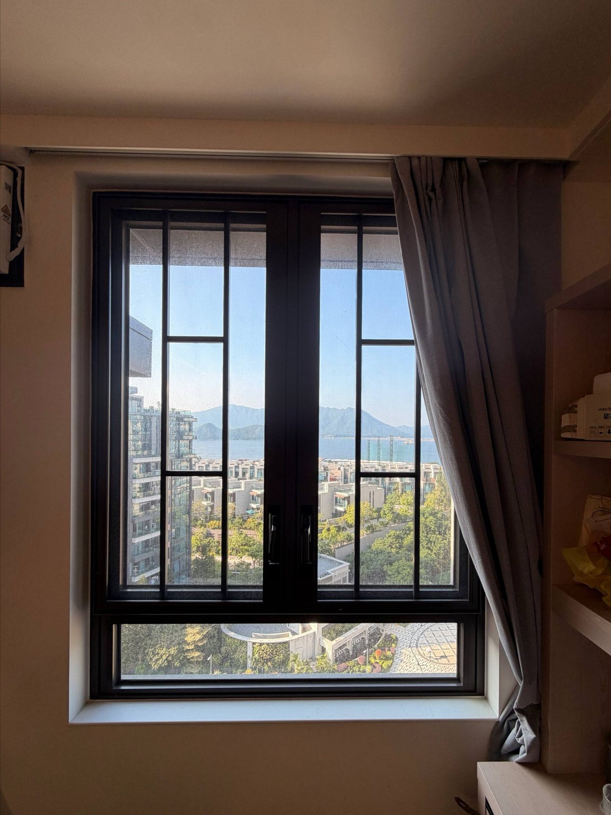  Photo 02a: NW-facing window and curtain | 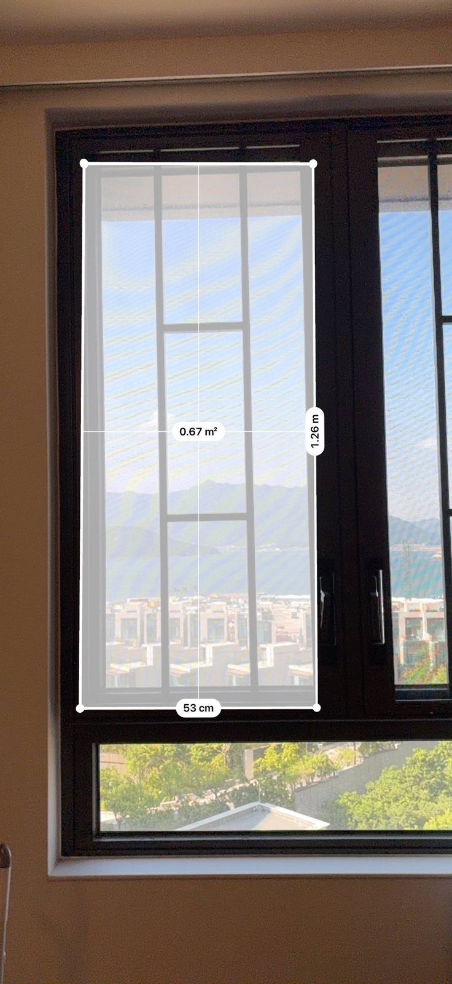  Photo 02c: casement measured 0.53 × 1.26 m | 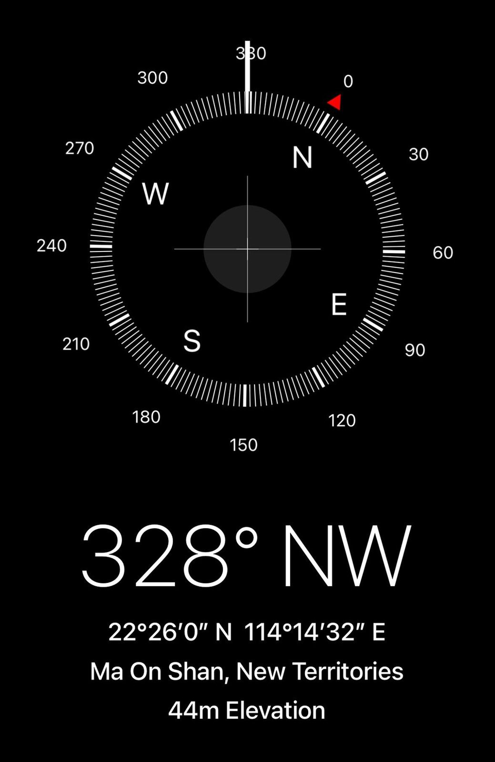  Photo 02d: 328° NW, Ma On Shan
Figure 4.1: Window, glazing measurement and orientation evidence

4.4 Occupancy profile
Table 4.2: Occupancy and operating schedule (reported)
Period | Time in room | Hours | AC use
Weekday | 22:00 - 11:00 | 13 h × 5 = 65 h | On all night in hot months
Saturday / Sunday | Most of the day | 20 h + 18 h = 38 h
Week total |  | 103 h (61% of the week)
Hot season (May-Oct) |  | AC 12 h/day at 25 °C | Octopus about HK$140/month
Cool season (Nov-Apr) |  | AC 4 h/day | Octopus about HK$50/month
Year | About 11 of 12 months in Hong Kong |  | 1-month break (Section 11)

4.5 Shared facilities
- Washroom (4 users): Stiebel Eltron DHB-E 27 electronic instantaneous water heater (24.4 kW at 380 V) [16], three LED downlights on an occupancy sensor, and a window exhaust fan that runs continuously.
- Floor kitchen (32 residents with access, about 20 active): two Panasonic NR-BV361B refrigerators, an Aquatek AQ-1323T three-temperature water dispenser, two Philips HD4911/80 induction hobs, a Toshiba microwave, and a Toshiba 7.0 kW split AC.
- Hall laundry: shared washers and dryers. The auditor uses one cold-wash load (45 min) and 12 minutes of drying per week.

5 Equipment inventory and operating characteristics
Table 5.1 lists every energy-using item within the boundary, the evidence behind its rating, how it is used, and its annual energy. Ratings come from nameplates and energy labels photographed on site wherever possible (Appendix B). This fulfils EAC §7.2(b), §7.3.1 and §8.1(c).
Table 5.1: Equipment inventory and annual energy (household = Room 1003B)
ID | Item | Make / model / evidence | Use | Share | Household kWh/yr | Per person kWh/yr
R1 | Window air-conditioner | Midea MW-12CRF8E, 1.5 HP inverter, R32, Grade 1 | Octopus spend ÷ tariff | 1 | 810.8 | 405.4
R2 | Ceiling LED linear battens | 2 surface battens (no label visible) | 6.0 h/day | 1 | 87.6 | 43.8
R3 | Under-shelf LED desk lights | Integrated in furniture | 4.0 h/day | 1 | 29.2 | 14.6
R4 | Oscillating desk fan | ZW02-180, 20 W nameplate | 12.0 h/day | 1 | 87.6 | 43.8
R5 | Laptops (auditor + roommate) | HP 65 W adapter TPN-CA17 (avg draw 50%) | 8.0 h/day | 1 | 189.8 | 94.9
R6 | Phone chargers | Typical 20 W fast charger | 1.0 h/day | 1 | 14.6 | 7.3
W1 | Instantaneous water heater (household showers) | Stiebel Eltron DHB-E 27, 24.4 kW @380 V | See HotWater sheet | 1 | 634.7 | 317.4
W2 | Window exhaust fan (runs 24 h) | J.E.E. window fan (label not visible) | 24.0 h/day | 2/4 | 131.4 | 65.7
W3 | LED downlights (occupancy sensor) | 3 surface downlights | 3.0 h/day | 2/4 | 16.4 | 8.2
K1 | Refrigerators | Panasonic NR-BV361B, Grade 1, 263 kWh/yr label | Energy label | 2/32 | 32.9 | 16.4
K2 | 3-temperature water dispenser | Aquatek AQ-1323T, 750 W heater + 160 W compressor | 1.5 kWh/day (assumed) | 2/32 | 34.2 | 17.1
K3 | Split air-conditioner | Toshiba RAS-24J2KCV-HK, 7.0 kW, R410A, Grade 1 (688 kWh/1,200 h) | 8 h/day hot, 4 h/day cool | 2/32 | 78.7 | 39.3
K4 | Kitchen lighting | Not photographed | 16.0 h/day | 2/32 | 32.9 | 16.4
K5 | Induction cooking (household) | Philips HD4911/80, 2,100 W max, Grade 2 (88.1%) | 0.4 h/day | 1 | 312.0 | 156.0
L1 | Washing machine (household) | Hall machine, cold wash 45 min | 1 load/week each | 1 | 31.2 | 15.6
L2 | Tumble dryer (household) | Hall machine, 12 min per load | 12 min/load | 1 | 62.4 | 31.2
 | Total |  |  |  | 2,586.4 | 1,293.2

5.1 Air-conditioning (EAC §8.1(e))
The room AC is a Midea MW-12CRF8E 1.5 HP inverter window unit. It is air-cooled (heat is rejected outdoors through the window sleeve) and uses refrigerant R32.
- Rated cooling capacity: 3.34 kW (11,400 Btu/h).
- Rated input: 1.192 kW, giving an EER of 2.80 kW/kW.
- Seasonal performance: CSPF 4.66, HK Energy Label Grade 1.
- Label consumption: 362 kWh/yr for 1,200 operating hours [9], [28]. This implies an average seasonal input of only 0.302 kW, about a quarter of the rated input, because the inverter compressor modulates at part load.
- Controls include Eco, Dry, Timer and fan-speed modes, all usable for EMOs.
- System type (EAC §8.1(e)(iii)): unitary air-conditioners only. There is no central chilled-water plant or air-distribution system within the boundary.
The shared kitchen has a Toshiba RAS-24J2KCV-HK 7.0 kW inverter split unit (Grade 1, R-410A, 688 kWh per 1,200 h). Neither unit provides heating.
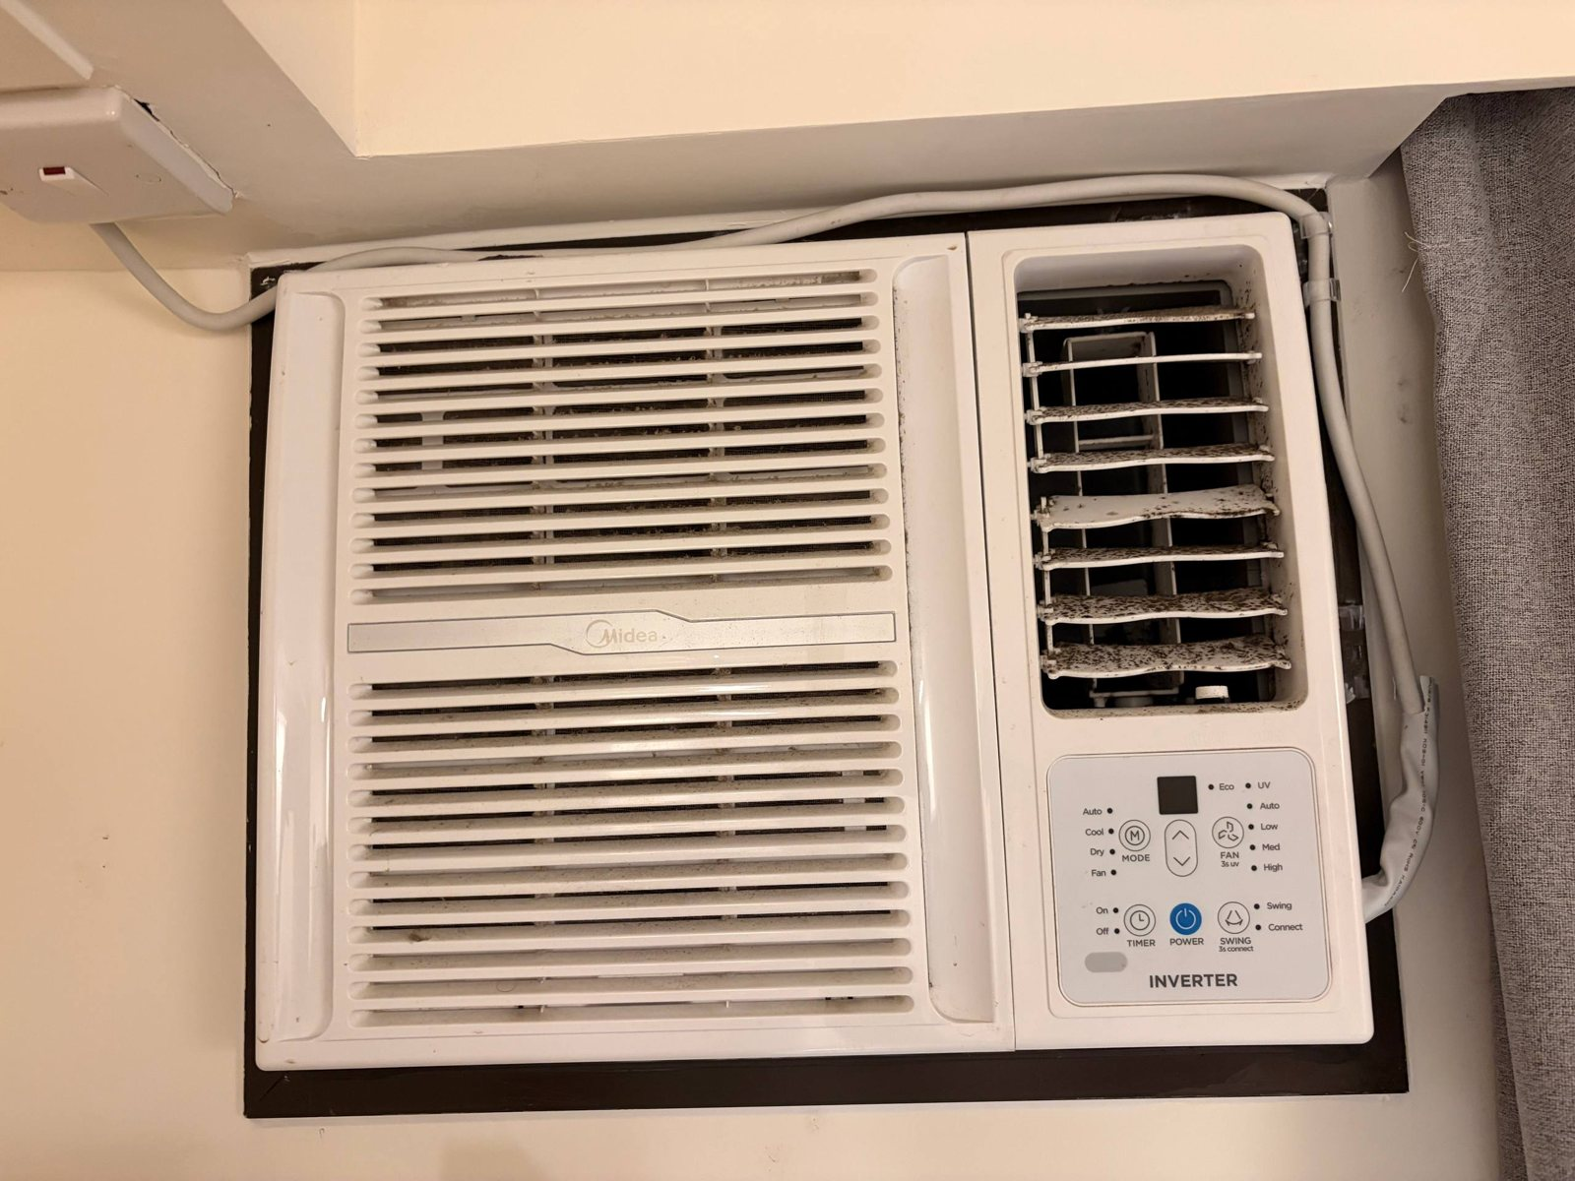  Photo 03b: Midea window AC - dark deposits on the discharge louvres | 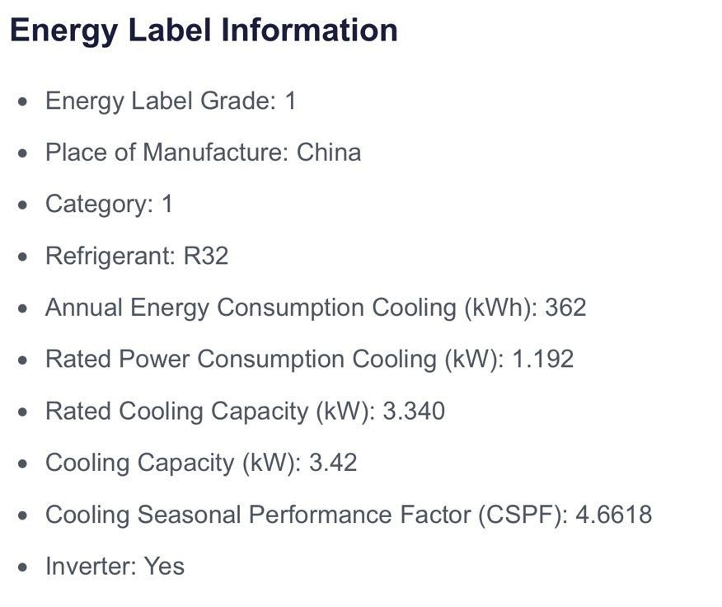  Photo 03a (energy-label part): Grade 1, R32, 362 kWh, 1.192 kW, CSPF 4.66
Figure 5.1: Room air-conditioner and its rating

5.2 Lighting (EAC §8.1(f))
The room has two surface-mounted LED linear battens and two under-shelf LED desk lights. No label was visible, so 20 W per batten and 10 W per desk light are assumed.
- Total room lighting power: 60 W, a lighting power density (LPD) of 4.0 W/m².
- This is 35% below the BEC 2021 limit of 6.2 W/m² for dormitories (6.1 W/m² in BEC 2024) [24]. The BEC applies to prescribed buildings, so it is used here only as a benchmark.
- The washroom's three LED downlights are switched by an occupancy sensor (about 3 h/day).

5.3 Plug loads and the desk fan
The auditor's laptop uses an HP 65 W adapter (TPN-CA17, efficiency level VI, which limits no-load losses). Average draw while in use is assumed to be 50% of the adapter rating (32.5 W). Both occupants are assumed to use a laptop for 8 h/day and charge a phone for 1 h/day. The oscillating desk fan is rated at 20 W (nameplate) and runs 12 h/day. The occupants report unplugging devices at night, so standby loads are negligible.
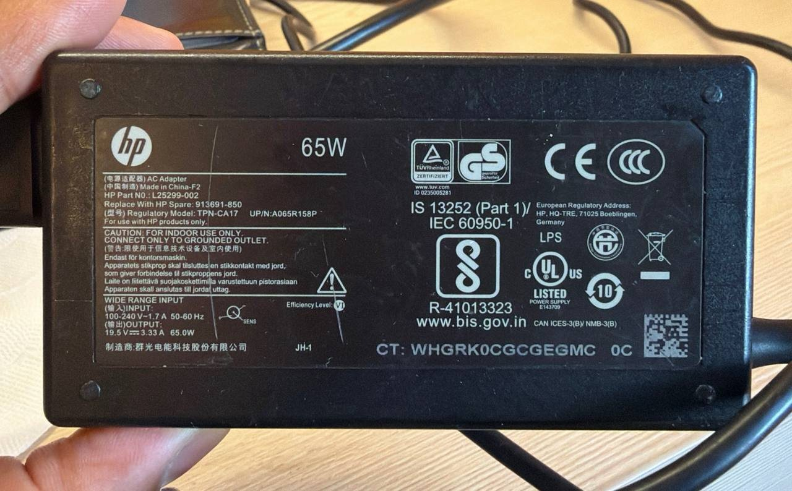  Photo 06a: HP 65 W adapter, efficiency level VI | 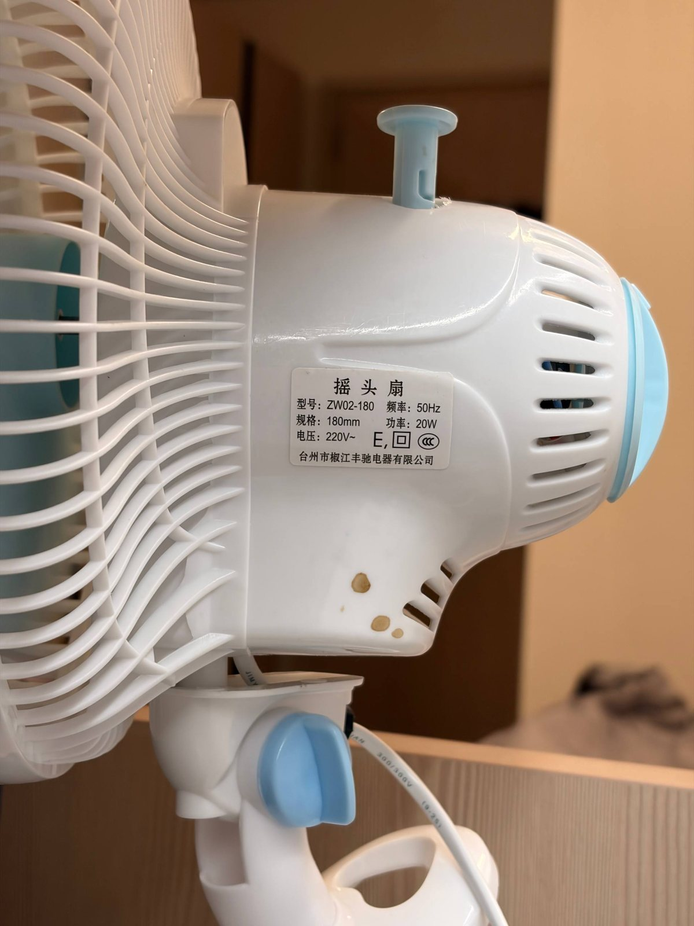  Photo 06b: desk fan label, 20 W | 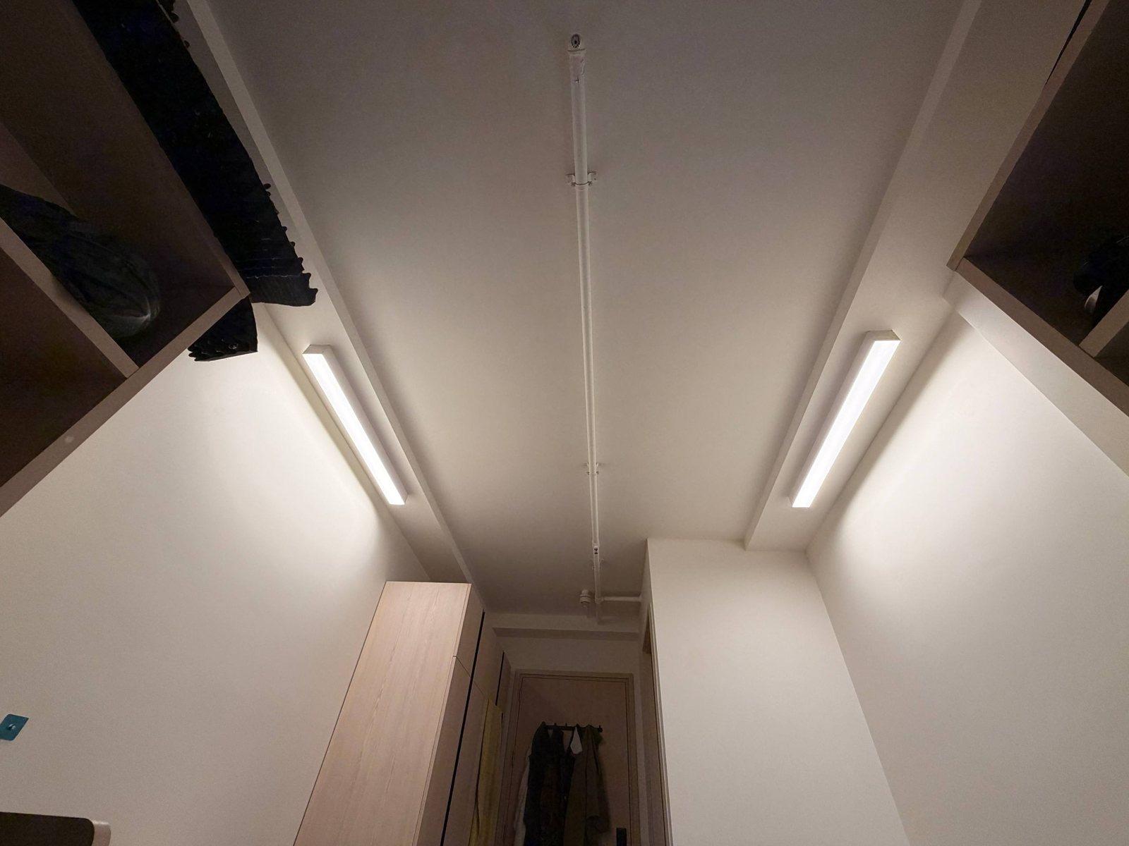  Photo 05a: ceiling LED battens
Figure 5.2: Plug-load and lighting evidence

5.4 Water heating and washroom ventilation
Showers are heated by a Stiebel Eltron DHB-E 27 electronic instantaneous heater: 27 kW at 400 V, or 24.4 kW at Hong Kong's 380 V three-phase supply [16]. It has no storage tank, so there are no standing losses. However, it draws a very large instantaneous power: a 9 L/min shower in January needs 14.9 kW (capacity headroom 1.64 ×). Across hundreds of washrooms, this drives the hall's maximum demand. The window exhaust fan (J.E.E.) runs 24 hours a day regardless of occupancy.
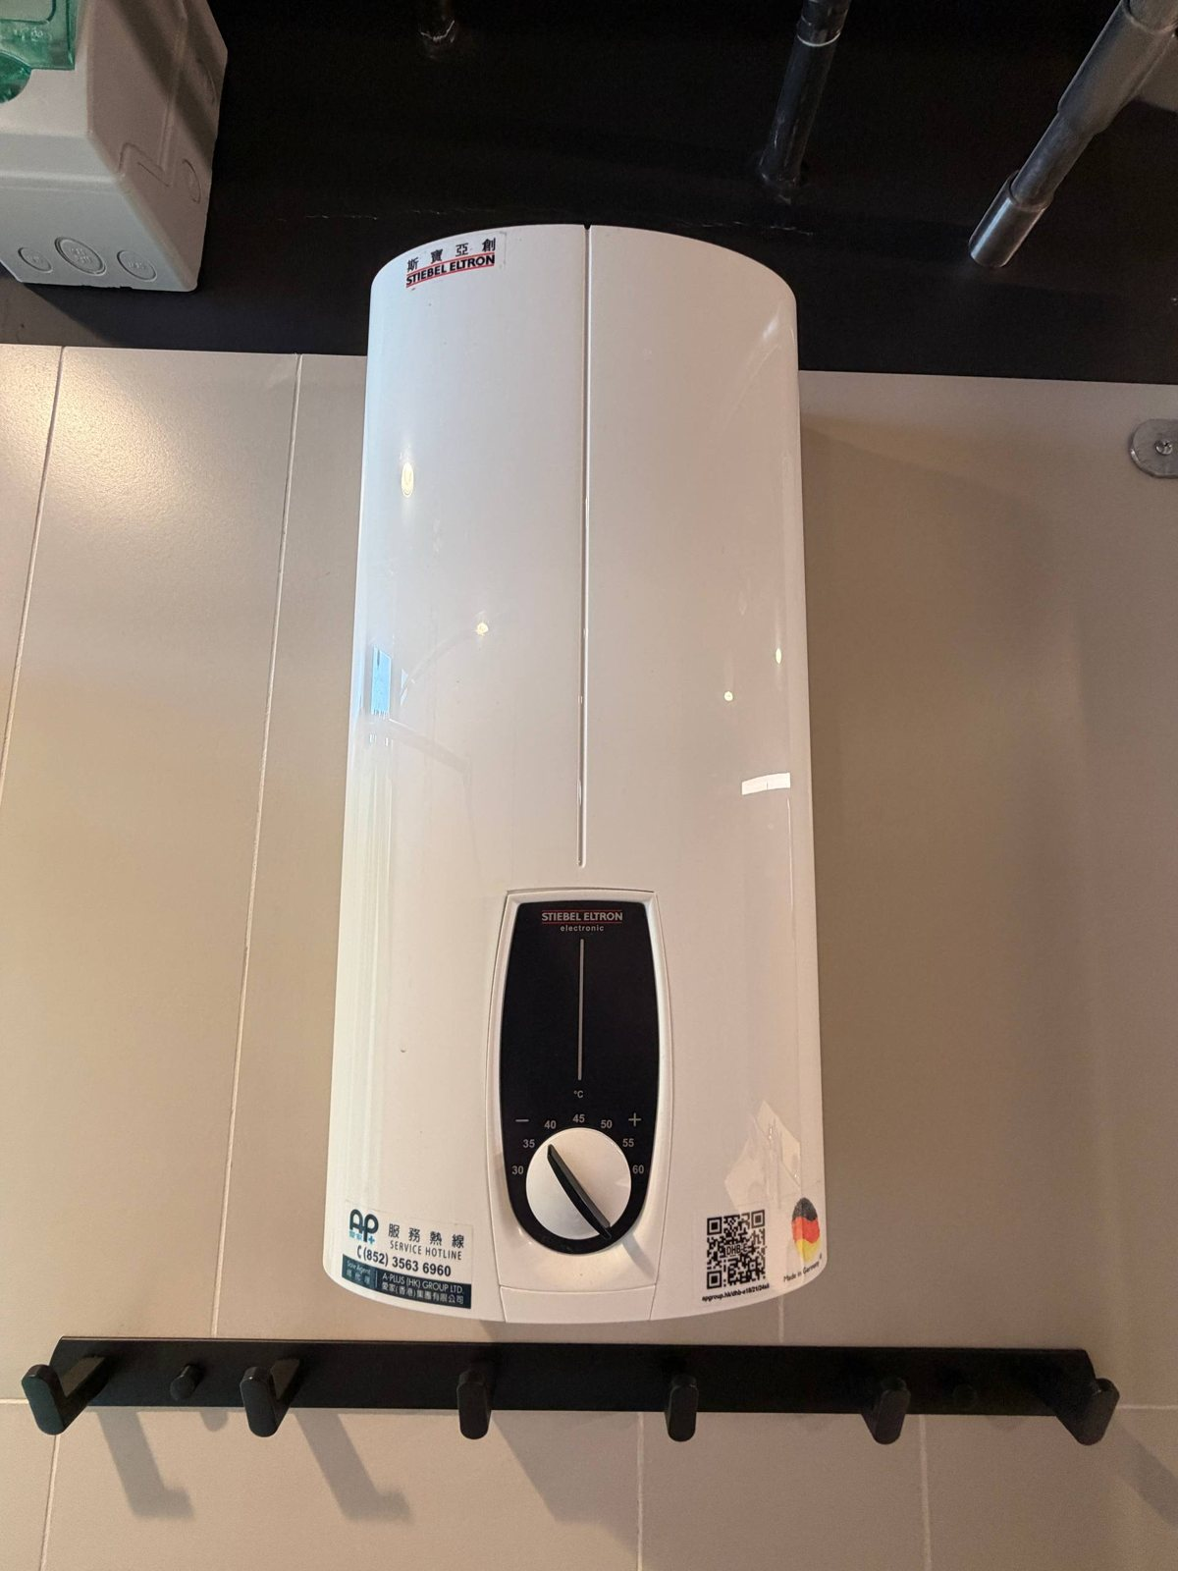  Photo 08a: Stiebel Eltron DHB-E instantaneous heater | 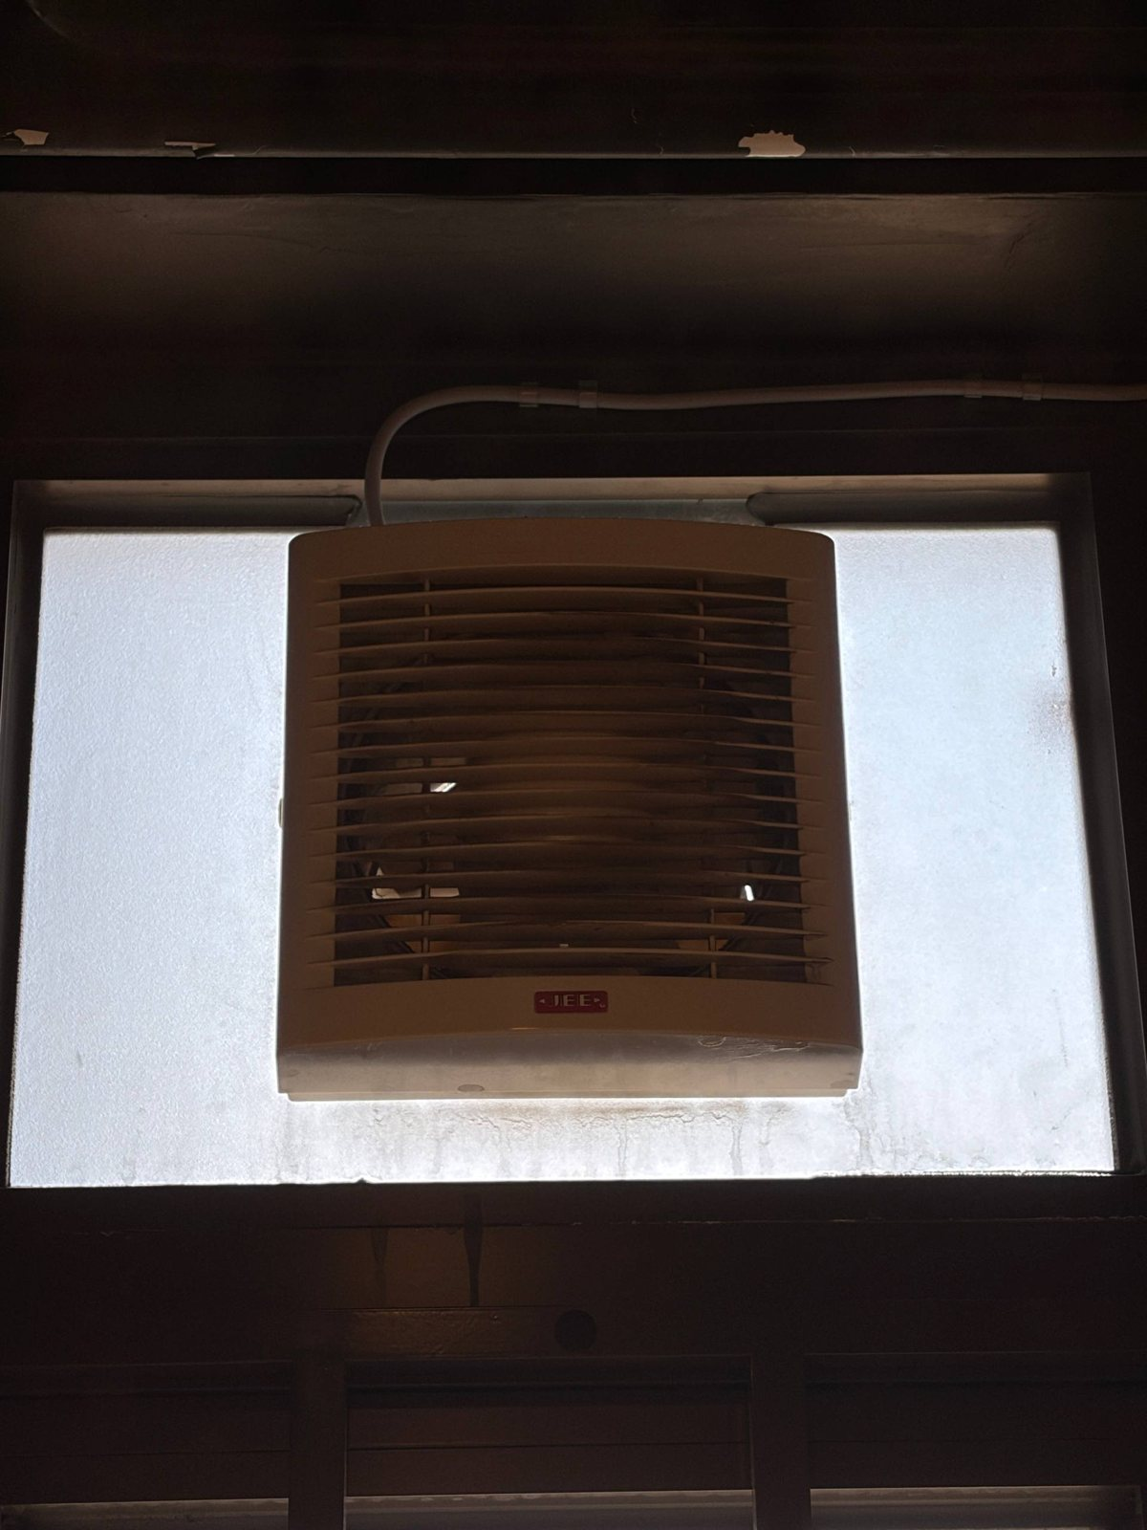  Photo 08d: exhaust fan running 24 h/day | 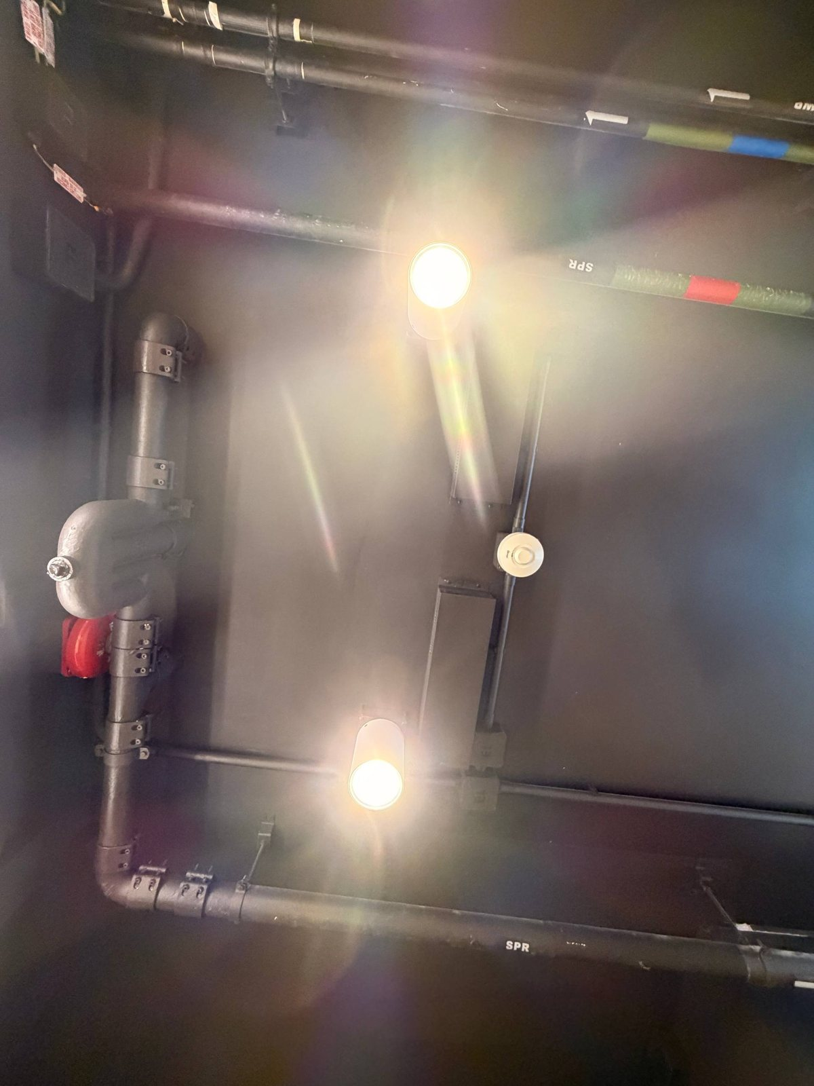  Photo 08b: sensor-controlled LED downlights
Figure 5.3: Shared washroom services

5.5 Kitchen and laundry appliances
The kitchen appliances are efficient, but some run all the time.
- Refrigerators: two Panasonic NR-BV361B units (233 L fresh + 99 L frozen), each Grade 1 at 263 kWh/yr.
- Induction hobs: Philips HD4911/80, Grade 2, 88.1% thermal efficiency, 2,100 W maximum with five power levels.
- Water dispenser: Aquatek AQ-1323T, 750 W heater + 160 W compressor. It keeps 10 L of water at 98 °C plus a 3 L ice tank, 24 hours a day, so it has unavoidable standing losses (assumed 1.5 kWh/day; the ENERGY STAR limit for storage hot-and-cold coolers is 0.87 kWh/day [20]).
- Kitchen AC: reported to be left running for 8 h or more by residents (Finding F4).
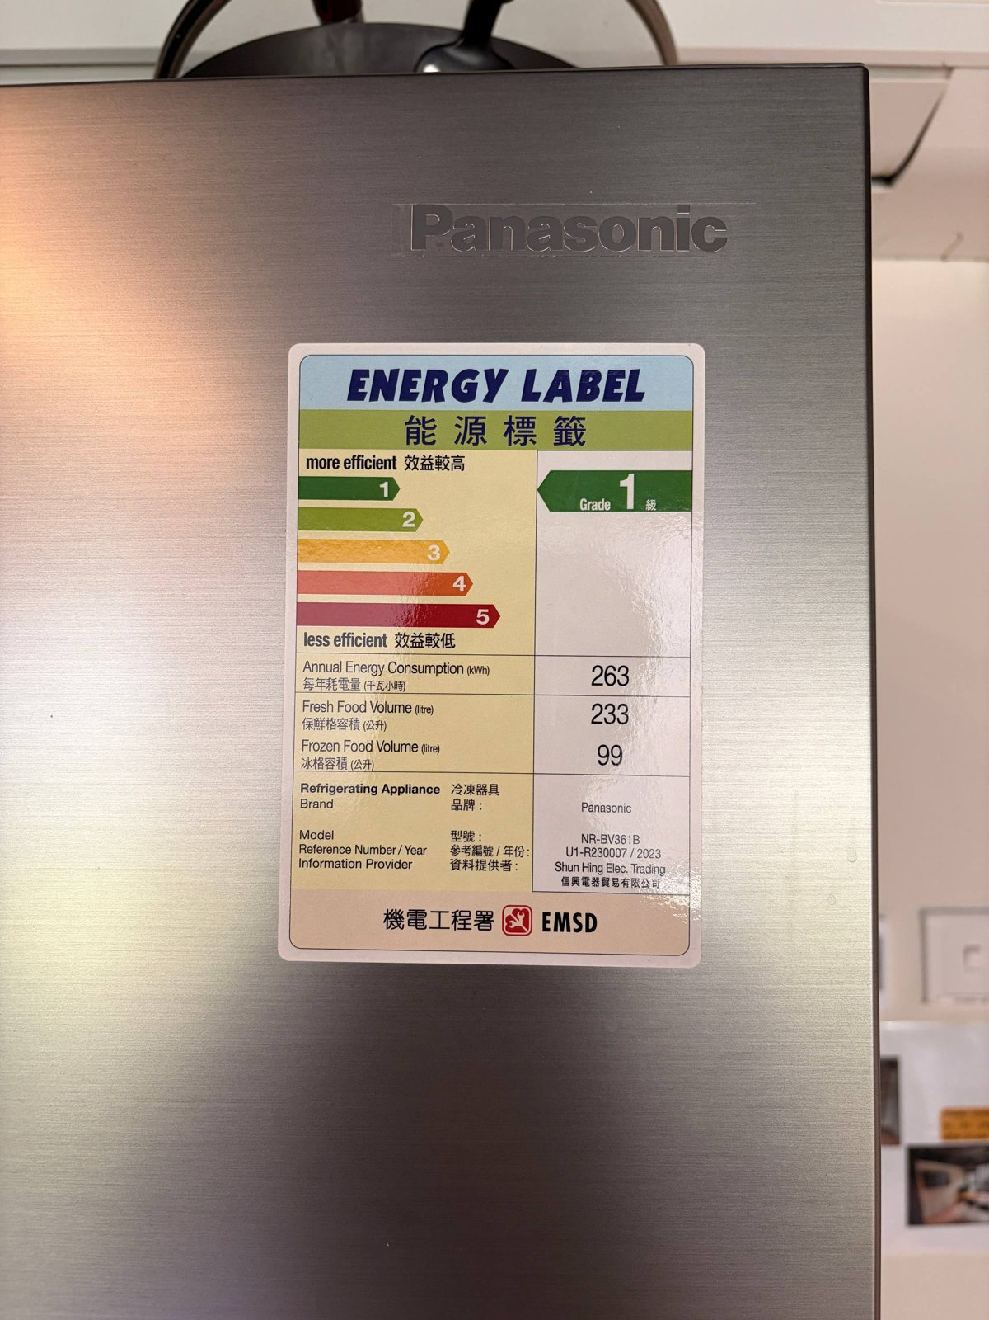  Photo 09i: refrigerator label, Grade 1, 263 kWh/yr | 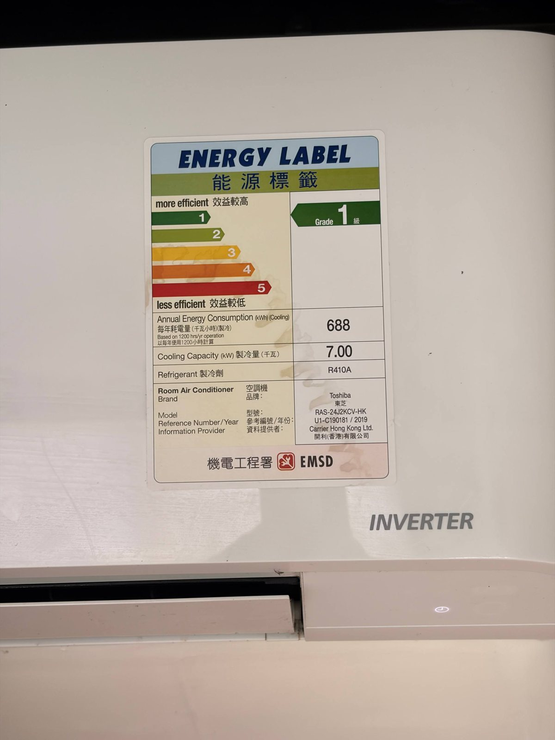  Photo 09g: kitchen AC label, 688 kWh/1,200 h | 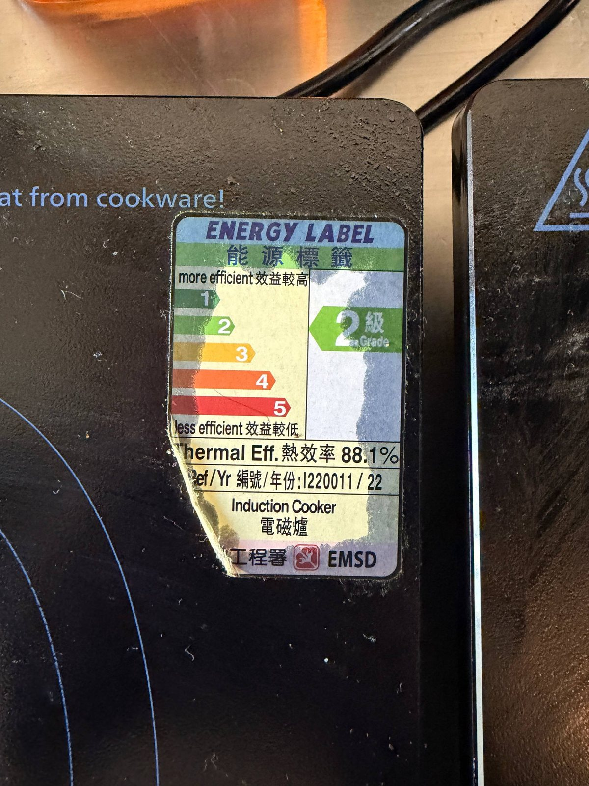  Photo 09e: induction hob, Grade 2, 88.1%
Figure 5.4: Energy labels of shared kitchen appliances

6 Energy consumption analysis (EAC §8.1(d), (g))

6.1 Room air-conditioning baseline: two independent methods
Only the room AC is metered, through Octopus pre-paid charges. The occupants report spending about HK$140 a month in hot months and HK$50 in cool months, HK$1,140 a year for both. Dividing by the CLP 2026 average net tariff of HK$1.406/kWh [6] gives a top-down baseline of 811 kWh/yr.
The bottom-up check takes the label's average input (0.302 kW) and multiplies it by the reported pattern of 12 h/day in May-Oct and 4 h/day in Nov-Apr (2,932 h/yr). This gives 884 kWh/yr, +9.1% relative to the spend-based figure (Table 6.1, Figure 6.1). Agreement within 10% between a financial record and an engineering estimate is good evidence that both the reported behaviour and the baseline are realistic.
Table 6.1: Room AC energy - top-down vs bottom-up
Month | Season | Octopus spend | Top-down kWh | Hours | Bottom-up kWh
Jan | Cool | HK$50 | 35.6 | 124 | 37.4
Feb | Cool | HK$50 | 35.6 | 112 | 33.8
Mar | Cool | HK$50 | 35.6 | 124 | 37.4
Apr | Cool | HK$50 | 35.6 | 120 | 36.2
May | Hot | HK$140 | 99.6 | 372 | 112.2
Jun | Hot | HK$140 | 99.6 | 360 | 108.6
Jul | Hot | HK$140 | 99.6 | 372 | 112.2
Aug | Hot | HK$140 | 99.6 | 372 | 112.2
Sep | Hot | HK$140 | 99.6 | 360 | 108.6
Oct | Hot | HK$140 | 99.6 | 372 | 112.2
Nov | Cool | HK$50 | 35.6 | 120 | 36.2
Dec | Cool | HK$50 | 35.6 | 124 | 37.4
Year |  | HK$1,140 | 810.8 | 2,932 | 884.5
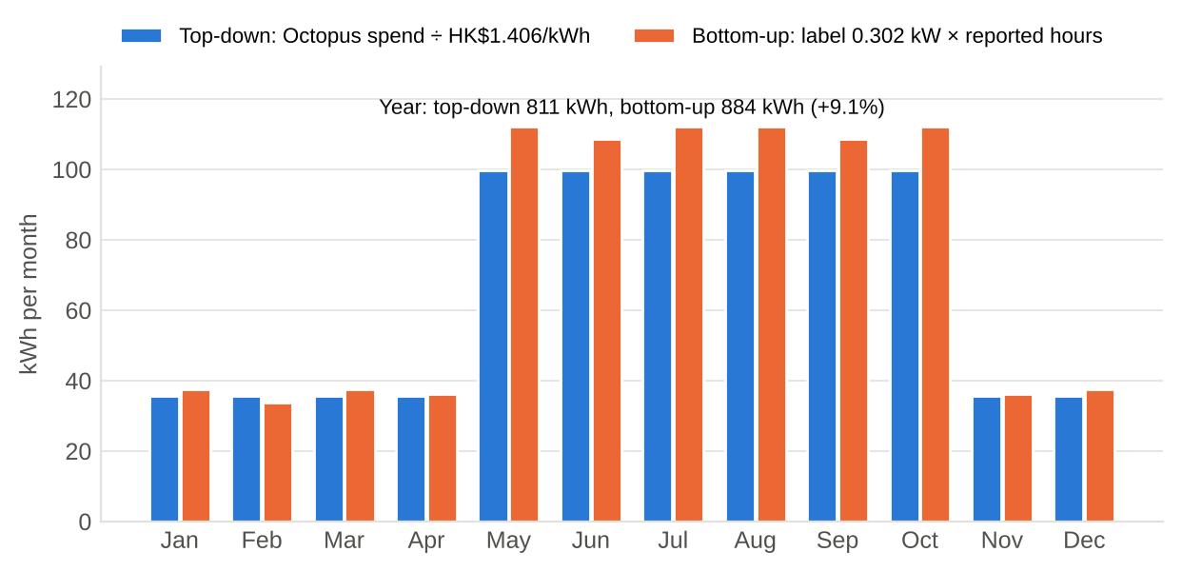
Figure 6.1: Monthly room AC energy, top-down vs bottom-up
What the reconciliation shows:
- If the bottom-up figure were exact, the implied Octopus rate would be HK$1.29/kWh. That lies between the CUHK hostel rate (HK$1.20) and the CLP average (HK$1.406), consistent with an at-cost charge [25].
- Average input while running is only 0.277 kW, 23% of the rated input. This confirms that the inverter mostly runs at part load in a small, lightly loaded room. It is equivalent to 680 full-load hours a year.
- 73.7% of AC energy falls in May-October, so hot-season measures matter most.
- The occupants' first estimate of "about HK$120 a month" would imply 1,024 kWh/yr. It is not consistent with their more specific seasonal figures, so it is treated as an upper bound (+8% in Section 11).

6.2 Shower hot water
Shower energy is not metered, so it was calculated from first principles. Each occupant takes one 5-minute shower a day at an assumed 9 L/min, which is 45 L a day. The water is heated to 40 °C from a mains temperature taken as the HKO monthly mean air temperature, at 99% heater efficiency.
- The annual-average temperature rise is 16.5 K.
- Household shower energy is 635 kWh/yr, 0.87 kWh per person per day.
- January uses 2.12 times as much energy as July (Figure 6.2). The cool months therefore partly offset the hot-season AC peak, which flattens the monthly profile.
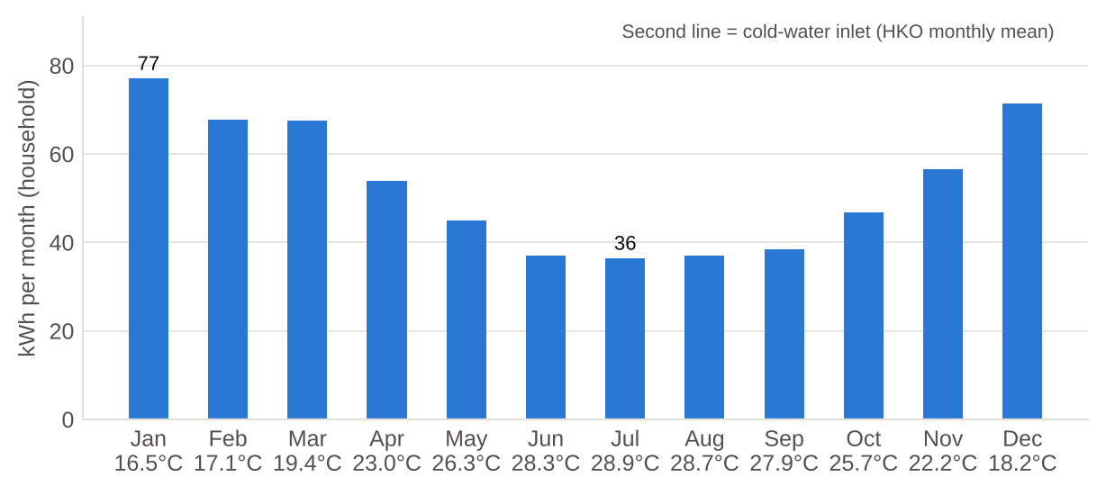
Figure 6.2: Monthly household shower energy and cold-water inlet temperature

6.3 Annual consumption and end-use breakdown
The household uses 2,586 kWh a year (1,293 kWh per person).
- Air-conditioning is the largest end-use at 34.4%: the room AC plus the household's share of the kitchen AC.
- Shower hot water is next at 24.5%, then cooking at 12.1%.
- Lighting is only 6.4%.
- The washroom exhaust fan's share (5.1%) is larger than all the room's lighting together, even though it is only half of one fan.
Table 6.2: Household electricity by end-use
End-use | kWh/yr | Share | kWh/person/yr | kg CO₂e/yr (CLP) | kg CO₂e/yr (0.7)
Air-conditioning | 889.5 | 34.4% | 444.8 | 302.4 | 622.7
Hot water | 634.7 | 24.5% | 317.4 | 215.8 | 444.3
Cooking | 312.0 | 12.1% | 156.0 | 106.1 | 218.4
Plug loads | 204.4 | 7.9% | 102.2 | 69.5 | 143.1
Lighting | 166.1 | 6.4% | 83.0 | 56.5 | 116.3
Ventilation | 131.4 | 5.1% | 65.7 | 44.7 | 92.0
Air movement (fan) | 87.6 | 3.4% | 43.8 | 29.8 | 61.3
Laundry | 93.6 | 3.6% | 46.8 | 31.8 | 65.5
Drinking water | 34.2 | 1.3% | 17.1 | 11.6 | 24.0
Refrigeration | 32.9 | 1.3% | 16.4 | 11.2 | 23.0
Total | 2,586.4 | 100.0% | 1,293.2 | 879.4 | 1,810.5
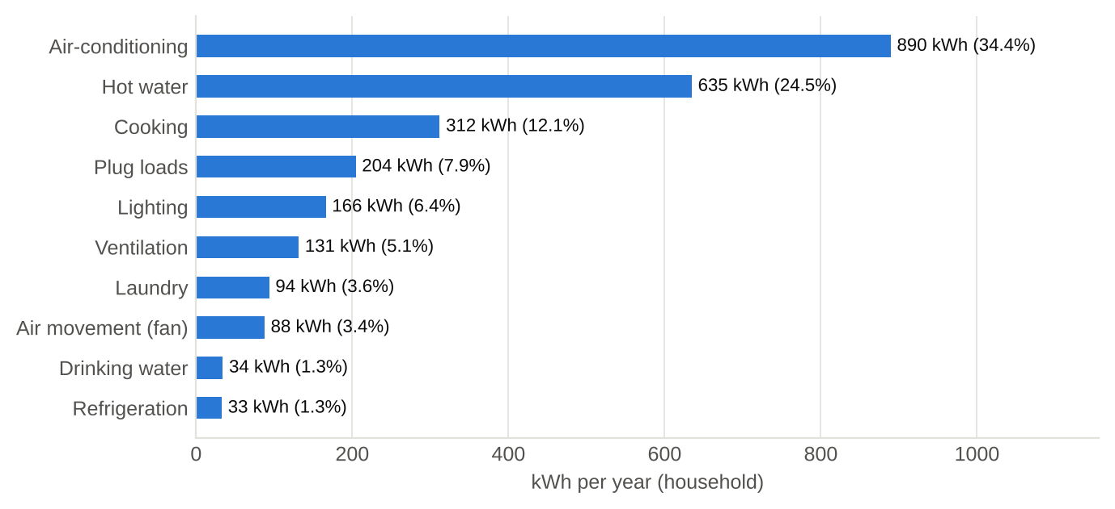
Figure 6.3: Household electricity by end-use (kWh/yr and share)

6.4 Breakdown by EAC installation category (EAC §8.1(g)(iv))
EAC §8.1(g)(iv) asks for the breakdown by installation: air-conditioning, lighting, lift and escalator, and others. The EE-EAes form notes that air-conditioning "includes central mechanical ventilation" [3]. Following that convention, the desk fan and the washroom exhaust fan are counted as air-conditioning.
- Inside the room: air-conditioning is 73.7% of energy.
- For the whole household: air-conditioning is 42.9%, and "others" grows to 50.7% because of water heating and cooking. Lifts and escalators are outside the boundary.
Table 6.3: EAC categories - room vs household
Category | Room kWh/yr | Room share | Room MJ/yr | Household kWh/yr | Household share
Air-conditioning | 898.4 | 73.7% | 3,234 | 1,108.5 | 42.9%
Lighting | 116.8 | 9.6% | 420 | 166.1 | 6.4%
Others | 204.4 | 16.8% | 736 | 1,311.8 | 50.7%
Lift & escalator | 0.0 | 0.0% | 0 | 0.0 | 0.0%
Total | 1,219.6 | 100.0% | 4,391 | 2,586.4 | 100.0%
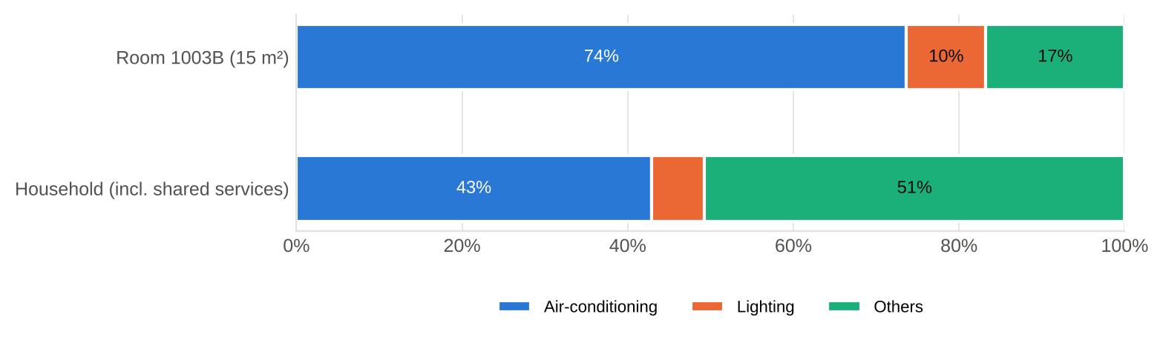
Figure 6.4: EAC installation categories - room vs household

6.5 Monthly profile and monthly EUI (EAC §8.1(g)(iii))
The monthly profile (Table 6.4) is presented graphically in Figures 6.5 and 6.6, as EAC §8.1(g)(v) requires. It is flatter than the AC alone would suggest. In winter, shower energy rises as AC use falls. Household use ranges from 181 kWh in April to 246 kWh in October. Because the room's own loads are dominated by the AC, the monthly EUI of the room roughly doubles between the cool months (about 16.1 MJ/m²) and the hot months (about 32.2 MJ/m²).
Table 6.4: Monthly energy, room EUI and emissions (typical year)
Month | Days | Season | Room AC | Hot water | Cooking | Other | Household kWh | Room EUI MJ/m² | kg CO₂e (CLP)
Jan | 31 | Cool | 35.6 | 77.0 | 26.5 | 68.2 | 207.2 | 16.87 | 70.5
Feb | 28 | Cool | 35.6 | 67.8 | 23.9 | 61.6 | 188.8 | 16.06 | 64.2
Mar | 31 | Cool | 35.6 | 67.5 | 26.5 | 68.2 | 197.7 | 16.87 | 67.2
Apr | 30 | Cool | 35.6 | 53.9 | 25.6 | 66.0 | 181.1 | 16.60 | 61.6
May | 31 | Hot | 99.6 | 44.9 | 26.5 | 72.6 | 243.6 | 32.23 | 82.8
Jun | 30 | Hot | 99.6 | 37.1 | 25.6 | 70.3 | 232.6 | 31.96 | 79.1
Jul | 31 | Hot | 99.6 | 36.4 | 26.5 | 72.6 | 235.0 | 32.23 | 79.9
Aug | 31 | Hot | 99.6 | 37.0 | 26.5 | 72.6 | 235.7 | 32.23 | 80.1
Sep | 30 | Hot | 99.6 | 38.4 | 25.6 | 70.3 | 233.8 | 31.96 | 79.5
Oct | 31 | Hot | 99.6 | 46.9 | 26.5 | 72.6 | 245.5 | 32.23 | 83.5
Nov | 30 | Cool | 35.6 | 56.4 | 25.6 | 66.0 | 183.6 | 16.60 | 62.4
Dec | 31 | Cool | 35.6 | 71.4 | 26.5 | 68.2 | 201.7 | 16.87 | 68.6
Year | 365 |  | 810.8 | 634.7 | 312.0 | 828.9 | 2,586.4 | 292.7 | 879.4
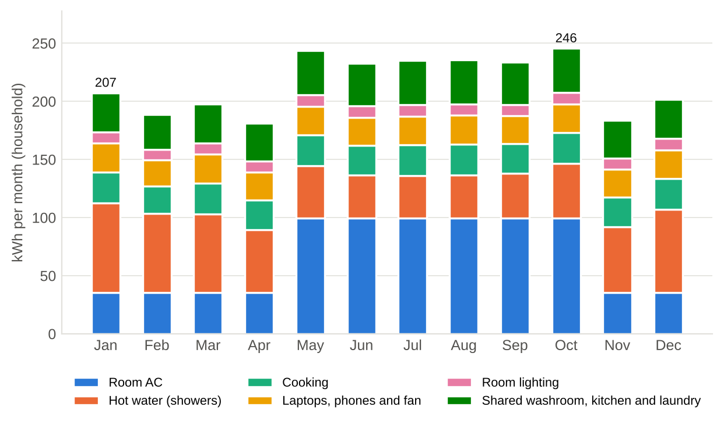
Figure 6.5: Household electricity by month and end-use group
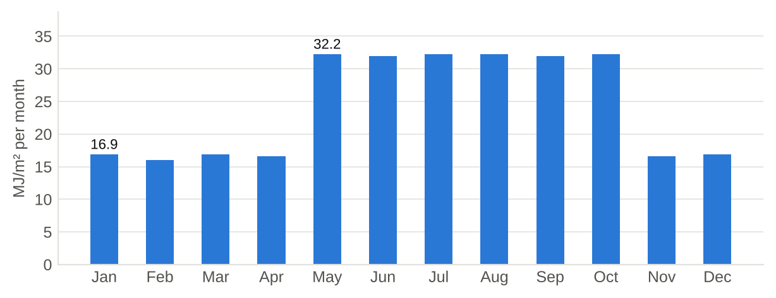
Figure 6.6: Monthly EUI of Room 1003B (MJ/m² per month)

6.6 Energy Utilisation Index and benchmarks
The room's EUI is 292.7 MJ/m²/yr (81.3 kWh/m²/yr). Hong Kong does not publish a statutory residential EUI benchmark, so one was derived from public statistics. A typical three-person household uses 275 kWh a month [7], and the median floor area per person is about 16 m² [23]. Together these give about 68.8 kWh/m²/yr (248 MJ/m²/yr).
The room is 1.18 × this benchmark, and household electricity per person is 1.18 × the typical 1,100 kWh. Two caveats apply:
- typical homes often cook and heat water with Towngas, whereas this household is all-electric, so the electricity comparison is conservative;
- the room has half the median floor area per person, so the same AC use is concentrated over fewer square metres.
Water use is well below average (70.6 vs 120.9 L/person/day [13]), and lighting power density is well below the BEC limit (Figure 6.7).
Table 6.5: Key performance indicators vs Hong Kong benchmarks
Indicator | This household | Benchmark | Ratio | Benchmark source
Room EUI (kWh/m²/yr) | 81.3 | 68.8 | 1.18 | 275 kWh/month ÷ 3 persons ÷ 16 m² [7], [23]
Electricity per person (kWh/yr) | 1,293 | 1,100 | 1.18 | Typical 3-person household [7]
Fresh water (L/person/day) | 70.6 | 120.9 | 0.58 | HK domestic 2023/24 [13]
Floor area per person (m²) | 7.5 | 16.0 | 0.47 | 2021 Census median [23]
Lighting power density (W/m²) | 4.0 | 6.2 | 0.65 | BEC 2021 dormitory [24]
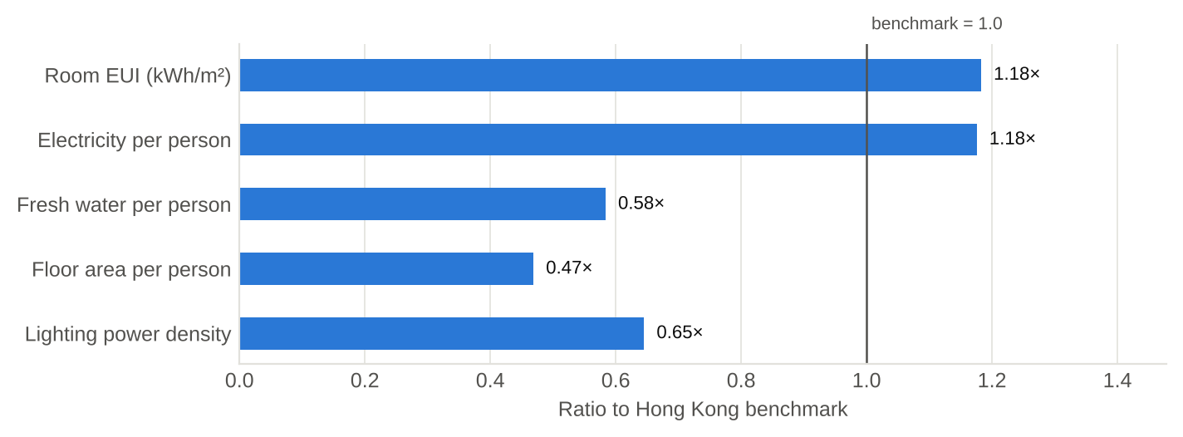
Figure 6.7: Household indicators as a ratio of Hong Kong benchmarks

6.7 Energy used outside the room (EAC §8.1(h))
EAC §8.1(h) asks how much energy central services supply to the building's units. The equivalent here is the share of household energy used in shared facilities: 52.8%, or 1,367 kWh/yr. It splits into the washroom (783 kWh), the kitchen (491 kWh) and the laundry (94 kWh).
This is the most important structural finding of the audit. A resident who changed only in-room habits could reach less than half of the household's footprint. EAC §7.4.3 allows EMOs that depend on other responsible persons to be recorded and conveyed to them for follow-up [1]. Here the roles are reversed: the audited unit is the room, and the person responsible for the shared services is the hall management. Many EMOs therefore have to be conveyed to the hall management.

7 Greenhouse-gas inventory

7.1 Emission factors
Table 7.1: Emission factors used (Hong Kong-specific where available)
Activity | Factor | Basis and source
Electricity - CLP Power (headline) | 0.34 kg CO₂e/kWh | CLP Power HK, electricity sold, 2025 (0.38 in 2024; 0.39 in 2023) [5]
Electricity - territory-wide default | 0.70 kg CO₂e/kWh | Guideline Table 5; must also be reported [2]
Fresh water (WSD) | 0.437 kg CO₂e/m³ | 0.624 kWh/m³ (WSD 2023/24) × 0.7 - Guideline Table 8 method [11]
Sewage (DSD) | 0.203 kg CO₂e/m³ | 0.29 kWh/m³ (DSD 2021/22) × 0.7 - Guideline Table 9 method [12]
Seawater for flushing (WSD) | 0.253 kg CO₂e/m³ | 0.362 kWh/m³ × 0.7 (optional item) [11]
Paper to landfill | 4.8 kg CO₂e/kg | Guideline Table 7 [2]
Refrigerants (GWP) | HFC-32: 650; R-410A: 1,725 | Guideline Table 3-1 [2]
The Guidelines date from 2010, and their tabulated factors (e.g. CLP 0.54 kg/kWh in 2008, water 0.424 kg/m³) are out of date. As the Guidelines themselves instruct, the latest published factors have been used with the Guidelines' methods [2]. CLP's factor has fallen from 0.39 (2023) to 0.34 kg CO₂e/kWh (2025) as its fuel mix has shifted towards natural gas and non-carbon sources [5].

7.2 Scope 1 - direct emissions
Combustion (Guideline Table 1): nil. There is no Towngas, LPG or other fuel, because cooking (induction) and water heating (electric) are all-electric.
Refrigerant (Guideline Table 3): the mass-balance method uses the change in refrigerant stock (purchases, disposals, inventory). The occupants hold no refrigerant, so this method gives zero. That would understate reality, so a screening estimate (IPCC operating leak rate of 4% of charge per year [21]) is added to Scope 1. The charges are assumed, because neither was on the photographed labels (Table 7.2).
Table 7.2: Scope 1 screening estimate of fugitive refrigerant
Equipment | Refrigerant | Charge (kg) | Leak rate | GWP | Household share | kg CO₂e/yr
Room window AC | R32 | 0.40 | 4% | 650 | 1 | 10.4
Kitchen split AC | R-410A | 1.40 | 4% | 1,725 | 2/32 | 6.0
Scope 1 total |  |  |  |  |  | 16.4

7.3 Scope 2 - purchased electricity
Table 7.3: Scope 2 by facility (Guideline Table 5 format)
Facility / source | kWh/yr | kg CO₂e/yr (CLP 0.34) | kg CO₂e/yr (default 0.7)
Room 1003B (incl. Octopus-metered AC) | 1,219.6 | 414.7 | 853.7
Shared washroom (own showers + 2/4 of fan & lights) | 782.5 | 266.1 | 547.8
Shared kitchen (own cooking + 2/32 of fixed loads) | 490.6 | 166.8 | 343.4
Hall laundry (own use) | 93.6 | 31.8 | 65.5
Scope 2 total | 2,586.4 | 879.4 | 1,810.5
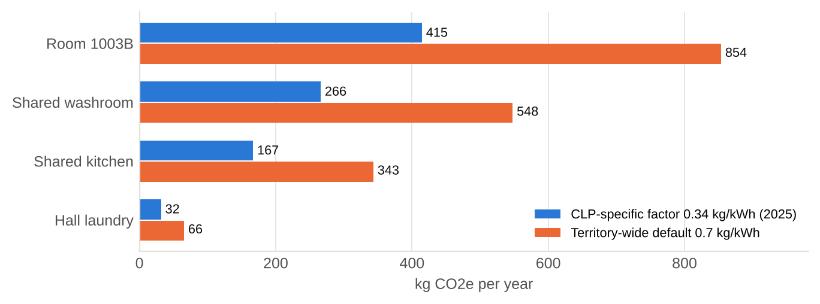
Figure 7.1: Scope 2 emissions by facility under the two required factors

7.4 Scope 3 - water, sewage and paper
Fresh water is estimated bottom-up at 70.6 L per person per day: showers 45 L, drinking water from the dispenser 2 L, basin, cooking and dish-washing about 15 L, and laundry about 8.6 L. The household total is 51.5 m³/yr; all of it is assumed to go to the public sewer.
Toilet flushing uses seawater, which serves about 85% of Hong Kong's population [13]. It is reported separately at 21.9 m³/yr.
Paper: the household uses about 2.0 kg a year. The auditor recycles, and half of the paper is assumed to be recycled. The remainder is counted to landfill at the Guideline factor.
Table 7.4: Scope 3 items (Guideline Tables 7-9 format)
Guideline item | Quantity | Unit | Factor | kg CO₂e/yr
Table 7 - Paper waste to landfill | 1.00 | kg | 4.800 kg CO₂e/kg | 4.80
Table 8 - Fresh water (WSD) | 51.52 | m3 | 0.437 kg CO₂e/m3 | 22.50
Table 9 - Sewage (DSD) | 51.52 | m3 | 0.203 kg CO₂e/m3 | 10.46
Seawater for flushing (WSD, optional) | 21.90 | m3 | 0.253 kg CO₂e/m3 | 5.55
Scope 3 total |  |  |  | 43.31

7.5 Inventory summary
Table 7.5: GHG inventory of the household (kg CO₂e/yr)
Scope | CLP-specific basis | Territory default basis | Share (CLP) | Per person (CLP) | Per person (default)
Scope 1 - direct (refrigerant screening) | 16.4 | 16.4 | 1.8% | 8.2 | 8.2
Scope 2 - purchased electricity | 879.4 | 1,810.5 | 93.6% | 439.7 | 905.2
Scope 3 - water, sewage, paper | 43.3 | 43.3 | 4.6% | 21.7 | 21.7
TOTAL | 939.1 | 1,870.2 | 100.0% | 469.6 | 935.1

The household emits 939 kg CO₂e a year on the CLP-specific basis (470 kg per person), or 1,870 kg on the territory-wide default. Scope 2 electricity is 93.6% of the total; the room's own Scope 2 intensity is 27.6 kg CO₂e/m²/yr. Because Scope 2 dominates, the choice of factor matters more than any single item of equipment.
- The 0.7 default reflects a coal-heavy grid of the 2000s.
- CLP's 2025 factor reflects today's gas and non-carbon mix and is the better estimate of this household's actual emissions.
Reporting both, as required, makes the results comparable with older Hong Kong building inventories.

7.6 Daily-activity extension (reported separately)
The assignment calls this a carbon audit of daily activity, so the auditor's personal travel and diet were also estimated. They are kept outside the building inventory because they fall outside the Guidelines' building boundary. They correspond to Scope 3 categories in the GHG Protocol and ISO 14064-1.
- MTR: 11,820 p-km/yr. This covers an 18 km commute each way, six days a week for 48 weeks, plus three other trips a month of 22 km each way. The factor is MTR's reported rail intensity of 0.0723 kg CO₂e/p-km [17].
- Flights: four flights in the last 12 months (Hong Kong-Delhi, Delhi-Hong Kong, Delhi-Goa, Goa-Hong Kong). Each uses its great-circle distance + 8%, with UK DESNZ 2025 economy factors including radiative forcing [18].
- Diet: mixed (medium meat-eater), taken from Scarborough et al. at 5.63 kg CO₂e/day [19].
Table 7.6: Auditor's daily-activity footprint
Activity | Quantity | Unit | Factor | kg CO₂e/yr
MTR commute (18 km x 2 x 6 days/week) | 10,368 | p-km | 0.0723 kg CO₂e/p-km | 750
Other MTR trips (22 km x 2 x 3/month) | 1,452 | p-km | 0.0723 kg CO₂e/p-km | 105
Flights (4 legs, table below) | 14,335 | p-km | 0.1180 kg CO₂e/p-km | 1,692
Diet - mixed (medium meat-eater) | 365 | days | 5.6300 kg CO₂e/day | 2,055
Lifestyle total |  |  |  | 4,601
Table 7.7: Flight legs
Leg | Great-circle km | Haul | km incl. 8% uplift | Factor (kg/p-km) | kg CO₂e
Hong Kong (HKG) - Delhi (DEL) | 3,747 | Long-haul | 4,047 | 0.11704 | 474
Delhi (DEL) - Hong Kong (HKG) | 3,747 | Long-haul | 4,047 | 0.11704 | 474
Delhi (DEL) - Goa (GOI) | 1,503 | Short-haul | 1,623 | 0.12580 | 204
Goa (GOI) - Hong Kong (HKG) | 4,276 | Long-haul | 4,618 | 0.11704 | 540
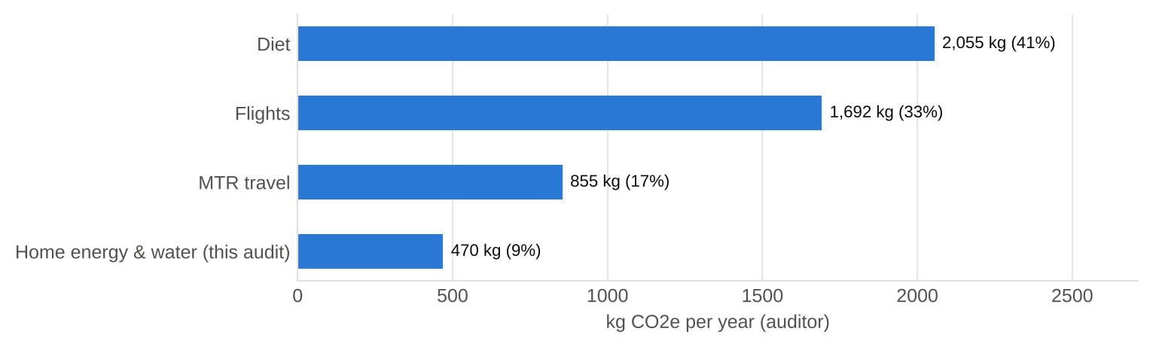
Figure 7.2: The auditor's annual footprint: home energy is a small part
The auditor's total is about 5.1 t CO₂e/yr, 1.11 × Hong Kong's per-capita figure of 4.58 t [10]. That figure is a territorial inventory, which excludes international aviation and the emissions embodied in imported food, so the comparison is indicative only. The key insight is proportion:
- diet (41%) and flights (33%) outweigh the home's energy and water (9%);
- the same pattern of Scope 3 dominance is typical of corporate footprints.

8 Walk-through findings (EAC §7.4.5, §8.1(i))
The site inspection was structured around the four kinds of obvious saving opportunity listed in EAC §7.4.5:
- (a) maintenance condition;
- (b) excessive provision of temperature, light or flow;
- (c) occupant behaviour;
- (d) match of operating schedules to need.
It also covered the building characteristics listed in §7.3.1(k).
Table 8.1: Findings from the walk-through
No. | Finding | EAC clause | Evidence | Leads to
F1 | Dark deposits (dust/mould) on the AC discharge louvres; filter last cleaned 2 months ago | 7.4.5(a) | Photo 03b | EMO-03, EMO-13
F2 | AC set at 25 °C and run all night (12 h/day in hot months) while the occupants sleep | 7.4.5(b), (d) | Questionnaire Q19-20 | EMO-01, EMO-02
F3 | Washroom exhaust fan runs 24 h/day regardless of occupancy | 7.4.5(d) | Photo 08d, Q35 | EMO-09
F4 | Kitchen AC (7 kW) left on for 8 h or more; no one is responsible for switching it off | 7.4.5(c), (d) | Photo 09f, Q46 | EMO-10
F5 | Water dispenser keeps 10 L at 98 °C and an ice tank around the clock; SRO already schedules a weekly auto-clean | 7.4.6(a) | Photo 09b | EMO-11
F6 | Single glazing in a dark aluminium frame facing NW: late-afternoon solar gain in summer | 7.3.1(k) | Photos 02a-02c | EMO-03, EMO-17
F7 | Lighting is all-LED; washroom lights are on occupancy sensors (good practice) | 7.4.1(e) | Photos 05a, 08b | EMO-04 only
F8 | AC, refrigerators and kitchen AC are all Grade 1 labelled; operation, not equipment, drives energy use | 7.4.4(a) | Photos 03a, 09g, 09i | EMO-16 not viable
F9 | 24.4 kW instantaneous shower heater: no standing loss but very high peak demand | 7.4.4(a) | Photos 08a, 08e | EMO-15
F10 | Shower flow and temperature are not displayed; heater dial setting not legible | 7.4.5(b) | Photo 08a | EMO-05, -06, -12
F11 | No metering of non-AC loads, which limits measurement and verification | 7.5.7, 7.6.3 | - | EMO-14
F12 | Good habits already in place: devices unplugged overnight, paper recycled, filtered tap water instead of bottled water | 7.4.5(c) | Questionnaire | Maintain

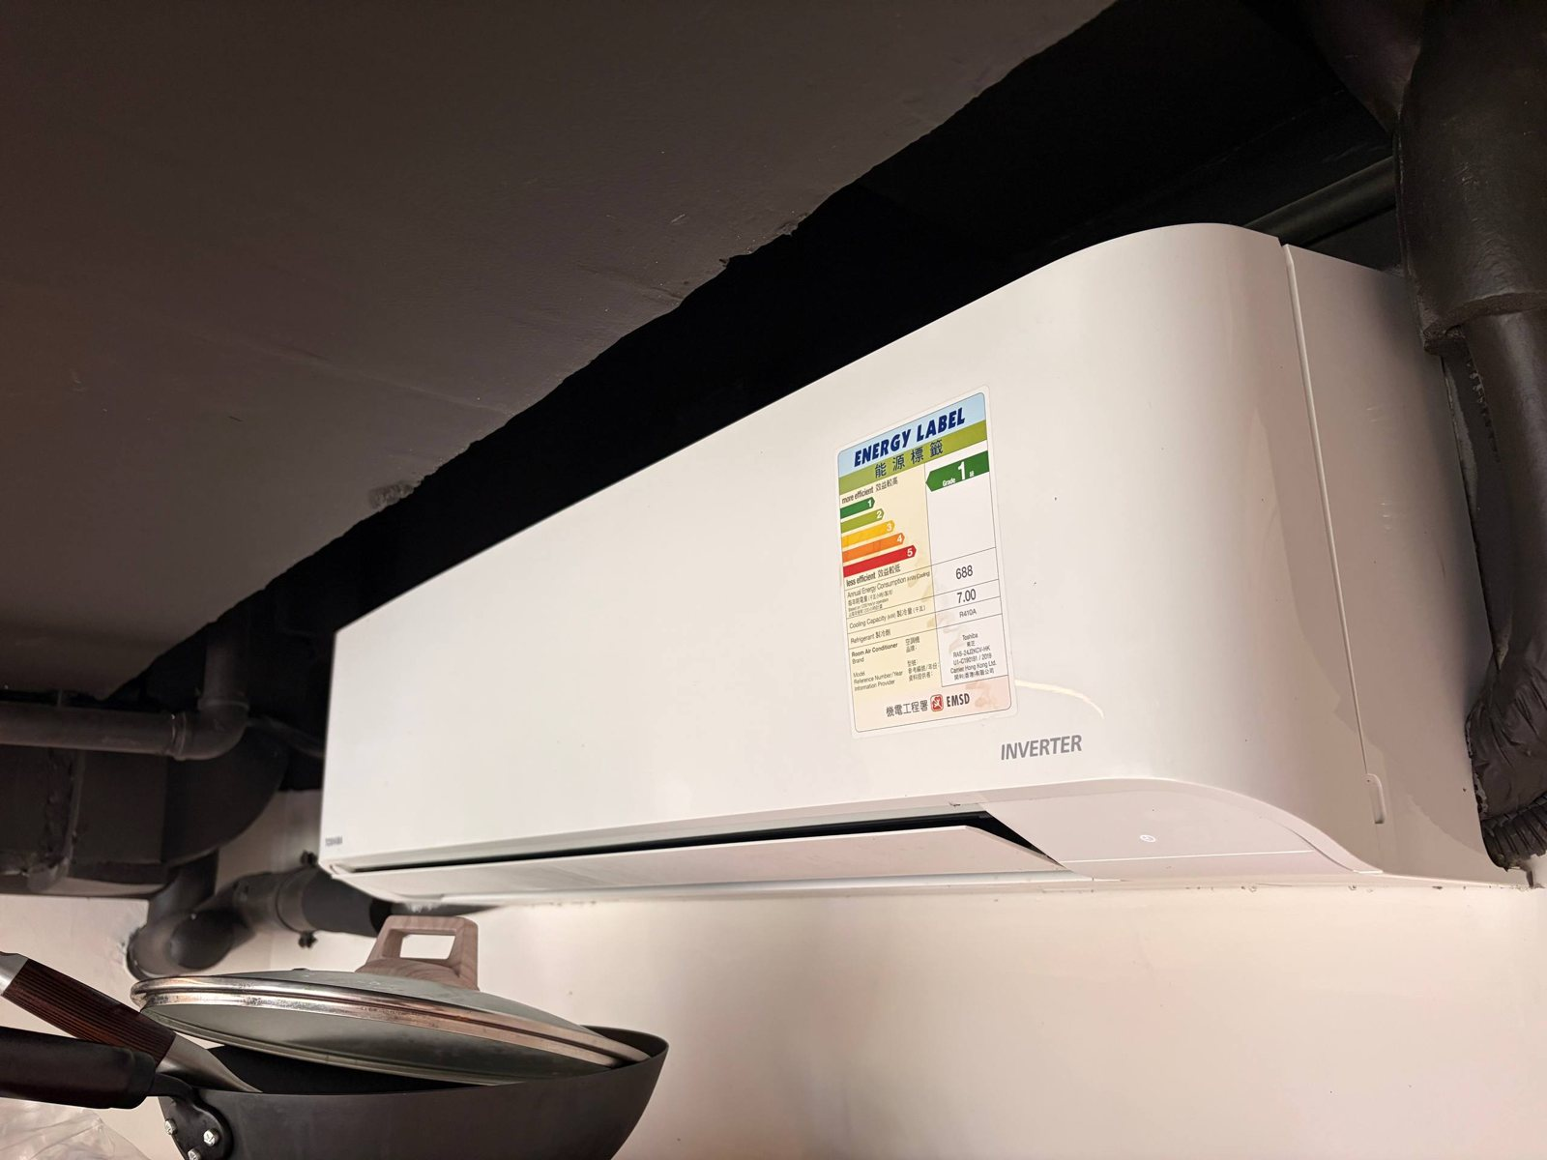  Photo 09f: kitchen AC (F4) | 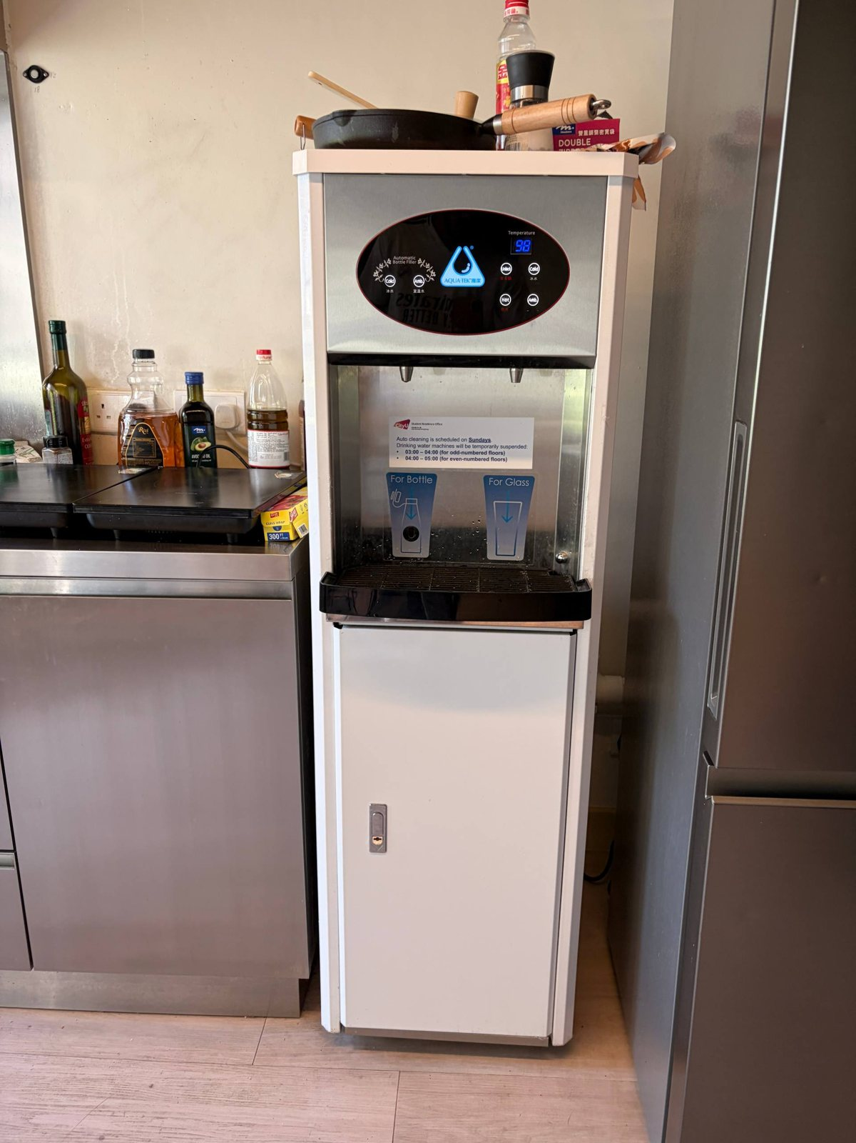  Photo 09b: dispenser at 98 °C (F5) | 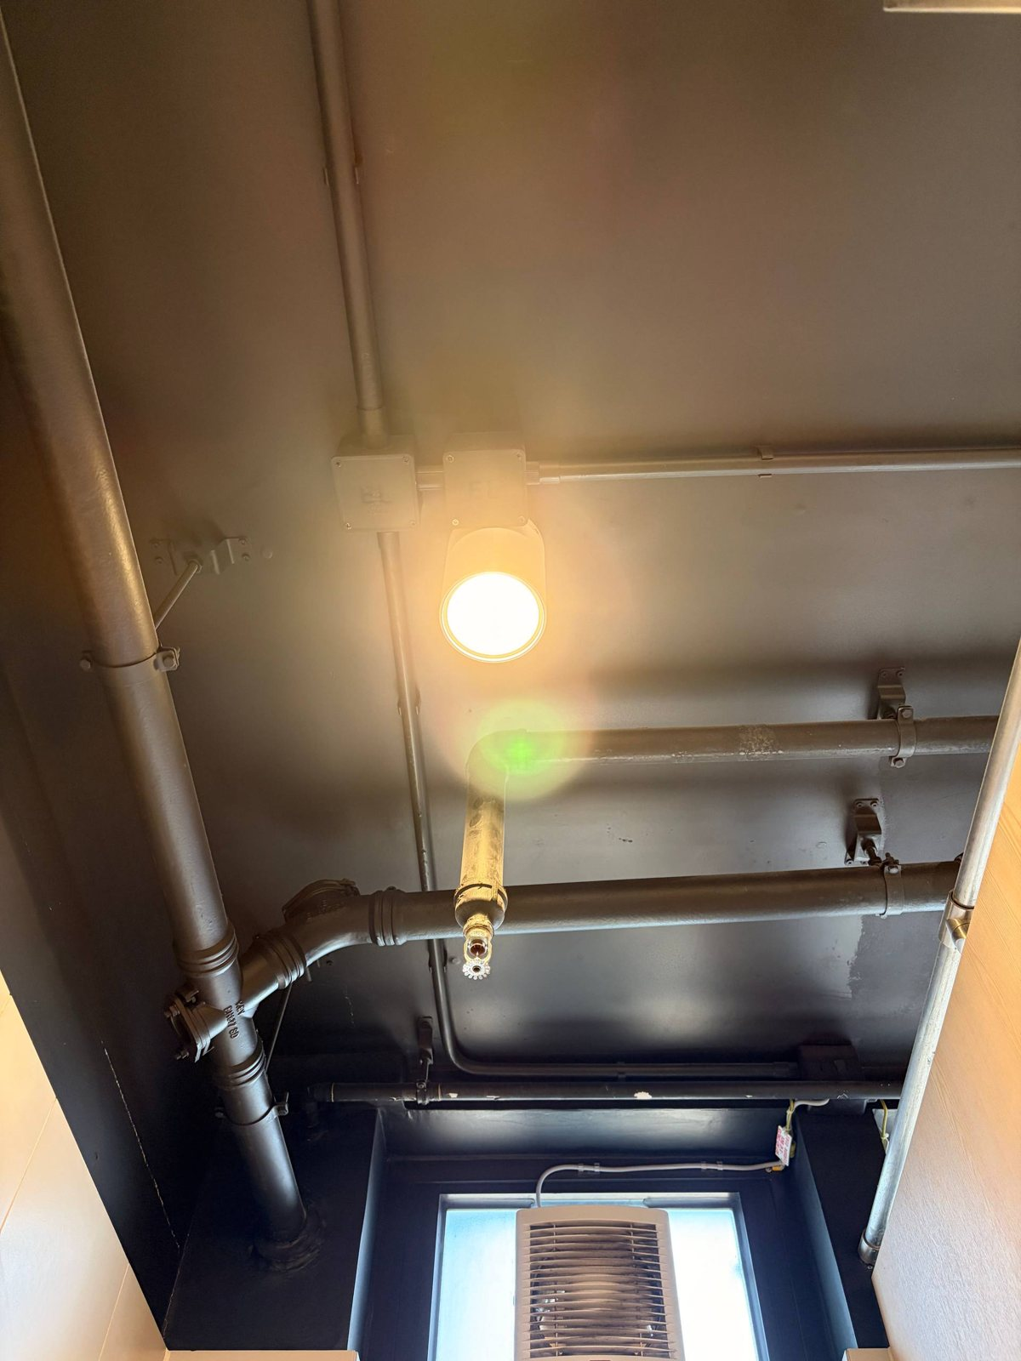  Photo 08c: washroom fan and light (F3)
Figure 8.1: Evidence for findings F3-F5

9 Energy Management Opportunities (EAC §6.2, §7.4-7.5)
Eighteen EMOs were identified and classified using the EAC categories [1]:
- Category I: housekeeping with practically no cost;
- Category II: operational changes with relatively low cost;
- Category III: higher capital investment.
They are also typed as in EE-EAes Part 3: LG lighting, AC air-conditioning, EL electrical, LE lift/escalator, or others.
Savings are shown as the household's share. For hall-level measures, the facility-level savings and paybacks are in the workbook's EMO_Register sheet. Savings are priced at HK$1.406/kWh and converted to CO₂e with the CLP 2025 factor. Capital costs are indicative and should be confirmed by quotation.
Table 9.1: EMO register (household share of savings)
Ref | Cat. | Type | Energy Management Opportunity | kWh/yr | HK$/yr | Cost HK$ | Payback (yr) | kg CO₂e/yr
EMO-01 | I | AC | Raise the AC set-point from 25 °C to 26 °C and keep the 20 W desk fan running for air movement | 24 | 34 | 0 | Immediate | 8
EMO-02 | I | AC | Use the AC's built-in timer to switch off 2 h before waking in hot months (12 to 10 h/day) | 100 | 140 | 0 | Immediate | 34
EMO-03 | I | AC | Clean the AC filter fortnightly in summer, wipe the soiled louvres, close the curtain against late-afternoon NW sun | 41 | 57 | 0 | Immediate | 14
EMO-04 | I | LG | Use the desk task lights instead of both ceiling battens for 3 of the 6 lit hours | 44 | 62 | 0 | Immediate | 15
EMO-05 | I | Others | Shorten showers from 5 to 4 minutes | 127 | 178 | 0 | Immediate | 43
EMO-06 | I | Others | Lower the delivered shower temperature from 40 °C to 38 °C (turn the heater dial down) | 77 | 108 | 0 | Immediate | 26
EMO-07 | I | EL | Laptop power management: lower brightness, sleep after 10 min idle, battery-saver mode | 28 | 40 | 0 | Immediate | 10
EMO-08 | I | Others | Cook with lids, match pan to the induction zone, batch-cook two meals per session | 62 | 88 | 0 | Immediate | 21
EMO-09 | II | AC | Washroom exhaust fan: replace 24 h running with an occupancy / humidistat run-on control (~8 h/day) | 88 | 123 | 800 | 3.2 | 30
EMO-10 | II | AC | Kitchen AC: 7-day timer + occupancy interlock, set-point locked at 25.5 °C (8 to 5 h/day hot, 4 to 2 h/day cool) | 33 | 46 | 1,000 | 1.4 | 11
EMO-11 | II | Others | Water dispenser: enable night set-back / timer on hot and ice tanks (00:00-06:00) | 9 | 12 | 200 | 1.0 | 3
EMO-12 | II | Others | Fit a WELS Grade-1 low-flow showerhead (9 to 7 L/min) in the shared washroom | 141 | 198 | 250 | 0.6 | 48
EMO-13 | II | AC | Annual professional clean of the window-AC coil and louvres (heavy soiling seen in photo 03b) | 24 | 34 | 400 | 11.7 | 8
EMO-14 | II | EL | Buy a plug-in power meter (about HK$120) to measure the laptop, fan and AC and verify savings (EAC §7.6.3) | - | - | 120 | n/a | -
EMO-15 | III | Others | Replace 24.4 kW instantaneous shower heaters with central air-source heat-pump water heating (COP about 3.5) and storage | 455 | 640 | 20,000 | 15.6 | 155
EMO-16 | III | AC | Replace the Grade-1 window AC (CSPF 4.66) with a best-in-class split unit (CSPF about 7.5) | 307 | 431 | 9,000 | 20.9 | 104
EMO-17 | III | AC | Solar-control film on the NW single glazing (1.55 m²) | 16 | 23 | 800 | 35.1 | 6
EMO-18 | III | Others | Expand rooftop solar PV under the CLP Feed-in Tariff (the village already has 110 panels) | - | - | 0 | Immediate | -

9.1 Category I - housekeeping (no cost)
EMO-01 Set-point 26 °C with fan - Each 1 °C rise saves about 3% of AC electricity [14]. Hong Kong's government guideline for offices is 25.5 °C [2], [14]. With the 20 W desk fan raising air speed, 26 °C remains comfortable (the elevated-air-speed principle of ASHRAE 55). Saving 24 kWh/yr.
EMO-02 Sleep timer - The AC's built-in timer switches it off 2 h before waking in hot months. The room stays cool from the overnight run, and the fan continues. Saving 100 kWh/yr (2 of 12 hot-season hours).
EMO-03 Filter, louvres and curtain - Clean the washable filter every two weeks during the cooling season, as the Guidelines' energy-saving tips advise [2]. Wipe the louvres and close the curtain against late-afternoon NW sun. The saving is set at 5%. This is the low end of the US DOE's 5-15% for replacing a clogged filter [32], and consistent with LBNL's finding that typical coil fouling degrades efficiency by less than 5% [26]. Saving 41 kWh/yr; it also improves indoor air quality.
EMO-04 Task lighting - Use the under-shelf desk lights instead of both ceiling battens for 3 of the 6 lit hours. Saving 44 kWh/yr.
EMO-05 4-minute showers - Saves 20% of shower heating energy and water: 127 kWh/yr for the household, plus about 6.6 m³ of water.
EMO-06 38 °C instead of 40 °C - Turn the heater dial down rather than mixing in cold water. Saving 77 kWh/yr, which is 2 K of the 16.5 K average temperature rise.
EMO-07 Laptop power management - Lower screen brightness, sleep after 10 minutes idle and use battery-saver mode. About 15% of laptop energy: 28 kWh/yr.
EMO-08 Efficient cooking - Use lids, match the pan to the induction zone and batch-cook two meals per session. About 20% of cooking energy: 62 kWh/yr.
The Category I package saves about 503 kWh/yr (19.5% of household electricity) and 171 kg CO₂e/yr at no cost. The AC measures (EMO-01 to -03) cut the occupants' own Octopus spend by about HK$231 a year, 20% of it. The other Category I measures mainly reduce energy paid for by the hall: a classic split incentive.

9.2 Category II - low-cost operational changes
EMO-09 Exhaust-fan control (hall) - Replace 24 h running with an occupancy sensor or humidistat with a run-on timer, giving about 8 h a day. Facility saving 175 kWh/yr per washroom (household share 88). Indicative cost HK$800; payback 3.2 years. Hong Kong's humidity makes run-on control essential to avoid condensation.
EMO-10 Kitchen-AC timer and set-point lock (hall) - A 7-day timer with an occupancy interlock, and a set-point fixed at 25.5 °C. Cutting run-hours from 8 to 5 h/day (hot season) and from 4 to 2 h/day (cool season) saves 524 kWh/yr per kitchen. Payback 1.4 years.
EMO-11 Dispenser night set-back (hall) - Use the dispenser's timer to switch off the hot and ice tanks from 00:00 to 06:00. The SRO already suspends the machines weekly for auto-cleaning (Photo 09b), so overnight scheduling is feasible. Saving 137 kWh/yr per kitchen.
EMO-12 Grade-1 showerheads (hall) - A WELS Grade-1 head at about 7 L/min instead of the assumed 9 L/min cuts energy and water by 22% for all four users. That is 282 kWh/yr per washroom; payback 0.6 years, the best of all the EMOs.
EMO-13 Annual AC coil clean (hall) - Saves about 3% of AC energy (24 kWh/yr). The energy payback of 11.7 years exceeds the one-year service interval, so this measure is justified by hygiene (Finding F1) and equipment life rather than energy. It should be bundled with routine maintenance, as EAC §7.6.4 suggests.
EMO-14 Plug-in power meter (occupants) - About HK$120, within the stated HK$200 budget. It measures the laptop, fan and AC directly, which turns the assumed values into measured ones and provides M&V (EAC §7.5.7, §7.6.3). No saving is claimed.

9.3 Category III - capital measures and cost-benefit with service life (EAC §7.5.4)
EMO-15 Heat-pump water heating (CityU) - A central air-source heat pump (COP about 3.5) with storage would replace the 24.4 kW instantaneous heaters. It saves about 72% of shower electricity (910 kWh/yr per washroom) and greatly reduces the hall's maximum demand. The indicative payback of 15.6 years is close to a 15-year life, so it needs a feasibility study covering the demand-charge savings and the space and structural limits of the MiC modules.
EMO-16 Replace the window AC (CityU) - A best-in-class split unit (CSPF about 7.5; Grade-1 units range from 5.06 to 7.51 [27]) would save 307 kWh/yr. However, the payback of 20.9 years exceeds the 12-year service life, and the existing unit is new and Grade 1. Not viable.
EMO-17 Solar-control film (CityU) - On only 1.55 m² of NW glazing, about 2% of AC energy is saved; payback 35.1 years. Not viable at present.
EMO-18 Rooftop PV (CityU) - A viability statement under EAC §7.4.4(d) and §8.1(l)(iii); see Section 9.4.
The paybacks above are simple paybacks at today's tariff. EAC §7.5.4(b) also asks for efficiency degradation over the payback period to be considered. Degradation would lengthen these paybacks further, so it does not change any of the viability conclusions.

9.4 Energy recovery and renewable energy (EAC §7.4.4(c)-(d), §8.1(l)(iii))
Energy recovery: drain-water heat recovery could pre-heat shower water. However, with one shower at a time, instantaneous heating and the tight MiC washroom pods, the recoverable heat is small and the retrofit intrusive, so it is not recommended.
Renewable energy: the village already has 110 rooftop PV panels [15]. Additional roof or façade PV would earn CLP's Feed-in Tariff: HK$3/kWh for 10-200 kW and HK$2.5/kWh for 200 kW-1 MW [22]. The economics are attractive at hall scale but are outside the household's control. They are recommended for study by CityU (EMO-18).
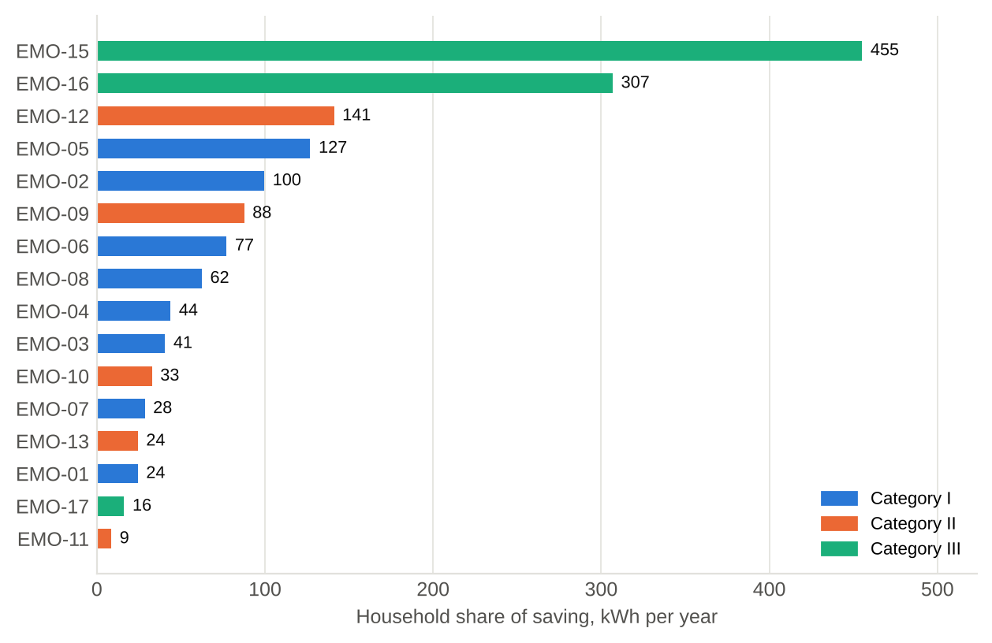
Figure 9.1: Household share of saving by EMO and category
Table 9.2: Combined impact by category (household share)
Category | No. of EMOs | kWh/yr saved | % of household electricity | kg CO₂e/yr (CLP) | Facility-level kWh/yr
Category I | 8 | 503 | 19.5% | 171 | 503
Category II | 6 | 294 | 11.4% | 100 | 1,143
Category III | 4 | 778 | 30.1% | 265 | 1,233
All EMOs* | 18 | 1,576 | 60.9% | 536 | 2,879
*Savings interact (e.g. shorter showers and low-flow heads both reduce the same hot water), so totals are indicative rather than strictly additive. The Category III total includes measures found not viable.

10 Recommendations, implementation and M&V (EAC §7.6)

10.1 Implementation plan
Table 10.1: Action plan
When | Action | Who | Cost | Indicator to track
Now | EMO-01 to -08: set-point 26 °C + fan, timer-off, filter cleaning, task lighting, 4-min showers at 38 °C, laptop settings, efficient cooking | Both occupants | HK$0 | Octopus spend per month; shower timer
Within 1 month | EMO-14: buy a plug-in power meter; measure laptop, fan and AC for 2 weeks | Auditor | About HK$120 | Measured W and kWh
Within 1 month | Send the findings memo (Section 10.3) to the Student Residence Office | Auditor | HK$0 | Reply / action from SRO
Next maintenance cycle | EMO-09 to -13: exhaust-fan control, kitchen-AC timer, dispenser set-back, Grade-1 showerheads, AC coil clean | SRO / hall maintenance | HK$200-1,000 each | Fan and AC run-hours; kitchen meter
Next capital plan | EMO-15 and -18: heat-pump hot water and PV feasibility studies | CityU Campus Development | Study cost | Business case

10.2 Measurement and verification plan (EAC §7.5.3, §7.6.3)
Table 10.2: Metering points, devices and intervals
Quantity | Metering point / device | Interval and duration | Adjustment
Room AC energy | Octopus AC balance (screenshot weekly); plug-in meter if the socket allows | Weekly, 4 weeks before and 4 weeks after the EMOs, in both seasons | Normalise by cooling degree-days from HKO daily data
Laptop and fan energy | Plug-in power meter | 2 weeks each | Per hour of use
Shower flow and time | Bucket test (L/min) and phone timer | Once; then a weekly sample | Inlet temperature by month (HKO)
Kitchen AC and exhaust fan hours | Run-hour log or smart-plug data (hall) | Continuous for 1 month | Occupancy (users per day)
Baseline record | This workbook (Inputs, AC_Baseline) | Kept with the report | Re-run with measured values

10.3 Communication with hall management (EAC §7.4.3)
More than half of the household's energy is in shared facilities, so the most effective EMOs depend on the Student Residence Office. A short memo should be sent to the SRO. It should:
- summarise findings F1, F3, F4 and F5;
- quantify the facility-level savings of EMO-09 to EMO-12 (about 1,118 kWh/yr per washroom and kitchen), and recommend the coil clean (EMO-13) on hygiene grounds;
- suggest piloting them on one floor, with before-and-after readings from the building management system.
This mirrors a corporate audit, where landlord-controlled central services are reported to the responsible persons for follow-up.

10.4 Further studies (EAC §7.6.5)
- Obtain CityU's actual Octopus AC tariff (HK$/kWh) to replace the CLP-average proxy. This is the largest single uncertainty.
- Measure the exhaust-fan, desk-light and ceiling-batten power ratings, and the washroom's floor area.
- Record the water heater's dial setting, and measure the shower flow with a bucket test.
- At hall level: sub-meter the washroom heaters and kitchens, and study the demand-charge benefits of heat-pump water heating.

11 Uncertainty, limitations and sensitivity
Each key assumption was varied one at a time, and household Scope 2 emissions were recalculated in the workbook (Table 11.1, Figure 11.1).
The territory-wide default factor of 0.7 kg/kWh raises the result by 106%. This is a reporting convention rather than an uncertainty, which is why both factors are reported. Among the physical assumptions, the largest effects are:
- AC energy: -12% to +8% across the alternative Octopus tariffs and the occupants' flat HK$120 estimate;
- roommate's habits: -12% if the roommate's personal use is half the auditor's;
- shower flow rate: -5% to +8% for 7-12 L/min.
Combining the main independent uncertainties by root-sum-square gives about ±20% on household electricity, i.e. roughly 2,070-3,103 kWh/yr.
Table 11.1: One-at-a-time sensitivity (household, CLP factor unless stated)
# | Scenario | Value | Room AC kWh | Household kWh | Scope 2 kg | Change
0 | Base case | CLP 0.34; HK$1.406/kWh | 811 | 2,586 | 879 | +0.0%
1 | CLP 2024 emission factor | 0.380 | 811 | 2,586 | 983 | +11.8%
2 | Territory-wide default factor | 0.700 | 811 | 2,586 | 1,810 | +105.9%
3 | Octopus AC rate HK$1.20/kWh (CUHK level) | 1.20 | 950 | 2,726 | 927 | +5.4%
4 | Octopus AC rate HK$2.31/kWh (HKU level) | 2.31 | 494 | 2,269 | 771 | -12.3%
5 | Stated flat average HK$120/month | 120.00 | 1,024 | 2,800 | 952 | +8.2%
6 | Bottom-up AC (label 362 kWh/1,200 h) | 362.00 | 884 | 2,660 | 904 | +2.8%
7 | Shower flow 7 L/min (Grade-1 head) | 7.00 | 811 | 2,445 | 831 | -5.5%
8 | Shower flow 12 L/min | 12.00 | 811 | 2,798 | 951 | +8.2%
9 | Laptop average draw 30% of adapter | 0.300 | 811 | 2,510 | 854 | -2.9%
10 | Laptop average draw 80% of adapter | 0.800 | 811 | 2,700 | 918 | +4.4%
11 | Roommate uses half the auditor's personal loads | 0.500 | 811 | 2,275 | 774 | -12.0%
12 | Kitchen allocated over 20 active users (not 32) | 20.00 | 811 | 2,694 | 916 | +4.1%
13 | One month away (11 of 12 months occupied) | 0.917 | 743 | 2,398 | 815 | -7.3%
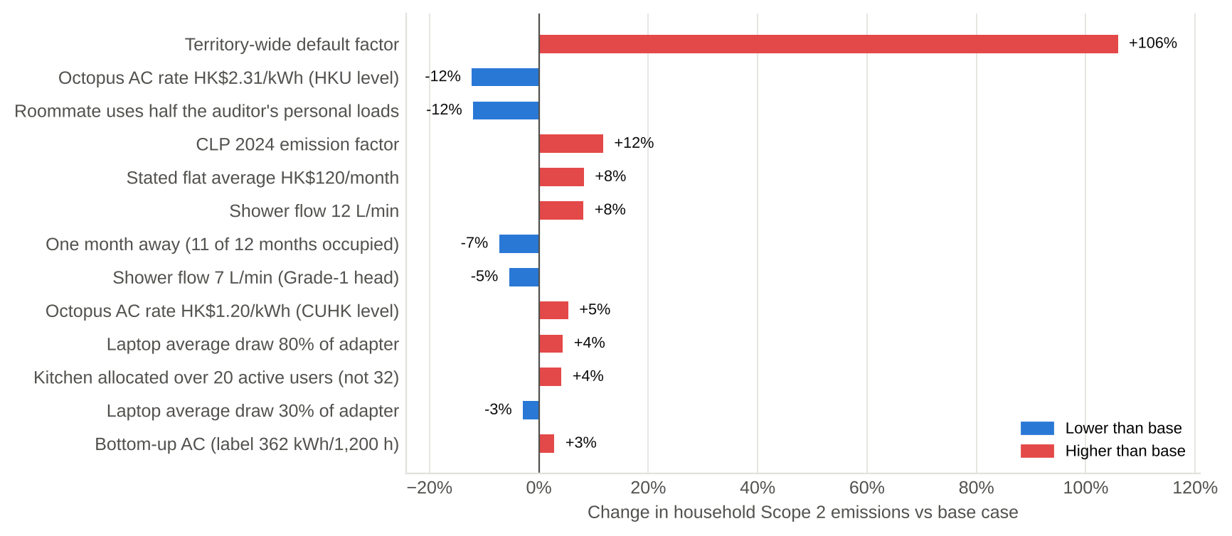
Figure 11.1: Sensitivity of household Scope 2 emissions to each assumption

11.1 Limitations
- No sub-metering: only the AC is metered (through spend), and all other loads are estimated from ratings and reported hours.
- 28 of 104 inputs are typical assumed values. Among them, lighting and fan wattages are assumed because no labels were visible.
- The roommate's personal loads are assumed equal to the auditor's.
- Shared loads are allocated per user, which ignores differences in individual use.
- The label-based AC estimate uses the HK test-condition average, not this room's measured load.
- Cold-water inlet temperature is taken as the monthly mean air temperature.
- The Guidelines (2010) are dated; current factors were substituted, using the Guidelines' methods.
- Daily-activity factors (DESNZ, Scarborough) are not Hong Kong-specific.

12 Conclusions and lessons for the corporate carbon audit

12.1 Conclusions
- The household uses about 2,586 kWh/yr of electricity: 1,293 kWh per person, and a room EUI of 292.7 MJ/m²/yr. This emits 939 kg CO₂e/yr on CLP's 2025 factor, or 1,870 kg on the 0.7 default.
- Air-conditioning (34.4%) and shower hot water (24.5%) dominate. Their seasonality runs in opposite directions, which flattens the monthly profile.
- The equipment is already efficient (Grade-1 labels, LED lighting). The savings lie in operation: set-points, schedules, run-hours of shared plant, and shower habits.
- 52.8% of the household's energy is in shared facilities, so the hall management is an essential partner.
- No-cost Category I measures save about 19.5%. The four main Category II measures at hall level (EMO-09 to EMO-12) pay back in under 4 years. Replacing the AC is not viable.

12.2 Lessons for the corporate carbon audit
- Set the boundary deliberately. In a hostel, as in a multi-tenant office, the energy a user causes sits partly in landlord-controlled central services. Organisational and operational boundaries, and the allocation rules between them, must be decided and documented before any data is collected.
- Build a data hierarchy and fill gaps transparently. Metered data, then nameplate ratings, then reported behaviour, then published values, then assumptions. Each value is tagged and stress-tested.
- Triangulate. Two independent estimates (financial and engineering) that agree within about 10% give far more confidence than one.
- Report emission factors explicitly. Hong Kong's Guidelines require both the territory default and the utility-specific factor; the choice alone changes the answer by a factor of two.
- Expect Scope 3 to dominate. Travel and food far exceeded the home's energy, as purchased goods and business travel typically do in corporate footprints.
- Behaviour and governance beat hardware. Split incentives (who pays versus who decides) shaped the EMO list as much as engineering did.
- Plan M&V from day one. Without metering points, savings cannot be verified (EAC §7.5-7.6).

References
[1] EMSD (2018) Code of Practice for Building Energy Audit (EAC 2018), Buildings Energy Efficiency Ordinance (Cap. 610). Course file EAC_2018.pdf.
[2] EPD & EMSD (2010) Guidelines to Account for and Report on Greenhouse Gas Emissions and Removals for Buildings (Commercial, Residential or Institutional Purposes) in Hong Kong. Course file.
[3] EMSD Technical Form EE-EAes (V.2) - Executive Summary of Energy Audit Report. Course file 2_EE-EAes2018 (V.0)_SEE6115-8115.xls.
[4] Penn State / SMARTdwell Home Energy Audit Tool (course version). Course file 1_SEE6115-8115_Home Energy Audit Tool.xlsx.
[5] CLP Holdings (2026) Sustainability Report 2025 - ESG Data Hub: CO₂e emissions intensity of electricity sold by CLP Power Hong Kong = 0.34 kg/kWh (2025); 0.38 (2024); 0.39 (2023). https://sustainability.clpgroup.com/en/2025/esg-data-hub
[6] CLP Power (2025) 2026 Tariff Adjustment - Average Net Tariff 140.6 cents/kWh (Basic Tariff 101.2 + Fuel Cost Adjustment 39.4). https://www.clp.com.hk/en/clp-power-tariff-adjustment-2026
[7] news.gov.hk (18 Nov 2025) 2026 electricity tariffs reduced - typical 3-person household consuming 275 kWh/month. https://www.news.gov.hk/eng/2025/11/20251118/20251118_171441_586.html
[8] Hong Kong Observatory - Climatological normals 1991-2020 (10-day and half-monthly mean air temperature, HKO Headquarters). https://www.hko.gov.hk/en/cis/normal/1991_2020/15day_normal.htm
[9] EMSD Mandatory Energy Efficiency Labelling Scheme - Room air conditioners: annual energy consumption stated on the label is based on 1,200 hours/year of operation. https://www.emsd.gov.hk/energylabel/en/households/rac/eels_ac_eot_popup.htm
[10] Environment and Ecology Bureau (17 Apr 2025) Hong Kong GHG emission inventory 2023 (AR5): about 4.58 t CO₂e per capita; electricity generation 61% of total. https://www.news.gov.hk/eng/2025/04/20250417/20250417_120238_003.html
[11] Water Supplies Department Annual Report 2023/24 (as cited by HKGBC): unit electricity consumption 0.624 kWh/m3 fresh water, 0.362 kWh/m3 salt water. https://hkgbc.org.hk/eng/resources/publications/HKGBC-Publication/Reports/green-building-in-action/references/2025.jsp
[12] Drainage Services Department Sustainability Report 2021/22 (as cited by HKU Water Centre): average unit electricity consumption of sewage treated 0.29 kWh/m3. https://water.hku.hk/wp-content/uploads/2024/05/221200-ECF_Final-report_website-updates.pdf
[13] HKU Water Centre - Water conservation: per-capita domestic fresh water consumption 120.9 L/day (2023/24); ~85% of population uses seawater for flushing. https://water.hku.hk/water-conservation/
[14] HKSAR Government (4 Jul 2012) LCQ5: raising indoor temperature by 1 degC can reduce AC electricity by around 3%; 25.5 degC guideline. https://www.info.gov.hk/gia/general/201207/04/P201207040635.htm
[15] CityUHK (11 Dec 2024) Opening and Naming Ceremony for Lee Shau Kee Student Residence Village, Ma On Shan - 6 halls in 3 towers, ~2,100 residents, MiC with 1,300+ modules, opened Q3 2024, 110 rooftop PV panels. https://www.cityu.edu.hk/en/media/press-release/2024/12/11/cityuhk-holds-opening-and-naming-ceremony-lee-shau-kee-student-residence-village
[16] Stiebel Eltron DHB-E 27 SLi electronic instantaneous water heater: 27 kW at 400 V / 24.4 kW at 380 V, max 13.8 L/min (HK distributor listing). https://hkele.com.hk/en/DHBE27SLI
[17] MTR Corporation CDP Climate Change 2022 response: Hong Kong rail intensity 0.0000723 t CO₂e per passenger-km (1,079,402 t / 14.93 bn p-km). https://www.mtr.com.hk/sustainability/assets/pdf/en/2022/MTR_CDP_Response.pdf
[18] UK DESNZ (2025) Greenhouse gas reporting: conversion factors 2025 - Business travel (air), economy class, with radiative forcing (long-haul 0.11704 kg CO₂e/p-km). https://www.gov.uk/government/publications/greenhouse-gas-reporting-conversion-factors-2025
[19] Scarborough P. et al. (2014) Dietary greenhouse gas emissions of meat-eaters, fish-eaters, vegetarians and vegans in the UK. Climatic Change 125:179-192 (medium meat-eaters 5.63 kg CO₂e/day). https://www.oxfordmartin.ox.ac.uk/publications/dietary-greenhouse-gas-emissions-of-meat-eaters-fish-eaters-vegetarians-and-vegans-in-the-uk
[20] US EPA ENERGY STAR Water Coolers Specification V2.0: storage-type hot & cold units <= 0.87 kWh/day standby. https://www.energystar.gov/sites/default/files/ES%20WC%20V2%200%20Spec.pdf
[21] IPCC (2006) Guidelines Vol.3 Ch.7 - operating emission factor for residential & commercial AC 1-10% of charge per year (summary: ASHRAE Journal, Oct 2022). https://www.ashrae.org/technical-resources/ashrae-journal/featured-articles/october-2022-analysis-of-refrigerant-use-for-ac-equipment-maintenance
[22] CLP Power (26 Apr 2022) Feed-in Tariff rates: HK$4/kWh (<=10 kW), HK$3/kWh (>10-200 kW), HK$2.5/kWh (>200 kW-1 MW). https://www.clpgroup.com/content/dam/clp-group/channels/media/document/2022/20220426_en.pdf.coredownload.pdf
[23] Development Bureau LCQ22: median per-capita floor area of domestic households 172 sq ft (~16 m2), 2021 Population Census. https://www.devb.gov.hk/en/sdev/press/index_id_11447.html
[24] EMSD - BEC 2021 vs BEC 2024 comparison: maximum lighting power density, Dormitory 6.2 W/m2 (BEC 2021), 6.1 W/m2 (BEC 2024). https://emsd.gov.hk/beeo/en/pee/BEC2021vsBEC2024.pdf
[25] Comparator hostel AC charges: HKU Jockey Club Student Village IV HK$2.31/kWh (2025/26); CUHK hostels HK$1.2/kWh. https://wys.cuhk.edu.hk/college-life-support/information-for-residents/
[26] Siegel J. et al. (2002) Dirty air conditioners: energy implications of coil fouling, LBNL - typical efficiency/capacity degradation < 5%. https://www.osti.gov/biblio/805122
[27] Consumer Council (May 2026) test of 13 x 1.5 HP Grade-1 inverter split ACs: CSPF 5.06-7.51 (RTHK report). https://news.rthk.hk/rthk/en/component/k2/1854660-20260514.htm
[28] Midea MW-12CRF8E 1.5 HP R32 inverter window AC - HK retailer specification (auditor screenshot + listing). https://www.feverelectrics.com/en/products/midea-mw12crf8e-1-5hp-r32-inverter-window-type-air-conditioner
[29] Auditor's completed questionnaire (audit-inputs/QUESTIONNAIRE.md) and 26 site photographs (photos/), Oct 2026.
[30] HKSAR Government press release (26 Jun 2024) Energy Saving and Decarbonisation for All campaign: buildings account for about 90% of Hong Kong's electricity consumption. https://www.info.gov.hk/gia/general/202406/26/P2024062600623.htm
[31] HKSAR Government (8 Oct 2021) Hong Kong's Climate Action Plan 2050: carbon neutrality before 2050; halve emissions by 2035 vs 2005; cut residential-building electricity use 20-30% (commercial 30-40%) from 2015 levels by 2050, half of that by 2035. https://www.info.gov.hk/gia/general/202110/08/P2021100800588.htm
[32] US Department of Energy, Energy Saver - Maintaining your air conditioner: replacing a dirty, clogged filter with a clean one can lower AC energy consumption by 5% to 15%. https://www.energy.gov/energysaver/maintaining-your-air-conditioner

Appendix A - Questionnaire responses (summary)
The full answers are in audit-inputs/QUESTIONNAIRE.md in the project repository.
Question | Response
A1-A5 Admin | Jayash Sahu; SEE8115; Hall 13, 10/F, Room 1003B; survey 01/01/2026 to present; roommate not named
B6 Floor area | About 15 m²
B7 Window direction | 328° NW (phone compass)
B8 Window | 2 × 0.67 m² + 0.209 m²; single glazing; metal frame; curtains
B9 Direct sun | Afternoon, about 40 minutes
B10 Building age | Answered 6-12-2024; the residence opened in 2024 [15]
B11-B12 Washroom / kitchen | Washroom size unknown (4 users); kitchen shared by 32 residents
C13-C15 Occupancy | Weekdays 22:00-11:00; weekends in hall (Sat 20 h, Sun 18 h); 1-month break in the last 10 months
D16 AC | Window, Midea 1.5 HP R32 inverter MW-12CRF8E, 11,400 Btu/h, input 1,192 W
D17-D18 AC charging | Octopus card, rate unknown; about HK$120/month combined; hot months HK$140, cold months HK$50
D19-D21 AC use | 25 °C, on all night; summer 12 h/day, winter 4 h/day; never with window open; filter cleaned 2 months ago
D22 Fan | One 20 W electric fan, 12 h/day
E23-E26 Lighting | 2 LED ceiling lights (6 h/day); 2 LED desk lights (wattage unknown); washroom sensor lights (about 3 h)
F27-F31 Electronics | 65 W laptop charger, 8 h/day; no monitor/PC/console; phone 1 h/day; no router/printer; nothing left on standby
G32 Other appliances | None
H33-H35 Washroom | Instantaneous tankless heater, 380 V (Stiebel Eltron DHB-E 27); 5-min showers; exhaust fan always on
I36-I38 Kitchen | 2 Panasonic NR-BV361B fridges (263 kWh/yr); Toshiba MW2-MM24PC microwave (800 W output); 2 Philips HD4911/80 induction (2,100 W); Aquatek AQ-1323T dispenser (750 W/160 W); cooking 3×/week, 1 h; about 20 active users
J39 Laundry | 1 load/week, 4 kg, 45 min wash, 12 min drying
K40-K41 Water and paper | Filtered water 2 L/day; 50 pages printed + 50 sheets used per semester; paper recycled
L42-L45 Daily activity | MTR 18 km × 2 × 6/week; 3 trips/month of 22 km × 2; canteen 7 + self-cooked 7 meals/week, mixed diet; 4 flights: HK-Delhi, Delhi-HK, Delhi-Goa, Goa-HK
M46-M48 Observations | Kitchen AC on 8 h+ (Toshiba RAS-24J2KCV-HK, 688 kWh/1,200 h, 7.00 kW, R410A); no changes allowed in the room; budget HK$200

Appendix B - Photo log
26 photographs were taken during the audit and are stored in the photos/ folder. Each was used to read a rating or label, or to evidence a finding.
Ref | File | What it shows | Data extracted
01 | 01_room_overview.jpg | Room 1003B: twin beds, desks, ceiling LED battens, window AC above NW window | Room layout; equipment present
02a | 02a_window_view.jpg | Window and outlook over Tolo Harbour / Ma On Shan | Single glazing, dark aluminium frame, fly screen
02b | 02b_window_fixed_pane_measured.jpg | Bottom fixed pane measured 1.10 m x 0.17-0.19 m | Glazing area 0.209 m²
02c | 02c_window_casement_measured.jpg | Casement measured 0.53 m x 1.26 m = 0.67 m² | Two casements 1.34 m²
02d | 02d_compass_328NW.jpg | Compass 328° NW, 22°26'0"N 114°14'32"E, Ma On Shan, 44 m | Orientation and location
02e | 02e_curtain_closed.jpg | Full-height grey curtain closed; AC at upper left | Internal shading
03a | 03a_ac_specification.jpg | Midea MW-12CRF8E specification / energy label data | 3.34 kW, 1,192 W, R32, Grade 1, 362 kWh, CSPF 4.66
03b | 03b_ac_front_louvres.jpg | AC front: dark deposits on discharge louvres; Eco, Timer, Dry modes | Maintenance finding; controls available
05a | 05a_ceiling_led_battens.jpg | Two linear LED ceiling battens | Lighting inventory
05b | 05b_desk_led_and_fan.jpg | Under-shelf LED desk light and desk fan | Task lighting
06a | 06a_laptop_adapter_65W.jpg | HP 65 W adapter TPN-CA17, Efficiency Level VI | Laptop power
06b | 06b_desk_fan_label_20W.jpg | Fan label: ZW02-180, 180 mm, 20 W, 220 V | Fan power
08a | 08a_water_heater_DHB-E.jpg | Stiebel Eltron DHB-E electronic instantaneous heater, 30-60 °C dial | Hot-water system type
08b | 08b_washroom_downlights.jpg | Two LED downlights, exposed services, sensor | Washroom lighting
08c | 08c_washroom_light_and_fan.jpg | Downlight and window exhaust fan | Washroom lighting / ventilation
08d | 08d_washroom_exhaust_fan.jpg | J.E.E. window exhaust fan (runs 24 h) | Ventilation finding
08e | 08e_water_heater_spec.jpg | Heater specification: 380 V, max 60 °C | Electrical supply
09a | 09a_dispenser_spec.jpg | Aquatek AQ-1323T: 750 W heater, 160 W compressor, 10 L hot / 7.9 L cold / 3 L ice | Dispenser ratings
09b | 09b_water_dispenser.jpg | Dispenser in kitchen, hot water at 98 °C; SRO cleaning notice | Standing losses
09c | 09c_induction_cooker_spec.jpg | Philips HD4911: 2,100 W, EEL Grade 2 | Cooking power
09d | 09d_induction_cooker_product.jpg | Philips 5000 Series HD4911/80 (retailer image) | Model identification
09e | 09e_induction_energy_label.jpg | Energy label Grade 2, thermal efficiency 88.1% (I220011/22) | Cooking efficiency
09f | 09f_kitchen_split_ac.jpg | Toshiba split AC in kitchen (also used as photo 12 - left on 8 h+) | Kitchen AC
09g | 09g_kitchen_ac_energy_label.jpg | Label: 688 kWh/yr @1,200 h, 7.00 kW, R410A, Grade 1 | Kitchen AC energy
09h | 09h_microwave.jpg | Toshiba MW2-MM24PC 24 L, 800 W output | Kitchen inventory
09i | 09i_fridge_energy_label.jpg | Panasonic NR-BV361B: Grade 1, 263 kWh/yr, 233 + 99 L | Refrigeration energy

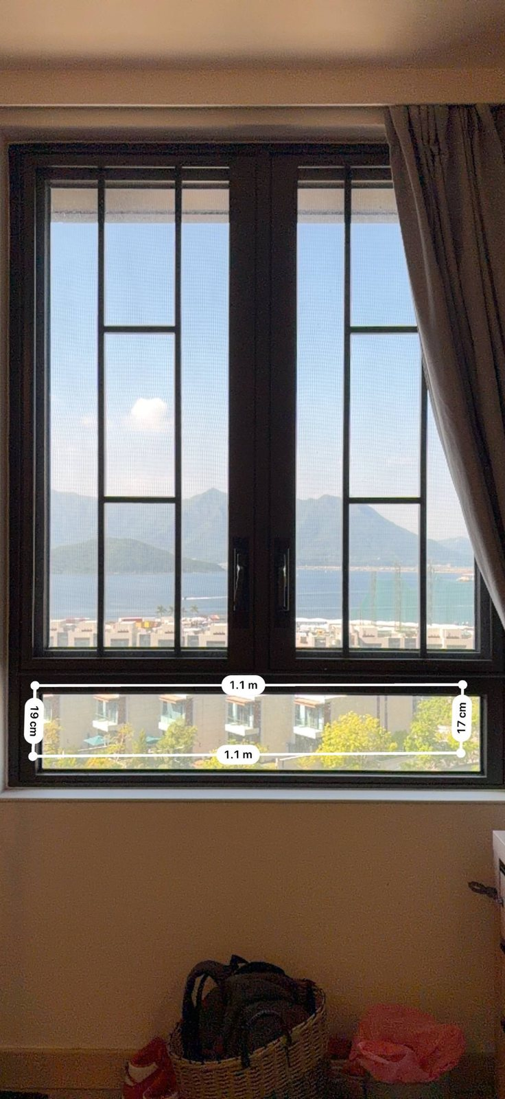  02b: fixed pane 1.10 × 0.19 m | 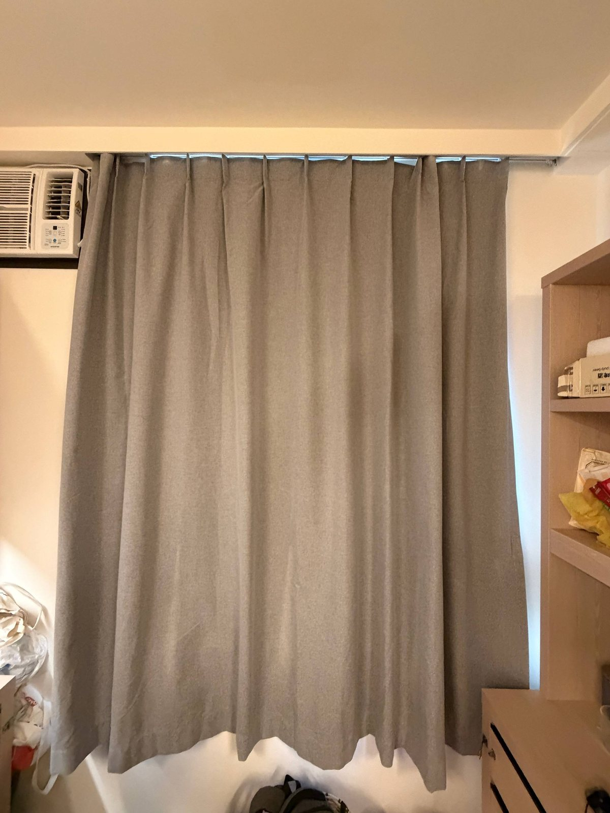  02e: curtain closed | 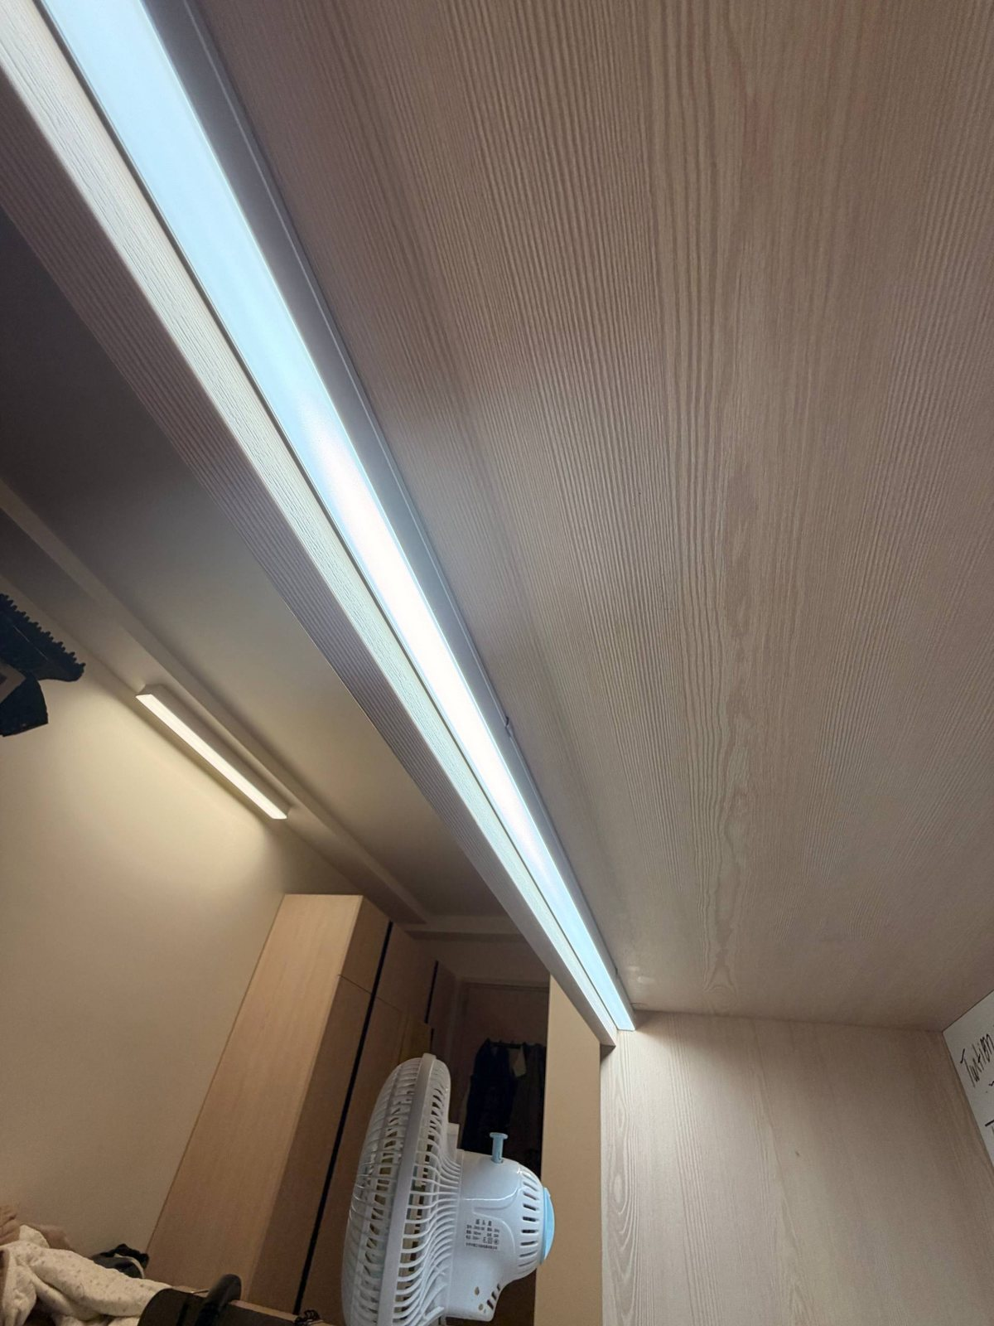  05b: desk LED and fan | 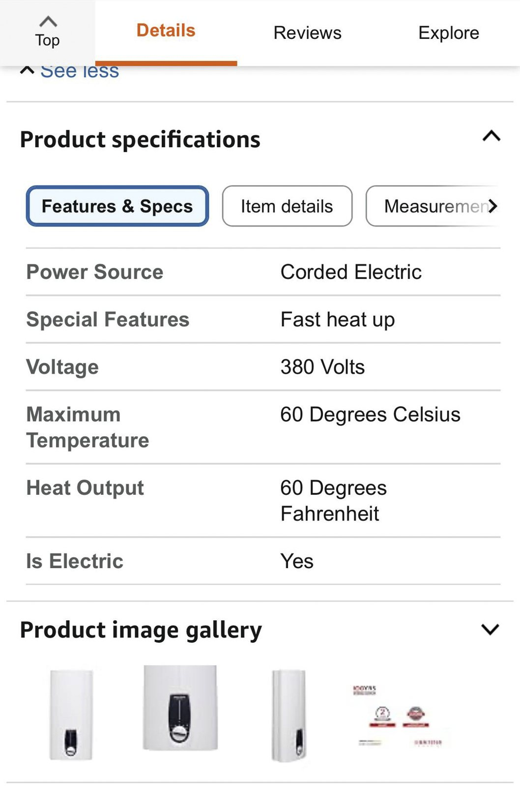  08e: heater spec, 380 V

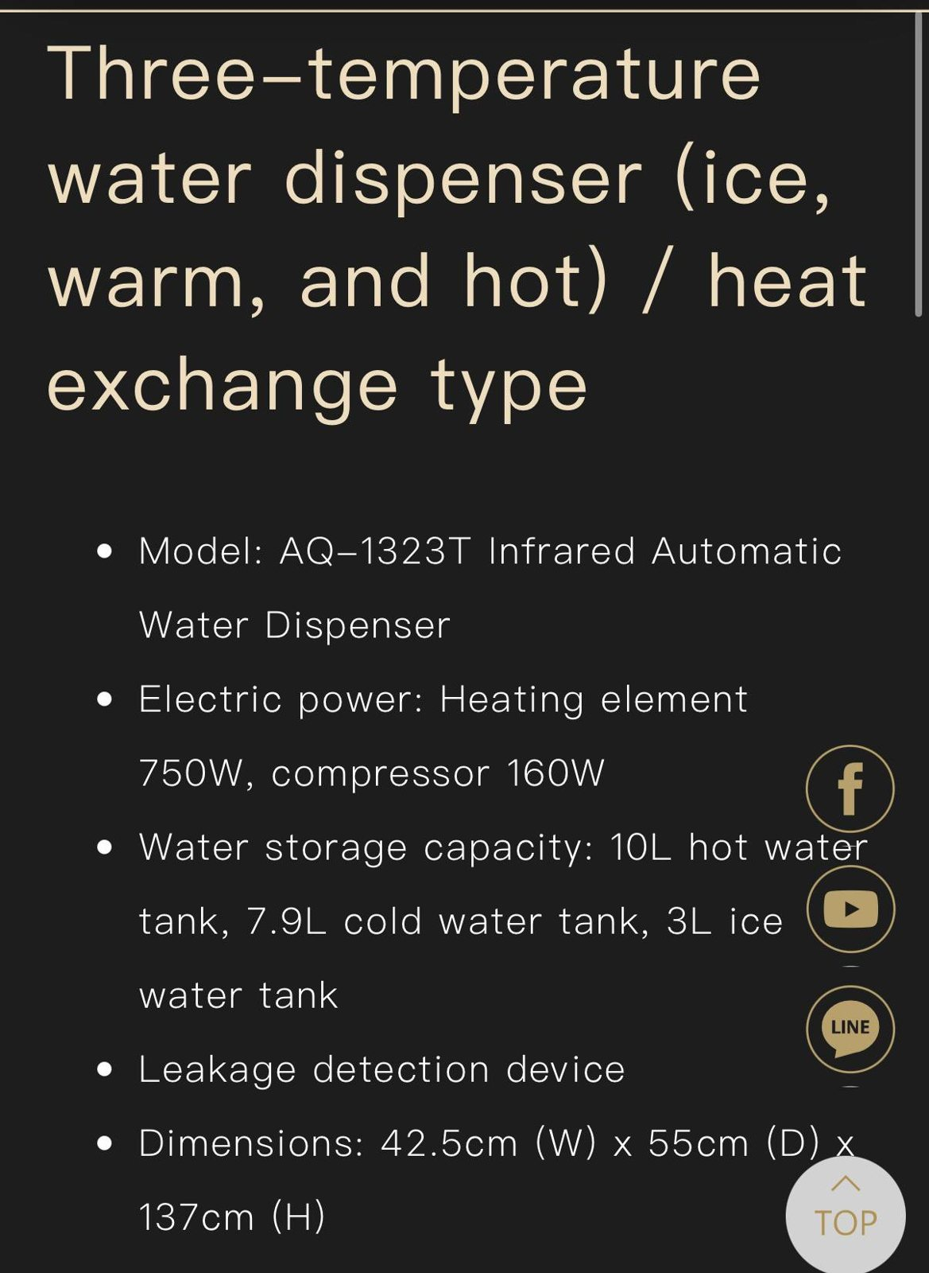  09a: dispenser ratings | 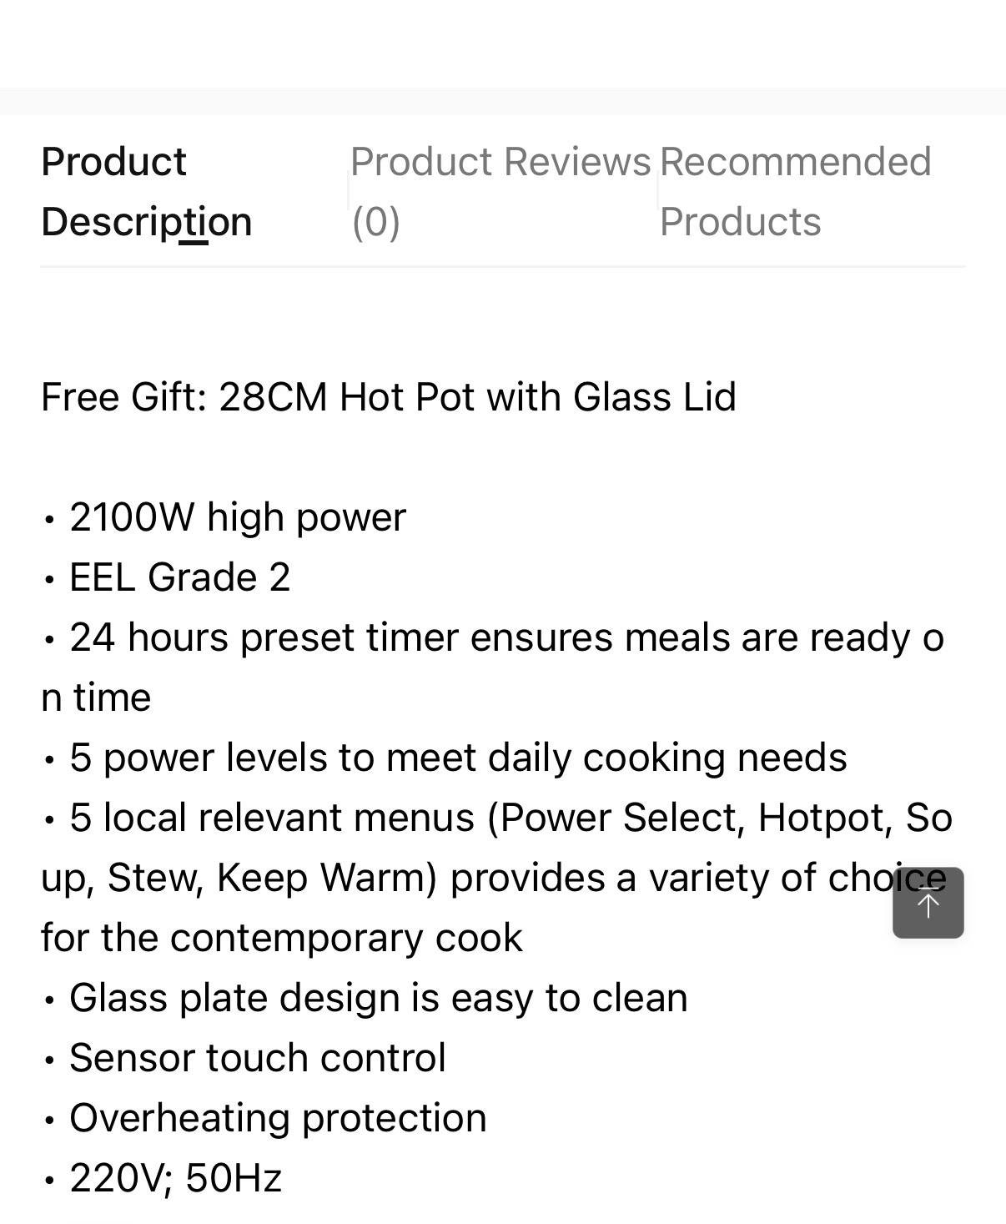  09c: hob 2,100 W, Grade 2 | 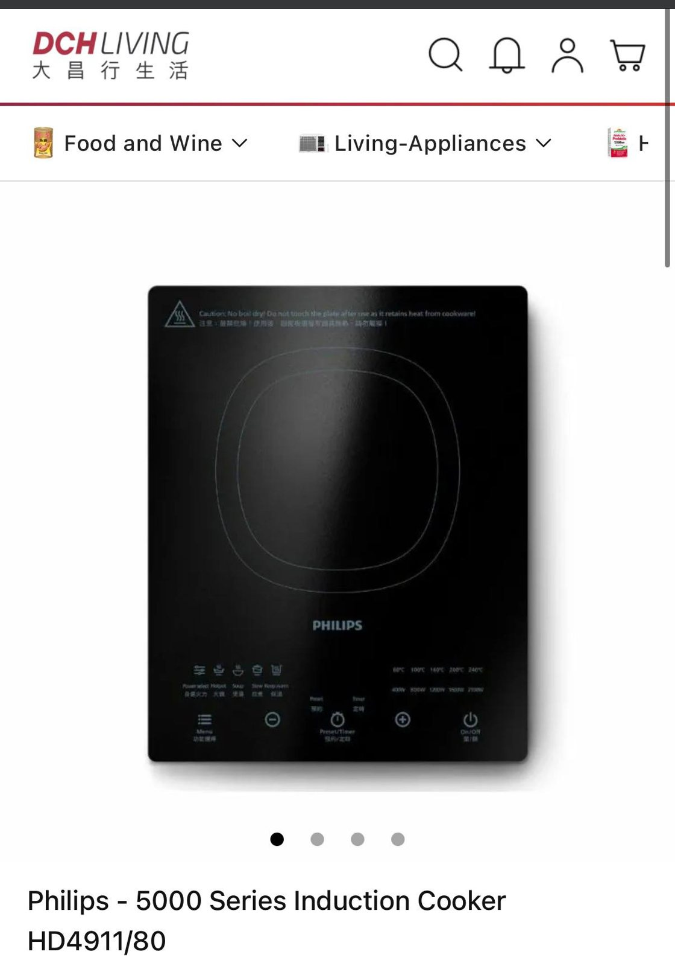  09d: Philips HD4911/80 | 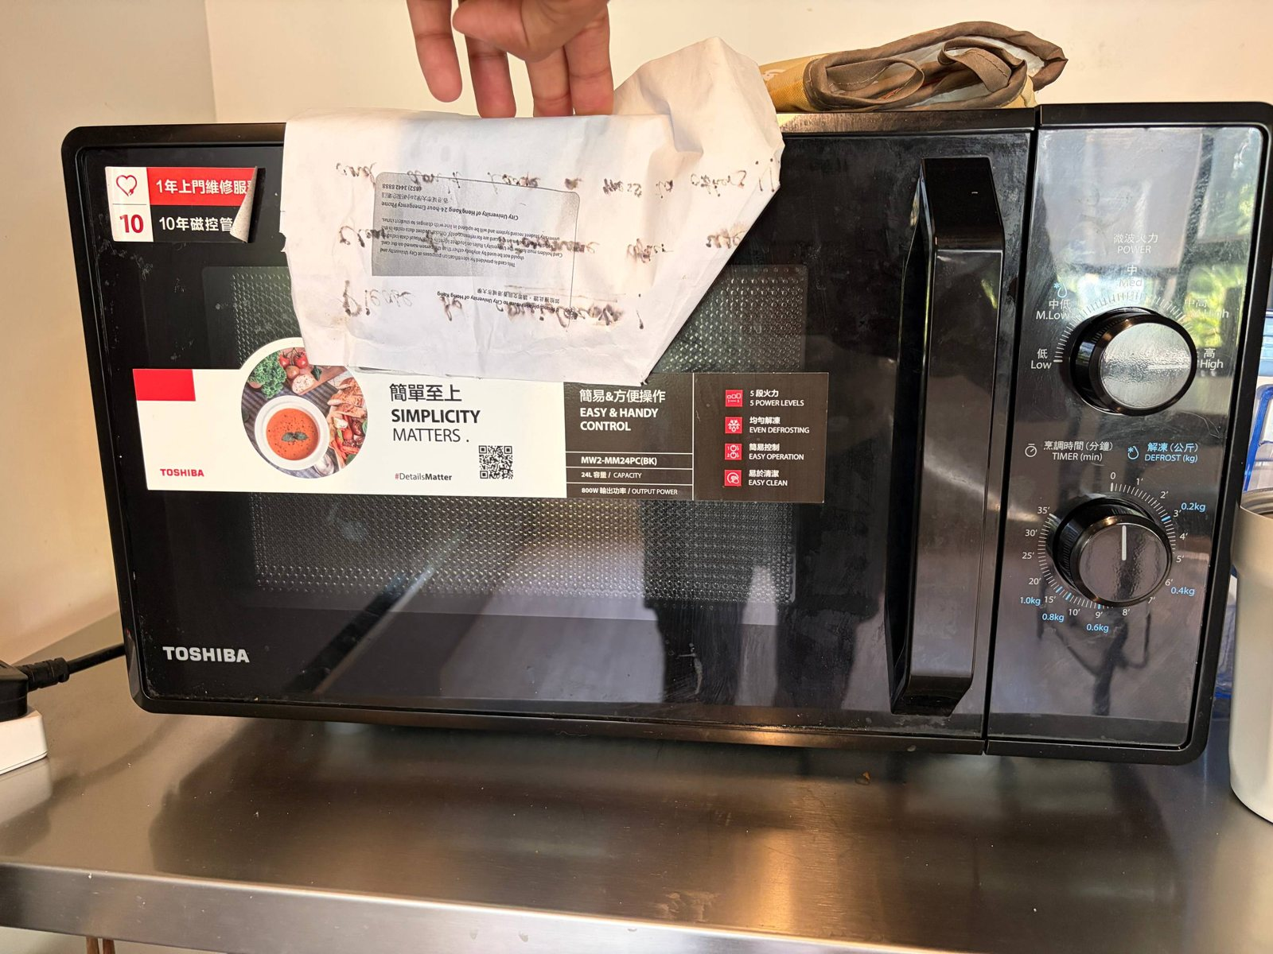  09h: microwave 800 W output
Figure B.1: Additional evidence photographs

Appendix C - Input data register
All 104 inputs used in the calculations, with unit, data-quality class and source ([n] = reference number). Values marked "Assumed" are typical values and are highlighted in yellow in the workbook.
Parameter | Value | Unit | Quality | Src
Occupants of Room 1003B (household) | 2 | persons | Reported | [29]
Users of the shared washroom | 4 | persons | Reported | [29]
Residents sharing the floor kitchen (allocation basis) | 32 | persons | Reported | [29]
Hours in room per weekday (22:00-11:00) | 13 | h/day | Reported | [29]
Hours in room on Saturday | 20 | h/day | Reported | [29]
Hours in room on Sunday | 18 | h/day | Reported | [29]
Internal floor area of Room 1003B | 15 | m2 | Reported | [29]
Days in hot season (May-Oct) | 184 | days | Derived
Days in cool season (Nov-Apr) | 181 | days | Derived
Energy conversion | 3.6 | MJ/kWh | Published | [3]
Specific heat of water | 4.186 | kJ/kg.K | Published
Electricity price used to convert AC spend to kWh (proxy) | 1.406 | HK$/kWh | Published | [6]
Comparator hostel AC rate - low | 1.2 | HK$/kWh | Published | [25]
Comparator hostel AC rate - high | 2.31 | HK$/kWh | Published | [25]
CLP Power HK emission factor (2025, latest) | 0.34 | kg CO₂e/kWh | Published | [5]
CLP Power HK emission factor (2024) | 0.38 | kg CO₂e/kWh | Published | [5]
Territory-wide default electricity factor | 0.7 | kg CO₂e/kWh | Published | [2]
WSD unit electricity - fresh water | 0.624 | kWh/m3 | Published | [11]
WSD unit electricity - salt (flushing) water | 0.362 | kWh/m3 | Published | [11]
DSD unit electricity - sewage treated | 0.29 | kWh/m3 | Published | [12]
Fraction of fresh water entering sewer (residential) | 1 | - | Published | [2]
Paper to landfill emission factor | 4.8 | kg CO₂e/kg | Published | [2]
GWP of HFC-32 (R32) | 650 | - | Published | [2]
GWP of R-410A | 1725 | - | Published | [2]
Annual refrigerant leak rate (screening) | 0.04 | fraction/yr | Published | [21]
Octopus AC spend - hot month (May-Oct), both occupants | 140 | HK$/month | Reported | [29]
Octopus AC spend - cool month (Nov-Apr), both occupants | 50 | HK$/month | Reported | [29]
Stated overall average AC spend | 120 | HK$/month | Reported | [29]
Rated input power (cooling) | 1.192 | kW | Nameplate / label | [28]
Rated cooling capacity | 3.34 | kW | Nameplate / label | [28]
Cooling seasonal performance factor | 4.6618 | - | Nameplate / label | [28]
Label annual energy consumption (cooling) | 362 | kWh/yr | Nameplate / label | [28]
Operating hours behind HK label figure | 1200 | h/yr | Published | [9]
AC operating hours - typical hot-season day | 12 | h/day | Reported | [29]
AC operating hours - typical cool-season day | 4 | h/day | Reported | [29]
Usual set-point | 25 | degC | Reported | [29]
Refrigerant charge (R32) - screening value | 0.4 | kg | Assumed
AC energy saving per +1 degC set-point | 0.03 | fraction | Published | [14]
Ceiling LED linear battens | 2 | no. | Nameplate / label | [29]
Power per ceiling batten | 20 | W | Assumed
Ceiling lights on | 6 | h/day | Reported | [29]
Under-shelf LED desk lights | 2 | no. | Reported | [29]
Power per desk light | 10 | W | Assumed
Desk lights on | 4 | h/day | Assumed
Laptop adapter rating | 65 | W | Nameplate / label | [29]
Average laptop draw as fraction of adapter rating | 0.5 | - | Assumed
Laptop use | 8 | h/day | Reported | [29]
Laptops in room (roommate assumed same as auditor) | 2 | no. | Assumed
Phone charger power | 20 | W | Assumed
Phone charging | 1 | h/day | Reported | [29]
Phones charged (both occupants) | 2 | no. | Assumed
Desk fan rated power | 20 | W | Nameplate / label | [29]
Desk fan use | 12 | h/day | Reported | [29]
Showers per person per day | 1 | no./day | Reported | [29]
Shower duration | 5 | min | Reported | [29]
Shower flow rate | 9 | L/min | Assumed
Delivered shower temperature | 40 | degC | Assumed
Instantaneous heater efficiency | 0.99 | - | Assumed | [16]
Water heater rating at 380 V | 24.4 | kW | Published | [16]
Washroom exhaust fan power | 30 | W | Assumed
Exhaust fan running | 24 | h/day | Reported | [29]
LED downlights | 3 | no. | Nameplate / label | [29]
Power per downlight | 10 | W | Assumed
Sensor lights on | 3 | h/day | Reported | [29]
Refrigerators | 2 | no. | Reported | [29]
Label consumption per refrigerator | 263 | kWh/yr | Nameplate / label | [29]
Water dispenser standby + dispensing energy | 1.5 | kWh/day | Assumed | [20]
Kitchen split AC label consumption | 688 | kWh/yr | Nameplate / label | [29]
Kitchen AC running - hot season | 8 | h/day | Reported | [29]
Kitchen AC running - cool season | 4 | h/day | Assumed
Kitchen AC refrigerant charge (R410A) - screening | 1.4 | kg | Assumed
Kitchen light fittings | 6 | no. | Assumed
Power per kitchen fitting | 15 | W | Assumed
Kitchen lights on | 16 | h/day | Assumed
Cooking sessions per person | 3 | per week | Reported | [29]
Induction hob on per session | 1 | h | Reported | [29]
Average hob power while cooking | 1 | kW | Assumed
Laundry loads per person | 1 | per week | Reported | [29]
Washer energy per cycle (cold wash) | 0.3 | kWh/cycle | Assumed
Tumble-dryer heater + drum power | 3 | kW | Assumed
Drying time per load | 12 | min | Reported | [29]
Water per wash | 60 | L/cycle | Assumed
Drinking water | 2 | L/person/day | Reported | [29]
Basin, cooking & dish-washing water | 15 | L/person/day | Assumed
Toilet flushing (seawater) | 30 | L/person/day | Assumed | [13]
Paper used per semester (50 printed + 50 written) | 100 | sheets | Reported | [29]
Semesters per year | 2 | no. | Assumed
Mass of one A4 80 g/m2 sheet | 5 | g | Derived
Share of used paper recycled | 0.5 | fraction | Assumed | [29]
MTR commute distance (18 km x 2 x 6 days) | 216 | km/week | Reported | [29]
Weeks of commuting per year | 48 | weeks | Assumed | [29]
Other MTR trips (22 km x 2 x 3 per month) | 132 | km/month | Reported | [29]
Months per year in Hong Kong | 11 | months | Reported | [29]
MTR rail emission intensity | 0.0723 | kg CO₂e/p-km | Published | [17]
Great-circle distance uplift | 1.08 | - | Published | [18]
Long-haul economy, with RF | 0.11704 | kg CO₂e/p-km | Published | [18]
Short-haul economy, with RF | 0.1258 | kg CO₂e/p-km | Published | [18]
Mixed (medium meat-eater) diet | 5.63 | kg CO₂e/day | Published | [19]
Typical HK household electricity | 275 | kWh/month | Published | [7]
Persons in typical household | 3 | persons | Published | [7]
Median per-capita floor area (2021 Census) | 16 | m2/person | Published | [23]
HK domestic fresh water use | 120.9 | L/person/day | Published | [13]
HK per-capita GHG emissions (2023) | 4.58 | t CO₂e/person | Published | [10]
BEC 2021 max lighting power density - dormitory | 6.2 | W/m2 | Published | [24]

Appendix D - Executive summary in EE-EAes structure
The EMSD Technical Form EE-EAes (V.2) is a macro-enabled workbook. Its sheets stay hidden and its tick-boxes stay inactive unless macros run in Excel. Re-saving it with other software was tested and found to strip its sheet-level macros, so the form has not been altered. Instead:
- the workbook sheet EE-EAes_Summary reproduces Parts 1(A), 1(B)(I), 1(B)(II), 2 and 3 with live values;
- the sheet EE-EAes_Entry_Guide lists, cell by cell, what to type into the official form.
The key Part 2 values are:
EE-EAes Part 2 item | Value
1) Annual electricity, past 1st 12-month (kWh/annum) | 1,219.6 (Room 1003B); 2nd and 3rd 12-month periods N/A (occupied from Jan 2026)
2) Annual other energy (MJ/annum) | 0 (no Towngas or LPG)
3) Annual total energy (MJ/annum) | 4,391
4) Annual EUI (MJ/m²/annum) | 292.7
5) Monthly EUI (MJ/m²/month) | Jan 16.9; Feb 16.1; Mar 16.9; Apr 16.6; May 32.2; Jun 32.0; Jul 32.2; Aug 32.2; Sep 32.0; Oct 32.2; Nov 16.6; Dec 16.9
6) Breakdown (MJ/annum) | AC 3,234; lighting 420; lift & escalator 0; others 736
7) Supply from shared services (%) | 52.8% of household electricity (adapted item)
8) Reference month | September 2026

Appendix E - Completed Penn State Home Energy Audit Tool
A copy of the course tool (1_SEE6115-8115_Home Energy Audit Tool_COMPLETED.xlsx) was filled with 178 values across nine sheets. Values were written directly into the tool's input cells, so its navigation buttons, logo, drop-down lists and formulas are unchanged; the original file is untouched. The tool uses US units, so the following conversions were applied:
- 15 m² = 161 ft²;
- 25 °C = 77 °F;
- 24.4 kW = 83,256 Btu/h;
- window dimensions in inches.
Sheet | What was filled
Main Page | Project details, occupant contact (no phone/e-mail), electricity price HK$1.406/kWh, home details (2024, 161 ft², 1 bedroom, shared bathroom, unit on 10/F)
Questionnaire | Occupants by age, thermostat (standard), cooling set-point 77 °F, appliance use, laundry (1 cold/cold load, 1 dryer load), water heating, AC 8 h/day average × 12 months, notes
Bedrooms | Renamed 'Room 1003B'; 2 fixtures (LED), single-pane aluminium windows with drapes and dimensions, 2 laptop chargers × 8 h/day, 1 portable fan, notes
Bathrooms | Renamed 'Shared washroom (4 users)'; LED downlights; notes on heater and 24 h fan
Kitchen | Electric stove, no oven, water chiller/heater present, 2 refrigerators (2023), microwave, notes on all appliances
Misc Areas | Tankless electric water heater (indoors, 0.99, 83,256 Btu/h), room AC 11,400 Btu/h EER 9.6 (2024), no heating, laundry (electric), notes
Home Exterior | Orientation NW, 1 storey, rectangle, concrete construction, notes on MiC building
Appliance Dataplate Info | 10 appliances with manufacturer, model, year and key ratings
Other Appliances | Laptops and phone chargers with use and wattage

Appendix F - Deliverables and reproducibility
File | Purpose
deliverables/Home_Energy_Carbon_Audit_Report.docx | This report
deliverables/Home_Energy_Carbon_Audit_Report.pdf | PDF copy of this report
deliverables/Home_Energy_Carbon_Audit_Workbook.xlsx | Calculation workbook - 15 sheets, 1,150 live formulas, no formula errors
deliverables/1_SEE6115-8115_Home Energy Audit Tool_COMPLETED.xlsx | Completed course data-collection tool
deliverables/figures/ | The 12 charts used in this report
photos/ | 26 evidence photographs
audit-inputs/QUESTIONNAIRE.md | Completed questionnaire
scripts/ | Python/Node scripts that rebuild the workbook, verify it against an independent model (84 cross-checks), fill the tool and generate this report
Rebuild sequence: build_workbook.py, then LibreOffice recalculation, then verify_workbook.py, then make_report_assets.py, then build_report.js, then finalize_report.py (contents page numbers and PDF copy). Every number in this report is read from the recalculated workbook.

