

**CIA – 1**

**Bike Management System**

By

**J Leo Clinton**

**(1847228)**

**Submitted to**

**Fr. Justin P Varghese**

July 2019

**Bike Management System**

**Submitted by:- J Leo Clinton**

**1847228**

**Introduction**

Bike management system describes a complete process of selling bikes to the customer from the company’s showroom. The convenience and hassle free work is always encouraged by the customer, and this system provides all the things that a customer need for a great shopping experience.

**List of Stake Holders**

Internal StakeHolders

1. owners
2. employees
3. Board members

External StakeHolders

1. Customers
2. Clients
3. Suppliers
4. Investors

**Process Model**

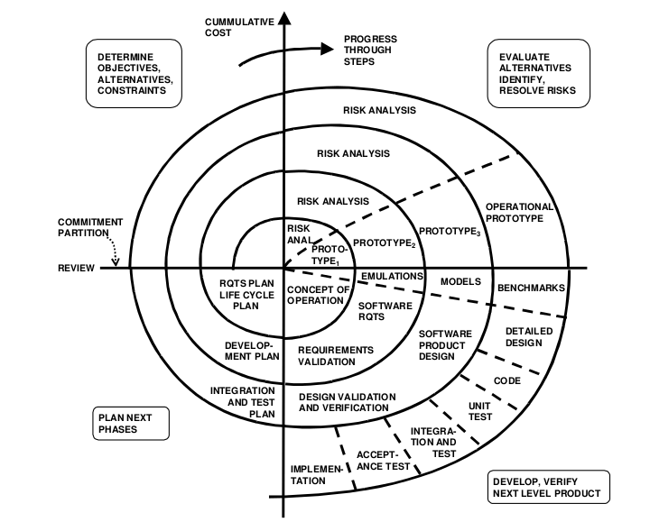

The SPIRAL model will be the best for use in the Bike management System software.

There are number of reasons to chose this process model.

1. Large project :- Bike Management System(BMS) as it is, has a lot of modules that needs to be implemented.
2. Frequent changes :- BMS has frequent changes. Bikes are added, the current features of the bikes are updated.
3. Unclear requirements :- creating a software for bike management, there are a lot of defined requirements and lot of undefined requirements.
4. High amount of risk analysis :- The risk analysis while implementing the spiral model increases and is enhanced.

* Risks like implementations of new technologies.
* Performance expectations.
* Organizational problems.

**Plan to get the requirement**

Requirements gathering, the act of trying to understand a problem by talking to a selection of actual and potential users.

For traditional water fall model, requirements need to be collected before starting the project. For projects like spiral model where the requirements keep changing, it can be a challenging work.

But for all the software models in SDLC we need to gather enough requirements to move ahead with the project.

## Requirements Gathering Process :-

* Structures the meeting into particular topic areas like review of old system, interview with users, potentials of new features and work through them with appropriate people.
* Enquiring about the basic functionality that the client needs in the system.
* Spending as much time as possible in the requirement collection phase and also talking to different people related to the project and gathering their opinion that they think is needed.
* Using SRS diagram to get more detail about the functional requirements.

**Requirement validation :-**

Validation is the process of confirming the completeness and correctness of requirements.  Validation also ensures that the requirements: 1) achieve stated business objectives, 2) meet the needs of stakeholders, and 3) are clear and understood by the developers. Validation is essential to identification of missing requirements and to ensure that the requirements meet certain quality characteristics.  Validation addresses each individual requirement to ensure that it is:

* **Correct –** accurately states a customer or external need
* **Clear –** has only one possible meaning
* **Feasible –** can be implemented within known constraints
* **Modifiable –** can be easily changed, with history, when necessary
* **Necessary –** documents something customers really need
* **Prioritized –** ranked as to importance of inclusion in product
* **Traceable –** can be linked to system requirements, and to designs, code, and tests
* **Verifiable –** correct implementation can be determined by testing, inspection, analysis,or demonstration

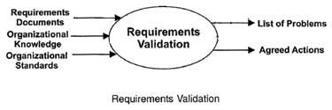

There are several techniques that which can be used for verifying the requirements.

Few techniques that can be used for this model are :-

1. Test_case_generation:-  
   Requirement mentioned in SRS document should be testable, the conducted tests reveal the error present in the requirement. It is generally believed that if the test is difficult or impossible to design than, this usually means that requirement will be difficult to implement and it should be reconsidered.
2. Requirements_Reviews:  
   In this approach, the SRS is carefully reviewed by a group of people including people from both the contractor organisations and the client side, the reviewer systematically analyses the document to check error and ambiguity.
3. Walk-through:  
   A walkthrough does not have a formally defined procedure and does not require a differentiated role assignment.
4. Checking early whether the idea is feasible or not.
5. Obtaining the opinions and suggestion of other people.
6. Checking the approval of others and reaching an agreement.

**Time line for the project**

According to the project complexity.

* 1 week for the communication phase.
* 1 week for risk analysis
* 2 weeks for development phase

So, the timeline for Bike management system is 4 weeks.