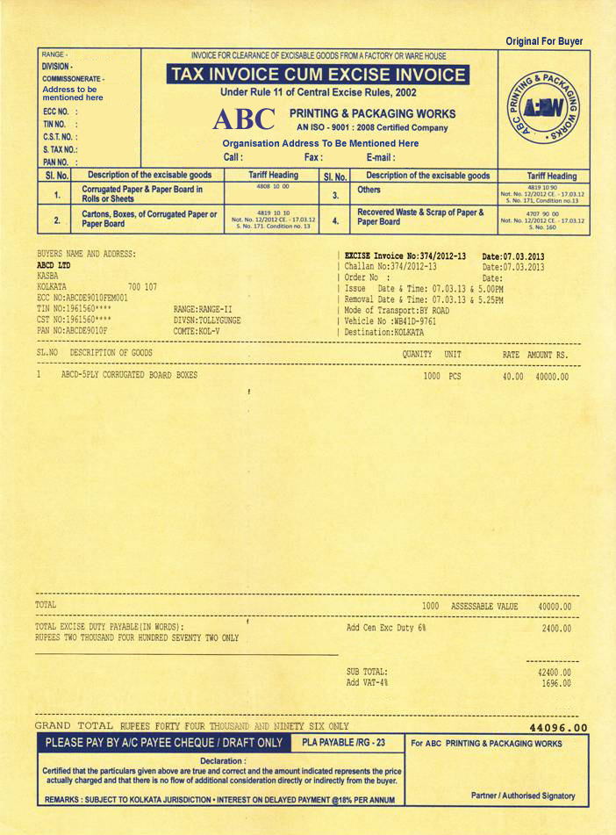
NOTE: The invoice is to be printed in four copies. The first copy is marked 'Original for Buyer' as per specimen above. The other three copies would have the same format and would be marked 'Sellers Copy', 'Duplicate for Transporter' & 'Extra Copy' respectively.

