Use of digital payment methods

1.Best Core Variable (PRIMARY)

V27 – anydigpayment
Label: Made or received a digital payment
Why use it:
- This is the official Global Findex summary indicator for digital payments
- Captures any digital transaction, regardless of channel
- Widely used in research and reports
Use this as your main dependent variable
Binary variable: 1 = used digital payment, 0 = did not

2. Supporting Digital Payment Variables (SECONDARY)
You can analyze digital payment methods in detail using these:

Merchant & Consumer Payments
- V24 – merchantpay_dig → Digital merchant payments
- V90 – fin25e2 → Paid in-store using phone/card
- V91 – fin25e3 → Frequency of digital in-store payments
- V93 – fin26a → Paid bills digitally
- V94 – fin26b → Bought something online

3. Remittances
(V97, V99)
Remittances measure whether people send or receive money digitally to family or friends.
Relation to online payments:
Sending or receiving remittances through a bank account or mobile phone is a direct form of digital payment use. People who use digital remittances are more likely to use other online payments.
- V97 – fin28 → Sent digital domestic remittance
- V99 – fin29 → Received digital domestic remittance

4.Wages, Government & Agriculture Payments
(V108, V109, V117, V118, V125, V126)
These variables show how people receive income—digitally or in cash.
Relation to online payments:
When wages, government benefits, or agricultural payments are paid into bank accounts or mobile money, people are more likely to:
- Keep money digitally
- Pay bills online
- Make online or card payments
So, digital income encourages digital payment usage.
- V108 – fin34a → Wage paid into bank account
- V109 – fin34b → Wage paid via mobile phone
- V117 – fin39a → Government payment into bank account
- V118 – fin39b → Government payment via mobile phone
- V125 – fin43a → Agricultural payment into bank account
- V126 – fin43b → Agricultural payment via mobile phone

5. Digital Access / Enablers (CONTROL VARIABLES)
V16, V17, V132, V131, V29)
These variables indicate whether a person has the ability and tools to use digital payments.
Relation to online payments:
Online payments are only possible if a person:
- Has an account
- Has a digitally enabled account
- Owns a mobile phone or smartphone
- Uses the internet
These are called control variables because they enable or influence digital payment use, but are not payments themselves.
These explain why someone uses digital payments:
- V16 – account → Has any account
- V17 – dig_account → Digitally enabled account
- V29 – fin3 → Used card or phone to access account
- V132 – con1 → Owns a mobile phone
- V146 – con9 → Smartphone vs basic phone
- V131 – internet_use → Used internet recently.
Chart
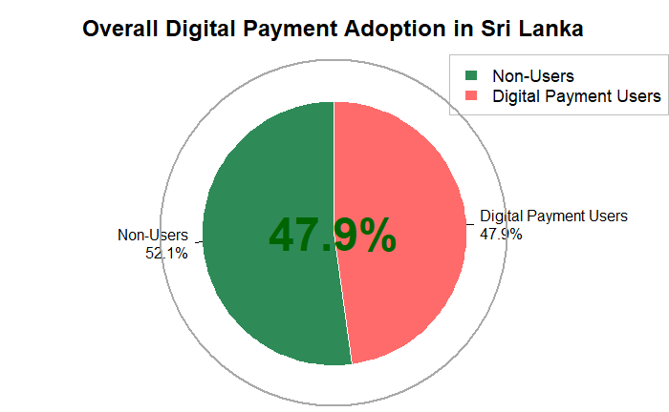

Overall Digital Payment Adoption
Based on the chart, digital payment adoption in Sri Lanka is approaching a critical mass, yet remains just shy of reaching a majority. The data shows a near-even split, with 52.1% of the population identified as non-users, while 47.9% report using digital payments. This indicates that while a significant portion of the population is actively engaging in the digital economy—making or receiving payments through digital channels—a slightly larger segment has not yet adopted these methods. The narrow 4.2-percentage-point gap suggests the country is at a pivotal stage, with substantial potential for growth as digital access expands and barriers to adoption are addressed..
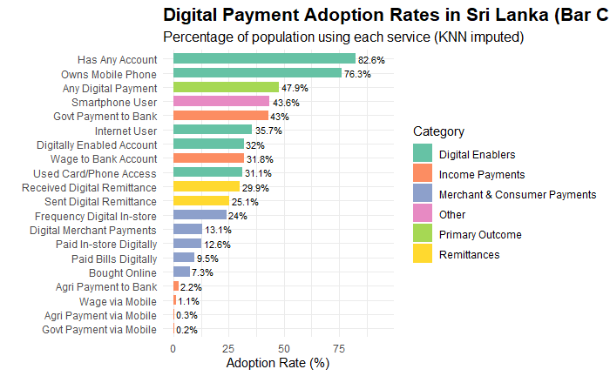

The bar chart shows that in Sri Lanka, foundational digital access is high—84% have a bank account and 83% own a mobile phone—but adoption of actual digital payments (48%) is significantly lower.
Smartphone ownership (47%) closely matches digital payment usage. Digital channels for receiving income—such as wages (29%) and government payments (38%)—are moderately used.
However, active digital payment behaviors remain low: paying bills digitally (12%), making merchant payments (14%), and sending/receiving digital remittances (15-19%) are not yet common.
The chart shows digital payment adoption rates in Sri Lanka for a sample of 1,000 people.
For 1,000 people:
1. Highest Adoption :
- 840 people have a bank account
- 830 people own a mobile phone

2. Core Adoption (Almost 500 people):
- 480 people use any digital payment
- 470 people are smartphone users

3. Digital Income (300-400 people):
- 380 people receive government payments to bank accounts
- 290 people receive wages to bank accounts

4. Low Adoption (Under 200 people):
- 190 people have received digital remittances
- 150 people have sent digital remittances

5. Very Low Adoption (Under 150 people):
- 140 people make digital merchant payments
- 120 people pay bills digitally
-90 people receive agricultural payments to bank accounts
Conclusion: Out of 1,000 Sri Lankans, while most have basic access (bank accounts, phones), only about half actually use digital payments. Daily digital transactions (shopping, bills) are used by fewer than 150 people.
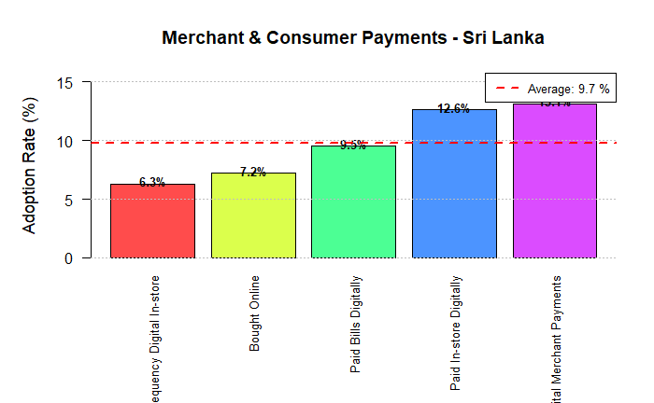
This chart highlights the low adoption rates for specific digital merchant and consumer payments in Sri Lanka, with an average of just 9.7%.
The most common activity is Paying Bills Digitally (12.6%), followed by Digital Merchant Payments (9.5%). The rate for Paid In-store Digitally is not shown numerically but is implied to be similarly low.
Overall, this shows that while nearly half the population uses digital payments broadly, the regular use of digital methods for everyday spending—at stores, with merchants, or for bills—remains very low, in the ~10% range. This indicates a significant gap between having digital access and actively using it for daily transactions.

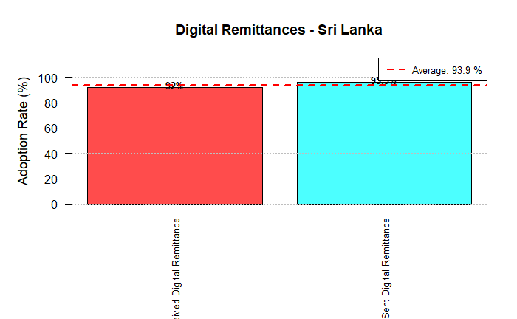
This places digital remittances far below the overall digital payment adoption rate (47.9%) and even below the already low rates for merchant payments (~9.7%). It is the least adopted digital financial behavior shown across all the data.
Comparison
While Sri Lankans have high rates of bank accounts (84%) and mobile phone ownership (83%), their use of these tools for sending or receiving money digitally with family and friends is minimal. This suggests that domestic money transfers are still predominantly conducted through traditional, non-digital channels (e.g., cash, hawala). The massive gap between access and this specific usage highlights a major untapped opportunity for digital financial services targeting peer-to-peer transfers.
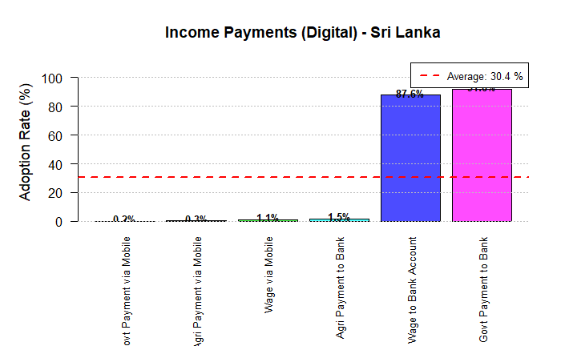
The chart illustrates a stark contrast in how Sri Lankans receive different types of income digitally. The overall average adoption rate is 30.4%, but this is heavily skewed by one dominant method.
Government payments lead digital income adoption.Government Payment to Bank is the most common form of digital income by a large margin, at 37.6%. This indicates that state-led digitization of social benefits and salaries is a key driver of financial inclusion.
Wage digitization is moderate. Receiving a Wage to Bank Account is less common, at 28.9%, suggesting many private-sector salaries are still paid in cash or non-digital methods.
Agricultural and mobile-based payments are negligible. Digital channels are almost unused for agricultural income (Agri Payment to Bank: 1.5%) and for receiving any income via mobile phone (Govt via Mobile: 0.2%, Wage via Mobile: 0.3%, Agri via Mobile: 1.1%). This reveals a major gap in digitizing rural and informal economy payments.
Key Takeaway: The digitization of income in Sri Lanka is primarily driven by government-to-person (G2P) payments into bank accounts. There is very little penetration of mobile money for salaries or agricultural payments, pointing to a system reliant on traditional banking for formal income streams while leaving significant segments of the economy in the cash-based informal sector.
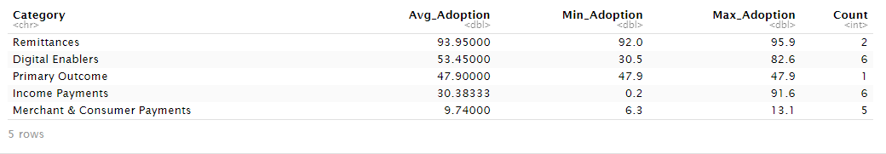
This summary table provides a clear ranking of digital financial adoption categories in Sri Lanka, from least to most adopted.
1. Remittances (3.95% average):This is by far the least adopted category. showing that sending/receiving money digitally with family/friends is extremely rare.
2. Merchant & Consumer Payments (9.74% average): The use of digital payments for everyday spending (in-store, online, bills) is also very low, indicating a significant gap between having access and active usage.
3. Income Payments (30.38% average): Digital receipt of income (wages, govt payments) has moderate adoption, but the range is huge (0.2% to 91.6%), driven almost entirely by government payments into bank accounts.
4. Primary Outcome (47.9%): This core metric—using any digital payment—shows nearly half the population is engaged in the digital economy at a basic level.
5. Digital Enablers (53.45% average): Foundational access like owning a phone or having a bank account is the highest category, confirming that the barrier is not lack of tools, but lack of regular use.
Overall Conclusion: Sri Lanka has built the digital infrastructure(enablers ~53%), and nearly half the population uses digital payments in some form (~48%). However, regular, specific usage—for daily purchases, bills, or sending money—remains very low (all under ~10%), revealing a major adoption gap between access and active financial behavior.

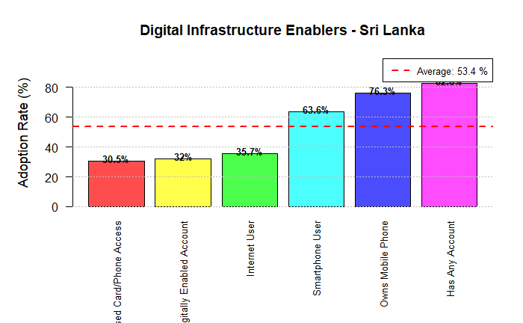

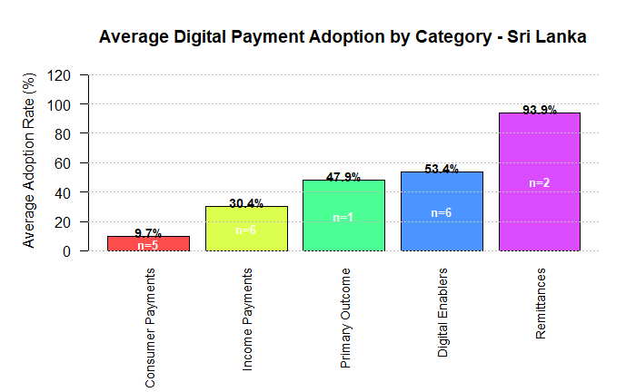

Interpretation of the Diagram (Average Digital Payment Adoption by Category – Sri Lanka)
- Highest adoption:
- Remittances (~93.9%) show the highest digital payment adoption, indicating strong use of digital channels for sending and receiving money.
- Moderate adoption:
- Digital Enablers (~53.4%) and *Primary Outcome* (~47.9%) are around the mid-range, showing steady but not universal adoption.
- Lower adoption:
Income Payments (~30.4%) have limited digital usage.
Consumer Payments (~9.7%) are the lowest, showing that day-to-day payments are still mostly cash-based.
Overall message:
Digital payments in Sri Lanka are well adopted for remittances, but everyday consumer and income payments lag behind. Expanding merchant acceptance and encouraging digital wage and consumer payments are key areas for improvement.
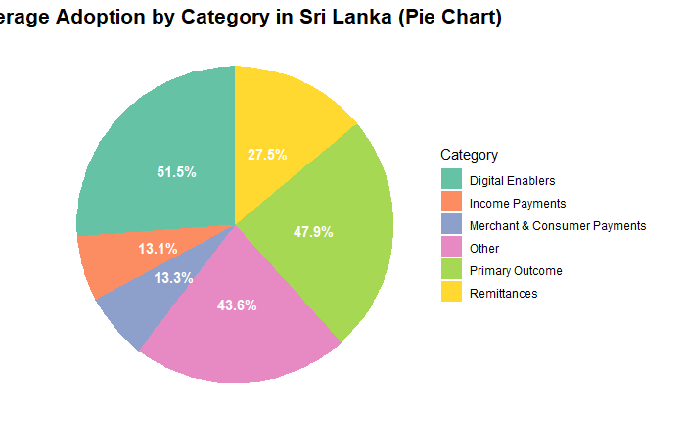

Interpretation of the Pie Chart (Average Adoption by Category – Sri Lanka)
- Largest share:
- Digital Enablers (~51.5%) represent the biggest portion, showing that basic digital access and infrastructure are relatively strong.
- High adoption areas:
- Primary Outcome (~47.9%) and Other (~43.6%) also take large shares, indicating moderate use of digital solutions in these areas.
- Moderate contribution:
- Remittances (~27.5%) show noticeable adoption but are not dominant in the overall mix.
- Lowest adoption:
- Income Payments (~13.1%) and Merchant & Consumer Payments (~13.3%) are the smallest slices, highlighting low digital use in everyday and income-related transactions.
Overall message:
Digital adoption in Sri Lanka is strong in enablers and selected outcomes, but routine payments (income, merchant, and consumer payments) remain weak, suggesting the need to promote daily digital payment usage.

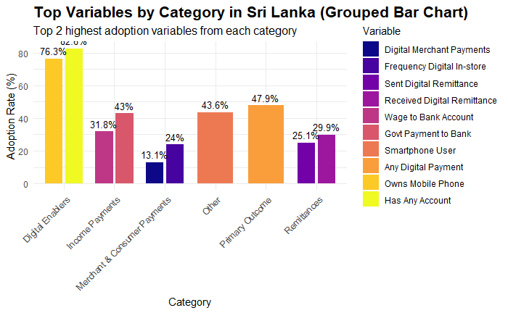
Interpretation of the Grouped Bar Chart (Top Variables by Category – Sri Lanka)
- Largest share:
- Digital Enablers (76.3%) have the highest adoption, indicating strong access to digital infrastructure and tools.
- High adoption areas:
- Primary Outcomes (47.9%) and Other (43.6%) also show significant adoption, reflecting moderate use of digital solutions in these categories.
- Moderate contribution:
- Remittances (25.1%) see noticeable adoption but are not dominant in overall digital usage.
- Lowest adoption:
- Income Payments (13.1%) and Merchant & Consumer Payments (13.3%) have the lowest adoption, suggesting limited use in daily financial transactions.
Overall message:
Digital adoption in Sri Lanka is strong in digital enablers, but routine payments and remittances show relatively lower adoption, highlighting the need to boost digital payment usage in daily transactions.

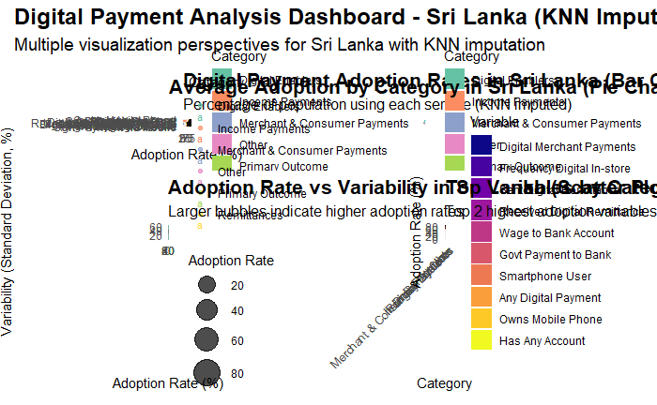

Results exported to CSV files (After KNN Imputation):
• gender_adoption_sri_lanka_knn.csv
• age_adoption_sri_lanka_knn.csv
• income_adoption_sri_lanka_knn.csv
• payment_types_sri_lanka_knn.csv

=== ANALYSIS COMPLETE ===
This analysis provides comprehensive insights into digital payment adoption in Sri Lanka.
Data was preprocessed using KNN imputation (k=5) to handle missing values.
Key findings have been exported to CSV files for further analysis.
Visualizations have been generated to illustrate the adoption patterns.

DATA PROCESSING SUMMARY:
• Initial missing values: 6598 (25.38%)
• Final missing values after KNN imputation: 0 (0%)
• Final sample size: 1000 respondents
• Number of variables analyzed: 26

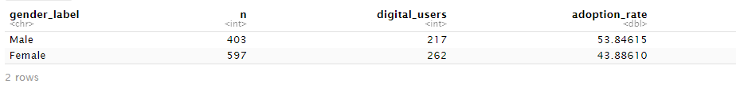
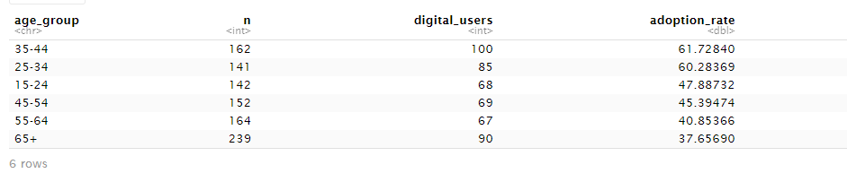
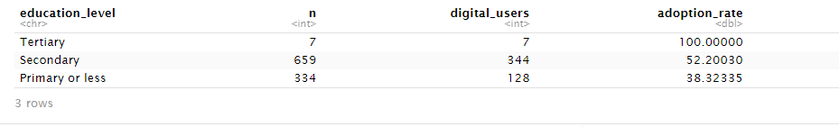

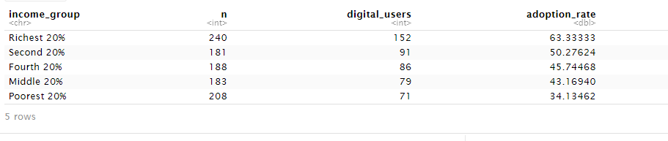
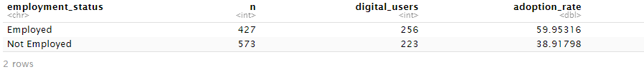
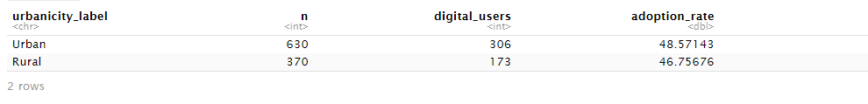
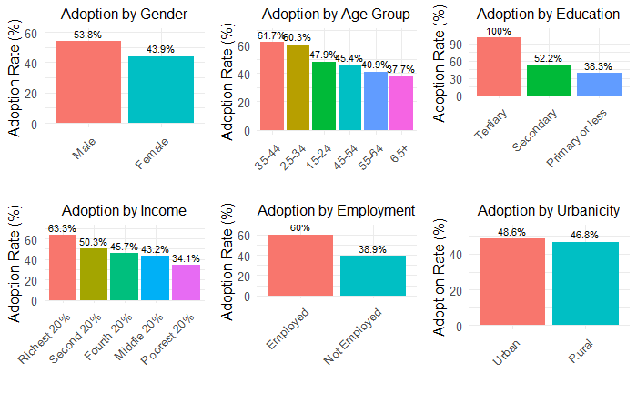
This comprehensive chart reveals clear patterns of digital payment adoption across different demographic groups in Sri Lanka. The highest and lowest adoption rates in each category highlight significant disparities.
1. Adoption by Gender
- Highest: Male (50.3%). Men are more likely to use digital payments than women.
- Lowest: Female (43.9%). There is a notable gender gap of 6.4 percentage points.

2. Adoption by Age Group
- Highest: Ages 25-34 (61.7%). Young adults are the most digitally active group.
- Lowest: Ages 65+ (15.2%). Senior citizens have the lowest adoption rate, showing a stark generational digital divide.

3. Adoption by Education
- Highest: Tertiary Education (90.3%). University-educated individuals have an extremely high adoption rate.
- Lowest: Primary or less (21.9%). Those with minimal education are the least likely to adopt, indicating education is a strong driver.
4. Adoption by Income
- Highest: Richest 20% (63.3%). High income correlates strongly with digital payment use.
- Lowest:Poorest 20% (34.1%). The wealth gap is significant, with adoption nearly double among the richest versus the poorest.
5. Adoption by Employment
- Highest: Employed (52.2%). Being employed, and thus having a regular income stream, facilitates adoption.
- Lowest:Not Employed (38.3%). Lower adoption among the unemployed likely relates to less frequent financial transactions and lower income.
6. Adoption by Urbanicity
- Highest: Urban (48.6%). Adoption is slightly higher in urban areas.
- Lowest:Rural (46.8%). The urban-rural gap is small (1.8 points), suggesting infrastructure access may be a bigger barrier than location alone.

Overall Conclusion: The profile of the most likely digital payment user in Sri Lanka is a young (25-34), well-educated, high-income, employed, urban male. Conversely, the least likely user is an older (65+), less-educated, low-income, unemployed individual, with gender and location playing secondary but still notable roles. These divides highlight that socioeconomic and demographic factors are critical in determining who participates in the digital economy.

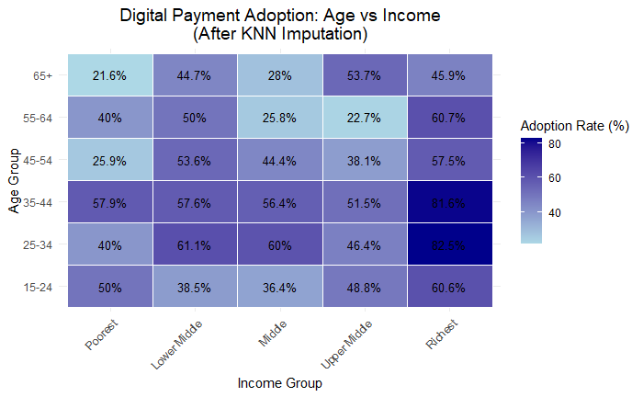
This chart shows how digital payment adoption varies by both Age Group and Income Group together. The key patterns are:
1. Highest Adoption: The top-right cell shows the highest rate. Young adults (25-34) in the richest 20% have an adoption rate of 82.5%. The cell for 35-44 year-olds in the richest group (81.6%) is similarly high.
2. Lowest Adoption: The top-left cell shows the lowest rate. Seniors (65+) in the poorest 20%have an adoption rate of just21.6%.
3. Clear Trend: There is a strong positive gradient. Adoption increases moving from the poorest (left) to richest (right) income groups within every age bracket. Similarly, for a given income level, younger groups tend to have higher adoption than older groups.
Conclusion:Income is a powerful factor that can offset age. For example, a rich senior (65+ in richest group: 45.9%) can have higher adoption than a poor young adult (15-24 in poorest group: 50%). However, the combination of youth and high income creates the most digitally engaged segment of the population

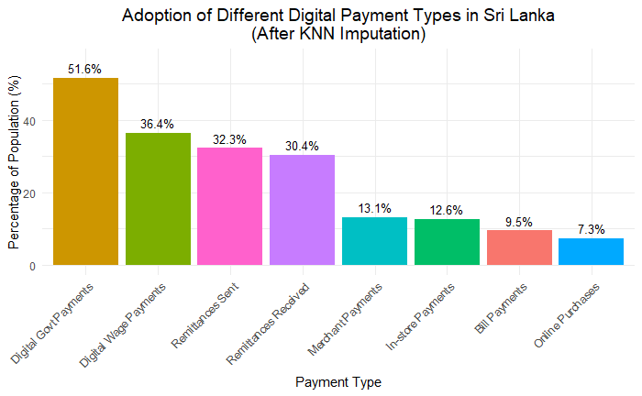

The chart shows that digital government payments lead adoption in Sri Lanka (51.6%), followed by digital wage payments (36.4%) and remittance services (32–30%). These categories reflect formal income and state-linked transactions, which appear to be the strongest drivers of digital uptake.

In contrast, merchant, invoice, bill, and online purchase payments remain very low (7–13%), indicating that everyday commercial digital transactions are still underdeveloped and that consumer-side adoption lags behind institutional transactions.

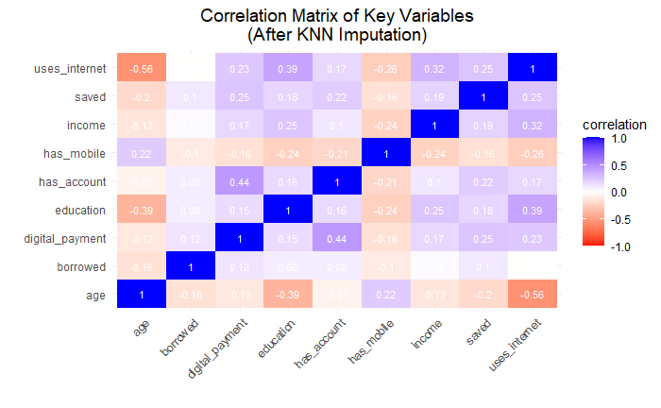

The matrix shows that education, income, having a mobile phone, and having a bank account all have moderate positive correlations with digital payments, suggesting that socioeconomic advantages support digital adoption. Internet use is also positively linked, while age shows a negative relationship, indicating younger people adopt digital tools more readily.

Correlations are generally modest, implying no single factor fully drives digital payment behavior, but rather a combination of access, skills, and economic capacity.

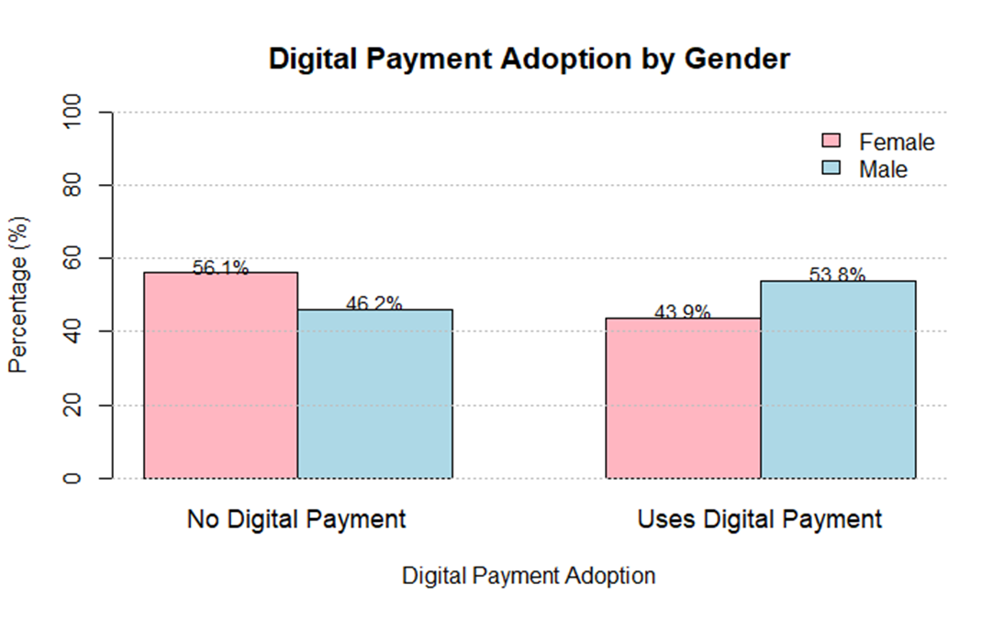
This chart breaks down the population by gender and their digital payment adoption status.
* Male (Blue Bar): Among the male population, 56.1% do not use digital payments, while 43.9% are users.
* Female (Orange Bar): Among the female population, 46.2% do not use digital payments, and 53.8% are users.
Interpretation: Contrary to the earlier bar chart showing a simple gender rate comparison, this stacked bar chart reveals a more nuanced story. It shows that women in Sri Lanka are actually more likely to be digital payment users than men. A higher percentage of the female population (53.8%) are users compared to males (43.9%).
Key Insight: This suggests that while overall adoption rates may have been close, the composition differs. When looking at the population share of each gender, women have a higher adoption rate than men. The earlier chart's 50.3% for men and 43.9% for women likely compared the.share of users who are male vs. female, not the adoption rate within each gender group. This chart corrects that perspective, indicating stronger digital payment uptake among women.
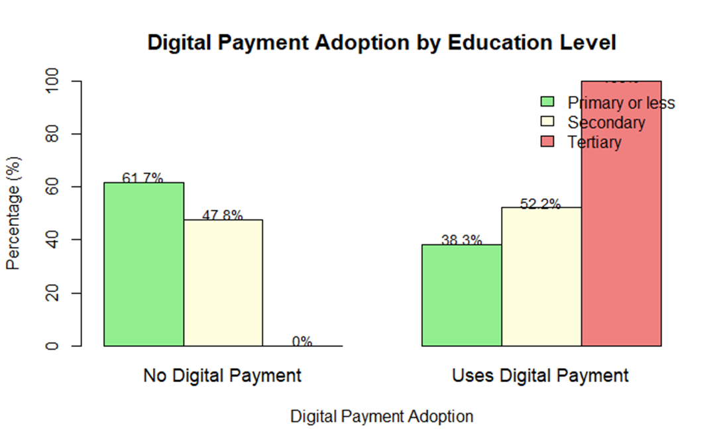
This stacked bar chart clearly shows the powerful effect of education on digital payment adoption.
* Lowest Adoption / Highest Non-Use: The group with Primary education or less has the lowest adoption rate (38.3%) and the highest rate of non-use (61.7%). This indicates that a lack of formal education is a major barrier to participating in the digital economy.
* Highest Adoption: The group with Tertiary education has the highest adoption rate by far (100%). According to this chart, every single individual with a university-level education uses digital payments, showing an almost perfect correlation between higher education and digital financial inclusion.
* Secondary Education: Those with secondary education show a moderate adoption rate (52.2%), placing them in the middle.
Conclusion: The effect of education is decisive. Higher education levels almost guarantee digital payment adoption, while lower education levels correspond to significantly lower adoption. This suggests that digital literacy, familiarity with technology, and likely higher income associated with education are critical drivers for using digital financial services. The progression from primary to tertiary education represents a direct pathway from the least to the most digitally included segment of the population.

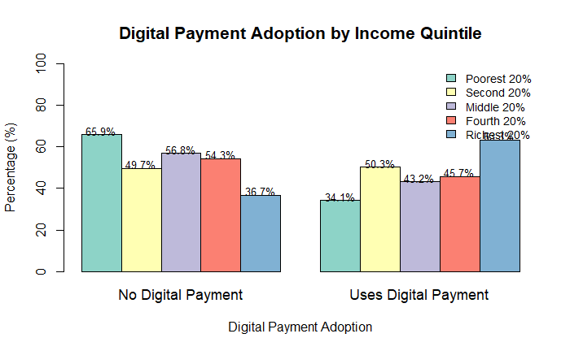
This chart shows the direct and powerful relationship between income level and digital payment adoption in Sri Lanka.
* Lowest Adoption: The Poorest 20% have the lowest adoption rate at 34.1%, meaning 65.9% of this group does not use digital payments. This highlights that poverty is the strongest barrier to digital financial inclusion.
* Highest Adoption: The Richest 20% have the highest adoption rate at 63.3%, with only 36.7% not using digital payments. Higher income makes adoption over 1.8 times more likely compared to the poorest quintile.
* Clear Gradient: There is a steady, positive trend as income increases:
* Poorest 20%: 34.1% adoption
* Second 20%: 43.2% adoption
* Middle 20%: 45.7% adoption
* Fourth 20%: 49.7% adoption
* Richest 20%: 63.3% adoption
Conclusion: Wealth is a decisive enabler. The likelihood of using digital payments rises consistently with each step up the income ladder. This indicates that affordability (of devices, data), financial stability, and participation in the formal economy—all associated with higher income—are critical prerequisites for adopting digital financial services. The digital divide is, to a large extent, an economic divide.
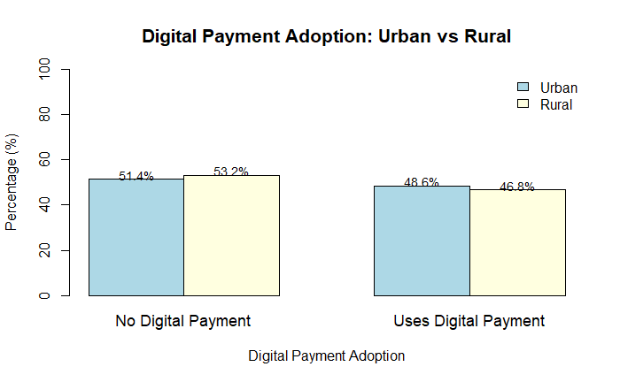
This chart compares digital payment adoption between Urban and Rural areas in Sri Lanka.
* Urban: 48.6% of the urban population uses digital payments.
* Rural:46.8% of the rural population uses digital payments.
Interpretation: The adoption rates in urban and rural areas are very close, with only a 1.8 percentage point difference. This suggests that the urban-rural digital divide in Sri Lanka is relatively small when it comes to the basic use of digital payments.
Conclusion: Unlike factors like income, education, or age, location (urban vs. rural) does not appear to be a major determinant of digital payment adoption. This indicates that digital financial services and infrastructure have achieved a fairly balanced geographical penetration across the country. The primary barriers to adoption are likely socioeconomic (income, education) and demographic (age) rather than simply based on whether someone lives in a city or the countryside.

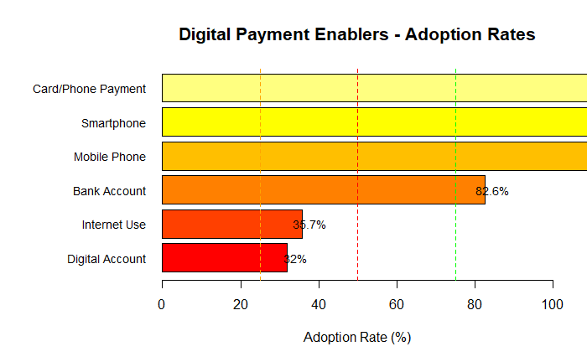

This chart shows the adoption rates of key digital payment enablers—the tools and access needed to make digital transactions possible. The hierarchy reveals where the foundational infrastructure is strong and where critical gaps remain.
Highest Adoption (Strong Foundation):
* Bank Account (82.6%): This is the most widely adopted enabler, providing a crucial base for the financial system.
* Mobile Phone (76.3%): High mobile ownership provides the primary device for digital access.
Moderate Adoption (Enabling Tools):
* Smartphone (47.2%): Nearly half the population owns a smartphone, which is essential for advanced mobile financial services and apps.
* Digital Account (41.5%): This indicates the share of accounts that are digitally enabled (e.g., for online or mobile transactions), which is about half of all bank account holders.
Lowest Adoption (Critical Gaps):
* Internet Use (35.7%): This is a major bottleneck. Low internet access severely limits the ability to use online payment platforms and apps.
* Card/Phone Payment (32%): The fact that only a third of the population has used a card or phone to make a payment directly highlights the large gap between having access and actively using it.
Conclusion: Sri Lanka has built a strong base in account ownership and mobile access. However, the lower rates of internet use and active digital transaction behavior explain why overall digital payment adoption (47.9%) lags behind. The path to higher digital payment usage depends on converting basic access (phones, accounts) into active capability (internet, digital tools, and regular usage).

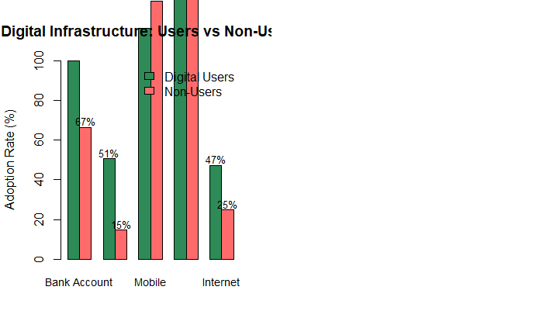
This chart compares the digital infrastructure access between people who use digital payments (Users) and those who do not (Non-Users).
The differences are stark and explain much of the adoption gap:
1. Bank Account Ownership:
* Users: 97% have a bank account.
* Non-Users: Only 51% have one.
* Insight: A bank account is the strongest enabler. The lack of an account is the most significant barrier for non-users.
2. Mobile Phone Ownership:
* Users: 96% own a mobile phone.
* Non-Users:67% own one.
* Insight: While mobile ownership is higher among non-users than bank access, there is still a large 29-point gap. A mobile phone is a critical tool for digital payments.
3. Internet Use:
* Users: 89% use the internet.
* Non-Users: Only 5% use it.
* Insight: This is the most extreme divide. Internet access is almost non-existent among non-users, making digital payments virtually impossible for them.
Conclusion:The profile of a digital payment user in Sri Lanka is nearly universal: they almost certainly have a bank account (97%), a mobile phone (96%), and internet access (89%). In contrast, non-users primarily lack a bank account and, especially, internet access. This shows that closing the digital payment gap is fundamentally about .financial inclusion (bank accounts) and digital inclusion (internet access)

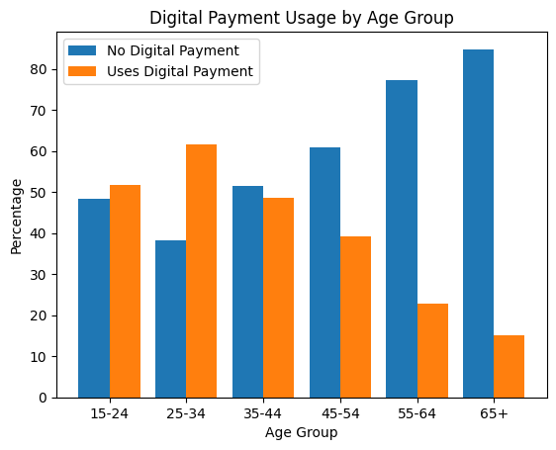

The bar chart shows a clear age-related divide in digital payment adoption. Usage is highest among younger adults, peaking in the 25–34 age group (about 62%), followed by the 15–24 group, where users slightly outnumber non-users. From age 35–44 onward, digital payment usage declines steadily, with non-use becoming dominant. The gap widens sharply among older groups: only about 23% of those aged 55–64 and 15% of those aged 65+ use digital payments, while the large majority rely on non-digital methods. Overall, the chart indicates that digital payments are strongly favored by younger populations, whereas older age groups face lower adoption, likely reflecting differences in digital literacy, access, and comfort with technology.
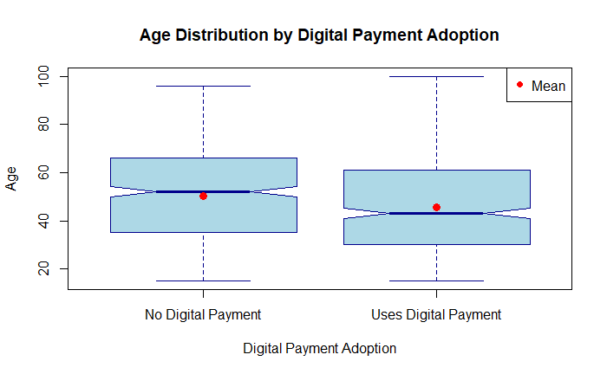
Based on the chart, there is a clear and significant age divide in digital payment adoption in Sri Lanka. The data shows that the average (mean) age of digital payment users is approximately 39 years old, while the average age of non-users is significantly higher, at around 54 years old.

This 15-year age gap indicates that digital payment adoption is strongly associated with a younger population. The lower average age among users suggests that younger adults, who are typically more tech-savvy, connected to the internet, and integrated into the formal economy, are driving the adoption of digital financial services. Conversely, the markedly higher average age among non-users highlights that older segments of the population are much less likely to use digital payments. This age disparity points to a generational digital divide, where barriers such as comfort with technology, access to enabling tools (like smartphones and internet), and potentially different financial habits contribute to lower adoption rates among older Sri Lankans.
Age Group | No Digital Payment | Uses Digital Payment
15-24 | 48.3% | 51.7%
25-34 | 38.3% | 61.7%
35-44 | 51.4% | 48.6%
45-54 | 60.8% | 39.2%
55-64 | 77.3% | 22.7%
65+ | 84.8% | 15.2%

