**CASE1: NON – ENGLISH CHARACTERS**

**INPUT:**

**dict1.json**

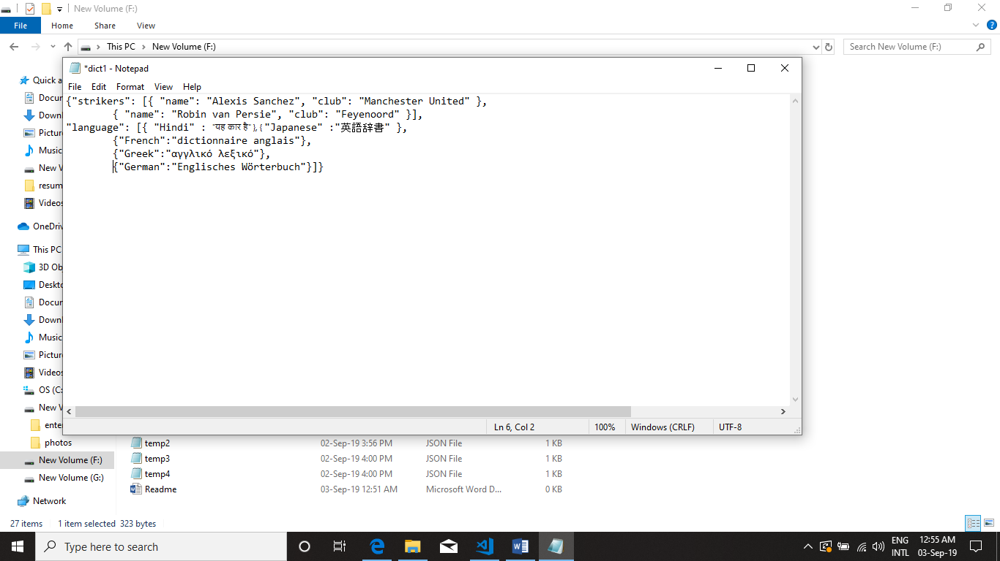

**dict2.json**

{"strikers": [{ "name": "Nicolas Pepe", "club": "Arsenal" }],

"employee":[{"name":"abcd", "age":2 },

{"name":"defg", "age":3 }]}

**dict3.json**

{"strikers": [{ "name": "Gonzalo Higuain", "club": "Napoli" },

{ "name": "Sunil Chettri", "club": "Bengaluru FC" }] }

**OUTPUT:**

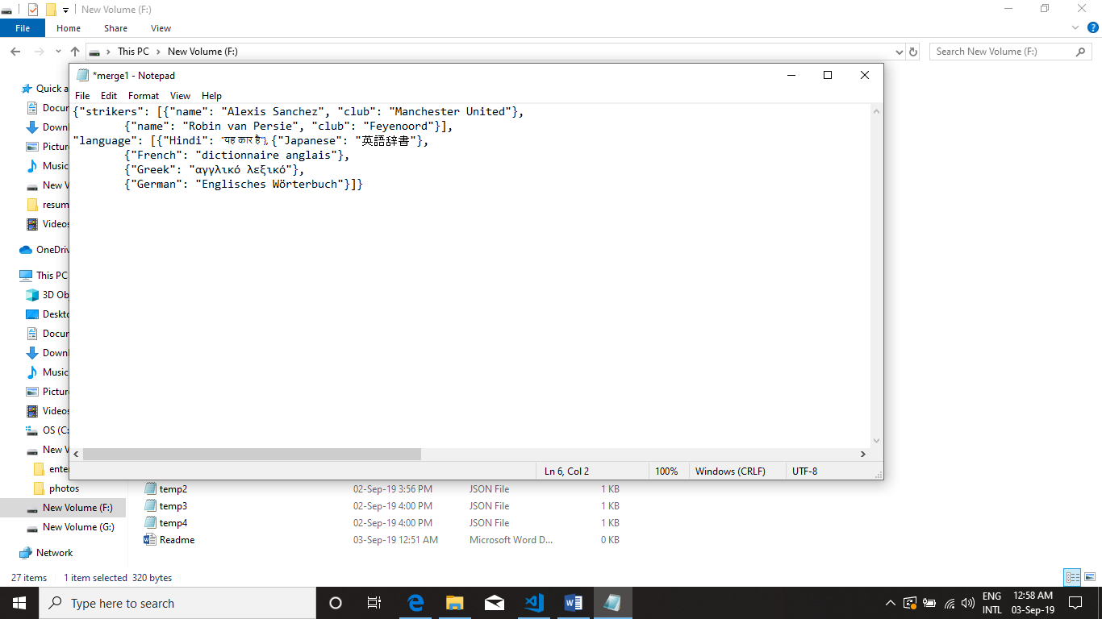

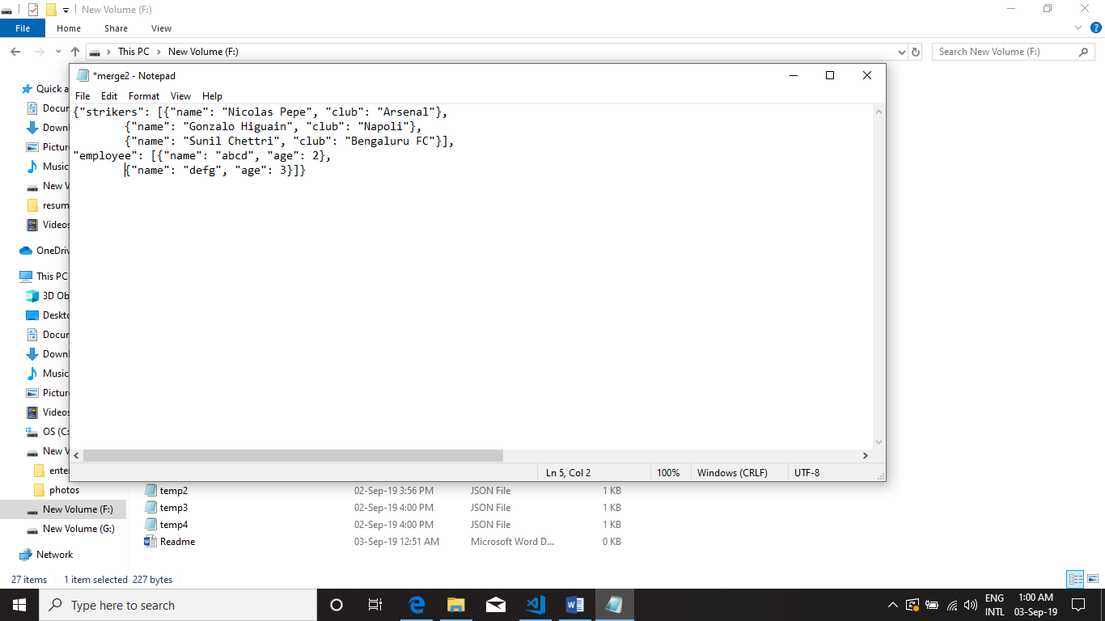

**CASE2: GENERIC SOLUTION**

**INPUT:**

**dict1.json**

{"strikers": [{ "name": "Gonzalo Higuain", "club": "Napoli" },

{ "name": "Sunil Chettri", "club": "Bengaluru FC" }] }

**dict2.json**

{"strikers": [{ "name": "Nicolas Pepe", "club": "Arsenal" }],

"employee":[{"name":"abcd", "age":2 },

{"name":"defg", "age":3 }]}

**dict3.json**

{"strikers": [{ "name": "Gonzalo Higuain", "club": "Napoli" },

{ "name": "Sunil Chettri", "club": "Bengaluru FC" }] }

**OUTPUT:**

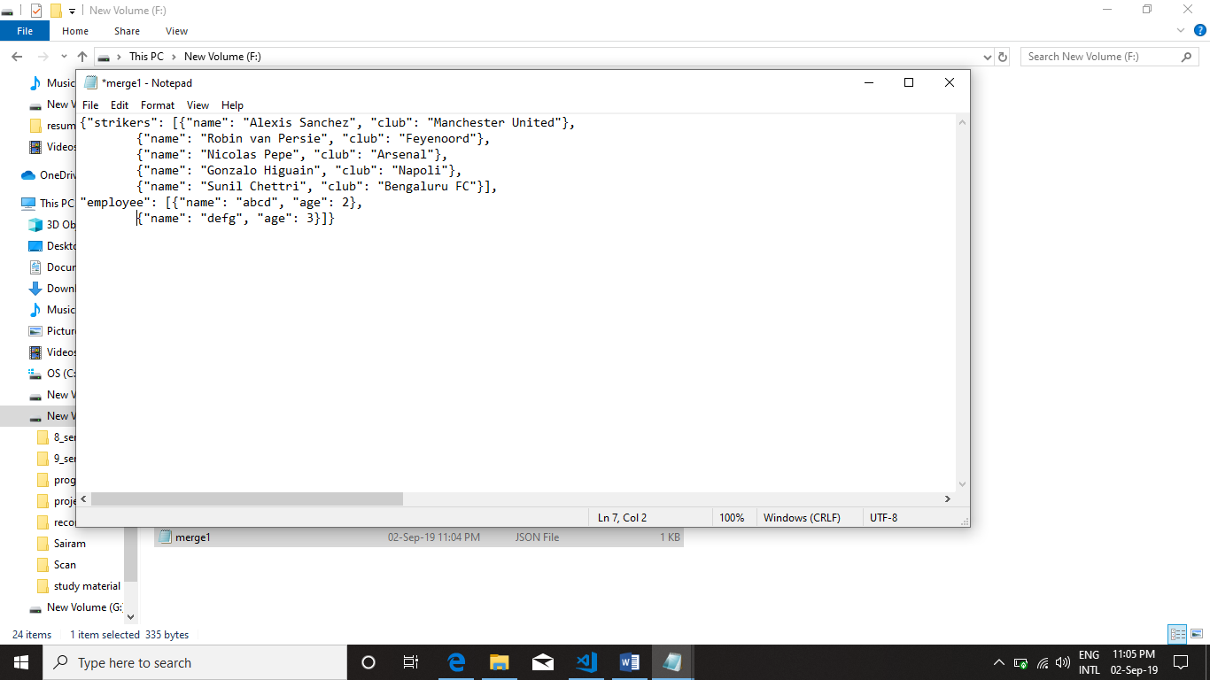

**CASE3: MAXIMUM FILE SIZ IS TOO SMALL**

**OUTPUT:**

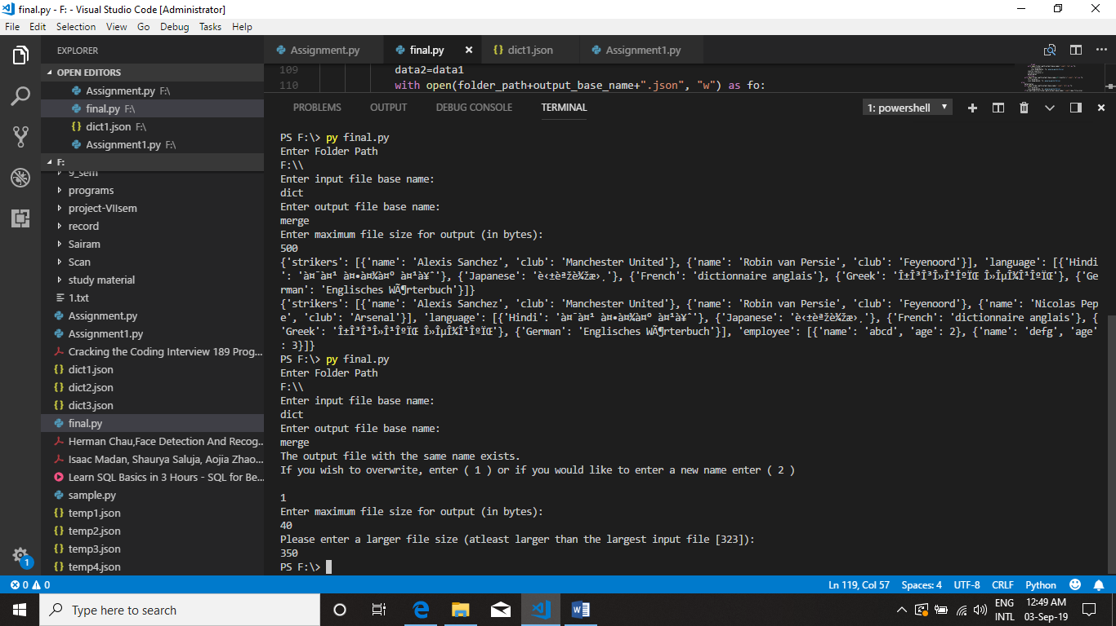

**REASON:**

Size of dict1: 323

Size of dict2: 69

Size of dict3: 112

Since, size of all files are greater than the given maximum file size.

**CASE4: MERGE FILE CREATION WITH SIZE CONSTRAINTS**

**INPUT:** folder_path – ‘F:\\’,

Input_base_File_name – ‘dict’,

Output_base_File_name – ‘merge’

Max_file_size – 150

**OUTPUT:**

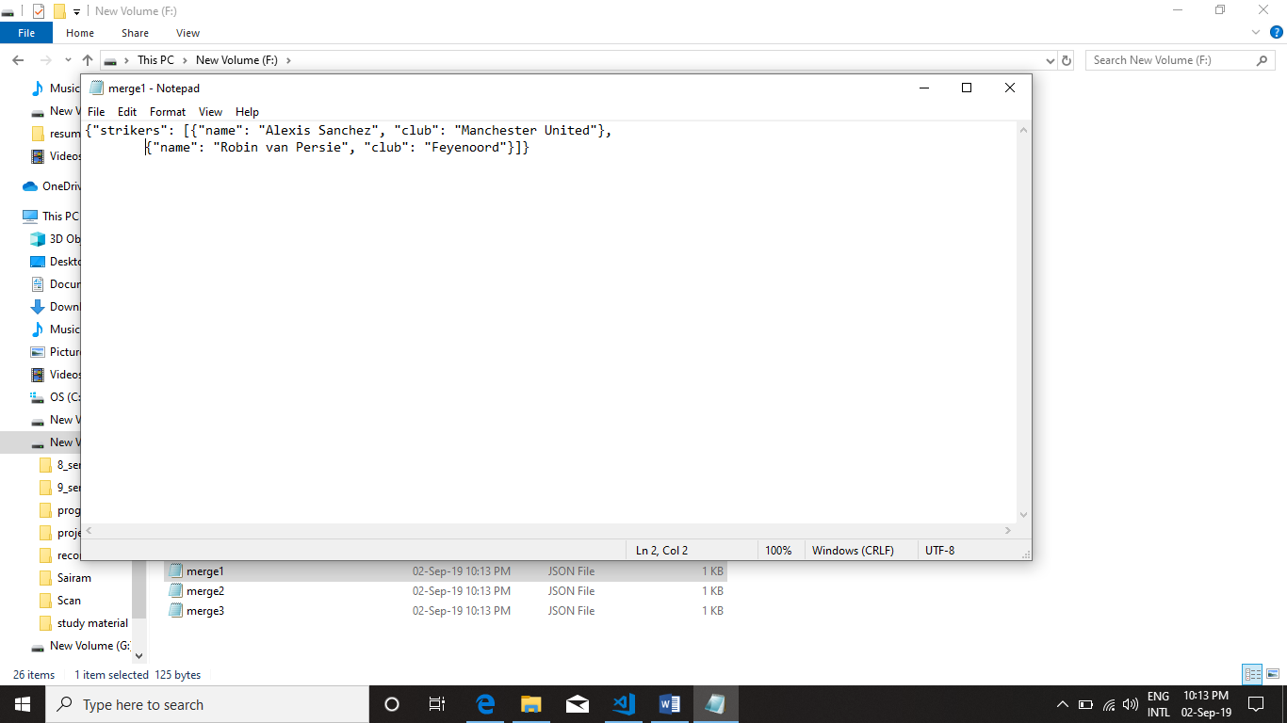

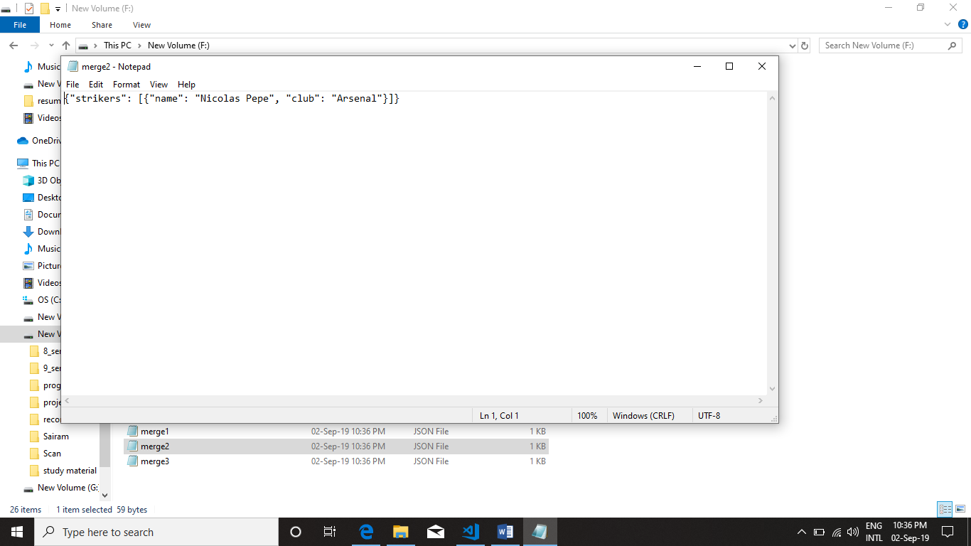

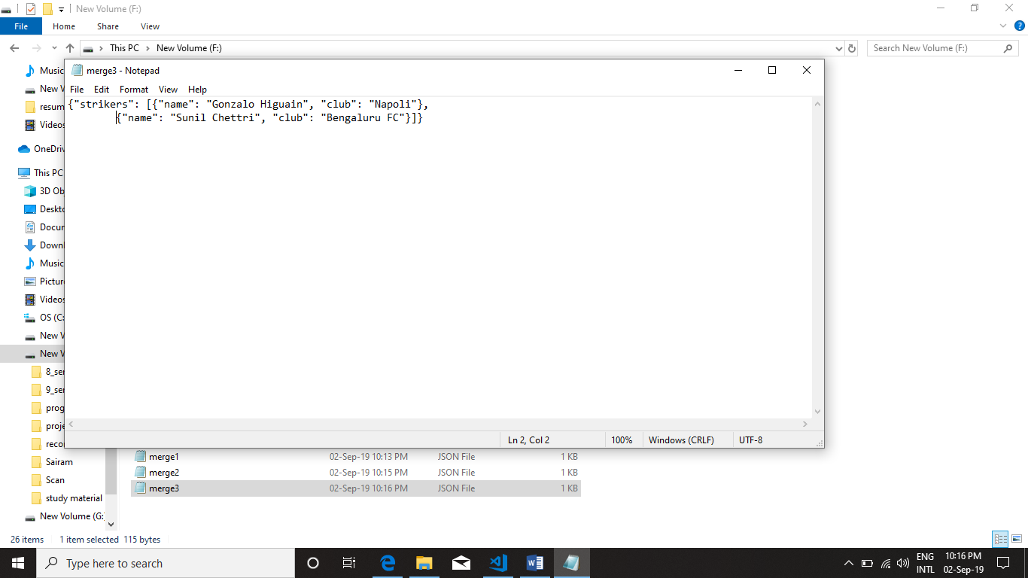

**REASON:**

Size of dict1: 127

Size of dict2: 69

Size of dict3: 112

Created 3 merge files, since the maximum file size of all is 150 and the given size is 150

**CASE5: MERGE FILE CREATION WITH SIZE CONSTRAINTS**

**INPUT:** folder_path – ‘F:\\’,

Input_base_File_name – ‘dict’,

Output_base_File_name – ‘merge’

Max_file_size – 250

**OUTPUT:**

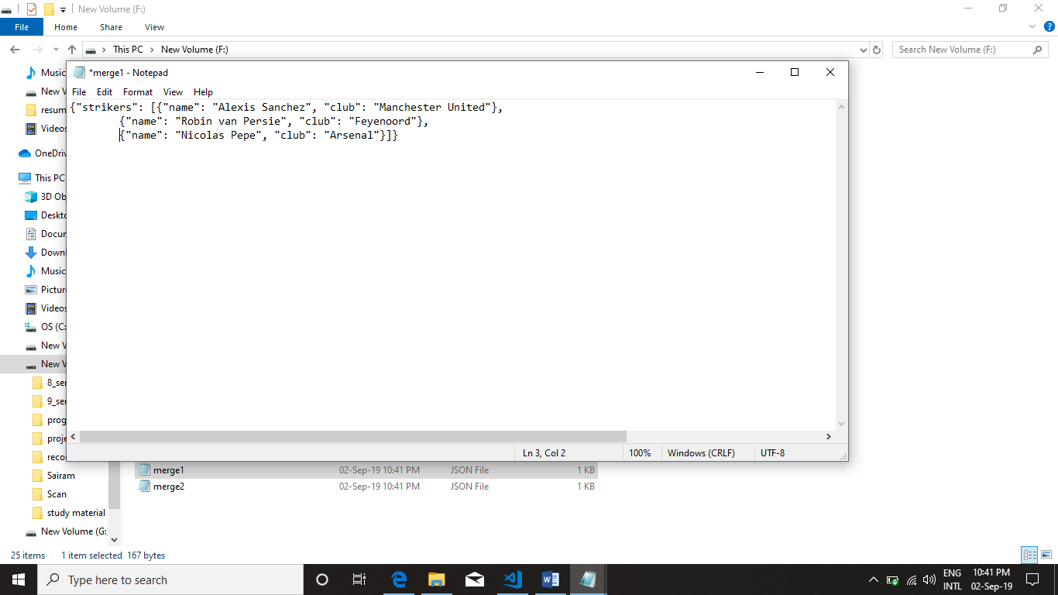

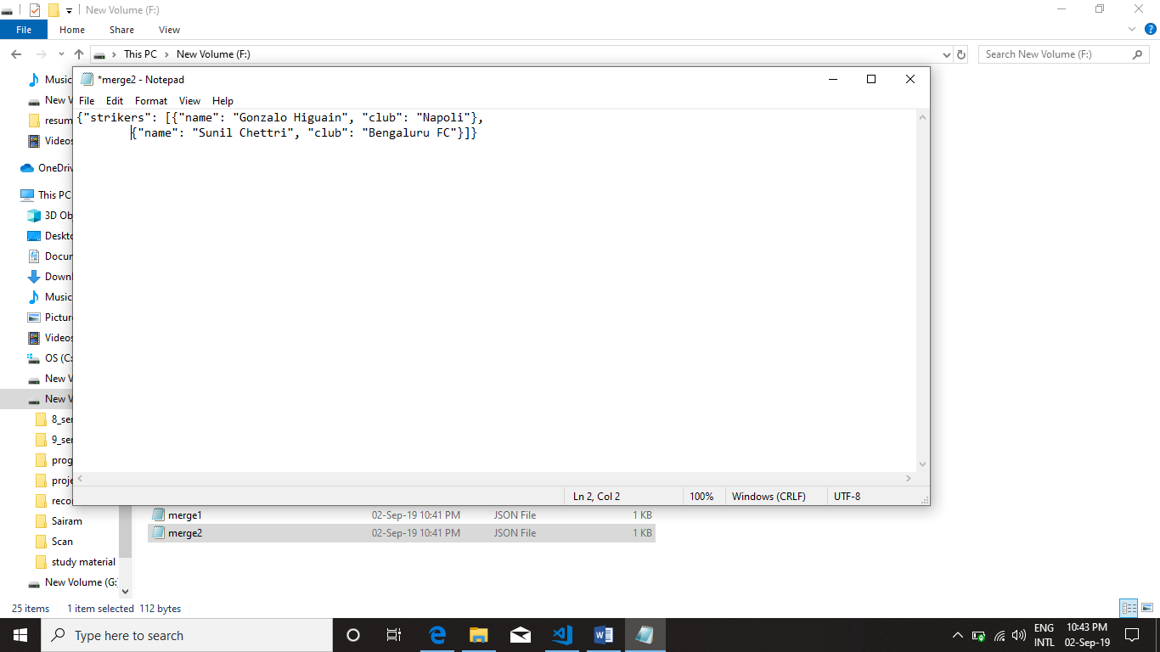

**REASON:**

Size of dict1: 127

Size of dict2: 69

Size of dict3: 112

Created 2 merge files, since the maximum file size of all is 144 and the given size is 250. So, size of merge1 file is 167 and merge2 is 112.

**CASE6: MERGE FILE CREATION WITH SIZE CONSTRAINTS**

**INPUT**: folder_path – ‘F:\\’,

Input_base_File_name – ‘dict’,

Output_base_File_name – ‘merge’

Max_file_size – 400

**OUTPUT:**

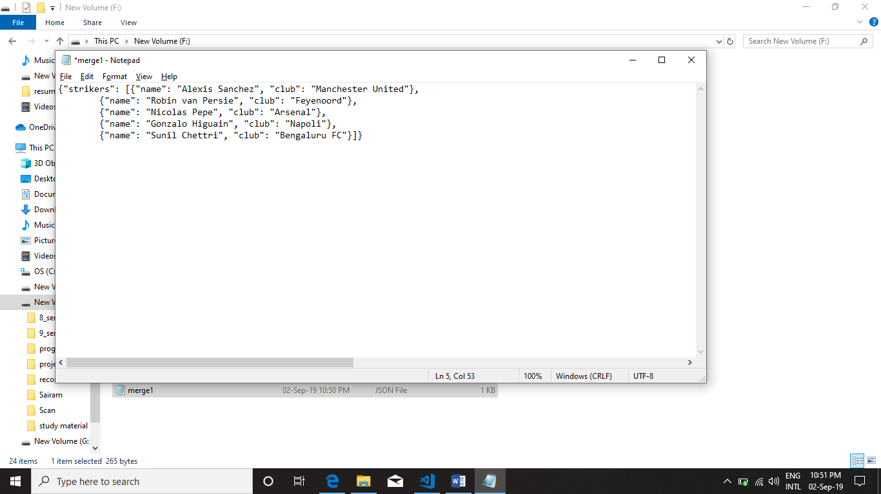

**REASON:**

Size of dict1: 127

Size of dict2: 69

Size of dict3: 112

Created 1 merge files, since the sum of size of all files are 308 and the given size is 400.