**Attendance tracking system using RFID sensor**

**Harini S (19Z317)**

**Jayasree B S (19Z322)**

**Nivedha K (19Z336)**

**Selva Keerthana B G (19Z346)**

Dissertation submitted in partial fulfillment of the requirements for the degree of

**BACHELOR OF ENGINEERING**

**Branch: COMPUTER SCIENCE AND ENGINEERING**

Of Anna University



## April 2022

**DEPARTMENT OF COMPUTER SCIENCE AND ENGINEERING**

**PSG COLLEGE OF TECHNOLOGY**

**(Autonomous Institution)**

**COIMBATORE – 641 004**

**1. INTRODUCTION:**

RFID that stands for Radio Frequency Identification is a wireless system that is composed of two components,

* Tags
* Readers

The reader is a device that is capable of emitting and receiving radio waves using its antenna Tags when brought near the reader emit radio waves in order to communicate the unique ID present inside it to the reader.

Radio-frequency identification (RFID) generates electromagnetic fields that identify and track tags attached to tags automatically. Unlike a [barcode](https://en.wikipedia.org/wiki/Barcode), the tag does not need to be within the [line of sight](https://en.wikipedia.org/wiki/Line-of-sight_propagation) of the reader, so it may be embedded in the tracked object.

RFID attendance system can be used to mark attendance at schools, colleges and work places. Students and workers can mark their attendance by placing their RFID card in front of the RFID reader.

**2. PROBLEM STATEMENT:**

A RFID based attendance tracking system by interfacing the RFID sensor(RC522) with Arduino UNO. Once the RFID data is read, it is displayed on the serial port of Arduino IDE. With the help of python code the serial data is stored in the phpMyAdmin database.

The marked attendance can be viewed using a web application developed using php, HTML and CSS. The user can view the attendance

* By date
* By student roll no

**3. COMPONENTS REQUIRED:**

* **Arduino UNO**
* RFID reader
* RFID tag
* Breadboard
* Jumper wire

**4. SCHEMATIC DIAGRAM:**

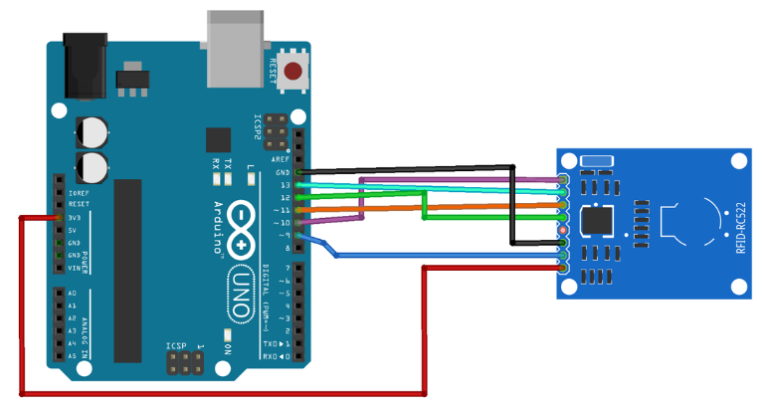

|  |  |
| --- | --- |
| **Arduino** | **RFID-RC522** |
| SDA | 10 |
| SCK | 13 |
| MOSI | 11 |
| MISO | 12 |
| GND | GND |
| RST | 9 |
| 3.3V | 3.3V |

**5. CODE:**

**5.1. Attendance.ino:**

#include <SPI.h> //include the SPI bus library

#include<MFRC522.h> //include the RFID reader library

#include <Ethernet.h>

#define SS_PIN 10 //slave select pin

#define RST_PIN 9 //reset pin

#define No_Of_Card 7

MFRC522 rfid(SS_PIN,RST_PIN); //instantiate a MFRC522 reader object

MFRC522::MIFARE_Key key; //create a MIFARE_Key struct named 'key' to hold card information

byte id[No_Of_Card][4]={

{51,143,132,174},

{67,195,242,11},

{185,206,89,136},

{105,86,132,135},

{233,30,69,135},

{217,185,113,135},

{89,233,103,136}

};

byte id_temp[3][3];

byte i;

int j=0;

void setup() {

Serial.begin(9600);

SPI.begin(); //initialise the SPI bus

rfid.PCD_Init();

for(byte i=0;i<6;i++)

{

key.keyByte[i]=0xFF;

}

}

//------------------------------------------------------------------------------

/* Infinite Loop */

void loop()

{int m=0;

if(!rfid.PICC_IsNewCardPresent())//look for new cards

return;

if(!rfid.PICC_ReadCardSerial())//select one of the cards

return;

for(i=0;i<4;i++)

{

id_temp[0][i]=rfid.uid.uidByte[i];

delay(50);

//Serial.print(rfid.uid.uidByte[i]);

//Serial.print(" ");

}

Serial.println("Card detected:");

for(i=0;i<No_Of_Card;i++)

{

if(id[i][0]==id_temp[0][0])

{

if(id[i][1]==id_temp[0][1])

{

if(id[i][2]==id_temp[0][2])

{

if(id[i][3]==id_temp[0][3])

{

for(int s=0;s<4;s++)

{

Serial.print(rfid.uid.uidByte[s]);

}

Serial.print(" ");

Sending_To_db();

j=0;

rfid.PICC_HaltA(); rfid.PCD_StopCrypto1(); return;

}

}

}

}

else

{j++;

if(j==No_Of_Card)

{

Serial.println("Card detected:");

for(int s=0;s<4;s++)

{

Serial.print(rfid.uid.uidByte[s]);

}

Serial.print(" ");

Sending_To_db();

j=0;

}

}

}

// Halt PICC

rfid.PICC_HaltA();

// Stop encryption on PCD

rfid.PCD_StopCrypto1();

}

void Sending_To_db()

{

if(j!=No_Of_Card)

{

Serial.print('1');

Serial.print(" ");

}

else

{

Serial.print('0');

Serial.print(" ");

}

}

**5.2. Rfid_attendance.py:**

import serial

import MySQLdb

import time

#establish connection to MySQL.

dbConn = MySQLdb.connect("localhost","root","","student_attendance") or die ("could not connect to database")

#open a cursor to the database

cursor = dbConn.cursor()

device = 'COM3'

try:

print("Trying...",device)

arduino = serial.Serial(device, 9600)

except:

print("Failed to connect on",device)

while True:

try:

data=arduino.readline()

print(data)

pieces=data.split()

try:

if(pieces[1][0]!=100):

cursor=dbConn.cursor()

cursor.execute("""INSERT INTO attendance_details (ID,Member_ID,allowed_members) VALUES (NULL,%s,%s)""", (pieces[0],pieces[1]))

dbConn.commit()

cursor.close()

data=arduino.readline()

except MySQLdb.IntegrityError:

print("failed to insert data")

finally:

cursor.close()

except:

print("Processing")

**6. SNAPSHOTS OF OUTPUT:**

**6.1. CONNECTION:**

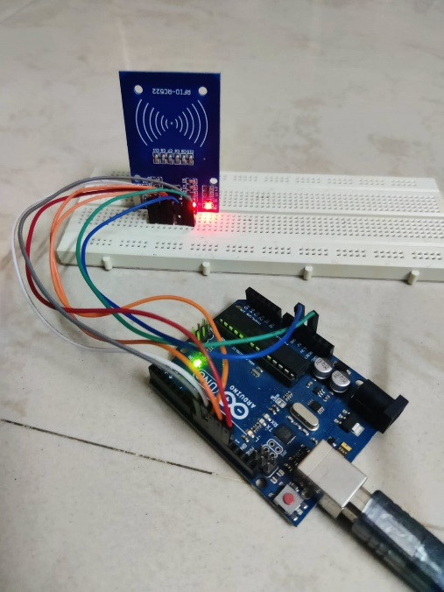

**6.2. SERIAL PORT:**

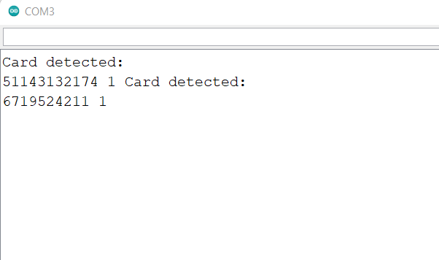

**6.3. WEB APPLICATION:**

**View by date:**

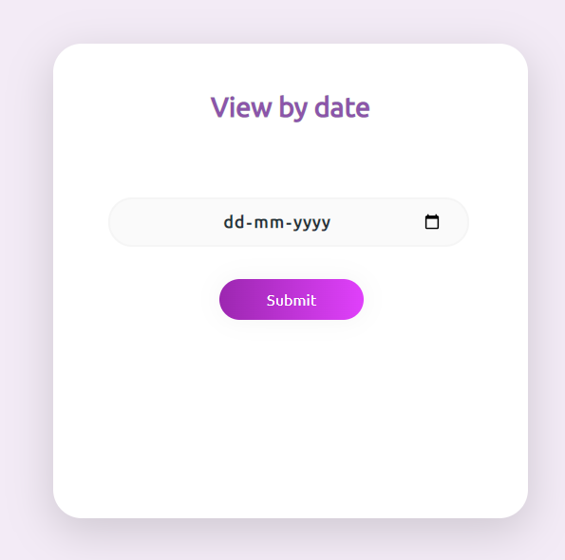

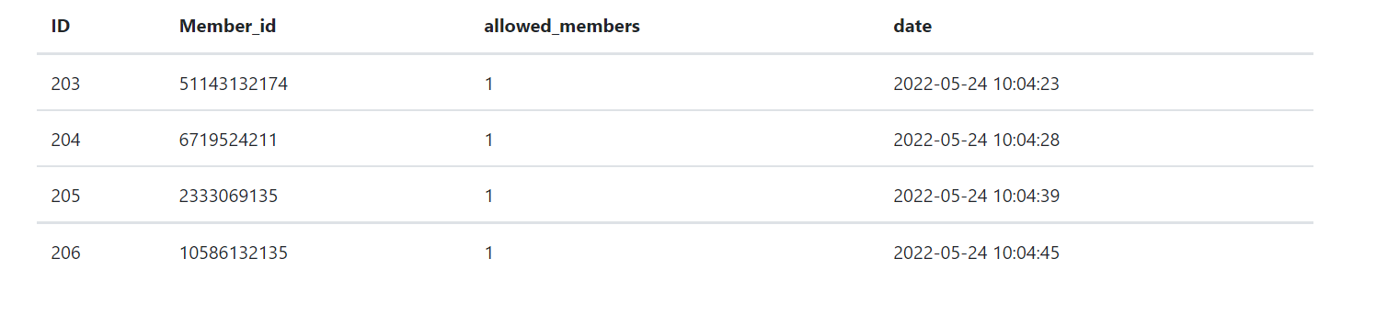

**View by student roll no:**

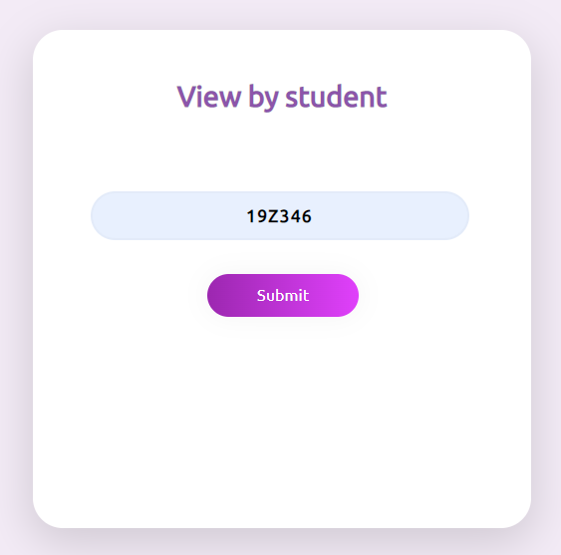

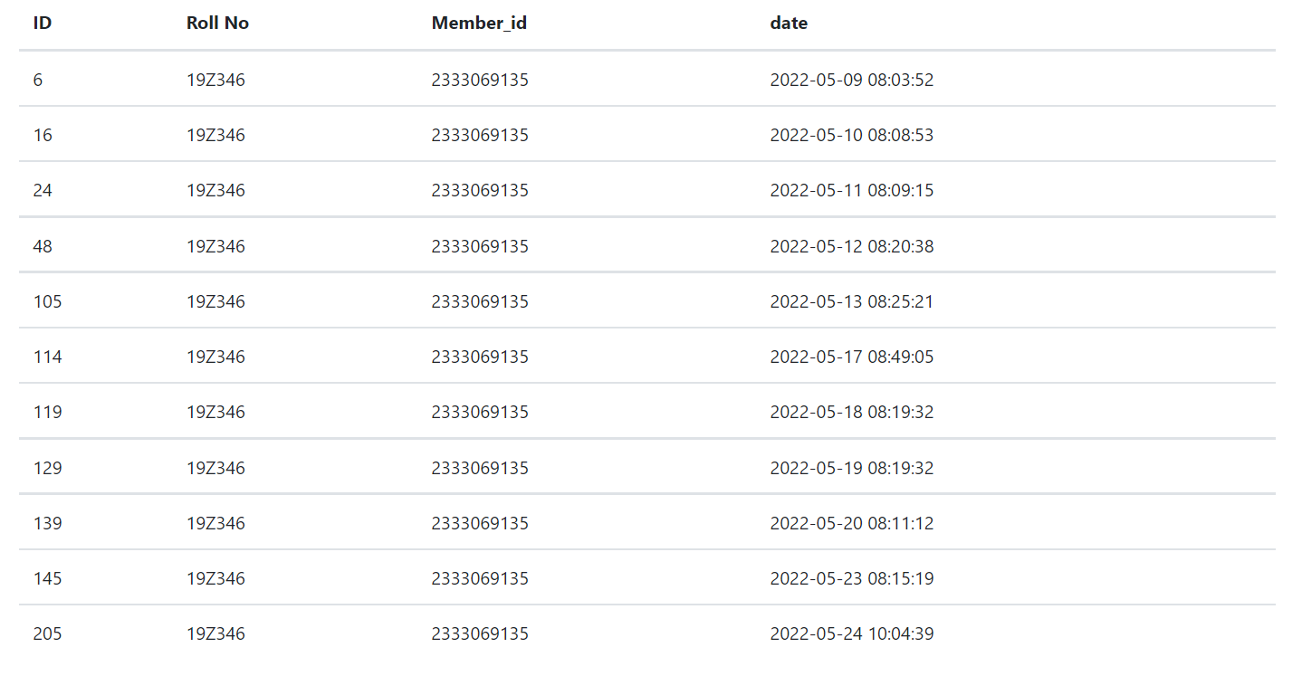

**7. CHALLENGES FACED:**

* The process of debugging the arduino code was quite challenging.

**8. CONTRIBUTION OF TEAM MEMBERS:**

|  |  |
| --- | --- |
| **Team Members** | **Contribution** |
| Harini.S(19Z317) | Worked on the interfacing of RFID sensor with arduino |
| Jayasree.B.S(19Z322) | Worked on the development of web application to display the attendance. |
| Nivedha.K(19Z336) | Worked on the storing of serial data in the database using python |
| Selva Keerthana.B.G(19Z346) | Worked on the development of web application to display the attendance. |

**9. REFERENCES:**

[1] <https://www.youtube.com/watch?v=aUHDtCRmVIo&t=4s>

[2] <https://create.arduino.cc/projecthub/embedotronics-technologies/attendance-system-using-arduino-and-rfid-with-python-3b69c8>

[3] <https://www.instructables.com/Attendance-System-by-Sending-RFID-Data-to-MySQL-Se/>

[4] <https://www.w3schools.com/php/>

**10.PLAGIARISM REPORT:**



plagiarism_report.pdf is attached in the github repository

**Github repository Link:**

[**https://github.com/jayasree012/RFID-Sensor.git**](https://github.com/jayasree012/RFID-Sensor.git)