JENKINS VERSION & JAVA VERSION:

BUILD SUCCESSFUL:

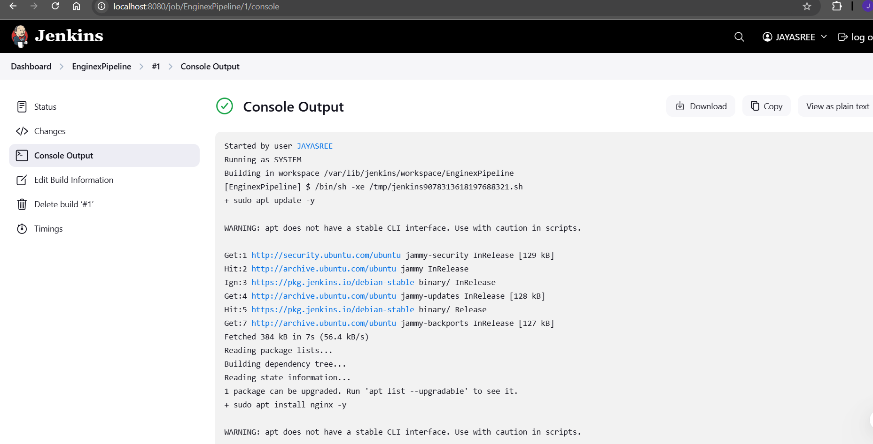

IP ADDRESS

PRIVILEGES GRANTED & JENKIN STATUS:

