NGINX CODE:

apiVersion: apps/v1

kind: Deployment

metadata:

  name: nginx-login

spec:

  replicas: 1

  selector:

    matchLabels:

      app: nginx-login

  template:

    metadata:

      labels:

        app: nginx-login

    spec:

      containers:

      - name: nginx-login

        image: nginx:latest # Public Nginx image from Docker Hub

        ports:

        - containerPort: 80

---

apiVersion: v1

kind: Service

metadata:

  name: nginx-login-service

spec:

type: NodePort

  selector:

    app: nginx-login

  ports:

    - protocol: TCP

      port: 80

      targetPort: 80

      nodePort: 30008

OUTPUT SCREENSHOTS:

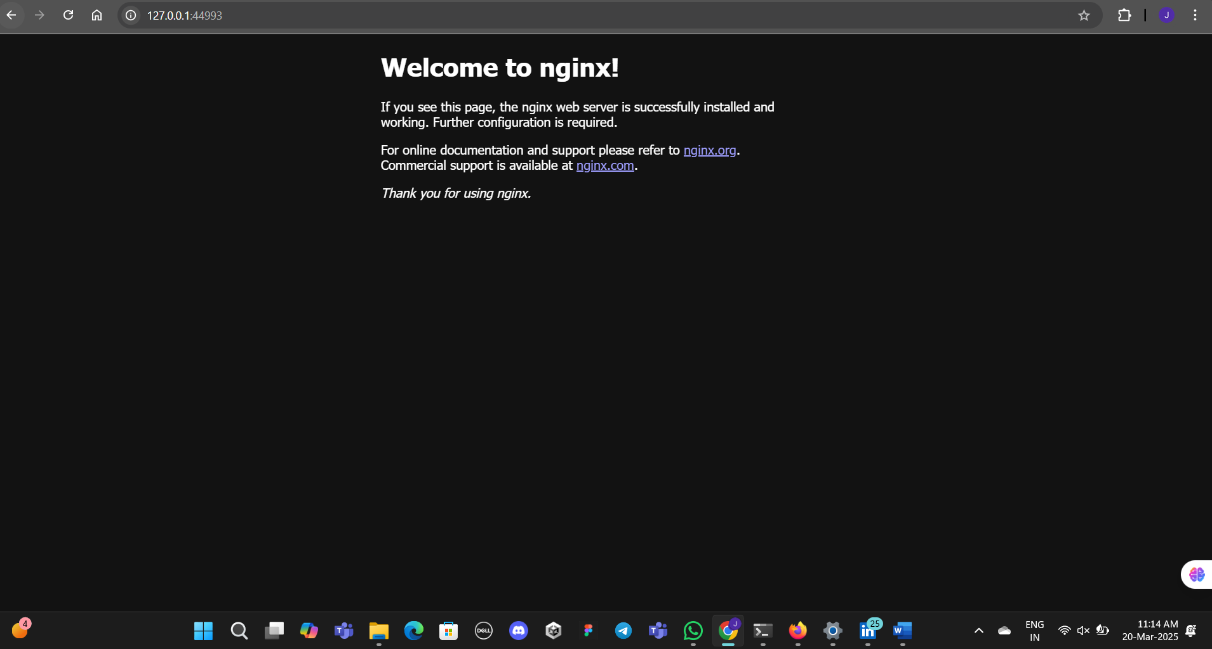

MY CUSTOM LOCALHOST POD CREATION:

echo '<h1>Welcome to My Custom Nginx Page!</h1>' > index.html

echo -e "FROM nginx\nCOPY index.html /usr/share/nginx/html/index.html" > Dockerfile

VERSIONS:

