**ACE**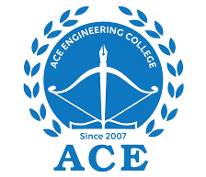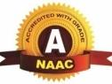

**Engineering College**

**An AUTONOMOUS Institution**

Ghatkesar, Medchal (Dist), Hyderabad, Telangana State – 501 301

(NBA Accredited B.Tech Courses Accredited NAAC with A Grade 3.20 CGPA)

Phone: 9133308533, 468, website: [www.aceec.ac.in](http://www.aceec.ac.in)

**DEPARTMENT OF CSE (ARTIFICIAL INTELLIGENCE & MACHINE LEARNING)**

### Assignment

**INFORMATION RETRIEVAL SYSTEMS**

III.B. Tech, CSE (AI&ML)

II SEMESTER –A, B & C SECTION

Unit – I

1. Explain the relationship between IRS and DBMS.
2. Explain recall and precision with a neat sketch.
3. Explain Functional overview of IR**S.**
4. Explain search and browse capabilities of IR**S.**

Unit - II

1. Explain indexing process with its objective**s**
2. Explain Stemming Algorithms**?**
3. Explain Inverted File Structure?
4. Explain PAT & N-Gram data structures with examples?
5. Explain Hypertext and XML Data Structures**?**

Unit – III

1. Explain classes of automatic indexing