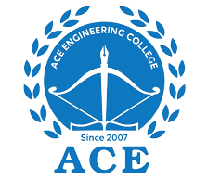

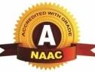
ACE
Engineering College
An AUTONOMOUS Institution
Ghatkesar, Medchal (Dist), Hyderabad, Telangana State – 501 301
(NBA Accredited B.Tech Courses Accredited NAAC with A Grade 3.20 CGPA)
Phone: 9133308533, 468, website: www.aceec.ac.in

DEPARTMENT OF CSE (ARTIFICIAL INTELLIGENCE & MACHINE LEARNING)

Assignment
INFORMATION RETRIEVAL SYSTEMS
III.B. Tech, CSE (AI&ML)
II SEMESTER –A, B & C SECTION

Unit – I
- Explain the relationship between IRS and DBMS.
- Explain recall and precision with a neat sketch.
- Explain Functional overview of IRS.
- Explain search and browse capabilities of IRS.
Unit - II
- Explain indexing process with its objectives
- Explain Stemming Algorithms?
- Explain Inverted File Structure?
- Explain PAT & N-Gram data structures with examples?
- Explain Hypertext and XML Data Structures?

Unit – III

- Explain classes of automatic indexing

