**Charting The Course Of Innovation:**

**A Startup Analysis**

Submitted by

**S.JAYASRI**

(Reg. No. 12020U25012)

**S.KALAIVANI**

(Reg. No. 12020U25013)

**A.INDHUMATHY**

(Reg. No. 12020U25010)

**A.JAGATHEESWARI**

(Reg. No. 12020U25011)

DEPARTMENT OF

BACHELOR OF SCIENCE IN MATHEMATICS



**KRISHNASAMY COLLEGE OF SCIENCE, ARTS & MANAGEMENT FOR WOMEN – CUDDALORE**

**PROJECT CONTENT**

1. INTRODUCTION
   1. Overview
   2. Purpose
2. PROBLEM DEFINITION & DESIGN THINKING
   1. Empathy Map
   2. Ideation & Brainstorming Map
3. RESULT
4. ADVANTAGES & DISADVANTAGES
5. APPLICFATIONS
6. CONCLUSION
7. FUTURE SCOPE
8. APPENDIX
9. SQL Source Code
10. HTML Source Code

1. **INTRODUCTION**

**1.1 Overview**

Starting a new company can be an exciting and rewarding experience, but it also requires careful planning and analysis to ensure that the business is viable and successful. There are several key areas that you should focus on when conducting a startup company analysis. Conducting a thorough analysis of these areas can help you identify potential challenges and opportunities, and develop strategies to address them. It is also important to regularly review and update your analysis as the business progresses, in order to adapt to changing market conditions.

* 1. **Purpose**

The business requirements for analyzing the performance and efficiency

of startups in India include identifying KPIs, comparing performance across different industries and states, identifying patterns and trends over time, identifying affecting factors, creating interactive dashboards and reports, identifying areas for improvement, making data-driven decisions, comparing to the industry average and creating forecasting models for future performance. The ultimate goal is to gain insights and improve performance through data visualization techniques.

A literature survey is a method of researching existing literature and studies related to a specific topic. In the context of analysing the performance and efficiency of startups in India, a literature survey would involve reviewing studies and articles that have been published on the topic of hotel performance and efficiency, as well as studies specific to startups approved by the Indian government. The literature survey would include sources such as academic journals, industry reports, and online articles. It would aim to identify key performance indicators (KPIs) and metrics that are commonly used to measure startup culture and its trend, as well as any best practices or strategies that have been identified for improving performance. The literature survey would also explore any existing research on startups in India of different domains specifically and would aim to identify any unique challenges or opportunities that the hotel chain faces in terms of performance and efficiency.

**Social Impact:** Startups are the boost for any country. By analysing the startups and number of startups coming every year and industries that are seeing the boom, may somebody with the dilemma to start or not start can start his/her own company and become successful.

**Business Model/Impact:** Can make this visualization application available for people, for more insights and ideas can ask for payment and also can give these insights to investors and banks to make the understand and help in the sense of investing.

1. **PROBLEM DEFINITION & DESIGN THINKING**

**2.1 Empathy Map**

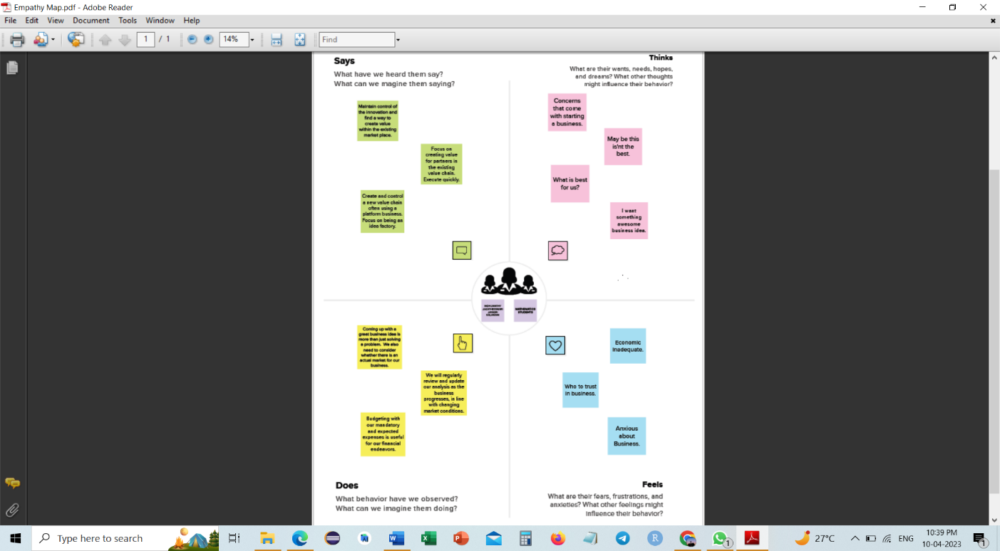

* 1. **Ideation & Brainstorming Map**

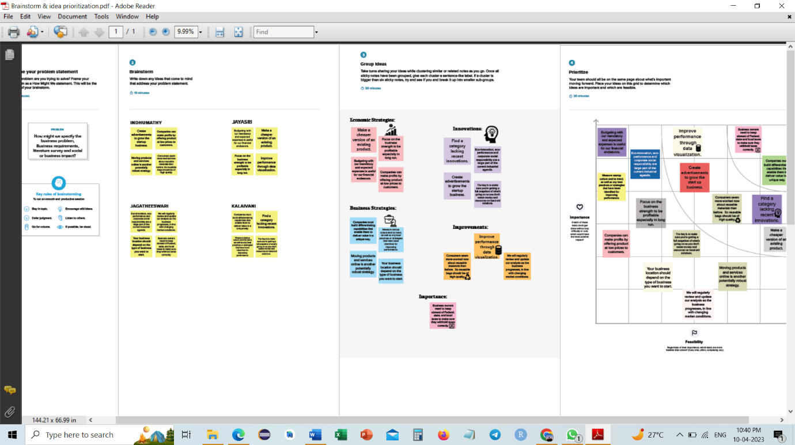

1. **RESULT**

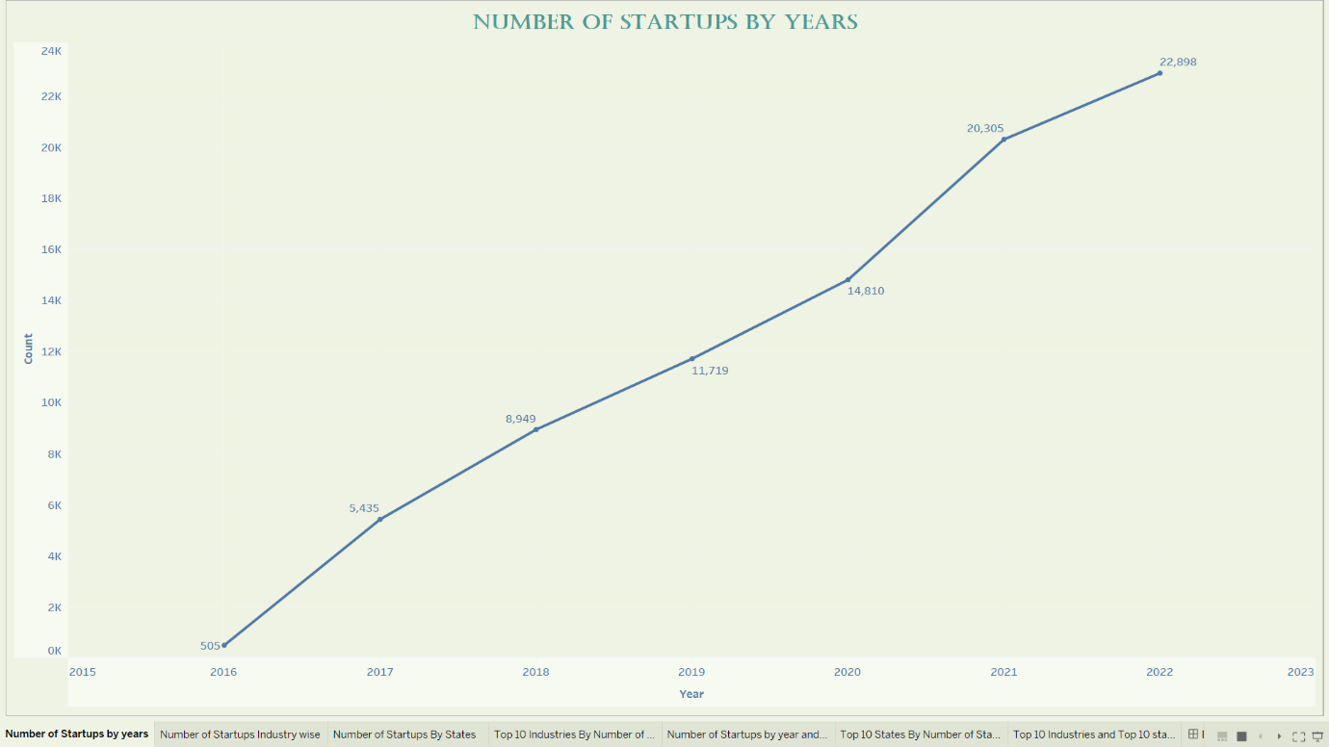

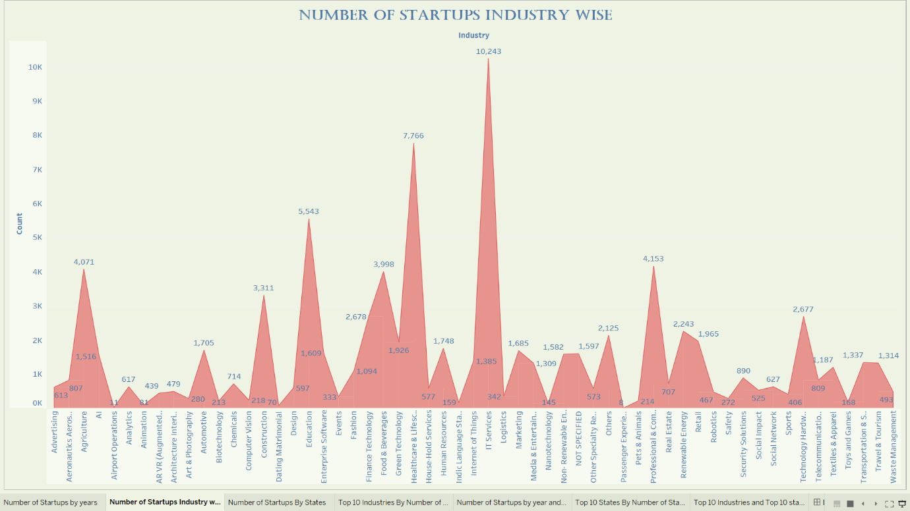

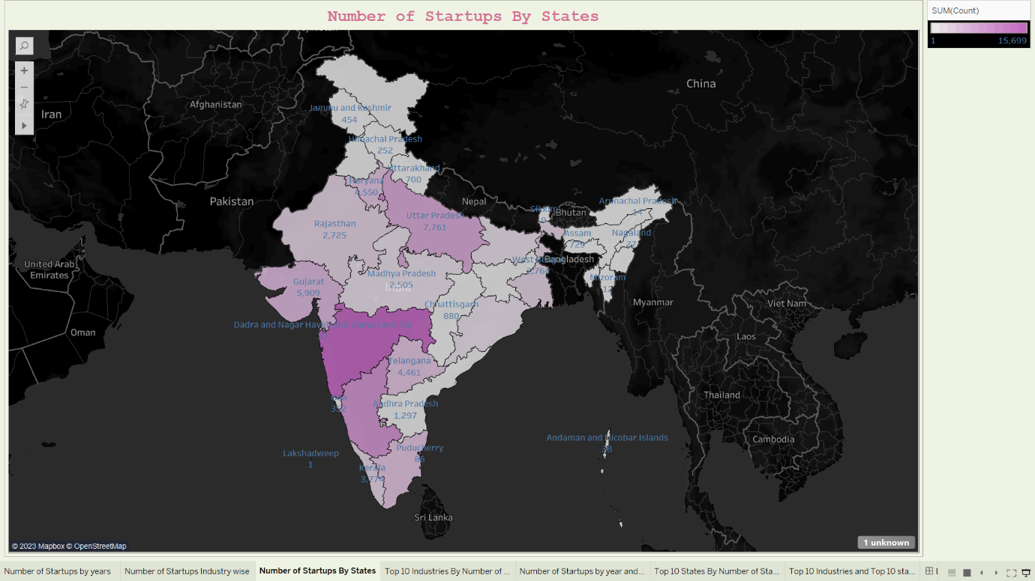

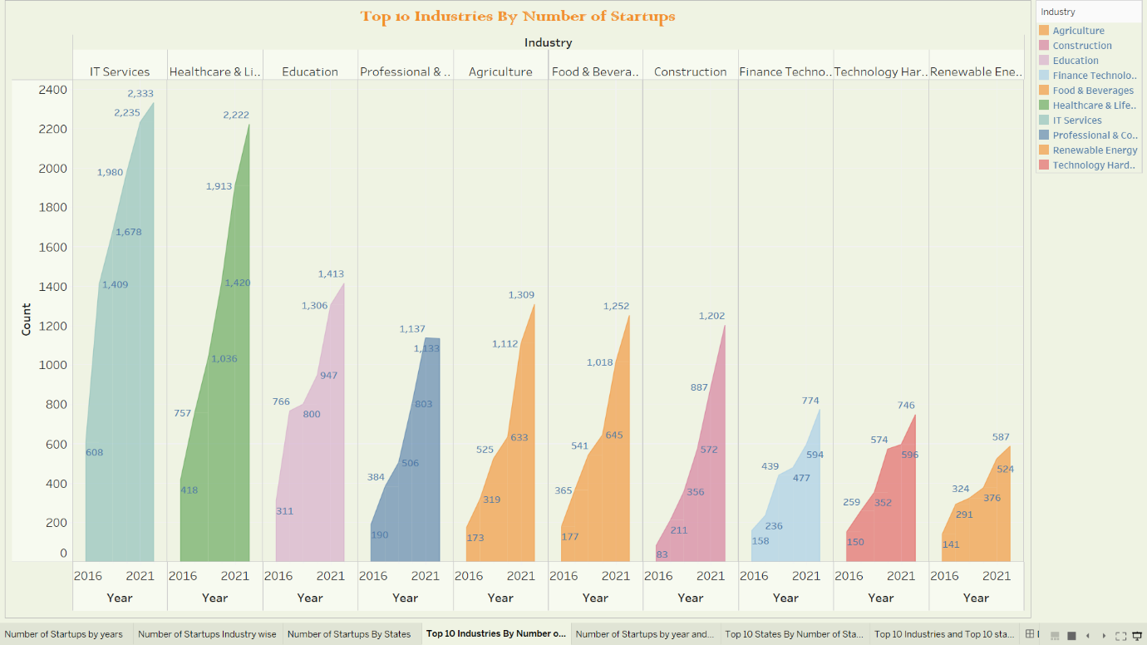

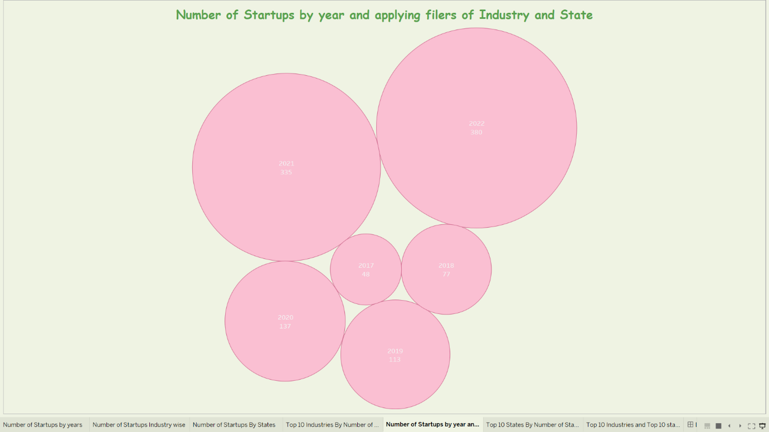

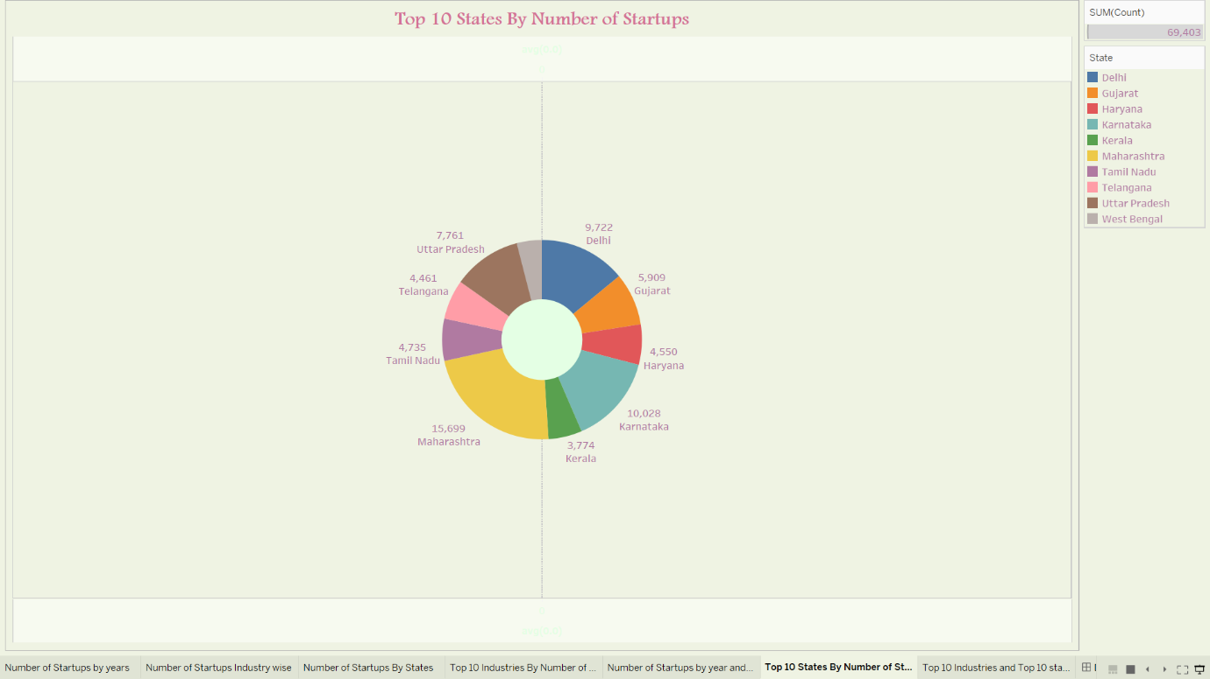

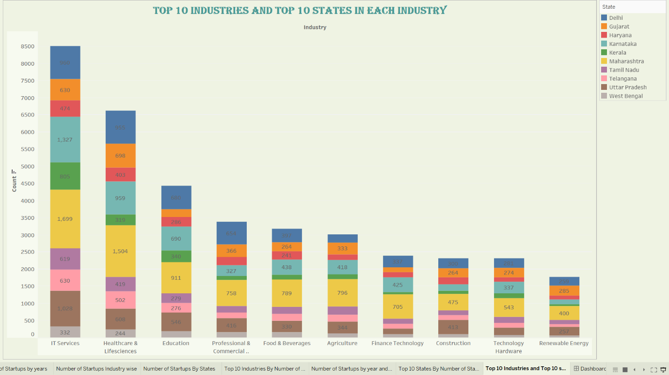

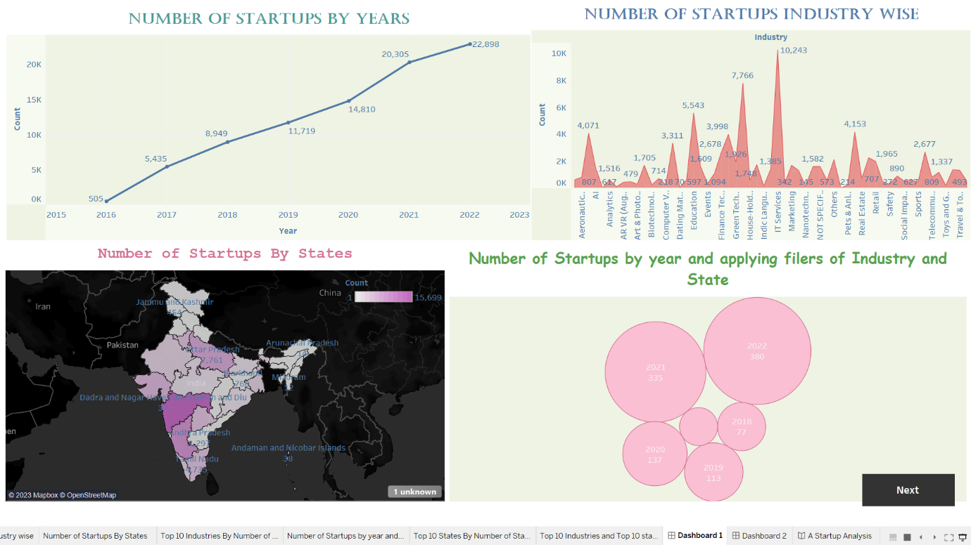

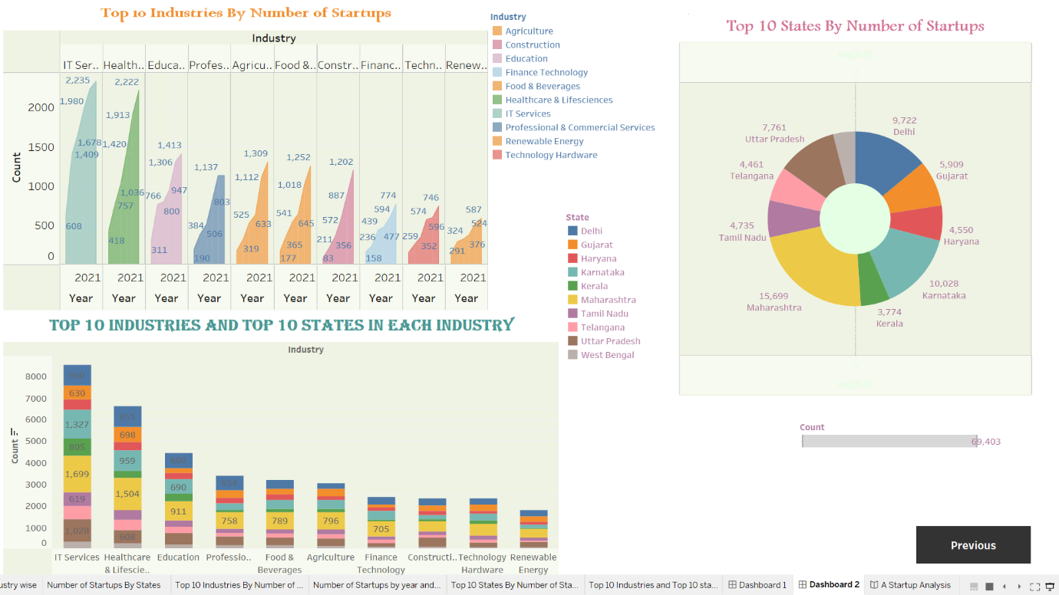

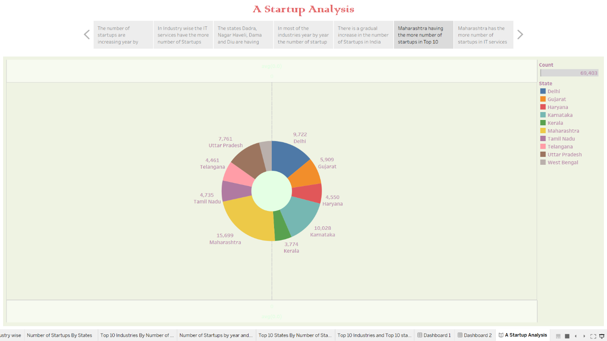

1. **ADVANTAGES & DISADVANTAGES**

* **ADVANTAGES**

1. **Agility :** Startups are smaller and less structured. They are also innovative and keep improving their business models, processes, and portfolio. These allow them to adapt to disruptive technologies and changes in market conditions. Established competitors face vested interests, a historic path, and a strong team culture. This makes them resistant to change.
2. **Efficiency:** Established companies have high administrative overheads. Startups offer their services in a more efficient, cost-effective and competitive manner. They are likely to be aware of their limitations and tend to focus on their core strengths. This causes them to partner with other small organizations. Customers often benefit with a superior value proposition.
3. **Team Culture:** Employees of large corporations get attracted by prestige and big salaries. They easily lose sight of the company’s vision, mission and values and the success of its customers. Startup employees form a close-knit community that shares passion, beliefs, and values. They must work together for the good of the company, its customers and the world at large.
4. **Personalization:** Startups deliver their products and services with a personal touch. This creates a uniquely personal experience for their customers. Startups also take time to study and understand their customers’ business requirements. This allows them to build lasting relationships with specific offerings and responsive solutions.
5. **Versatility:** Startup employees multitask and the salesperson could double up as the relationship manager. This adds continuity to customer relationships and enables startups to respond to emergencies. Most startups support learning and have a higher tolerance for mistakes. Both factors enhance the versatility of startup employees.
6. **Flexibility:** Your organization could have rather unique needs and demands for products and services. These might not be met by established service providers operating in a rigid manner. Startups are very flexible and are more likely to work at the hours, the place and in the manner that suits you.
7. **Fun:** Last but now least, working with a startup could be a lot more fun. A startup doesn’t have to please everyone and may decide to select clients that are fun to work with. Spontaneous fun activities after work are a lot easier to organize in a startup. Your colleagues could become your best friends.

* **DISADVANTAGES**

1. **Risk:** Most startups fail within their first year of operations, so the risk of failure is high. Working under such high risk can blur a startup’s strategic vision. So they either fail to seize market opportunities or overestimate their sales projections. High risk also hinders a startup’s ability to attract experienced and competent staff.
2. **Compensation:** It takes blood, sweat, and tears to build a company, and long working hours are the norm for startups. The rewards might be low since it takes time to generate revenue and make profits. Some startups give up since it’s demotivating to work without proper compensation.
3. **Market Access:** Many customers prefer a business that they have worked with over a new startup. Besides it is more expensive to acquire new customers than to retain old ones. Without a customer base, understanding market needs also becomes a real struggle. All these factors combined increase the cost of business development for startups.
4. **Team Composition:** Some startups are born out of desperation since the founder could not find or hold on to a job. Such founders often struggle to build a team that the business needs to succeed. A successful startup requires founders/co-directors with complementary personalities and competencies. Even then disagreements can creep in when the going gets tough.
5. **Resources:** Growth hacking, cloud computing, and venture capitalism allow startups to gain market entry. Most startups operate on a shoestring budget, against competitors that are well-resourced. It gives the competitors an edge in product development, sales, and marketing. They use that edge to push startups out of the market when they become a threat.
6. **Processes:** Startups are flat organizations that lack defined business processes and operational procedures. This exposes them to poor customer service, legal liability, and financial losses. Startups might thus opt to outsource non-core business processes to external service providers. But the high associated costs could form a barrier.
7. **Stress**: We did mention that working for a startup is fun, but it could also become very stressful. Low compensation, many responsibilities and long working hours are more or less expected. Add legal prosecution, imminent business failure, and screaming customers and work becomes unbearable.
8. **APPLICATIONS**

In [Startup analytics](https://www.analyticssteps.com/blogs/marketing-analytics-overview), data visualisation is a boon. We may use visuals and reports to analyse various patterns and trends analysis, such as sales analysis, statup research analysis, customer analysis, defect analysis, cost analysis, and forecasting. These studies serve as a foundation for marketing and sales.

Visual aids can assist your audience grasp your main message by visually engaging them and visually engaging them. The major advantage of visualising data is that it can communicate a point faster than a boring spreadsheet.

In b2b firms, data-driven yearly reports and presentations don't fulfil the needs of people who are seeing the information. They are unable to grasp the art of engaging with their audience in a meaningful or memorable manner. Your audience will be more interested in your facts if you present them as visual statistics, and you will be more inclined to act on your discoveries.

Using visuals and reports, we may analysis numerous patterns and trends analysis such as sales analysis, startup research analysis, customer analysis, defect analysis, cost analysis, and forecasts. These evaluations serve as a foundation for marketing and sales.

1. **CONCLUSION**

While the world-changing potential in startups is sometimes overhyped, successful startups do have the potential to create a significant positive impact on the world. And even when startups fail, they still have an impact, especially through the learnings for the founders, employees, investors and other stakeholders.

1. **FUTURE SCOPE**

Personalization is another trend that is set to shape the future of data visualization. With personalization, users will be able to customize their data visualizations to suit their individual needs and preferences. For example, users may be able to choose the colours and fonts used in their visualizations or select the data points that are displayed.

Inthe future of data visualization is full of possibilities. With AI and ML, interactive visualization, VR and AR, and data storytelling, data visualization tools will become even more powerful and effective at communicating complex information to a wide audience. As the amount of data being produced continues to grow, data visualization will become an essential tool for understanding and interpreting this data.

1. **APPENDIX**
2. **SQL Source Code**
3. create startup_analysis;
4. use startup_analysis;
5. select*from start_up;
6. **HTML Source Code**

1. <!DOCTYPE html>

<html lang="zxx">

<head>

  <meta charset="utf-8">

  <title>Startups</title>

  <!-- mobile responsive meta -->

  <meta name="viewport" content="width=device-width, initial-scale=1">

  <meta name="viewport" content="width=device-width, initial-scale=1, maximum-scale=1">

  <!-- ** Plugins Needed for the Project ** -->

  <!-- Bootstrap -->

  <link rel="stylesheet" href="plugins/bootstrap/bootstrap.min.css">

  <!-- themefy-icon -->

  <link rel="stylesheet" href="plugins/themify-icons/themify-icons.css">

  <!-- slick slider -->

  <link rel="stylesheet" href="plugins/slick/slick.css">

  <!-- venobox popup -->

  <link rel="stylesheet" href="plugins/Venobox/venobox.css">

  <!-- aos -->

  <link rel="stylesheet" href="plugins/aos/aos.css">

  <!-- Main Stylesheet -->

  <link href="css/style.css" rel="stylesheet">

  <!--Favicon-->

  <link rel="shortcut icon" href="images/favicon.ico" type="image/x-icon">

  <link rel="icon" href="images/favicon.ico" type="image/x-icon">

</head>

<body>

<!-- navigation -->

<section class="fixed-top navigation">

  <div class="container">

    <nav class="navbar navbar-expand-lg navbar-light">

      <a class="navbar-brand" href="index.html"><img src="images/logo.png" alt="logo"></a>

      <button class="navbar-toggler border-0" type="button" data-toggle="collapse" data-target="#navbar" aria-controls="navbar"

        aria-expanded="false" aria-label="Toggle navigation">

        <span class="navbar-toggler-icon"></span>

      </button>

      <!-- navbar -->

      <div class="collapse navbar-collapse text-center" id="navbar">

        <ul class="navbar-nav ml-auto">

          <li class="nav-item">

            <a class="nav-link" href="index.html">Home</a>

          </li>

          <li class="nav-item">

            <a class="nav-link" href="about.html">About</a>

          </li>

          <li class="nav-item">

            <a class="nav-link" href="service.html">Dashboard</a>

          </li>

          <li class="nav-item">

            <a class="nav-link page-scroll" href="#pricing">Story</a>

          </li>

          <li class="nav-item">

            <a class="nav-link" href="contact.html">Contact</a>

          </li>

        </ul>

      </div>

    </nav>

  </div>

</section>

<!-- /navigation -->

<!-- hero area -->

<section class="hero-section hero" data-background="" style="background-image: url(images/hero-area/banner-bg.png);">

  <div class="container">

    <div class="row">

      <div class="col-lg-12 text-center zindex-1">

        <h1 class="mb-3">Indian Startups<br>

          Analysis and visualization</h1>

        <p class="mb-4">We have analized and about the startups that are especially in India and approved by Indian Govt.</p>

        <a href="#" class="btn btn-secondary btn-lg">explore us</a>

        <!-- banner image -->

        <img class="img-fluid w-100 banner-image" src="images/hero-area/banner-img.png" alt="banner-img">

      </div>

    </div>

  </div>

  <!-- background shapes -->

  <div id="scene">

    <img class="img-fluid hero-bg-1 up-down-animation" src="images/background-shape/feature-bg-2.png" alt="">

    <img class="img-fluid hero-bg-2 left-right-animation" src="images/background-shape/seo-ball-1.png" alt="">

    <img class="img-fluid hero-bg-3 left-right-animation" src="images/background-shape/seo-half-cycle.png" alt="">

    <img class="img-fluid hero-bg-4 up-down-animation" src="images/background-shape/green-dot.png" alt="">

    <img class="img-fluid hero-bg-5 left-right-animation" src="images/background-shape/blue-half-cycle.png" alt="">

    <img class="img-fluid hero-bg-6 up-down-animation" src="images/background-shape/seo-ball-1.png" alt="">

    <img class="img-fluid hero-bg-7 left-right-animation" src="images/background-shape/yellow-triangle.png" alt="">

    <img class="img-fluid hero-bg-8 up-down-animation" src="images/background-shape/service-half-cycle.png" alt="">

    <img class="img-fluid hero-bg-9 up-down-animation" src="images/background-shape/team-bg-triangle.png" alt="">

  </div>

</section>

<!-- /hero-area -->

<!-- feature -->

<section class="section feature mb-0" id="feature">

  <div class="container">

    <div class="row">

      <div class="col-lg-12 text-center">

        <h2 class="section-title">Awesome Features</h2>

      </div>

      <!-- feature item -->

      <div class="col-md-6 mb-80">

        <div class="d-flex feature-item">

          <div>

            <i class="ti-ruler-pencil feature-icon mr-4"></i>

          </div>

          <div>

            <h4>Awesome Design</h4>

            <p>The Graphs and Charts used in here

               for visualization will be more understand at a

               quick glance.</p>

          </div>

        </div>

      </div>

      <!-- feature item -->

      <div class="col-md-6 mb-80">

        <div class="d-flex feature-item">

          <div>

            <i class="ti-layout-cta-left feature-icon mr-4"></i>

          </div>

          <div>

            <h4>Easy Customize</h4>

            <p>The Dashboard that is created in the responsive

              and dynamic dashboard that you can use to

               analyse and understand more.</p>

          </div>

        </div>

      </div>

      <!-- feature item -->

      <div class="col-md-6 mb-80">

        <div class="d-flex feature-item">

          <div>

            <i class="ti-split-v-alt feature-icon mr-4"></i>

          </div>

          <div>

            <h4>Saving Time</h4>

            <p>To start you startup, now need to keep hours of

              your time to just understand what the stage of all

              startups here you can understand quickly by just

              looking the Visualization.</p>

          </div>

        </div>

      </div>

      <!-- feature item -->

      <div class="col-md-6 mb-80">

        <div class="d-flex feature-item">

          <div>

            <i class="ti-layers-alt feature-icon mr-4"></i>

          </div>

          <div>

            <h4>Story</h4>

            <p>The Narration of data based the Visualization and

              analysis is super engaging.</p>

          </div>

        </div>

      </div>

    </div>

  </div>

  <img class="feature-bg-1 up-down-animation" src="images/background-shape/feature-bg-1.png" alt="bg-shape">

  <img class="feature-bg-2 left-right-animation" src="images/background-shape/feature-bg-2.png" alt="bg-shape">

</section>

<!-- /feature -->

  <!-- background image -->

  <img class="img-fluid service-bg" src="images/backgrounds/service-bg.png" alt="service-bg">

  <!-- background shapes -->

  <img class="service-bg-shape-1 up-down-animation" src="images/background-shape/service-half-cycle.png" alt="background-shape">

  <img class="service-bg-shape-2 left-right-animation" src="images/background-shape/feature-bg-2.png" alt="background-shape">

</section>

<!-- /service -->

<!-- team -->

<section class="section-lg team" id="team">

  <div class="container-fluid">

    <div class="row">

      <div class="col-lg-12 text-center">

        <h2 class="section-title">Our Team</h2>

      </div>

    </div>

    <div class="col-10 mx-auto">

      <div class="team-slider">

        <!-- team-member -->

        <div class="team-member">

          <div class="d-flex mb-4">

            <div class="mr-3">

              <img class="rounded-circle img-fluid" src="images/team/team-1.jpg" alt="team-member">

            </div>

            <div class="align-self-center">

              <h4>JAYASRI.S</h4>

              <h5 class="text-color">B.Sc.Maths</h5>

              <h6 class="text-color">12020U25012</h6>

            </div>

          </div>

        </div>

        <!-- team-member -->

        <div class="team-member">

          <div class="d-flex mb-4">

            <div class="mr-3">

              <img class="rounded-circle img-fluid" src="images/team/team-2.jpg" alt="team-member">

            </div>

            <div class="align-self-center">

              <h4>KALAIVANI</h4>

              <h5 class="text-color">B.Sc.Maths</h5>

              <h6 class="text-color">12020U25013</h6>

            </div>

          </div>

        </div>

        <!-- team-member -->

        <div class="team-member">

          <div class="d-flex mb-4">

            <div class="mr-3">

              <img class="rounded-circle img-fluid" src="images/team/team-3.jpg" alt="team-member">

            </div>

            <div class="align-self-center">

              <h4>INDHUMATHY</h4>

              <h5 class="text-color">B.Sc.Maths</h5>

                <h6 class="text-color">12020U25010</h6>

            </div>

          </div>

        </div>

        <!-- team-member -->

        <div class="team-member">

          <div class="d-flex mb-4">

            <div class="mr-3">

              <img class="rounded-circle img-fluid" src="images/team/team-1.jpg" alt="team-member">

            </div>

            <div class="align-self-center">

              <h4>JAGATHEESWARI</h4>

              <h5 class="text-color">B.Sc.Maths</h5>

                <h6 class="text-color">12020U25011</h6>

            </div>

          </div>

        </div>

      </div>

    </div>

  </div>

  <!-- backgound image -->

  <img src="images/backgrounds/team-bg.png" alt="team-bg" class="img-fluid team-bg">

  <!-- background shapes -->

  <img class="team-bg-shape-1 up-down-animation" src="images/background-shape/seo-ball-1.png" alt="background-shape">

  <img class="team-bg-shape-2 left-right-animation" src="images/background-shape/seo-ball-1.png" alt="background-shape">

  <img class="team-bg-shape-3 left-right-animation" src="images/background-shape/team-bg-triangle.png" alt="background-shape">

  <img class="team-bg-shape-4 up-down-animation img-fluid" src="images/background-shape/team-bg-dots.png" alt="background-shape">

</section>

<!-- /team -->

<!-- pricing -->

<section class="section-lg pb-0 pricing" id="pricing">

  <div class="container">

    <div class="row">

      <div class="col-lg-12 text-center">

        <h2 class="section-title">Story</h2>

        <div class='tableauPlaceholder' id='viz1680855640187' style='position: relative'><noscript><a href='#'><img alt='A Startup Analysis ' src='https:&#47;&#47;public.tableau.com&#47;static&#47;images&#47;St&#47;Startup__Analysis_&#47;AStartupAnalysis&#47;1_rss.png' style='border: none' /></a></noscript><object class='tableauViz'  style='display:none;'><param name='host_url' value='https%3A%2F%2Fpublic.tableau.com%2F' /> <param name='embed_code_version' value='3' /> <param name='site_root' value='' /><param name='name' value='Startup__Analysis_&#47;AStartupAnalysis' /><param name='tabs' value='no' /><param name='toolbar' value='yes' /><param name='static_image' value='https:&#47;&#47;public.tableau.com&#47;static&#47;images&#47;St&#47;Startup__Analysis_&#47;AStartupAnalysis&#47;1.png' /> <param name='animate_transition' value='yes' /><param name='display_static_image' value='yes' /><param name='display_spinner' value='yes' /><param name='display_overlay' value='yes' /><param name='display_count' value='yes' /><param name='language' value='en-US' /><param name='filter' value='publish=yes' /></object></div>                <script type='text/javascript'>                    var divElement = document.getElementById('viz1680855640187');                    var vizElement = divElement.getElementsByTagName('object')[0];                    vizElement.style.width='100%';vizElement.style.height=(divElement.offsetWidth*0.75)+'px';                    var scriptElement = document.createElement('script');                    scriptElement.src = 'https://public.tableau.com/javascripts/api/viz_v1.js';                    vizElement.parentNode.insertBefore(scriptElement, vizElement);                </script>

      </div>

    </div>

  </div>

  <!-- background shapes -->

  <img class="pricing-bg-shape-1 up-down-animation" src="images/background-shape/seo-ball-1.png" alt="background-shape">

  <img class="pricing-bg-shape-2 up-down-animation" src="images/background-shape/seo-half-cycle.png" alt="background-shape">

  <img class="pricing-bg-shape-3 left-right-animation" src="images/background-shape/team-bg-triangle.png" alt="background-shape">

</section>

<!-- /pricing -->

<!-- newsletter -->

<section class="newsletter">

  <div class="container">

    <div class="row">

      <div class="col-lg-12 text-center">

        <h2>Subscribe to our newsletter</h2>

        <p class="mb-5">Receive updates, news and deals</p>

      </div>

      <div class="col-lg-8 col-sm-10 col-12 mx-auto">

        <form action="#">

          <div class="input-wrapper position-relative">

            <input type="email" class="newsletter-form" id="newsletter" placeholder="Enter your email">

            <button type="submit" value="send" class="btn newsletter-btn">subscribe</button>

          </div>

        </form>

      </div>

    </div>

  </div>

  <!-- background shapes -->

  <img class="newsletter-bg-shape left-right-animation" src="images/background-shape/seo-ball-2.png" alt="background-shape">

</section>

<!-- /newsletter -->

<!-- footer -->

<footer class="footer-section footer" style="background-image: url(images/backgrounds/footer-bg.png);">

  <div class="container">

    <div class="row">

      <div class="col-lg-4 text-center text-lg-left mb-4 mb-lg-0">

        <!-- logo -->

        <a href="index.html">

          <img class="img-fluid" src="images/logo.png" alt="logo">

        </a>

      </div>

      <!-- footer menu -->

      <nav class="col-lg-8 align-self-center mb-5">

        <ul class="list-inline text-lg-right text-center footer-menu">

          <li class="list-inline-item active"><a href="index.html">Home</a></li>

          <li class="list-inline-item"><a href="about.html">About</a></li>

          <li class="nav-item"><a href="service.html">Dashboard</a></li>

          <li class="list-inline-item"><a class="page-scroll" href="#team">Team</a></li>

          <li class="list-inline-item"><a class="page-scroll" href="#pricing">Story</a></li>

          <li class="list-inline-item"><a href="contact.html">Contact</a></li>

        </ul>

      </nav>

      <!-- footer social icon -->

      <nav class="col-12">

        <ul class="list-inline text-lg-right text-center social-icon">

          <li class="list-inline-item">

            <a class="facebook" href="#"><i class="ti-facebook"></i></a>

          </li>

          <li class="list-inline-item">

            <a class="twitter" href="#"><i class="ti-twitter-alt"></i></a>

          </li>

          <li class="list-inline-item">

            <a class="linkedin" href="#"><i class="ti-linkedin"></i></a>

          </li>

          <li class="list-inline-item">

            <a class="black" href="#"><i class="ti-github"></i></a>

          </li>

        </ul>

      </nav>

    </div>

  </div>

</footer>

<!-- /footer -->

<!-- jQuery -->

<script src="plugins/jQuery/jquery.min.js"></script>

<!-- Bootstrap JS -->

<script src="plugins/bootstrap/bootstrap.min.js"></script>

<!-- slick slider -->

<script src="plugins/slick/slick.min.js"></script>

<!-- venobox -->

<script src="plugins/Venobox/venobox.min.js"></script>

<!-- aos -->

<script src="plugins/aos/aos.js"></script>

<!-- Main Script -->

<script src="js/script.js"></script>

</body>

</html>