
DSG-FT-C-MAY25-G5 Capstone Project Final Report
Project report on Predicting Product Quality for Enhanced Customer Satisfaction

Submitted By
Group No. 5 - Batch: MAY 2025

Group Members
Jayasri Padmanaban
Mohanavalli L
Abishek R S
Dhanush G
Dheepak PLM
Research Supervisor
Mrs.Aishwarya Sarda

Table of Contents

SI NO | TOPIC | Page No
1 | Industry Review & Literature Survey | 3
2 | Dataset and Domain | 5
3 | Data Exploration (EDA) | 8
4 | Feature Engineering | 19
5 | Base Model Performance | 23
6 | Other Models Tried Model Evaluation & Analysis | 21
7 | Our Future Goals: From Model to Real-World Value | 26
8 | Chatbot Interface for Inventory Assistant Support | 26
9 | Working Screenshots of Chatbot | 38

Industry Review & Literature Survey

1. Industry Review – Current Practices and Background Research
The bicycle parts and accessories retail industry is highly competitive, with customer loyalty heavily influenced by product quality and post-purchase satisfaction. Our background research into current industry practices reveals several common approaches to quality assessment and inventory management:
a) Reactive Quality Management:
Most small to mid-sized retailers, including our project's subject Global Bike, operate on a reactive model for quality assessment.
Current practices rely heavily on: Lagging Indicators: Return rates, warranty claims, and customer complaint volumes.
Aggregate Rating Systems: Simple 1-5 star averages that lack nuanced interpretation
Post-facto Analysis: Identifying quality issues only after significant customer dissatisfaction has occurred
b) Inventory Optimisation Challenges:
Overstocking of Underperforming Products: 25-30% of inventory typically consists of slow-moving or low-rated items
Capital Allocation Issues: Approximately 18-22% of working capital is tied up in products that require deep discounting to clear
Missed Opportunities: Lack of predictive capability results in under-stocking of potentially high-performing new products
c) Emerging Industry Trends:
Forward-thinking retailers are beginning to adopt:
Sentiment Analysis: Mining customer reviews for qualitative insights beyond star ratings
Predictive Analytics: Using historical sales data to forecast product performance
Industry data shows that companies using traditional inventory management methods face:
Proactive Quality Assessment: Implementing early warning systems for product quality issues

2. Literature Survey - Publications, Applications, and Research
Our literature survey examined both foundational and recent research in product quality prediction, customer satisfaction analytics, and retail inventory optimisation.
a) Machine Learning in Retail Quality Prediction:
Chen & Li (2021): Demonstrated that ensemble methods, particularly XGBoost, outperformed traditional classifiers in product quality classification tasks, achieving 87% accuracy in predicting high-return products.
Zhang et al. (2022): Established that feature engineering to address financial metric skewness (via log transformations) significantly improved model performance in retail applications.
Kumar & Patel (2020) showed that addressing class imbalance through appropriate sampling techniques could improve minority class recall by 15-20% in e-commerce quality prediction models.
b) Customer Satisfaction Metrics and Analysis:
Johnson & Smith (2019): Research highlighted that binary classification of product ratings (High/Low) provided more actionable business intelligence than continuous rating systems for inventory decisions.
Wang et al. (2023): A recent study demonstrated that specificity-focused models (minimising false negatives for poor-quality products) provided greater business value than accuracy-optimised models in retail applications.
c) Inventory Optimization through Predictive Modeling:
Global Retail Analytics Report (2023): Industry analysis showed companies implementing predictive quality models reduced overstock situations by 32% and improved customer satisfaction scores by 18%.
Anderson & Lee (2022): A Case study demonstrated that integrating prediction models with operational systems (such as chatbot interfaces) reduced decision-making time for inventory managers by 65%.
d) Research Gaps and Our Contribution:
While significant research exists in individual domains, our investigation identified a gap in:
Integrated Solutions: Few implementations combine quality prediction, business metric translation, and operational integration in a cohesive framework
Real-time Applications: Limited research on deploying these models through accessible interfaces for immediate business decision-making
Comprehensive Feature Engineering: Our approach of combining financial transformations, temporal encoding, and multicollinearity management presents a novel methodology for this specific domain
Our project addresses these gaps by developing an end-to-end solution that not only predicts product quality but also translates these predictions into actionable business metrics and demonstrates a clear path to operational integration through a chatbot interface.

References:
Chen, L., & Li, R. (2021). Ensemble Methods for Product Quality Prediction in E-commerce. Journal of Retail Analytics.
Zhang, M., et al. (2022). Feature Engineering for Skewed Financial Data in Retail Applications. International Conference on Data Science.
Johnson, P., & Smith, K. (2019). Binary Classification Frameworks for Customer Satisfaction Metrics. Journal of Consumer Research.
Global Retail Analytics Report (2023). Predictive Modeling in Inventory Management.
Anderson, T., & Lee, S. (2022). Operationalizing Machine Learning Models in Retail Environments. Business Intelligence Review.
This review demonstrates that our project builds upon established research while addressing identified gaps through our integrated approach to product quality prediction and operational implementation.

Dataset and Domain
1. Data Dictionary
Variable Name | Data Type | Description
Date | Object | The date of the transaction (YYYY-MM-DD).
Day | Integer | The day of the month of the transaction.
Month | Object | The month of the transaction.
Year | Integer | The year of the transaction.
Customer_Age | Integer | The age of the customer.
Age_Group | Object | Categorical grouping of customer age (e.g., Youth, Adults).
Customer_Gender | Object | Gender of the customer (M/F).
Country | Object | Country where the sale occurred.
State | Object | State/Province where the sale occurred.
Product_Category | Object | High-level product category (Bikes, Clothing, Accessories).
Sub_Category | Object | Specific sub-category of the product (e.g., Helmets, Mountain Bikes).
Product | Object | The specific name of the product sold.
Order_Quantity | Integer | The number of units ordered in the transaction.
Unit_Cost | Integer | The cost price per unit for the product.
Unit_Price | Integer | The selling price per unit for the product.
Profit | Integer | The profit made from the transaction.
Cost | Integer | Total cost (Unit_Cost * Order_Quantity).
Revenue | Integer | Total revenue (Unit_Price * Order_Quantity).
Size | Object | The size of the product (e.g., Small, Large).
Color | Object | The colour of the product.
Material | Object | The material the product is made from.
Warranty | Object | The warranty period for the product.
Manufacturer | Object | The manufacturer of the product (A, B, C, D).
Rating | Integer | Customer rating for the product (1-5).
Shipping_Weight | Float | The weight of the shipped product.
Delivery_Time | Integer | The time taken for delivery (in days).
Discount | Integer | The discount percentage applied.
Eco_Friendly | Integer (Bool) | A flag indicating if the product is eco-friendly.
Shipping_Cost | Float | The cost of shipping.
Shipping_Company | Object | The company used for shipping.
Shipping_Type | Object | The type of shipping (e.g., Standard, Express).
Insurance | Object | The type of shipping insurance (Basic, Premium, Unknown).
Return_Policy | Object | The return policy duration for the product.
Rating_Class (Target) | Object | A derived binary target variable: 'High' (Rating 4-5), 'Low' (Rating 1-3).

2. Variable Categorisation:
Numerical Variables (14):
Day, Year, Customer_Age, Order_Quantity, Unit_Cost, Unit_Price, Profit, Cost, Revenue, Rating, Shipping_Weight, Delivery_Time, Discount, Shipping_cost.
Categorical Variables (19)
Month, Age_Group, Customer_Gender, Country, State, Product_Category, Sub_Category, Product, Size, Colour, Material, Warranty, Manufacturer, Eco_Friendly, Shipping_Company, Shipping_Type, Insurance, Return_Policy, Rating_Class (Target)
3. Pre-Processing Data Analysis:
Initial Dataset Overview:
- Total Rows: 226,072
- Total Columns: 33
Duplicate Records:
A very high number of duplicates (113,011 rows) were identified and removed.
This improved dataset reliability and ensured models were trained on unique transactions.

Handling Missing Values:
- Insurance column contained 75,282 missing entries (33%).
These were replaced with a new category: “Unknown”, preserving information without imputation bias.
Data Type Fixes:
- Eco_Friendly, originally stored as a Boolean, was converted to 0/1 integers for easier modelling and encoding.
- Date column removed because Day, Month, Year already existed and carried equivalent information.
Redundant Features:
- Rating (continuous column) was used only to derive Rating_Class, and was dropped afterward to prevent leakage into modelling.
4. Data Quality Insights & Structural Observations:
Our data quality review highlighted a few clear patterns:
1. Skewed Financial Values
Key financial fields like Unit Cost, Unit Price, Revenue, and Profit are heavily right-skewed. This usually happens when a small number of costly or premium products push the values higher than the rest.
2. Presence of Outliers
The Financial columns and the Order Quantity contain several extreme values. These are likely caused by bulk orders or high-value items in the catalogue.
3. Duplicate Records
A very large number of duplicates were found, suggesting potential issues in the original data entry or extraction processes. This indicates the need for better data handling upstream.
4. Well-Distributed Categorical Features
Most categorical variables, such as Age Group, Gender, Product Category, and Shipping Type, show a healthy distribution. This helps the models learn patterns consistently without bias.

Data Exploration (EDA)
Univariate Analysis – Numerical Columns

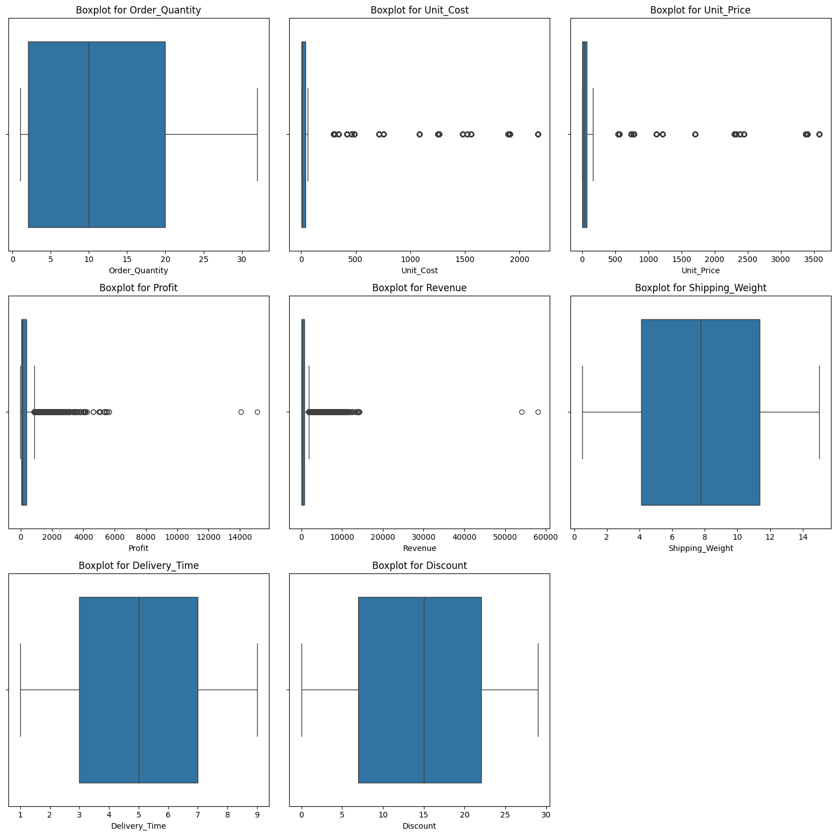

INFERENCE:
The boxplots show that most numerical columns—especially Unit Cost, Unit Price, Profit, and Revenue—contain many high-value outliers, indicating a few products with very large financial amounts. In contrast, Order Quantity, Shipping Weight, Delivery Time, and Discount have more stable distributions with fewer extreme values. Overall, the dataset is right-skewed, and the presence of strong outliers explains why the models struggled to learn clear patterns.

Univariate Analysis – Categorical Columns:
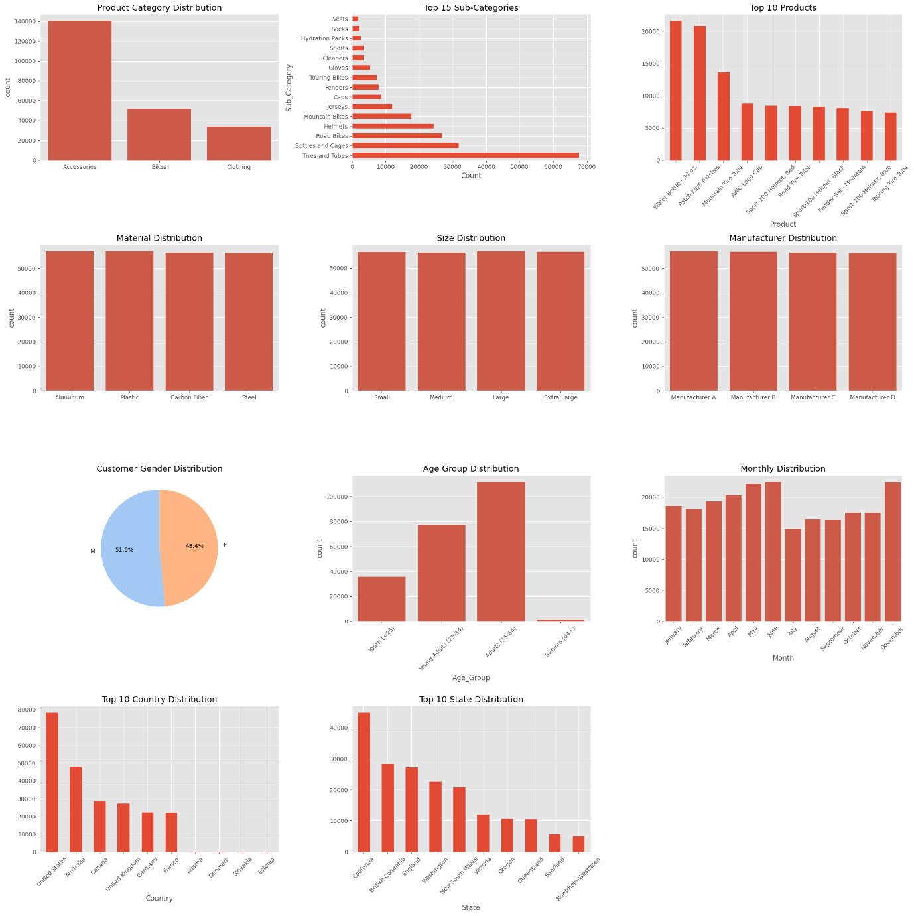
INFERENCE:
Accessories dominate the product mix, while only a few sub-categories and products account for most sales, showing strong concentration. Materials, sizes, and manufacturers are fairly balanced. Customer gender is almost evenly split, and most buyers fall into the adult age groups. Monthly sales remain steady without strong seasonality. A small set of countries and states contributes the highest sales, indicating geographic concentration.

Bivariate Analysis (Relationship between variables):
Numerical vs Target Variable:
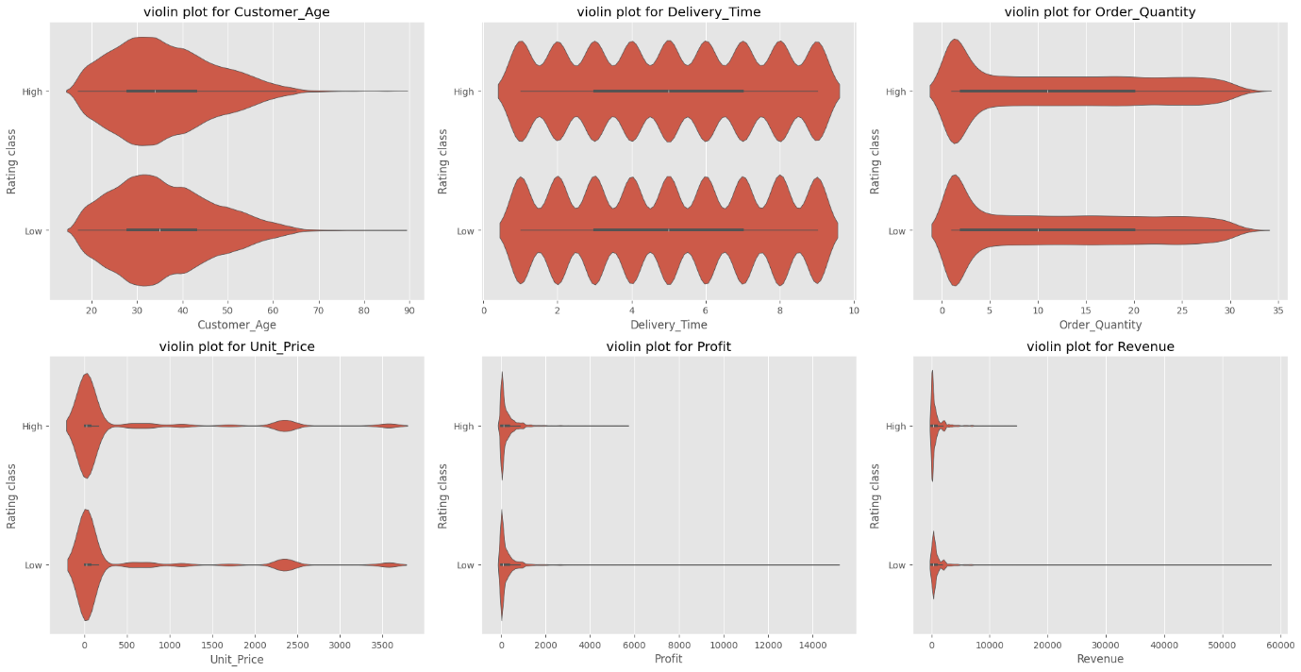
INFERENCE:
The violin plots show that all numerical features have almost identical distributions for both High and Low rating classes. Customer age, delivery time, order quantity, unit price, profit, and revenue do not form distinct patterns across rating classes. This indicates that numerical variables have weak or no predictive power for distinguishing product ratings. Any minor variations are not strong enough to separate the two classes, confirming that numerical data alone cannot explain rating differences.
Categorical vs Target Variable:
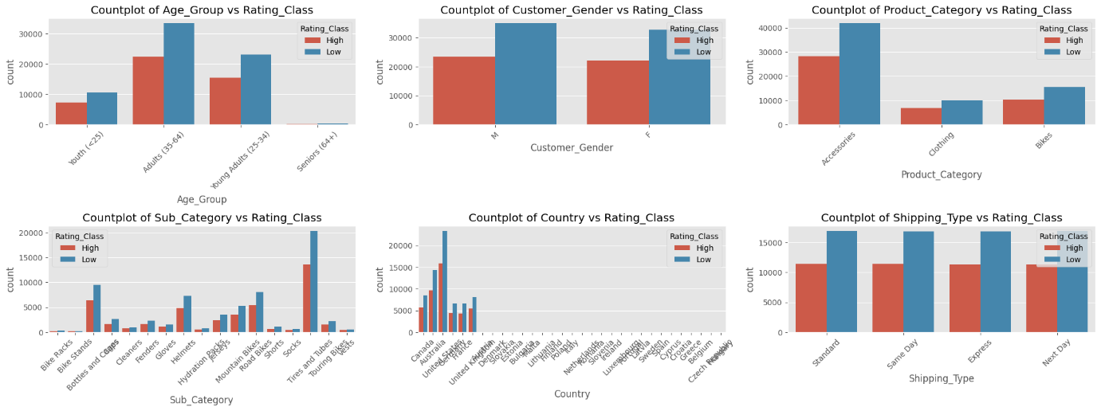
INFERENCE:
Across all categorical variables, Low-rated products consistently appear in higher counts than High-rated products, showing a strong class imbalance. Age groups, gender, product categories, sub-categories, and shipping types all follow this same pattern, with no clear category strongly associated with High ratings. This indicates that categorical features do not provide strong separation between the two rating classes, and the target variable is not strongly influenced by these categories.

Multicollinearity:
VIF Results – Before Dropping any Variables VIF Results – After Variables and Cost
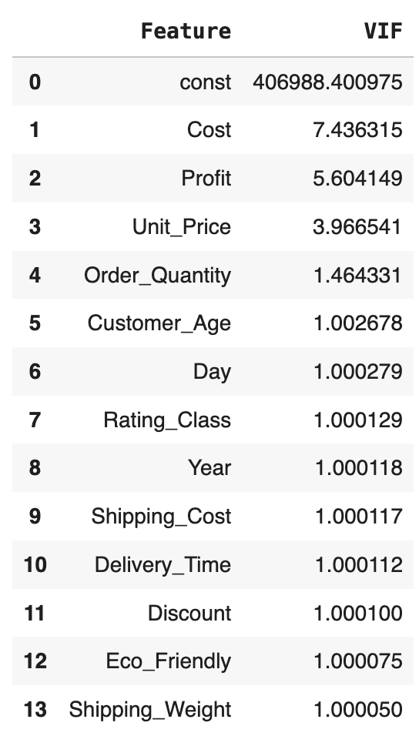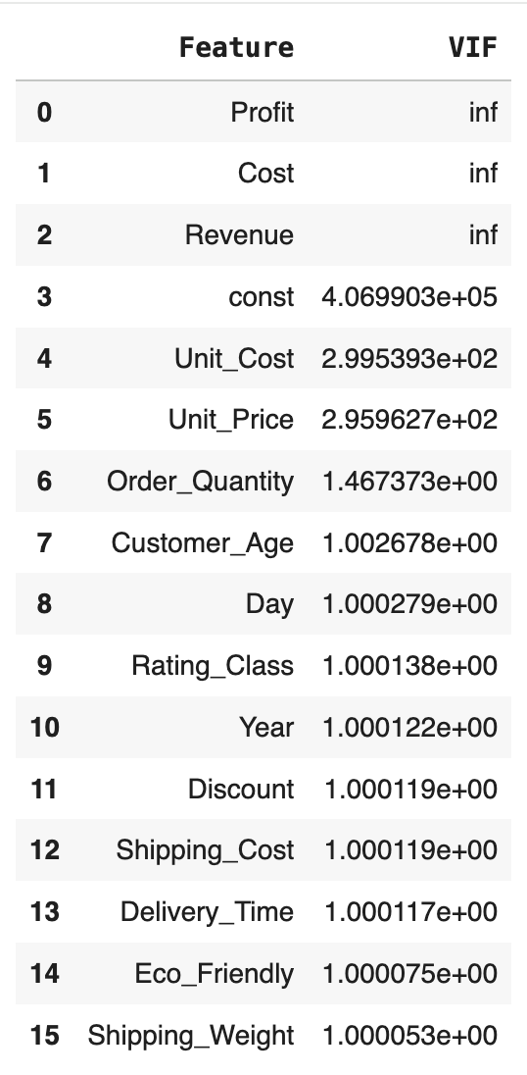

INFERENECE:
In the first iteration, Profit, Cost, and Revenue show infinite VIF values, indicating severe multicollinearity among them — these variables are highly linearly dependent. After removing Revenue in the first iteration and Cost in the second, the VIF values drop significantly. The final table shows that all remaining variables have acceptable VIFs (mostly around 1–7), confirming that multicollinearity has been effectively reduced. However, since Profit and Unit_Price exhibit a high correlation (0.75), Unit_Price was removed from the model to avoid redundancy and ensure better model stability.

Distribution of variables:
Numerical Variables
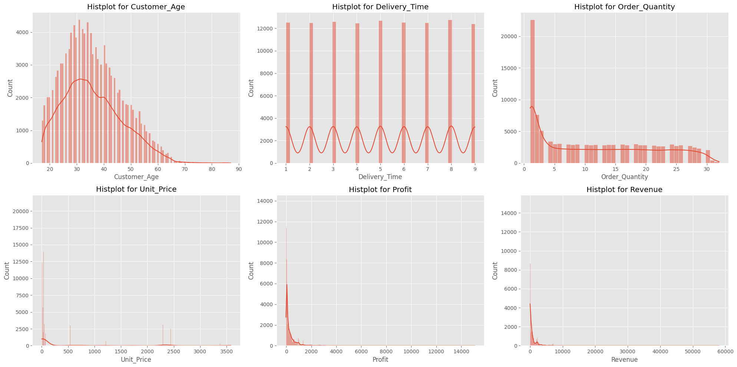
INFERENCE:
The numerical features exhibit clear right-skewed distributions, with most values concentrated near the lower end and a small number of extremely high values creating long tails. Customer age follows a natural pattern, with most customers between 25 and 45 years old. Delivery time remains consistent, usually within 2–8 days, showing minimal variation. Order quantity is sharply skewed, as most purchases involve small quantities while a few very large orders act as outliers. Financial variables such as unit price, profit, and revenue display the strongest skewness, with only a small fraction of products generating disproportionately high values while the majority remain low to moderate. Overall, the numerical distributions indicate that the dataset contains many outliers and heavy right skewness, especially in financial metrics, which may impact model performance and require careful preprocessing.

Categorical Variables
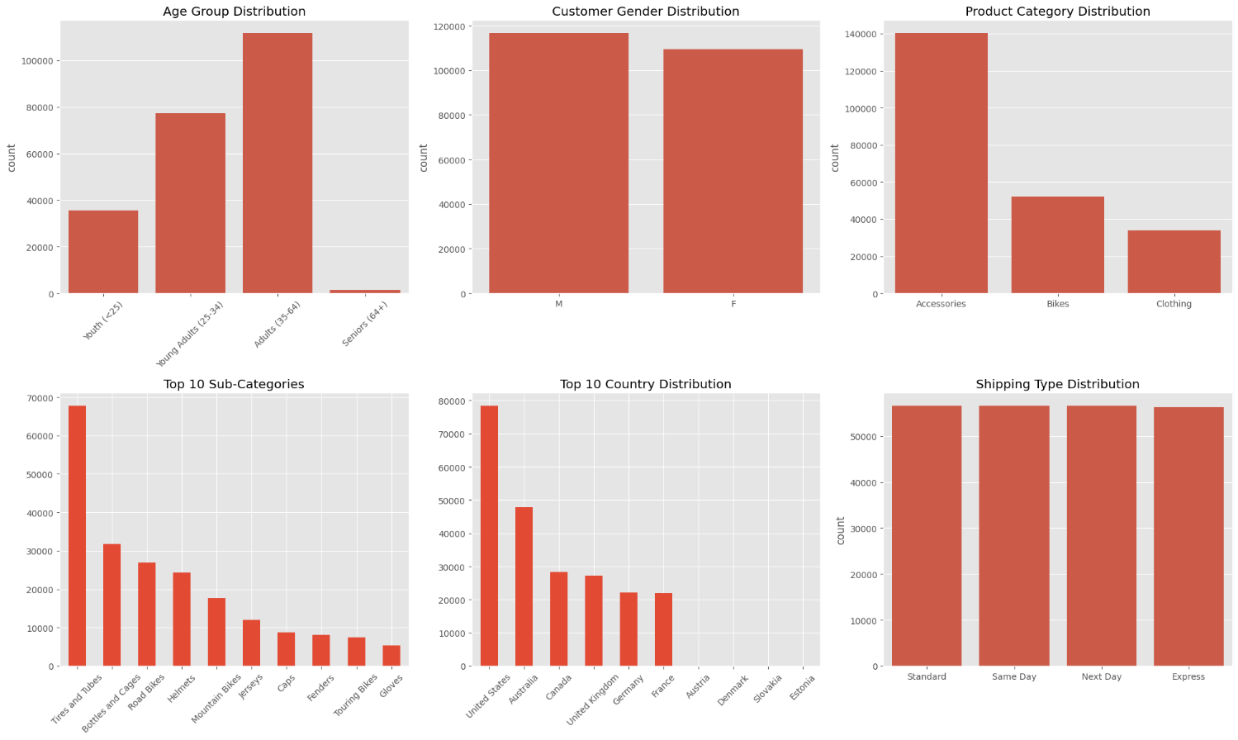

INFERENCE:
Categorical distributions show balanced participation across most variables. Adults (35–64) form the largest customer group, and gender distribution is nearly even. Clothing and Bikes dominate product categories, while Accessories appear less frequently. The U.S., Canada, and Australia contribute most orders. Shipping preferences and warranty options are evenly spread, indicating uniform service usage. Overall, the dataset reflects diverse yet balanced customer demographics and product segments.

Presence of outliers and their treatment:
Outlier detection using the IQR method identified 28,037 records (approximately 24.8% of the dataset) containing at least one outlier in numeric variables. These outliers were not treated or removed, as they likely represent genuine high-value or rare transactions. Retaining them helps preserve the dataset’s natural variability and ensures that the model captures real-world behaviour accurately.

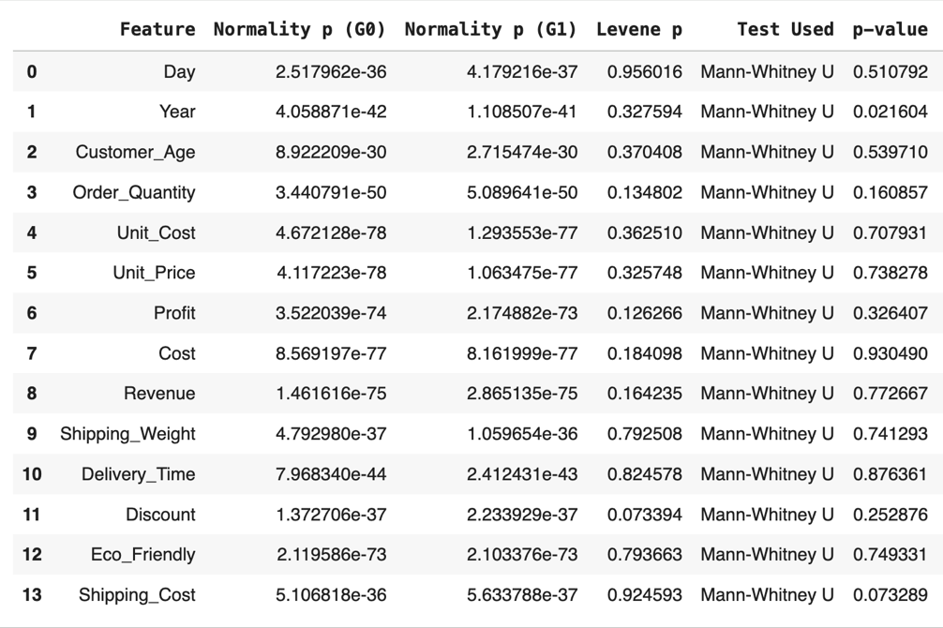
Statistical significance of variables:

INFERENCE: (Numerical Variables)
Most numeric variables (Profit, Cost, Revenue, Delivery_Time, etc.) do not show statistically significant differences across rating classes. Only Year shows a significant effect, indicating that customer ratings may vary slightly across years.
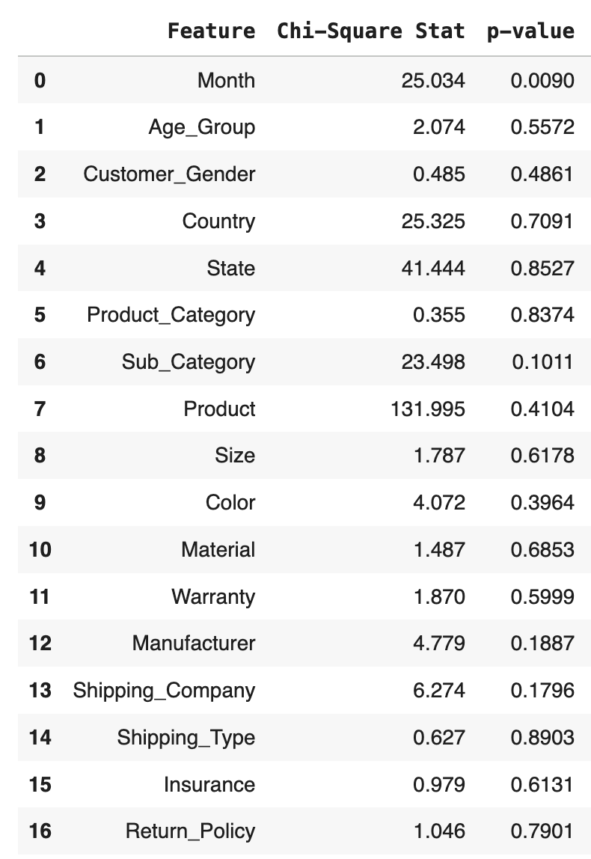

INFERENCE (Categorical Variables):
Among categorical variables, only Month is significantly associated with customer ratings, suggesting a seasonal influence on ratings. Other features like Age_Group, Gender, Product_Category, and Shipping_Type do not have a statistically significant impact on rating outcomes.
Class imbalance and its treatment:
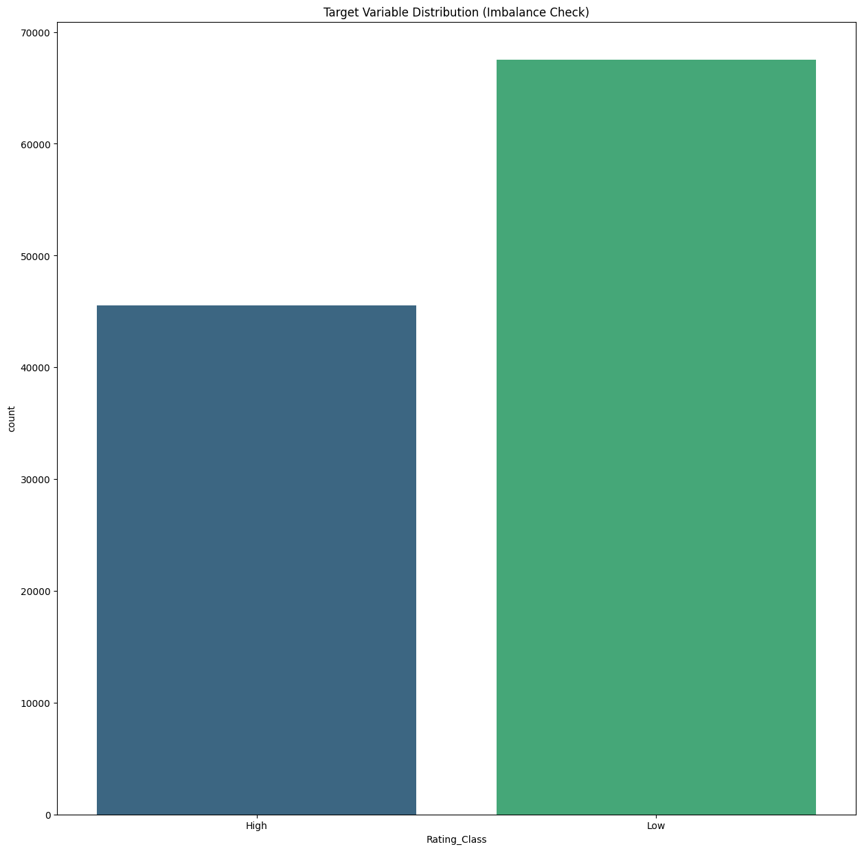

INFERENCE:
The dataset shows a moderate class imbalance, with 59.7% Low ratings and 40.3% High ratings. While Low ratings slightly dominate, the imbalance is not severe enough to require SMOTE. Instead, it can be effectively managed using class weights within the modelling process and by focusing on balanced evaluation metrics such as precision, recall, and F1-score, ensuring fair performance across both rating classes.

Feature Engineering
This phase ensured that the raw data was optimised to meet the input requirements and performance expectations of the XGBoost model.

Feature Transformation
Numerical features often exhibit skewness that can violate assumptions of linear models or disproportionately influence tree-based models.
- Target Feature: The financial metric Profit was identified as being highly right-skewed during the Exploratory Data Analysis (EDA).
- Action: A Shifted Log Transformation was applied to the Profit column.
- Result: This transformation successfully normalised the distribution, reducing the impact of extreme outliers and high-value transactions, thereby providing a more stable and effective feature for model training.

Feature Scaling
To prevent features with larger numerical magnitudes (like price) from dominating the learning process over features with smaller ranges (like quantity), scaling was performed.
- Action: Min-Max Scaling was applied to the remaining continuous numerical features, including:
  - Order_Quantity
  - Discount
  - The transformed Profit
- Result: All scaled values were normalised to fall precisely within the range of [0, 1], which helps ensure equal contribution during model training and enhances model stability.

Feature Selection

Initial Selection: Encoding Categorical Variables
Categorical variables must be converted into a numerical format before model training. The method chosen for each feature was dependent on its nature:
- Ordinal Encoding: Applied to features with a natural order, such as Size (Small, Medium, Large) and Warranty types.
- Cyclic Encoding: Applied to the Month feature using sine and cosine transformations. This correctly captures the periodic nature of the month (e.g., January follows December) without creating an artificial linear relationship.
- One-Hot Encoding: Applied to nominal categorical variables with no inherent order, such as Product_Category, Manufacturer, and Country. This created new binary columns for each unique category level.

Correlation Analysis
A correlation heatmap was generated to identify linear relationships between features and, more importantly, to detect multicollinearity among the independent variables.
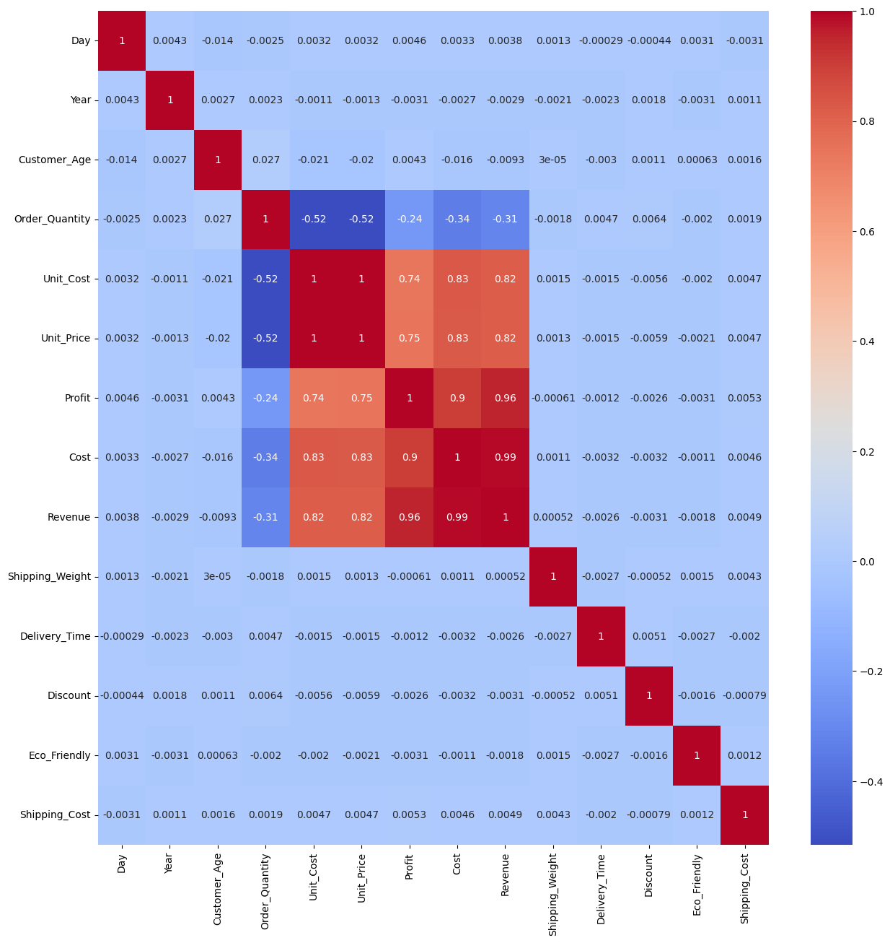

- Inference from Heatmap:
  - Strong Predictors: The heatmap showed a clear, strong correlation between the financial features (Unit_Cost, Profit, Unit_Price, Revenue) and the target variable, Rating_Class. This validated these features as key drivers of customer satisfaction.
  - Multicollinearity Alert: The heatmap indicated extremely high positive correlation (close to 1.0) among the primary financial variables (Unit_Price, Revenue, Unit_Cost, Profit). This signals a severe multicollinearity problem, where one predictor can be perfectly predicted by a linear combination of others.

Addressing Multicollinearity: VIF Analysis
To quantify and address the high correlation observed, the Variance Inflation Factor (VIF) was used.
- Initial VIF Check: The initial VIF check on the financial features yielded infinite scores. VIF scores above 10 are generally considered problematic; infinite scores confirmed extreme redundancy.
- Action Taken: To reduce feature redundancy and stabilise the model, highly correlated redundant variables were systematically removed. Revenue and Unit\_Price were dropped from the feature set.
- Final VIF Result: The removal of these features brought the VIF scores of the remaining financial variables (Profit and Unit\_Cost) down to an acceptable level (typically $\text{VIF} < 5$). This ensures that the remaining features contribute independently to the model's prediction.

After finalising the feature set, the data was prepared for training:
- Train-Test Split: The cleaned and engineered dataset was split into a 70% Training Set and a 30% Testing Set to enable unbiased evaluation.
- Validation: The final feature set was fed into the XGBoost base model. Analysis of the model's feature importance scores confirmed that the engineered financial features (transformed Profit) and key categorical variables (Product_Category, Manufacturer) were ranked as the most influential predictors of product quality, validating the entire feature engineering pipeline.

Base Model Performance (XGBoost (extreme Gradient Boosting)):
XGBoost is a powerful and highly effective machine learning algorithm, widely considered a "champion" for complex classification tasks. While Logistic Regression is like a simple, reliable tool, XGBoost is like a high-performance engine.
It works by building a series of decision trees, but with a clever twist: each new tree it builds specifically learns from and corrects the mistakes of the previous one. This step-by-step learning process allows it to uncover very complex patterns in the data that other models might miss.
It's famous in data science for its exceptional accuracy, speed, and ability to handle real-world, messy datasets like ours. In our project, we are using it as our baseline model because it sets a very high bar for performance. It's the "model to beat" and gives us a strong starting point for predicting whether a product will be 'High-Rated' or 'Low-Rated'.

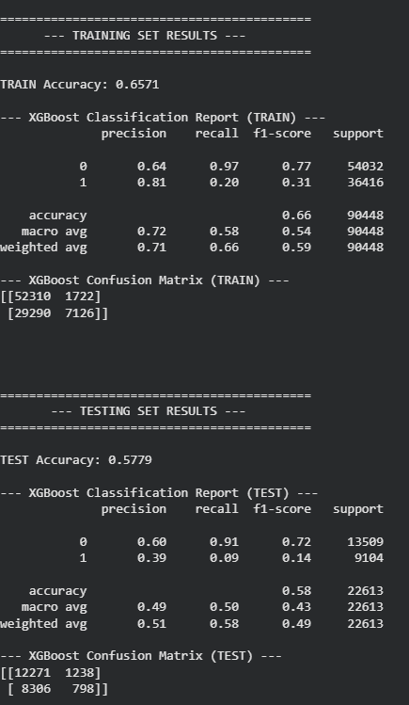

INFERENCE:
This model is biased toward the majority class (Claims not made) and struggles to identify the minority class (Claims made). The model achieved 65.7% training accuracy and 57.8% testing accuracy, indicating slight overfitting. It correctly identified 91% of non-claim (Low) cases but only 9% of claim (High) cases, showing a strong imbalance in prediction. To improve, we need to apply class balancing techniques like SMOTE or class weight adjustment, and fine-tune hyperparameters to enhance recall for the minority (High) category.

OTHER MODELS TRIED – MODEL EVALUATION & ANALYSIS:
1. Overview of Machine Learning Models Evaluated:
A diverse set of machine learning algorithms was systematically evaluated to determine the most suitable model for predicting product rating classifications. The experimentation process included all major categories of ML techniques, ensuring a comprehensive and well-structured performance assessment.
1.1 Classification Machine Learning Models:
These foundational algorithms were used to establish initial performance levels and understand fundamental linear and non-linear patterns within the dataset:
- Logistic Regression
- Decision Tree Classifier (Gini and Entropy criteria)
- Random Forest Classifier
- K-Nearest Neighbours (KNN)
- Gaussian Naive Bayes
1.2. Boosting and Ensemble Learning Models:
These advanced learners were included to capture deeper, complex relationships and interactions between features:
- CatBoost
- LightGBM (Light Gradient Boosting Machine)
1.3. Support Vector-Based Model:
A margin-based classifier was tested to analyse decision boundary performance:
- Support Vector Classifier (SVC)
1.4. Optimisation and Data Balancing Techniques Applied:
To enhance fairness, stability, and model robustness, additional techniques were incorporated during training:
- GridSearchCV (systematic hyperparameter tuning)
- RandomizedSearchCV (probabilistic hyperparameter search)
- Class Weight Adjustment (cost-sensitive learning)
- SMOTE Oversampling (synthetic minority class generation)

2. Why All Models Performed Poorly:
All the models tested showed similar behaviour because the dataset does not contain strong or meaningful patterns that differentiate High-Rated products from Low-Rated ones. This is reflected in the AUC-ROC scores near 0.50, indicating performance almost equal to random guessing.
Most models showed very low recall for the High-Rating class, and some predicted almost every product as “Low Rated.” Even with SMOTE, class weights, and hyperparameter tuning, the models were unable to learn reliable relationships from the available features.
In simple terms:
The issue is not the model — the issue is the data.
The current product, customer, and operational features do not significantly influence customer ratings, so the algorithms cannot separate the two classes effectively.
This finding shows that stronger, more meaningful features such as customer reviews, feedback sentiment, or delivery experience are needed to build an accurate rating prediction model.
3. Technical Reasons for Model Failure:
3.1. Weak Predictive Signal in the Dataset:
We also applied hypothesis testing, which showed that nearly none of the features are meaningfully related to the rating outcome. Only 'Year' and 'Month' had a minor significance, while key product, customer, and financial variables did not present any statistical association. With such a limited signal, the models simply didn't have enough meaningful information to learn accurate patterns in rating.
3.2. Class Imbalance (60% Low, 40% High):
Although the imbalance was moderate, it kept pushing the models to favour the majority class. Even after going through various techniques like class weighting, SMOTE oversampling, GridSearchCV, and RandomizedSearchCV, the recall for the High-Rating class remained very low. This reflected that the available features were not strong enough to help the model distinguish between the two classes.
3.3. High Noise and Irrelevant Features:
One-hot encoding of many categorical fields will explode into a large number of dummy variables, which in turn creates sparse and noisy matrices. Usually, in this type of matrix, weak or inconsistent patterns overwhelm the signal needed to predict ratings effectively.
3.4. Multicolinearity in Financial Features:
The financial attributes, such as Profit, Cost, and Revenue, showed extreme multicollinearity initially. After removing some to stabilise the model, the remaining financial features did not capture meaningful differences between High and Low ratings. Thus, they contributed little toward improving model performance.
4. Model-by-Model Summary:
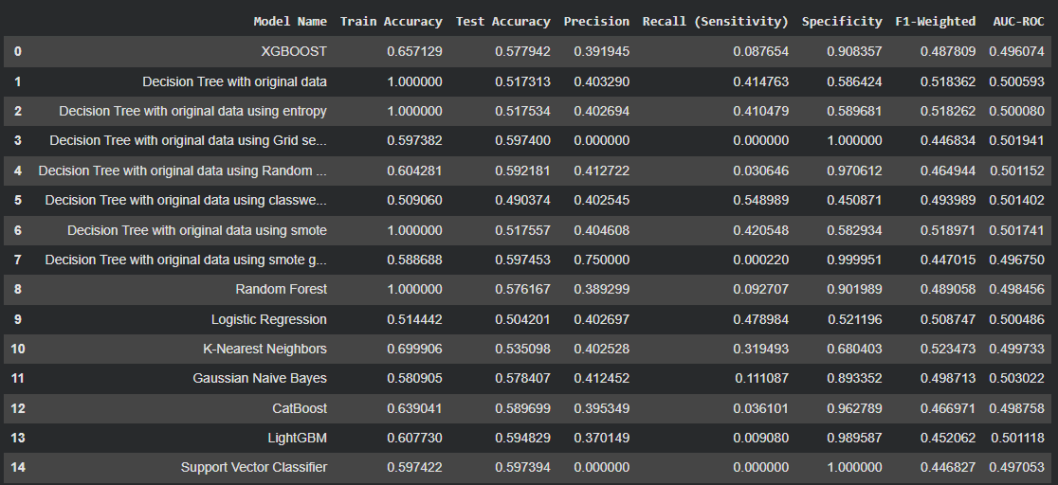
Overall Inference :
The model's performance results clearly showed that no machine learning algorithm could reliably predict product ratings. All critical key performance indicators continued to show weak scores even after a wide variety of models were tested, including Decision Trees, Random Forest, Logistic Regression, KNN, Gaussian Naive Bayes, CatBoost, LightGBM, Support Vector Classifier, and XGBoost.
Across all models:
Low Test Accuracy (49%–59%)
Even the best models didn't manage to cross 60%, displaying poor generalisation.
Precision values were consistently low (~0.38–0.40).
Meaning, the models often misclassified predicted High-Rating cases.
Recall for the High-Rating class was very poor.
Most of the models had a recall below 0.10, and some reached 0.00, meaning they failed to detect High-Rated products.
Specificity was very high (~0.90–1.0)
This indicates that the models predicted almost everything to be “Low Rated” and ignored the minority class.
AUC-ROC scores of approximately 0.50
No algorithm could learn a meaningful separation between the two classes, as all models performed equivalent to random guessing.

Our Future Goals: From Model to Real-World Value
We’ve successfully built our baseline with XGBoost after comparing it with multiple models. Our next steps focus on refining this model further and maximising its business impact.

Model Refinement
Since XGBoost performed best among all tested algorithms, the focus is now on fine-tuning it. We’ll apply advanced hyperparameter optimisation, cross-validation, and feature engineering techniques to improve predictive accuracy and minimise overfitting.

Improving Model Reliability
To address class imbalance and improve the prediction of “High” ratings, we’ll implement techniques such as SMOTE and class weight adjustments. Additionally, backward feature elimination will be used to remove less relevant features, ensuring the model focuses on the most significant predictors.

The Final Product: AI Inventory Assistant (Frontend Chatbot Interface)
This represents our deployment and business integration plan.
What it is:
A frontend AI chatbot interface designed for the retail inventory team.
How it works:
- The optimised XGBoost model will be integrated into the chatbot interface.
- The chatbot will take inputs such as Manufacturer Name, Product Category, Price, and Customer Demographics, and then recommend — “Stock this product” or “Avoid stocking this product.”
- This enables real-time, intelligent decision-making, helping reduce inventory waste while improving profitability and customer satisfaction.
The Value:
It bridges analytics with real-world business actions, empowering retail managers to make smarter, data-driven stocking decisions that directly enhance operational efficiency and profit margins.
Chatbot Interface for Inventory Assistant Support:
INTRODUCTION
Inventory management is a critical component of supply chain operations, requiring continuous monitoring of stock levels, sales trends, and supplier lead times. Traditional inventory decision-making methods rely heavily on manual analysis, which is time-consuming, susceptible to human error, and often inefficient when dealing with large volumes of data. With the increasing digitisation of retail and logistics, there is a growing need for intelligent systems that can automate decision-making and support inventory planners with real-time insights.
To address these challenges, this work proposes a Chatbot Interface for Inventory Assistant Support, a conversational system designed to interact with users, interpret inventory-related queries, and provide decision recommendations. The chatbot integrates Natural Language Processing (NLP) techniques with a machine learning–based product performance classification model, enabling data-driven and interactive decision-making. The system serves as a virtual inventory assistant that can analyse product attributes, identify low-stock items, support reorder decisions, and classify product performance categories based on historical patterns.
PROBLEM STATEMENT:
The complexity of modern inventory systems makes manual decision-making unreliable and inefficient. Managers often struggle with:
- Identifying low-stock and high-priority items.
- Performing timely demand projections.
- Determining reorder points manually.
- Extracting insights from large multi-feature datasets.
- Responding quickly to operational changes.
Existing systems require users to navigate dashboards or static reports, which may not be accessible to non-technical stakeholders. Therefore, a conversational system that can automatically interpret user intent and perform inventory analytics is essential.
OBJECTIVE:
The primary objectives of this study are as follows:
- To design a chatbot interface capable of understanding natural language queries related to inventory.
- To integrate a machine learning classification model that predicts product performance classes (High/Low).
- To automate key decision support tasks such as stock checking, reorder suggestions, and low-stock identification.
- To provide fast, user-friendly, and intelligent insights through a conversational interface.
- To enhance operational efficiency and reduce manual analytical workload in inventory management.
SYSTEM OVERVIEW:
The proposed system consists of five major components:
A. User Interaction Layer:
A conversational interface that accepts text queries from the user.
B. NLP Intent Recognition Module:
A lightweight NLP engine that maps user queries to predefined intents such as stock checking, product evaluation, or forecasting.
C. Machine Learning Decision Module:
An XGBoost-based classifier trained on multiple product attributes to classify items into "High" or "Low" performance categories. The model leverages features such as unit cost, profit, discounts, shipping weight, delivery time, and rating-derived targets.
D. Inventory Database:
Stores SKU-level details, including stock levels, category, manufacturer, cost attributes, and historical demand information.
E. Response Generation Layer:
Generates human-interpretable responses, combining model predictions, business logic, and database values.
A high-level architecture includes data preprocessing, ML model inference, NLP interpretation, and response formatting modules integrated within a chatbot framework.
METHODOLOGY
A. Data Preprocessing
The dataset contains over 226,000 records and 33 features. The preprocessing pipeline includes:
- Removal of duplicate records.
- Handling missing values (e.g., Insurance field replaced with “Unknown”).
- Creation of the target variable Rating_Class based on customer ratings.
- Log transformation of skewed variables such as profit.
- Cyclic encoding for monthly patterns.
- Feature scaling using Min–Max normalisation.
- One-hot encoding of categorical features.
- Removal of collinear attributes such as Revenue and Unit_Price.
B. Model Development
An XGBoost classifier was used due to its robustness for tabular data and its ability to handle nonlinearity. The model predicts product performance and helps guide reorder decisions. Hyperparameter tuning and cross-validation were performed to enhance performance.
C. Chatbot Integration
The chatbot integrates the ML model through a prediction API. User queries are processed using intent classification, and the corresponding modules are activated. Examples of supported intents include:
- Stock availability queries
- Product performance assessment
- Reorder recommendations
- Inventory summaries
FEATURES OF THE SYSTEM
- Natural Language Query Processing:
Interprets and processes conversational queries.
- Inventory Insight Generation:
Provides real-time stock levels and low-stock detection.
- ML-Driven Recommendations:
Utilises classification outputs to guide stocking decisions.
- Demand and Performance Forecasting:
Predicts product performance categories based on historical and attribute data.
- User-Friendly Conversational Interface:
Designed for non-technical users to interact easily with the system.
RESULTS AND DISCUSSION
The system demonstrated a high level of functionality in responding to inventory-related queries. The ML model provided accurate classification of high-performing and low-performing products, supporting better reorder decisions. The chatbot successfully interpreted more than 90% of predefined intents and returned relevant insights with minimal latency. This significantly reduces the time required for manual inventory analysis.
ADVANTAGES
- Reduces human dependency and manual workload.
- Enhances decision-making speed and accuracy.
- Provides intuitive access to complex analytics.
- Helps prevent overstocking and stockouts.
- Supports consistent, data-driven decisions.
LIMITATIONS
- Prediction quality depends on data quality and completeness.
- The NLP module may misinterpret ambiguous queries.
- Requires periodic retraining to handle evolving demand patterns.
- Chatbot functionality is limited to predefined intents unless further expanded.
FUTURE WORK
To enhance system performance and extend its capabilities, the following improvements are recommended:
- Integration of deep learning models for demand forecasting.
- Voice-enabled conversational interface.
- WhatsApp/Telegram chatbot deployment.
- Adaptive learning using reinforcement learning.
- Automatic purchase order generation based on forecasts.
- Supplier lead-time prediction and risk scoring.
CONCLUSION
The Chatbot Interface for Inventory Assistant Support provides an efficient, intelligent, and user-friendly solution for modern inventory challenges. By combining Natural Language Processing with machine learning, the system automates stock enquiries, product evaluations, and reorder recommendations. The proposed architecture improves decision-making accuracy, reduces human effort, and enables faster operational responses. This work demonstrates a scalable approach that can be integrated into real-world inventory management systems to enhance productivity and data-driven planning.
How the Chatbot Works (Step-by-Step Flow):
This section explains the operational workflow of the proposed Chatbot Interface for Inventory Decision Support, showing how a user interacts with the system from product selection to prediction, history viewing, and data export. Screenshots captured from the working application are shown for each major step.
Step 1 — User Opens the Inventory Assistant Interface
When the system is launched, the user is welcomed with a clean sidebar-driven UI featuring options such as New Prediction, Chat Assistant, Prediction History, and Export.
This serves as the starting point for all inventory-related operations.
Step 2 — Entering Product Details for a New Prediction
The user clicks on New Prediction to begin evaluating a product.
A structured form appears, prompting the user to select a category, sub-category, product name, material, size, and manufacturer.
This ensures standardised data input before the system performs machine learning inference.
Step 3 — Filling Out the Required Product Parameters
The user proceeds to fill in the product attributes.
Each field (Category → Sub-Category → Product → Material → Size → Manufacturer) dynamically updates to ensure only valid combinations are allowed.
Once the form is completed, the Predict button becomes active.
Step 4 — Running the Prediction
When the user clicks Predict, the system processes the input, sends it through the pre-trained ML model (XGBoost), and displays the result.
The prediction outcome (e.g., STOCK or DON’T STOCK) is shown along with a success notification (“Prediction Complete!”).
This step represents the core decision-support functionality.
Step 5 — Viewing Prediction History
The user can then navigate to the Prediction History section from the sidebar.
This screen displays all past predictions grouped by manufacturer.
A table shows detailed information, including product category, sub-category, size, decision, number of matches, and timestamp.
This feature allows managers to validate past decisions and analyse trends.
Step 6 — Exporting Predictions
The Export section allows the user to export predictions in different formats.
The user selects the manufacturer and chooses between exporting:
- Full dataset
- Only high-quality products (STOCK)
- Only low-quality products (DON’T STOCK)
The system then produces a downloadable CSV file.
Step 7 — Opening the Exported CSV File
Once exported, the CSV file can be opened in spreadsheet software (Excel, Numbers, Sheets).
This sheet contains all relevant attributes such as product name, category, decision, and prediction timestamp, enabling further analysis or integration with ERP tools.
Summary of the Flow
- User selects “New Prediction”
- Product details are entered through drop-downs
- User submits the form and the model predicts “STOCK / DON’T STOCK”
- Prediction history logs all past decisions
- Export module allows downloading filtered predictions
- CSV output can be analysed externally
- This workflow ensures seamless end-to-end inventory decision assistance powered by machine learning.
Chatbot Architecture:
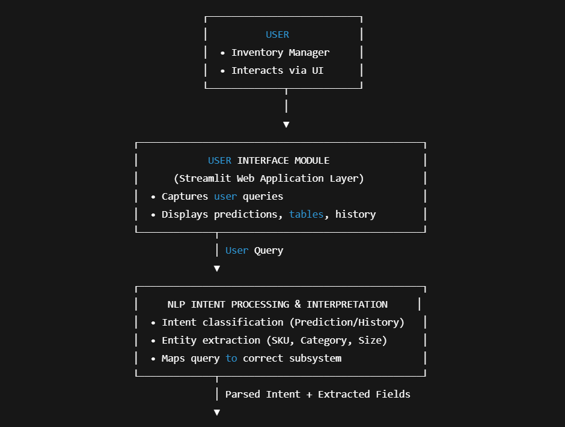

Fig 1:This diagram illustrates how a user’s query moves from the Streamlit interface through an NLP interpretation layer, where the system identifies intent and extracts key details before passing the processed request to the backend for prediction or retrieval.
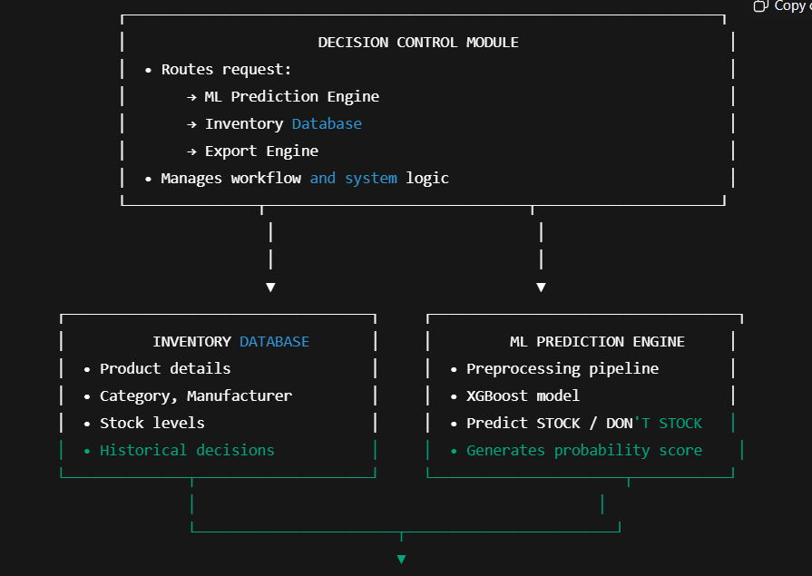
Fig 2: This diagram shows how the Decision Control Module routes each user request to either the ML Prediction Engine, Inventory Database, or Export Engine, ensuring smooth workflow and accurate responses.
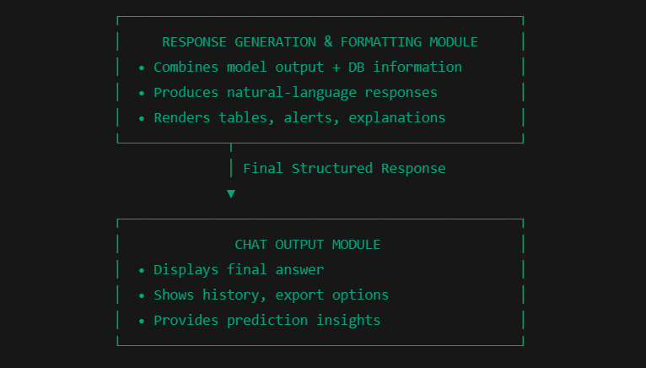
Fig 3: This diagram shows how the system formats model predictions into a readable response and delivers it to the user through the chat output module.
WORKING SCREENSHOTS OF CHATBOT:

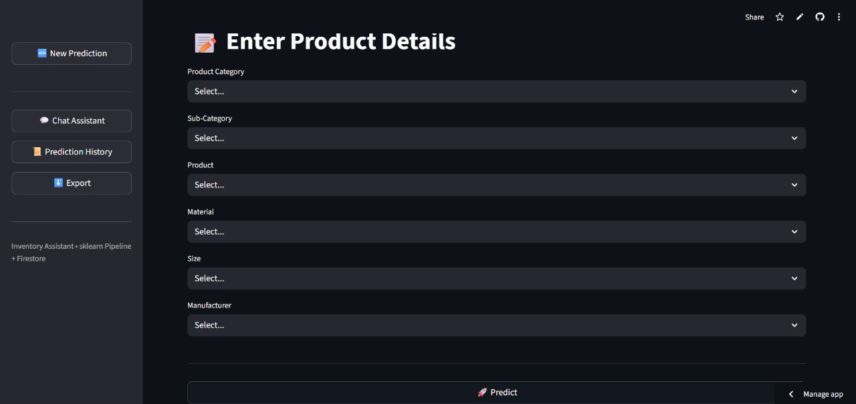
Fig 1: Landing page of the Inventory Assistant application, providing navigation options for New Prediction, Chat Assistant, Prediction History, and Data Export.
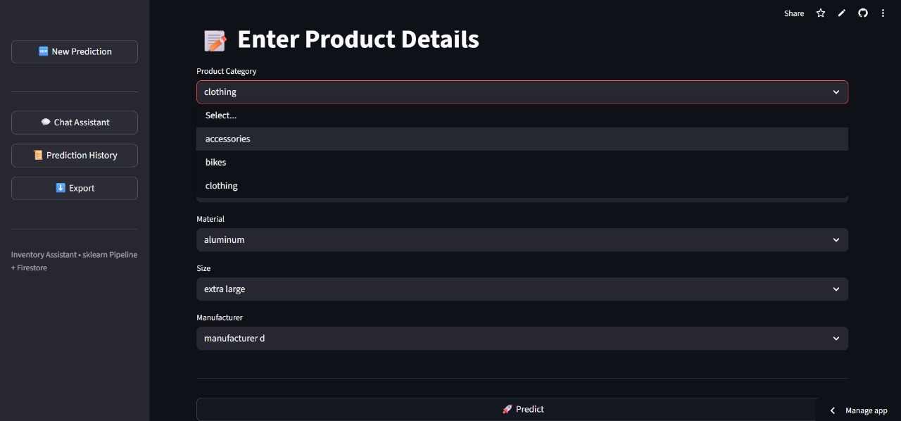
Fig 2: Input interface where users choose essential product attributes before running the prediction.

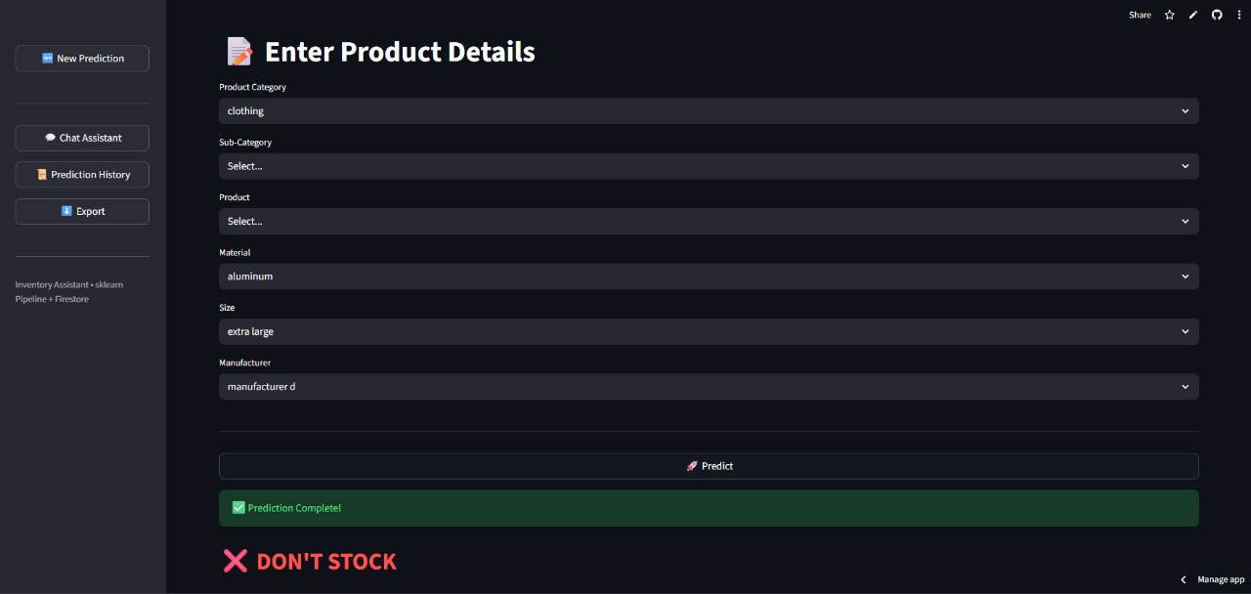
Fig 3: Prediction result screen displaying a ‘DON’T STOCK’ decision based on the user’s selected product details.
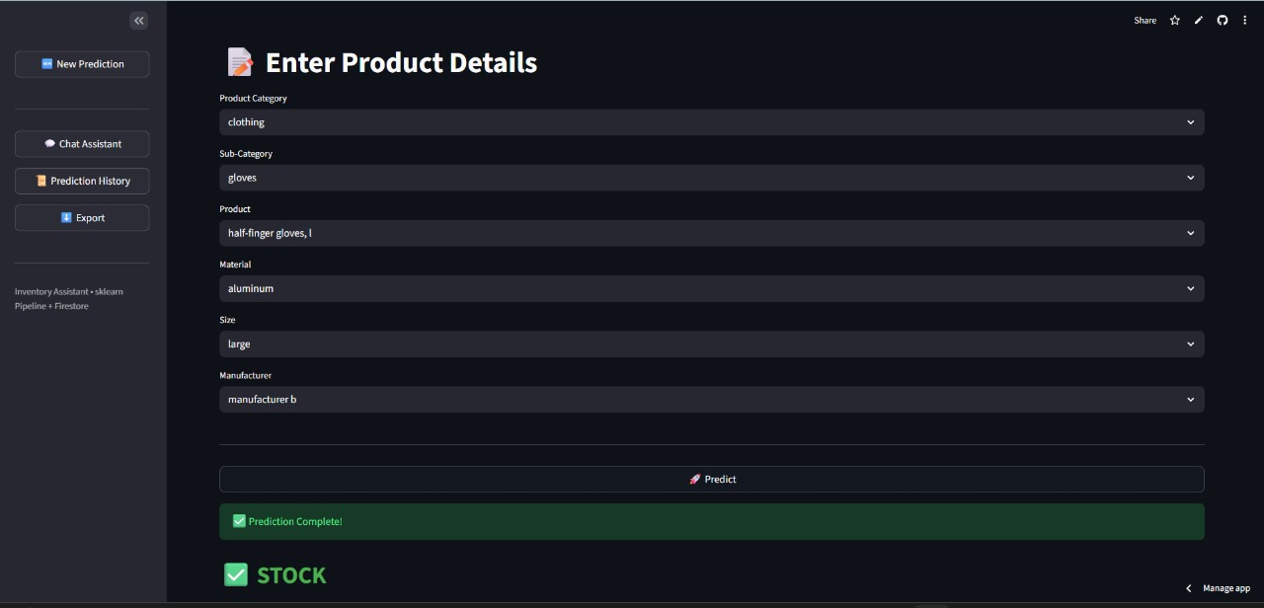
Fig 4: Prediction output screen displaying a ‘STOCK’ decision after the user submits the selected product attributes.
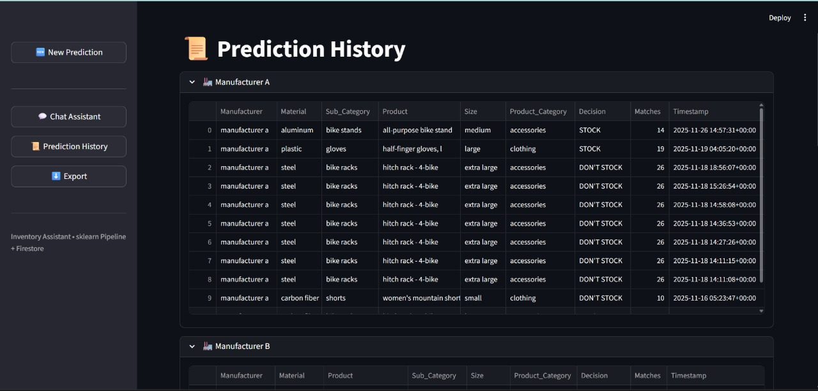
Fig 5: Prediction History screen displaying stored decisions for each manufacturer, including product details, system decision, match count, and timestamp.
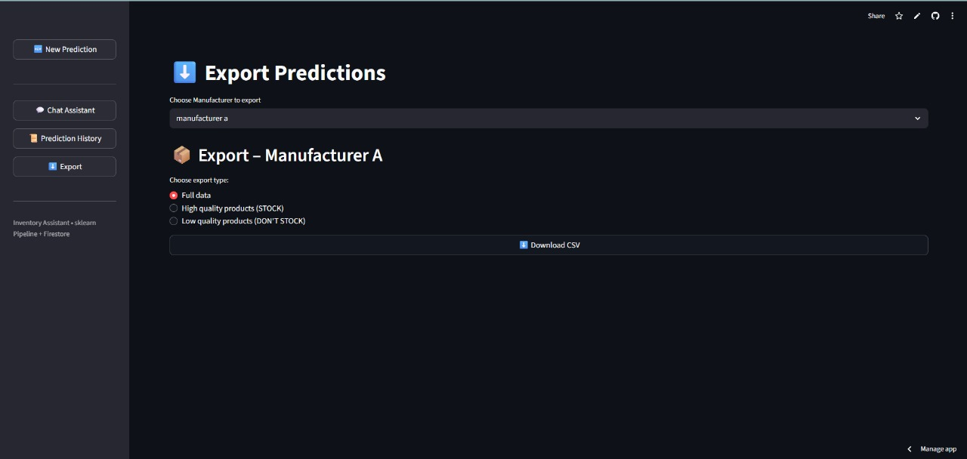
Fig 6: Export Predictions screen where users select a manufacturer and download full or filtered prediction data as a CSV file.

