## Serverless IOT data processing

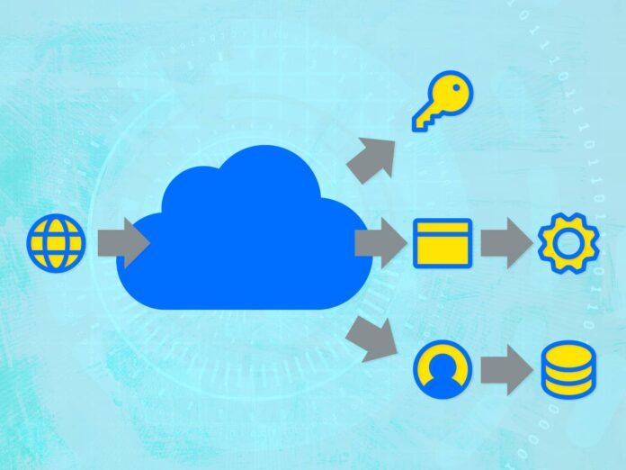

So you’ve launched a new IoT product, perhaps using the [IoT framework provided by AWS, Azure](https://www.mistywest.com/posts/azure-vs-aws-which-iot-framework-is-right-for-you/), or another major cloud provider, and your devices can now send and receive data from the cloud. Now, how do you process that data to get valuable insights, such as device health telemetry or user behavior tracking? There are a number of different ways to set up data processing infrastructure in the cloud that trade off control and complexity. [Serverless architecture](https://www.iotforall.com/serverless-architecture-iot-solution) is ultimately a software design principle that allows you to build, scale, and run services without managing the infrastructure, and MistyWest is excited about how this “serverless” pattern can enable teams to rapidly build and scale cloud solutions.

## Benefits of Going Serverless

1. **Charging**: One benefit is that serverless platforms tend to charge based on how often the serverless functions run and for how long, so you only pay for the compute time that you use. This can keep costs low during development while building in a way that automatically scales up during launch.
2. **Fast Response**: Serverless functions also tend to respond quickly to spikes in demand as the platform automatically scales up the amount of compute power available to run the functions, then downscale when the load is reduced. This produces an efficient usage of resources, deploying compute power only when needed.
3. **Language Options**: There is good support for a variety of programming languages, so you can very likely build your serverless functions in your language of choice. For example, AWS Lambda natively supports Java, Go, PowerShell, Node.js, C#, [Python](https://www.iotforall.com/pandas-vs-numpy-data-analysis), and Ruby, and provides a Runtime API to allow the use of other programming languages. Azure Functions support C#, Javascript, F#, Java, Powershell, Python, and Typescript.
4. **Bug Prevention**: Building with serverless functions necessarily creates a stateless and hostless system, which can simplify reasoning about the system and prevent some complex bugs around state management.
5. **Data Pipeline**: With your IoT framework, you can set up automated, event-driven data pipeline triggers and database storage. By additionally hooking in visualization frameworks or developing your internal dashboard, you can monitor the progress immediately.
6. **Pay for Less**: If you have a VM spun up, you’re paying regardless of whether you’re using the full extent of those resources or if it’s just sitting.

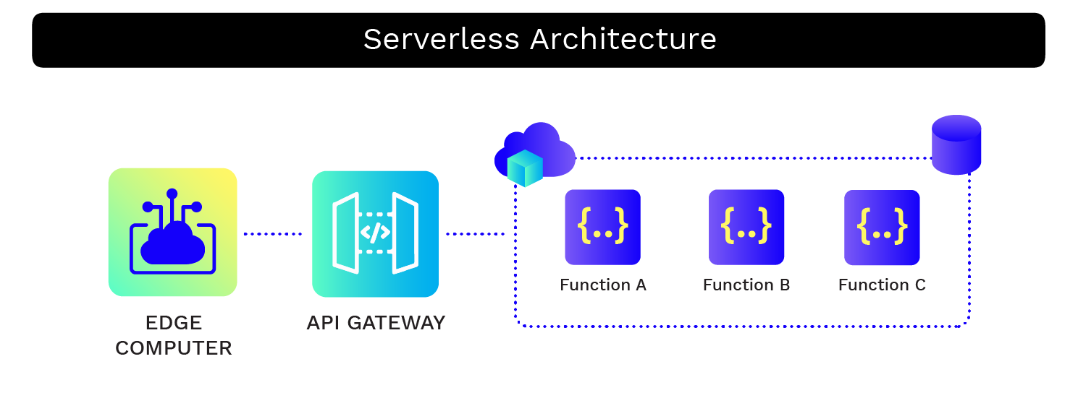

Building a serverless IoT data processing user interface (UI) involves creating a web or mobile interface that allows users to interact with and visualize data from IoT devices in a serverless architecture. Here are the key components and considerations for creating such a UI;

Building a serverless IoT data processing user interface (UI) involves creating a web or mobile interface that allows users to interact with and visualize data from IoT devices in a serverless architecture. Here are the key components and considerations for creating such a UI:

1. User Interface Design:

* Design the UI to be user-friendly and intuitive, keeping in mind the specific needs and expectations of your users
* Consider responsive design principles to ensure the UI works well on different devices and screen sizes.

2. Frontend Framework:

* Choose a frontend framework or technology stack for building the user interface. Popular options include React, Angular, Vue.js, and Flutter for mobile apps.

3. Authentication and Authorization:

* Implement user authentication to control access to IoT data. This can be done using Identity as a Service (IDaaS) providers like Auth0 or AWS Cognito.
* Define user roles and permissions to ensure that users only see and interact with the data they are authorized to access.

4. Real-time Data Display:

* For real-time data processing, use WebSocket or Server-Sent Events (SSE) to push data updates to the UI in real-time as IoT devices send data.
* Utilize frontend libraries such as Socket.io or GraphQL subscriptions for real-time data synchronization.

5. Data Visualization:

* Choose appropriate data visualization libraries and tools to represent IoT data in meaningful charts, graphs, and dashboards. Libraries like D3.js, Chart.js, or highcharts can be helpful.

6.API Gateway:

* Set up an API Gateway, such as AWS API Gateway, Azure API Management, or Google Cloud Endpoints, to expose serverless functions and data endpoints to the UI.

7. Serverless Functions:

* Develop serverless functions (e.g., AWS Lambda, Azure Functions, Google Cloud Functions) to process IoT data, aggregate, and transform it as needed.
* Expose these functions through your API Gateway, enabling the UI to trigger data processing and retrieval.

8. Database Integration:

* Connect the UI to the serverless IoT database to fetch and display data. You can use RESTful APIs, GraphQL, or SDKs provided by cloud providers.

9. Caching:

* Implement caching mechanisms (e.g., Redis, AWS ElastiCache) to improve the performance of data retrieval and reduce the load on the serverless functions.

10. Error Handling:

* Include error handling and user-friendly error messages to guide users when data processing or retrieval issues occur.

11. User Feedback:

* Allow users to provide feedback or report issues. Include a mechanism for support or contact information.

12. Scalability:

* Ensure that your UI can scale with your serverless infrastructure. Consider using Content Delivery Networks (CDNs) to optimize content delivery.

13. Security:

* Secure the UI by implementing best practices for web application security, such as HTTPS, input validation, and protection against common web vulnerabilities.

14.Testing and Monitoring:

* Regularly test the UI to identify and address issues. Set up monitoring and logging for both the UI and the serverless components to track performance and user behavior.

15. Documentation:

* Provide documentation for users on how to use the interface and any API endpoints or features.

16. Compliance:

* Ensure that the UI complies with any relevant data privacy regulations or industry standards.

17. Feedback Loop:

* Establish a feedback loop with IoT users to continuously improve the UI based on their needs and suggestions.

Creating a serverless IoT data processing UI requires collaboration between frontend and backend development teams, as well as a good understanding of the IoT use case and the serverless architecture in place. The UI should empower users to interact with and gain insights from the IoT data in an efficient and user-friendly manner.