**HackathonProjectPhasesTemplate**forthe**AutoSageApp**project.

HackathonProjectPhasesTemplate

# ProjectTitle:

**Logocraft: Innovative Logo Generation with Diffusion Technology**

# TeamName:

Team Explore AI

# TeamMembers:

* Ch.Harshitha
* A.Jayasri
* Ch.Anjali
* B.Mythri
* B.Revathi

# Phase-1:Brainstorming&Ideation

## Objective:

Develop an AI-powered logo generation tool using Diffusion technology to help businesses create unique and professional-grade logos based on user descriptions.

## KeyPoints:

1. **ProblemStatement:**

* Many businesses struggle to create a distinctive logo that accurately represents their brand identity and values.
* Traditional logo design services can be costly, time-consuming, and may not align with a company's vision.
* Startups and small businesses often lack design expertise and resources to develop a professional logo.

1. **ProposedSolution:**

* An AI-powered application leveraging Diffusion technology to generate high-quality, custom logos based on user input.
* The platform offers an intuitive interface with easy-to-use controls, allowing users to refine and customize their logo selections.
* AI-driven logo generation ensures uniqueness, brand alignment, and high visual appeal.

1. **TargetUsers:**

* Entrepreneurs and startups seeking an affordable and efficient way to create a logo.
* Small and medium-sized businesses looking for a professional logo without hiring a designer.
* Companies rebranding or launching new products that require fresh logo designs.

1. **ExpectedOutcome:**

* A user-friendly, AI-powered logo creation platform that simplifies the design process.
* High-quality, customizable logos tailored to a brand’s identity and vision.
* Empowered businesses with strong brand recognition through visually appealing logos.

# Phase-2:RequirementAnalysis

## Objective:

## Develop an AI-powered logo generation tool using Diffusion technology to help businesses create unique and professional-grade logos based on user descriptions.

## KeyPoints:

1. **TechnicalRequirements:**

· **Programming Language:** Python

· **Backend:** Stability AI's **Stable Diffusion 2.1** model (via diffusers and transformers)

· **Frontend:** Streamlit Web Framework

· **Database:** Not required initially (API-based queries)

1. **FunctionalRequirements:**

· Ability to generate high-quality logos using **Stable Diffusion 2.1** based on user’s descriptions.

· Provide multiple logo variations with different styles and color schemes.

· User-friendly **Streamlit UI** with:

· Option to download generated logos in **PNG/JPG format**.

1. **Constraints&Challenges:**

· **Ensuring high-quality logo generation** with AI while maintaining originality.

· **Optimizing inference time** for faster logo generation.

· **Handling GPU/CPU resource limitations** for real-time processing.

· **Providing an intuitive UI** with seamless user experience in Streamlit.

# Phase-3:ProjectDesign

## Objective:

Developthearchitectureanduserflowoftheapplication.

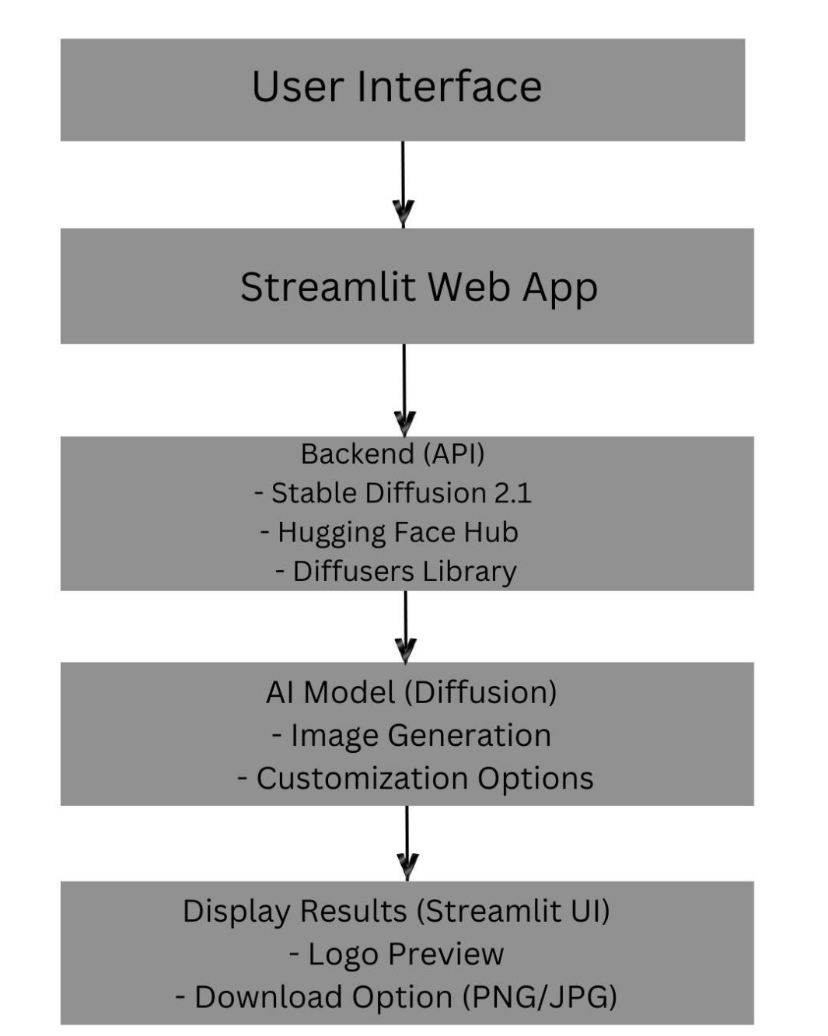

## KeyPoints:

1. **SystemArchitecture:**

* User enters a **brand description** and preferences via the UI.
* The query is processed using the **Stable Diffusion 2.1** model via the Hugging Face API.
* AI generates multiple **custom logo designs** based on user input.
* The frontend displays **logo variations** for selection and download.

1. **UserFlow:**

* **Step 1:** User enters a **text prompt** describing the brand identity (e.g., "A modern tech startup with a futuristic and minimalistic logo").
* **Step 2:** The **backend processes** the input and sends it to **Stable Diffusion 2.1** via diffusers.
* **Step 3:** AI generates multiple **logo designs** based on the input.
* **Step 4:** The generated logos are **displayed** on the UI. The user can preview and download the desired logo.

1. **UI/UXConsiderations:**

* **Minimalist and intuitive UI** for seamless interaction.
* **Customization controls** (color, font style, icon choices) for enhanced user flexibility.
* **Dark & Light Mode** for improved user experience.
* **Instant download** options for PNG/JPG formats.

# Phase-4:ProjectPlanning(AgileMethodologies)

## Objective:

Breakdowndevelopmenttasksforefficientcompletion.

|  |  |  |  |  |  |  |  |
| --- | --- | --- | --- | --- | --- | --- | --- |
| **Sprint** | **Task** | **Priority** | **Duration** | **Deadline** | **Assigned To** | **Dependencies** | **Expected Outcome** |
| Sprint 1 | EnvironmentSetup & API Integration | 🔴High | 1 hours  (Day 1) | EndofDay 1 | Jayasri | Python, Streamlit, Stable Diffusion API key | APIconnection established &working |
| Sprint 1 | Frontend UI Development | 🟡  Medium | 3 hours  (Day 1) | EndofDay 1 | Anjali | API response format finalized | BasicUIwithinput fields |
| Sprint 2 | LogoGeneration& Customization | 🔴High | 3 hours  (Day 2) | Mid-Day 2 | Harshitha & Jayasri | APIresponse,UI elements ready | Logo generation with customization |
| Sprint 2 | ErrorHandling&Debugging | 🔴High | 4 hours  (Day 2) | Mid-Day 2 | Mythri & Revathi | APIlogs,UI inputs | ImprovedAPI stability |
| Sprint 3 | Testing & UI Enhancements | 🟡  Medium | 4 hours  (Day 2) | Mid-Day 2 | Harshitha | APIresponse,UI layout completed | ResponsiveUI, better user experience |
| Sprint 3 | FinalPresentation & Deployment | 🟢 Low | 1 hour  (Day 2) | EndofDay 2 | Entire Team | Working prototype | Demo-ready project |

## SprintPlanningwithPriorities

**Sprint1–Setup&Integration(Day1)**

· (🔴 High Priority) Set up the development environment & install dependencies.

· (🔴 High Priority) Integrate Stable Diffusion API for image generation.

· (🟡 Medium Priority) Build a basic UI with input fields.

## Sprint2–CoreFeatures&Debugging(Day2)

· (🔴 High Priority) Implement logo generation and customization functionalities.

· (🔴 High Priority) Debug API issues & handle errors in queries.

## Sprint3–Testing,Enhancements&Submission(Day2)

· (🟡 Medium Priority) Test API responses, refine UI, & fix UI bugs.

· (🟢 Low Priority) Final demo preparation & deployment.

# Phase-5:ProjectDevelopment

## Objective:

Implement the core features of the **LogoCraft** application.

## KeyPoints:

1. **TechnologyStackUsed:**

* **Frontend:** Streamlit
* **Backend:** Stable Diffusion API (Hugging Face)
* **Programming Language:** Python

1. **DevelopmentProcess:**

* Implement API key authentication and Stable Diffusion API integration.
* Develop **logo customization** and **style variation** logic.
* Optimize image generation queries for **performance and relevance**.

1. **Challenges&Fixes:**

* **Challenge:** Slow logo generation time.
* **Fix:** Implement optimized **image sampling techniques** and use GPU acceleration.  
  ○ **Challenge:** Limited API calls per minute.
* **Fix:** **Optimize API calls** by reusing models and caching frequently generated results.

# Phase-6:Functional&PerformanceTesting

## Objective:

EnsurethattheAutoSageAppworksasexpected.

|  |  |  |  |  |  |
| --- | --- | --- | --- | --- | --- |
| **Test CaseID** | **Category** | **TestScenario** | **ExpectedOutcome** | **Status** | **Tester** |
| TC-001 | Functional Testing | Query "Generate a modern tech startup logo" | A relevant and unique logo should be generated. | ✅Passed | Harshitha |
| TC-002 | Functional Testing | Query "Create a minimalist logo for a bakery" | A simple yet creative logo should be displayed. | ✅Passed | Jayasri |

|  |  |  |  |  |  |
| --- | --- | --- | --- | --- | --- |
| TC-003 | Performance Testing | Image generation time under 3 seconds | Logo should be generated quickly. | ⚠ Needs Optimization | Anjali |
| TC-004 | Bug Fixes &Improvements | Fixed incorrect logo styles in API responses | Generated logos should match user preferences. | ✅Fixed | Mythri |
| TC-005 | Final Validation | EnsureUIisresponsive across devices. | UIshouldworkon mobile&desktop. | ❌Failed - UI brokenonmobile | Revathi |
| TC-006 | Deployment Testing | Hosttheappusing Streamlit Sharing | App should be accessibleonline. | 🚀Deployed | DevOps |

# FinalSubmission

1. **ProjectReportBasedonthetemplates**
2. **DemoVideo(3-5Minutes)**
3. **GitHub/CodeRepositoryLink**
4. **Presentation**