A SEMINAR REPORT

ON

**“Age of A.I.”**

BY

**GUTHULA JAYASRI SAI NIKITHA (17HP1A0571)**



**DEPARTMENT OF COMPUTER SCIENCE AND ENGINEERING**

**ANDHRA LOYOLA INSTITUTE OF ENGINEERING AND TECHNOLOGY**

*(****Approved by A.I.C.T.E, New Delhi and Affiliated to JNTU Kakinada***

***Accredited by NAAC & An ISO 9001 : 2015 Certified Institution****)*

***ALC Campus, Vijayawada, Andhra Pradesh – 520008***

[www.andhraloyola.org](http://www.andhraloyola.org)

2020-2021

**CONTENTS**

|  |  |  |
| --- | --- | --- |
| S.No | Content Name | Page No. |
| 1 | Introduction | 4 |
| 2 | What is Artificial Intelligence? | 5 |
| 3 | Evolution of AI | 6 |
| 4 | Applications of AI | 7-8 |
| 5 | What is AI capable of | 9-10 |
| 6 | How AI works? | 11-12 |
| 7 | Transforming farming | 13-14 |
| 8  9  10 | Healing People  Creating Music  Prediction and Forecast | 15-16  17  18-19 |
| 11 | Reinventing Food | 20-22 |
| 12  13  14  15  16  17  18  19  20 | Human vs AI  Seat Synchronization  Progress in A.I.  Future of A.I.  Current Performance  Advantages  Disadvantages  Conclusion  Bibliography | 23-25  26  27  28  29-30  31  32  33  34 |
|  |  |  |

**INTRODUCTION**

Technology is advancing faster and taking less time to be widely adopted than ever before, like as in it took 10,000 years to go from writing to printing press, but only about 500 more to get to email. Now it seems we're at the dawn of a new age, the age of A.I. Artificial Intelligence is teaching the machine, and the machine becoming smart. Each time we create a more powerful technology, we create a bigger lever for changing the world. So, these are all driven by neural networks. "Neural network" is a virtual, much simpler version of the human brain. The brain is the most complex system in our body. It's got 85 billion neurons, each of which fire non-stop, receiving, processing, and sending information.

**WHAT IS ARTIFICIAL INTELLIGENCE?**

Artificial Intelligence (Noun): It is a wide-ranging branch of computer science concerned with building smart machines capable of performing tasks that typically require human intelligence. AI is an interdisciplinary science with multiple approaches, but advancements in [machine learning](https://builtin.com/machine-learning) and [deep learning](https://builtin.com/artificial-intelligence/deep-learning) are creating a paradigm shift in virtually every sector of the tech industry.

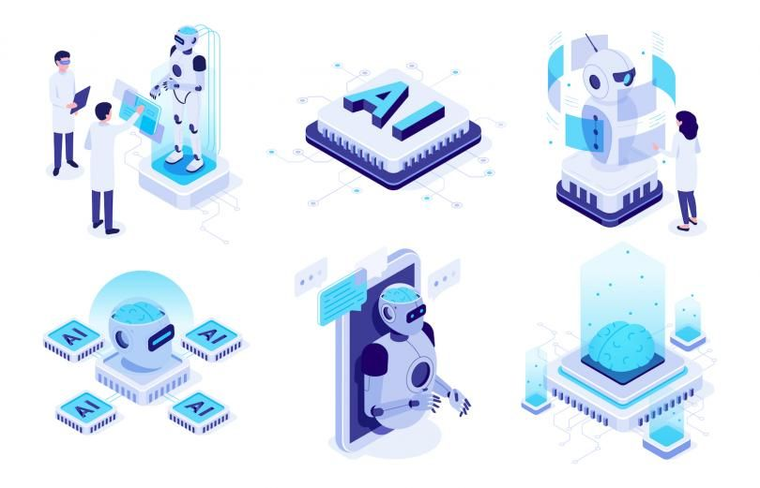

**EVOLUTION OF A.I.**

* In 1800s, AI was limited in Myths, Speculation and Fiction
* The real initiation began in 1950s when Alan Turing came up with the idea that machines can think and the term Artificial Intelligence is coined by Mc Carthy, Minsky, Nathaniel Rochester and Claude E. Shannon
* In 1966, Eliza was the first chat bot created at MIT ‘s AI lab.
* 1990s is the age where Internet break through and AI is feeding on data shared on Web.
* Deep Blue in 1997, Watson in 2011 and AlphaGo in 2016 competed and won against humans in games.
* Self Driving Cars in 2018

Artificial intelligence (AI) is evolving literally. Researchers have created software that borrows concepts from Darwinian evolution, including “survival of the fittest,” to build AI programs that improve generation after generation without human input. The program replicated decades of AI research in a matter of days, and its designers think that one day, it could discover new approaches to AI.

**APPLICATIONS OF A.I.**

Artificial Intelligence has various applications in today's society. It is becoming essential for today's time because it can solve complex problems with an efficient way in multiple industries, such as Healthcare, entertainment, finance, education, etc. AI is making our daily life more comfortable and fast.

Following are some sectors which have the application of Artificial Intelligence:

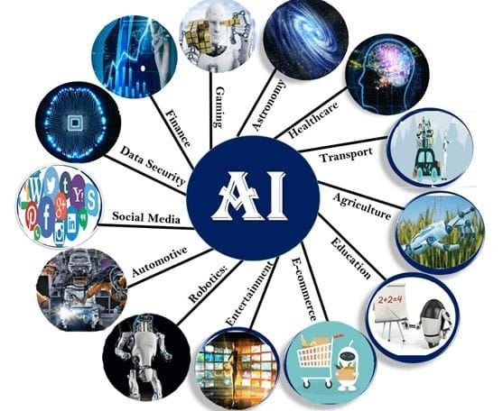

### Health Care

AI applications can provide personalized medicine and X-ray readings. Personal health care assistants can act as life coaches, reminding you to take your pills, exercise or eat healthier.

### Retail

AI provides virtual shopping capabilities that offer personalized recommendations and discuss purchase options with the consumer. Stock management and site layout technologies will also be improved with AI.

### Manufacturing

AI can analyze factory IoT data as it streams from connected equipment to forecast expected load and demand using recurrent networks, a specific type of deep learning network used with sequence data.

### Life sciences

From ensuring drug safety to getting new therapies to market faster, AI technologies can unleash the full potential of data to solve some of our greatest health challenges.

### Banking

Artificial Intelligence enhances the speed, precision and effectiveness of human efforts. In financial institutions, AI techniques can be used to identify which transactions are likely to be fraudulent, adopt fast and accurate credit scoring, as well as automate manually intense data management tasks.

### Public sector

Artificial Intelligence can make smart cities smarter. It can support national defense with mission readiness and predictive maintenance. Across the board, AI can improve program efficiency and effectiveness.

**WHAT IS A.I. CAPABLE OF?!**

* **AI automates repetitive learning and discovery through data.** Instead of automating manual tasks, AI performs frequent, high-volume, computerized tasks. And it does so reliably and without fatigue. Of course, humans are still essential to set up the system and ask the right questions.
* **AI adds intelligence** to existing products. Many products you already use will be improved with AI capabilities, much like Siri was added as a feature to a new generation of Apple products. Automation, conversational platforms, bots and smart machines can be combined with large amounts of data to improve many technologies. Upgrades at home and in the workplace, range from security intelligence and smart cams to investment analysis.
* **AI adapts through progressive learning algorithms** to let the data do the programming. AI finds structure and regularities in data so that algorithms can acquire skills. Just as an algorithm can teach itself to play chess, it can teach itself what product to recommend next online. And the models adapt when given new data.

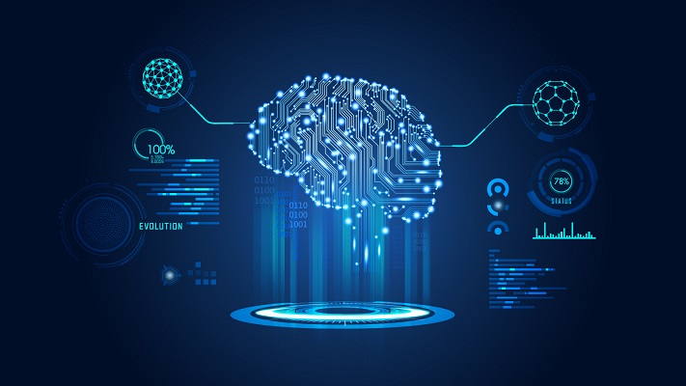

* **AI analyzes more and deeper data**using neural networks that have many hidden layers. Building a fraud detection system with five hidden layers used to be impossible. All that has changed with incredible computer power and big data. You need lots of data to train deep learning models because they learn directly from the data.
* **AI achieves incredible accuracy** through deep neural networks. For example, your interactions with Alexa and Google are all based on deep learning. And these products keep getting more accurate the more you use them. In the medical field, AI techniques from deep learning and object recognition can now be used to pinpoint cancer on medical images with improved accuracy.
* **AI gets the most out of data.**When algorithms are self-learning, the data itself is an asset. The answers are in the data. You just have to apply AI to find them. Since the role of the data is now more important than ever, it can create a competitive advantage. If you have the best data in a competitive industry, even if everyone is applying similar techniques, the best data will win.

**HOW ARTIFICIAL INTELLIGENCE WORKS**

AI works by combining large amounts of data with fast, iterative processing and intelligent algorithms, allowing the software to learn automatically from patterns or features in the data. AI is a broad field of study that includes many theories, methods and technologies, as well as the following major subfields:

* **Machine learning**automates analytical model building. It uses methods from neural networks, statistics, operations research and physics to find hidden insights in data without explicitly being programmed for where to look or what to conclude.
* **A neural network** is a type of machine learning that is made up of interconnected units (like neurons) that processes information by responding to external inputs, relaying information between each unit. The process requires multiple passes at the data to find connections and derive meaning from undefined data.
* **Deep learning** uses huge neural networks with many layers of processing units, taking advantage of advances in computing power and improved training techniques to learn complex patterns in large amounts of data. Common applications include image and speech recognition.
* **Computer vision** relies on pattern recognition and deep learning to recognize what’s in a picture or video. When machines can process, analyze and understand images, they can capture images or videos in real time and interpret their surroundings.
* **Natural language processing**(NLP) is the ability of computers to analyze, understand and generate human language, including speech. The next stage of NLP is natural language interaction, which allows humans to communicate with computers using normal, everyday language to perform tasks.

Additionally, several technologies enable and support AI:

* **Graphical processing units** are key to AI because they provide the heavy compute power that’s required for iterative processing. Training neural networks requires big data plus compute power.
* **The Internet of Things**generates massive amounts of data from connected devices, most of it unanalyzed. Automating models with AI will allow us to use more of it.
* **Advanced algorithms**are being developed and combined in new ways to analyze more data faster and at multiple levels. This intelligent processing is key to identifying and predicting rare events, understanding complex systems and optimizing unique scenarios.
* **APIs, or application programming interfaces,**are portable packages of code thatmake it possible to add AI functionality to existing products and software packages. They can add image recognition capabilities to home security systems and Q&A capabilities that describe data, create captions and headlines, or call out interesting patterns and insights in data.

**TRANSFORMING FARMING**

Agriculture is the mainstay occupation in many countries worldwide and with rising population, which as per UN projections will increase from 7.5 billion to 9.7 billion in 20501, there will be more pressure on land as there will be only an extra 4% of land, which will come under cultivation by 2050. This means that farmers will have to do more with less. According to the same survey, the food production will have to increase by 60% to feed an additional two billion people. However, traditional methods are not enough to handle this huge demand. This is driving farmers and agro companies to find newer ways to increase production and reduce waste. As a result, Artificial Intelligence (AI) is steadily emerging as part of the agriculture industry’s technological evolution. The challenge is to increase the global food production by 50% by 20502 to feed an additional two billion people.AI-powered solutions will not only enable farmers to improve efficiencies but they will also improve quantity, quality and ensure faster go-to-market for crops.

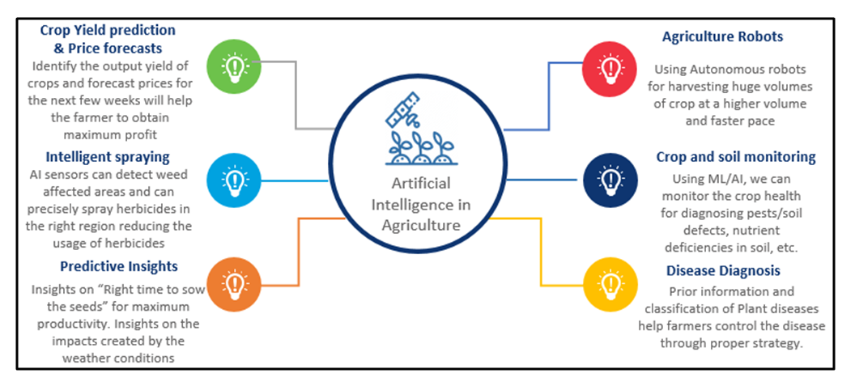



Basalt and Plastic polymer made from Corn are used for printing Buildings.

This is Renewable, Recyclable and Biodegradable



**Printing Buildings on MARS**

**HEALING PEOPLE**

In healthcare, AI can be used for early detection, personalization, even disease diagnosis - all from crunching large volumes of data. In almost all cases, AI either directly interacts with the user, chat bots for instance, or empowers the physician to better understand his/her patient. The AI-human relationship has so far been one-on-one.

**AI Helps Humans Decide**  
For the most part, AI/ML in healthcare means a very smart algorithm crunches through large volumes of data and discovers patterns that might be hard for humans to see. Statistical models can be formed based on training data sets. Once AI parameters are fine-tuned, it can be used for prediction/detection and maybe alert the caregiver if things deviate from the norm. AI helps the human decide better. Empowering patients, physicians and hospitals to track, monitor and diagnose, making data-driven decisions that are not limited to the individual’s training and experience. AI has the potential of turning every doctor into a “best doctor” by offering data-driven insights at critical decision-making points that go beyond the individual’s training and experience helping the physician see the alternatives and effects of different paths.

Some of the algorithms used in today’s AI systems include: deep learning, reinforcement learning, generalized linear models, random forests, and support vector machines.

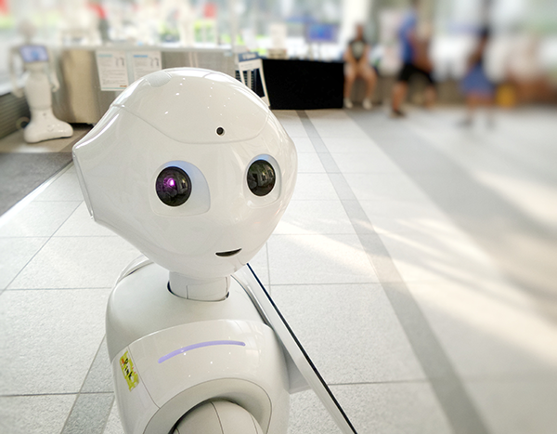

**HEALING ALS**

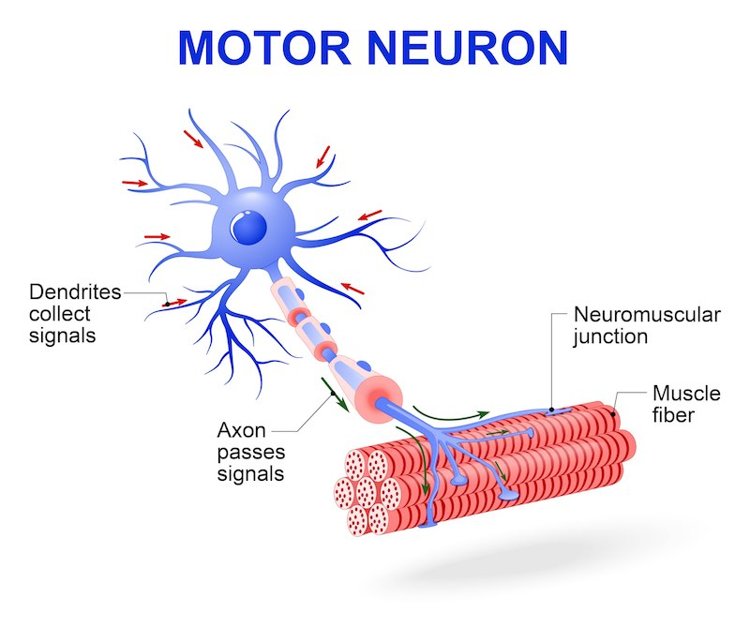

Amyotrophic lateral sclerosis (ALS) is a rare neurological disease that primarily affects the nerve cells (neurons) responsible for controlling voluntary muscle movement (those muscles we choose to move).

**CREATING MUSIC**

Using AI as a tool to make music or aid musicians has been in practice for quite some time. In the ‘90s, David Bowie helped develop an app called the [Verbasizer](https://motherboard.vice.com/en_us/article/xygxpn/the-verbasizer-was-david-bowies-1995-lyric-writing-mac-app), which took literary source material and randomly reordered the words to create new combinations that could be used as lyrics. In 2016, researchers at Sony used software called Flow Machines to create a melody in the style of The Beatles. This material was then turned over to human composer Benoît Carré and developed into a [fully produced pop song called “Daddy’s Car.”](https://www.theverge.com/2016/9/26/13055938/ai-pop-song-daddys-car-sony) (Flow Machines was also used to help create an entire album’s worth of music [under the name SKYGGE](http://www.bbc.com/culture/story/20180112-is-this-the-worlds-first-good-robot-album), which is Danish for “shadow.”) On a consumer level, the technology is already integrated with popular music-making programs like Logic, a piece of software that is used by musicians around the world, and it can [auto-populate unique drum patterns](https://www.theverge.com/2018/1/26/16936662/logic-pro-x-update-smart-tempo-chromaverb-namm) with the help of AI.

Now, there’s an entire industry built around AI services for creating music, including the aforementioned Flow Machines, [IBM Watson Beat](https://www.ibm.com/case-studies/ibm-watson-beat), [Google Magenta’s NSynth Super](https://www.theverge.com/circuitbreaker/2018/3/13/17114760/google-nsynth-super-ai-touchscreen-synth), [Jukedeck](https://www.jukedeck.com/), [Melodrive](http://melodrive.com/), Spotify’s [Creator Technology Research Lab](https://artists.spotify.com/blog/innovating-for-writers-and-artists), and [Amper Music](https://www.ampermusic.com/).

Most of these systems work by using deep learning networks, a type of AI that’s reliant on analyzing large amounts of data. Basically, you feed the software tons of source material, from dance hits to disco classics, which it then analyzes to find patterns. It picks up on things like chords, tempo, length, and how notes relate to one another, learning from all the input so it can write its own melodies. There are differences between platforms: some deliver MIDI while others deliver audio. Some learn purely by examining data, while others rely on hard-coded rules based on musical theory to guide their output.

However, they all have one thing in common: on a micro scale, the music is convincing, but the longer you listen, the less sense it makes. None of them are good enough to craft a Grammy Award-winning song on their own... yet.

**PREDICTION AND FORECAST**

Artificial intelligence uses algorithms to cast predictions and forecast trends. Algorithmic forecasting has limits that machine-based learning can't overcome, which means that our judgement will not be taken over by machines for quite a while. However, machine learning is faster are more accurate when combing through large amounts of data. Over 200 studies have compared the predictive nature of artificial intelligence to human experts, with algorithms almost always outperforming unaided human judgement. New methods have been discovered for improving human judgement, though, making it unbiased in the process. Algorithms don't have the power to completely replace human intelligence, but analyzing the data they provide can improve accuracy.

Data is everywhere in supply chains. Businesses know how long it takes to make a certain product, how long a consumer waits, how much inventory can be produced in a day, etc. According to IBM, we now produce over 2.5 quintillion bytes of data daily. 80% of that data is unstructured and invisible to current technology. How can a planner effectively analyze all that data? It sounds next to impossible. Having artificial intelligence to sift through this information will allow businesses to learn faster, be proactive, and sell more.

Artificial intelligence and its branch offs (machine learning, algorithms) can now be packaged up nicely and sold to businesses through supply chain planning software. These packages include a form of pattern recognition software that identifies trends, providing your business with information to prepare and act accordingly. If there are peak times of the year where your inventory sells out fast, this technology can identify it. When the time comes, you can ensure there will be enough for consumers who want, distributing your product effectively. Artificial intelligence can also help your transportation issues. If large quantities of trucks need to go out with products during a certain time, companies can schedule more. Rather than having customers wait longer for their purchases, they'll be delighted when the product arrives ahead of schedule.

Artificial intelligence and machine learning can more quickly analyze the data that supply chains generate. By using this technology, supply chains can determine trends that affect their inventory levels and arrival times. Therefore, they can be better preparing for their business cycles. Using artificial intelligence in your supply chain will help you make sense and act on all those numbers you're receiving.

With enormous amounts of good quality datasets, AI can predict the occurrence of numerous natural disasters like Earth Quakes, Volcanoes, Floods and Hurricanes which can be the difference between life and death for thousands of people.



**REINVENTING FOOD**

It’s been more than 18 years of efforts of making meat and other non-vegetarian food items by using plant-based replacement and there are few successful products out there in the market. Scientists are working on this since the last 18 years. The process of understanding each food item takes time and mimicking the same with plant-based ingredients takes more time, it is not only about getting the properties right at its molecular level. Texture, appearance, flavour and functionality should match too. To put it simply, plants are crunchy, and meat is chewy. Companies like **Impossible Food** and **Beyond Meat**are the ones who started early in this game and have already launched their products in the market and achieved one of the top positions on the demand chart. In the year 2015, a company was founded named **‘*NotCo’***, which claimed to make plant-based mayonnaise and milk and surprisingly it was registered as a tech company, not a food company. The hidden gem of NotCo was not their product rather the **Machine Learning Algorithms,**the so-called AI they use to make it. They named it **Giuseppe**after the Renaissance painter Giuseppe Arcimboldo, famous for his portraits of human faces constructed with fruits and vegetables.

The **Giuseppe**reportedly uses many more than 1,000 plant-based proteins in its data set to find meat and dairy replacement ingredients. It does the genome mapping to figure out which combinations would give much similar product.

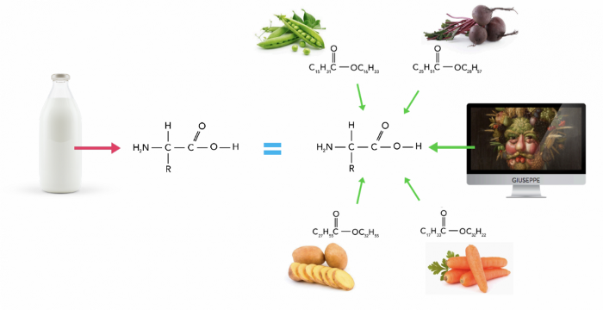

The above image shows the basic idea behind the process of making plant-based milk using NotCo’s AI which is proven to be tastier and creamy than the ideal milk sold in the market. Each time the NotCo team inputs the food item they hope to replace, the algorithm delivers an output of 50 to 60 recipes. The team then tests each version of the recipe, giving the flavour, texture, colour, and other properties numerical rankings, which are incorporated back into the algorithm. This makes the process of experimenting and prototyping much faster than the conventional laboratory method. All the successful product they launch has a ‘Not’ as a prefix to the original product name, The milk they made is called Not Milk and In the year 2019 NotCo raised **$30M** in Funding.

Replacing animal-based foods can’t be the only reason why this startup is successful and has a good future. When we talk about plant-based foods it delivers a long list of benefits. It’s been long known, and long ignored by meat-eaters, that plant-based diets are good for people’s health and the environment.

* Meat Production Produces Greenhouse Gases: Experts predict a vegan world could reduce greenhouse gas emissions by 70%.
* Meat Production May Be Contributing To Antibiotic Resistance: Many animals in close quarters are constantly fed a low dose of antibiotics to reduce illness across the livestock.
* Factory Farm Conditions Make Many People Sad: Often, animals in factory farms are subjected to what many consider cruel.
* Vegetarian Diets May Reduce The Risk Of Cardiovascular Disease: Limiting the amount of meat consumed can reduce cholesterol levels, decreasing the risk of heart disease.

Seeing all these benefits pushes us to think about environmental harm meat causes. Talking about NotCo, now selling us Not Mayo, Not Milk, Not Ice-cream and soon in 2021 they are launching ‘Not meat’ in the market which reportedly tastes better than meat and has the same nutritional properties.

**HUMAN VS A.I.**

Artificial Intelligence has come a long way from being a component of science fiction to reality. Today, we have a host of intelligent machines like self-driving cars, smart virtual assistants, chat bots, and surgical robots, to name a few.

### ****Nature****

While Human Intelligence aims to adapt to new environments by utilizing a combination of different cognitive processes, Artificial Intelligence aims to build machines that can mimic human behaviour and perform human-like actions. The human brain is analogous, but machines are digital.

### ****Functioning****

Humans use the brain’s computing power, memory, and ability to think, whereas AI-powered machines rely on data and specific instructions fed into the system.

### ****Learning power****

Human Intelligence is all about learning from various incidents and past experiences. It is about learning from mistakes made via trial and error approach throughout one’s life. Intelligent thought and intelligent behavior lie at the core of Human Intelligence. However, Artificial Intelligence falls behind in this respect – machines cannot think.

They can learn from data and through continuous training, but they can never achieve the thought process unique to humans. While AI-powered systems can perform specific tasks quite well, it can take years for them to learn a completely different set of functions for a new application area.

Artificial Intelligence has helped develop intelligent machines that can outperform humans in some respects (case in point – [AlphaGo](https://en.wikipedia.org/wiki/AlphaGo_versus_Lee_Sedol) and [DeepBlue](https://en.wikipedia.org/wiki/Deep_Blue_versus_Garry_Kasparov)), they have yet to go a very long way to match the human brain’s potential. Although AI systems are designed and trained to mimic and simulate human behavior, they cannot make rational decisions like humans.

The decision-making power of AI systems is primarily based on events, the data they’re trained on, and how they are related to a particular event. AI machines cannot understand the concept of “cause and effect” simply because they lack common sense. [Nick Burns](https://medium.com/syncedreview/2018-in-review-10-ai-failures-c18faadf5983), an SQL Services Data Scientist, puts it quite well: “No matter how good your models are, they are only as good as your data…”

Humans possess the unique ability to learn and apply their acquired knowledge in combination with logic, reasoning, and understanding. Real-world scenarios require a holistic, logical, rational, and emotional approach that is specific to humans.

Right now, AI is still developing and advancing. The time required to train AI systems is considerably high, which isn’t possible without human intervention. Be it autonomous cars and robots, or sophisticated technologies like [natural language processing](https://www.upgrad.com/blog/natural-language-processing-nlp-projects-ideas-topics-for-beginners/) and image processing, they all rely on human intelligence.

Presently, automation is the leading [AI application](https://www.upgrad.com/blog/artificial-intelligence-applications/) that’s penetrating the industry rapidly. In a 2018 [report](https://www.bbc.com/news/business-45545228#:~:text=Millions%20of%20jobs%20are%20likely,%2D%20a%20%22net%20positive%22.) by the WEF, the Swiss Think Tank predicted that by 2022, AI would displace 75 million jobs globally while also creating 133 million new jobs. The new job profiles will demand Data Science specific skills like knowledge of Mathematics & Statistics and ML algorithms, proficiency in programming, data mining, data wrangling, software engineering, and data visualization.

AlphaGo is a computer program that plays the board game Go. It was developed by DeepMind Technologies which was later acquired by Google. Subsequent versions of AlphaGo became increasingly powerful, including a version that competed under the name Master.



**SEAT SYNCHRONIZATION**



Light sticks used to represent different fandom are now under the shadow of technology. Latest version of ARMY bomb (Light stick of BTS) includes Bluetooth connectivity. This enables the Central control to make sync the music with the lights. Artificial Intelligence is being used to make the light sticks glow up with the rhythm. Even the light intensity is varying based on the beat. Usage of technology can bring more colours and joy to life.

**PROGRESS IN A.I.**

Many thousands of AI applications are deeply embedded in the infrastructure of every industry." In the late 1990s and early 21st century, AI technology became widely used as elements of larger systems, but the field is rarely credited for these successes.

[Kaplan](https://en.wikipedia.org/wiki/Andreas_Kaplan) and Haenlein structure artificial intelligence along three evolutionary stages:

1) Artificial narrow intelligence – applying AI only to specific tasks;

2) [Artificial general intelligence](https://en.wikipedia.org/wiki/Artificial_general_intelligence) – applying AI to several areas and able to autonomously solve problems they were never even designed for; and

3) Artificial [super intelligence](https://en.wikipedia.org/wiki/Super_intelligence) – applying AI to any area capable of scientific [creativity](https://en.wikipedia.org/wiki/Creativity), [social skills](https://en.wikipedia.org/wiki/Social_skills), and general [wisdom](https://en.wikipedia.org/wiki/Wisdom).

To allow comparison with human performance, artificial intelligence can be evaluated on constrained and well-defined problems. Such tests have been termed [subject matter expert Turing tests](https://en.wikipedia.org/wiki/Subject_matter_expert_Turing_test). Also, smaller problems provide more achievable goals and there are an ever-increasing number of positive results.

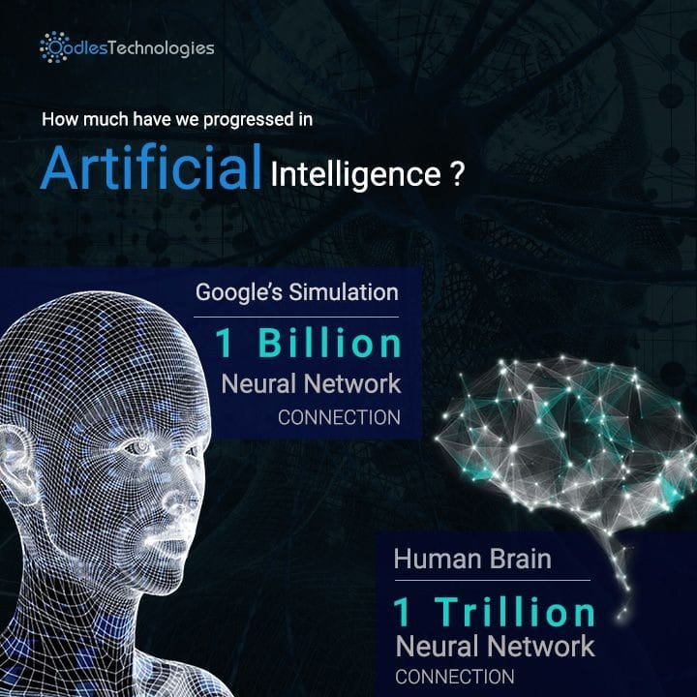

**FUTURE OF A.I.**

**Transportation:** Although it could take [a decade or more](https://www.mckinsey.com/industries/automotive-and-assembly/our-insights/self-driving-car-technology-when-will-the-robots-hit-the-road) to perfect them, autonomous cars will one day ferry us from place to place.

**Manufacturing:**[AI powered robots work alongside humans](https://builtin.com/artificial-intelligence/ai-manufacturing-robots-automation) to perform a limited range of tasks like assembly and stacking, and predictive analysis sensors keep equipment running smoothly.

**Healthcare:** In the comparatively AI-nascent field of healthcare, diseases are more quickly and accurately diagnosed, drug discovery is sped up and streamlined, virtual nursing assistants monitor patients and big data analysis helps to create a more personalized patient experience.

**Education:** Textbooks are digitized with the help of AI, early-stage virtual tutors assist human instructors and facial analysis gauges the emotions of students to help determine who’s struggling or bored and better tailor the experience to their individual needs.

**Media:** Journalism is harnessing AI, too, and will continue to benefit from it. Bloomberg uses Cyborg technology to help make quick sense of complex financial reports. The Associated Press employs the natural language abilities of Automated Insights to produce 3,700 earning reports stories per year — nearly four times more than in the recent past.

**Customer Service:** Last but hardly least, Google is working on an AI assistant that can place human-like calls to make appointments at, say, your neighborhood hair salon. In addition to words, the system understands context and nuance.

**CURRENT PERFORMANCE**

In his famous [Turing test](https://en.wikipedia.org/wiki/Turing_test), Alan Turing picked language, [the defining feature of human beings](https://en.wikipedia.org/wiki/Animal_language#Aspects_of_human_language), for its basis. Yet, there are many other useful abilities that can be described as showing some form of intelligence. This gives better insight into the comparative success of artificial intelligence in different areas.

In what has been called the [Feigenbaum test](https://en.wikipedia.org/wiki/Feigenbaum_test), the inventor of [expert systems](https://en.wikipedia.org/wiki/Expert_system) argued for subject specific expert tests. A paper by [Jim Gray](https://en.wikipedia.org/wiki/Jim_Gray_(computer_scientist)) of [Microsoft](https://en.wikipedia.org/wiki/Microsoft) in 2003 suggested extending the Turing test to [speech understanding](https://en.wikipedia.org/wiki/Speech_recognition), [speaking](https://en.wikipedia.org/wiki/Speech_synthesis) and [recognizing objects](https://en.wikipedia.org/wiki/Outline_of_object_recognition) and behavior.

AI, like electricity or the steam engine, is a general purpose technology. There is no consensus on how to characterize which tasks AI tends to excel at. Some versions of [Moravec's paradox](https://en.wikipedia.org/wiki/Moravec%27s_paradox) observe that humans are more likely to outperform machines in areas such as physical dexterity that have been the direct target of natural selection While projects such as [AlphaZero](https://en.wikipedia.org/wiki/AlphaZero) have succeeded in generating their own knowledge from scratch, many other machine learning projects require large training datasets Researcher [Andrew Ng](https://en.wikipedia.org/wiki/Andrew_Ng) has suggested, as a "highly imperfect rule of thumb", that "almost anything a typical human can do with less than one second of mental thought, we can probably now or in the near future automate using AI.”

Games provide a high-profile benchmark for assessing rates of progress; many games have a large professional player base and a well-established competitive rating system. [AlphaGo](https://en.wikipedia.org/wiki/AlphaGo) brought the era of classical board-game benchmarks to a close when Artificial Intelligence proved their competitive edge over humans in 2016. [Deep Mind’s](https://en.wikipedia.org/wiki/DeepMind) AlphaGo AI software program defeated the world’s best professional Go Player [Lee Sedol](https://en.wikipedia.org/wiki/Lee_Sedol). Games of [imperfect knowledge](https://en.wikipedia.org/wiki/Perfect_knowledge) provide new challenges to AI in the area of [game theory](https://en.wikipedia.org/wiki/Game_theory); the most prominent milestone in this area was brought to a close by [Libratus](https://en.wikipedia.org/wiki/Libratus)' poker victory in 2017. [E-sports](https://en.wikipedia.org/wiki/E-sports) continue to provide additional benchmarks; [Facebook](https://en.wikipedia.org/wiki/Facebook) AI, [Deepmind](https://en.wikipedia.org/wiki/Deepmind), and others have engaged with the popular [*StarCraft*](https://en.wikipedia.org/wiki/StarCraft_(video_game)) franchise of videogames.

Broad classes of outcome for an AI test may be given as:`

* **optimal**: it is not possible to perform better (note: some of these entries were solved by humans)
* **super-human**: performs better than all humans
* **high-human**: performs better than most humans
* **par-human**: performs similarly to most humans
* **sub-human**: performs worse than most humans

### C:\Users\HP\AppData\Local\Microsoft\Windows\INetCache\Content.Word\aaaa.jpg

**ADVANTAGES**

* AI drives down the time taken to perform a task. It enables multi-tasking and eases the workload for existing resources.
* AI enables the execution of hitherto complex tasks without significant cost outlays.
* AI operates 24x7 without interruption or breaks and has no downtime
* AI augments the capabilities of differently abled individuals
* AI has mass market potential, it can be deployed across industries.
* AI facilitates decision-making by making the process faster and smarter.

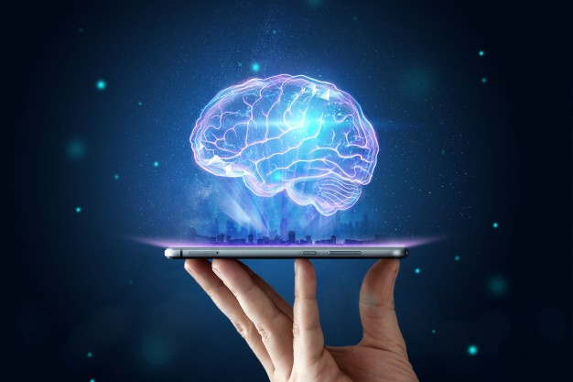

**DISADVANTAGES**

* High cost of Implementation
* Can’t replace Humans
* Lacks Creativity



* Doesn’t improve with experience
* Risk of Unemployement

**CONCLUSION**

AI is at the centre of a new enterprise to build computational models of intelligence. The main assumption is that intelligence (human or otherwise) can be represented in terms of symbol structures and symbolic operations which can be programmed in a digital computer. There is much debate as to whether such an appropriately programmed computer would be a mind, or would merely simulate one, but AI researchers need not wait for the conclusion to that debate, nor for the hypothetical computer that could model all of human intelligence. Aspects of intelligent behaviour, such as solving problems, making inferences, learning, and understanding language, have already been coded as computer programs, and within very limited domains, such as identifying diseases of soybean plants, AI programs can outperform human experts. Now the great challenge of AI is to find ways of representing the commonsense knowledge and experience that enable people to carry out everyday activities such as holding a wide-ranging conversation, or finding their way along a busy street. Conventional digital computers may be capable of running such programs, or we may need to develop new machines that can support the complexity of human thought.

**BIBLIOGRAPHY**

1. <https://en.wikipedia.org/wiki/Artificial_Intelligence>
2. <https://www.theverge.com/2018/8/31/17777008/artificial-intelligence-taryn-southern-amper-music>
3. <https://en.wikipedia.org/wiki/Progress_in_artificial_intelligence>
4. <https://sitn.hms.harvard.edu/flash/2019/artificial-intelligence-in-medicine-applications-implications-and-limitations/>
5. <https://www.forbes.com/sites/bernardmarr/2019/07/05/the-amazing-ways-artificial-intelligence-is-transforming-the-music-industry/>
6. <https://www.sciencedirect.com/science/article/pii/S258972172030012X#:~:text=AI%20is%20an%20emerging%20technology,et%20al.%2C%202007>).
7. <https://builtin.com/artificial-intelligence/artificial-intelligence-future#:~:text=Artificial%20intelligence%20is%20impacting%20the,innovator%20for%20the%20foreseeable%20future>.
8. <https://youtube.com/playlist?list=PLjq6DwYksrzz_fsWIpPcf6V7p2RNAneKc>