WEB DEVELOPMENT
PROJECT DOCUMENTATION
HTML and CSS Website Designs
Submitted by: ______________________________
Class / Section: ______________________________
Roll Number: _________________________________
This document presents the HTML structure, CSS styling, and final browser output of three website projects.

Contents
- 01. VIBE 2026 – College Fest Website
- 02. Sweet Cravings – Bakery Website
- 03. Foodie Hub – Online Food Ordering Website
Each project is documented in the same order: website title and description, HTML code screenshot with an explanation, CSS code screenshot with an explanation, and the final website output with a brief evaluation.

01. VIBE 2026 – College Fest Website

Website Description
VIBE 2026 is a college fest information website designed to present festival details in an attractive and organized format. It introduces the event and provides sections for information about the fest, event categories, the schedule, registration, and contact details. The home section highlights the festival name, a short promotional message, the event dates, and a Register Now link. The website helps students and visitors quickly understand the fest and explore its activities.

HTML Code
The HTML code defines the structure and content of the webpage. The screenshot below shows the HTML file opened in Visual Studio Code.
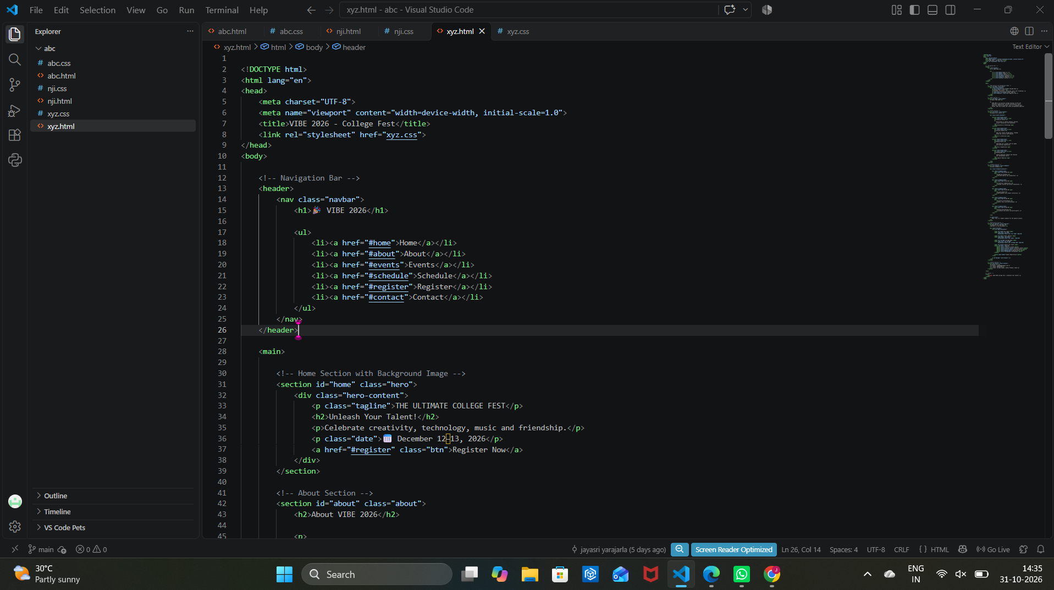
Figure: HTML source code in Visual Studio Code

HTML Elements Used
- Document structure: DOCTYPE, html, head, and body elements establish the basic HTML page structure.
- Page information: meta tags set the character encoding and responsive viewport; the title element names the page.
- External stylesheet: the link element connects the HTML page to xyz.css.
- Navigation: header, nav, ul, li, and a elements create links to Home, About, Events, Schedule, Register, and Contact.
- Content sections: main and section elements organize the home and other website content; headings and paragraphs present text.
- Call to action: the Register Now anchor links visitors to the registration section.

CSS Code
The CSS code controls the visual presentation of the webpage, including colours, spacing, alignment, layouts, typography, and interactive visual effects. The screenshot below shows the CSS file.
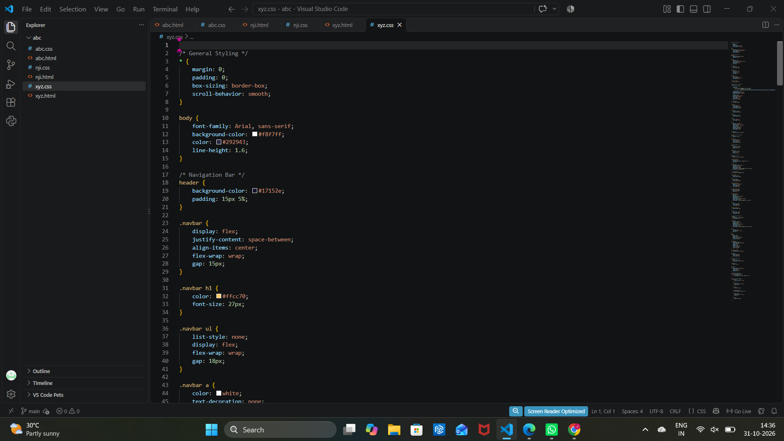
Figure: CSS source code in Visual Studio Code

CSS Properties and Techniques Used
- Global styling: the universal selector resets margin and padding and applies border-box sizing and smooth scrolling.
- Page appearance: body rules set the Arial font, light background colour, text colour, and line spacing.
- Navigation bar: header and .navbar rules style the dark header and arrange its contents using Flexbox, spacing, and wrapping.
- Typography and links: heading and anchor rules control text colour, size, weight, and link decoration.
- Colour theme: the CSS uses contrasting dark, light, and accent colours to make important text and navigation visible.
- Layout and interaction: section and component styles create a consistent layout and visual feedback for interactive elements.

Output
The following screenshot shows the webpage running in a browser after the HTML and CSS files are connected.
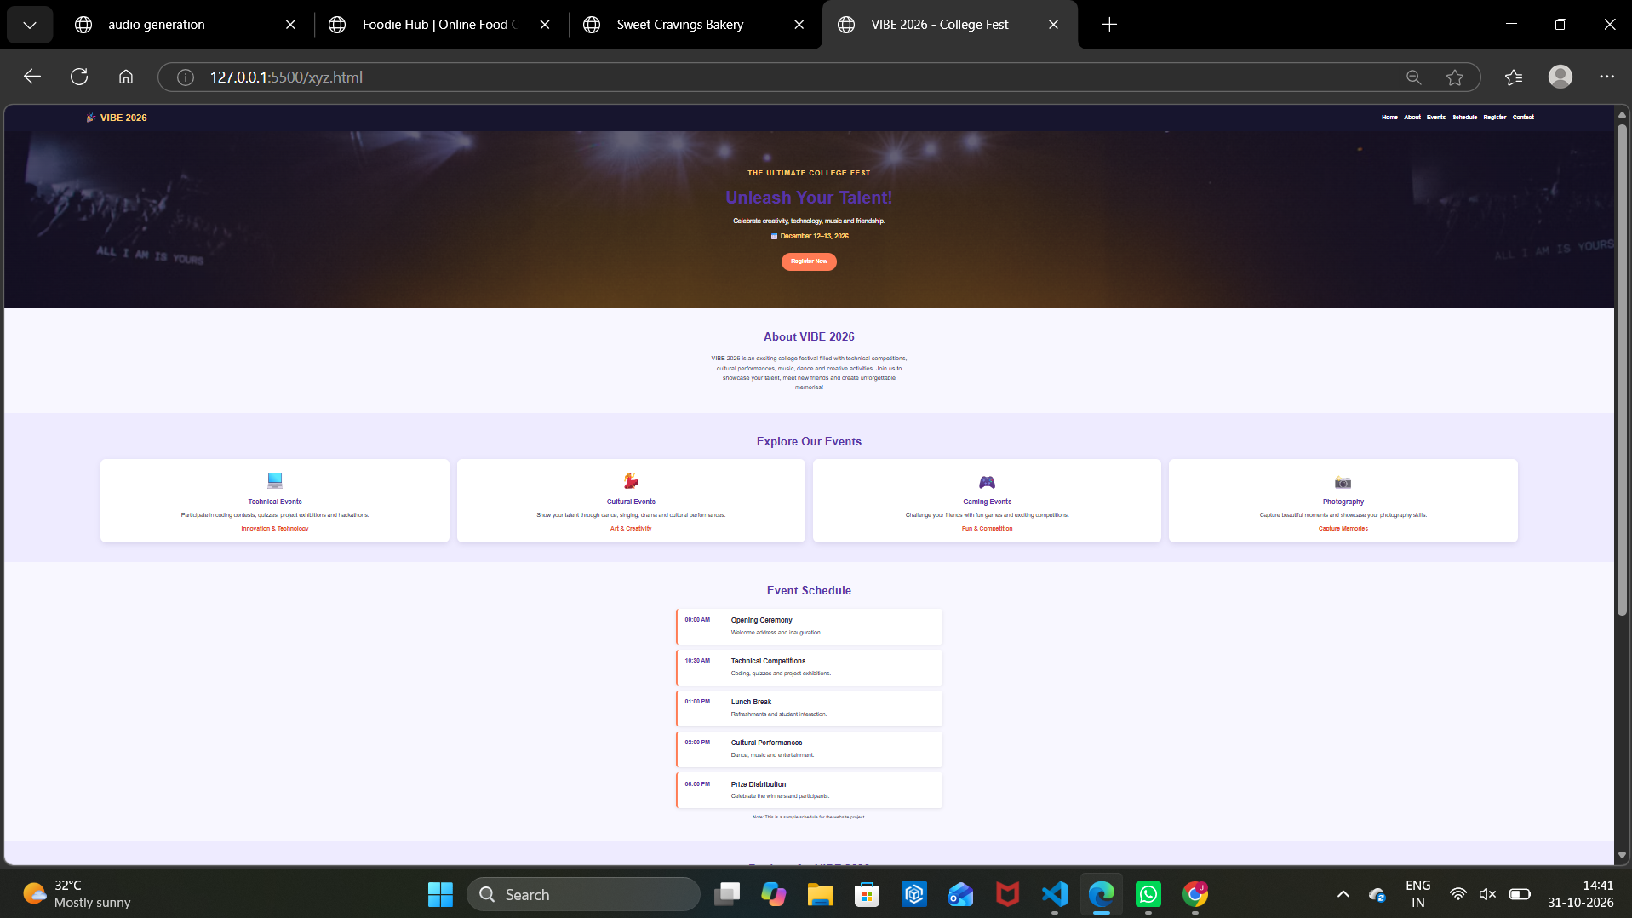
Figure: Final website output in the browser
The final browser view displays the VIBE 2026 website with a dark festival-themed hero banner, a prominent event title, a Register Now button, an About section, event-category cards, and a schedule. The sections are visually separated with light backgrounds and clear headings. This output demonstrates how the HTML content and CSS design work together to create a structured college fest webpage.

02. Sweet Cravings – Bakery Website

Website Description
Sweet Cravings is a bakery website created to introduce a bakery and display its products. The page includes a navigation bar, a home banner with a bakery message, an About section, and a menu showing baked items such as cakes, cupcakes, croissants, cookies, pastries, and brownies. The design gives visitors a simple way to browse the bakery's products and find the order and contact sections.

HTML Code
The HTML code defines the structure and content of the webpage. The screenshot below shows the HTML file opened in Visual Studio Code.
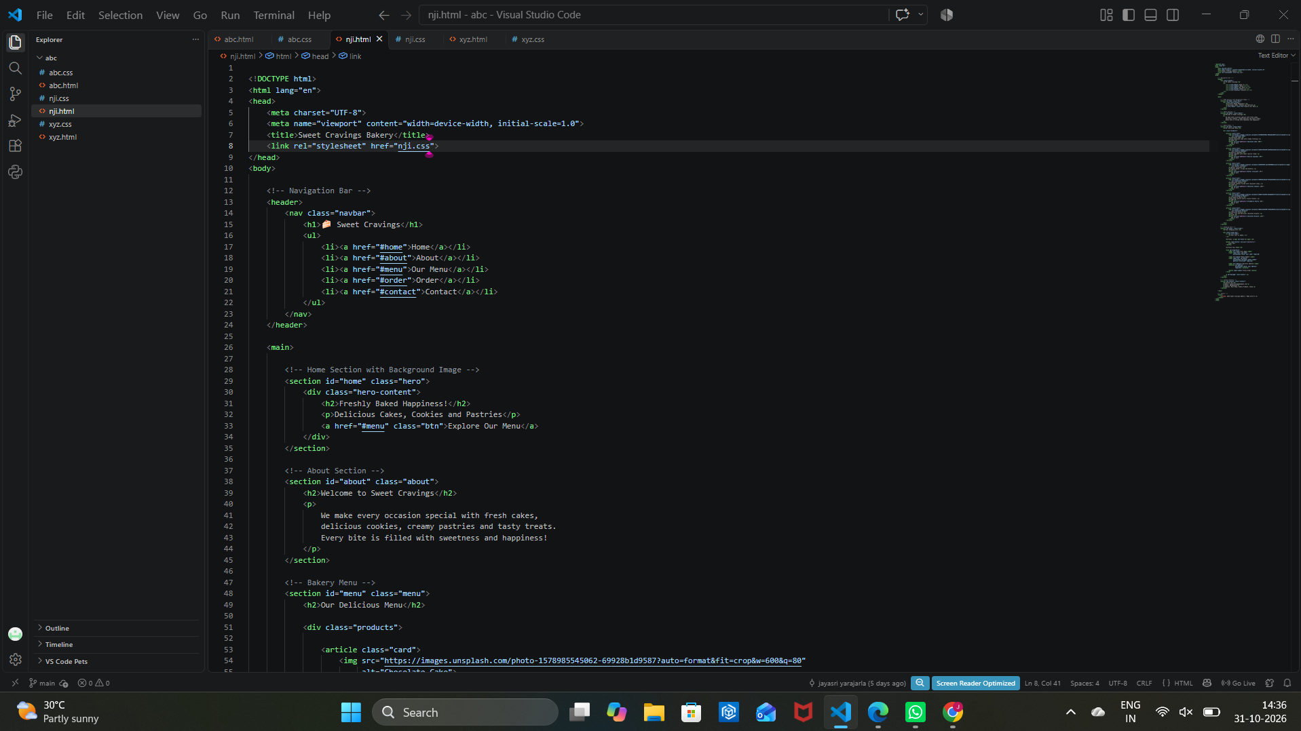
Figure: HTML source code in Visual Studio Code

HTML Elements Used
- Document structure: DOCTYPE, html, head, and body elements form the standard HTML document.
- Page information: meta tags define character encoding and viewport settings, while the title element identifies the page as Sweet Cravings Bakery.
- Stylesheet connection: the link element connects the page to the external file nji.css.
- Navigation: header, nav, ul, li, and a elements create Home, About, Our Menu, Order, and Contact links.
- Main content: main and section elements divide the page into the home, About, and bakery menu sections.
- Product cards: article and div elements group product information; image, heading, and paragraph elements display product pictures, names, and descriptions.
- Navigation links: anchor elements connect visitors to the relevant page sections.

CSS Code
The CSS code controls the visual presentation of the webpage, including colours, spacing, alignment, layouts, typography, and interactive visual effects. The screenshot below shows the CSS file.
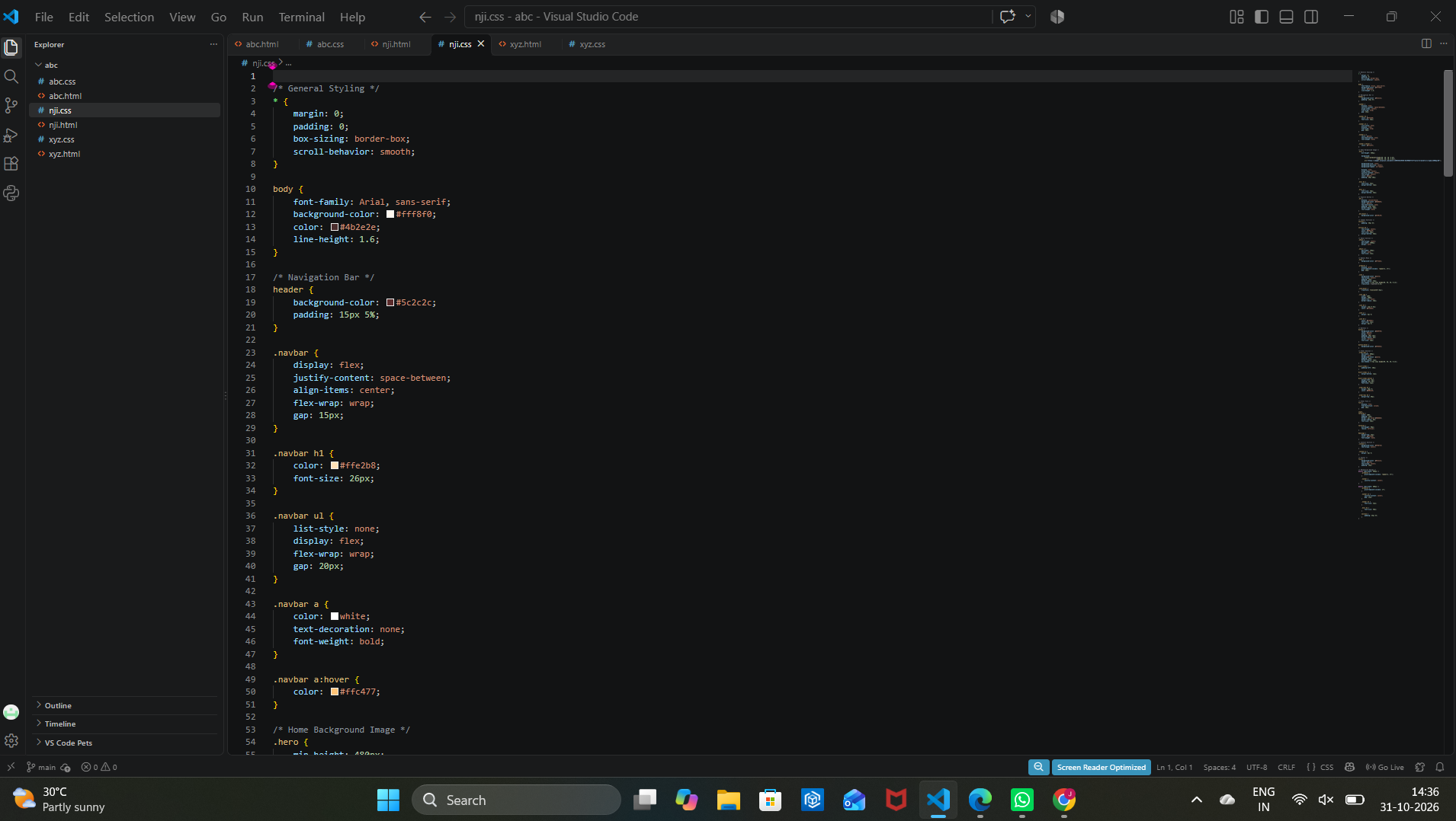
Figure: CSS source code in Visual Studio Code

CSS Properties and Techniques Used
- Reset and page defaults: the universal selector removes default spacing, applies border-box sizing, and enables smooth scrolling.
- Body design: body rules set the font, warm light background, text colour, and line height.
- Header and navigation: the header uses a deep brown colour; Flexbox, gaps, and wrapping arrange the navigation items.
- Bakery colour palette: warm brown, cream, and orange accent colours support the bakery theme.
- Menu layout: CSS Grid arranges the product cards in columns with consistent gaps.
- Product card styling: white backgrounds, padding, rounded corners, and box shadows make each product card distinct.
- Image and hover effects: product images fill their card area, use object-fit: cover, and the hover rule lifts cards slightly for visual feedback.

Output
The following screenshot shows the webpage running in a browser after the HTML and CSS files are connected.
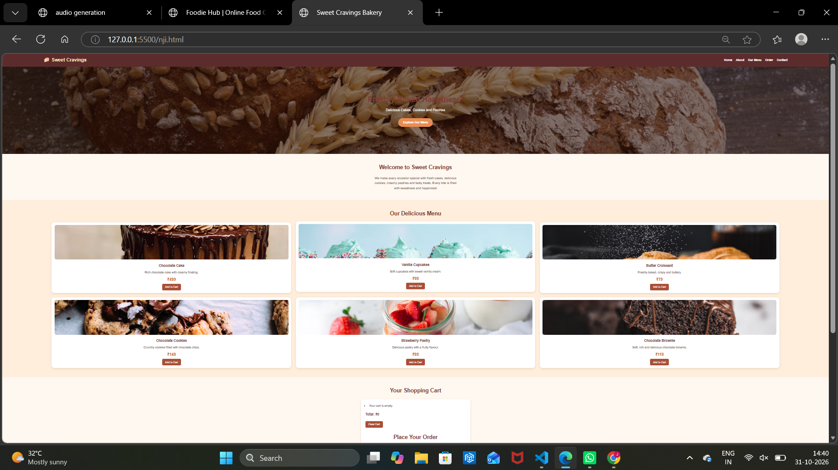
Figure: Final website output in the browser
The final browser view shows the Sweet Cravings bakery page with a brown navigation bar, a large bakery-themed hero image, a welcome message, and a menu arranged in product cards. Each card contains a product image, name, short description, price, and an Add to Cart button. The shopping-cart and order areas appear below the menu. The warm colours and card layout make the bakery products easy to browse.

03. Foodie Hub – Online Food Ordering Website

Website Description
Foodie Hub is an online food ordering website concept designed to display popular food items and provide a simple ordering interface. The website contains a navigation bar, a home banner, an About section, a popular-dishes menu, a shopping cart, and an order area. The menu presents items such as pizza, burgers, pasta, noodles, cake, and cold coffee, along with descriptions, prices, and Add to Cart buttons.

HTML Code
The HTML code defines the structure and content of the webpage. The screenshot below shows the HTML file opened in Visual Studio Code.
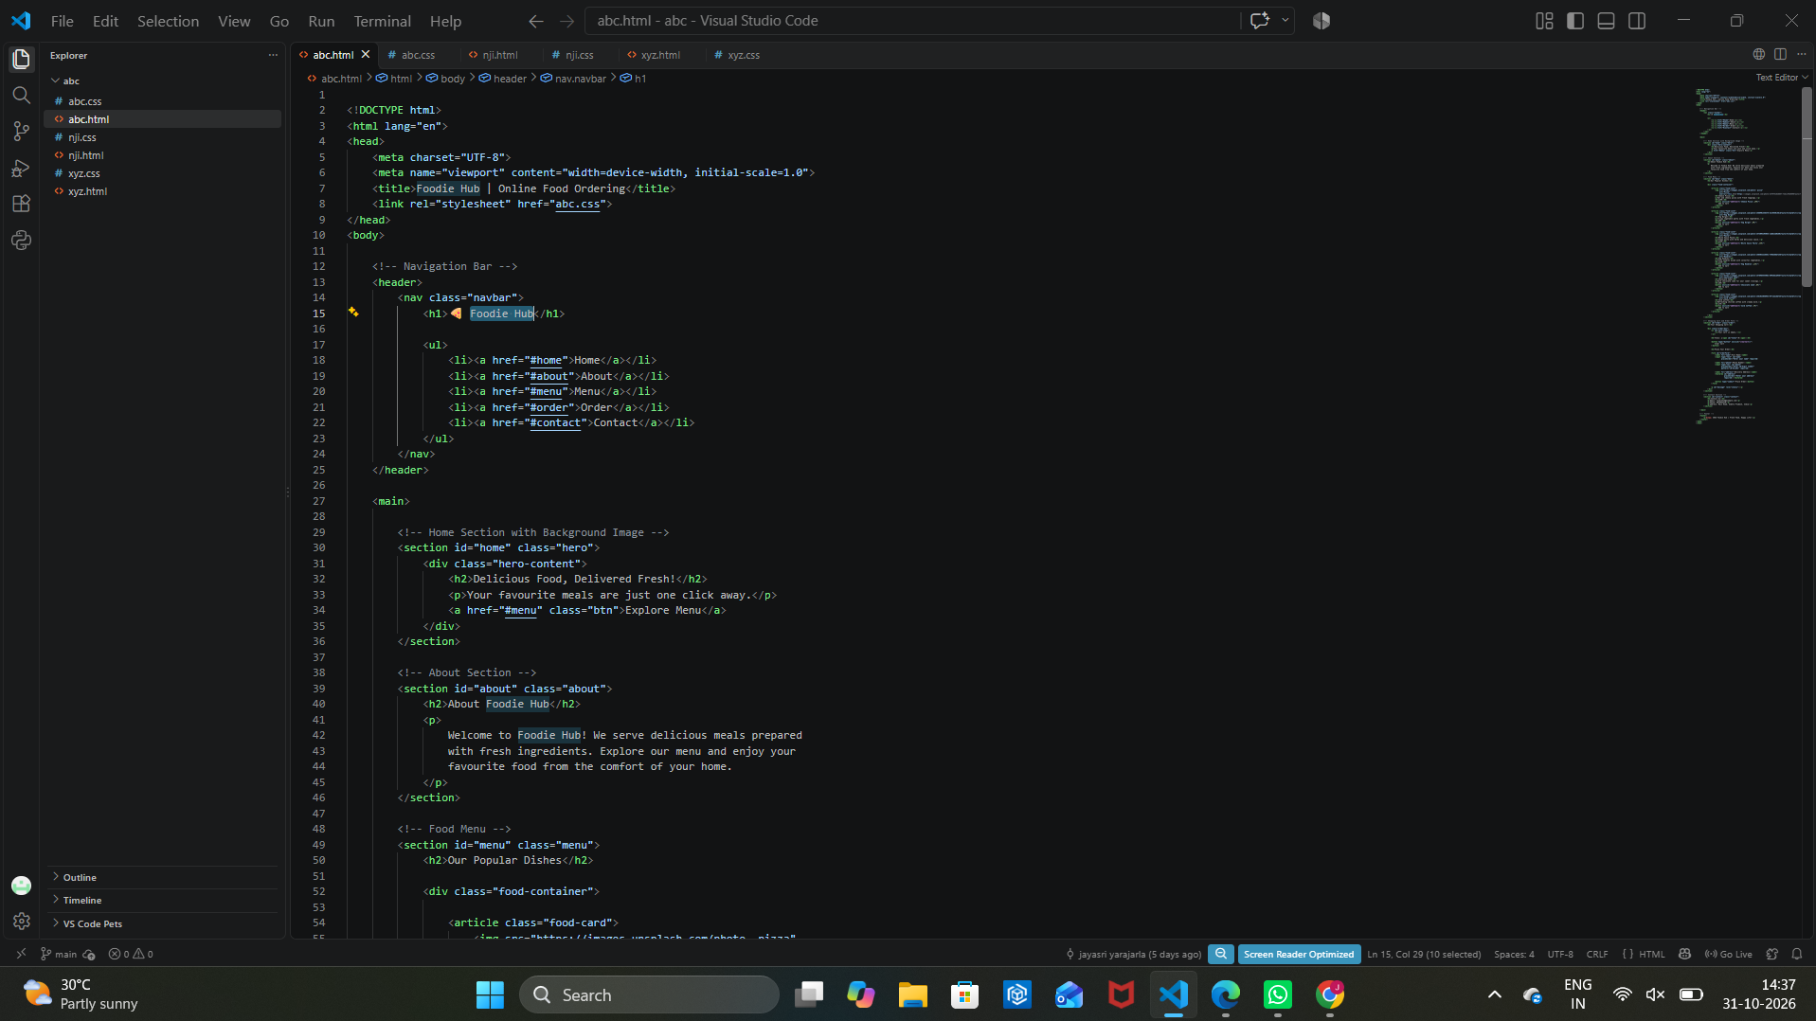
Figure: HTML source code in Visual Studio Code

HTML Elements Used
- Document structure: DOCTYPE, html, head, and body elements define the page structure.
- Page information: meta tags provide character encoding and viewport settings; the title element names the page Foodie Hub | Online Food Ordering.
- Stylesheet connection: the link element attaches the external stylesheet abc.css.
- Navigation: header, nav, ul, li, and a elements create Home, About, Menu, Order, and Contact links.
- Home and About sections: main and section elements organize the welcome banner and the website introduction.
- Food menu: the menu section and article/div containers group food cards; image, heading, and paragraph elements show each dish and its description.
- Ordering interface: buttons and section links provide visible controls for exploring the menu and order area.

CSS Code
The CSS code controls the visual presentation of the webpage, including colours, spacing, alignment, layouts, typography, and interactive visual effects. The screenshot below shows the CSS file.
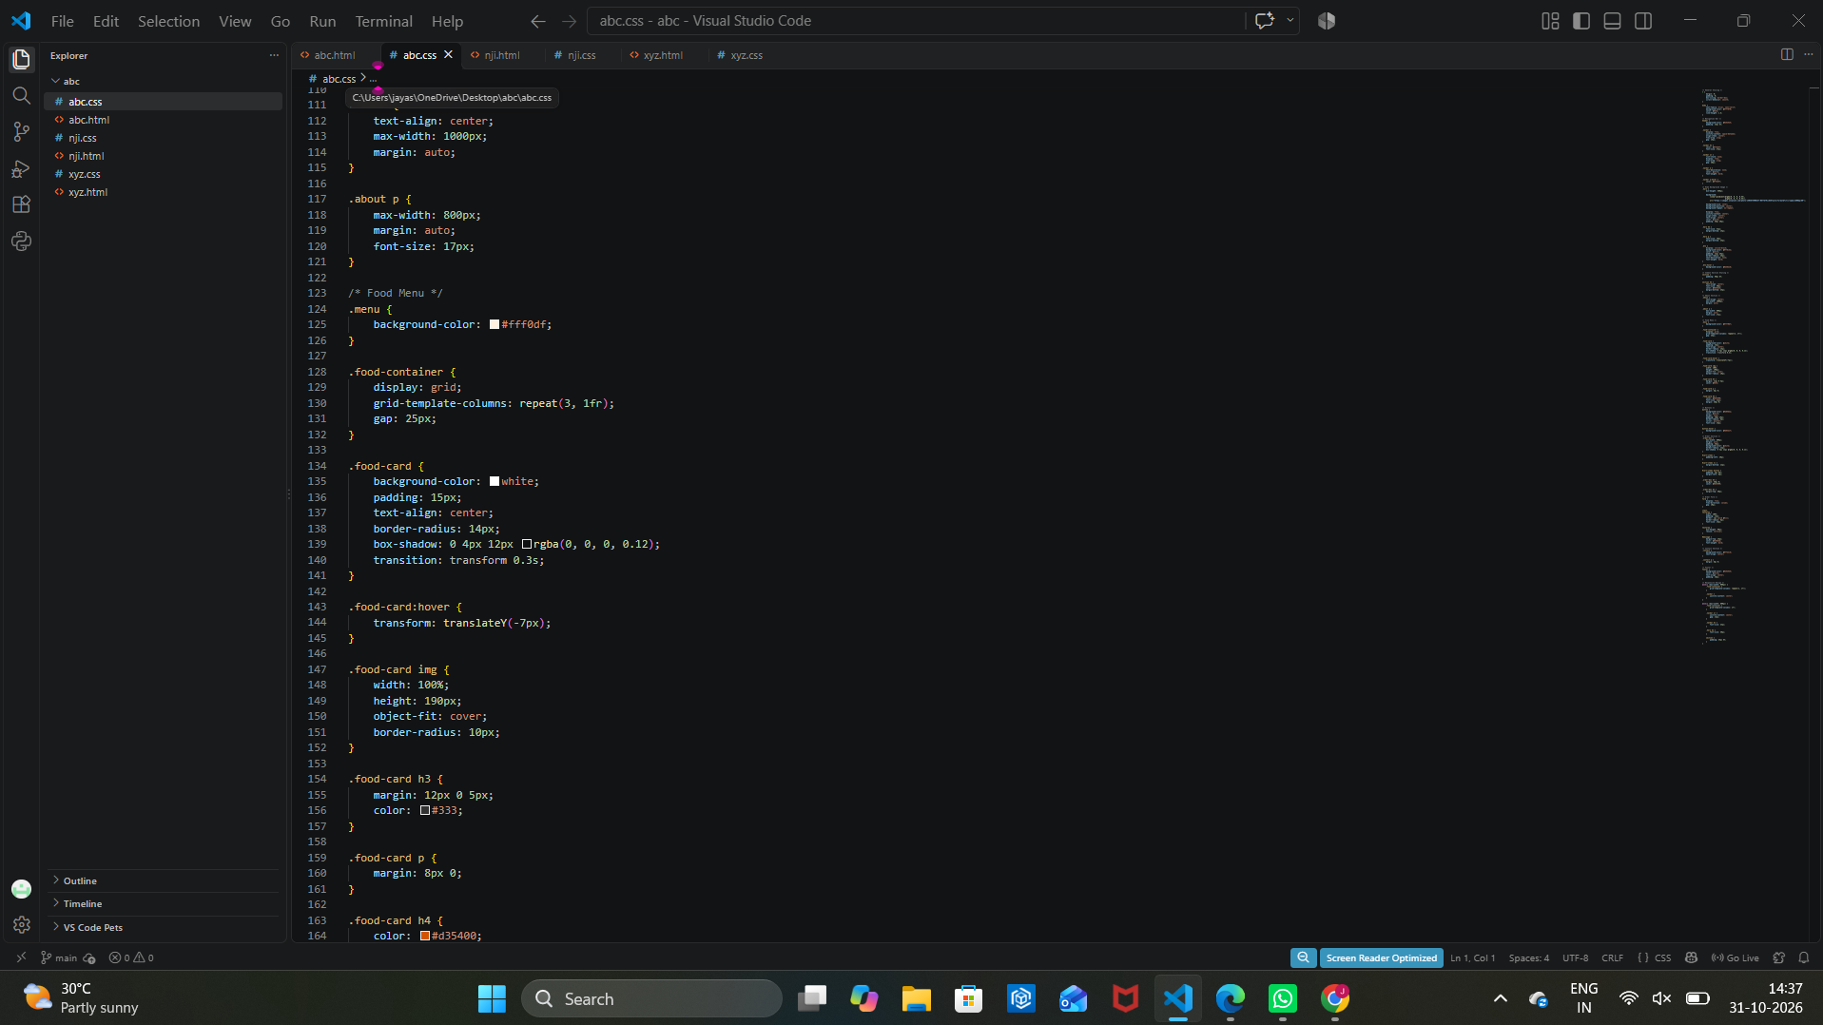
Figure: CSS source code in Visual Studio Code

CSS Properties and Techniques Used
- Global and body styling: the CSS resets default spacing, applies border-box sizing, and sets the page font, background, text colour, and line height.
- Navigation styling: header and navigation rules create the top bar and arrange the brand and links using Flexbox.
- Food menu background: the menu section uses a light warm background to distinguish it from other sections.
- Grid layout: .food-container uses CSS Grid with three equal columns and a gap to arrange food cards.
- Food cards: .food-card rules add a white background, padding, centered text, rounded corners, and a soft shadow.
- Hover interaction: the hover rule moves a food card slightly upward when the pointer is over it.
- Images and text: image sizing and object-fit keep food pictures within their cards; heading and paragraph rules organize product names and descriptions.

Output
The following screenshot shows the webpage running in a browser after the HTML and CSS files are connected.
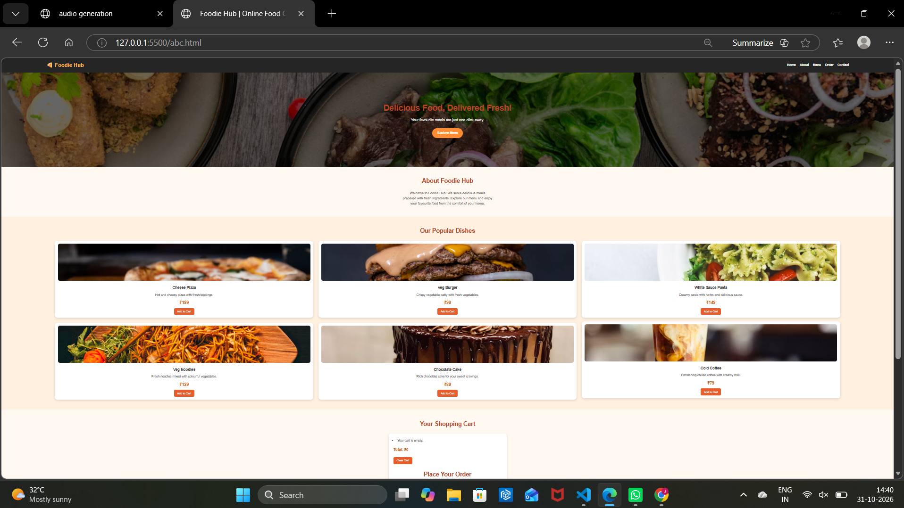
Figure: Final website output in the browser
The final browser view displays Foodie Hub with a food-themed background banner, a clear welcome message, an About section, and a grid of six popular dishes. Each dish card shows a picture, item name, short description, price, and Add to Cart button. A shopping-cart area and Place Your Order section are visible below the menu. The layout brings the food choices and ordering area together in one webpage.

