**PE01: Programming Exercise-Jayasudha Kalamegam**

**Amazon Rekognition Custom Labels Demo**

Follow exactly <https://github.com/aws-samples/amazon-rekognition-custom-labels-demo> to learn and use Amazon Rekognition. You’ll need to complete all steps in the github link.

**Your task for PE01 is to:**

1. Complete above task
2. Please randomly try a couple of pictures in your computer to see if it can successfully classify them by using the default trained demo model.
3. Please provide screenshots after completing task1 step 4,9,10 under “deployment” section

**Screenshots for deployment Section:**

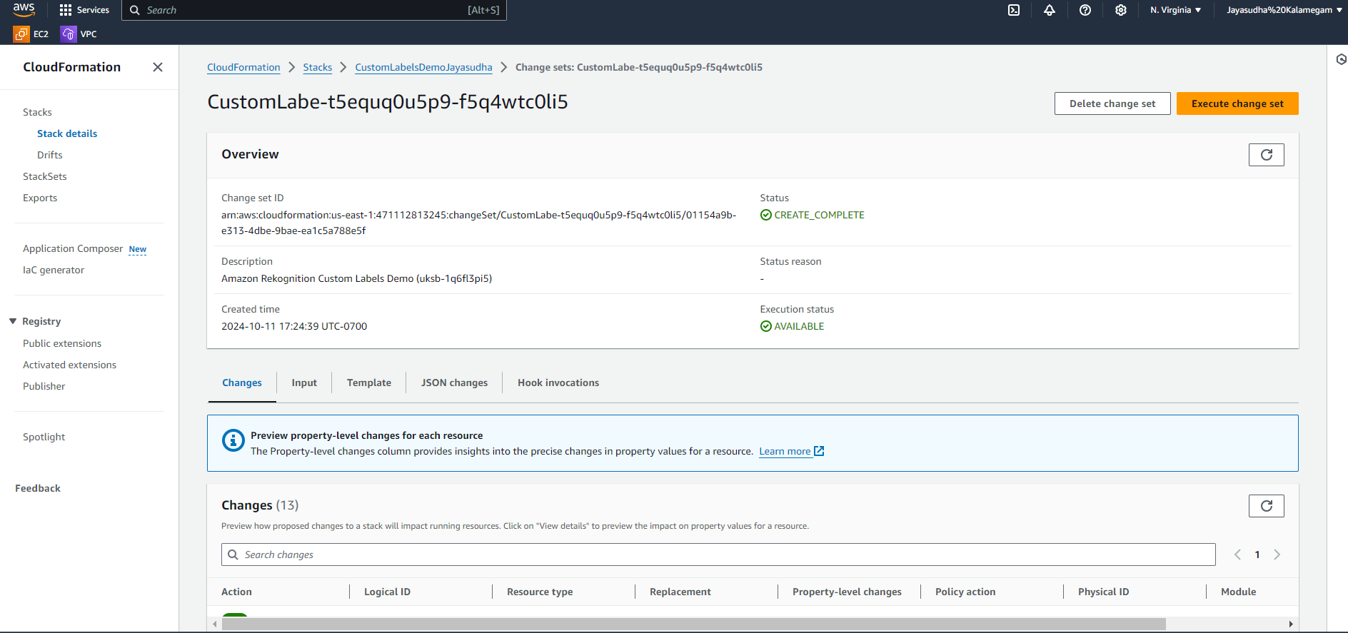

1. Please complete task2, and 100-200 words of overall feelings using Amazon Rekognition

Using Amazon Rekognition and deploying it via the CloudFormation template was a highly efficient and streamlined process for me. The **Custom Labels** feature in Amazon Rekognition made it easier to handle image recognition tasks, allowing me to create machine learning models without needing deep expertise in AI. I found the deployment process intuitive, with CloudFormation automatically managing most of the setup, including creating IAM resources and configuring S3, Cognito, and CloudFront.

One of the key things I learned was how to monitor the entire stack creation through CloudFormation’s Events tab, which provided me with real-time updates and transparency as the demo moved toward completion. I also customized parameters such as stack names and email addresses, which gave me the flexibility to tailor the setup to fit the specific needs of my project.

After deploying the stack, accessing the web interface using the auto-generated URL was straightforward. Overall, this hands-on experience with Amazon Rekognition, CloudFormation, and Cognito showed me how AWS services can work together to simplify and accelerate AI model deployment.

* + *A screenshot of a room with a fireplace and a couch

    Description automatically generated*

