PE04-Jayasudha Kalamegam

Creating the Table
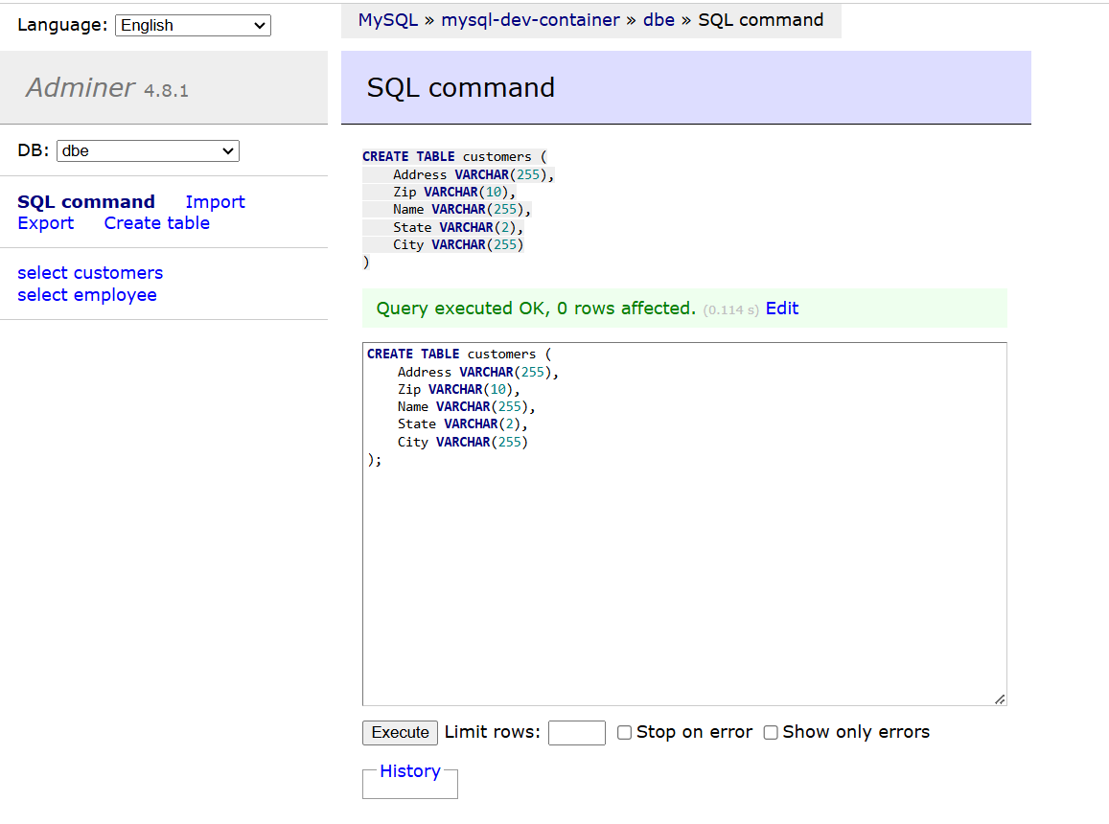
Inserting Data into the Table
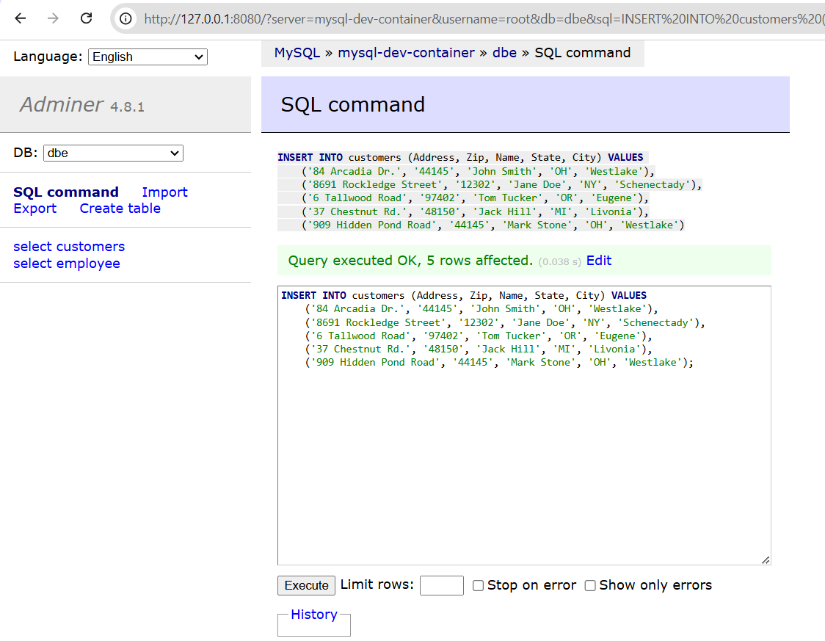

- Return all rows and columns in the database (before any changes)

This query retrieves all data from the customers table without any filters, showing each row and column in the table. By using SELECT * FROM customers; we ensure all records are displayed in their original state. This provides a baseline view of the data before any modifications. Observing the result allows us to verify that the initial data is accurate and aligns with the expected structure.
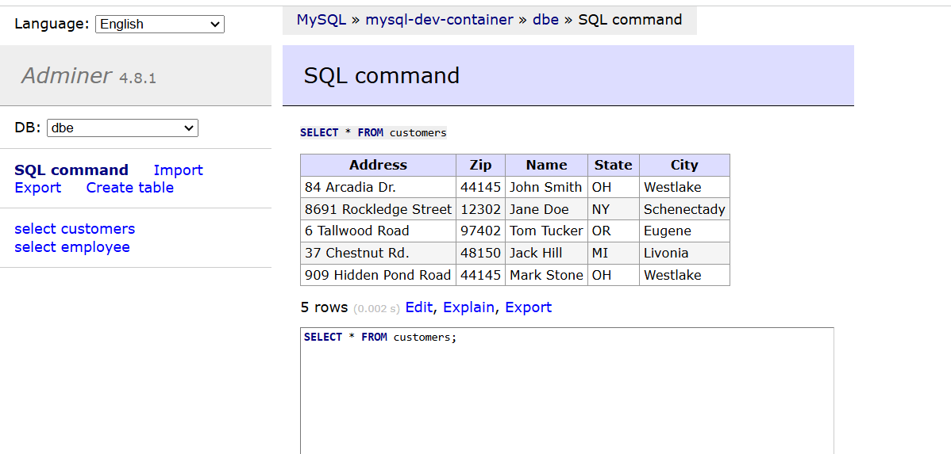

- Return all customers that live in Ohio
This query selects only those customers whose State is 'OH'. The query SELECT * FROM customers WHERE State = 'OH'; uses a WHERE clause to filter results based on the state value. This is useful for identifying customers within a specific geographic location, such as Ohio, to target location-based services or analyze regional patterns. The result should show only the customers who live in Ohio.
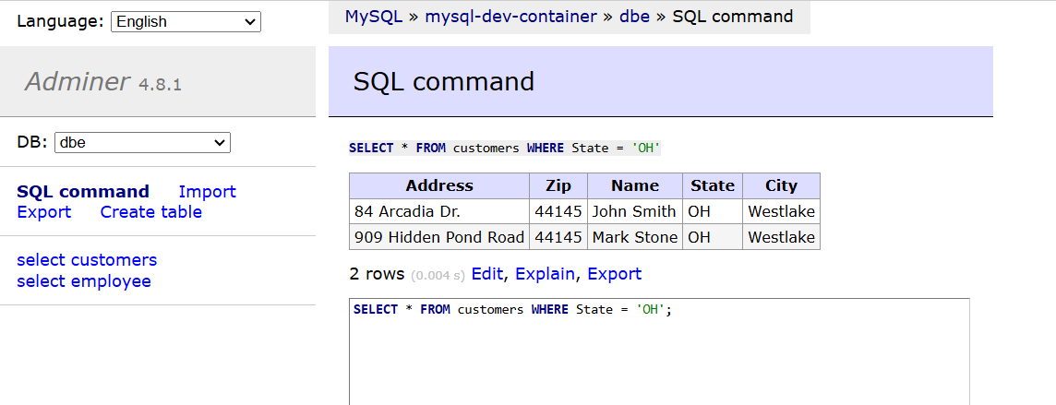

- Return the Name and Address of customers that live in Westlake
This query retrieves only the Name and Address of customers residing in the city of Westlake. By using SELECT Name, Address FROM customers WHERE City = 'Westlake'; it filters records by city and limits columns to relevant details. This is efficient when only specific information is needed, like for mailing addresses. The expected result includes only the names and addresses of Westlake residents.
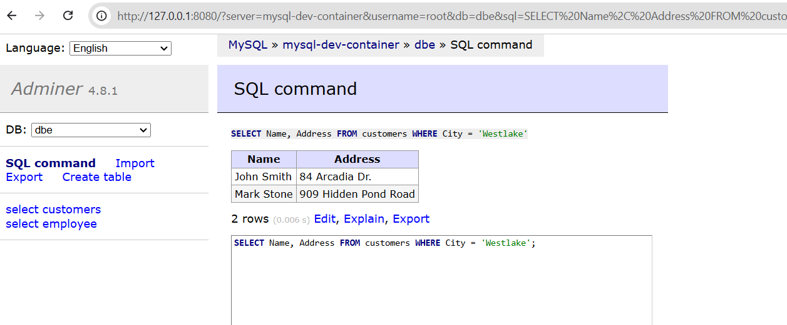

- Change Jane Doe's Zip code to 12303
This query updates Jane Doe’s Zip code from 12302 to 12303 using the command UPDATE customers SET Zip = '12303' WHERE Name = 'Jane Doe'; The UPDATE statement modifies existing data, while the WHERE clause targets only Jane Doe's record. This allows for precise adjustments without altering other rows. After running the query, Jane Doe's record should reflect the new zip code, confirming the update.
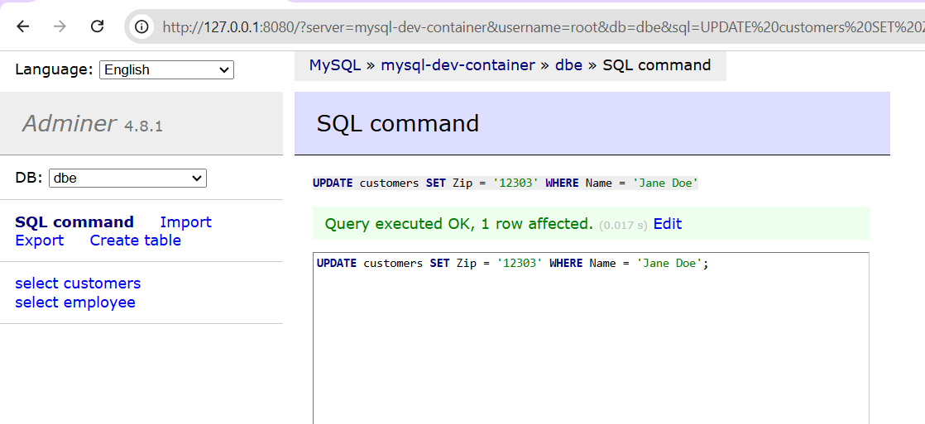

- Delete Jack hill from the table
This query removes Jack Hill's record from the customers table by using DELETE FROM customers WHERE Name = 'Jack Hill'; The DELETE command combined with the WHERE clause ensures only Jack Hill’s entry is deleted, preserving other data. This is helpful for removing outdated or incorrect records. After executing, Jack Hill’s row should no longer appear in the table, indicating successful deletion.
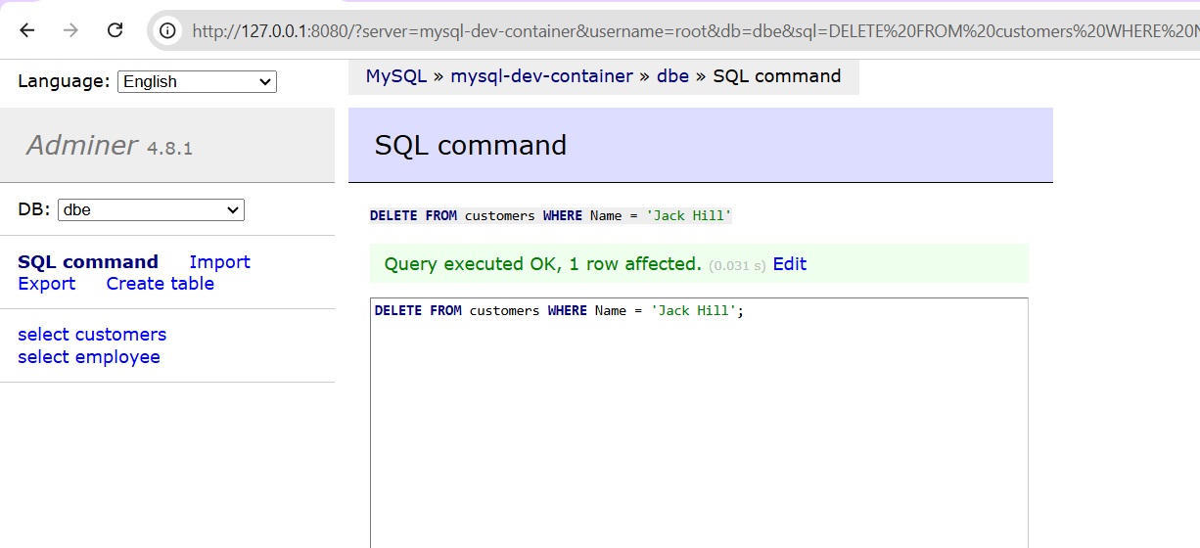

- Return all rows and columns in the database (after the changes above)
This query once again retrieves all rows and columns from the customers table using SELECT * FROM customers; By viewing the data after changes, we can confirm that the updates (Jane Doe's zip code change) and deletions (Jack Hill’s record) were applied correctly. This final check provides a clear view of the modified dataset, ensuring all operations were successful and the database reflects the intended state.
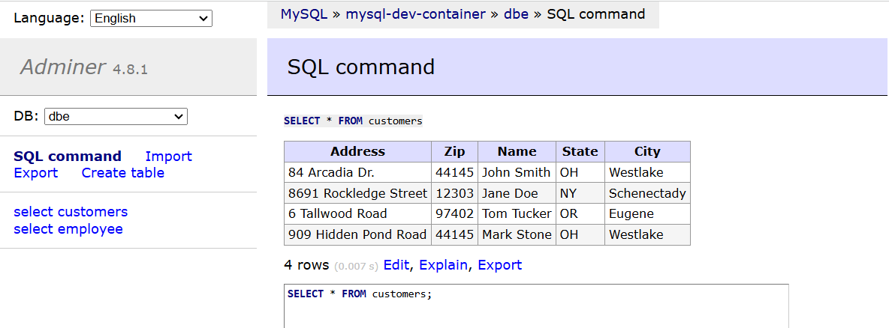

Questions
- List the data types used for the columns in the table.
For the customers table, here are the data types which I have used for each of the column:

Address: VARCHAR(255) — A variable-length character string that can hold up to 255 characters.
Zip: VARCHAR(10) — A variable-length character string that can hold up to 10 characters, suitable for storing postal codes.
Name: VARCHAR(255) — A variable-length character string that can hold up to 255 characters, used to store customer names.
State: VARCHAR(2) — A 2-character string to store state abbreviations (e.g., OH, NY).
City: VARCHAR(255) — A variable-length character string that can hold up to 255 characters, used to store city names.

- Explain the query that you used for this part:
“Return all customers that live in Ohio”
SELECT * FROM customers WHERE State = 'OH';
This query is used to select all rows from the customers table where the State column has the value 'OH'. The SELECT * statement retrieves all columns, so the output will include the Address, Zip, Name, State, and City columns for each customer in Ohio. The WHERE clause filters the results, ensuring only records with State = 'OH' are returned. This is useful for identifying customers from Ohio specifically.

- Explain the query that you used for this part:
“Change Jane Doe's Zip code to 12303”
UPDATE customers SET Zip = '12303' WHERE Name = 'Jane Doe';
This query updates the Zip column for the customer named "Jane Doe." The UPDATE statement targets the customers table, and the SET clause specifies the new value for the Zip column ('12303'). The WHERE clause filters the update to only the row where Name is 'Jane Doe'. Without the WHERE clause, the Zip code would be updated for all rows, so it’s critical to include this filter to change only Jane Doe’s zip code.

