Operating Systems

ASSIGNMENT 1

CO1: Apply the concepts of operating system types, structures and system calls to demonstrate their functions in various computing environments – history of operating systems, mainframe, desktop, multiprocessor, distributed, clustered, real-time and handheld systems, OS structure, services, system calls, system design, CPU states, memory hierarchy and I/O systems.

Assignment Title: Evaluate and Justify the Operating-System Design of a Smart Hospital
(Total Marks - 50)

Nature of Assignment: Individual
Duration: 1 Week
Submission Date:06-11-2026

Bloom’s Levels Assessed: K5 – Evaluate (every task in this assignment is at K5 level)

Mandatory Execution and GitHub Submission

• Every student must individually execute every task in this assignment, including all
“Complete the Code” programs.
• Create a GitHub repository named CSA04(1924260172)Assignment1 and share it with the course faculty (public, or private with the faculty added as a collaborator).
• Keep one folder for each task (for example: Task01, Task02 … or Q1, Q2 …), containing the C source files, shell scripts, configuration files (Dockerfile, YAML), command outputs and screenshots.
• Include a README.md with your name, register number, compiler and version (for example gcc 13), the Linux distribution and version used, the exact gcc command used to compile (for example gcc -std=c11 -Wall -Wextra -pthread), the steps to run each program, and a short note of the result of each task.
• Commit your work progressively – at least one commit for each task. The commit history will be checked; a single upload of all files on the last day will not be accepted.
• Submit the GitHub link below and on the cover page of your report. An assignment submitted without a working GitHub link will not be evaluated.

GitHub Repository Link: https://github.com/jayasurya07068-crypto/OS-ASSIGNMENT-1/tree/main

How to Answer the Additional Questions

Complete the Code: Copy the given code into your repository, replace every TODO with working code without changing the rest of the program, execute it and compare your output (or result) with the expected output.

Alternative Concept and Complexity Analysis: Describe how the solution would change if the alternative concept were used, with code or pseudocode, and analyse and compare the time complexity and space complexity of both solutions using Big-O notation, supported by your own measurements wherever possible.
Scenario — Operating Systems for a Smart Hospital

A 500-bed hospital is replacing its computer systems. It needs: bedside patient monitors that must raise an alarm within 10 milliseconds of an abnormal reading; nurses’ handheld tablets; doctors’ desktop workstations; a central database server for patient records that must never stop; an imaging server that processes MRI scans using many processors; and a link to two partner hospitals that share records.

The IT team has proposed using one general-purpose operating system everywhere. The clinical staff are concerned that alarms may be delayed, the database may stop during updates, and the tablets’ batteries will not last a shift.

The number of devices may grow:

1 ward (40 monitors, 10 tablets) → 1 hospital (500 monitors, 120 tablets, 80 workstations) → a group of 3 hospitals sharing records

You are required to evaluate the requirements of every part of the system, judge which type and structure of operating system suits each, examine how programs obtain OS services through system calls, and defend a complete operating-system plan for the hospital.

Design Challenge:

The hospital is adding remote patient monitoring at home and a cloud-based records service.

Re-evaluate your original design and determine whether it should be retained, modified or redesigned.

TASK 1 – Evaluate the Requirements of Each Computing Environment 4 Marks

Bloom’s Level: K5 – Evaluate

Evaluate what each part of the hospital needs from its operating system.

Discuss:
• Response-time, reliability, throughput, battery and security requirements of each device
• Which requirements conflict (for example: fast response and many users on one machine)
• Which requirements are critical to patient safety
• How the lessons from the history of operating systems (batch, time-sharing, personal, mobile) apply to each environment

You are expected to rank the requirements of each environment and justify the ranking.

Alternative Concept and Complexity Analysis

If the whole hospital used a single general-purpose operating system on every device, instead of a different type of OS for each environment, what would the solution be? Evaluate the worst-case alarm response time (unbounded scheduling delay versus a guaranteed deadline), the memory needed on each device, and the administration effort.

Evidence Expected

A ranked requirement table for every environment with a justification for each ranking.
TASK 2 – Judge the Type of Operating System for Each Environment 3 Marks

Bloom’s Level: K5 – Evaluate

Compare the types of operating systems for the hospital.

Discuss:
• Mainframe, desktop, multiprocessor, distributed, clustered, real-time (hard and soft) and handheld systems
• Which type best fits the monitors, tablets, workstations, database server, imaging server and partner link
• Symmetric versus asymmetric multiprocessing for the imaging server
• A clustered system with fail-over for the database server

Alternative Concept and Complexity Analysis

If the database server used a single large multiprocessor machine instead of a cluster of smaller machines with fail-over, what would the solution be? Evaluate the availability (a single point of failure versus fail-over within seconds), the cost, and how throughput grows with the number of processors (time) and the memory available (space).

Evidence Expected

A justified choice of operating-system type for each environment, with the rejected alternatives and reasons.

TASK 3 – Evaluate Operating-System Structures 4 Marks

Bloom’s Level: K5 – Evaluate

Evaluate the possible structures of the operating system.

Discuss:
• Simple (monolithic), layered, microkernel, modular (loadable kernel modules) and hybrid structures
• The effect of each structure on reliability, performance and ease of updating
• Which structure suits the patient monitors and which suits the database server
• How Linux, Windows, Android and a real-time OS such as FreeRTOS or QNX are structured

Alternative Concept and Complexity Analysis

If the bedside monitors used a monolithic kernel instead of a microkernel, what would the solution be? Evaluate the time cost of a service request (one system call versus message passing between servers), the memory taken by the kernel, and the effect of a faulty driver on the whole system.

Evidence Expected

A comparison of structures against the hospital’s requirements, with a defended choice for two environments.

TASK 4 – Evaluate the Services an Operating System Must Provide 4 Marks

Bloom’s Level: K5 – Evaluat
Evaluate the services each environment needs.

Discuss:
• User interface, program execution, I/O operations, file systems, communication, error detection, resource allocation, accounting, protection and security
• Which services can be removed from the bedside monitor to make it smaller and faster
• Which services are essential for the database server
• How the OS protects one patient’s records from another user’s programs

Alternative Concept and Complexity Analysis

If the tablets used a full desktop operating system with every service enabled instead of a reduced handheld OS, what would the solution be? Evaluate the memory and storage used by the extra services (space), the start-up time and the battery life (time).

Evidence Expected

A service table for each environment with justified inclusions and exclusions.

TASK 5 – Examine System Calls 4 Marks

Bloom’s Level: K5 – Evaluate

Examine how a program obtains OS services.

Discuss:
• The categories of system calls (process control, file management, device management, information maintenance, communication, protection)
• What happens step by step when a program calls read(): library call, trap, mode switch, kernel work, return
• How parameters are passed to the kernel (registers, a block in memory, the stack)
• How strace shows the system calls made by a program

Alternative Concept and Complexity Analysis

If programs called the C library functions fopen, fread and fwrite instead of the open, read and write system calls directly, what would the solution be? Evaluate the number of system calls for a file of n bytes (about n / 4096 with library buffering versus n / b for a buffer of b bytes) and the extra buffer space used by the library.

Evidence Expected

A step-by-step explanation of a system call with strace evidence from a real program.

TASK 6 – Evaluate the Cost of System Calls 4 Marks

Bloom’s Level: K5 – Evaluate

Evaluate how the number of system calls affects performance.

Discuss:
• Why each system call costs much more than an ordinary function call
• How the buffer size changes the number of read() and write() calls when the database copies a file
• How library buffering (fread, fwrite) reduces the number of system calls
• The best buffer size for the hospital’s backup program, using your measurements

Complete the Code

Complete TODO 1 below using the read() and write() system calls, and execute the program on
Linux.

#define _POSIX_C_SOURCE 200809L
#include <stdio.h>
#include <fcntl.h>
#include <unistd.h>

/* Copy src to dst with the read() and write() system calls, using a buffer of bufsize bytes. Returns the number of read() calls made, or -1 on error. */
long copy_file(const char *src, const char *dst, size_t bufsize)
{
char buf[8192];
int in = open(src, O_RDONLY);
if (in < 0) return -1;
int out = open(dst, O_WRONLY | O_CREAT | O_TRUNC, 0644);
if (out < 0) { close(in); return -1; }
long calls = 0;
ssize_t n;
// TODO 1: Loop: read up to bufsize bytes into buf (count every read call in calls);
// stop when read returns 0 (end of file) or -1; write exactly the n bytes that
// were read

close(in); close(out); return calls;
}

int main(void)
{
FILE *f = fopen("records.dat", "w"); /* a 10,000-byte test file */
for (int i = 0; i < 10000; i++) fputc('A' + i % 26, f);
fclose(f);

size_t sizes[] = {1, 512, 4096};
for (int i = 0; i < 3; i++)
printf("buffer %4zu bytes: %5ld read() calls\n", sizes[i], copy_file("records.dat", "copy.dat", sizes[i]));
unlink("records.dat"); unlink("copy.dat"); return 0;
}

Expected output:

buffer 1 bytes: 10001 read() calls buffer 512 bytes: 21 read() calls buffer 4096 bytes: 4 read() calls

Run the program under strace -c and compare the number of read() calls reported with the program’s output.

Alternative Concept and Complexity Analysis

If the backup program used memory-mapped files (mmap) instead of read() and write() with a buffer, what would the solution be? Evaluate the number of system calls (a few versus about n / b), the copying between kernel and user space, and the memory used for very large files.
Evidence Expected

Measured system-call counts and times for different buffer sizes, with a justified recommendation.

TASK 7 – Evaluate Process Control System Calls 4 Marks

Bloom’s Level: K5 – Evaluate

Evaluate how a command shell on the database server starts and manages programs.

Discuss:
• What fork(), exec(), wait() and exit() each do
• How a shell runs a command, and how it obtains the command’s exit status
• What a zombie and an orphan process are, and how the OS deals with them
• Why fork() followed by exec() is used instead of a single “create process” call

Complete the Code

Complete TODO 1 below using fork(), execlp() and waitpid(), and execute the program on Linux.

#define _POSIX_C_SOURCE 200809L
#include <stdio.h>
#include <stdlib.h>
#include <unistd.h>
#include <sys/wait.h>

int main(void)
{
printf("shell: running job 1\n");
fflush(stdout); /* empty the buffer before fork() */
// TODO 1: Create a child with fork(). In the child, replace the program with
// execlp("expr", "expr", "6", "*", "7", (char *)NULL) and exit(127) if exec
// fails. In the parent, wait for the child with waitpid() and print "job 1 exit
// status N" using WEXITSTATUS

printf("shell: running job 2\n");
fflush(stdout);
pid = fork();
if (pid == 0) _exit(3); /* a child that fails with code 3 */
waitpid(pid, &status, 0);
printf("job 2 exit status %d\n", WEXITSTATUS(status));
return 0;
}

Expected output:

shell: running job 1
42
job 1 exit status 0 shell: running job 2 job 2 exit status 3

Explain why stdout is flushed before each fork(). Then remove the second fflush(stdout), change
_exit(3) to exit(3), redirect the output to a file and explain why “shell: running job 2” now appears twice.
Alternative Concept and Complexity Analysis

If commands were run with posix_spawn() or with threads instead of fork() followed by exec(), what would the solution be? Evaluate the time to start 1,000 commands, the memory copied or shared (copy-on-write), and the isolation between commands.

Evidence Expected

A working program that runs commands like a shell, with process diagrams and a reasoned evaluation.

TASK 8 – Evaluate CPU States and Protection 3 Marks

Bloom’s Level: K5 – Evaluate

Evaluate how the hardware protects the hospital system.

Discuss:
• User mode and kernel mode, privileged instructions and the mode bit
• Interrupts, traps and the timer interrupt
• What would happen to the monitors if any program could disable interrupts
• How the hardware stops one program from reading another program’s memory

Alternative Concept and Complexity Analysis

If the monitors used polling (checking the sensor in a loop) instead of interrupts, what would the solution be? Evaluate the worst-case delay before an abnormal reading is noticed (the polling interval versus the interrupt latency) and the CPU time and power wasted by polling.

Evidence Expected

A reasoned explanation of CPU modes, interrupts and protection, applied to the monitors.

TASK 9 – Evaluate the Memory Hierarchy and I/O Systems 4 Marks

Bloom’s Level: K5 – Evaluate

Evaluate how data moves between storage levels and devices.

Discuss:
• The levels of the memory hierarchy (registers, cache, main memory, SSD, hard disk, network storage) with typical access times and sizes
• Where MRI images, patient records and monitor readings should be kept
• Programmed I/O, interrupt-driven I/O and DMA, and which suits the MRI scanner
• The effect of caching on the speed of record look-up

Alternative Concept and Complexity Analysis

If the MRI scanner transferred images with interrupt-driven I/O (one interrupt per word) instead of
DMA, what would the solution be? Evaluate the number of interrupts and the CPU time for a 500
MB image, and the memory buffers needed in each method.

Evidence Expected

A justified data-placement plan and I/O method for each device, using typical access times.

TASK 10 – Measure and Compare 4 Marks

Bloom’s Level: K5 – Evaluate

Measure the behaviour of your programs on a Linux system.

Discuss:
• The number of system calls made by your copy program for different buffer sizes (strace
-c)
• The time spent in user mode and in kernel mode (the time command)
• The time to create 1,000 processes with fork() and to create 1,000 threads
• How the measurements support or contradict your earlier judgements

Alternative Concept and Complexity Analysis

If threads were created instead of processes for the measurements, what would the result be? Evaluate the creation time for 1,000 threads versus 1,000 processes and the memory used by each, and explain the difference using what each one shares.

Evidence Expected

Measured results in tables, compared with expectations, with explained differences.

TASK 11 – Recommend and Defend the Operating-System Plan 4 Marks

Bloom’s Level: K5 – Evaluate

Recommend the complete operating-system plan for the hospital.

Discuss:
• The type and structure of operating system for each environment
• The services, protection and I/O methods each will use
• The limitations and risks of your plan
• Whether the plan remains suitable for the group of three hospitals

Your recommendation must be based on evidence from your own analysis and measurements.

Alternative Concept and Complexity Analysis

If the whole system were moved to virtual machines on two large servers, instead of separate physical machines for each environment, what would the solution be? Evaluate the effect on response time for the monitors, the memory and processor overhead of virtualisation, and the effect on reliability.

Evidence Expected

A technically justified plan supported by analysis and measurements.
DAY-4 DESIGN CHALLENGE

TASK 12 – Re-evaluate and Adapt the Design 8 Marks

Bloom’s Level: K5 – Evaluate

Changed Requirement

The hospital adds remote monitoring devices in patients’ homes that send readings over the internet, and moves patient records to a cloud service shared with the partner hospitals.

Re-evaluate your original design. You may RETAIN → MODIFY → or REDESIGN your original solution.

A. Impact Analysis – 2 Marks

Identify which operating-system types, services and protection mechanisms are affected.

Evidence Expected

A clear analysis of how the changed requirements affect the original design.

B. Evaluation of the Original Design – 2 Marks

Evaluate whether your plan can support home devices and cloud records, considering response time, reliability and security.

Evidence Expected

A technically supported evaluation of the original design.

C. Adaptation or Redesign – 2 Marks

Describe the revised plan (for example: an embedded real-time OS on home devices, a distributed system for shared records).

Evidence Expected

An appropriate design response.

D. Evidence-Based Defence – 2 Marks

Defend your decision using evidence and the trade-offs involved.

Evidence Expected

A well-supported final decision integrating evidence and the changed requirements.

MARK DISTRIBUTION

Task | Bloom’s  Level | Marks
Task 1 – Requirements of Each Environment | K5 – Evaluate | 4
Task 2 – Types of Operating Systems | K5 – Evaluate | 3
Task 3 – Operating-System Structures | K5 – Evaluate | 4
Task 4 – Operating-System Services | K5 – Evaluate | 4
Task 5 – System Calls | K5 – Evaluate | 4
Task 6 – Cost of System Calls | K5 – Evaluate | 4
Task 7 – Process Control System Calls | K5 – Evaluate | 4
Task 8 – CPU States and Protection | K5 – Evaluate | 3

Task | Bloom’s  Level | Marks
Task 9 – Memory Hierarchy and I/O | K5 – Evaluate | 4
Task 10 – Measurement and Comparison | K5 – Evaluate | 4
Task 11 – Final Recommendation | K5 – Evaluate | 4
Subtotal |  | 42
Task 12 – Day-4 Design Challenge | K5 – Evaluate | 8
TOTAL |  | 50

Submission Requirements

• GitHub repository link (mandatory) containing the executed code for every task, including every completed “Complete the Code” program, script and configuration file, with input files, output screenshots and a README.md.
• Your assignment report containing the required evidence for Tasks 1–12, including requirement tables, diagrams, strace and time outputs, measurements and complexity analyses.

Assessment Verification

Students may be asked to explain, execute or modify any part of their code during a brief verification discussion/viva. The student should be able to explain and defend the work submitted as their own.

How to Use This Answer Document
This report follows the 12 tasks in the supplied CSA04 Assignment 1. Replace the cover-page details and GitHub link with your own information. The C programs and Linux commands are provided for execution. Actual timing results depend on your computer, Linux distribution, compiler, storage device and system load; therefore, do not present invented timings as measurements. Run the commands in Task 10 and enter your own measured values in the marked tables.
The assignment requires a GitHub repository named CSA04-<RegisterNumber>-Assignment1, one folder per task, source files, outputs/screenshots and a README.md. Commit each task separately. The report alone does not replace the required execution and GitHub evidence.

Executive Summary
A smart hospital should not force every device to use one general-purpose operating system. Patient monitors need predictable, bounded response; handheld tablets need low power and secure mobility; workstations need interactive desktop services; the patient-record database needs continuous availability; the MRI imaging server needs high parallel throughput; and the three-hospital link needs secure distributed communication. The recommended design is heterogeneous: a certified hard real-time platform for safety-critical monitor functions, a managed handheld OS for tablets, a desktop OS for workstations, a clustered server OS for patient records, a multiprocessor server OS for imaging, and secure distributed services for inter-hospital and cloud access.
The design is retained but modified for home monitoring and cloud records. Safety alarms remain local and do not depend on internet connectivity. Cloud connectivity is used for synchronisation and shared records, protected by strong authentication, encryption, access control, audit logs and resilient network design.

TASK 1 – Evaluate the Requirements of Each Computing Environment
The hospital has several different workloads. Requirements are ranked by their effect on patient safety and service continuity. A requirement ranked 1 is the highest priority.
Environment | Ranked requirements (1 = highest) | Justification
Bedside patient monitors | 1. Deterministic response; 2. Reliability; 3. Correct sensor I/O; 4. Security; 5. Low memory/power | An abnormal reading must raise an alarm within 10 ms. A missed deadline can affect patient safety, so predictable scheduling is more important than general-purpose throughput.
Nurses’ handheld tablets | 1. Security/privacy; 2. Battery life; 3. Reliability; 4. Responsive UI; 5. Wireless connectivity | Tablets access sensitive records while moving between wards. Low-power scheduling, device encryption, authentication and reliable Wi-Fi are essential.
Doctors’ desktop workstations | 1. Security; 2. Interactive response; 3. Reliability; 4. Compatibility; 5. Throughput | Doctors use clinical applications, imaging viewers and record systems. They need responsive multitasking and strong access controls.
Central patient-record database | 1. Availability; 2. Data integrity; 3. Security; 4. Transaction throughput; 5. Backup/recovery | The service must continue during maintenance or a node failure. Replication, transaction logging, backups and fail-over protect records.
MRI imaging server | 1. Throughput; 2. Parallel processing; 3. Memory capacity; 4. Reliability; 5. Security | MRI processing is computationally intensive and benefits from multiple processors, large memory and fast storage.
Partner-hospital link | 1. Confidentiality/integrity; 2. Availability; 3. Interoperability; 4. Throughput; 5. Manageability | Records must be exchanged securely between organisations. Authentication, encryption, audit and resilient network links are required.

Conflicting requirements and patient-safety priorities
- Fast response conflicts with heavy multi-user workloads if all processes compete on one machine. Real-time monitor tasks therefore need reserved CPU time and bounded scheduling.
- High availability can conflict with maintenance simplicity and cost. A cluster costs more than one server but avoids a single point of failure.
- Battery conservation can conflict with always-on communication. Tablets should use power-aware wireless and background-service policies, without disabling urgent clinical notifications.
- Patient-safety-critical functions are monitor sampling, alarm detection and local alarm generation. These functions must continue even if the hospital network or cloud service is unavailable.

Lessons from OS history
Batch systems improved automation but offered poor interaction and delayed results. Time-sharing introduced interactive access for many users and is relevant to desktop workstations. Personal-computer operating systems provide local interactive applications. Mobile operating systems add power management, wireless connectivity, sensor support and application sandboxing, making them suitable for tablets. Real-time operating systems extend these ideas with bounded response for monitors.

Alternative: one general-purpose OS everywhere
A single general-purpose OS simplifies image management, training and administration, but it is unsuitable as the only platform. General-purpose schedulers do not necessarily guarantee a 10 ms worst-case alarm deadline; background tasks, drivers and interrupt handling can cause variable or unbounded delay. A full desktop OS also needs more RAM and storage than a small monitor requires. One standard image may reduce administration effort, but different hardware, updates and clinical risk still require separate configurations. A single failure or common update defect could affect every environment. The heterogeneous design has more administration overhead but better matches safety, power and availability requirements.
Worst-case response comparison: a hard real-time design admits tasks only when deadlines can be met and uses bounded interrupt/scheduling behaviour; a general-purpose design aims for good average response, not a guaranteed deadline. Exact memory sizes depend on the selected OS and hardware and must be taken from vendor specifications.
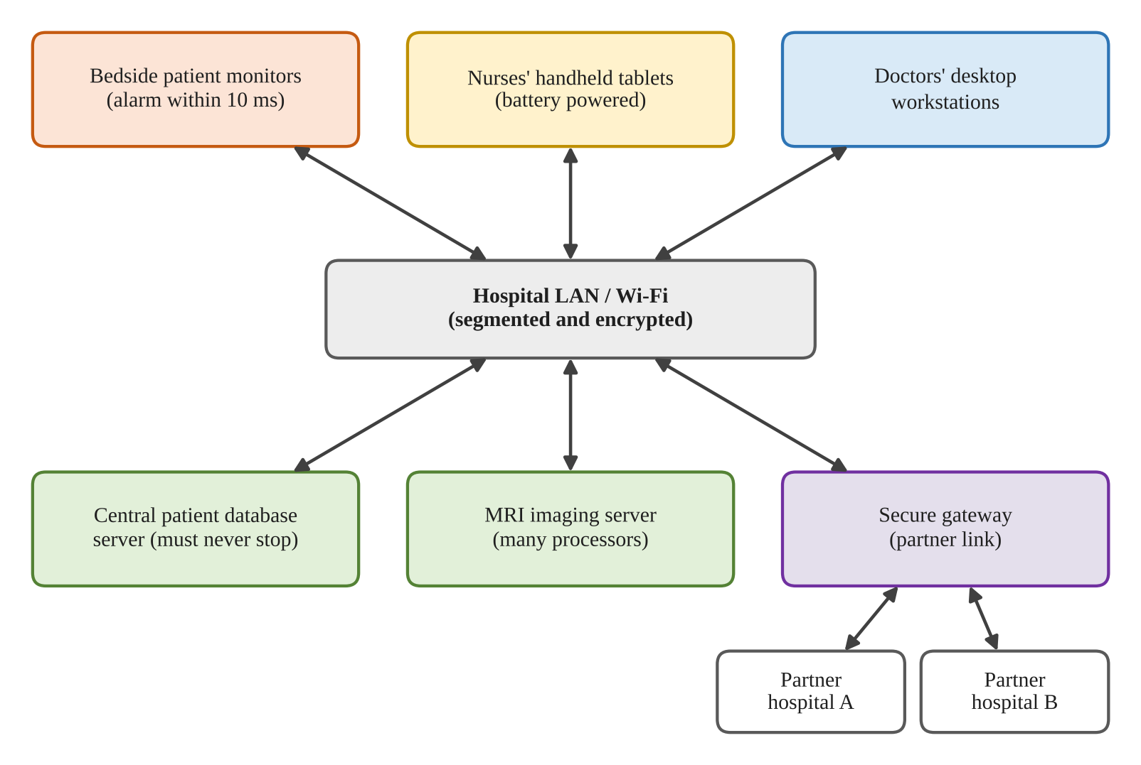
Figure 1: Overall architecture of the smart-hospital computing environments

TASK 2 – Judge the Type of Operating System for Each Environment
Environment | Recommended OS type | Rejected / less suitable alternatives
Bedside monitors | Hard real-time / embedded OS | Desktop or time-sharing OS: unnecessary services and no strict deadline guarantee by default.
Nurses’ tablets | Handheld/mobile OS | Mainframe OS: unsuitable device model; desktop OS: higher power and resource use.
Doctors’ workstations | Desktop, multi-user networked OS | Hard real-time OS: not needed for ordinary interactive applications.
Patient-record database | Clustered server OS with fail-over; distributed storage/replication | One standalone server: single point of failure. Mainframe may be reliable but can be expensive and still needs disaster recovery.
MRI imaging server | Multiprocessor server OS | Single-processor OS: lower parallel throughput.
Partner-hospital link | Distributed-system architecture over secure networks | A single central machine without replication or secure communication is a bottleneck and failure point.

Symmetric vs asymmetric multiprocessing for MRI
Symmetric multiprocessing (SMP) is recommended. In SMP, processors share main memory and the operating system can schedule work on any available processor. It supports load balancing and parallel image-processing tasks. Asymmetric multiprocessing assigns particular tasks to particular processors; it can be useful for specialised embedded designs but is less flexible for a changing MRI workload. SMP is therefore the better general choice, provided the software is parallelised and memory bandwidth is sufficient.

Clustered database with fail-over
Use at least two database nodes with shared or replicated storage, health monitoring, quorum/witness configuration and automatic fail-over. If the active node fails, a standby node takes over. Database transactions must use durable logs and replication that is appropriate to the required recovery-point objective. A cluster improves availability but does not replace backups or disaster recovery.

Alternative: one large multiprocessor database server
One large SMP server may have lower initial software and administration complexity and can provide strong throughput. However, the entire machine, power supply, motherboard, OS and maintenance window remain potential single points of failure. A cluster can continue service after a node failure, often with a short interruption while fail-over occurs. Throughput may increase with processor count, but not linearly because of lock contention, memory bandwidth, storage and serial database operations (Amdahl’s law). Processor growth uses additional CPU resources (time capacity); memory capacity is limited by the server’s physical configuration and must be sized for the working set. The cluster is preferred for availability.
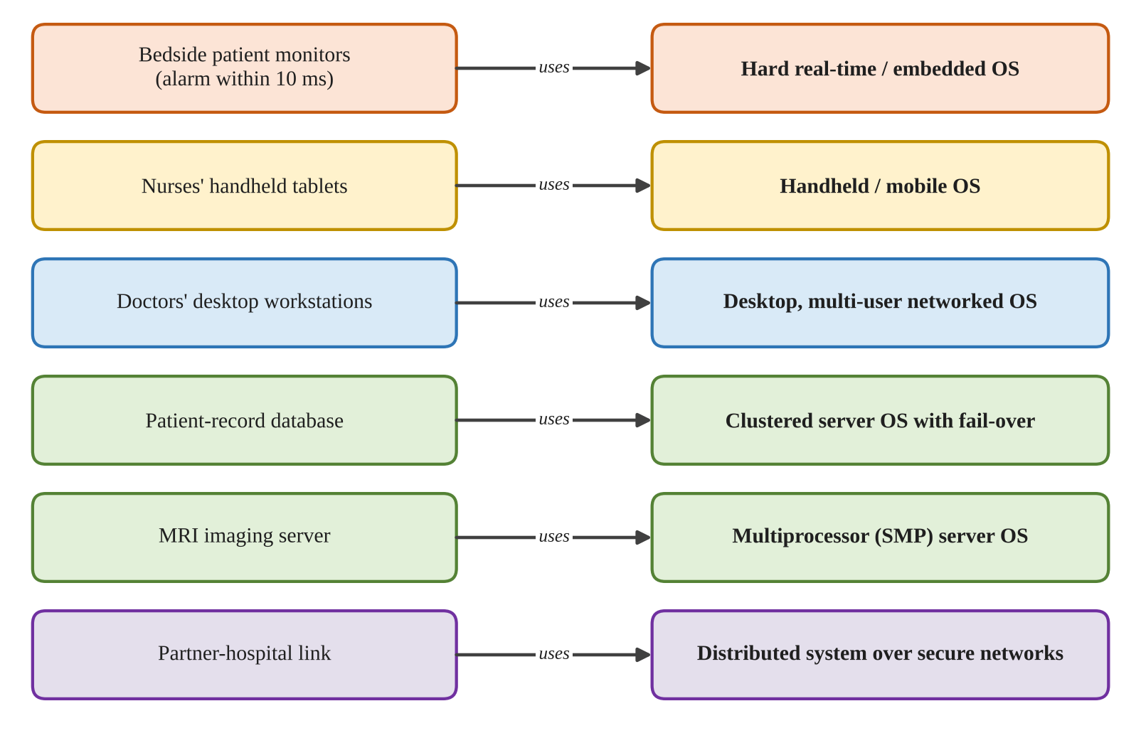
Figure 2: Recommended operating-system type for each hospital environment

TASK 3 – Evaluate Operating-System Structures
Structure | Reliability | Performance | Updates / suitability
Monolithic / simple | A fault in a kernel component can affect the whole kernel. | Fast internal calls; fewer boundaries. | Kernel changes can be risky. Suitable where compactness and speed dominate.
Layered | Clear boundaries can improve maintainability and verification. | Layer crossings may add overhead. | Easier to reason about and test layer by layer.
Microkernel | Small kernel; many services run separately, improving fault isolation. | Message passing and context switches can add overhead. | Services/drivers can often be restarted independently.
Modular (loadable modules) | Core remains integrated; a faulty kernel module can still crash the system. | Near-monolithic performance for many operations. | Modules can be loaded/updated without rebuilding the entire kernel.
Hybrid | Combines microkernel ideas with performance-oriented in-kernel services. | Designed to reduce the cost of strict microkernel separation. | Complex but balances compatibility, performance and modularity.

Choice for monitors and database
For bedside monitors, choose a small microkernel-based real-time OS where the selected certified platform supports the required sensor drivers, timing analysis and safety certification. Keeping the kernel small improves fault isolation; only necessary services are included. For the database server, choose a modular or hybrid server kernel such as a supported Linux distribution. Loadable drivers and modules make administration practical while providing high I/O and networking performance.

Examples of common OS structures
- Linux: monolithic but modular kernel; loadable kernel modules provide extensibility.
- Windows: commonly described as a hybrid kernel architecture.
- Android: uses the Linux kernel with Android framework and runtime layers.
- FreeRTOS: a small real-time kernel; QNX is a microkernel-based real-time OS.

Alternative: monolithic kernel on bedside monitors
A monolithic kernel may make a service request with fewer internal transitions and can be faster than message passing between separate servers. It may also have a compact footprint. However, drivers and many services execute in privileged kernel space; a faulty driver can corrupt kernel memory or stop the entire monitor. A microkernel adds message-passing and context-switch cost, but isolates many drivers/services in user space. For a 10 ms alarm requirement, the measured and analysed worst-case latency matters more than a small average-speed advantage. Select the structure only after verifying the complete hardware/OS timing budget.
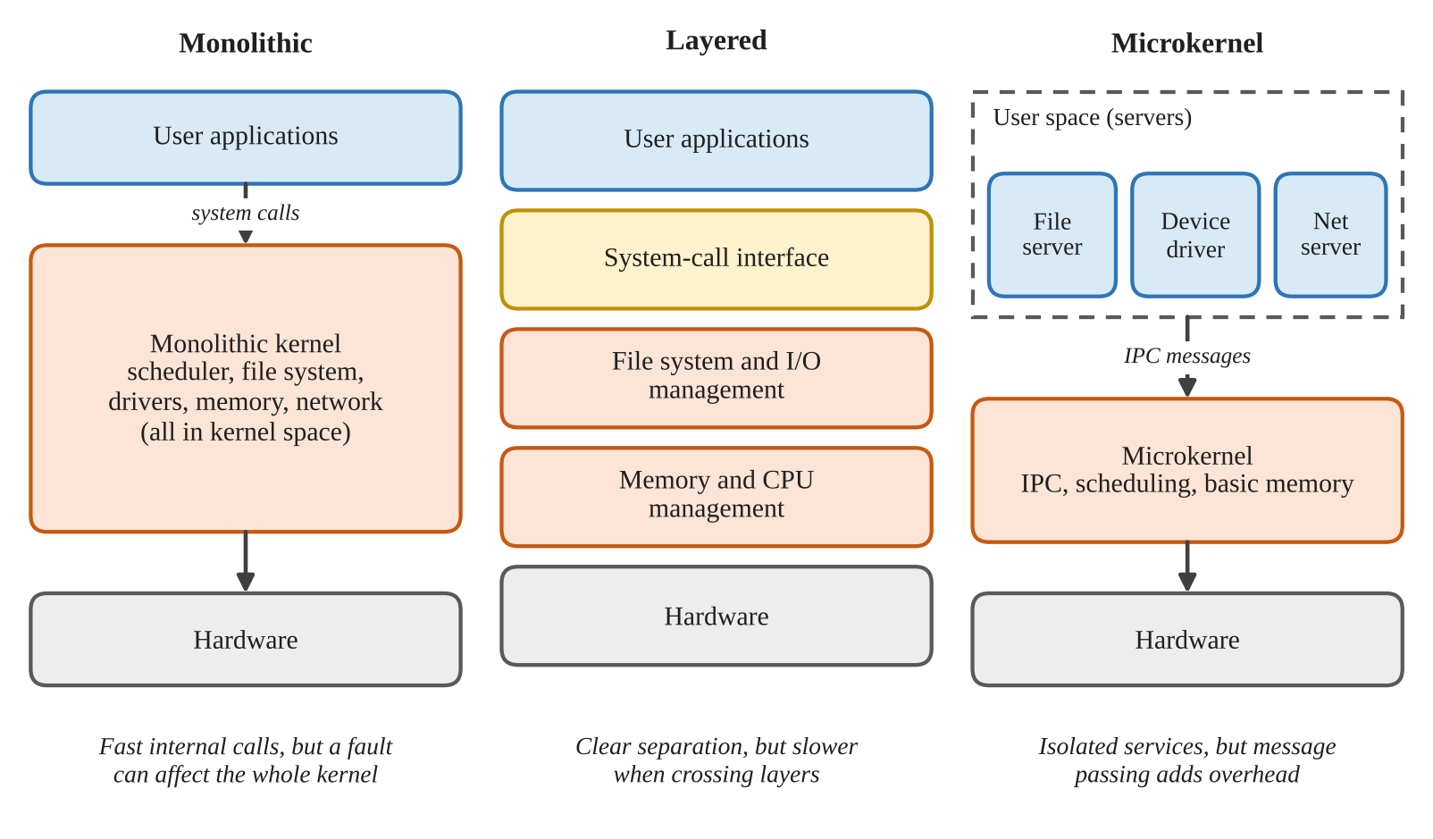
Figure 3: Monolithic, layered and microkernel operating-system structures

TASK 4 – Evaluate the Services an Operating System Must Provide
Service | Monitors | Tablets / workstations | Database / imaging
User interface | Minimal status/alarm display | Touch UI / graphical UI | Admin and monitoring tools
Program execution | Only sampling, validation and alarm tasks | Clinical apps and managed background tasks | Database engine, analytics and image processing
I/O operations | Sensor and alarm I/O; bounded drivers | Touch, display, Wi-Fi, camera/scanner as needed | High-speed disk, network and imaging devices
File system | Small configuration/log storage | Encrypted local cache and app storage | Reliable journalled file system and database storage
Communication | Only required local/network protocol | Secure Wi-Fi and hospital services | Secure database replication and service APIs
Error detection | Watchdog, sensor and task fault checks | Application/device health checks | ECC, disk/RAID checks, logs and cluster health
Resource allocation | Fixed priorities and bounded CPU/memory | Power-aware CPU and memory scheduling | CPU, RAM, storage and network allocation
Accounting | Minimal event/audit log | Usage and security logs | Capacity, performance and audit records
Protection/security | Secure boot, least privilege, authenticated updates | Encryption, screen lock, MDM, app sandbox | RBAC, MFA, encryption, audit, network segmentation

Services to remove from a monitor
Remove general desktop UI features, printing, media playback, general-purpose package managers, unnecessary network services, unused file-system features and nonessential background daemons. Keep the real-time scheduler, sensor drivers, alarm output, watchdog, minimal diagnostics, secure boot, authentication and protected update mechanism. Do not remove functions required by the device’s safety case.

Essential database services and record protection
The database needs process/thread management, memory management, file and block I/O, networking, time services, error reporting, logging, backup support, access control and audit. Each user or application receives an authenticated identity and role. The database enforces least-privilege permissions at table/row/column level where appropriate; the OS isolates processes using virtual memory and user IDs; encryption protects data in transit and at rest. Audit logs record access and changes. A nurse should see only the records needed for assigned care.

Alternative: full desktop OS on tablets
A full desktop OS can run a wider range of applications but generally consumes more RAM, storage and background CPU time. More services increase startup work and may wake the device more often, reducing battery runtime. A managed handheld OS offers a smaller service set, app sandboxing, mobile power management and device-management controls. Exact space and battery differences depend on the selected device and must be measured; the mobile OS is the better fit.

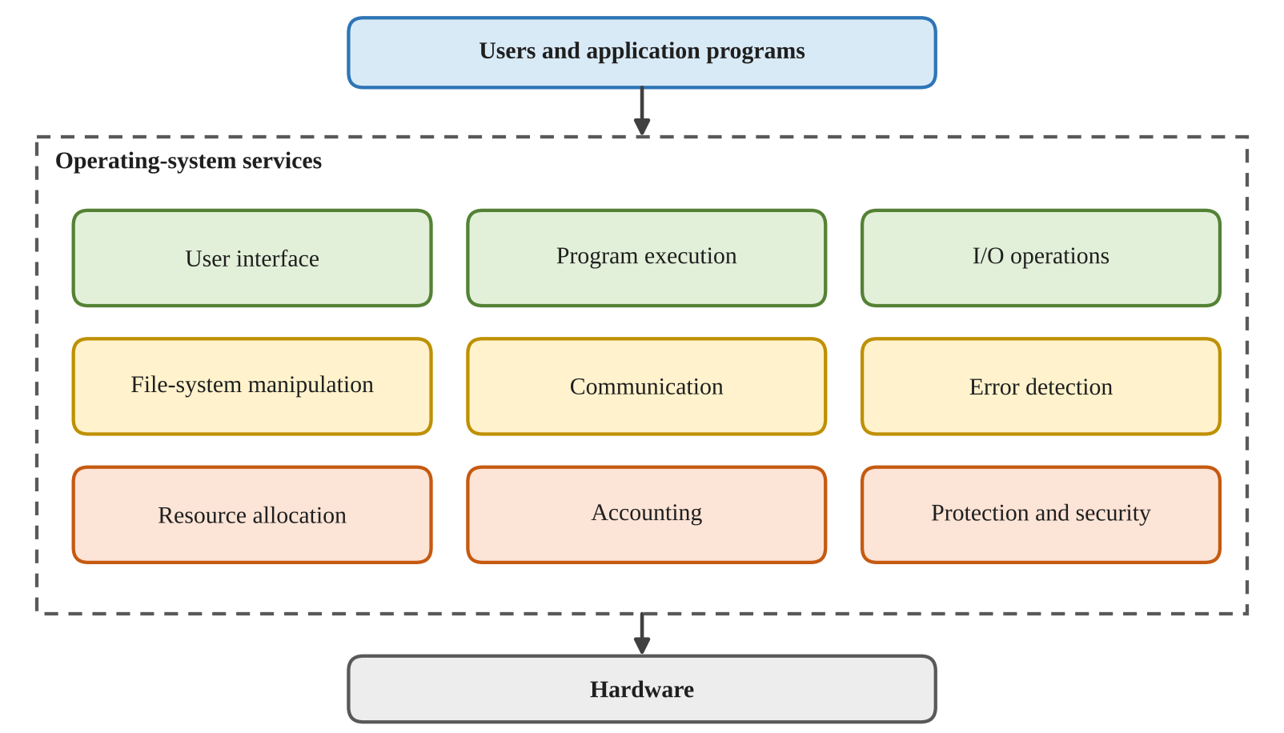
Figure 4: Services provided by the operating system to users and programs

TASK 5 – Examine System Calls

Categories of system calls
Category | Examples | Hospital use
Process control | fork, execve, wait, exit | Start clinical services and background jobs.
File management | open, read, write, close, stat | Read configuration, logs and files.
Device management | ioctl, read, write | Control supported devices and drivers.
Information maintenance | getpid, clock_gettime, uname | Obtain process, time and OS information.
Communication | socket, connect, send, recv, pipe | Communicate with servers and devices.
Protection | chmod, chown, setuid; access checks | Set permissions and enforce identity boundaries.

What happens during read()
- An application calls the C library wrapper read(fd, buffer, count).
- The wrapper places the system-call number and arguments in the architecture-defined registers or memory locations.
- The CPU executes a trap/system-call instruction and changes from user mode to kernel mode.
- The kernel validates the file descriptor and user buffer, then invokes the relevant file-system/device operations.
- Data is copied or mapped to the user buffer; the kernel prepares the return value or error.
- The CPU returns to user mode and the library wrapper returns the byte count or -1 with errno set.
System-call arguments are commonly passed in registers. If there are too many or complex arguments, a pointer to a block in memory may be passed; some ABIs also define stack-based conventions. The exact convention depends on the processor architecture and ABI.

strace evidence
Run a small program with: strace -e trace=openat,read,write,close ./program. The trace displays system calls, their arguments and return values. Use strace -c ./program for a summary count and time. Library calls such as printf may internally cause write() calls; buffered I/O may delay those calls.

Alternative: stdio functions vs direct system calls
fopen(), fread() and fwrite() are C library functions. They normally use open()/read()/write() internally and add user-space buffering. If a file has n bytes and a library buffer is approximately 4096 bytes, the number of data read/write system calls is roughly ceil(n/4096), plus open/close and other calls. With direct system calls using a buffer of b bytes, it is roughly ceil(n/b), plus the final EOF read. A library buffer consumes additional memory (often several kilobytes per stream) but reduces transitions into the kernel. Direct calls give more explicit control; buffered stdio is usually simpler and efficient for sequential file processing.
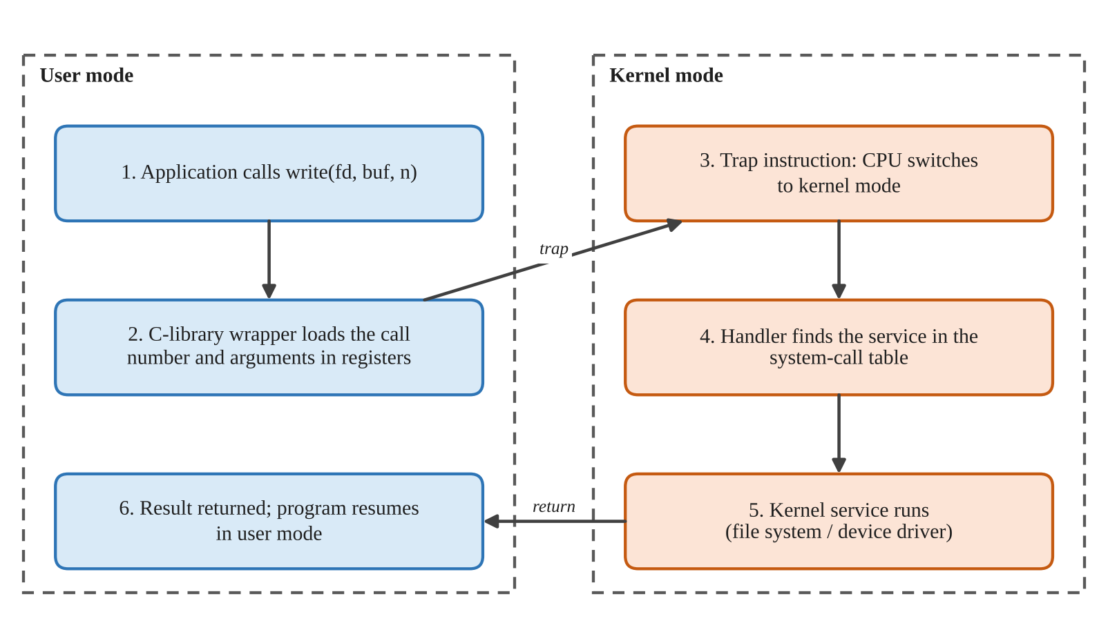
Figure 5: Flow of a system call from user mode to kernel mode and back

TASK 6 – Evaluate the Cost of System Calls
A normal function call usually changes control flow within the same privilege level. A system call crosses the user/kernel boundary, performs validation and kernel work, may block or schedule another task, and then returns. It therefore has higher overhead. For file copying, larger buffers reduce the number of read() and write() calls.
Buffer size | Expected read() calls for 10,000 bytes | Reason
1 byte | 10,001 | 10,000 successful reads plus one EOF read.
512 bytes | 21 | 20 full/partial data reads plus one EOF read.
4096 bytes | 4 | Three data reads (4096 + 4096 + 1808) plus EOF.

Completed C program
#define _POSIX_C_SOURCE 200809L
#include <stdio.h>
#include <fcntl.h>
#include <unistd.h>
#include <errno.h>
#include <stdlib.h>

long copy_file(const char *src, const char *dst, size_t bufsize)
{
char buf[8192];
if (bufsize == 0 || bufsize > sizeof buf) return -1;

int in = open(src, O_RDONLY);
if (in < 0) return -1;

int out = open(dst, O_WRONLY | O_CREAT | O_TRUNC, 0644);
if (out < 0) { close(in); return -1; }

long calls = 0;
ssize_t n;
for (;;) {
do {
n = read(in, buf, bufsize);
calls++;
} while (n < 0 && errno == EINTR);

if (n == 0) break;
if (n < 0) { calls = -1; break; }

ssize_t written = 0;
while (written < n) {
ssize_t w = write(out, buf + written, (size_t)(n - written));
if (w < 0 && errno == EINTR) continue;
if (w <= 0) { calls = -1; break; }
written += w;
}
if (calls < 0) break;
}

if (close(in) < 0 || close(out) < 0) return -1;
return calls;
}

int main(void)
{
FILE *f = fopen("records.dat", "w");
if (!f) return 1;
for (int i = 0; i < 10000; i++) fputc('A' + i % 26, f);
fclose(f);

size_t sizes[] = {1, 512, 4096};
for (int i = 0; i < 3; i++)
printf("buffer %4zu bytes: %5ld read() calls\n",
sizes[i], copy_file("records.dat", "copy.dat", sizes[i]));

unlink("records.dat");
unlink("copy.dat");
return 0;
}

Compile and run:
gcc -std=c11 -Wall -Wextra copy_file.c -o copy_file
./copy_file
strace -c ./copy_file

Expected read-call counts for the copy operation are 10001, 21 and 4 respectively. The strace total includes other reads performed by the C runtime or loader, so filter with strace -e trace=read or inspect the trace rather than comparing the unfiltered total blindly.

Alternative: mmap()
With mmap(), a process maps file pages into its virtual address space. It can access the mapped data without issuing one read() system call per buffer. Mapping and unmapping require a small number of system calls, and page faults occur as pages are first accessed. mmap() can avoid an explicit read-to-user-buffer copy, but it does not make storage I/O free: page faults, page-cache activity and write-back still cost time. A very large mapping consumes virtual address space and may increase page-table and resident-memory pressure, although not every mapped page must be resident simultaneously. For a simple sequential backup, buffered read()/write() is predictable and easy to handle; mmap() is worth benchmarking for the actual workload.

TASK 7 – Evaluate Process Control System Calls
fork() creates a child process as a logical copy of the calling process, commonly using copy-on-write pages. exec() replaces the current process image with a new program. wait()/waitpid() collects a child’s termination status. exit() terminates a process and makes its status available to the parent.

How a shell runs a command
- The shell parses the command and prepares its arguments and environment.
- The shell calls fork() to create a child.
- The child calls exec() to replace itself with the requested program.
- The parent calls waitpid() and is suspended until the child changes state.
- The child exits; the parent collects the status using WIFEXITED() and WEXITSTATUS().
A zombie is a terminated child whose exit status has not yet been collected by its parent. wait()/waitpid() reaps it. An orphan is a child whose parent terminates first; it is adopted by a system reaper (commonly init/systemd), which later collects its status.

Completed C program
#define _POSIX_C_SOURCE 200809L
#include <stdio.h>
#include <stdlib.h>
#include <unistd.h>
#include <sys/wait.h>

int main(void)
{
pid_t pid;
int status;

printf("shell: running job 1\n");
fflush(stdout);

pid = fork();
if (pid < 0) { perror("fork"); return 1; }
if (pid == 0) {
execlp("expr", "expr", "6", "*", "7", (char *)NULL);
perror("execlp");
_exit(127);
}
if (waitpid(pid, &status, 0) < 0) { perror("waitpid"); return 1; }
if (WIFEXITED(status))
printf("job 1 exit status %d\n", WEXITSTATUS(status));

printf("shell: running job 2\n");
fflush(stdout);
pid = fork();
if (pid < 0) { perror("fork"); return 1; }
if (pid == 0) _exit(3);

if (waitpid(pid, &status, 0) < 0) { perror("waitpid"); return 1; }
if (WIFEXITED(status))
printf("job 2 exit status %d\n", WEXITSTATUS(status));

return 0;
}

Compile and run: gcc -std=c11 -Wall -Wextra process_shell.c -o process_shell && ./process_shell. Expected output includes 42 from expr, followed by job 1 exit status 0 and job 2 exit status 3.

Why flush stdout before fork()
When stdout is redirected to a file, it is usually fully buffered. If the text remains in the user-space buffer at fork(), the child inherits a copy of that buffer. If both parent and child later call exit(), both copies may be flushed, duplicating the text. fflush(stdout) empties the buffer before fork(). The child uses _exit() after failure because _exit() does not flush inherited stdio buffers.

Alternative: posix_spawn() or threads
posix_spawn() can combine process creation and program execution with less application-side fork setup, and may be more efficient on some systems. It still creates a separate process with isolation. Threads are cheaper to create and share the same address space, but a faulty command can corrupt shared memory and requires careful synchronisation. For 1,000 independent commands, process creation costs more memory and time than threads, but provides stronger isolation. Exact timing must be measured on the target Linux system.
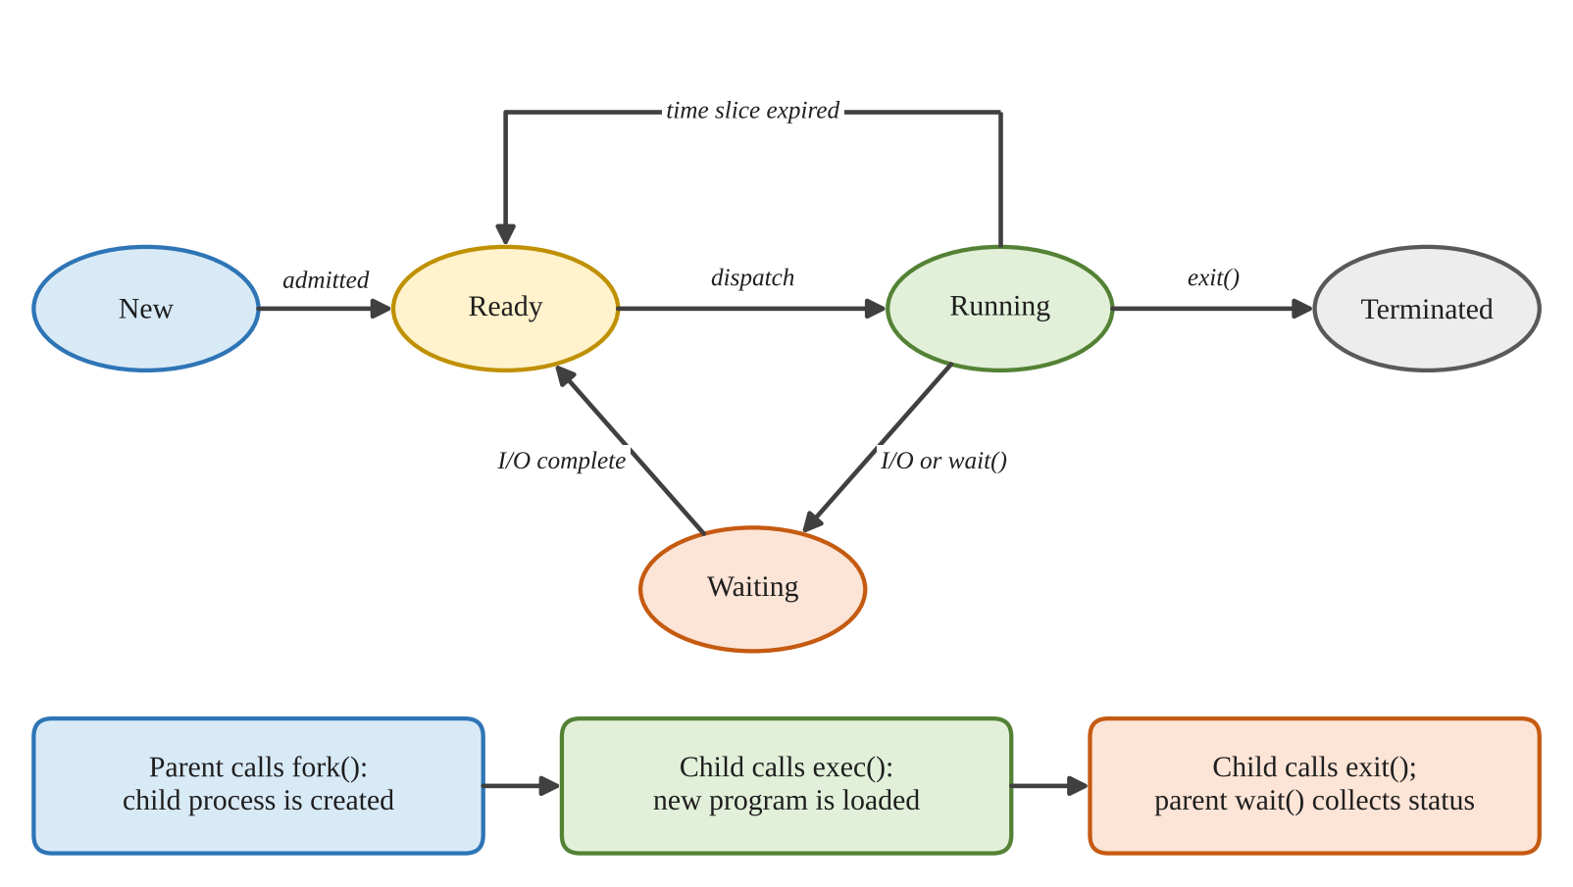
Figure 6: Process states and the fork, exec, exit and wait calls

TASK 8 – Evaluate CPU States and Protection
The CPU operates in at least two privilege levels. User mode restricts application instructions and memory access. Kernel mode permits privileged operations such as managing page tables, device control and interrupt configuration. A mode bit or equivalent processor state identifies the current privilege level.
- A system call or exception/trap transfers control to a kernel entry point; the kernel validates the request and returns to user mode.
- A hardware interrupt signals an event such as a timer tick or device completion. The timer interrupt lets the scheduler regain control even if a user process runs continuously.
- If any user program could disable interrupts, it could prevent timely scheduling and device servicing. A monitor alarm could be delayed, and the whole machine could become unresponsive. Disabling interrupts is therefore privileged.
- Virtual memory and page-table permissions prevent one process from reading or writing another process’s private memory. The memory-management unit checks each access; invalid access causes a protection fault.

Alternative: polling instead of interrupts
With polling, the program checks the sensor periodically. If the polling interval is P milliseconds, the detection delay can approach P milliseconds, plus processing time. To satisfy a 10 ms deadline, P must be comfortably below 10 ms after accounting for sensor conversion, scheduling and alarm-output time. Very frequent polling wastes CPU cycles and power even when no event occurs. Interrupt-driven input can notify the CPU when a reading is ready, reducing idle work, but interrupt latency and handler execution must still be bounded. A hybrid design may use hardware sampling and interrupts with watchdog checks.
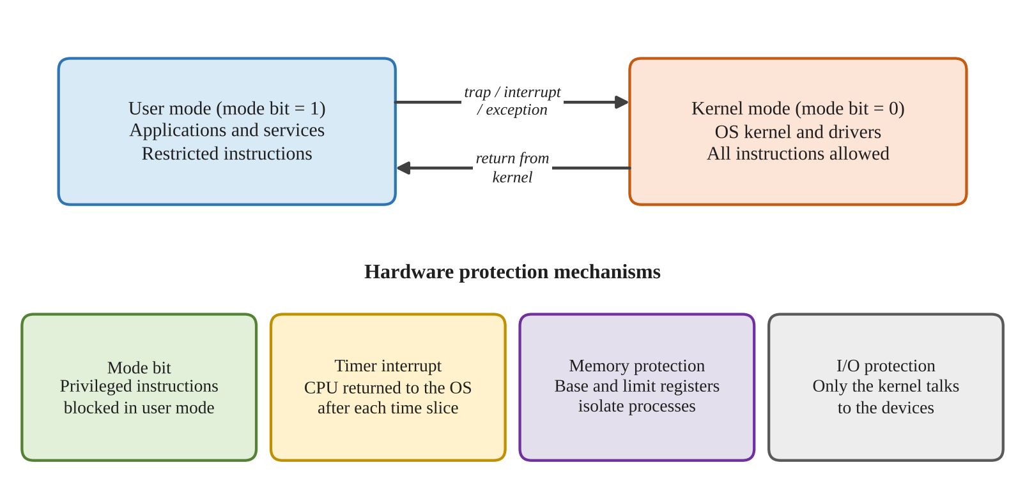
Figure 7: CPU modes and the hardware protection mechanisms

TASK 9 – Evaluate the Memory Hierarchy and I/O Systems
Level | Typical access time (approximate) | Typical capacity / role
CPU registers | Sub-nanosecond to a few ns | Bytes to a few KB per core; current operands.
CPU cache (L1/L2/L3) | About 1–20 ns, depending on level | KB to tens of MB; frequently used data.
Main memory (DRAM) | About 50–100 ns | GBs; active applications and buffers.
SSD | About 50–200 microseconds for random access (device-dependent) | Hundreds of GB to TB; fast persistent storage.
Hard disk | About 5–15 ms seek/rotation (varies) | TBs; bulk/nearline storage.
Network storage | Sub-ms on fast local networks to many ms or more | Shared, scalable storage; latency depends on network and service.

These are illustrative orders of magnitude, not guaranteed specifications. Actual access times vary with hardware, queue depth, caching and workload.

Data placement
- MRI images: keep active images and processing data in RAM/fast local NVMe SSD; archive completed studies in redundant storage with backup and retention controls.
- Patient records: keep the transactional database on redundant low-latency SSD storage with replication, durable logs and protected backups.
- Monitor readings: keep the current safety-critical state locally in monitor memory; send timestamped readings to the central system asynchronously where possible, with a safe local buffer during network outages.

Programmed I/O, interrupts and DMA
Programmed I/O makes the CPU repeatedly check and transfer device data. Interrupt-driven I/O lets a device notify the CPU when service is needed. Direct Memory Access (DMA) allows a device controller to transfer blocks between the device and memory with limited CPU involvement. DMA is best for large MRI image transfers because it reduces per-word CPU handling and interrupt overhead. The driver still handles setup, completion and errors.

Caching
A database cache keeps frequently used pages or query results in RAM. A cache hit avoids slower storage access and speeds up record look-up. Cache correctness must be maintained when records change, and sensitive data must not be exposed across users or tenants.

Alternative: one interrupt per word for a 500 MB image
For a 500 MB image, the number of interrupts would be enormous if one interrupt were generated per word. Assuming 4-byte words, 500 × 1,000,000 / 4 = 125,000,000 interrupts (about 131,072,000 if 500 MiB is intended). The CPU would spend substantial time saving state, entering handlers and scheduling work. DMA instead transfers large blocks and typically uses a small number of completion/error interrupts. Interrupt-driven transfer needs software/device buffering and repeated CPU service; DMA needs suitably sized pinned or DMA-capable buffers, descriptors and cache-coherency handling. DMA is clearly preferred.
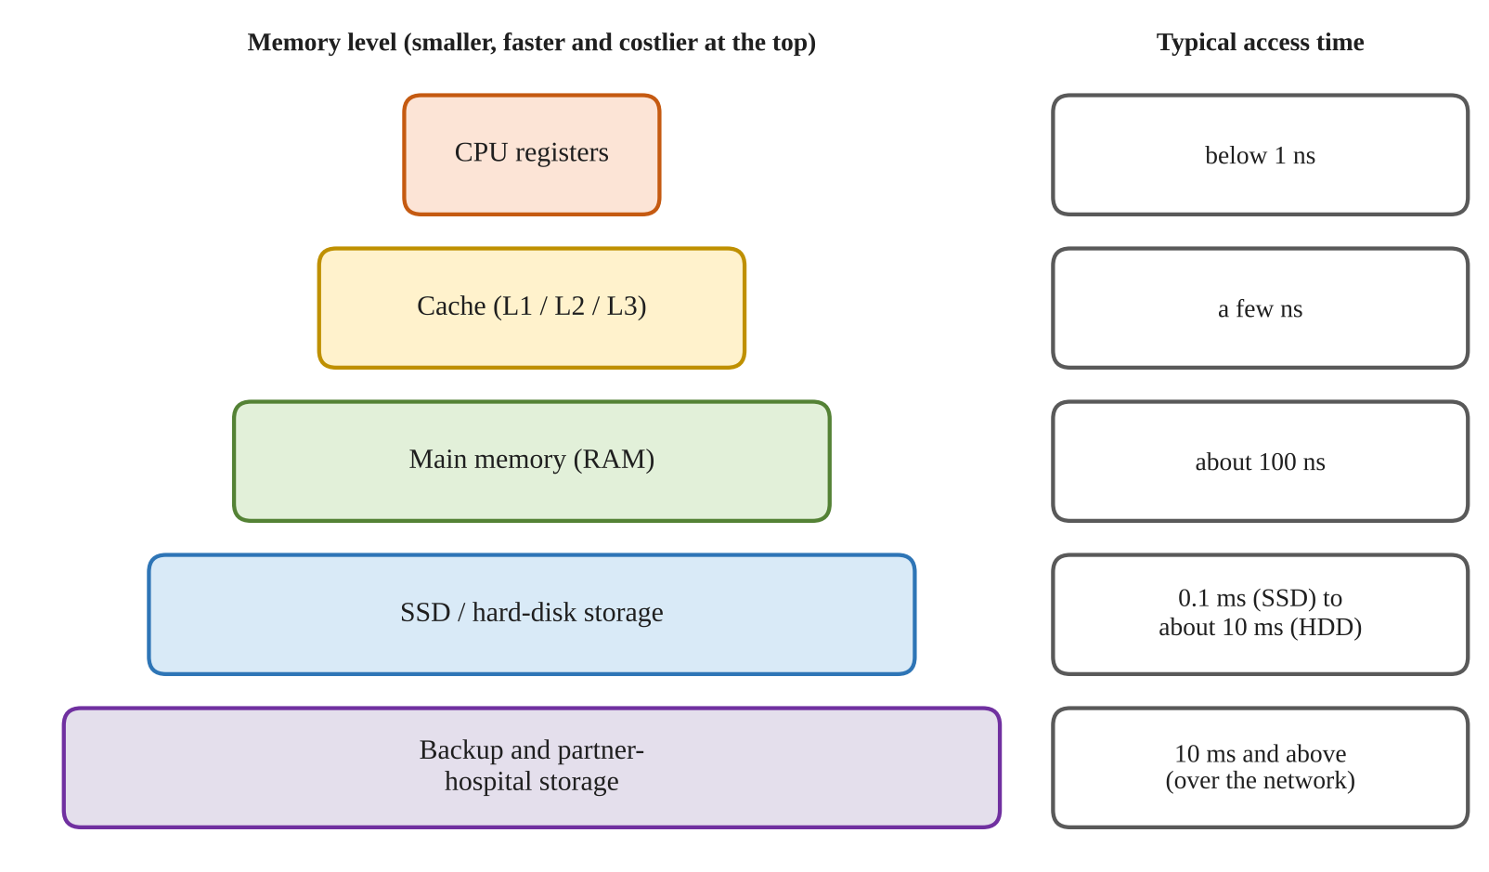
Figure 8: Memory hierarchy from CPU registers to backup storage

TASK 10 – Measure and Compare
This task must be completed on the Linux computer used for submission. Measurements vary with CPU, kernel, compiler, filesystem cache, storage and background load. The following procedure produces reproducible evidence.

A. System-call counts and time
gcc -std=c11 -Wall -Wextra copy_file.c -o copy_file
strace -c ./copy_file
strace -e trace=read,write ./copy_file 2> trace.txt
/usr/bin/time -v ./copy_file

Record the read() counts for each buffer size from the program output. For a separate measurement of each buffer size, modify the sizes array to contain one value at a time or add a command-line argument. Run each case at least five times and report the median. strace -c adds tracing overhead; use it to compare call counts and relative behaviour, not as an exact production benchmark.
Buffer size | Program read() calls | strace read() calls | Elapsed time | User time | System time
1 byte | 10001 | Enter measured value | Enter measured value | Enter measured value | Enter measured value
512 bytes | 21 | Enter measured value | Enter measured value | Enter measured value | Enter measured value
4096 bytes | 4 | Enter measured value | Enter measured value | Enter measured value | Enter measured value

B. Compare 1,000 processes and 1,000 threads
Use the following small benchmark programs or equivalent scripts. Run them several times and record real results.
/* proc_bench.c */
#include <stdio.h>
#include <stdlib.h>
#include <unistd.h>
#include <sys/wait.h>
#include <time.h>

int main(void) {
struct timespec a,b;
clock_gettime(CLOCK_MONOTONIC, &a);
for (int i=0; i<1000; i++) {
pid_t p=fork();
if (p<0) { perror("fork"); return 1; }
if (p==0) _exit(0);
if (waitpid(p,NULL,0)<0) { perror("waitpid"); return 1; }
}
clock_gettime(CLOCK_MONOTONIC, &b);
double s=(b.tv_sec-a.tv_sec)+(b.tv_nsec-a.tv_nsec)/1e9;
printf("1000 fork/wait children: %.6f seconds\n",s);
return 0;
}

/* thread_bench.c */
#include <stdio.h>
#include <pthread.h>
#include <time.h>

static void *worker(void *p) { (void)p; return NULL; }

int main(void) {
pthread_t t[1000];
struct timespec a,b;
clock_gettime(CLOCK_MONOTONIC, &a);
for (int i=0; i<1000; i++) {
int e=pthread_create(&t[i],NULL,worker,NULL);
if (e) { fprintf(stderr,"pthread_create: %d\n",e); return 1; }
}
for (int i=0; i<1000; i++) pthread_join(t[i],NULL);
clock_gettime(CLOCK_MONOTONIC, &b);
double s=(b.tv_sec-a.tv_sec)+(b.tv_nsec-a.tv_nsec)/1e9;
printf("1000 threads: %.6f seconds\n",s);
return 0;
}

gcc -std=c11 -Wall -Wextra proc_bench.c -o proc_bench
gcc -std=c11 -Wall -Wextra -pthread thread_bench.c -o thread_bench
./proc_bench
./thread_bench

Measurement | Actual result on your system
Linux distribution / kernel | ________________________________________
CPU model and RAM | ________________________________________
1000 fork + wait children | ________ seconds
1000 threads create + join | ________ seconds
Repeated runs / median | ________________________________________

Interpretation
Threads are generally faster and use less per-task memory because they share the process address space, code and many resources. Processes have separate virtual address spaces and stronger isolation; fork() initially uses copy-on-write rather than copying every page immediately. Thread stacks and kernel task structures still consume memory, and 1,000 simultaneous threads may hit system limits. Measurements can differ from this expectation because scheduling, stack size and resource limits affect results. Explain any difference using the actual data you recorded.

TASK 11 – Recommend and Defend the Operating-System Plan
Hospital component | Recommended platform / structure | Services and protection
Bedside monitors | Hard real-time embedded OS; small microkernel where validated | Fixed-priority scheduling, bounded interrupt latency, sensor/alarm drivers, watchdog, secure boot, minimal network services.
Nurses’ tablets | Managed mobile/handheld OS | Encryption, device management, app sandbox, MFA, secure Wi-Fi, power management and remote wipe.
Doctors’ workstations | Supported desktop OS | Clinical UI, endpoint protection, least privilege, patching, disk encryption and secure access to records.
Patient database | Clustered server OS; modular/hybrid kernel | Replication, fail-over, durable storage, backups, RBAC, audit, encryption and monitored recovery.
MRI imaging | SMP multiprocessor server OS | Parallel processing, large RAM, fast SSD/NVMe, DMA-capable I/O, job isolation and access controls.
Partner hospitals | Distributed services over secure network | Authenticated APIs, encryption in transit, identity federation, audit trails, data minimisation and retry-safe synchronisation.

Limitations and risks
- Different OS platforms increase administration, patching, staff training and integration effort.
- A cluster can still fail through common-mode faults, incorrect configuration, network partition or corrupted replicated data.
- Real-time guarantees depend on the complete hardware, driver, application and certification configuration; an OS name alone does not prove a 10 ms deadline.
- Network and cloud services introduce latency and availability dependencies. Local monitor alarms must not depend on them.
- Backups must be tested through restoration exercises; replication alone can replicate accidental deletion or corruption.

Three-hospital scalability
The design remains suitable for three hospitals if shared records use a distributed architecture with secure APIs, replicated services, central identity governance and local caching where appropriate. Each hospital should retain local operation for essential clinical services during WAN failure. Use standard data formats and agreed patient identity matching. Monitor network capacity, replication lag, audit events and service health.

Alternative: two large virtualisation hosts
Virtual machines can consolidate workstation/server workloads, improve provisioning and use hardware efficiently. However, hypervisor scheduling and shared-resource contention add overhead and can make latency less predictable. Monitor workloads requiring hard 10 ms deadlines should remain on validated dedicated hardware or a rigorously qualified real-time virtualisation platform, not ordinary shared VMs. Two hosts still create risks from shared storage, network, power and common software faults. Virtualisation is appropriate for many non-real-time servers but should not replace the complete heterogeneous design.
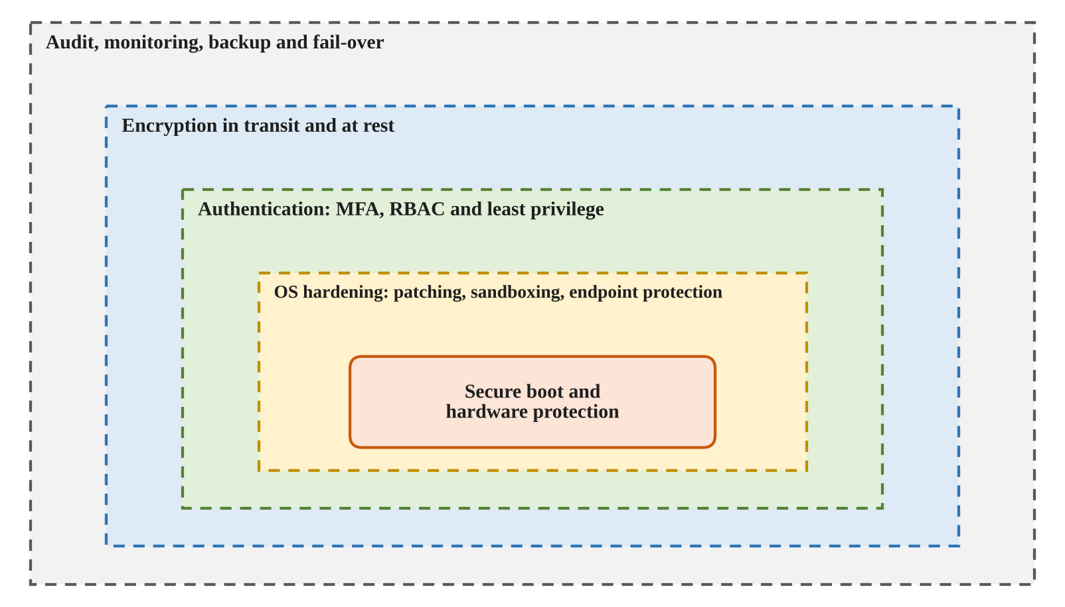
Figure 9: Layered protection recommended for the hospital operating-system plan

TASK 12 – DAY-4 DESIGN CHALLENGE: Re-evaluate and Adapt the Design

A. Impact Analysis
Home monitoring changes the communication environment: devices use residential Wi-Fi or mobile networks rather than a controlled hospital LAN. The system must handle variable latency, temporary disconnection, device loss, insecure home networks and remote updates. Cloud-based records introduce multi-hospital identity management, tenant/data separation, internet-facing services, service-provider availability and data-residency/compliance requirements.
- Affected OS types: embedded real-time OS on home monitors, mobile OS on patient companion devices, and distributed/cloud server OS for shared records.
- Affected services: secure networking, device enrolment, time synchronisation, store-and-forward buffering, remote management, logging, backup and monitoring.
- Affected protection: mutual device/server authentication, encryption in transit and at rest, least privilege, secure boot, signed updates, MFA for users, API authorisation and audit trails.

B. Evaluation of the Original Design
The original local design remains strong for bedside safety because alarm detection can occur on the device. It is not sufficient by itself for home monitoring or cloud records: home internet response is variable and cannot provide a guaranteed 10 ms alarm path. Cloud records improve sharing and scalability but create dependence on external connectivity and cloud-service availability. Therefore, the original design should not be discarded; its local real-time safety layer must be retained and the communication/data layer extended.

C. Adaptation / Revised Plan
Area | Revised design
Home patient monitor | Embedded hard real-time OS for local sampling and alarms; local alarm remains active without internet. Store readings securely when offline.
Home gateway / mobile app | Managed mobile OS or secure gateway; device identity, encrypted connection, user consent and authenticated pairing.
Communication | Mutually authenticated TLS connections; secure API gateway; retry with backoff; timestamped messages and duplicate detection.
Cloud records | Distributed, highly available cloud database/service with replication across failure zones, backups, access controls and audit.
Three hospitals | Federated identity and role mapping, standard APIs/data formats, patient identity matching, data-sharing agreements and monitored synchronisation.
Operations | Signed updates, vulnerability management, central logging, alerting, disaster-recovery tests and documented incident response.

D. Evidence-Based Defence and Final Decision
Decision: MODIFY the original design. Retain hard real-time local monitor control and alarm generation, mobile OS tablets, desktop workstations, clustered database services and SMP imaging. Add secure home-device connectivity and a distributed cloud record service. This is preferable to a complete redesign because the original design already separates workloads according to their timing, power and availability needs. It is preferable to retaining the design unchanged because home networks and cloud sharing require stronger device identity, internet security, buffering, synchronisation and distributed availability.
The key trade-off is that cloud sharing increases accessibility and scalability but cannot provide deterministic local alarm timing. The system therefore separates safety-critical control from non-critical remote synchronisation. Evidence should include the measured copy-call counts, process/thread timings, strace output, and verified real-time response tests on the selected monitor hardware. No unmeasured timing value should be claimed as proof of a deadline.

Overall Conclusion
A smart hospital requires a purpose-built combination of operating-system types rather than one general-purpose OS. The proposed design assigns hard real-time computing to patient monitoring, mobile computing to tablets, desktop computing to workstations, clustered server computing to patient records, SMP computing to MRI processing and distributed computing to partner/cloud services. Small and isolated structures protect monitor reliability, while modular server kernels and clusters support throughput and availability. System calls, privilege modes, memory hierarchy, DMA and buffering explain how the OS manages hardware efficiently and securely. The design is modified—not replaced—for home monitoring and cloud records, while local patient-safety functions remain independent of internet availability.
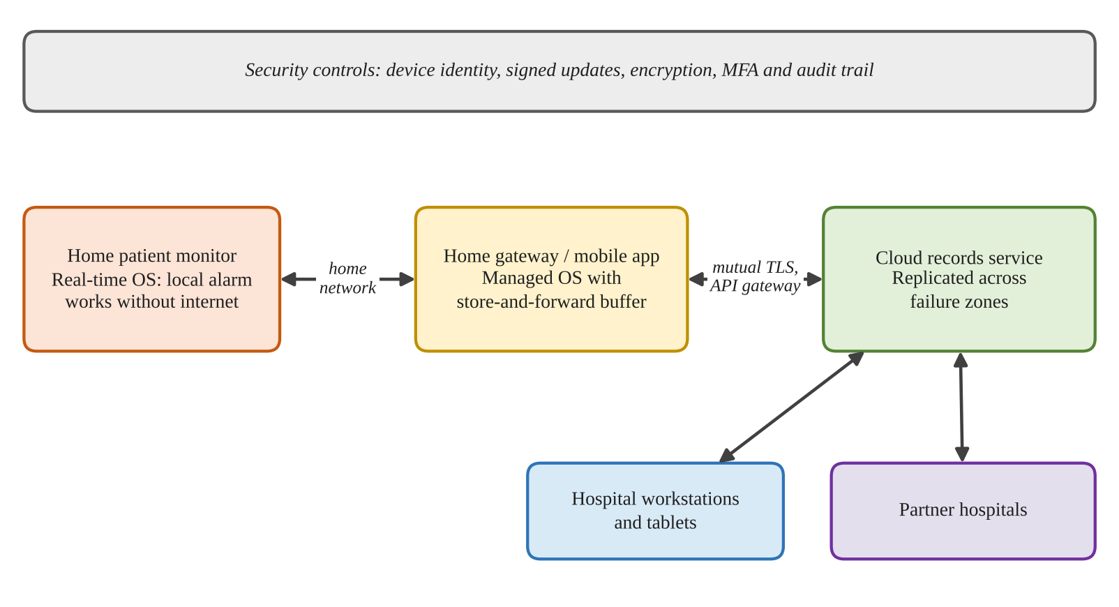
Figure 10: Revised design with home monitoring and cloud-based records

SUPPLEMENTARY DETAILED EXPLANATION FOR TASKS 1–12
The following expanded discussion develops the evaluation, trade-offs and technical reasoning already presented in the task answers. It follows the same task order and does not replace the required execution evidence. All numerical benchmark results must still be collected on the student's own Linux system.

TASK 1 – DETAILED REQUIREMENT JUSTIFICATION
The requirements table should be interpreted as a priority order rather than a statement that lower-ranked requirements are unimportant. Every environment needs reliability and security, but the consequence of failure differs. In a bedside monitor, a late alarm can be more serious than a slow screen refresh. In a tablet, a short delay while opening a non-urgent screen is normally less serious than exposing a patient's record to an unauthorised person. In the database, a brief increase in query latency may be acceptable if transactions remain correct and the service remains available. This difference in failure consequence is the main reason for selecting different operating-system configurations.
For bedside monitors, deterministic response is ranked first because the stated alarm deadline is 10 milliseconds. The complete path includes sensor conversion, device interrupt or sampling, driver execution, task scheduling, threshold evaluation and activation of the alarm output. It is not sufficient to say that the processor is fast. Each part of the path must have a bounded maximum delay, and the combined worst-case time must remain below the deadline with an engineering margin. Reliability is second because a fast but frequently failing monitor is not safe. Sensor validation and watchdog supervision help detect faults. Security is also important because unauthorised configuration changes could affect alarm thresholds or device behaviour.
For tablets, confidentiality and integrity rank first because the devices display identifiable clinical information and may be carried outside a controlled workstation area. Encryption, authentication, automatic screen locking and managed application installation are therefore essential. Battery life ranks highly because a device that powers down during a shift interrupts clinical work. Power-saving settings must not suppress essential notifications. For workstations, security and interactive response are both important: staff need quick access, but convenience must not override access control. Centralised identity, role-based permissions, endpoint updates and screen locking reduce risks.
The database has a different priority profile. Availability means that authorised clinical applications can continue to retrieve and update records. Integrity means that a completed transaction is not silently lost or partially applied. Replication, transaction logs, tested backups and controlled maintenance support these goals. For MRI processing, throughput and memory capacity are prominent because large image sets require substantial computation. The partner link prioritises confidentiality, integrity and interoperability. The network must authenticate both sides, protect data in transit and use agreed formats so that records are interpreted consistently.
The historical progression of operating systems explains the design choices. Batch processing introduced job automation but did not provide the immediate interaction needed by clinicians. Time-sharing made interactive multi-user access practical and informs workstation and server design. Personal-computer systems brought local applications to individual users. Mobile systems added power management, wireless networking and application isolation. Embedded real-time systems add predictable scheduling for dedicated equipment. The hospital should use the useful lesson from each stage without assuming that one historical model can satisfy every workload.

TASK 2 – DETAILED EVALUATION OF OPERATING-SYSTEM TYPES
Operating-system type describes the environment and workload that the system is designed to support. A mainframe is intended for centralised, high-volume processing, large numbers of transactions and strong management of shared resources. It could support a large hospital information workload, but it is not an appropriate operating environment for a small bedside monitor or battery-powered tablet. A desktop operating system is designed for interactive applications and peripheral support, so it suits doctors' workstations. A handheld operating system is designed around touch input, wireless connectivity, limited energy and application permissions, so it suits nurses' tablets.
A real-time operating system is selected according to deadline behaviour. A hard real-time task must meet its deadline; a missed deadline is treated as a system failure for the safety function. A soft real-time task benefits from prompt completion, but occasional delay may reduce quality rather than cause immediate failure. The monitor alarm path is a hard real-time workload because the scenario specifies a 10 ms requirement. MRI image reconstruction is generally a throughput-oriented workload: completing work sooner is valuable, but it is not normally governed by the same millisecond alarm deadline. The database is best treated as a high-availability server workload, with clustering and replication providing continuity.
A multiprocessor system contains more than one processor or core and can execute multiple activities concurrently. SMP allows processors to share the operating system and memory resources, with scheduling across available processors. This is useful for MRI tasks that can be divided into independent operations. However, adding processors does not guarantee proportional speed-up. Some image-processing stages may be serial, and processors can compete for memory bandwidth, cache capacity and storage. Software parallelism and workload measurement are therefore necessary before purchasing additional processors.
Asymmetric multiprocessing assigns different responsibilities to processors. It may be useful when a dedicated processor handles a fixed device function and another processor performs general work. For the hospital's general MRI server, however, SMP offers a more flexible way to distribute jobs and balance load. A clustered system is different from a multiprocessor machine: it uses multiple independent computers coordinated to provide a service. A cluster is recommended for the patient-record database because a node can take over when another node fails. The cluster needs health checks, quorum rules, replication and tested recovery procedures.
The partner-hospital connection is a distributed system because independent computers communicate over a network and cooperate to provide access to shared information. A distributed design must tolerate delay, partial failure and network disconnection. It should not assume that all hospitals always have a perfect connection. Local services should continue where possible, and synchronisation should resume safely after a connection returns. The rejected alternative of a single large database server may offer strong performance, but it leaves a single machine as a major failure point. A cluster costs more and is more complex to administer, but the additional complexity is justified by the requirement for continuous patient-record access.

TASK 3 – DETAILED OPERATING-SYSTEM STRUCTURE ANALYSIS
The structure of an operating system determines where services execute and how components communicate. In a monolithic design, many operating-system services execute in kernel mode. This can provide efficient direct calls between components, but it creates a large trusted code base. A fault in a kernel driver may corrupt shared kernel data and affect the entire system. For a general server, a modular monolithic kernel can be practical because it combines good performance with the ability to load selected drivers and features.
A layered design organises services into levels. Each layer uses services provided by a lower layer and offers functions to the layer above. This separation can make responsibilities easier to understand, test and maintain. Its disadvantage is that requests may cross several layers, adding overhead. A strict layered design can also be difficult when a service needs to communicate with a component that is not immediately below it. The approach is valuable as a design and teaching model even when a production operating system does not follow perfectly separated layers.
A microkernel keeps only essential mechanisms in the kernel, such as scheduling, basic memory management and inter-process communication. Other services, including many drivers and file-system functions, can run as separate processes. If a user-space service fails, the system may be able to restart it without crashing the kernel. This fault isolation is attractive for a patient monitor. The trade-off is communication overhead: a request may require message passing and context switches between components. The selected implementation must be benchmarked and its worst-case timing analysed.
A hybrid structure combines ideas from microkernels and monolithic kernels. It may keep performance-sensitive services in kernel space while using modular boundaries elsewhere. It can balance performance and maintainability, but its complexity makes verification important. Linux is commonly described as a monolithic kernel with loadable modules. Windows is commonly described as hybrid. Android uses the Linux kernel beneath its framework and application layers. FreeRTOS provides a compact real-time kernel, while QNX is known for a microkernel architecture. These labels describe broad structures; actual suitability depends on version, configuration, drivers and certification.
For bedside monitors, a small real-time microkernel is a defensible choice only when the exact device, driver set and software configuration are supported and validated. The structure alone does not establish compliance with the 10 ms requirement. For the database, a supported modular or hybrid server kernel is more appropriate because it supports mature storage, networking, monitoring and administration tools. The monolithic alternative on a monitor could reduce the number of internal transitions, but a faulty in-kernel driver has a wider failure impact. The microkernel's extra message-passing cost is acceptable only if measured worst-case latency remains within the safety budget.

TASK 4 – DETAILED OPERATING-SYSTEM SERVICE JUSTIFICATION
Operating-system services should be selected according to the function of each device. Program execution is required everywhere, but the number and type of permitted programs should differ. A bedside monitor should run a small, controlled set of sampling, validation, alarm and diagnostic tasks. A tablet should run approved clinical applications and the services needed for authentication, secure connectivity and device management. A database server needs the database engine, backup agents, monitoring services and secure network services. Removing unnecessary services reduces the attack surface and resource consumption.
The user interface also differs. A monitor needs a clear, limited display that presents the relevant reading, status and alarm state. It does not need a general desktop environment, media player or office suite. A tablet needs a touch-oriented interface that supports quick clinical workflows. A workstation benefits from a full graphical interface and accessibility features. Server systems may operate with a limited administrative interface to reduce resource use and reduce the number of exposed components.
I/O services are especially important. Monitor I/O must support sensor sampling and alarm output with predictable driver behaviour. Tablet I/O includes touch, display, wireless networking and possibly camera or barcode devices. Database I/O must support storage devices, network interfaces and reliable writes. MRI I/O may include high-throughput scanner interfaces and large data transfers. Error detection must also be matched to risk: a monitor needs watchdogs and sensor plausibility checks; a server needs hardware health monitoring, storage checks, logs and cluster monitoring.
File-system requirements are not identical. A monitor may need only a small configuration area and a bounded event log. A tablet needs protected local application storage and possibly a controlled offline cache. The database needs a reliable file system, durable transaction logs, backup and recovery support. Communication should be limited on monitors to only the protocols required by the clinical system. Tablets and workstations need authenticated communication with hospital services. Servers need secure replication and service interfaces.
Protection must exist at multiple levels. The operating system isolates processes and restricts device access. The application authenticates users and applies clinical roles. The database enforces permissions for records and operations. Encryption protects data at rest and in transit. Audit records allow authorised review of access and changes. A user should receive only the access required for assigned duties. This is the principle of least privilege.
Using a full desktop OS on tablets would provide compatibility with a wider range of software, but it would also install and run services that a mobile clinical workflow may not need. Extra background processes can consume memory, storage and CPU time, increase startup time and cause more frequent wake-ups. A handheld OS is therefore preferable, provided the clinical applications are supported and security updates are maintained. Exact battery and storage savings must be measured on the selected hardware rather than invented.

TASK 5 – DETAILED SYSTEM-CALL EXPLANATION
A system call is the controlled interface through which a user program requests a service from the operating-system kernel. Applications normally do not manipulate hardware directly. Instead, they request operations such as creating a process, opening a file, reading data, writing data, obtaining system information or communicating through a socket. The kernel checks the request and applies permissions before performing the operation.
The six broad categories in the assignment can be applied directly to the hospital. Process-control calls start, execute, wait for and terminate services. File-management calls open clinical configuration files, read logs and write output. Device-management calls communicate with supported device drivers and configure device operations. Information-maintenance calls obtain process identifiers, system time and operating-system information. Communication calls create sockets and transfer information between devices and servers. Protection calls change or inspect permissions and identities, subject to the caller's authority.
For read(), the application first invokes the C library wrapper with a file descriptor, a destination buffer and a byte count. The wrapper follows the system-call convention for the processor architecture. It places the system-call number and arguments in the required registers or other ABI-defined locations and executes the system-call instruction. The CPU changes privilege level and transfers control to a kernel entry point. The kernel validates the descriptor and checks whether the destination memory is accessible. It then requests data from the relevant file-system or device layer. The call may complete immediately or block until data becomes available.
When the operation completes, the kernel returns a byte count or an error indication. The CPU returns to user mode and the library wrapper presents the result to the application. On POSIX systems, a return value of -1 indicates an error and errno describes the reason. A return value of zero from read() indicates end-of-file for ordinary file reads. Programs must handle partial reads because a successful read is not required to fill the entire requested buffer.
System-call arguments are commonly passed through registers because this is efficient for a small number of arguments. More complex requests can use a pointer to a structure in memory. The exact mechanism depends on the CPU architecture and application binary interface. The kernel must validate user pointers because a user program must not be allowed to make the kernel access arbitrary memory.
strace provides evidence of the calls made by a Linux program. For example, `strace -e trace=openat,read,write,close ./program` displays selected calls, arguments and return values. `strace -c ./program` summarises counts and time. The trace may include calls made by the C runtime and dynamic loader, not only calls written explicitly in the source code. Therefore, the experiment should identify the relevant calls and distinguish program-level counts from total process activity.

TASK 6 – DETAILED SYSTEM-CALL COST AND BUFFER ANALYSIS
The cost of a system call is higher than an ordinary function call because it crosses a protection boundary. The processor must enter the kernel through a controlled entry point, the kernel validates arguments and permissions, and the operation may interact with a device or file system. The call may also block, wake another task or cause scheduling activity. The exact cost depends on the processor, operating-system version, cache state, file system and whether the data is already in memory.
For the supplied 10,000-byte file, a one-byte buffer requires 10,000 successful reads and one final read that reports end-of-file. A 512-byte buffer needs 20 successful reads and one EOF read. A 4096-byte buffer needs three successful reads (4096, 4096 and 1808 bytes) and one EOF read. These counts show why a larger buffer reduces system-call frequency. The number of writes is also reduced because each successful read is written as a block, although a robust implementation must handle partial writes.
The theoretical data-read count for a file of n bytes and a buffer of b bytes is approximately ceil(n/b), plus one additional call to discover EOF when the loop uses a final read. This formula assumes ordinary successful sequential reads and does not include retries caused by signals or other exceptional conditions. The program should retry a read interrupted by EINTR and should continue writing until all bytes from the read have been written. The supplied completed program includes these checks.
The buffer must not be made arbitrarily large. A larger buffer reduces call overhead but consumes more memory and may not improve performance after the storage or page cache becomes the bottleneck. For a backup service, a moderate buffer such as 4096 bytes is a reasonable starting point for the assignment experiment, but the best production value should be established through repeated measurements using realistic file sizes and storage devices. Measurements should include elapsed time, user CPU time and system CPU time.
Memory-mapped I/O is an alternative. mmap() maps file-backed pages into a process's virtual address space. The program accesses bytes through memory operations instead of repeatedly issuing read() calls. Mapping and unmapping require system calls, and accessing pages can still cause page faults and storage activity. mmap() may reduce explicit copying into a user buffer, but it does not eliminate the cost of disk access or write-back. For very large files, virtual address space, page tables and resident-memory pressure must be considered. The choice between buffered I/O and mmap() should be based on measured performance, memory use, error handling and the required predictability.

TASK 7 – DETAILED PROCESS-CONTROL ANALYSIS
A process is an executing program together with its execution state and resources. A process has an address space, registers, open-file information, security identity and scheduling state. The operating system provides process-control operations so that a shell or service manager can start work, supervise it and collect its result. This is important on the database server, where backup scripts, maintenance jobs and administrative commands must be managed without leaving uncontrolled processes.
fork() creates a child process. The child initially has a logical copy of the parent's process state. Modern systems commonly use copy-on-write so that physical memory pages are shared until one process modifies a page. This avoids immediately copying the entire address space. exec() replaces the calling process's program image with a new executable. If exec succeeds, it does not return to the old program. If it fails, the child should report the error and terminate with a defined failure status.
The shell normally parses the command, prepares arguments and environment variables, creates a child with fork(), and calls an exec function in the child. The parent waits using wait() or waitpid() when it is running a foreground command. When the child terminates, the parent collects the status. WIFEXITED(status) checks whether the child exited normally, and WEXITSTATUS(status) obtains its exit code. A non-zero exit code allows the shell or script to identify that a command failed.
A zombie is a process that has terminated but whose parent has not yet collected its status. It no longer executes, but a small process-table entry remains until it is reaped. An orphan is a child whose parent exits first. The operating system adopts the orphan through the system's reaper mechanism so that its eventual termination can be collected. Correct use of waitpid() prevents unnecessary accumulation of zombies.
The stdout flush before fork() matters because a standard I/O stream may contain buffered text in user-space memory. If that buffer is duplicated by fork(), both processes can later flush the same text. This is especially visible when stdout is redirected to a file and is fully buffered. fflush(stdout) writes pending output before the fork, preventing the duplicated buffer. _exit() is used in a child after an exec failure because it terminates without flushing inherited stdio buffers or running parent-oriented exit handlers.
posix_spawn() can combine process creation and program execution in a single interface and may be efficient for launching many independent commands. Threads can be cheaper because they share an address space and process resources, but they do not provide the same isolation. A command that corrupts shared memory can affect other threads. For independent administrative commands, separate processes are safer; for cooperating activities inside one trusted application, threads may be appropriate. The correct choice balances launch cost, memory, isolation and failure containment.

TASK 8 – DETAILED CPU MODES AND HARDWARE PROTECTION
Modern operating systems rely on hardware privilege levels to prevent ordinary applications from controlling the whole computer. In user mode, a process is restricted from executing privileged instructions or accessing protected kernel memory. In kernel mode, the operating system can manage memory mappings, configure devices, respond to interrupts and perform other privileged operations. A processor mode bit or equivalent state records the current privilege level.
A system call is a deliberate transition from user mode to kernel mode. The application requests a service, and the CPU transfers control to a known kernel entry point. An exception or trap may also occur when an instruction requires kernel handling or when a program performs an invalid operation. A hardware interrupt is different: it is generated by an external event such as a timer or device signal. The kernel saves enough state to handle the event and then resumes or schedules work.
The timer interrupt is essential for pre-emptive scheduling. Without a mechanism that periodically returns control to the kernel, a user process could continue running and prevent other tasks from receiving CPU time. The scheduler uses timer events to enforce time slices and to regain control from CPU-bound applications. For a patient monitor, bounded interrupt handling and predictable task scheduling are required so that alarm work is not delayed by unrelated tasks.
If an ordinary application could disable interrupts, it could prevent the kernel from responding to device events and timer ticks. This could delay sensor handling, stop normal scheduling and make the system unresponsive. Therefore, interrupt-control instructions are privileged and are used only by trusted kernel code or carefully controlled low-level components. The monitor's safety case must include interrupt latency and the time spent in critical sections.
Memory protection is provided through virtual memory and the memory-management unit. Each process has an address space, and page-table entries describe which pages may be read, written or executed and at what privilege level. An attempt to access a forbidden page raises a protection fault. This prevents one ordinary process from freely reading another process's private memory. Kernel memory is also protected from user-mode access. Protection is not a substitute for application security: authorised applications still need correct identity checks and database permissions.
Polling is a design alternative in which software repeatedly checks a sensor. If the polling interval is P milliseconds, a newly available reading may wait almost P milliseconds before it is checked, in addition to processing and scheduling delay. To satisfy a 10 ms deadline, the polling interval must be substantially less than 10 ms so that the rest of the processing path has time to complete. Very frequent polling consumes CPU cycles and energy even when no event occurs. Interrupt-driven input can reduce unnecessary checks, but the interrupt handler and follow-up task must still have bounded execution time.

TASK 9 – DETAILED MEMORY HIERARCHY AND I/O ANALYSIS
The memory hierarchy places small, fast storage close to the CPU and larger, slower storage farther away. Registers hold the operands currently used by instructions. CPU caches retain recently or frequently used instructions and data. Main memory holds active programs, database pages and working buffers. SSDs provide persistent storage with much lower access latency than hard disks for many workloads. Hard disks provide economical capacity for bulk or archival data. Network storage makes data available to multiple systems but adds network and service latency.
The hierarchy is important because the same information should not be stored at only one level. A database keeps frequently used pages in RAM to reduce repeated SSD access. It also writes durable transaction logs to persistent storage so that committed changes can be recovered. MRI processing uses RAM and fast local storage for active image data, while completed studies can be transferred to protected archival storage. Monitor readings should first be handled locally so that alarm decisions do not depend on a remote storage service. A local queue can retain timestamped readings temporarily during network disruption.
Typical access times are only orders of magnitude. Registers and caches are measured in very small fractions of a microsecond, DRAM in tens of nanoseconds, SSD access in microseconds or more, and hard-disk seek time in milliseconds. Network storage varies widely according to the network, protocol, server load and distance. These values should not be treated as fixed specifications. The actual hospital design should use measurements from the selected hardware and storage configuration.
Programmed I/O requires the CPU to repeatedly check device status and move data. It is simple but can waste CPU time for large transfers. Interrupt-driven I/O allows a device to notify the CPU when it needs attention or has completed an operation. DMA allows a device controller to transfer a block directly between a device and memory, reducing CPU involvement in each word transfer. The CPU still configures the transfer, manages buffers and handles completion or error notifications.
MRI image transfer is a strong candidate for DMA because image data can be large. If a 500 MB image were transferred with one interrupt per 4-byte word, the number of interrupts would be approximately 125 million using decimal megabytes. If the size is 500 MiB, the count would be about 131 million. This would create substantial interrupt-handling overhead. DMA transfers blocks and typically needs far fewer completion or error interrupts. DMA buffers must be suitable for the device, and the driver must manage buffer ownership and cache coherency correctly.
Caching speeds record lookup when the requested page is already in memory. However, a cache must remain coherent when records are updated. Sensitive records must not leak between users or tenants through application-level caching. Cache eviction, invalidation and access-control checks must be part of the design. A fast cache is useful only when it returns correct, authorised and current information.

TASK 10 – DETAILED MEASUREMENT METHOD AND INTERPRETATION
Task 10 is an evidence task. The report should distinguish theoretical expectations from measured observations. The supplied code predicts the number of read() calls for the three buffer sizes, but actual elapsed time depends on the computer and the execution environment. The expected read counts are derived from the file size and buffer size; the measured time values must come from the student's Linux system. No benchmark value should be copied from another computer and presented as a personal measurement.
First record the environment. `cat /etc/os-release` identifies the Linux distribution, `uname -r` reports the running kernel version, and `gcc --version` identifies the compiler. Record the CPU model and installed memory using an appropriate system-information command. Keep the compiler options consistent for each test. For the thread program, include `-pthread` at compilation and linking. Save the terminal output in the matching task folder so that the evidence can be checked later.
For the copy program, run each buffer size separately several times. A single run may be affected by filesystem cache state, background tasks and other activity. Repeat at least five times and report the median rather than selecting the fastest result. Use `strace -e trace=read,write` to inspect individual calls and `strace -c` to obtain a summary. Remember that the program creates the test file using stdio, so the trace may include runtime calls in addition to the copy loop. Explain which calls belong to the measured copy operation.
Use `/usr/bin/time -v` to collect elapsed time, user CPU time and system CPU time. User time is time spent executing application instructions. System time is time spent executing kernel code on behalf of the process. The copy program with a one-byte buffer is expected to spend more time in system-call handling because it performs many more reads and writes. A larger buffer should reduce call count, but the total elapsed time may not decrease proportionally if storage speed or caching dominates.
The process benchmark creates one child at a time and waits for it, so it measures repeated process creation and collection rather than the cost of 1,000 simultaneously running processes. The thread benchmark creates 1,000 threads and then joins them. The two tests therefore have different concurrency patterns and should be described accurately. Threads generally have lower creation overhead and share process resources, but their stacks and scheduling structures still use memory. Processes provide separate address spaces and stronger isolation, while copy-on-write reduces immediate memory copying after fork().
A useful results table includes the system description, test configuration, number of repetitions, individual observations and median. If results contradict expectations, investigate rather than hiding the difference. Possible reasons include CPU frequency scaling, memory pressure, system limits, tracing overhead, storage caching and background workload. The conclusion should state what the measurements support and what they cannot prove.

TASK 11 – DETAILED FINAL OPERATING-SYSTEM PLAN
The recommended plan is a deliberately heterogeneous architecture. Bedside monitors use a validated embedded hard real-time platform. Their alarm function is local, has a fixed-priority task arrangement and uses bounded drivers and interrupt handling. A watchdog and diagnostic log support fault detection. Secure boot and authenticated updates reduce the risk of unauthorised changes. Network communication is limited to the functions needed for sending readings and receiving approved configuration.
Nurses' tablets use a managed handheld operating system. Device encryption protects local information, application sandboxing separates software, and mobile-device management enforces screen locking, approved applications and security updates. Doctors' workstations use a supported desktop operating system configured with endpoint protection, disk encryption, least-privilege accounts and central identity. Both mobile and desktop clients connect to hospital services through authenticated encrypted interfaces rather than accessing database storage directly.
The patient-record database uses a clustered server environment with replication, health monitoring and automatic fail-over. The database maintains durable transaction logs and regular backups. Backup restoration must be tested because replication alone can copy accidental deletion or corruption to another node. Role-based access control, multi-factor authentication for privileged access, audit logs and encryption protect records. The MRI server uses an SMP multiprocessor platform with enough RAM, high-speed storage and DMA-capable device support. Parallel image-processing software should be profiled to identify serial stages and memory bottlenecks.
Partner hospitals connect through distributed services and secure APIs. Each organisation needs a clear identity and role model. Data formats and patient identity matching must be agreed before sharing records. Network links should use encryption and authentication, and synchronisation should be monitored for delay and failure. Each hospital should preserve local capability for essential clinical operations when the wide-area network is unavailable.
The design has limitations. Multiple operating systems increase patching, support and staff-training effort. A cluster may still be affected by common-mode software defects, misconfiguration or a network partition. A real-time OS cannot guarantee a deadline if the selected sensor, driver or hardware introduces an unbounded delay. Virtualisation can consolidate many non-real-time server workloads, but it adds a scheduling layer and shared-resource contention. Therefore, monitor alarm control should remain on dedicated validated hardware unless a real-time virtualisation platform is separately qualified.
For three hospitals, the plan scales through standard interfaces, federated identity, replicated cloud or regional services and local caching. Capacity planning should monitor transaction volume, network bandwidth, storage growth, replication lag and backup duration. The system should be reviewed periodically as the number of monitors, tablets and workstations increases. Scaling should be based on workload evidence rather than simply adding processors or storage without measuring bottlenecks.

TASK 12 – DETAILED DESIGN-CHALLENGE DEFENCE
The addition of home monitoring changes the trust boundary. A hospital-controlled LAN has managed switches, known device locations and centrally administered network controls. A home environment may use shared Wi-Fi, a mobile network or an intermittent internet connection. The system must therefore assume that connectivity can be delayed or unavailable and that the device may communicate through networks that the hospital does not control. The home device must authenticate the cloud service, and the service must authenticate the device.
The original design should be modified rather than completely replaced. The local real-time layer remains responsible for sampling and local alarms. A home device must not wait for an internet round trip before detecting an abnormal reading or activating its local alert mechanism. The device can store readings securely with timestamps and transmit them when connectivity returns. A gateway or mobile application may help provide connectivity, but it should not become the only route for a safety-critical local alarm.
The cloud records service introduces distributed-system concerns. Multiple hospitals may access the same patient record, and updates can arrive from different locations. The design therefore needs authenticated APIs, role mapping, tenant separation, audit trails and conflict-handling rules. Encryption should protect data in transit and at rest. Backups and replication should be designed across separate failure zones, and recovery procedures should be tested. Data sharing should follow agreed patient identity matching and minimum-necessary access.
Remote device management also requires care. Updates should be signed and verified before installation. Devices should have unique identities and a secure enrolment process. Lost or compromised devices must be revocable. Logs should record enrolment, authentication, configuration changes and update outcomes. Time synchronisation is important because readings from different locations need reliable timestamps, but the system should also record uncertainty when a device has been offline.
The key trade-off is between cloud accessibility and deterministic response. Cloud services make information available across hospitals and can scale storage and processing, but internet latency cannot guarantee a 10 ms alarm path. Keeping alarm decisions local preserves predictable behaviour. The cloud is used for record sharing, trend analysis and clinician review, not as the sole mechanism for immediate safety action.
The final decision is MODIFY. Retain the embedded real-time monitor design, handheld tablets, desktop workstations, clustered database principles and SMP imaging. Add secure home-device enrolment, store-and-forward communication, cloud-hosted distributed records, federated identity and stronger remote monitoring. This decision preserves the strongest parts of the original design while addressing the new network and sharing requirements. Evidence for the final defence should include completed code, actual Linux measurements, trace outputs and verified timing tests for the selected monitor hardware. The report must clearly distinguish measured evidence from theoretical estimates.

FURTHER TECHNICAL DISCUSSION AND IMPLEMENTATION CONSIDERATIONS
This additional section strengthens the evaluation by explaining acceptance criteria, operational controls and measurement limitations for each task. It is supplementary to the main answers and keeps the original task sequence.

Additional evaluation: acceptance criteria for Task 1
The hospital should convert each ranked requirement into an acceptance criterion before purchasing equipment. For monitors, the acceptance test should measure the complete sensor-to-alarm path under maximum expected CPU and I/O load, not merely the scheduler in isolation. The test should include simultaneous alarms, communication activity, device startup and recovery from a transient fault. The measured maximum should be compared with the 10 ms requirement and an agreed safety margin. For tablets, acceptance should include a full-shift battery test with realistic Wi-Fi use, screen brightness and clinical application activity. Security acceptance should include verification of encryption, authentication, timeout and remote management policies.
For the database, acceptance should include planned node failure, storage failure simulation, backup restoration and transaction consistency checks. The team should record recovery time and any transactions that need reconciliation. For imaging, test representative MRI workloads and record throughput, memory use and completion time as processor count increases. For partner links, test authentication, encrypted transfer, network interruption and safe retry. These tests turn broad priorities into observable engineering requirements. A requirement is not satisfied merely because a product brochure uses words such as reliable, fast or secure.

Additional evaluation: availability and scaling for Task 2
Availability is a service property, not simply a feature of an operating-system label. A clustered OS configuration must be paired with redundant power, network paths, storage and monitoring. If both nodes depend on one switch or one storage controller, the cluster may still fail when that shared component fails. The hospital should identify single points of failure and decide which ones require redundancy based on clinical impact.
Scaling also differs by workload. Adding monitor devices mainly increases the number of real-time endpoints and network messages; it does not mean that all monitors should share one real-time scheduler. Adding tablets increases wireless, identity and application-management demand. Adding workstations increases interactive sessions and server requests. MRI scaling may require more processors, memory bandwidth or accelerator capacity. Database scaling may require read replicas, partitioning or additional nodes, but these changes must preserve transaction consistency. Distributed partner access requires capacity planning for network bandwidth and replication delay. Therefore, the operating-system type is only one part of a wider capacity and availability plan.

Additional evaluation: verification of structure for Task 3
The structure choice should be verified against the exact release and configuration deployed. A product may be described as microkernel-based or modular, but optional drivers and vendor components can change the trusted computing base. The hospital should obtain documentation for the selected release, identify which services run in privileged mode, and determine how drivers are updated and restarted. For the monitor, fault containment should be demonstrated through controlled testing in a non-clinical validation environment. The test should confirm that a recoverable user-space service failure does not stop the core alarm function.
For the database, kernel updates should follow a staged process. A test node receives the update first, compatibility is checked with storage and network drivers, and a maintenance plan is prepared for the cluster. The update should be applied one node at a time where the architecture supports it, while checking replication and service health. Rollback procedures should be documented. This operational discipline is as important as the abstract structure because a well-designed kernel can still be deployed unsafely.

Additional evaluation: service lifecycle for Task 4
Services should be reviewed throughout the device lifecycle. During installation, the device should be enrolled, assigned an owner and placed into the correct security group. During operation, health monitoring should confirm that required services are active and that security updates are current. During maintenance, updates should be authenticated, tested and scheduled so that patient care is not disrupted. At end of life, credentials should be revoked and stored data securely erased according to hospital policy.
A minimum-service configuration should be documented for each device class. The monitor baseline should list the required real-time tasks, sensor drivers, alarm services and approved communication components. The tablet baseline should list approved clinical applications and management agents. The workstation baseline should list endpoint protection and approved productivity or clinical software. The server baseline should list database, backup, monitoring and security services. Comparing the live configuration with the baseline helps detect accidental changes and reduces configuration drift.

Additional evaluation: secure system-call use for Task 5
System calls are not automatically safe simply because the kernel provides them. Applications must validate inputs, check return values and handle errors. A file-copy program should check whether open() succeeded, handle interrupted reads, handle partial writes and close file descriptors. A network service should validate message lengths and authentication before processing a request. The kernel enforces access permissions, but an application can still contain logic errors that expose information or overwrite the wrong file.
The hospital should also distinguish a library API from a system call. fopen() is a C library interface; it commonly uses lower-level system calls internally. printf() formats text in user space and may eventually call write(). The library can buffer data and reduce system-call frequency. This distinction matters when interpreting strace output: a source-code line does not necessarily correspond to one system call. The actual trace is the evidence of kernel transitions performed during execution.

Additional evaluation: benchmark fairness for Task 6
A fair buffer-size comparison keeps the file content, destination, compiler flags, filesystem and test procedure constant. The test should avoid comparing a cold-cache run for one buffer with a warm-cache run for another. It should also record whether the source file was created immediately before the measurement. Because strace adds overhead, traced timings should not be treated as normal application timings. Use tracing primarily to count and inspect calls, and use a separate untraced timing run for elapsed-time comparison.
The expected count is a useful correctness check. If the program reports a count different from the expected 10001, 21 or 4, check whether the buffer-size loop, EOF handling or error handling has changed. If the program reports -1, inspect the source and destination open operations and permissions. A result table should include the date, machine details and repeated-run median so that another student or assessor can reproduce the experiment.

Additional evaluation: process safety for Task 7
Process isolation is valuable for server administration because a failed utility should not normally corrupt the memory of the database engine or another maintenance command. The parent process can check each child's exit status and decide whether to continue, retry or report failure. Scripts should not assume that a command succeeded merely because it was launched. A zero exit status normally indicates success according to the command's convention, while a non-zero status signals an error or special condition.
The shell example uses a foreground wait. A real shell may also support background jobs, pipelines and signal handling. For a pipeline, multiple processes may be connected through file descriptors created with pipe(). The parent must close unused descriptors and collect all children. This demonstrates how process control and communication system calls work together. For critical database maintenance, job supervision should include timeouts, logging and a safe recovery procedure rather than relying only on process creation.

Additional evaluation: protection policy for Task 8
Hardware protection should be combined with operating-system and application controls. User mode prevents a normal application from executing privileged instructions, but it does not decide which nurse may view a particular patient's record. That decision belongs to the identity, application and database access-control layers. Likewise, memory protection separates processes, but a privileged administrator or compromised kernel component may still have broad access. Strong authentication, least privilege, secure updates and audit trails are needed in addition to CPU privilege levels.
The monitor should keep the alarm path small and avoid long critical sections that delay interrupts. Interrupt handlers should perform only bounded essential work and defer longer processing to scheduled tasks where appropriate. The timing analysis should include interrupt masking intervals, higher-priority interrupt activity and driver execution. This makes the 10 ms requirement a property of the complete configured system rather than a theoretical claim based on CPU clock speed.

Additional evaluation: storage and recovery for Task 9
Data placement should also consider retention, confidentiality and recovery. MRI images may be large and need an agreed retention period, archive tier and retrieval process. Patient records require durable transaction handling and tested backups. Monitor readings may need short-term local buffering and later synchronisation, but the buffer must have a defined capacity and policy for full storage. The system should identify what happens if a device remains offline longer than the buffer can retain data.
Storage redundancy is not the same as backup. RAID can help a system continue after some disk failures, and replication can keep another node current, but neither protects against every form of accidental deletion, ransomware or logical corruption. Backups should be isolated appropriately and restoration should be tested. Access to archives should be logged and restricted. These controls are important because the hospital's information remains sensitive even when it is no longer part of an active clinical session.

Additional evaluation: reproducibility for Task 10
The measurement report should include the exact command line, source-code version and date of execution. If the program is changed to accept a buffer-size argument, keep a copy of the original assignment version and document the modification. Run tests when the system is reasonably idle and avoid launching unrelated heavy applications during timing. Repeat measurements and report the median and, if useful, the range. A very small file may complete too quickly for stable timing, so a larger test file can be used as an additional experiment, while retaining the required 10,000-byte test for the expected output check.
The process and thread tests should also be interpreted in context. The process test forks and waits serially, while the thread test creates all threads before joining them. This means the thread test includes a different concurrency pattern. The report should explain this limitation and avoid claiming that the numbers are a universal comparison of all process and thread workloads. A stronger experiment could use matching workloads and report both serial launch and concurrent creation separately.

Additional evaluation: operational governance for Task 11
The hospital should establish ownership for every operating-system platform. The clinical engineering team should approve monitor firmware and real-time configuration. The endpoint team should manage tablets and workstations. The database team should manage clustering, backups and access policies. The imaging team should validate scanner interfaces and processing performance. The security team should coordinate vulnerability management, identity, audit and incident response. Clear ownership reduces the chance that an important update or alert is missed because each team assumes another team is responsible.
Change management is essential. Updates should be tested in a representative environment, approved by the responsible team and scheduled with clinical operations. Emergency changes should still be recorded and reviewed. Configuration backups and rollback plans should be maintained. Monitoring should alert staff to cluster fail-over, replication delay, disk capacity, failed backups and abnormal endpoint status. These operational controls make the technical design sustainable over the hospital's lifecycle.

Additional evaluation: remote monitoring risk controls for Task 12
Home monitoring requires a clear policy for stale or missing data. A cloud dashboard should show the timestamp of the last received reading and should not present an old value as if it were current. If a device is disconnected, the system should indicate the communication state and follow an approved escalation process. Local alarm behaviour must remain independent of cloud status. Patient-facing instructions and clinical escalation procedures should be defined by the hospital's clinical governance team.
Cloud migration also requires a clear responsibility model between the hospital and provider. The agreement should define service availability, incident notification, backup responsibilities, data location, access logging, deletion and recovery. The hospital remains responsible for deciding who may access clinical records and for reviewing audit activity. A distributed service should be tested for partial failure, delayed messages, duplicate delivery and recovery after a network outage. These controls support the decision to modify the design while retaining local safety functions.

IMPLEMENTATION CHECKS AND ACCEPTANCE POINTS

Task 1 – Requirement traceability
A requirement-traceability record should connect each hospital need to a design decision and a verification method. For example, the 10 ms alarm requirement maps to a real-time scheduler, bounded sensor driver and local alarm output; verification maps to worst-case timing tests under maximum load. Battery life maps to mobile power management and a full-shift endurance test. Database availability maps to clustering and a controlled fail-over test. This traceability prevents a requirement from being forgotten during procurement or later upgrades. Each requirement should have an owner, a measurable pass condition and a record of the test result.

Task 2 – Failure-domain separation
The hospital should separate failure domains so that a fault in one workload does not unnecessarily affect another. A monitor should not share its alarm execution path with general desktop applications. MRI processing should not consume all CPU resources needed by the database. Database replicas should not all depend on the same power or network component. Distributed services should be designed to tolerate a remote partner being temporarily unavailable. Resource limits, network segmentation and independent recovery procedures help enforce these boundaries.

Task 3 – Driver and update control
Drivers deserve special attention because they connect the kernel to physical devices. A driver may execute with high privilege and can affect system stability. The hospital should maintain an approved driver inventory, verify vendor support and test updates before deployment. For monitors, the driver version is part of the validated timing configuration. For servers, storage and network driver compatibility must be checked before kernel updates. Unapproved driver installation should be prevented through access control and change-management policy.

Task 4 – Minimum configuration baseline
A baseline configuration should record enabled services, listening network ports, user accounts, update settings and security controls. The monitor baseline should be especially small and stable. Tablet and workstation baselines should define encryption, screen-lock settings, application permissions and endpoint protection. Server baselines should define administrative access, backup agents, monitoring and network exposure. Periodic comparison with the baseline can identify unexpected services or configuration drift. This is a practical way to keep the operating-system service plan consistent over time.

Task 5 – Error handling and permissions
Every system-call result should be checked. A failed open() must not be followed by read() on an invalid descriptor. A short write() must not be treated as if the entire buffer was saved. Permission errors should be handled without attempting to bypass access control. Network calls may fail because a partner service is unavailable, so applications need timeouts and retry policies. Correct error handling improves reliability and prevents a temporary operating-system error from becoming data loss or an incorrect clinical display.

Task 6 – Choosing a practical buffer
The buffer-size decision should consider both call overhead and memory footprint. Small buffers are simple but increase the number of kernel transitions. Large buffers reduce call count but consume more memory and may provide diminishing returns. A backup process that copies multiple files concurrently must account for the total buffer allocation across all workers. The preferred size is therefore the smallest size that achieves acceptable throughput in representative tests, while preserving memory for the database and other clinical services.

Task 7 – Child-process supervision
A production job launcher should handle fork() failure, exec() failure, signals and abnormal termination. The parent should distinguish a normal exit from a child killed by a signal by using WIFEXITED() and WIFSIGNALED(). It should record the command, start time, finish time and exit status. Long-running jobs may need timeouts and controlled termination. These practices are relevant to backup, report generation and maintenance scripts because they make failures visible and support recovery.

Task 8 – Scheduling and timing margin
A timing design should reserve margin for sensor conversion, interrupt entry, driver work, scheduling, application processing and alarm activation. If the total worst-case path is close to 10 ms, normal average measurements are not enough to establish safety. The design should account for higher-priority interrupts, non-pre-emptible sections and worst-case execution time. Changes to hardware, drivers or compiler options can change timing and should trigger revalidation. This is why the monitor configuration must be treated as a complete validated system.

Task 9 – Data integrity across levels
Data copied between RAM, caches and persistent storage must preserve integrity. The database should use durable commit rules and verify that a transaction is safely recorded before reporting success. Backups should be checked for completeness and periodically restored in a test environment. Network transfers should detect incomplete or duplicated messages. Monitor readings should include timestamps and device identity so that delayed data is not mistaken for a current measurement. These measures connect the memory hierarchy to clinical data correctness.

Task 10 – Reporting measured evidence
A strong measurement report includes the source file, compile command, exact run command, system details and raw output. It explains the expected result before presenting the observed result. If the measurements differ, the report discusses possible causes and repeats the experiment where appropriate. Screenshots should show the terminal command and result clearly, and the same files should be committed to the correct GitHub task folder. This makes the assignment reproducible and allows the viva assessor to verify the work.

Task 11 – Disaster recovery
The operating-system plan should be supported by a disaster-recovery procedure. The hospital should identify recovery-time and recovery-point objectives for the database and shared services. Backups should be protected from routine administrator credentials where practical. Recovery tests should include restoration of records, configuration and application services. A second hospital or cloud region may provide additional resilience, but it must not be assumed to be immediately usable without identity, network and data-consistency checks.

Task 12 – Safe cloud synchronisation
Synchronisation should be designed for retries and duplicate delivery. A device may send a reading, lose its connection before receiving confirmation and send the same reading again. The server should use a unique event identifier or equivalent deduplication method so that the reading is not counted twice. Messages should carry timestamps and device identity. The cloud service should distinguish a delayed reading from a live reading. These rules make store-and-forward communication reliable while preserving the local monitor's independent alarm function.

FINAL VALIDATION, SECURITY AND MAINTENANCE PLAN

Validation before clinical use
Before any operating-system configuration is used in a clinical environment, the hospital should complete a documented validation process. The validation team should confirm that the device boots from an approved image, that required services start correctly and that unauthorised services are disabled. The team should test normal operation, boundary conditions, loss of connectivity, restart behaviour and recovery after a controlled fault. For a bedside monitor, tests must include the sensor-to-alarm timing path and should be conducted on the exact hardware and software configuration intended for deployment. Results should be reviewed by the responsible clinical engineering and safety personnel. A successful demonstration on a different computer or a development build is not sufficient evidence for the deployed monitor.

Security and privacy controls
The hospital should apply defence in depth. Device identity establishes which monitor or tablet is communicating. User authentication establishes who is requesting access. Authorisation determines which records and operations are permitted. Encryption protects information while stored and transmitted. Audit logs record important events and support investigation. Network segmentation limits unnecessary communication between monitors, workstations, imaging systems and servers. Administrative accounts should be separate from ordinary user accounts, and privileged access should be limited and monitored. Security updates should be applied through a controlled process that checks compatibility with clinical applications and validated device configurations.

Maintenance and continuity
Maintenance should be planned around clinical availability. Database nodes should be updated in a controlled sequence while monitoring replication and fail-over health. Workstation and tablet updates should be tested with the clinical applications before broad deployment. Monitor updates require additional validation because changes can affect response time and device behaviour. The hospital should keep approved installation media, configuration backups and recovery instructions. Staff should know how to continue essential work during a network outage, and local monitor alarms should remain available without cloud access. Periodic exercises should verify that these procedures work in practice.

Final evaluation
The recommended architecture balances competing requirements instead of maximising one property across every device. Real-time monitors prioritise predictable response; tablets prioritise secure mobility and energy efficiency; workstations prioritise interactive clinical access; database clusters prioritise availability and integrity; imaging servers prioritise parallel throughput; and distributed services prioritise secure sharing across organisations. The architecture introduces management complexity, but that complexity is controlled through standard baselines, ownership, monitoring and change management. It is therefore more suitable than deploying one general-purpose operating system everywhere. The design is modified for remote monitoring and cloud records while preserving local safety functions. The final acceptance decision should be based on verified device timing, recovery tests, security checks and the student's actual Linux execution evidence.

VIVA PREPARATION AND PRACTICAL DEFENCE
During the viva, the student should be able to explain why a single operating system is not suitable for every hospital device. The central argument is that the devices have different timing, power, availability and workload requirements. The bedside monitor has a strict 10 ms alarm requirement, so its local alarm path needs a validated real-time configuration. A tablet needs power management and application isolation. The database needs replication and fail-over. The MRI server needs parallel processing and high-throughput I/O. The partner-hospital connection needs secure distributed communication.
The student should also be able to explain the difference between a multiprocessor system and a cluster. A multiprocessor computer contains multiple processors or cores within one computer and can improve parallel processing. A cluster contains independent computers that cooperate to provide a service and can improve availability through fail-over. SMP allows work to be scheduled across processors, whereas asymmetric multiprocessing assigns specialised responsibilities to processors. These concepts solve different problems and should not be used as interchangeable terms.
For system calls, the student should describe the transition from user mode to kernel mode, argument validation, kernel work and return to user mode. The student should know that library functions such as fopen() are not themselves necessarily system calls. For process control, the student should explain fork(), exec(), waitpid() and exit(), including why the parent collects the child's status and why stdout is flushed before fork(). For I/O, the student should compare programmed I/O, interrupt-driven I/O and DMA, explaining why DMA is suitable for large MRI transfers.
The student should be honest about experimental evidence. The read-call counts for the supplied file can be predicted from its size and buffer size, but elapsed time and process/thread creation time must be measured on the actual Linux computer. If asked about a timing result, the student should show the command, output and environment rather than quoting an assumed value. This approach demonstrates understanding, reproducibility and ownership of the submitted work.

Appendix A – Linux Execution and GitHub Checklist
- Create repository: CSA04-<RegisterNumber>-Assignment1.
- Create Task01 through Task12 folders (or Q1 through Q12).
- Save each C program in the matching folder and compile with gcc -std=c11 -Wall -Wextra; add -pthread where required.
- Save terminal output, strace output, timing tables and screenshots in the matching task folder.
- Add README.md with name, register number, compiler version, Linux distribution/version, exact compile commands, run steps and short results.
- Commit progressively, with at least one meaningful commit per task.
- Paste the working GitHub repository link on the cover page and in the assignment submission.

Appendix B – Important Commands
cat /etc/os-release
uname -r
gcc --version
gcc -std=c11 -Wall -Wextra copy_file.c -o copy_file
strace -c ./copy_file
/usr/bin/time -v ./copy_file

Note: This document supplies the written analysis and code completions. The student must personally compile, execute, verify outputs, collect screenshots and enter actual benchmark results before submission.

KEY TECHNICAL TERMS USED IN THE REPORT
Availability: The degree to which an authorised user can access a service when it is required.
Deterministic response: A response whose timing is predictable and bounded under the defined operating conditions.
Hard real-time system: A system in which missing a specified deadline is treated as a failure of the required function.
Soft real-time system: A system in which late completion reduces quality or usefulness but is not necessarily a total failure.
System call: A controlled request from a user program for a service provided by the operating-system kernel.
Kernel mode: A privileged CPU execution mode in which the operating system can perform protected operations.
User mode: A restricted CPU execution mode used by ordinary applications.
Context switch: The operation of saving one execution context and restoring another so the CPU can run a different task.
SMP: Symmetric multiprocessing, in which processors share memory and can run operating-system tasks.
Cluster: A group of independent computers coordinated to provide a service with improved capacity or availability.
Fail-over: The transfer of a service from a failed or unavailable component to a standby component.
DMA: Direct Memory Access, a method that lets a device transfer data to or from memory with limited CPU involvement.
Buffering: Temporary storage of data in memory to reduce transfer overhead or handle differences in data rates.
Copy-on-write: A technique that allows processes to share memory pages until a process attempts to modify a page.
Zombie process: A terminated child process whose exit status has not yet been collected by its parent.
Orphan process: A child process whose parent has terminated before the child.
Microkernel: An OS structure that keeps a small set of essential mechanisms in the kernel and moves many services outside it.
Replication: Maintaining copies of data or services on multiple systems to improve availability or access.
Least privilege: Giving each user or process only the permissions needed to perform its assigned work.
Audit log: A protected record of security-relevant actions, access and system changes.
Operating Systems – Assignment 1
Implementation Code: Evaluate and Justify the Operating-System Design of a Smart Hospital
This document contains the completed C programs for Tasks 6, 7 and 10 and the alternative-concept programs. All programs were compiled with gcc -std=c11 -Wall -Wextra on Linux and executed.
GitHub repository: https://github.com/jayasurya07068-crypto/OS-ASSIGNMENT-1/tree/main
Task 6 – Cost of System Calls (copy_file.c)
TODO 1 is completed with a read()/write() loop. Every read() call is counted, including the final end-of-file read, and an inner loop handles short writes so exactly the bytes read are written.
#define _POSIX_C_SOURCE 200809L
#include <stdio.h>
#include <fcntl.h>
#include <unistd.h>

/* Copy src to dst with read()/write(), using a buffer of bufsize bytes.
Returns the number of read() calls made, or -1 on error. */
long copy_file(const char *src, const char *dst, size_t bufsize)
{
char buf[8192];
if (bufsize == 0 || bufsize > sizeof buf) return -1;
int in = open(src, O_RDONLY);
if (in < 0) return -1;
int out = open(dst, O_WRONLY | O_CREAT | O_TRUNC, 0644);
if (out < 0) { close(in); return -1; }
long calls = 0;
ssize_t n;

/* TODO 1 – completed */
while (1) {
n = read(in, buf, bufsize);
calls++; /* count every read() call, incl. the EOF one */
if (n <= 0) break; /* 0 = EOF, -1 = error */
ssize_t off = 0;
while (off < n) { /* write exactly the n bytes read (handle short writes) */
ssize_t w = write(out, buf + off, (size_t)(n - off));
if (w < 0) { close(in); close(out); return -1; }
off += w;
}
}
if (n < 0) { close(in); close(out); return -1; }

close(in); close(out); return calls;
}

int main(void)
{
FILE *f = fopen("records.dat", "w"); /* a 10,000-byte test file */
for (int i = 0; i < 10000; i++) fputc('A' + i % 26, f);
fclose(f);
size_t sizes[] = {1, 512, 4096};
for (int i = 0; i < 3; i++)
printf("buffer %4zu bytes: %5ld read() calls\n", sizes[i], copy_file("records.dat", "copy.dat", sizes[i]));
unlink("records.dat"); unlink("copy.dat"); return 0;
}

Output:
buffer 1 bytes: 10001 read() calls
buffer 512 bytes: 21 read() calls
buffer 4096 bytes: 4 read() calls

Compile and run: gcc -std=c11 -Wall -Wextra copy_file.c -o copy_file && ./copy_file. Then run strace -c ./copy_file and compare the read count with the program output.
Task 7 – Process Control (shell_jobs.c)
TODO 1 is completed with fork(), execlp() and waitpid(). The variables pid and status are declared in the TODO block because the template uses them later.
#define _POSIX_C_SOURCE 200809L
#include <stdio.h>
#include <stdlib.h>
#include <unistd.h>
#include <sys/wait.h>

int main(void)
{
printf("shell: running job 1\n");
fflush(stdout); /* empty the buffer before fork() */

/* TODO 1 – completed */
pid_t pid = fork();
int status = 0;
if (pid < 0) { perror("fork"); return 1; }
if (pid == 0) {
execlp("expr", "expr", "6", "*", "7", (char *)NULL);
_exit(127); /* only reached if exec fails */
}
waitpid(pid, &status, 0);
printf("job 1 exit status %d\n", WEXITSTATUS(status));

printf("shell: running job 2\n");
fflush(stdout);
pid = fork();
if (pid == 0) _exit(3); /* a child that fails with code 3 */
waitpid(pid, &status, 0);
printf("job 2 exit status %d\n", WEXITSTATUS(status));
return 0;
}

Output:
shell: running job 1
42
job 1 exit status 0
shell: running job 2
job 2 exit status 3

Buffering experiment (shell_jobs_experiment.c)
The second fflush(stdout) is removed and _exit(3) is changed to exit(3). When the output is redirected to a file, stdout is fully buffered, so unflushed text is copied into the child by fork(). exit() then flushes the child’s copy, so lines such as “shell: running job 2” appear twice. _exit() skips the flush, which is why the original program is safe. Flushing before each fork() ensures the child does not inherit pending output.
Output:
shell: running job 1
42
job 1 exit status 0
shell: running job 2
job 1 exit status 0
shell: running job 2
job 2 exit status 3

Alternative Concepts
Task 5/6 – stdio buffering (copy_stdio.c)
fopen/fread/fwrite use a library buffer (about 4096 bytes), so the number of real read() system calls is about n/4096 regardless of the chunk size requested by the program.
#define _POSIX_C_SOURCE 200809L
#include <stdio.h>
/* Task 5/6 alternative: fopen/fread/fwrite (library buffering, ~4096 B internal buffer) */
long copy_stdio(const char *src, const char *dst, size_t chunk)
{
char buf[8192];
if (chunk == 0 || chunk > sizeof buf) return -1;
FILE *in = fopen(src, "rb"); if (!in) return -1;
FILE *out = fopen(dst, "wb"); if (!out) { fclose(in); return -1; }
long calls = 0; size_t n;
while ((n = fread(buf, 1, chunk, in)) > 0) { calls++; fwrite(buf, 1, n, out); }
fclose(in); fclose(out);
return calls; /* fread() calls; real read() syscalls are far fewer */
}
int main(void)
{
FILE *f = fopen("records.dat", "w");
for (int i = 0; i < 10000; i++) fputc('A' + i % 26, f);
fclose(f);
size_t sizes[] = {1, 512, 4096};
for (int i = 0; i < 3; i++)
printf("chunk %4zu: %5ld fread() calls\n", sizes[i], copy_stdio("records.dat", "copy.dat", sizes[i]));
return 0;
}

Output:
chunk 1: 10000 fread() calls
chunk 512: 20 fread() calls
chunk 4096: 3 fread() calls

Task 6 – Memory-mapped copy (copy_mmap.c)
mmap needs only a few system calls (open, fstat, ftruncate, mmap, msync, munmap) instead of about n/b read/write calls. Data is mapped from the page cache, avoiding the kernel-to-user copy; page faults load pages on demand, so very large files do not need a large user buffer.
#define _POSIX_C_SOURCE 200809L
#include <stdio.h>
#include <fcntl.h>
#include <unistd.h>
#include <string.h>
#include <sys/mman.h>
#include <sys/stat.h>
/* Task 6 alternative: memory-mapped copy (a few syscalls, no read()/write() loop) */
int copy_mmap(const char *src, const char *dst)
{
int in = open(src, O_RDONLY); if (in < 0) return -1;
struct stat st; if (fstat(in, &st) < 0) { close(in); return -1; }
int out = open(dst, O_RDWR | O_CREAT | O_TRUNC, 0644);
if (out < 0) { close(in); return -1; }
if (st.st_size == 0) { close(in); close(out); return 0; }
if (ftruncate(out, st.st_size) < 0) { close(in); close(out); return -1; }
void *s = mmap(NULL, st.st_size, PROT_READ, MAP_PRIVATE, in, 0);
void *d = mmap(NULL, st.st_size, PROT_READ | PROT_WRITE, MAP_SHARED, out, 0);
if (s == MAP_FAILED || d == MAP_FAILED) { close(in); close(out); return -1; }
memcpy(d, s, st.st_size);
msync(d, st.st_size, MS_SYNC);
munmap(s, st.st_size); munmap(d, st.st_size);
close(in); close(out);
return 0;
}
int main(void)
{
FILE *f = fopen("records.dat", "w");
for (int i = 0; i < 10000; i++) fputc('A' + i % 26, f);
fclose(f);
printf("mmap copy returned %d\n", copy_mmap("records.dat", "copy.dat"));
return 0;
}

Output:
mmap copy returned 0

Task 7 – posix_spawn (spawn_jobs.c)
posix_spawnp() replaces fork() followed by exec() in one call, avoiding copying the parent address space, which makes starting many commands cheaper. fork()+exec() remains more flexible (the child can adjust descriptors and state before exec).
#define _POSIX_C_SOURCE 200809L
#include <stdio.h>
#include <spawn.h>
#include <sys/wait.h>
extern char **environ;
/* Task 7 alternative: posix_spawnp() replaces fork()+exec() */
int main(void)
{
char *argv[] = {"expr", "6", "*", "7", NULL};
pid_t pid; int status;
printf("shell: running job 1\n"); fflush(stdout);
if (posix_spawnp(&pid, "expr", NULL, NULL, argv, environ) != 0) { perror("posix_spawnp"); return 1; }
waitpid(pid, &status, 0);
printf("job 1 exit status %d\n", WEXITSTATUS(status));
return 0;
}

Output:
shell: running job 1
42
job 1 exit status 0

Task 10 – Measure and Compare
Both benchmarks include #define _POSIX_C_SOURCE 200809L as the first line; without it, -std=c11 hides clock_gettime and the build fails.
proc_bench.c
#define _POSIX_C_SOURCE 200809L
#include <stdio.h>
#include <stdlib.h>
#include <unistd.h>
#include <sys/wait.h>
#include <time.h>

int main(void) {
struct timespec a,b;
clock_gettime(CLOCK_MONOTONIC, &a);
for (int i=0; i<1000; i++) {
pid_t p=fork();
if (p<0) { perror("fork"); return 1; }
if (p==0) _exit(0);
if (waitpid(p,NULL,0)<0) { perror("waitpid"); return 1; }
}
clock_gettime(CLOCK_MONOTONIC, &b);
double s=(b.tv_sec-a.tv_sec)+(b.tv_nsec-a.tv_nsec)/1e9;
printf("1000 fork/wait children: %.6f seconds\n",s);
return 0;
}

thread_bench.c
#define _POSIX_C_SOURCE 200809L
#include <stdio.h>
#include <pthread.h>
#include <time.h>

static void *worker(void *p) { (void)p; return NULL; }

int main(void) {
pthread_t t[1000];
struct timespec a,b;
clock_gettime(CLOCK_MONOTONIC, &a);
for (int i=0; i<1000; i++) {
int e=pthread_create(&t[i],NULL,worker,NULL);
if (e) { fprintf(stderr,"pthread_create: %d\n",e); return 1; }
}
for (int i=0; i<1000; i++) pthread_join(t[i],NULL);
clock_gettime(CLOCK_MONOTONIC, &b);
double s=(b.tv_sec-a.tv_sec)+(b.tv_nsec-a.tv_nsec)/1e9;
printf("1000 threads: %.6f seconds\n",s);
return 0;
}

gcc -std=c11 -Wall -Wextra proc_bench.c -o proc_bench
gcc -std=c11 -Wall -Wextra -pthread thread_bench.c -o thread_bench
./proc_bench
./thread_bench

Sample measurements (my test environment)
Measurement | Result (3 runs)
1000 fork + wait children | 0.050, 0.047, 0.066 seconds
1000 threads create + join | 0.026, 0.023, 0.026 seconds

Threads were about twice as fast because they share the address space, while fork() must set up a new process. These values are from a sandbox; re-run on your own Linux machine and record your own distribution, kernel, CPU, RAM and median of at least five runs.
Compile Commands Summary
gcc -std=c11 -Wall -Wextra Task06/copy_file.c -o copy_file
gcc -std=c11 -Wall -Wextra Task07/shell_jobs.c -o shell_jobs
gcc -std=c11 -Wall -Wextra Task10/proc_bench.c -o proc_bench
gcc -std=c11 -Wall -Wextra -pthread Task10/thread_bench.c -o thread_bench
strace -c ./copy_file

