Programming Assignment-II

Computer Vision-CAP 5415

Implementation

Model 1:

Created a fully connected layer of 784 in_features and 100 out features as hidden layer (with 100 neurons) is required. Sigmoid activation function is used and a learning rate of 0.1 is utilized.

Model 2:

2 Convolutional layers are added with 40 kernels and kernel size of 5x5 and stride of 1 with pooling over a 2x2 region output of these layers is flattened and passed to a fully connected layer to get the output. Sigmoid activation function is used and a learning rate of 0.1 is utilized.

Model 3:

Same as model 2 but the sigmoid activation is replaced by ReLU and a learning rate of 0.03 is used.

Model 4:

A fully connected layer with 100 neurons is added to model 3 in the form of a hidden fully connected layer.

Model 5:

Fully connected layers with 1000 neurons and a dropout of 0.5 used for regularization after both fully connected layers.System is trained with learning rate of 0.03 for 40 epochs.

Results

Model 1: Accuracy is 97.83

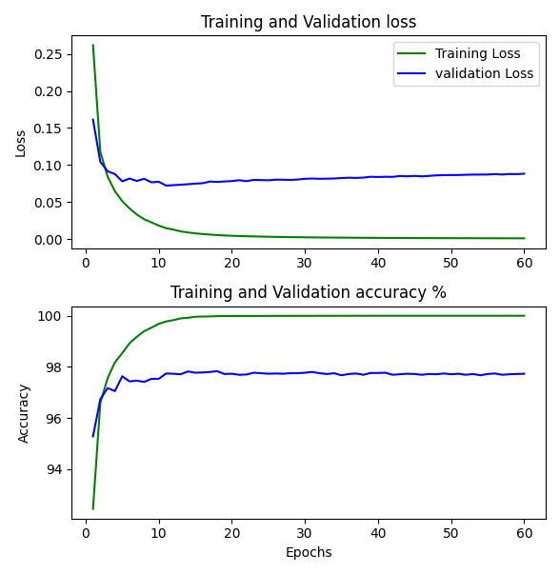

The training loss became minimized after the 15th epoch and testing accuracy was also the highest after that point.

Model 2: Accuracy is 99.24

Both training and testing set accuracy reached the maximum value by the 20th epoch and thus having trained it with 60 epochs was beyond the point of diminishing returns.

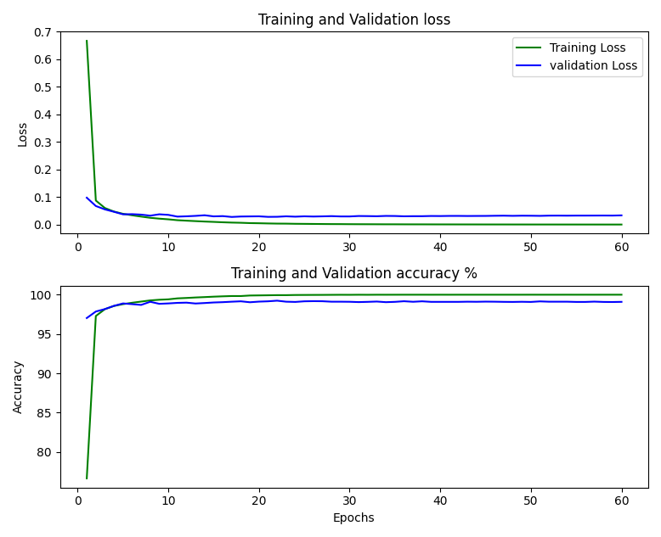

Model 3: Accuracy is 99.47

Has a higher accuracy compared to the previous models and values plateaued past the 20th epoch.As the learning rate was lesser than model 2 it took slightly more epochs to converge at the best accuracy.

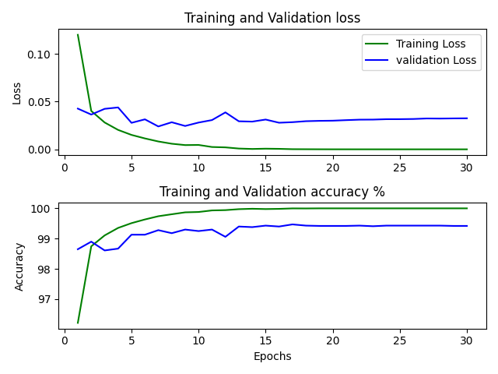

Model 4: Accuracy is 99.37

Performed similarly to model 3 and was trained for only 30 epochs after considering the results of the previous models.Accuracy hit a cap at 99.37% after about 20 epochs.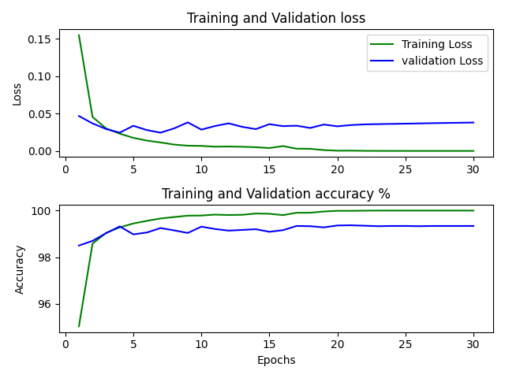

Model 5: Accuracy is 99.32

Model was trained for 40 epochs along with using a dropout for regularization and the accuracy of 99.32% was obtained only towards the final few epochs.The learning rate of 0.03 used was not sufficient for this model

