Programming Assignment-V

Computer Vision-CAP 5415

**Question: Image segmentation**

To implement a simple thresholding-based image binarization algorithm

**Implementation and Observations**

In binary segmentation, all pixels are split into either foreground or background based on some threshold. If the pixel value is above the threshold, then the pixel is set to the maximum value and if the pixel is below the threshold it is set to the minimum value. For example, if the range of pixel values is between 0 and 255 and a threshold is set to 100, then all pixels greater than 100 will be set to 255 and all pixels below will be set to zero.

In this instance we have 3 images, and we take a look at the histogram of the images and choose 3 different threshold values and perform binary segmentation. Follows Image 1 and its results

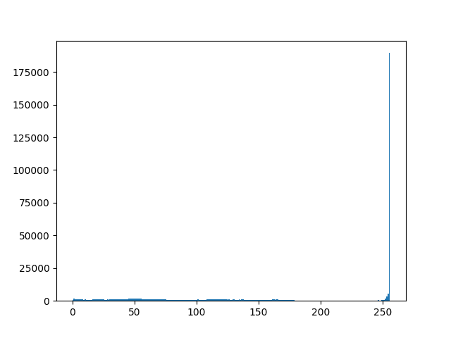

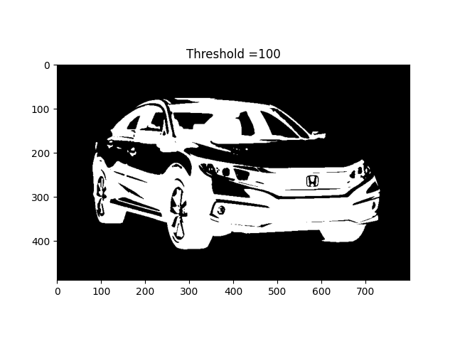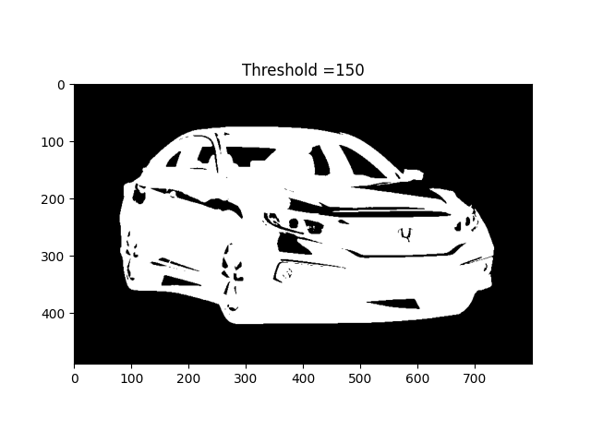

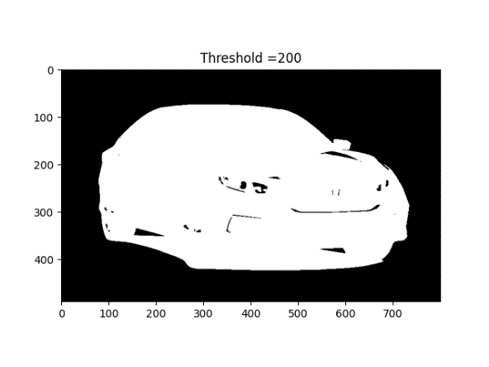As the background is plain white and the color of the car is blue, this image can be segmented easily and from the graph the threshold values of 150 and 200 give the best results.

Image 2

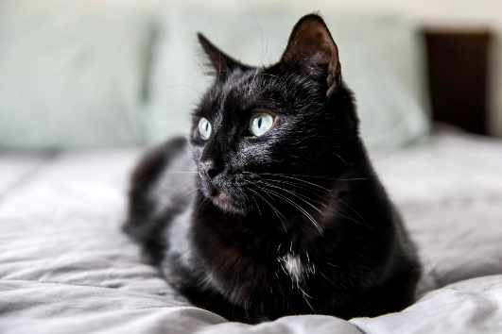 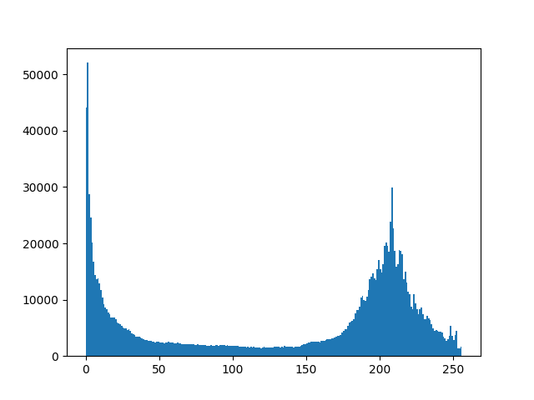

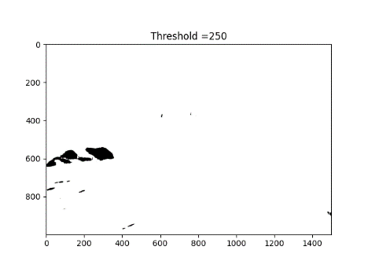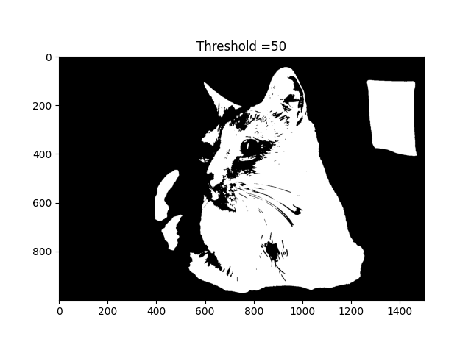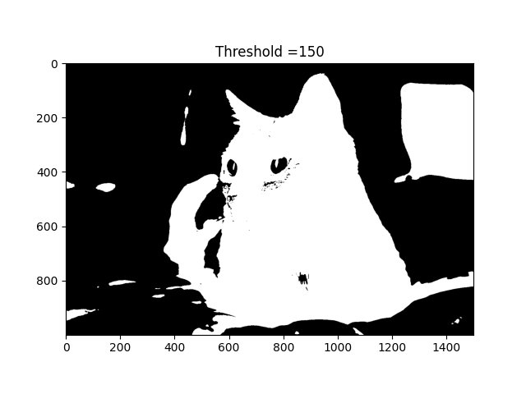

As the cat is in black and the background is of a lighter color, a lower threshold value gives the best results compared to the previous image and the same can be seen in the histogram. Segmentation with a threshold of 250 gives us almost no usable output.

Image 3

 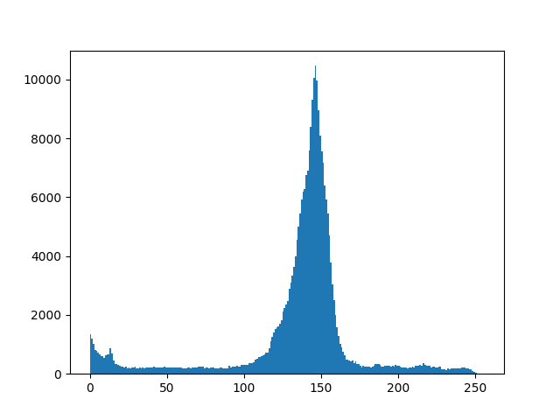

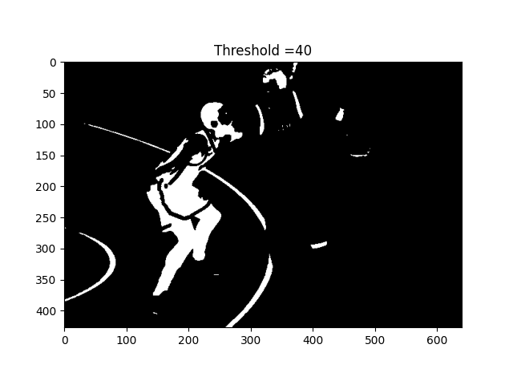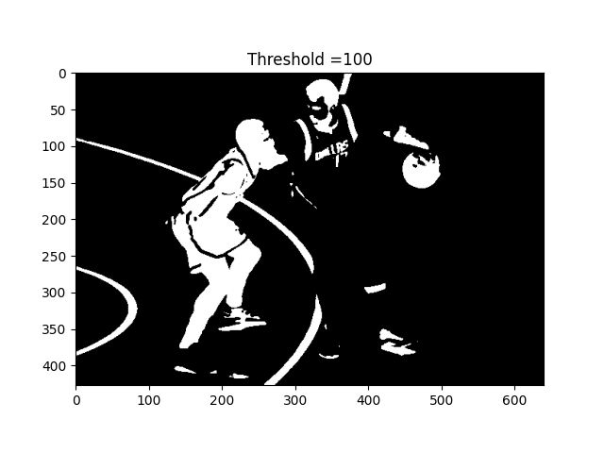

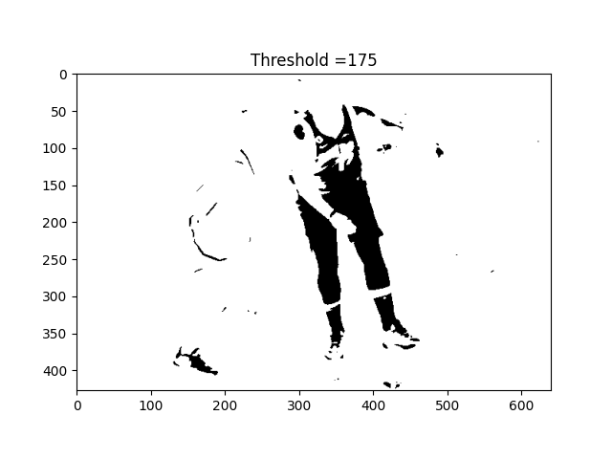

As seen from the image both the players have different colored jerseys in black and white respectively. This causes a peak in the histogram in the middle. With the image with threshold of 40 showing the player in black jersey and with 175 showing the player in the white jersey and the other is right between both.

**Otsu segmentation**

This algorithm estimates the optimal threshold by maximizing the between-class variance of the segments in the histogram. Performing Otsu segmentation for the same 3 images.

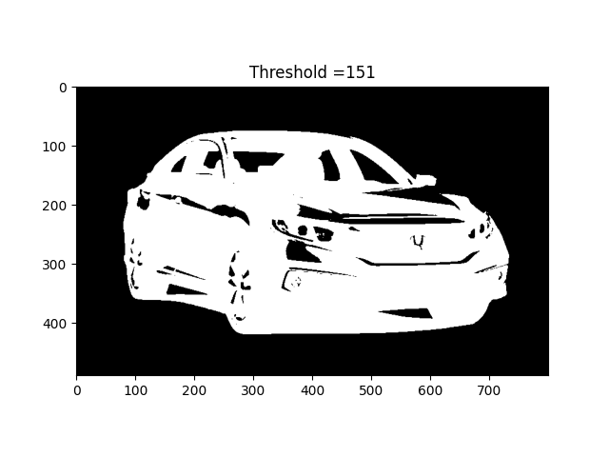

The threshold given by the Otsu method is 151 which is close to the 150 that was already tried.

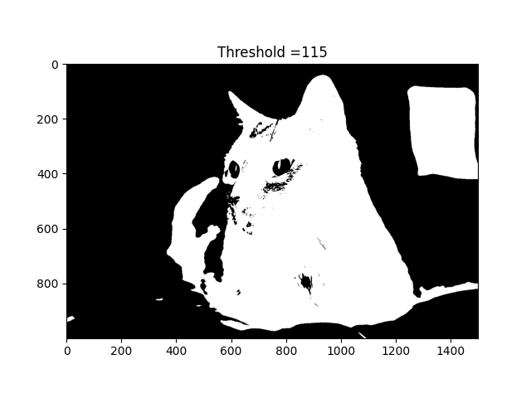

The optimal threshold given by the otsu method is 115 as opposed to the estimated values of 50 and 150.

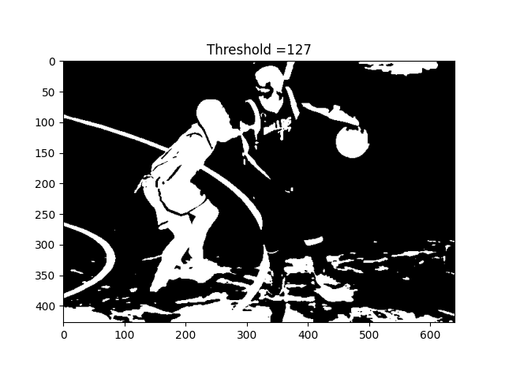

For the final image the optimal Otsu value is 127 whereas the threshold for binary were estimated to be 40 and 175 .

**Conclusion**

We can draw the conclusion that it is challenging to manually pick the ideal threshold because most histograms have numerous local minima, making it challenging to identify the optimum one. The results show that none of the estimated thresholds were even close to the Otsu. Because Otsu does not require the user to manually select the threshold and often performs better than manual settings, it is a better method of implementing a thresholding methodology.