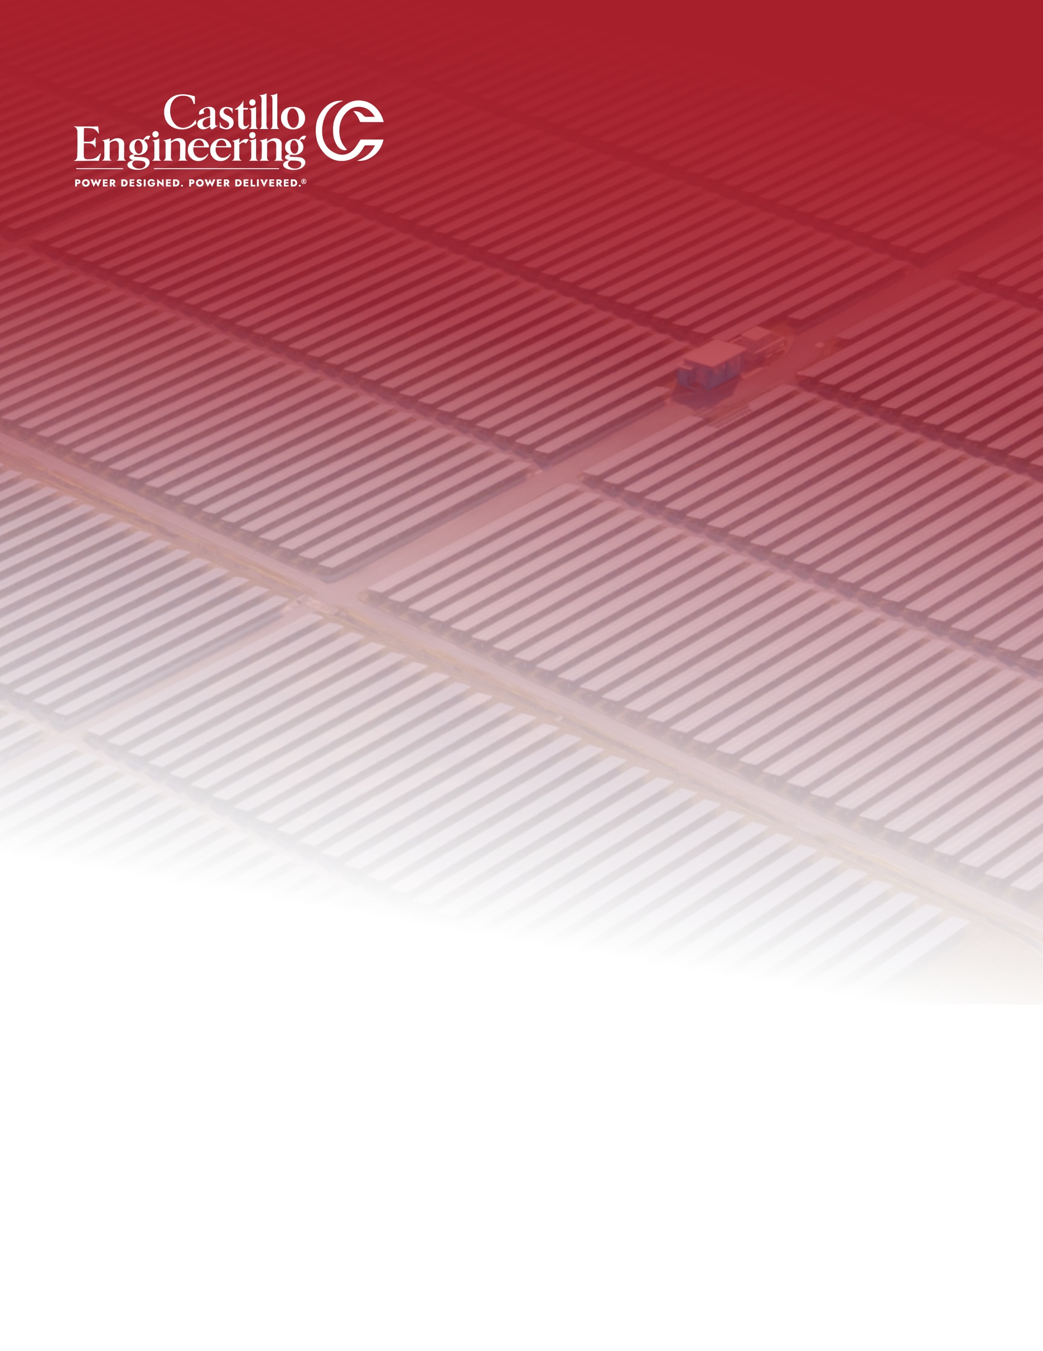

BAGBY SOLAR PROJECT, LLC

SAM REPORT

Prepared by
Avinash Rengarajan
Checked by
Manjil Puri

Owner
Generate Capital
(845) 324-5411

EPC
Recon Corporation
(931) 207-4354
Completed on
December 9, 2025


Engineering Company
Castillo Engineering Services LLC
(407) 289-2575

support@castillope.com
1060 Maitland Center Commons Suite 270, Maitland, FL 32751

Table of Contents

1 Body.Heading.Section.Title
Body.Text

Typical ‘’High Production’’ Daily Load Factors
Month | # Hours Production | # Hours Peak Production | Load Factor (%)
Jan | 9 | 0 | 32
Feb | 11 | 7 | 38
Mar | 11 | 10 | 43
Apr | 12 | 10 | 48
May | 14 | 11 | 51
Jun | 14 | 11 | 52
Jul | 14 | 11 | 51
Aug | 13 | 10 | 48
Sep | 12 | 9 | 45
Oct | 11 | 8 | 40
Nov | 10 | 2 | 35
Dec | 9 | 0 | 30
 | Average |  | 43
 | MAX |  | 52

