CASTILLO ENGINEERING · CIVIL
Pile Plan Optimizer
User Guide

Terrain-following pile plans for utility-scale solar: north–south torque tubes on flex joints. Import an Excel file, set the limits, review the results and export the plan.

Document | User Guide
Version | 1.0 (draft for review)
Date | 5 October 2026
Application | Pile Plan Optimizer v1.1, source revision 962d668
Audience | Civil engineers and checkers who use the tool
Companion document | Pile Plan Optimizer — Technical Documentation (architecture, API, operations and the ADR log)
Contents page | Page numbers can be refreshed in Word: right-click the contents list and choose Update Field.

Basis of this guide
This guide was written from the application source at revision 962d668 and checked by running the application in a browser with the sample file. The behaviour listed under Known issues (section 12) was reproduced. Other behaviour is described from the source code. Where the help text on screen and the code disagree, this guide follows the code.

Contents
1 Introduction 4
1.1 What the Pile Plan Optimizer does 4
1.2 What you need 4
1.3 Where your data goes 5
1.4 Key terms 5
2 Quick start 6
3 Preparing your input data 6
3.1 File types 6
3.2 Columns 6
3.3 Tracker IDs 7
3.4 Per-pile reveal limits 7
3.5 Coordinates, units and ordering 7
3.6 Checklist before you load a file 8
3.7 The sample file 8
4 The workspace 8
5 Setting the limits 10
5.1 The controls 10
5.2 Things to know 11
6 What happens when you load data 11
7 Reviewing the results 11
7.1 Two sets of results: first pass and final 11
7.2 Solution types 12
7.3 Profile tab 13
7.4 Slope tab 14
7.5 Piles tab 15
7.6 Fleet tab 16
7.7 Adjacency tab 16
8 Correcting adjacency flags 17
8.1 N–S corrections 17
8.2 E–W corrections 18
8.3 Reverting 18
8.4 Recommended order 18
9 Exporting results 19
9.1 Optimization Results 19
9.2 Tracker Ends 19
9.3 Design Parameters 19
9.4 Practical notes 20
10 Saving and reopening runs 20
10.1 Saving 20
10.2 Opening 21
10.3 Working with colleagues 22
11 Troubleshooting 23
11.1 Messages and symptoms 23
11.2 Reporting a problem 24
12 Known issues and limitations 24
12.1 The Profile tab can blank the page (reproduced) 25
12.2 Other issues (K2 to K13) 25
Appendix A Sample file excerpt 26

1 Introduction

1.1 What the Pile Plan Optimizer does
The Pile Plan Optimizer plans the top-of-pile elevations for solar tracker rows that use a north–south torque tube carried on piles and joined by flex joints. You load the surveyed ground elevation at every pile location, set the engineering limits, and the tool works out where each pile top should sit.
For every tracker row it looks for the tube position that satisfies all of the following at the same time:
- the reveal of every pile (how far the pile stands above the ground) stays inside the minimum–maximum window;
- the tube slope between neighbouring piles stays within the maximum slope;
- the slope change from one span to the next, which is the rotation asked of each flex joint, stays within its limit;
- the ends of neighbouring rows line up within the north–south and east–west adjacency limits.
The tool prefers plans that need no earthwork. Where the limits cannot be met without moving earth, it reports how much cut or fill is needed at each pile (a regrade).
For each row it tries three things in order: a single straight line, then a tube that follows the terrain without grading, then a tube that follows the terrain with grading. A site-wide solve then couples all rows together. Section 6 describes what you see while this runs.
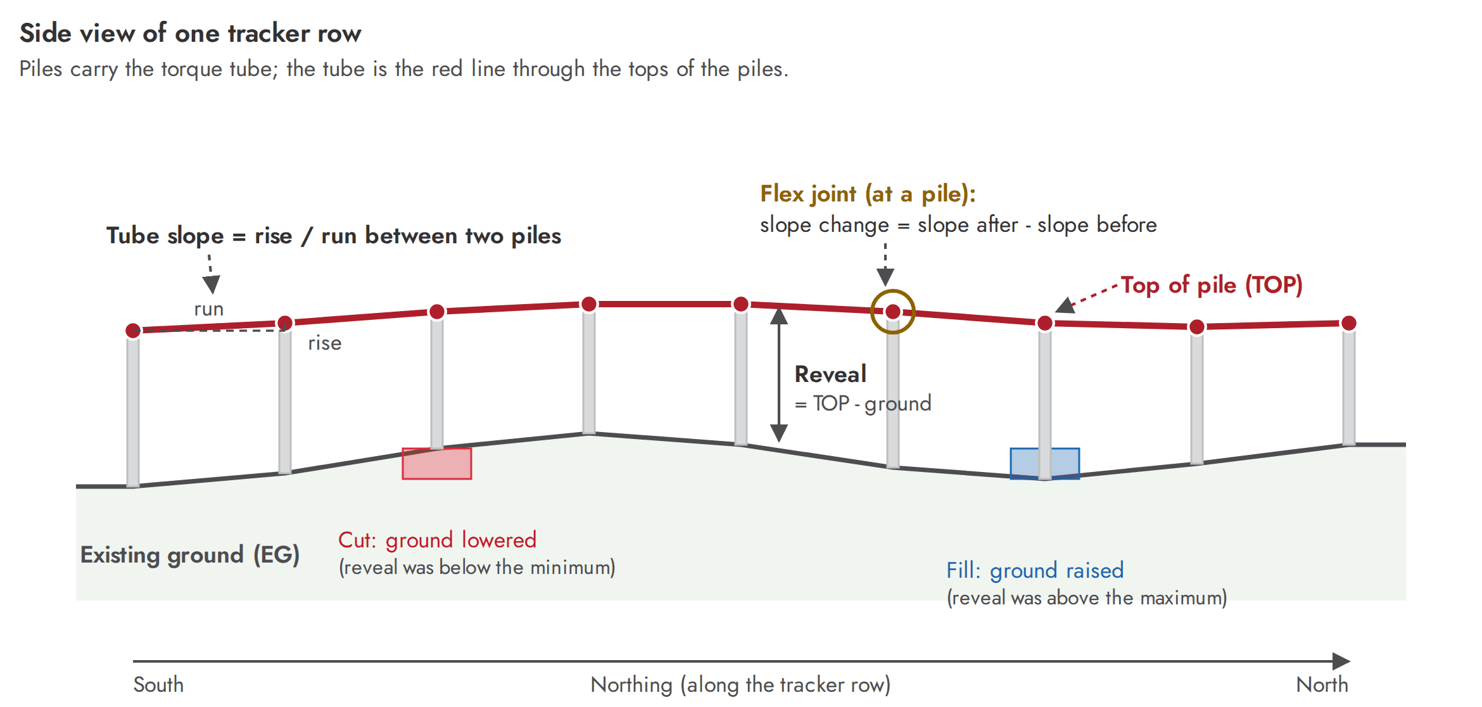
Figure 1. Terms used in this guide: reveal, top of pile, tube slope, flex-joint slope change, cut and fill.

1.2 What you need
Item | Requirement
Account | A Castillo staff account (@castillope.com) that belongs to the staff security group. Guest accounts are refused.
Address | https://civiltools.castillope.com
Browser | A current desktop browser. Edge or Chrome are recommended; the repository does not contain a browser compatibility list.
Screen | A desktop screen at least 1280 pixels wide. The interface uses a fixed-width constraints panel and fixed-width charts.
Data | An Excel (.xlsx) or CSV file of pile locations (section 3).

1.3 Where your data goes
- Everything is calculated in your browser. Loading a file does not upload it.
- Pile data leave your computer only when you press Save Run. The saved snapshot (inputs, limits and results) is stored on the Castillo server and can be opened by any signed-in staff member.
- Export .xlsx writes a file to your own computer.
- Reloading or closing the page discards anything you have not saved or exported. There is no autosave.

1.4 Key terms
Term | Meaning
Tracker (row) | A line of piles along the north–south axis that carries one torque tube. Identified by its TrackerID.
Pile reveal | Height of the pile top above the ground at that pile (top of pile minus ground). Limited to a minimum and a maximum.
EG, existing ground | Surveyed ground elevation (an input).
TOP, top of pile | Elevation of the top of the pile, where the tube sits. This is what the tool calculates.
FG, final ground | Ground elevation after any cut or fill: existing ground plus the ground adjustment.
Tube slope | Rise divided by run of the tube between two neighbouring piles, shown in %. Positive means the tube rises toward the north.
Slope change (Δ) | Change in slope from one span to the next. It is the rotation the flex joint at that pile has to accept.
Cut, fill | Ground adjustment. Cut lowers the ground (shown as a negative number); fill raises it (positive).
Regrade | Earthwork the tool could not avoid, shown as non-zero cut or fill.
N–S adjacency | Two rows in line end to end (same easting, small gap). The tops of their facing ends must differ by no more than the N–S limit.
E–W adjacency | Two neighbouring rows side by side. The slope between their tops must not exceed the E–W limit.
Block | A group of rows that sit side by side. The part of the TrackerID before the hyphen.

2 Quick start
- Open https://civiltools.castillope.com and sign in with your Castillo account. The header shows “signed in as …” once the page has loaded.
- Press Load .xlsx / .csv in the header and choose your file. The first file you load replaces the three demonstration trackers the page starts with. Check that the Input & Export tab reports the pile and tracker counts you expect.
- Wait for the progress indicator at the right of the header to finish. It shows the tracker count and the elapsed time, for example “12 trackers 0.2s”. Export and Save are disabled while it runs.
- Adjust the limits in the Constraints panel on the left if the defaults do not suit the project. Every change re-solves the whole site and clears any corrections you applied.
- Review the result. Start with the Fleet tab and the Adjacency tab. Use Piles and Slope to look at individual trackers.
- If the Adjacency tab lists flags, press Apply N-S Corrections, then Apply E-W Corrections. Each has a Revert button.
- Press Export .xlsx to download TrackerOptimization_Results.xlsx.
- Press Save Run if you want a named, versioned copy that you or a colleague can reopen later.
Known issue: the Profile tab can blank the page
If the Profile tab is open and the selected tracker is anything other than a straight line, the whole page goes blank. The same happens when you click a row in the Fleet or Adjacency tables that opens the Profile tab for such a tracker. Reload the page to recover. Section 12.1 explains how to avoid it.

3 Preparing your input data

3.1 File types
The tool reads Excel (.xlsx) and CSV (.csv) files. For Excel files it uses the first sheet whose first row contains the headers it needs, so the headers must be in row 1. The file picker also lists legacy .xls files; the tested workflow is .xlsx and .csv.

3.2 Columns
Column | Required | Unit | Meaning and accepted spellings
TrackerID | Yes | text | Identifies the row the pile belongs to, for example 1-13 (section 3.3). Also accepted: tracker_id.
Northing | Yes | ft | Coordinate along the tracker (north–south) axis. CSV files also accept N.
Easting | Include it | ft | Coordinate across the rows. Needed for the E–W checks and to pair rows end to end. Always supply it (known issue K10). CSV files also accept E.
ExistingGround | Yes | ft | Surveyed ground elevation at the pile. Also accepted: existing_ground. CSV files also accept ground.
MinReveal | No | ft | Lowest allowed reveal at this pile, above existing ground. Also accepted: min_reveal, min reveal, minimumreveal, minimum reveal, minrev.
MaxReveal | No | ft | Highest allowed reveal at this pile, above existing ground. Also accepted: max_reveal, max reveal, maximumreveal, maximum reveal, maxrev.

Column names are not case-sensitive and leading or trailing spaces are ignored. Any other columns are ignored.
Easting and the error message
If no sheet qualifies, the tool says “No sheet with TrackerID, Northing, Easting, ExistingGround columns found.” In practice an Excel file is accepted when it has TrackerID, Northing and ExistingGround; a missing Easting column is filled with 0 for every pile, which disables the E–W checks. Do not rely on that: always include Easting.

3.3 Tracker IDs
Name each tracker <block>-<row>, for example 1-1, 1-13, 2-37. The part before the hyphen identifies the block, a group of rows that sit side by side. The number after it orders the rows from west to east.
- The tracker drop-down and the Fleet table list trackers by block number, then row number.
- E–W checks and corrections compare a row only with the next row in the same block (the next higher row number).
- N–S checks do not use the ID; they pair rows by easting.
IDs that do not follow the pattern
An ID such as T001 still solves, but the tool treats each ID as a block of its own, so no E–W checks or corrections are made, and the list order may not follow the layout of the site.

3.4 Per-pile reveal limits
If a row of your file has MinReveal and MaxReveal, the tool treats [ground + MinReveal, ground + MaxReveal] as a hard box for that pile and ignores the Min Reveal and Max Reveal sliders for it. Piles without values use the sliders. A typical use is tighter limits at the end piles of each tracker: the sample file holds the end piles to 2.5–5.5 ft and all other piles to 2.0–6.0 ft.
Per-pile limits are not shown on screen
The interface does not tell you when per-pile limits are in use, and the red values and warning marks on the Piles and Fleet tabs compare against the sliders, not the per-pile limits (known issue K3).

3.5 Coordinates, units and ordering
- Use feet for Northing, Easting and ExistingGround. State-plane coordinates are fine.
- Rows are assumed to run north–south. The tool sorts the piles of each tracker by northing, so the order in the file does not matter.
- Pile numbers shown in the Piles and Adjacency tabs count from the north: pile 1 is the northernmost pile.

3.6 Checklist before you load a file
- Headers are in row 1 (Excel) and spelled as in the table above.
- Numbers are stored as numbers, not as text with units or thousands separators.
- Every pile row has a TrackerID. Rows with a blank TrackerID, or a Northing or ExistingGround that is not a number, are skipped without a message. Compare the pile count shown on the Input & Export tab with your file.
- Easting is present and tracker IDs follow <block>-<row>.
- CSV only: plain comma-separated values. A field that itself contains a comma is not supported, and quotation marks are removed rather than interpreted.

3.7 The sample file
The repository ships a format template, public/sample-pile-data.xlsx: 180 piles in 12 trackers (4 rows by 3 blocks; 15 piles per tracker about 27.1 ft apart; rows 24.9 ft apart; IDs 1-1 to 3-37) with per-pile reveal limits. You can fetch it from the tool at https://civiltools.castillope.com/sample-pile-data.xlsx (there is no link to it inside the application) or from the public folder of the repository. Appendix A shows its first rows.
With the default limits the sample solves with no earthwork, so it is good for learning the screens but does not show a regrade.

4 The workspace
Figure 2 shows the workspace with the 12-tracker sample loaded. The numbers refer to the table below the figure.
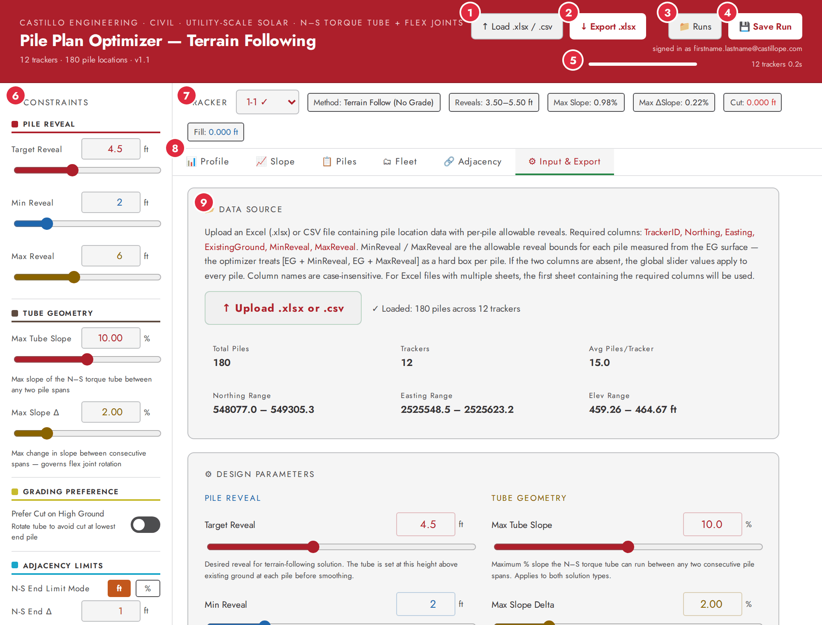
Figure 2. The workspace with the sample file loaded (Input & Export tab). Numbers refer to the table below.
Table 1. Areas of the workspace (numbers as in Figure 2).
# | Area | What it does
1 | Load .xlsx / .csv | Choose a file. It replaces the current data and restarts the solve.
2 | Export .xlsx | Downloads the results workbook. Disabled while the solve is running.
3 | Runs | Opens the list of saved runs (section 10).
4 | Save Run | Saves the session as a named, versioned run. Reads “Save v2”, “Save v3” … once a run is open.
5 | Progress | A bar with the tracker count and elapsed time. While solving it reads “done / total trackers”. The line above it shows the account you are signed in with.
6 | Constraints panel | All engineering limits (section 5), plus the Fleet Summary at the bottom.
7 | Tracker selector and chips | Choose a tracker. The chips show Method, Reveals, Max Slope, Max ΔSlope, Cut and Fill for it (first-pass result, section 7.1).
8 | View tabs | Profile, Slope, Piles, Fleet, Adjacency, Input & Export.
9 | Main view | The content of the selected tab.

The page starts on the Input & Export tab with three demonstration trackers (1-1, 1-13 and Demo-Steep, 45 piles). Loading a file keeps you on that tab; opening a saved run takes you to the Fleet tab.

5 Setting the limits
The Constraints panel on the left is always visible. Each control pairs a number box with a slider: type in the box or drag the slider. You can type a value outside the slider’s range. The Input & Export tab repeats the same controls with a description of each; some ranges there are wider.

5.1 The controls
Table 2. Controls in the Constraints panel (defaults and slider ranges).
Control | Default | Range | What it does
Pile Reveal
Target Reveal | 4.5 ft | 1–10 ft | The reveal the tool aims for when nothing forces otherwise. The tube starts at ground + target before smoothing; in the site-wide solve it is only a tie-break.
Min Reveal | 2.0 ft | 0.5–8 ft | Lowest allowed pile reveal. Piles below it need fill or a higher tube.
Max Reveal | 6.0 ft | 2–12 ft | Highest allowed pile reveal. Piles above it need cut or a lower tube.
Tube Geometry
Max Tube Slope | 10 % | 0.1–20 % | Largest slope the tube may have between two consecutive piles.
Max Slope Δ | 2 % | 0.01–10 % | Largest change in slope between consecutive spans. Governs flex-joint rotation and is usually the most constraining check on undulating ground.
Grading Preference
Prefer Cut on High Ground | Off | On / off | Rotates the tube to avoid cut at the lowest end pile. Applies to the first-pass terrain-follow step with grading; the site-wide solve starts from those results but does not use the setting itself, so its effect on the final plan is indirect.
Adjacency Limits
N-S End Limit Mode | ft | ft | % | Chooses how the N–S limit is expressed (next two rows).
N-S End Δ | 1 ft | 0.1–5 ft | ft mode: largest difference in top elevation between facing ends of two rows in line, whatever the gap.
N-S End Slope | 10 % | 1–100 % | % mode: largest end-to-end slope across the gap. The allowed difference equals this slope times the actual gap, so wider gaps allow more.
E-W End Slope | 8 % | 1–20 % | Largest slope between the tops of E–W adjacent piles, using their actual easting spacing.
E-W Spacing Limit | 25 ft | 5–50 ft | Largest easting distance for two piles to count as E–W adjacent. Pairs further apart are not checked.
E-W N-S Gap Limit | 20 ft | 1–100 ft | Largest northing distance between a pile and its closest pile in the next row for the E–W check to apply.
N-S Gap Limit | 20 ft | 1–50 ft | Largest northing gap between row ends for two rows to count as N–S adjacent.

5.2 Things to know
- Every change restarts the solve and clears any N–S or E–W corrections and E–W anchors. Make your changes first, wait for the progress indicator to finish, then apply corrections.
- Per-pile limits in the file win over Min Reveal and Max Reveal (section 3.4).
- The same slope and slope-change limits apply to every tracker, whatever method solves it.
- On the Input & Export tab a few ranges are wider than in the panel: E-W Spacing Limit up to 100 ft and N-S Gap Limit up to 100 ft; its Max Slope Delta slider starts at 0.1 %.

6 What happens when you load data
As soon as data or a limit changes, the tool solves the whole site by itself, in two stages:
- Per tracker. Each tracker is solved on its own, in batches of 50 so the page stays responsive. The header counts “done / total trackers”.
- Site-wide. All rows are then re-solved together against all the limits, including their neighbours, in repeated sweeps (at most 80) until the largest movement of any pile top is 0.003 ft or less. The Input & Export tab shows “global solve — sweep N, max move X ft” under Fleet computation.
When it finishes, the progress bar is full and reads, for example, “12 trackers 0.2s”. Export and Save are disabled until then.
How long does it take?
The 180-pile sample finished in 0.2 s on a desktop-class computer (the figure the header displayed). docs/FINDINGS.md records about 30 s on an earlier first run. The tool is designed for sites up to about 200,000 piles (roughly 14,000 trackers), but a site of that size has not been timed. If a large site is slow, solve it in phases.

7 Reviewing the results

7.1 Two sets of results: first pass and final
The tool keeps two result sets, and the tabs do not all show the same one. Know which is which before you rely on a number.
 | First pass (each tracker on its own) | Final (after the site-wide solve and any corrections)
Where you see it | The chips above the tabs, and the Profile, Slope and Piles tabs for the selected tracker. | The Fleet tab, the Fleet Summary in the Constraints panel, the Adjacency tab, the Export, and saved runs.
Reflects the site-wide solve? | No. | Yes.
Reflects corrections? | No. | Yes.

The two can differ noticeably. In the sample file, tracker 2-1 shows as a straight line in the chips (Method: Straight Line; reveals 4.16–4.65 ft; max slope 0.22 %; max Δslope 0.00 %), while the Fleet tab lists it as “TF” with reveals 4.189–4.635 ft, max slope 0.248 % and max Δslope 0.010 %, because the site-wide result is not perfectly straight.
Which to trust
Treat the Fleet tab and the exported workbook as the record of the result. Use Profile, Slope and Piles to understand how a tracker behaves in the first pass.

7.2 Solution types
Where it appears | Label | Meaning
Fleet table | Straight | One straight line satisfies every limit. Reported only when every slope change is below 0.000001, that is, the tube is exactly straight.
Fleet table | TF | “Terrain follow”: the tube bends with the terrain within all limits and no earthwork is needed. A nearly straight tube is reported here.
Fleet table | TF w/Grade | Earthwork is needed; the Cut and Fill columns are non-zero.
Fleet Summary (panel) | Straight Line / Optimized (no regrade) / Needs Regrade | The same three classes, as counts.
Export, Solution Type | Straight Line / Terrain Following / Terrain Following (Regrade) | The same three classes, per tracker.
Chips and Profile (first pass) | Straight Line / Terrain Follow (No Grade) / Terrain Follow (w/ Grade) | The three steps of the per-tracker solve (section 7.1).

7.3 Profile tab
The Profile tab explains how the first pass solved the selected tracker and draws its elevation profile.
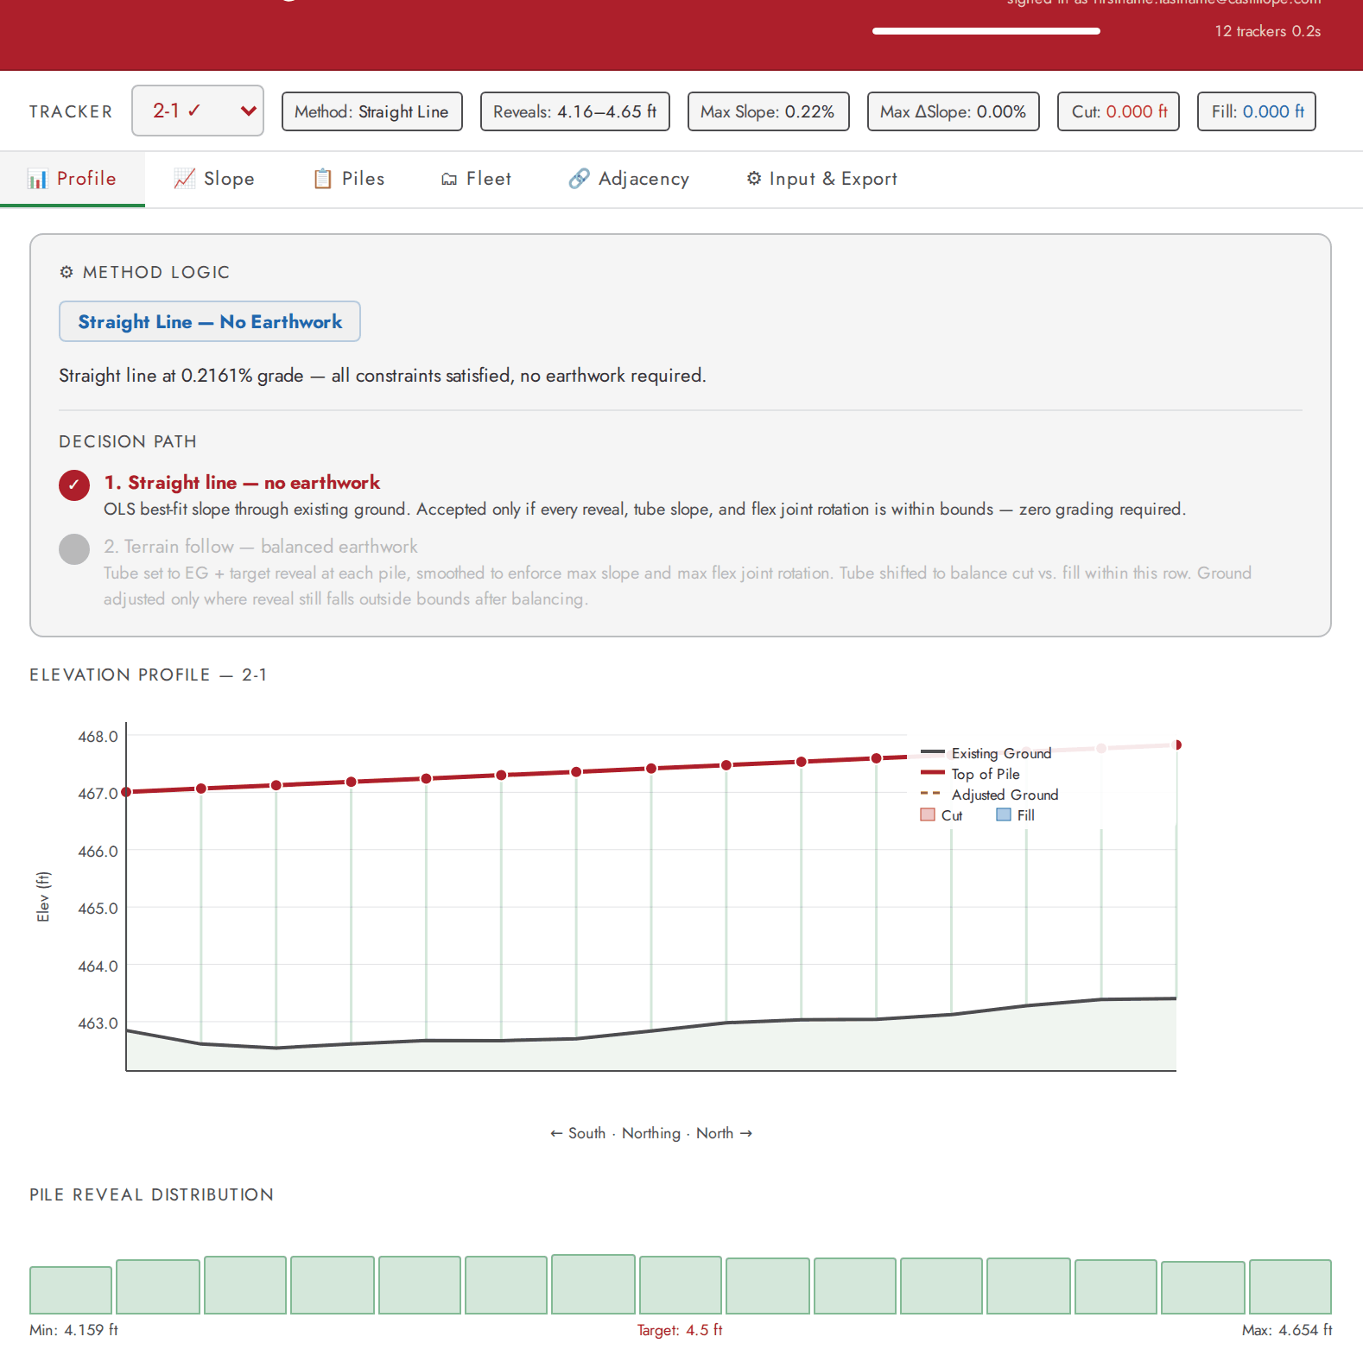
Figure 3. Profile tab for tracker 2-1 of the sample file (a straight line).
- Method Logic: a badge (for example “Straight Line — No Earthwork”), a sentence explaining the decision, and a Decision Path showing which step was accepted. When earthwork is needed it adds an Earthwork Balance (CUT, FILL and NET, in ft) and lists any Active Violations.
- Elevation Profile: existing ground (dark grey line and shaded ground), top of pile (red line and dots; the dots turn bright red when the tracker has violations), thin green lines for each pile’s reveal, the adjusted ground (dashed amber line) with cut (red) and fill (blue) bars where the ground is adjusted. If a row sits end to end with the selected one, its profile is overlaid in blue.
- Pile Reveal Distribution: one bar per pile, green when the reveal is inside the Min–Max window and red when it is not, with the minimum, target and maximum reveal underneath.
Only straight-line trackers can be shown
Today the Profile tab works only when the selected tracker’s Method chip reads Straight Line. For any other tracker the page goes blank (section 12.1). Use the Piles and Slope tabs for those trackers.

7.4 Slope tab
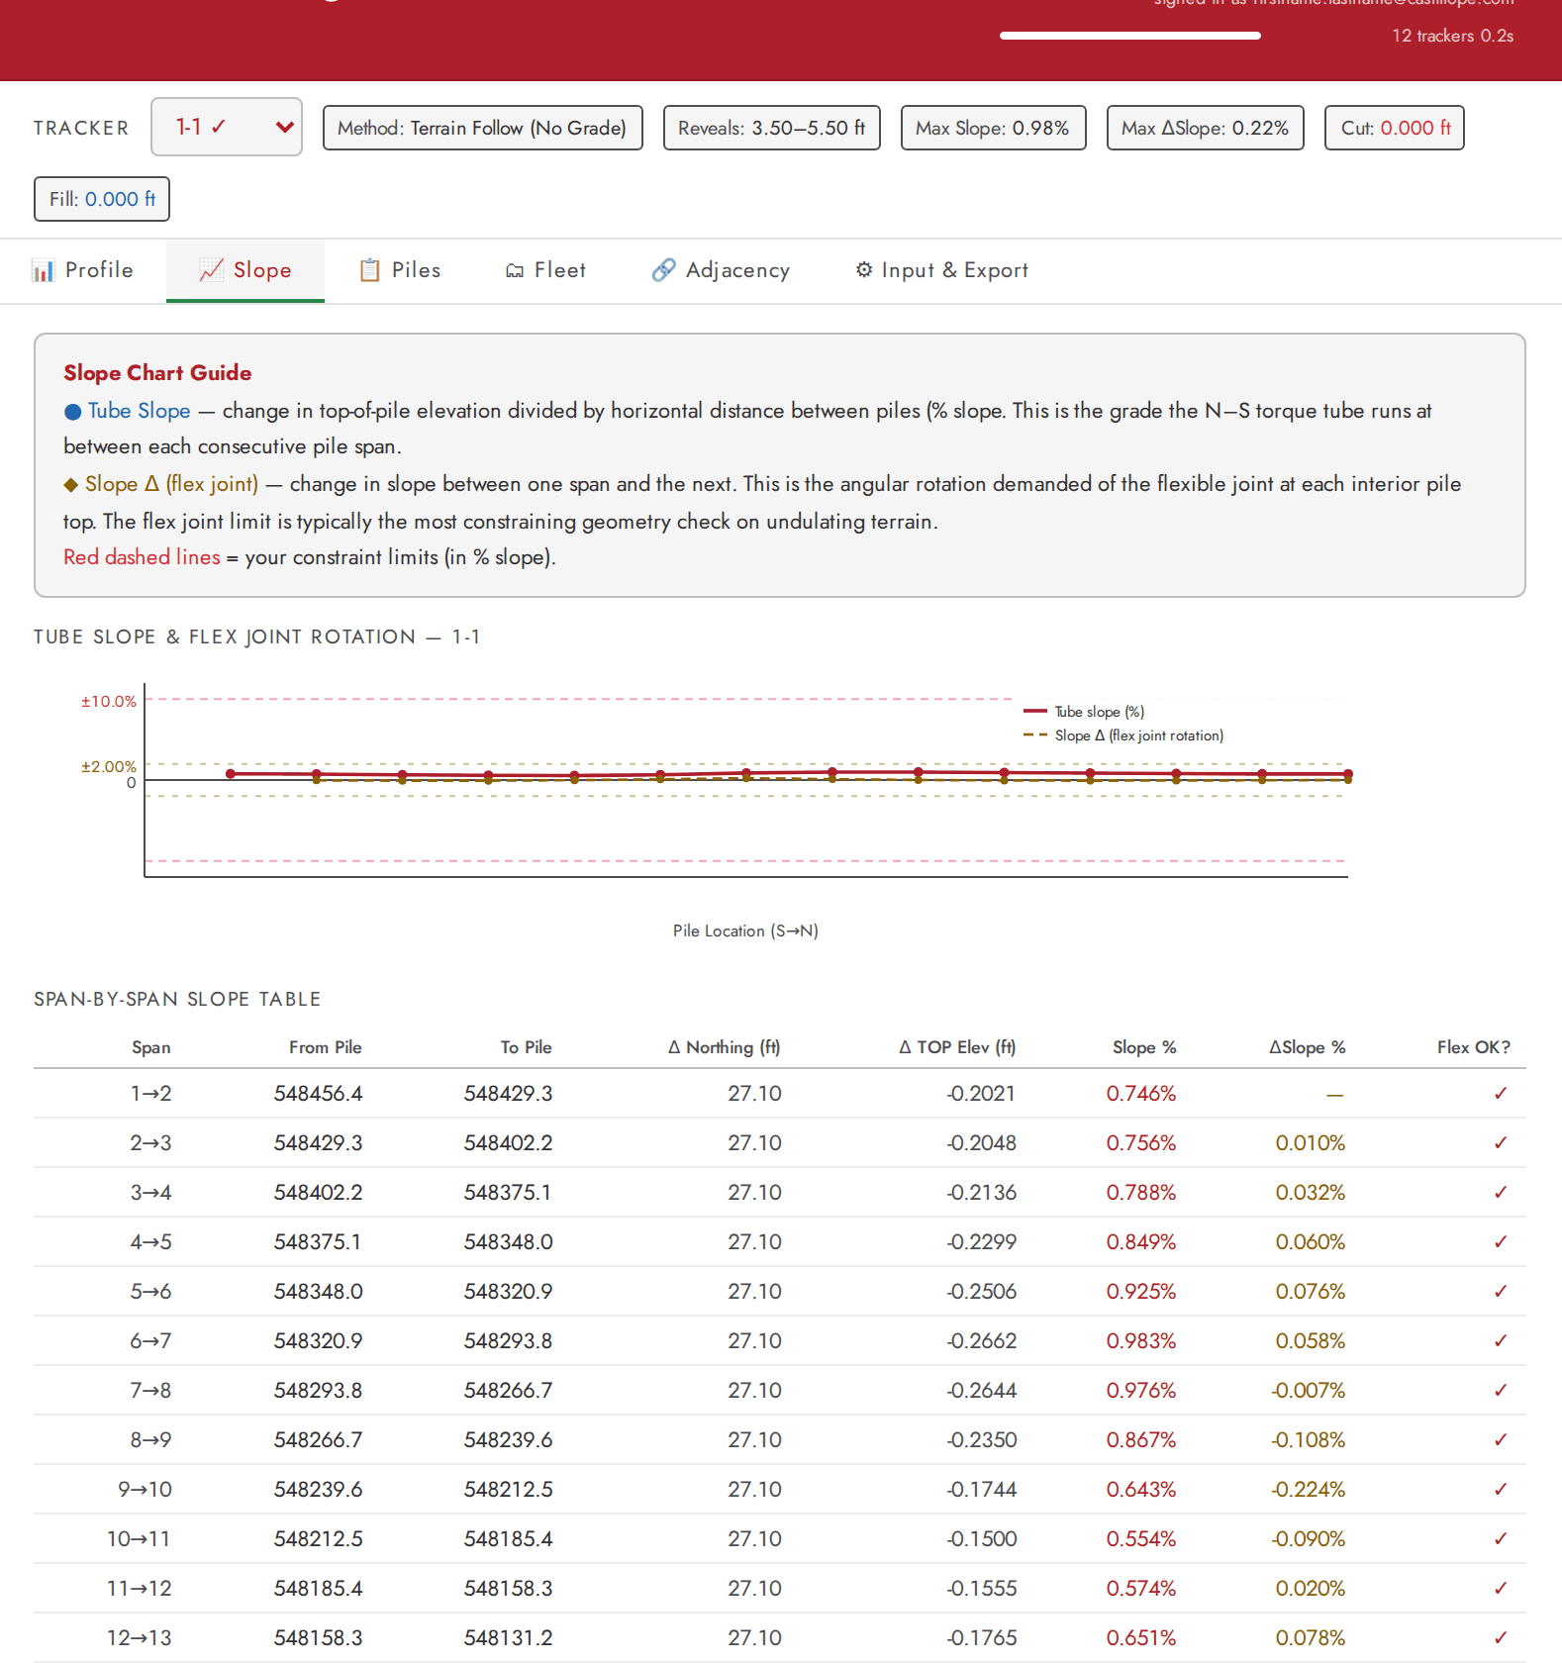
Figure 4. Slope tab for tracker 1-1 of the sample file.
- The chart plots the tube slope (red line) and the slope change at each flex joint (amber dashed line) along the tracker. The red dashed lines are your Max Tube Slope limits and the amber dotted lines your Max Slope Δ limits.
- The chart scales to the limits, so small slopes look flat. Use the table for the numbers.
- The span-by-span table lists each span: Span, From Pile and To Pile (the northing of each pile), Δ Northing, Δ TOP Elev, Slope %, ΔSlope % and Flex OK?. Values above a limit turn red and Flex OK? shows a warning mark.

7.5 Piles tab
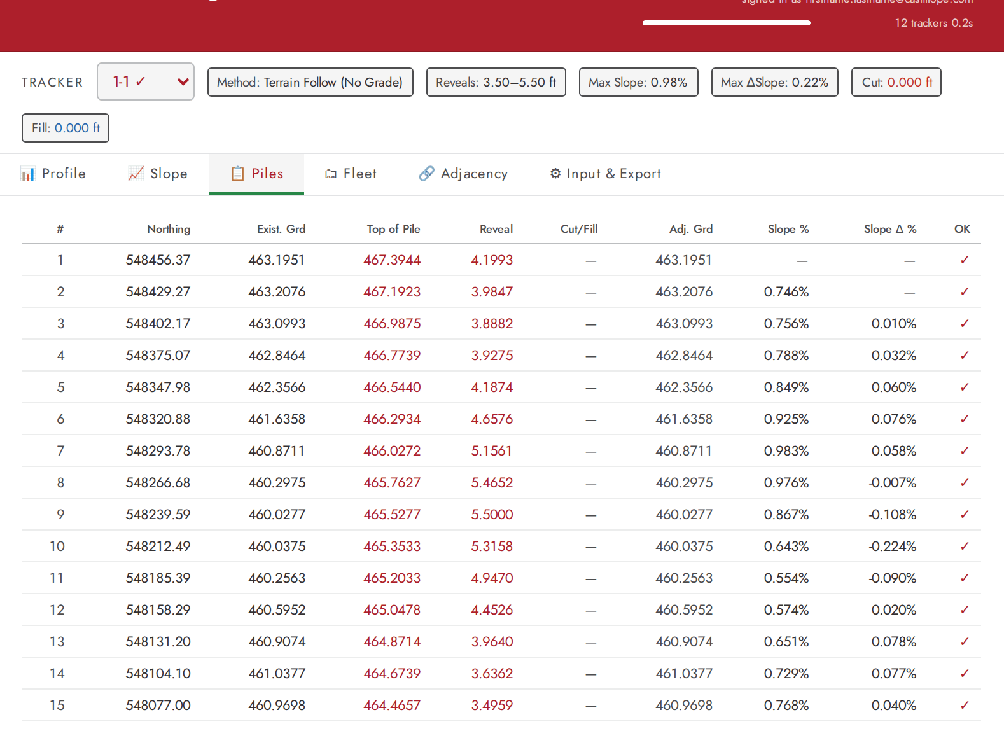
Figure 5. Piles tab for tracker 1-1 of the sample file.
One row per pile, from north (pile 1) to south. Columns: #, Northing, Exist. Grd, Top of Pile, Reveal, Cut/Fill, Adj. Grd, Slope %, Slope Δ % and OK.
- Cut/Fill is negative for cut (ground lowered) and positive for fill (ground raised); a dash means no adjustment. Adj. Grd is the ground after the adjustment.
- Slope % is the slope of the span to the north of that pile; positive means the tube rises toward the north. Slope Δ % is the change in slope at the pile.
- OK shows a warning mark when the reveal is outside the Min Reveal/Max Reveal sliders, or the slope or slope change is above its limit.

7.6 Fleet tab
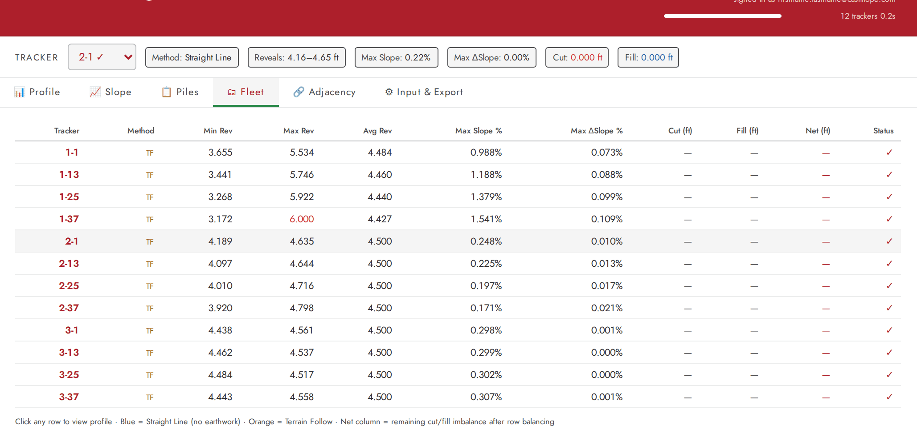
Figure 6. Fleet tab for the 12-tracker sample file.
One row per tracker, from the final result. Columns: Tracker, Method, Min Rev, Max Rev, Avg Rev, Max Slope %, Max ΔSlope %, Cut (ft), Fill (ft), Net (ft) and Status.
- Status shows a tick when the tracker’s slope and slope change were within limits when the solver finished, or a warning mark with the number of violations. It does not test reveals. It is not recalculated after you apply corrections, whereas the Max Slope % and Max ΔSlope % columns are, so check those after correcting (known issue K13).
- Min Rev and Max Rev turn red when outside the Min Reveal/Max Reveal sliders. A value shown at exactly the limit (for example 6.000) can be red because it exceeds the limit by a tiny fraction.
- Net is the remaining difference between cut and fill for that tracker.
- Clicking a row selects the tracker and opens the Profile tab. See the warning in section 7.3 before you do.
The Fleet Summary at the bottom of the Constraints panel shows the totals: Total Trackers, Compliant, Violations, Straight Line, Optimized (no regrade), Needs Regrade, Fleet Cut Total, Fleet Fill Total, and the N–S and E–W flag counts.

7.7 Adjacency tab
This tab checks the final result against the adjacency limits and is where you apply corrections (section 8). Two cards show the number of N-S End Flags and E-W End Flags, with the limit in use underneath. If both are zero it says “No adjacency violations found with current parameters”.
After the site-wide solve, flags are expected to be rare, because that solve already enforces the adjacency limits. They appear when the limits cannot all be met together, for example across a steep step in the ground.
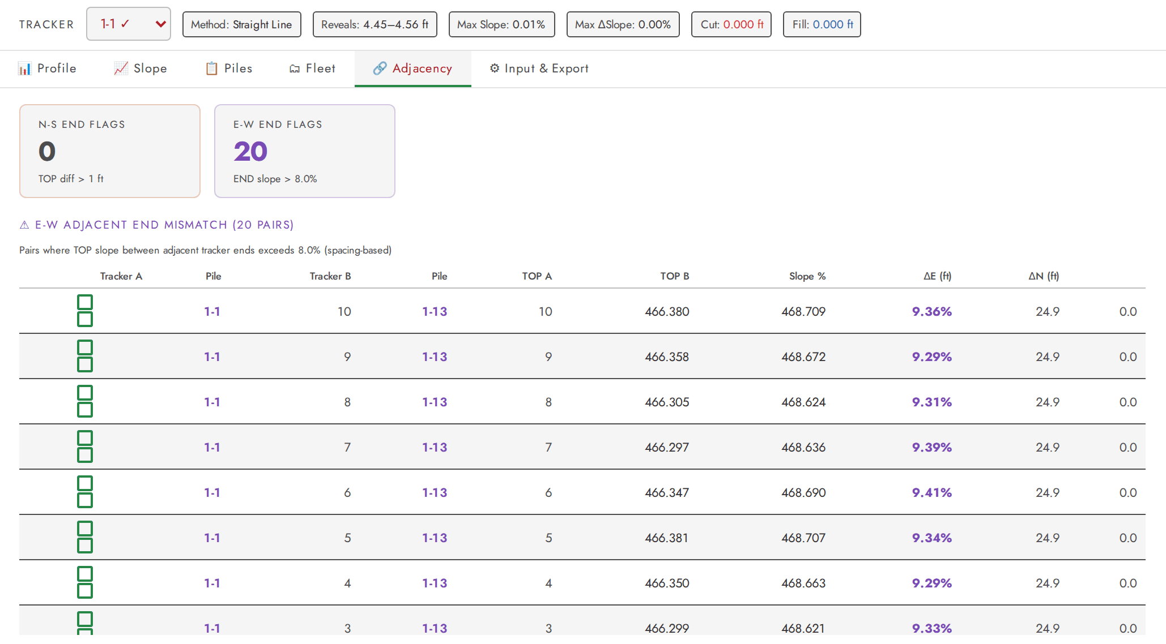
Figure 7. Adjacency tab with E–W flags (illustration: a small synthetic file with deliberate elevation steps between rows).
- N–S flags list pairs of rows in line end to end whose facing ends differ by more than the limit. Columns: S Tracker (N end), N Tracker (S end), TOP (S), TOP (N), Δ TOP (ft), Gap (ft). Click a row to view a tracker.
- E–W flags list pairs of piles in neighbouring rows whose tops are steeper than the E–W limit. Columns, in order: an anchor selector (two small squares, one per tracker), Tracker A, Pile, Tracker B, Pile, TOP A, TOP B, Slope %, ΔE (ft), ΔN (ft).
The E–W table headings are shifted
The anchor selector column has no heading, so every heading in the E–W table sits one column to the left of its data (for example “Slope %” appears above the TOP B values). Read the columns in the order listed above (known issue K4).

8 Correcting adjacency flags
Corrections work on the final results and can be undone. Apply them last, after the limits are settled, because changing any limit afterwards discards them.

8.1 N–S corrections
Press Apply N-S Corrections on the Adjacency tab. Starting with the largest difference, the tool closes only the excess beyond the limit for each flagged pair: it moves the facing ends toward each other, and shares the movement between the two rows. A row without earthwork takes up its share first, limited by the room left in its reveal window; the remainder is split equally. The two end piles move together, the change is carried inward along the tracker, and the tube is re-smoothed to the slope and slope-change limits. Where a reveal still ends up outside its window, ground adjustment (cut or fill) is added.
Afterwards the card shows “n pairs corrected” and, if some pairs could not be fixed, “m residual” with a table of the remaining differences and the reason.

8.2 E–W corrections
Press Apply E-W Corrections. Within each block, the tool finds chains of consecutive rows that have flagged pairs. In each chain one row is the anchor and stays where it is; the others are adjusted outward from it, each relative to its neighbour nearer the anchor. A row being moved is re-solved so that each flagged pile stays inside the allowed E–W band, the slope and slope-change limits still hold, and the movement is as small as possible. This repeats for a pair, up to six times, until it is clean. Reveals that end up outside the window get cut or fill.
To choose the anchor, click one of the small squares beside a tracker in the E–W table (click again to clear). A green square marks a row with no N–S flags, which is the safer choice; an amber square marks a row that still has N–S flags. If you choose none, the middle row of each chain is used. Afterwards the card shows “n pile pairs · m chains” and lists any residual pairs.
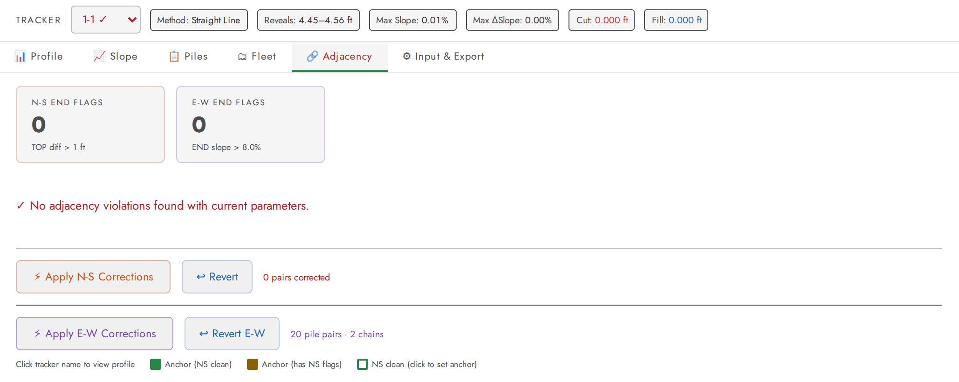
Figure 8. Adjacency tab after Apply E-W Corrections on the illustration file: no flags remain.

8.3 Reverting
- Revert restores the results as they were just before you last pressed Apply N-S Corrections. Revert E-W does the same for the E–W button. Only the latest application of each can be undone.
- If you applied both, press Revert E-W first. Reverting N–S restores the state from before the N–S step and therefore also removes the E–W changes made after it.
- The flag counts update straight away after every correction or revert.

8.4 Recommended order
- Settle the limits and wait for the solve to finish.
- Apply N–S corrections, then check the Adjacency tab.
- Choose anchors (prefer green squares), apply E–W corrections, and check again.
- Review the Fleet tab, export, and save the run. Corrections are saved with the run.

9 Exporting results
Press Export .xlsx (in the header, or on the Input & Export tab) once the solve has finished. The workbook comes from the final results, including any corrections, and has three sheets.

9.1 Optimization Results
One row per pile, ordered from north to south within each tracker, trackers in the same order as the tracker list.
Table 3. Columns of the Optimization Results sheet.
Column | Meaning
Tracker ID | The tracker the pile belongs to.
Northing (ft), Easting (ft), Existing Ground (ft) | The input values (4 decimals).
Top of Pile (ft) | The calculated top-of-pile elevation (4 decimals).
Pile Reveal (ft) | Top of pile minus Final FG: the reveal measured to the finished ground, after any cut or fill.
Solution Type | Straight Line, Terrain Following or Terrain Following (Regrade). One value per tracker (section 7.2). A nearly straight tube is reported as Terrain Following.
Final FG (ft) | Existing ground plus the ground adjustment.
Ground Adj (ft) | The cut or fill at this pile; blank when there is none. Negative is cut (ground lowered), positive is fill (ground raised).
Cut / Fill | “Cut” or “Fill” where there is an adjustment; blank otherwise.
Tube Slope | Slope of the span that enters this pile from the south, as a fraction (0.01 = 1 %): rise divided by the distance between the piles. Positive means rising toward the north. Blank on the southernmost pile of each tracker (the last row of each tracker in the file).
Slope Delta | Change of slope at this pile, as a fraction: its Tube Slope minus the slope of the span to its south. Blank on the two southernmost piles of each tracker.

9.2 Tracker Ends
Three columns: TrackerID, North Pile TOP and South Pile TOP: the top elevation of the northernmost and southernmost pile of each tracker, in the tracker list order. The tube is fully defined by its two ends, which is what the downstream CAD workflow uses.

9.3 Design Parameters
A snapshot with Parameter, Value and Unit columns: Target Reveal, Min Reveal, Max Reveal, Max Tube Slope (%), Max Slope Delta (%); then Run Date, Total Trackers, Total Piles, the counts for Straight Line, Optimized (no regrade) and Needs Regrade, and Fleet Cut Total and Fleet Fill Total (ft).
What the export does not record
The Design Parameters sheet does not record the adjacency limits, the grading preference, or whether per-pile limits were used, and it rounds the two slope values to 0.1 %. If you need a complete record, save the run as well (section 10).

9.4 Practical notes
- The file is always named TrackerOptimization_Results.xlsx. Rename it after each export; the name does not contain the project or date.
- The workbook has number formats and column widths but no header fill or banded rows.
- Export is disabled while a solve is running and when no data are loaded.

10 Saving and reopening runs
A run is a named piece of work. Every time you save, the tool adds a new version to the run. Versions are permanent: nothing is overwritten, so earlier versions can always be reopened.

10.1 Saving
- Wait for the solve to finish (saving is disabled while it runs).
- Press Save Run. Fill in Run name (required for the first save), Project / job number, Engineer (of record), Checker and a Note for this version.
- Press Save. The message “Saved version 1.” appears, the header shows the run name and version, and the button now reads “Save v2”.
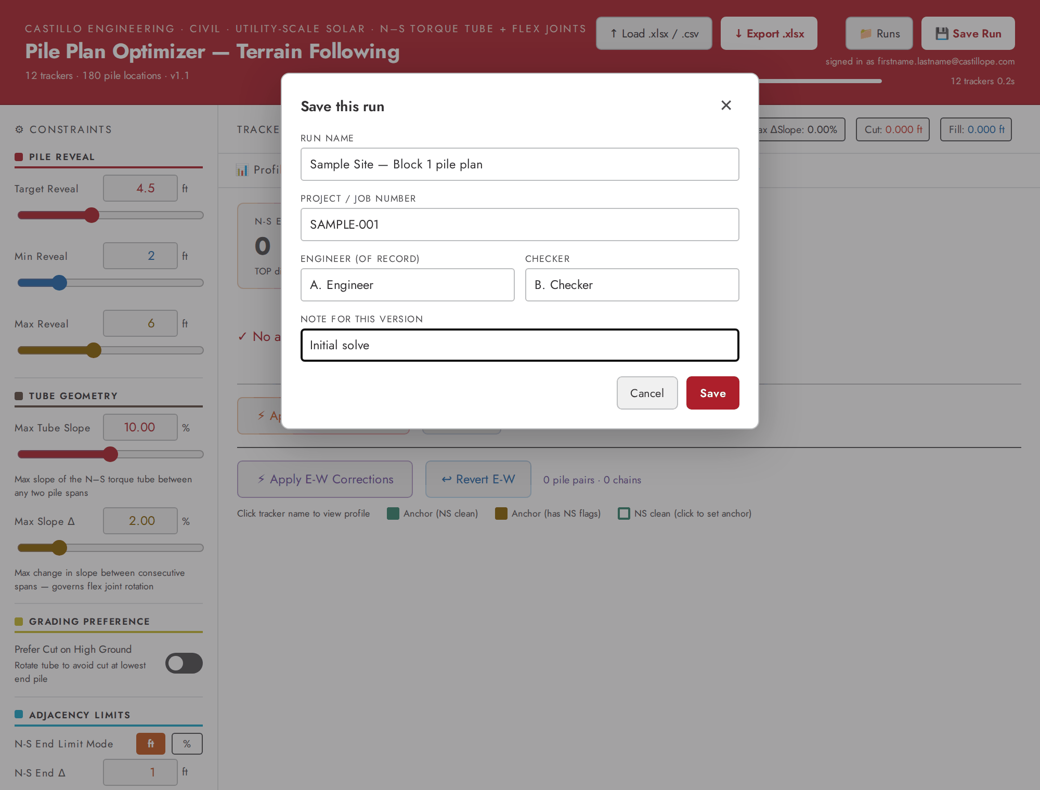
Figure 9. The Save dialog (illustrative values).

10.1.1 What is saved
With each version: the run name and project, engineer, checker, note, who saved it and when, the build of the application, the pile and tracker counts, and a snapshot of the session. The snapshot holds the input rows, all limits, the final results including any corrections, the selected tracker and the E–W anchors. The Revert buttons are not saved.
Snapshots are compressed in your browser before upload. A 200,000-pile fleet measured under 1 MB compressed. The server refuses a save above 32 MiB compressed with the message “Split the site into phases.”

10.2 Opening
Press Runs. The Saved runs window lists runs, newest first, with name, project, latest version, time and who saved it last. Use the search box (name or project), tick show archived to include archived runs, and Load more if the list is long.
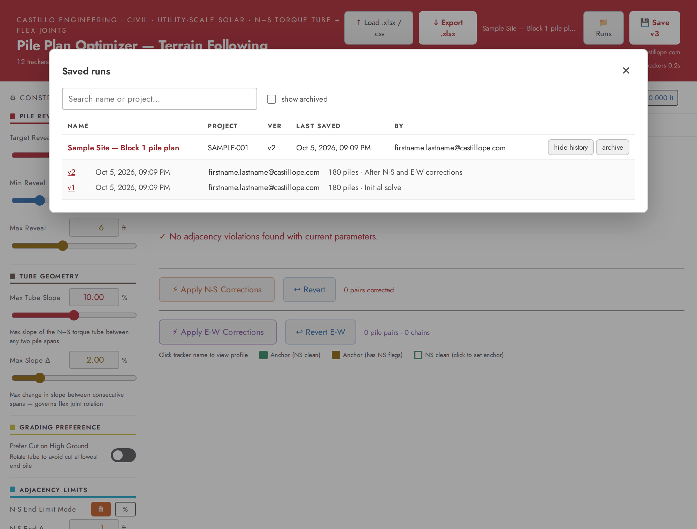
Figure 10. The Saved runs window with the history of a run expanded (illustrative values).
- Click a run name to open its latest version. Click history to list its versions and click a version number to open that one.
- Opening restores the data, limits, results (with corrections), selected tracker and anchors, and takes you to the Fleet tab. The header shows the run name and version.
- If you open an older version the header shows “v1 of 3” (for example) and a message reads “Viewing version 1 of 3 — saving will create version 4.” Saving from it adds a new latest version; it does not rewrite history.
- The Profile, Slope and Piles tabs recalculate their first-pass view from the stored inputs and limits; the Fleet, Adjacency and Export use the saved results.
- The ✕ next to the run name closes the run. The data stay on screen, but the next save creates a new run.
Editing a limit after opening a run
Changing any limit re-solves the site and discards the saved corrections, just as in a new session. Save the result as a new version only if that is what you intend.

10.3 Working with colleagues
Table 4. Who can do what with saved runs.
Action | Who
Save a new run; open any run or version; add a version to any run | Any signed-in staff member. Each version records who saved it.
Rename a run or change its project | The run’s owner (whoever created it) or a run administrator. Other people’s attempts are ignored without a message: their version is saved, the name stays.
Archive or restore a run | The owner or a run administrator. Others see “This run belongs to … Ask them, or a run administrator, to change it.”
Delete a run or a version | Not possible. Archive hides a run from the default list.

If a colleague saves while you are working on the same run, your next save is refused with “Someone saved version N while you were editing. Nothing was lost — click Save again to add your changes as the next version.” Press Save again and your work becomes the next version. Their version is still there in the history.

11 Troubleshooting

11.1 Messages and symptoms
What you see | Likely cause | What to do
The page goes blank (white) after you pick a tracker or click a table row. | Known issue: Profile tab with a tracker that is not a straight line (section 12.1). | Reload the page. Reopen your saved run, or reload the file. Avoid the Profile tab for those trackers.
“No sheet with TrackerID, Northing, Easting, ExistingGround columns found.” | No sheet has the required headers in row 1, or they are spelled differently. | Put the headers in row 1 and use the spellings in section 3.2.
“No valid rows found. Need: TrackerID, Northing, Easting, ExistingGround” | No row has a TrackerID and numeric Northing and ExistingGround, or a CSV is not comma-separated. | Check the data and the header names.
“Parse error: …” | The file is damaged or is not a spreadsheet or CSV. | Re-save it from Excel as .xlsx or .csv and load it again.
Fewer piles loaded than are in the file. | Rows with a blank TrackerID or a non-numeric Northing or ExistingGround are skipped silently. | Compare the count on the Input & Export tab with the file and fix the rows.
No E–W flags or corrections ever appear. | Tracker IDs do not follow <block>-<row>, or Easting is missing. | Rename the trackers (section 3.3) and include Easting.
Export .xlsx is greyed out. | The solve is still running, or no data are loaded. | Wait for the progress bar to finish.
Results and corrections disappeared after touching a slider. | Every limit change restarts the solve and clears corrections. | Set the limits first, then apply corrections.
“A solve is still running — wait for it to finish, then save.” | A save was attempted during a solve or file load. | Wait for the progress indicator, then save.
“Give the run a name first.” | The first save needs a run name. | Enter a name in the Save dialog.
“Someone saved version N while you were editing…” | A colleague saved the same run first. | Press Save again; your work is added as the next version.
“This run belongs to …” | Only the owner or an administrator can archive or restore a run. | Ask the owner or an administrator.
“Compressed payload is X MB; the ceiling is 32 MB. Split the site into phases.” | The snapshot is larger than the server accepts. | Split the site into phases and save each separately.
“Could not reach the server. Check your connection and try again.” | Network problem, or the service is unavailable. | Retry later. Your work on screen is intact; export it meanwhile.
“Limited to Castillo Engineering staff accounts (@castillope.com).” | You signed in with a guest or non-staff account. | Sign out and sign in with your staff account.
“This app is not reachable directly. Sign in at the published address.” | The request reached the application without passing through the sign-in service. | Use https://civiltools.castillope.com.
“Could not establish your identity. Sign in again.” | The sign-in service did not supply your identity. | Sign out and in again.
“This run was saved in an unknown format … It may need a newer version of the app.” | The run was saved by a newer version of the tool. | Reload with Ctrl+F5 to get the current version.
“… fails its integrity hash — do not trust this record.” | The stored data no longer match their checksum. | Do not use the run; report it to the maintainers.
The site address cannot be found. | The DNS record for the address may not have been created yet. | Ask the maintainers (see the Technical Documentation, deployment section).

11.2 Reporting a problem
Report problems to the Castillo civil tools maintainers (the owners of the pile-optimizer repository). Include what you did, the tracker ID, a screenshot, and the build identifier: while signed in, open https://civiltools.castillope.com/api/me in your browser and copy the build value.

12 Known issues and limitations
Status as of 5 October 2026, revision 962d668. Items marked “reproduced” were seen in a running copy of the application; the others are read from the code.

12.1 The Profile tab can blank the page (reproduced)
The Profile tab’s Method Logic card refers to a variable that does not exist (isTF2). It is evaluated for every tracker that is not a straight line. The browser reports “isTF2 is not defined” and, because the application has no error handler, the whole page goes blank.
Safe | Not safe unless the tracker is a straight line
The Slope, Piles, Fleet, Adjacency and Input & Export tabs, for any tracker. | The Profile tab.
Choosing a tracker in the drop-down while a safe tab is open. | Clicking a row in the Fleet table, a row in the N–S flag table, or a tracker name in the E–W flag table (each opens the Profile tab).

To check a tracker first, choose it in the drop-down on the Piles or Slope tab and read the Method chip; open Profile only if it says Straight Line. The sample file has 8 such trackers out of 12. If the page goes blank, reload it; unsaved work is lost, which is a reason to save a run before exploring.

12.2 Other issues (K2 to K13)
ID | Issue | Effect and advice
K2 | Two result sets (first pass versus final). Reproduced. | Chips, Profile, Slope and Piles show the first pass; Fleet, Adjacency, Export and saved runs show the final result. They can differ (section 7.1). Use Fleet and the export as the record.
K3 | Reveal checks use the sliders, not per-pile limits. | The warning marks and red values on Piles and Fleet, and the cut/fill added by N–S and E–W corrections, use the Min Reveal and Max Reveal sliders. If your file has per-pile limits, check them separately.
K4 | E–W table headings are shifted one column. Reproduced. | Read the columns in the order given in section 7.7.
K5 | The Export card says the workbook has two sheets. | It has three: Optimization Results, Tracker Ends and Design Parameters.
K6 | Design Parameters is incomplete. | No adjacency limits, grading preference or per-pile-limit flag; slopes rounded to 0.1 %. Save the run for a full record.
K7 | The export file name is constant and has no cell styling. | Rename the file yourself.
K8 | Every limit change discards corrections. | By design. Apply corrections last.
K9 | Solve time for very large sites has not been measured. | The code targets about 200,000 piles. Split large sites into phases if the solve is slow.
K10 | CSV import: no Easting default and a simple parser. | A CSV without an Easting column leaves it undefined and the site-wide solve cannot work; Excel files substitute 0, which disables E–W checks. Always include Easting. Fields containing commas are not supported.
K11 | Saved runs cannot be deleted and are visible to all staff. | Archive hides a run from the default list only. Do not save data that must not be seen by colleagues.
K12 | No autosave. | Reloading loses unsaved work. Save a run or export before you experiment.
K13 | Status marks are not refreshed by corrections. | The Status column on Fleet and the tick or warning mark next to each tracker in the drop-down come from the solver. After corrections, check the Max Slope % and Max ΔSlope % columns, which are recalculated.

Appendix A Sample file excerpt
The first rows of public/sample-pile-data.xlsx (sheet “Pile Layout”). The full file has 180 rows.
TrackerID | Northing | Easting | ExistingGround | MinReveal | MaxReveal
1-1 | 548077.0000 | 2525548.5470 | 460.9698 | 2.5 | 5.5
1-1 | 548104.0977 | 2525548.5470 | 461.0377 | 2.0 | 6.0
1-1 | 548131.1954 | 2525548.5470 | 460.9074 | 2.0 | 6.0
1-1 | 548158.2931 | 2525548.5470 | 460.5952 | 2.0 | 6.0
1-1 | 548185.3908 | 2525548.5470 | 460.2563 | 2.0 | 6.0
1-1 | 548212.4885 | 2525548.5470 | 460.0375 | 2.0 | 6.0
1-1 | 548239.5862 | 2525548.5470 | 460.0277 | 2.0 | 6.0
1-1 | 548266.6839 | 2525548.5470 | 460.2975 | 2.0 | 6.0

End piles are held to MinReveal 2.5 / MaxReveal 5.5 ft; interior piles to 2.0 / 6.0 ft. Elevations and coordinates are in feet.

