

HOURLY BILLING RATES
• Project Engineer $250 • Senior Engineer $350
• Project Manager $300 • Administrative Tasks $150
Change Order Valid for 30 days.
30% Deposit. Remaining deliverables invoiced upon their respective milestones.
All documents delivered in PDF format. Hard copies - $0.50 per sq. ft.
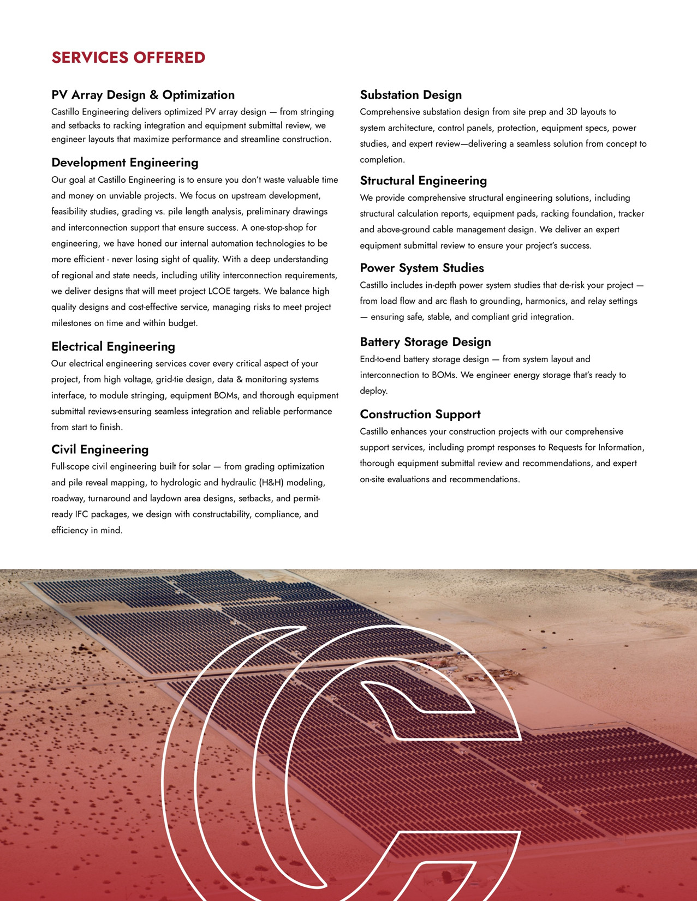

PREPARED BY
{{PREPARER_NAME}}
{{PREPARER_TITLE}}
{{PREPARER_PHONE}}
{{PREPARER_EMAIL}}
Castillo Engineering Services, LLC
1060 Maitland Center Commons, Suite 270, Maitland, FL 32751

