**FLOOD MONITORING AND EARLY WARNING SYSTEM USING ULTRASONIC SENSOR**

|  |  |
| --- | --- |
| **TEAM ID** | **Proj_220535_Team_3** |
| **TEAM MEMBERS** | 1. **H.BABULAL** 2. **N.JAYASURYA** 3. **B.SATHIKALI** 4. **M.CHANDRU** 5. **S.SOUNDARRAJ** |

**1. Introduction**

Floods are among the most devastating natural disasters, causing loss of life, property damage, and significant economic and environmental impacts. In response to the increasing frequency and severity of floods, flood monitoring and early warning systems have emerged as critical tools for disaster mitigation. These systems leverage technology, data collection, and predictive models to provide timely information and alerts to communities at risk, enabling them to take proactive measures to minimize the impact of flooding.

In most countries in the world, flood had caused damages to properties and it involved a large amount of loss to individuals and governments. During flood, it is important to have efficient flood response operation system to manage all activities among different related agencies.

These last decades, lots of flooding risk technologies has been developed to minimize the danger of flood in inhabited areas. Currently, the Philippine government funded the Project NOAH of the Department of Science and Technology (DOST). They installed Automated Rain Gauges (ARG) and Water Level Monitoring Stations (WLMS) along the country’s major river basins (RBs) [1]. However, project NOAH is still under development in which some essential information are not yet available to view in their website.

Most of these technologies being developed commonly apply in weather forecasting, flood detection and monitoring system using sensing devices, modeling software, Internet and mobile technology [2]. However, these systems are usually for one-way communication only. In order to get an update or latest information, local communities need to access the website. And in accessing this website, it requires computer or smart phone that has an Internet feature, and most individual could hardly afford to purchase one. In addition to that, individuals are busy for their daily routine, and monitoring activity cannot be their priority [1]. These are the reasons why communities are blinded with the current status of the nearby river watershed. The unawareness led to the overflow of the watercourses of the river waterway and the subsequent inundation of various localities causing extensive damages to properties and human life.

The City of Ilagan is located at the central portion in the province of Isabela. It is the River Basin of its neighboring towns particularly in the southern portion of the province. Floods caused by these rivers flow down very slowly because of surface retention over the extensive flood plain, extremely gentle slope, retardation of flood by several gorges and river meander .

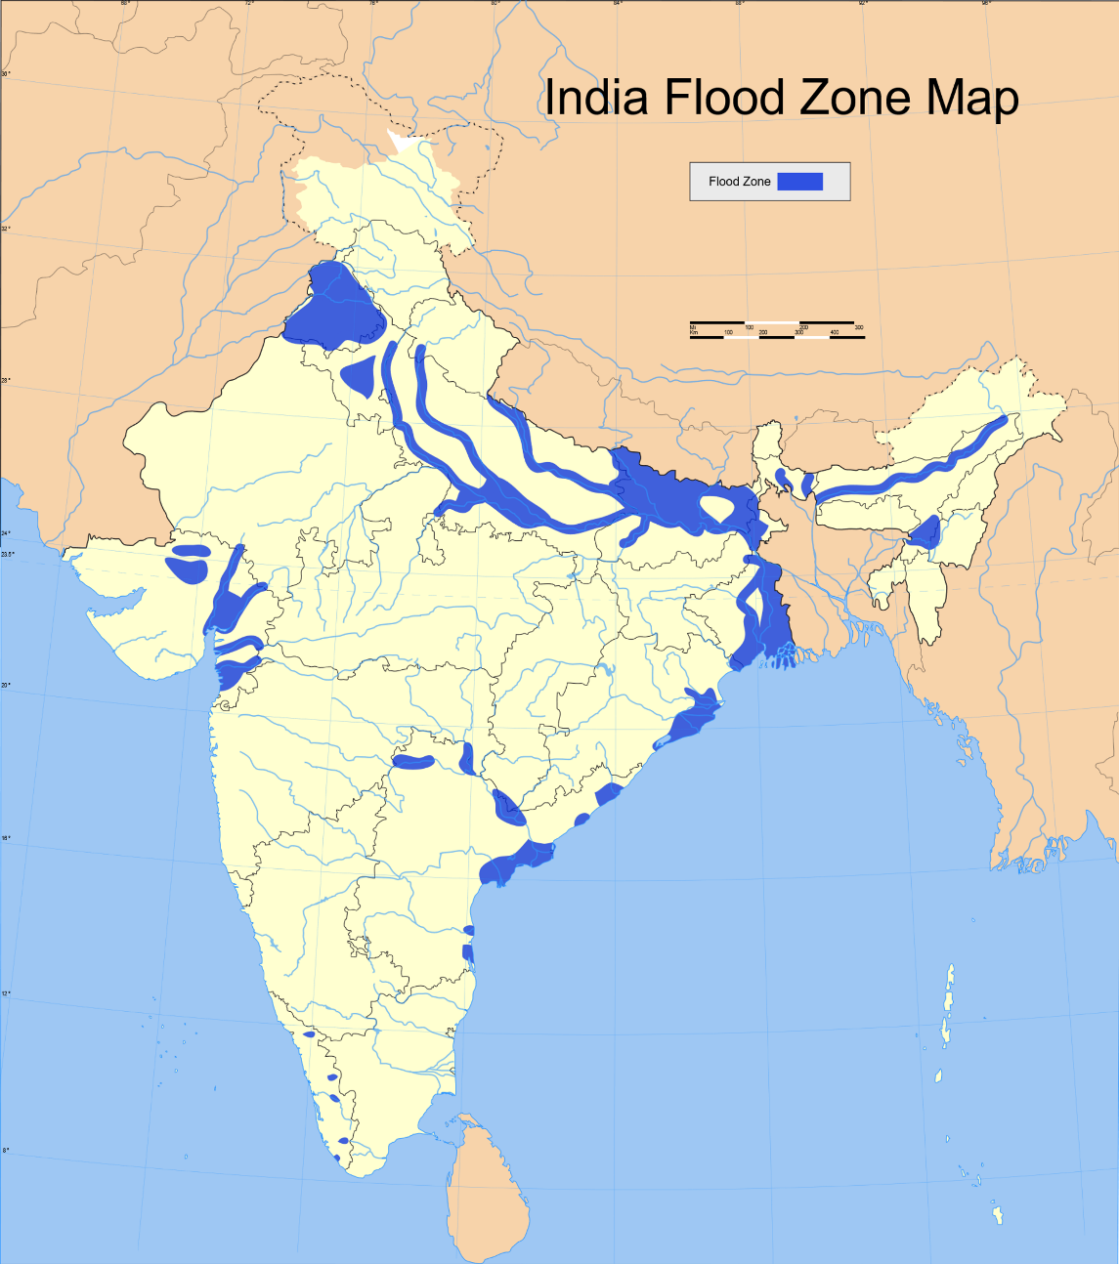

**Figure 1**. Geographical Map of Flooded Areas in India

This paper presents a project that is more localized to help the communities affected by flood in the province of Isabela particularly in the northern area by providing an interactive and real-time information on the current water level in the two majors portion of the province. This project also widens the coverage of people that can receive the information to improve the emergency measures during floods.

Furthermore, this study builds a prototype that detects the current water level across the watershed of Cagayan River and its surrounding areas through ultrasonic sensors. The geographical area was subdivided into two, where monitoring devices were installed. Specifically, the objectives of this study is to create a flood monitoring system that monitor the water level of the rivers using ultrasonic sensors and to design and develop an early warning system.

**2. Architectural Framework**

The two monitoring devices are composed of Ultrasonic sensor to measure the distance of the water level, Arduino micro-controller that process the signal from the sensor, GSM module to send the data or information from the micro-controller to the computer server and a power source using Solar Panel, Regulator and Battery. Once a sensor is triggered, an output signal will be relayed to the micro-controller which serves as a switch that triggers the connected GSM module to send an alert message or water level status to another GSM modem connected to a computer server. Then, the developed program installed in the computer server will interpret and analyze the message received then automatically send a text message to the concern agencies’ numbers stored in a database. Also, the developed program will then automatically relay the alert message or status by uploading to the developed website. Furthermore, concern agencies, local officials and the local communities could inquire about the current status by sending a message that contains keywords.

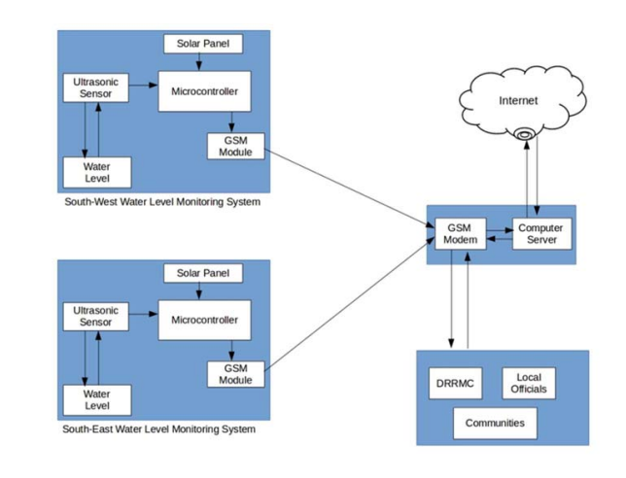

**Figure 2**. Architecture Design

This paper presents the utilization of ultrasonic sensors because of its capability and reliability. Since the Philippines is considered among the most flood prone in the world due to variety of factors, the project NOAH relies on Ultrasonic sensors for water level monitoring. Ultrasonic sensors are deployed on hundreds of coastal tide gauge platforms that provide tsunami and tropical storm surge warning data.

They are also deployed on similar platforms that monitor flooding on the different rivers. The newest flood warning system is being deployed to monitor flooding on urban street. And with continues development in ultrasonic sensing, the researchers opted to use this sensor for the project. The use of GSM also presented in this paper for transmitting data and as mode of communication to the concern stakeholders of this project.

Due to its simplicity and availability to the public now-a-days, it is very obvious that information dissemination can be easily achieved. Specifically, the study utilizes the use of SMS for the reason that aside for being the cheapest way to avail and transmit information in a remote area, it doesn’t require high data bandwidth.

**3. Approach**

The ultimate aim is to build a water level detection using ultrasonic sensor to monitor the rivers in the south-east and south-west portion of the province of Isabela and develop a web and SMS application as an early warning system that provides essential information to the local communities and concern agencies. An SMS approach was used for transmitting data from the monitoring system to the computer server and for sending notification to the concern stakeholders. The SMS application was installed in the computer server to process the received data and make proper action. The application also implement fuzzy logic algorithm for decision making.

The inputs of the algorithm are the water level status coming from the two monitoring systems sent through SMS. A threshold value was set in the two monitoring system as basis for the Arduino to trigger the GSM module to send an SMS to the computer server. Then the developed program installed in the computer server send an SMS notification to the concern stakeholders and uploads an update post in the developed web-based monitoring system. After the development of the prototype, the model had undergone several tests and experimentations to check the effectiveness of the system.

**4. Result**

***Flood monitoring system that monitors the water level of the rivers using ultrasonic sensor:***

The researchers played out a model, test the ease of use and dependability of the developed prototype. It was tried first in a prototype environment that the researchers made and played out the trial. The test decided whether it meets the necessities of the client. The figure below shows the prototype assembled and the connection of the different hardware components.

***Prototype Monitoring System Testing:***

The researchers tested the developed prototype through a temporary basin to test the level of water. The inputs have several sub-parameters to obtain accurate data. In the designed prototype, water level is measured in inches. The input has four options to consider. When the water level exceed the threshold value set in the script that was uploaded in the Arduino Micro-controller, a notification message containing the level of water and the alert level will be sent to the computer server. The table below shows the different option as input for the monitoring system.

***Table 1.*** Threshold Value Set for Prototype Testing

|  |  |  |
| --- | --- | --- |
| **Water level (inches)** | **Alert Level** | **SMS Notification Delivery** |
| 5” and below | Normal | 10 minutes interval |
| 6”-10” | Moderate | 5 minutes interval |
| 11”-15” | Critical | 1 minute interval |
| 16” and above | Emergency | 1 minute interval |

***Design and develop an early warning system using Web and SMS:***

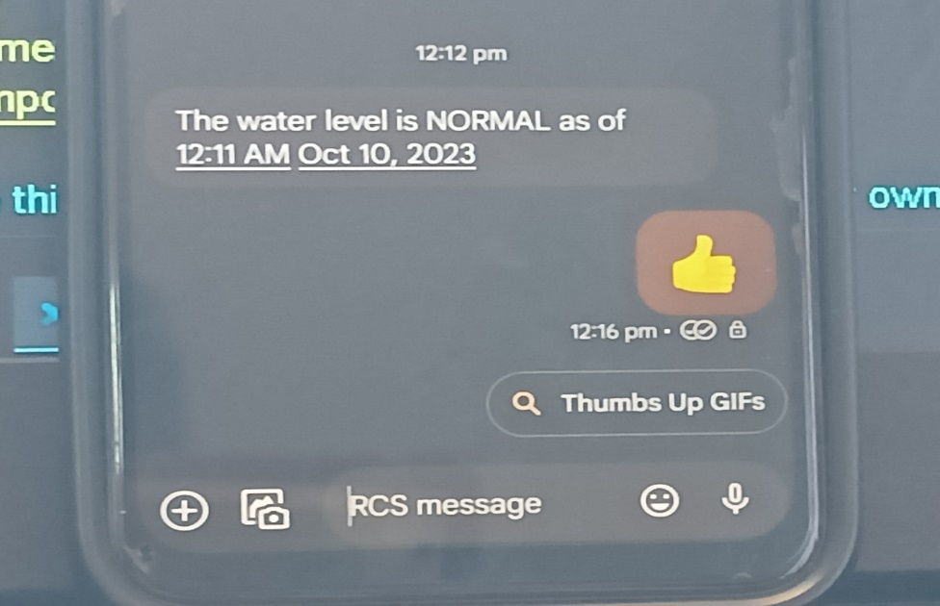

The researchers developed two different platforms in disseminating information to the concern stakeholders for a possible flood event. One would be the real-time monitoring through a web-based system that can be access through the Internet. Another one is the SMS notification system wherein an automatic communication between the system and the local communities and other concern agencies in the province of India.

The web-based monitoring system was written in PHP programming language and used MySQL as back-end to store information uploaded by the SMS notification system. The web-based monitoring system also contains the different information for monitoring flood such as level of water, alert level, flood warning status, affected areas and update logs. Also the web application automatically updated when new information was uploaded.

Also, the developed SMS application allows concern individuals to inquire about the current status of a possible flood event. By sending a message containing the keywords “Flood Status”, the system will send a reply message that contains the alert level, flood warning status and areas affected by flood. By this feature it allows the system to perform two-way communication between the system and the community in general.

**5. Conclusion**

The project contributes towards economy and the citizens. It envisions a safe, prepared and less casualty community before, during and after typhoon devastation. The model also promotes the use of real-time monitoring system through the developed web-based application and SMS notification system as an easy medium in disseminating information particularly in the remote areas. By allowing the system in two-way communication, it gives more flexibility in providing important information to the community.

Finally, the developed flood monitoring and early warning system that utilizes ultrasonic sensor to detect water level, functions perfectly according to the specification provided. It successfully passed several tests based on the different parameters.