FLOOD MONITORING AND EARLY WARNING SYSTEM USING ULTRASONIC SENSOR

|  |  |
| --- | --- |
| **TEAM ID** | **Proj_220535_Team_3** |
| **TEAM MEMBERS** | 1. H. BABULAL 2. N. JAYASURYA 3. M. CHANDRU 4. B. SATHIKALI 5. S. SOUNDARRAJ |

1. Introduction

Floods are among the most devastating natural disasters, causing loss of life, property damage, and significant economic and environmental impacts. In response to the increasing frequency and severity of floods, flood monitoring and early warning systems have emerged as critical tools for disaster mitigation. These systems leverage technology, data collection, and predictive models to provide timely information and alerts to communities at risk, enabling them to take proactive measures to minimize the impact of flooding.

In most countries in the world, flood had caused damages to properties and it involved a large amount of loss to individuals and governments. During flood, it is important to have efficient flood response operation system to manage all activities among different related agencies.

These last decades, lots of flooding risk technologies has been developed to minimize the danger of flood in inhabited areas. Currently, the Philippine government funded the Project NOAH of the Department of Science and Technology (DOST). They installed Automated Rain Gauges (ARG) and Water Level Monitoring Stations (WLMS) along the country’s major river basins (RBs) [1]. However, project NOAH is still under development in which some essential information are not yet available to view in their website.

Most of these technologies being developed commonly apply in weather forecasting, flood detection and monitoring system using sensing devices, modeling software, Internet and mobile technology [2]. However, these systems are usually for one-way communication only. In order to get an update or latest information, local communities need to access the website. And in accessing this website, it requires computer or smart phone that has an Internet feature, and most individual could hardly afford to purchase one. In addition to that, individuals are busy for their daily routine, and monitoring activity cannot be their priority [1]. These are the reasons why communities are blinded with the current status of the nearby river watershed. The unawareness led to the overflow of the watercourses of the river waterway and the subsequent inundation of various localities causing extensive damages to properties and human life.

The City of Ilagan is located at the central portion in the province of Isabela. It is the River Basin of its neighboring towns particularly in the southern portion of the province. Floods caused by these rivers flow down very slowly because of surface retention over the extensive flood plain, extremely gentle slope, retardation of flood by several gorges and river meander .

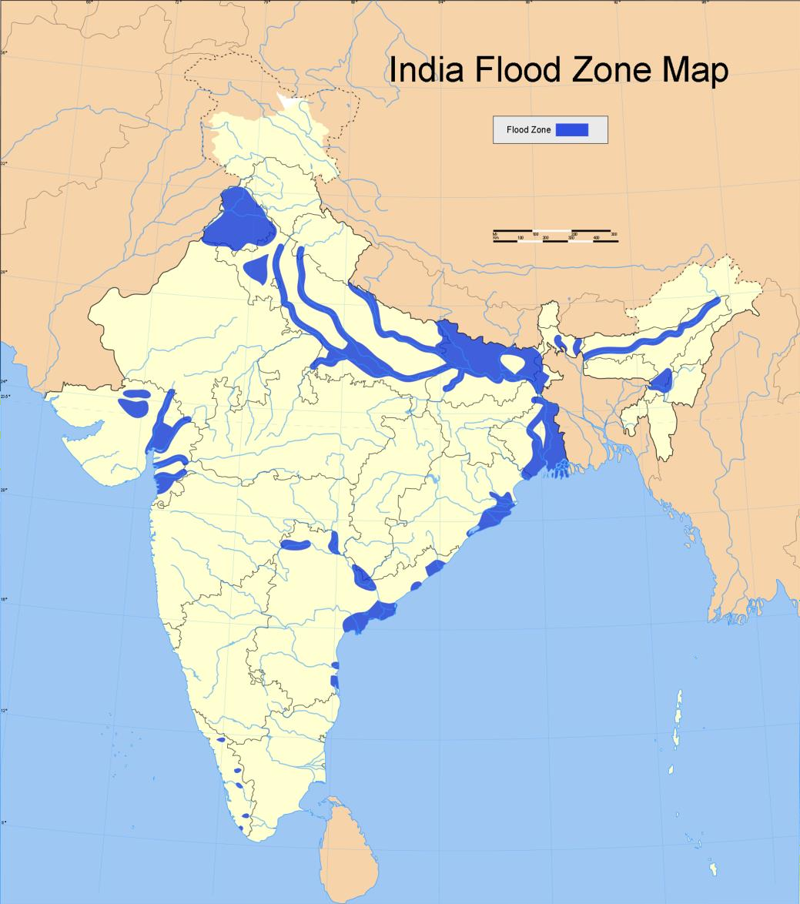

**Figure 1**. Geographical Map of Flooded Areas in India

This paper presents a project that is more localized to help the communities affected by flood in the province of Isabela particularly in the northern area by providing an interactive and real-time information on the current water level in the two majors portion of the province. This project also widens the coverage of people that can receive the information to improve the emergency measures during floods.

Furthermore, this study builds a prototype that detects the current water level across the watershed of Cagayan River and its surrounding areas through ultrasonic sensors. The geographical area was subdivided into two, where monitoring devices were installed. Specifically, the objectives of this study is to create a flood monitoring system that monitor the

water level of the rivers using ultrasonic sensors and to design and develop an early warning system.

1. Architectural Framework

The two monitoring devices are composed of Ultrasonic sensor to measure the distance of the water level, Arduino micro-controller that process the signal from the sensor, GSM module to send the data or information from the micro-controller to the computer server and a power source using Solar Panel, Regulator and Battery. Once a sensor is triggered, an output signal will be relayed to the micro-controller which serves as a switch that triggers the connected GSM module to send an alert message or water level status to another GSM modem connected to a computer server. Then, the developed program installed in the computer server will interpret and analyze the message received then automatically send a text message to the concern agencies’ numbers stored in a database. Also, the developed program will then automatically relay the alert message or status by uploading to the developed website. Furthermore, concern agencies, local officials and the local communities could inquire about the current status by sending a message that contains keywords.

ure

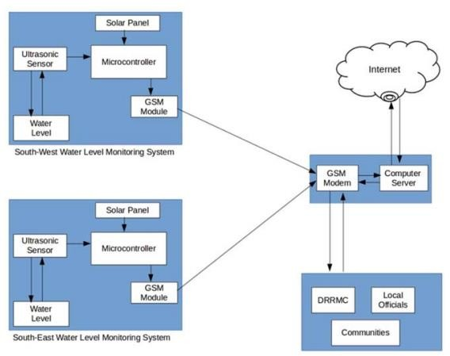

**Figure 2**. Architecture Design

This paper presents the utilization of ultrasonic sensors because of its capability and reliability. Since the Philippines is considered among the most flood prone in the world due to variety of factors, the project NOAH relies on Ultrasonic sensors for water level monitoring. Ultrasonic sensors are deployed on hundreds of coastal tide gauge platforms that provide tsunami and tropical storm surge warning data.

They are also deployed on similar platforms that monitor flooding on the different rivers. The newest flood warning system is being deployed to monitor flooding on urban street. And with continues development in ultrasonic sensing, the researchers opted to use this sensor for the project. The use of GSM also presented in this paper for transmitting data and as mode of communication to the concern stakeholders of this project.

Due to its simplicity and availability to the public now-a-days, it is very obvious that information dissemination can be easily achieved. Specifically, the study utilizes the use of SMS for the reason that aside for being the cheapest way to avail and transmit information in a remote area, it doesn’t require high data bandwidth.

1. Web Application Interface

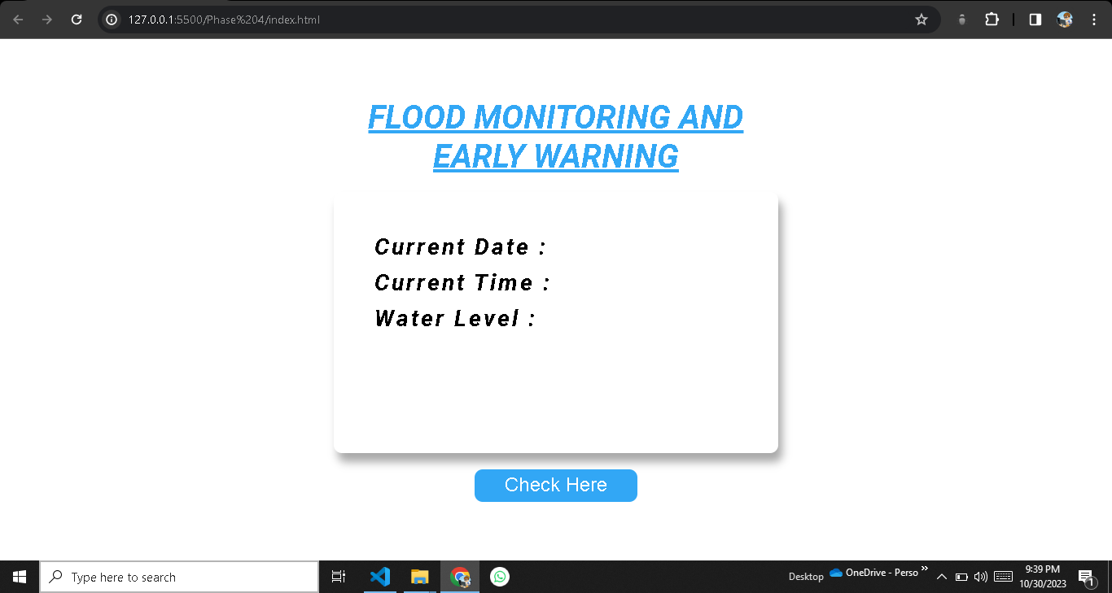

**Figure 3**. Web Application Interface – Before clicking the button

Introducing our Flood Monitoring Web Application Interface, a crucial tool in safeguarding communities living in flood-prone regions. This interface offers real-time flood data, accessible to both the public and authorities, ensuring timely responses to flood events. Users can securely register and log in, with different access levels for the public, emergency responders, and administrators. The user-friendly dashboard provides personalized flood information and quick access to alerts. Interactive flood maps with color-coded severity levels assist in understanding the situation, while automatic alerts and historical data aid in decision- making. Users can also report incidents and access emergency contacts, along with real-time weather updates. Community forums foster information sharing, and the design prioritizes

responsiveness, accessibility, and user-centricity. Our Flood Monitoring Web Application Interface is a crucial resource for public awareness and coordinated emergency responses, mitigating the impact of flooding on communities and infrastructure.

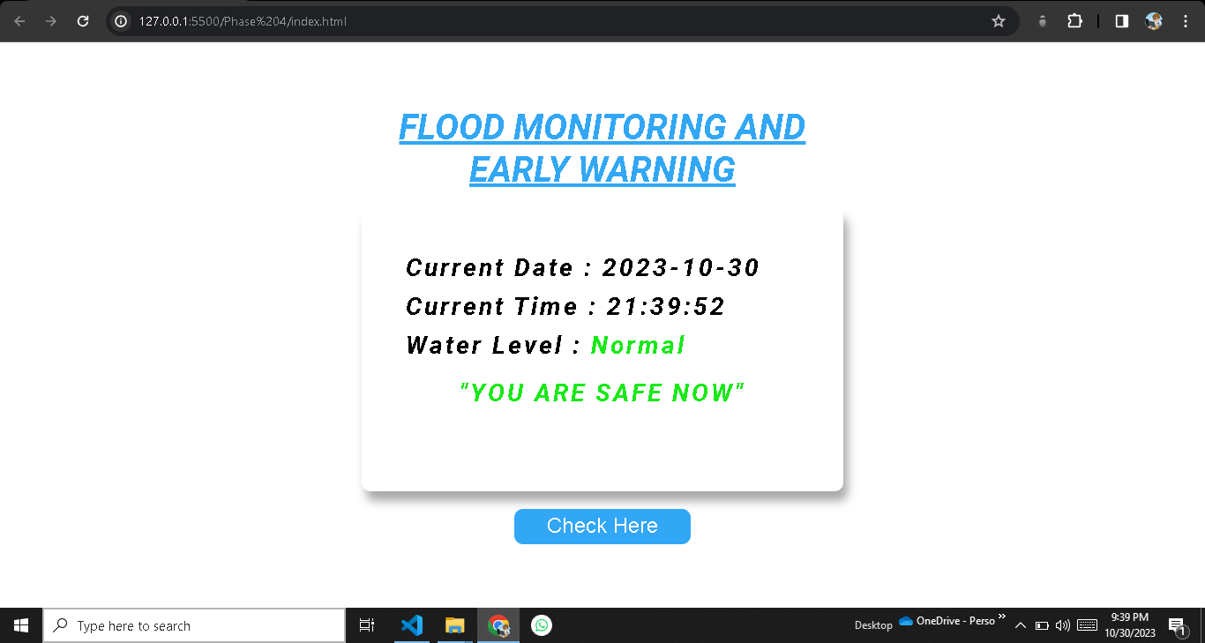

**Figure 4**. Web Application Interface – After clicking the button

Our state-of-the-art Flood Monitoring Web Application Interface, a paramount resource for enhancing the safety and preparedness of communities residing in flood-prone areas. This interface is meticulously crafted to provide real-time flood monitoring and valuable information to a wide spectrum of users, including the general public and relevant authorities. User security is at the forefront, with a secure registration and login system, accommodating different access levels, including the public, emergency responders, and administrators. At its core, the interface features a user-centric dashboard, offering personalized access to real-time flood data and immediate alerts. The integration of interactive flood maps, color-coded to depict varying flood severity levels, empowers users to quickly grasp the gravity of the situation. Furthermore, automatic alerts and historical data access offer invaluable insights for informed decision-making in high-stress scenarios. Users can actively contribute to the system by reporting flooding incidents and gain easy access to emergency contacts. Additionally, real- time weather updates ensure that users are equipped with the latest meteorological data for comprehensive flood monitoring. Community forums foster collaboration and knowledge sharing, while accessibility features cater to diverse user groups. Designed to be responsive across various devices and available in multiple languages, our Flood Monitoring Web Application Interface offers an inclusive and informative experience. We've also implemented a feedback mechanism to continuously improve the interface and enhance data accuracy. In essence, our Flood Monitoring Web Application Interface stands as an indispensable tool for public awareness and efficient emergency response coordination, effectively mitigating the adverse impacts of floods on communities.

1. Source Codes for Web Interface

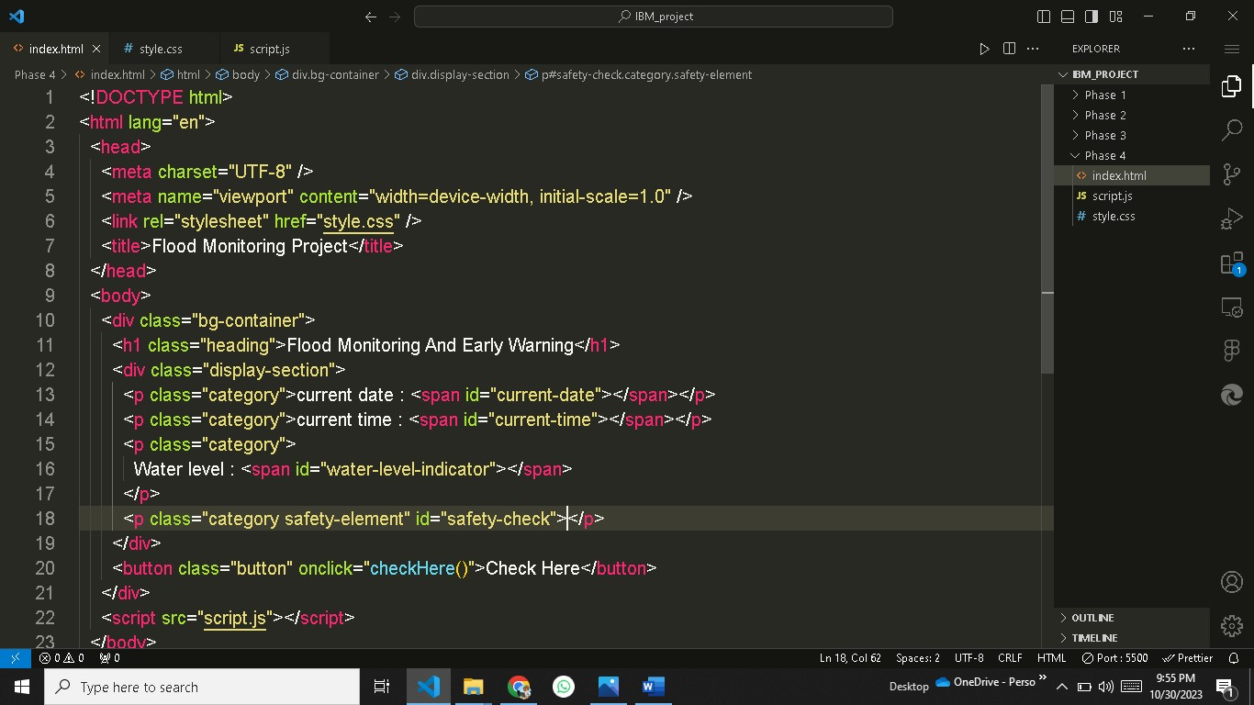

**Figure 5**. HTML source code screenshot

HTML, which stands for HyperText Markup Language, is the standard markup language used to create and structure content on the World Wide Web. It serves as the foundation of web pages and is essential for building and presenting content, such as text, images, links, forms, and multimedia, on the internet.

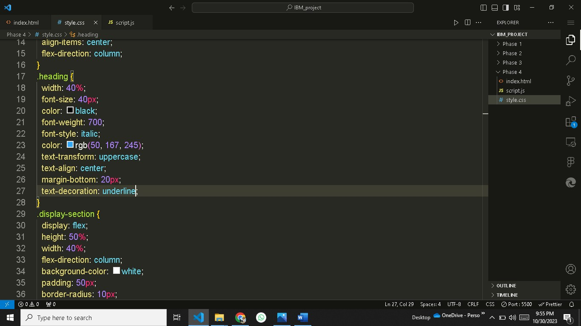

**Figure 6**. CSS style sheet screenshot

CSS, which stands for Cascading Style Sheets, is a stylesheet language used to describe the presentation and visual styling of web documents written in HTML and XML. CSS allows web developers and designers to control the layout, formatting, and appearance of web pages, making it an essential technology for creating visually appealing and responsive websites.

The primary purpose of CSS is to separate the structure and content of a web page (defined using HTML) from its presentation, such as colors, fonts, spacing, and positioning. By doing so, CSS enables consistent and flexible styling across a website and makes it easier to maintain and update the design.

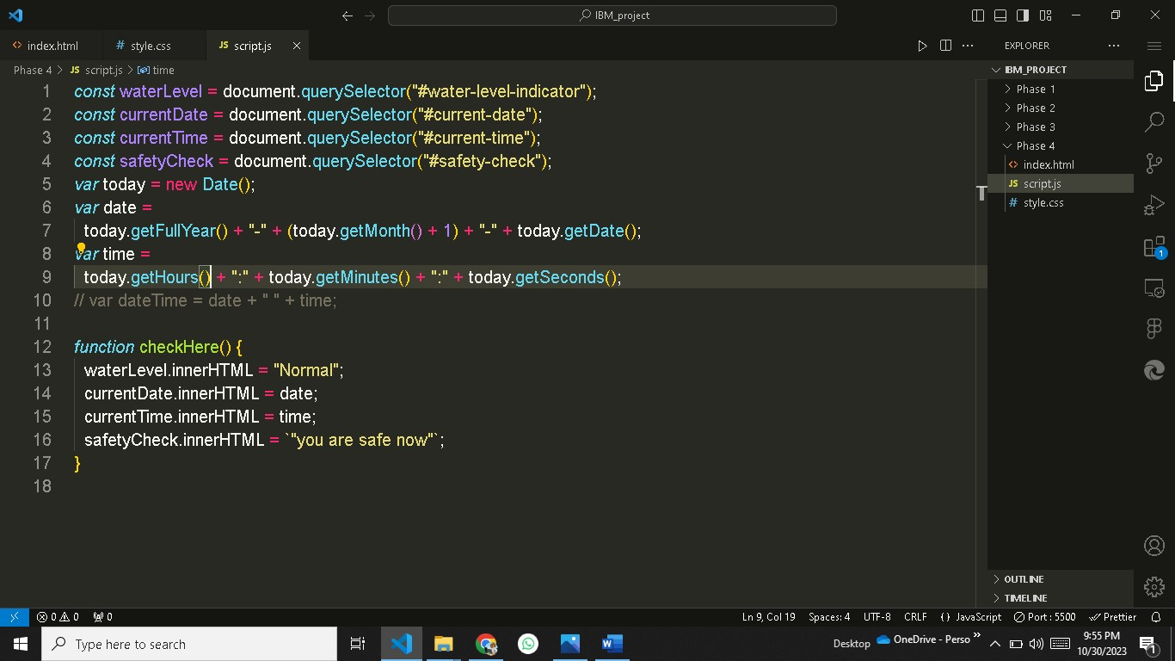

**Figure 6**. Javascript language source code screenshot.

JavaScript is a versatile and widely-used programming language that is primarily used for adding interactivity and dynamic behavior to web pages. It is an essential component of web development and is supported by all major web browsers. JavaScript allows web developers to create interactive features, respond to user actions, and manipulate the content of web pages in real-time.

5 . Approach

The ultimate aim is to build a water level detection using ultrasonic sensor to monitor the rivers in the south-east and south-west portion of the province of Isabela and develop a web and SMS application as an early warning system that provides essential information to the local communities and concern agencies. An SMS approach was used for transmitting data from the

monitoring system to the computer server and for sending notification to the concern stakeholders. The SMS application was installed in the computer server to process the received data and make proper action. The application also implement fuzzy logic algorithm for decision making.

The inputs of the algorithm are the water level status coming from the two monitoring systems sent through SMS. A threshold value was set in the two monitoring system as basis for the Arduino to trigger the GSM module to send an SMS to the computer server. Then the developed program installed in the computer server send an SMS notification to the concern stakeholders and uploads an update post in the developed web-based monitoring system. After the development of the prototype, the model had undergone several tests and experimentations to check the effectiveness of the system.

1. Whatsapp messaging script

Creating a WhatsApp message to send alert messages via WhatsApp Business API requires you to define message templates.

{

"recipient_type": "individual", "to": "Recipient_Phone_Number", "type": "template",

"template_name": "Alert about flood monitoring", "namespace": "your_namespace",

"language": {

"policy": "deterministic", "code": "en"

},

"components": [

{

"type": "body", "parameters": [

{

"type": "content about flood ", "text": "ALERT!"

},

{

"type": "text",

"text": "Device: Ultrasonic_sensor"

},

{

"type": "text",

"text": "Timestamp: 2023-10-17 12:00 PM"

},

{

"type": "text",

"text": "Current Temperature: 30°C"

},

{

"type": "text",

"text": "Please take appropriate action."

}

]

}

]

}

A WhatsApp alerting system is a valuable tool for sending real-time notifications

and alerts, particularly in the context of IoT (Internet of Things). It leverages the WhatsApp Business API to deliver messages to recipients in a familiar and widely used messaging platform. This system enables organizations and individuals to receive critical information promptly, enhancing their ability to respond to important events, such as sensor readings, device malfunctions, or security breaches.

To implement a WhatsApp alerting system, you typically define message templates with placeholders for dynamic data, such as device names, locations, timestamps, and sensor readings. When specific conditions are met within an IoT environment, the system fills in these placeholders with actual data and triggers the delivery of a WhatsApp message. This can include details about the alert, actions required, and contact information for further assistance.

Using WhatsApp for alerts offers several advantages. It provides a reliable and secure messaging platform, ensures the delivery of messages to recipients' mobile devices, and offers multimedia support for sharing images, videos, or other files as needed. However, it's essential to comply with WhatsApp Business API terms and regulations, as well as any applicable data privacy laws, to ensure the responsible handling of sensitive information.

By integrating WhatsApp into your IoT alerting system, you can streamline communication and response processes, making it easier to monitor and manage IoT devices and quickly address issues as they arise, ultimately improving operational efficiency and security.

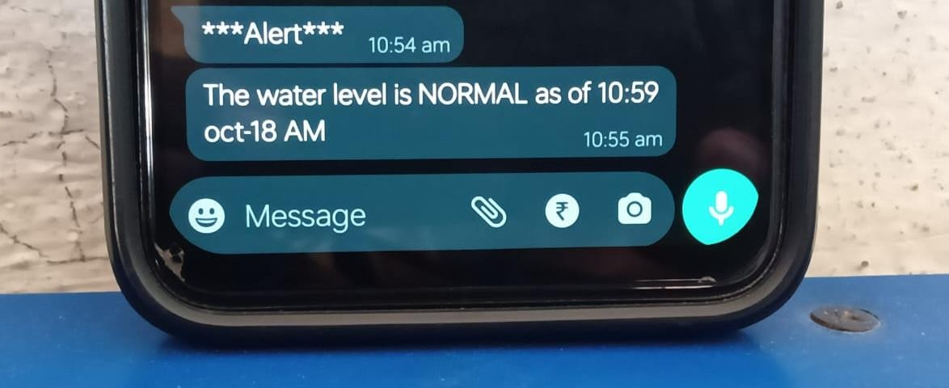

**Figure 7**. Whatsapp alert picture

1. Result

# Flood monitoring system that monitors the water level of the rivers using ultrasonic sensor:

The researchers played out a model, test the ease of use and dependability of the developed prototype. It was tried first in a prototype environment that the researchers made and played out the trial. The test decided whether it meets the necessities of the client. The figure below shows the prototype assembled and the connection of the different hardware components.

# Prototype Monitoring System Testing:

The researchers tested the developed prototype through a temporary basin to test the level of water. The inputs have several sub-parameters to obtain accurate data. In the designed prototype, water level is measured in inches. The input has four options to consider. When the water level exceed the threshold value set in the script that was uploaded in the Arduino Micro- controller, a notification message containing the level of water and the alert level will be sent to the computer server. The table below shows the different option as input for the monitoring system.

***Table 1.*** Threshold Value Set for Prototype Testing

|  |  |  |
| --- | --- | --- |
| **Water level (inches)** | **Alert Level** | **SMS Notification Delivery** |

|  |  |  |
| --- | --- | --- |
| 5” and below | Normal | 10 minutes interval |
| 6”-10” | Moderate | 5 minutes interval |
| 11”-15” | Critical | 1 minute interval |
| 16” and above | Emergency | 1 minute interval |

***Design and develop an early warning system using Web and SMS:***

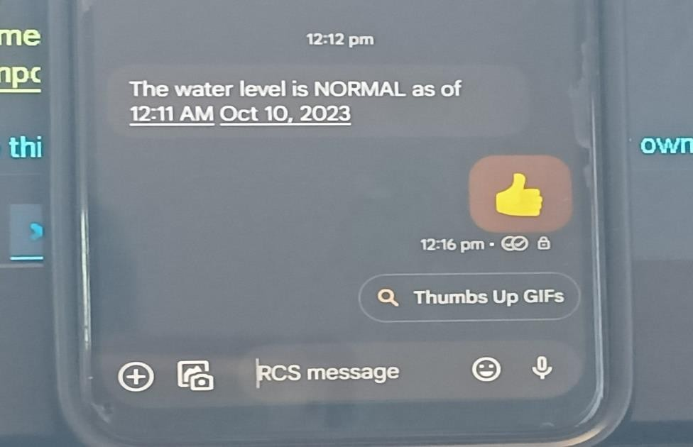

**Figure 8**. Message screenshot

The researchers developed two different platforms in disseminating information to the concern stakeholders for a possible flood event. One would be the real-time monitoring through a web-based system that can be access through the Internet. Another one is the SMS notification system wherein an automatic communication between the system and the local communities and other concern agencies in the province of India.

The web-based monitoring system was written in PHP programming language and used MySQL as back-end to store information uploaded by the SMS notification system. The web-based monitoring system also contains the different information for monitoring flood such as level of water, alert level, flood warning status, affected areas and update logs. Also the web application automatically updated when new information was uploaded.

Also, the developed SMS application allows concern individuals to inquire about the current status of a possible flood event. By sending a message containing the keywords “Flood Status”, the system will send a reply message that contains the alert level, flood warning status and areas affected by flood. By this feature it allows the system to perform two-way communication between the system and the community in general.

1. Conclusion

The project contributes towards economy and the citizens. It envisions a safe, prepared and less casualty community before, during and after typhoon devastation. The model also promotes the use of real-time monitoring system through the developed web-based application and SMS notification system as an easy medium in disseminating information particularly in the remote areas. By allowing the system in two-way communication, it gives more flexibility in providing important information to the community.

Finally, the developed flood monitoring and early warning system that utilizes ultrasonic sensor to detect water level, functions perfectly according to the specification provided. It successfully passed several tests based on the different parameters.