MAIN DDR (DETAILED DIAGNOSTIC REPORT)
Generated strictly from: Sample Report.pdf and Thermal Images.pdf
Rule followed: no outside data, no invented facts; missing or unclear details are marked as Not Available.

Source Document Details
Field | Extracted value
Inspection date and time | 27.09.2022 14:28 IST
Inspected by | Krushna & Mahesh
Property type | Flat
Floors | 11
Previous structural audit done | No
Previous repair work done | No
Thermal report date | 27/09/22
Thermal device | GTC 400 C Professional

1. Property Issue Summary
- Point 1: Observed dampness at the skirting level of Hall of Flat No. 103; linked exposed side finding: Observed gaps between the tile joints of Common Bathroom of Flat No. 103.
- Point 2: Observed dampness at the skirting level of the Common Bedroom of Flat No. 103; linked exposed side finding: Observed gaps between the tile joints of Common Bathroom of Flat No. 103.
- Point 3: Observed dampness at the skirting level of Master Bedroom of Flat No. 103; linked exposed side finding: Observed gaps between the tile joints of Master Bedroom Bathroom of Flat No. 103.
- Point 4: Observed dampness at the skirting level of Kitchen of Flat No. 103; linked exposed side finding: Observed gaps between the tile joints of Master Bedroom Bathroom of Flat No. 103.
- Point 5: Observed dampness & efflorescence on the wall surface of Master Bedroom of Flat No. 103; linked exposed side finding: Observed cracks on the External wall of building near Master Bedroom of Flat No. 103.
- Point 6: Observed leakage at the Parking ceiling below Flat No. 103; linked exposed side finding: Observed plumbing issue & gaps between the tile joints of Common Bathroom of Flat No. 103.
- Point 7: Observed mild dampness at the ceiling of Common Bathroom of Flat No. 103; linked exposed side finding: Observed gap between tile joints of Common & Master Bedroom Bathrooms of Flat No. 203.

2. Area-wise Observations

Point 1 - Hall of Flat No. 103
Inspection observation: Observed dampness at the skirting level of Hall of Flat No. 103
Linked exposed/positive-side observation: Observed gaps between the tile joints of Common Bathroom of Flat No. 103
Thermal readings from mapped thermal pages: Page 1 (RB02380X.JPG): Hotspot 28.8 °C, Coldspot 23.4 °C; Page 2 (RB02386X.JPG): Hotspot 27.4 °C, Coldspot 22.4 °C; Page 3 (RB02395X.JPG): Hotspot 27 °C, Coldspot 22 °C; Page 4 (RB02402X.JPG): Hotspot 25.7 °C, Coldspot 20.7 °C
Image evidence from provided PDFs:
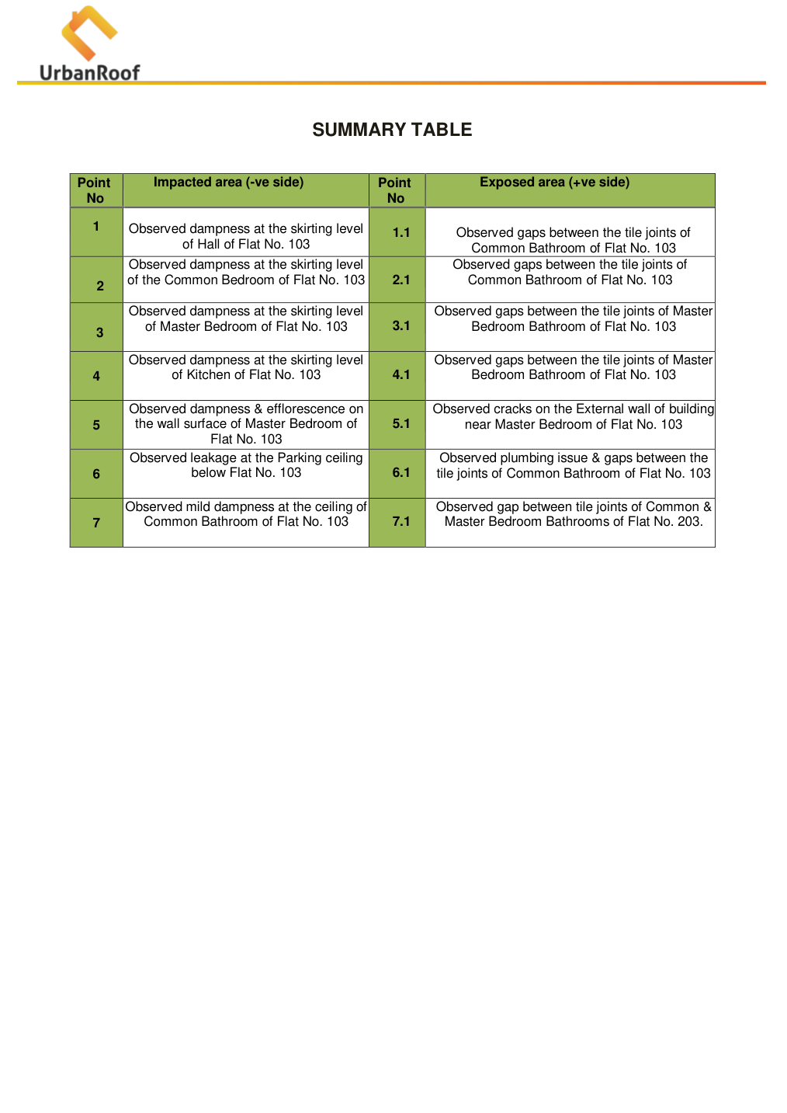
Inspection PDF page 10 - summary/source evidence
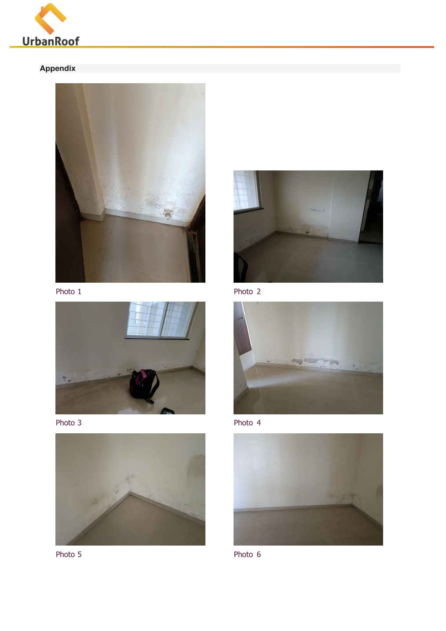
Inspection PDF page 11 - area/photo evidence
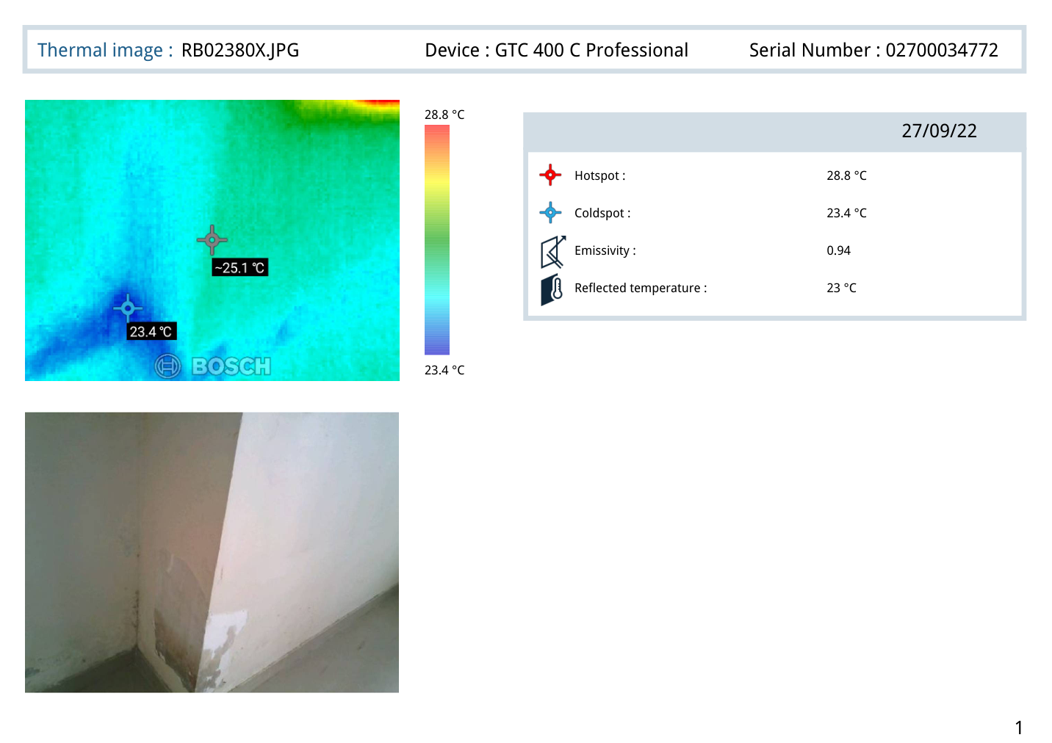
Thermal Images PDF page 1 - thermal evidence
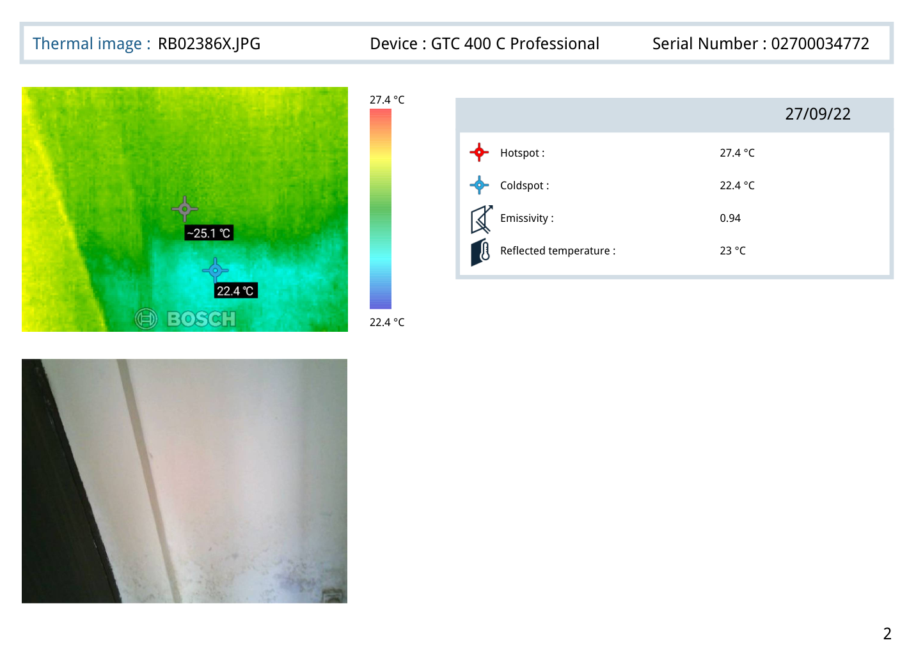
Thermal Images PDF page 2 - thermal evidence

Point 2 - Common Bedroom of Flat No. 103
Inspection observation: Observed dampness at the skirting level of the Common Bedroom of Flat No. 103
Linked exposed/positive-side observation: Observed gaps between the tile joints of Common Bathroom of Flat No. 103
Thermal readings from mapped thermal pages: Page 5 (RB02403X.JPG): Hotspot 25.5 °C, Coldspot 20.5 °C; Page 6 (RB02404X.JPG): Hotspot 25.8 °C, Coldspot 20.8 °C; Page 7 (RB02405X.JPG): Hotspot 26.2 °C, Coldspot 21.2 °C; Page 8 (RB02406X.JPG): Hotspot 26.5 °C, Coldspot 21.5 °C
Image evidence from provided PDFs:

Inspection PDF page 10 - summary/source evidence
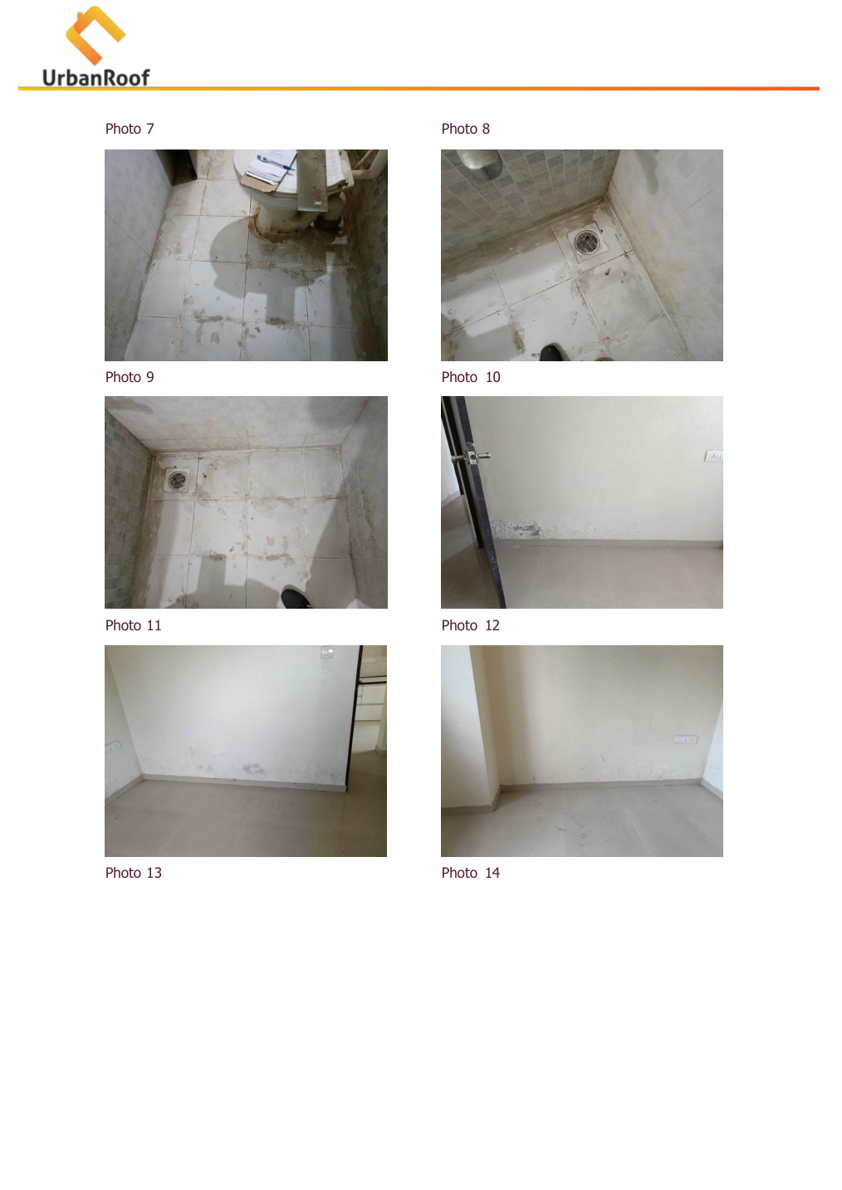
Inspection PDF page 12 - area/photo evidence
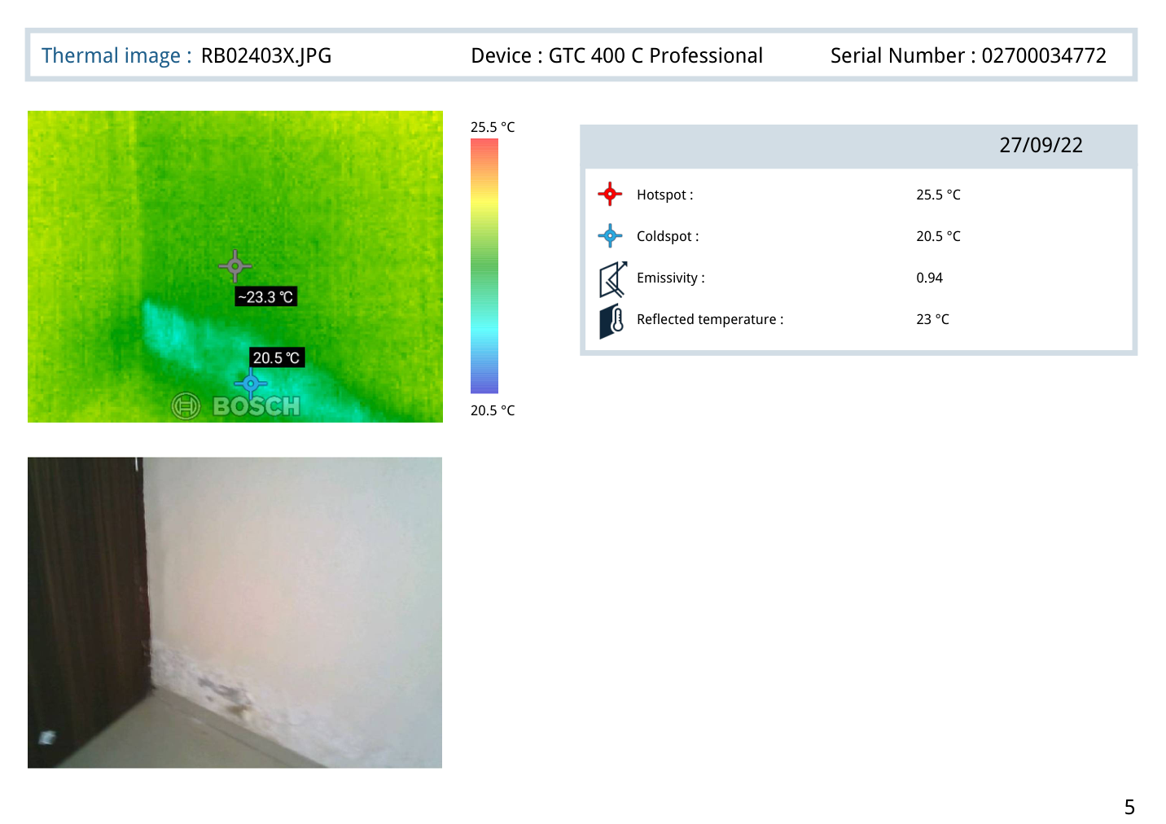
Thermal Images PDF page 5 - thermal evidence
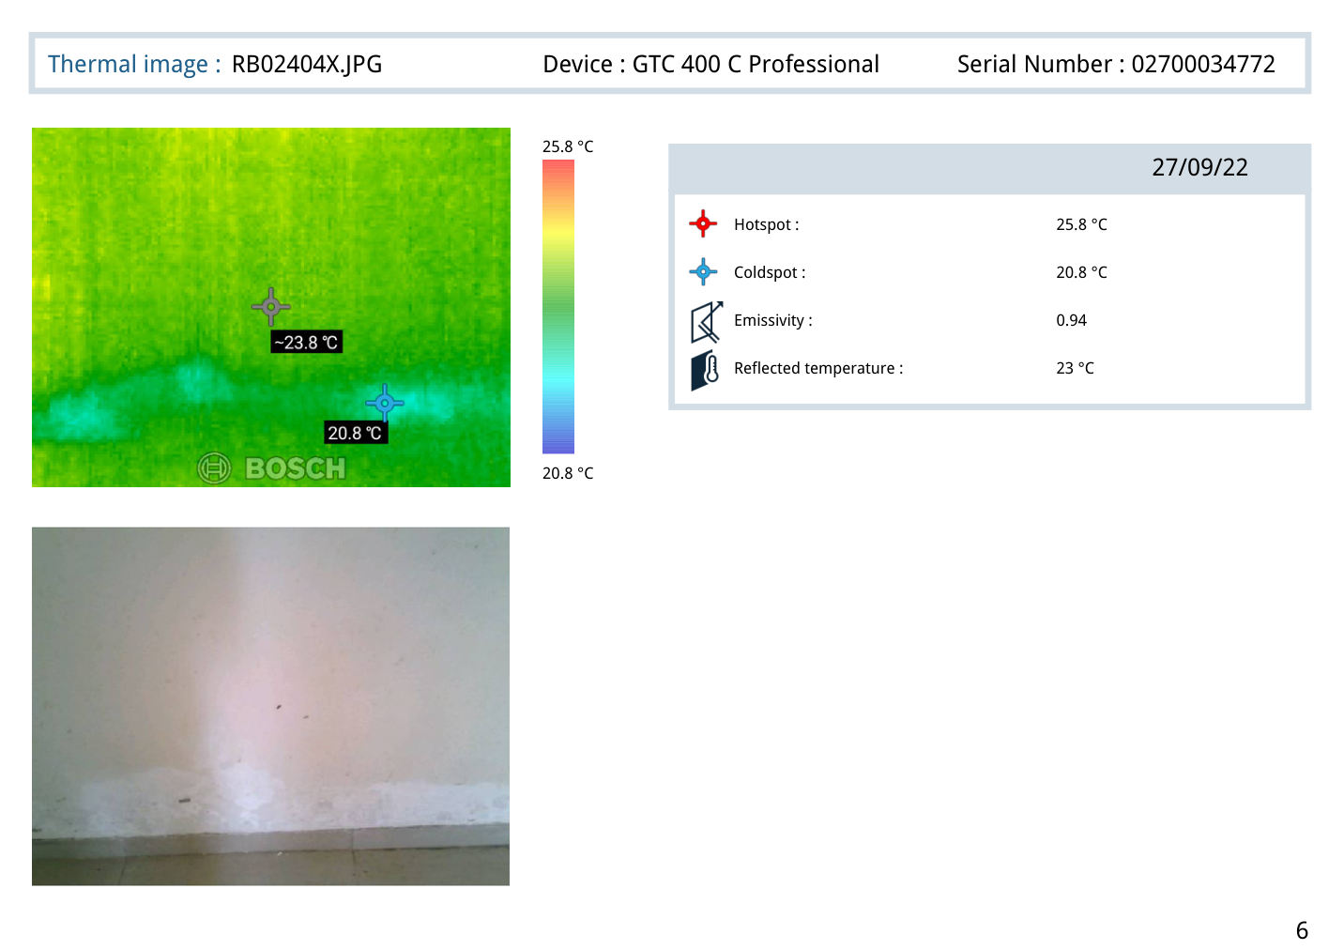
Thermal Images PDF page 6 - thermal evidence

Point 3 - Master Bedroom of Flat No. 103
Inspection observation: Observed dampness at the skirting level of Master Bedroom of Flat No. 103
Linked exposed/positive-side observation: Observed gaps between the tile joints of Master Bedroom Bathroom of Flat No. 103
Thermal readings from mapped thermal pages: Page 9 (RB02392X.JPG): Hotspot 25.8 °C, Coldspot 20.8 °C; Page 10 (RB02393X.JPG): Hotspot 25.9 °C, Coldspot 20.9 °C; Page 11 (RB02394X.JPG): Hotspot 26 °C, Coldspot 21 °C; Page 12 (RB02396X.JPG): Hotspot 26.1 °C, Coldspot 21.1 °C
Image evidence from provided PDFs:

Inspection PDF page 10 - summary/source evidence
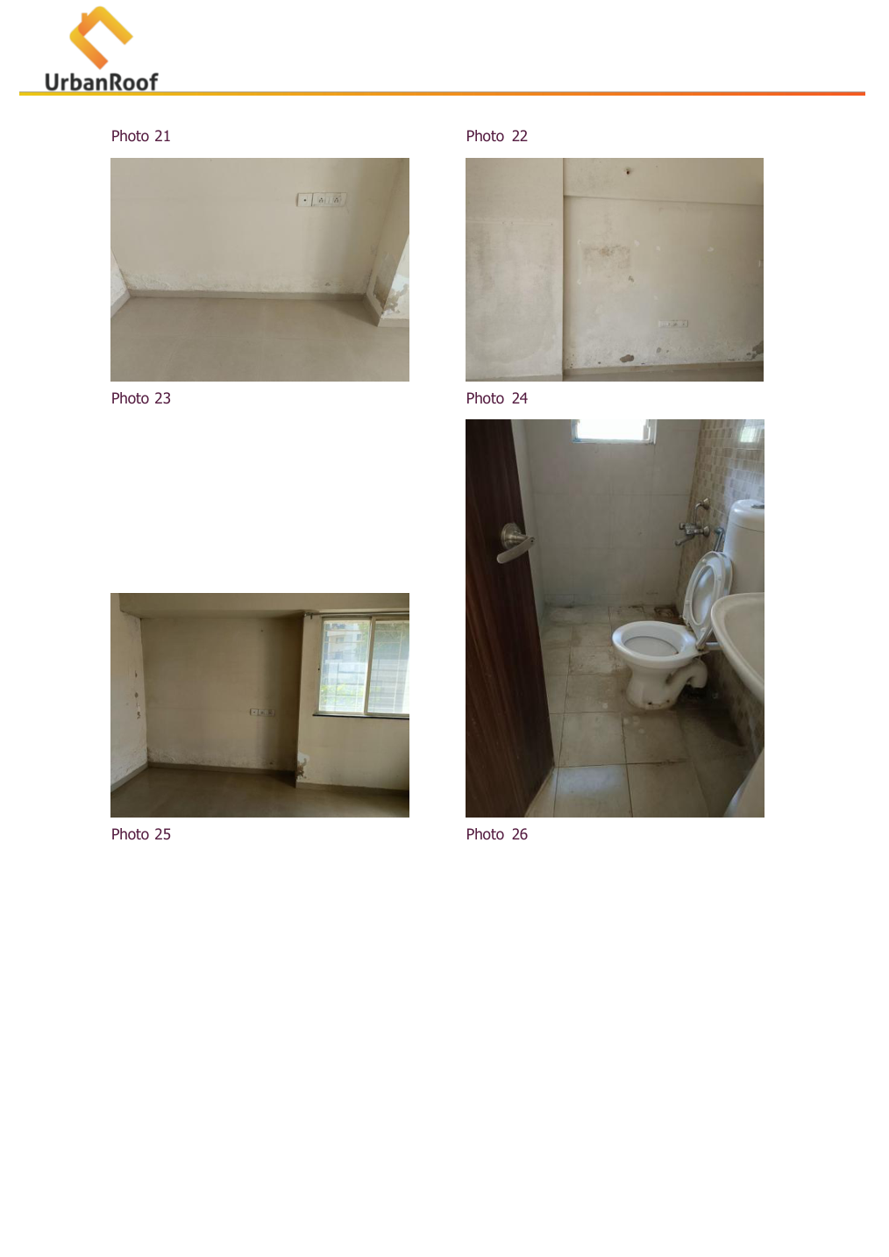
Inspection PDF page 14 - area/photo evidence
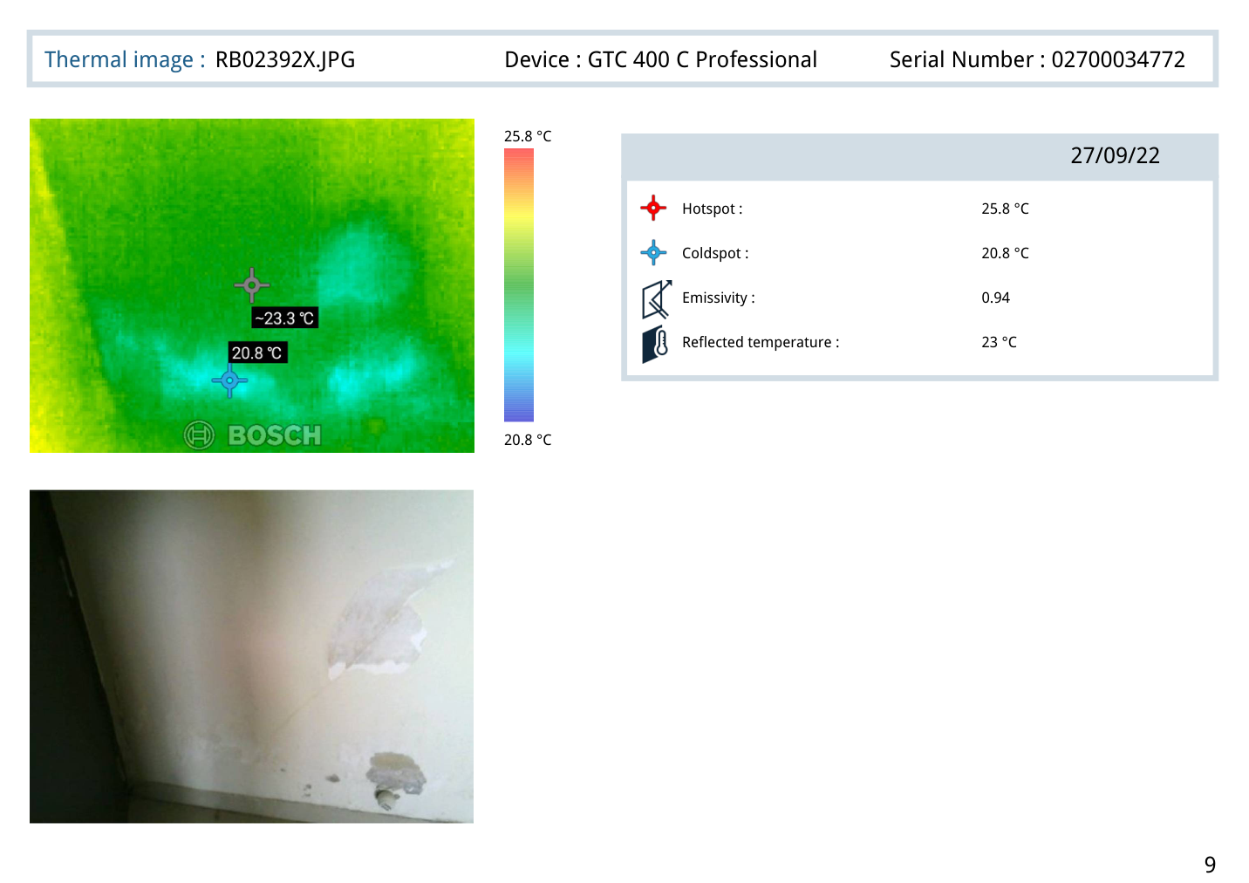
Thermal Images PDF page 9 - thermal evidence
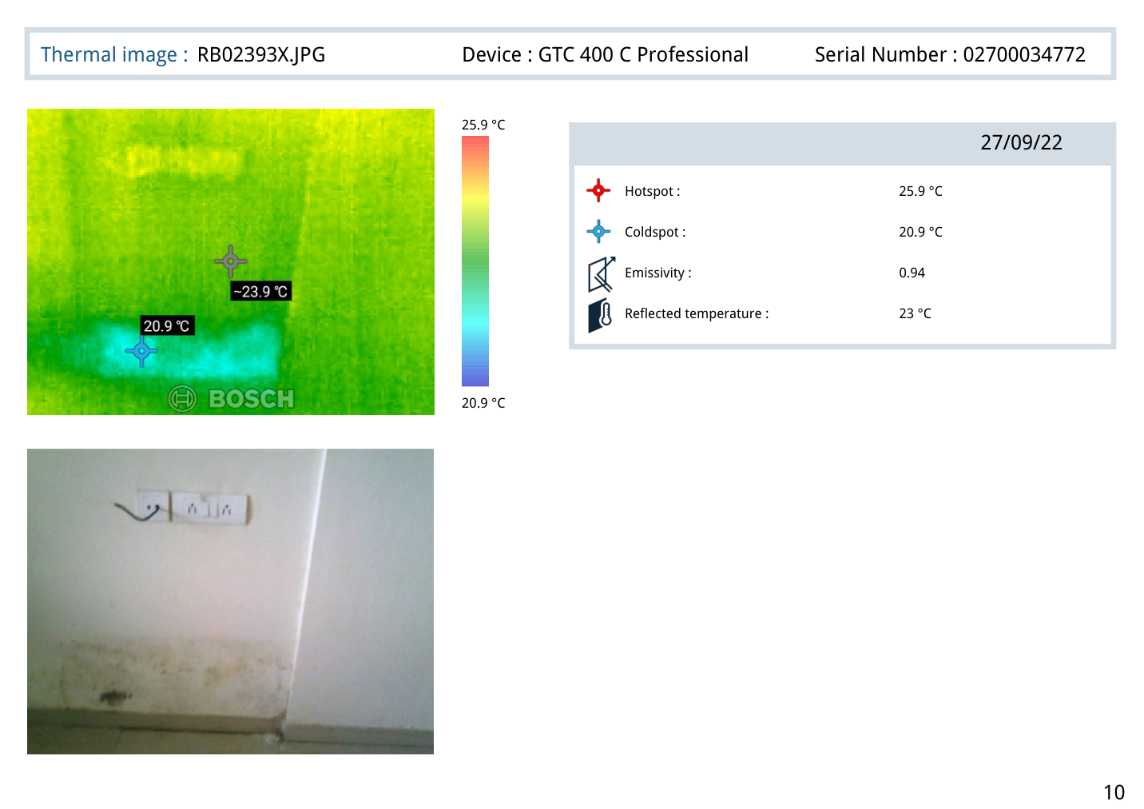
Thermal Images PDF page 10 - thermal evidence

Point 4 - Kitchen of Flat No. 103
Inspection observation: Observed dampness at the skirting level of Kitchen of Flat No. 103
Linked exposed/positive-side observation: Observed gaps between the tile joints of Master Bedroom Bathroom of Flat No. 103
Thermal readings from mapped thermal pages: Page 13 (RB02397X.JPG): Hotspot 26.3 °C, Coldspot 21.3 °C; Page 14 (RB02398X.JPG): Hotspot 25.6 °C, Coldspot 20.6 °C; Page 15 (RB02399X.JPG): Hotspot 26.5 °C, Coldspot 21.5 °C; Page 16 (RB02400X.JPG): Hotspot 25.2 °C, Coldspot 20.2 °C
Image evidence from provided PDFs:

Inspection PDF page 10 - summary/source evidence
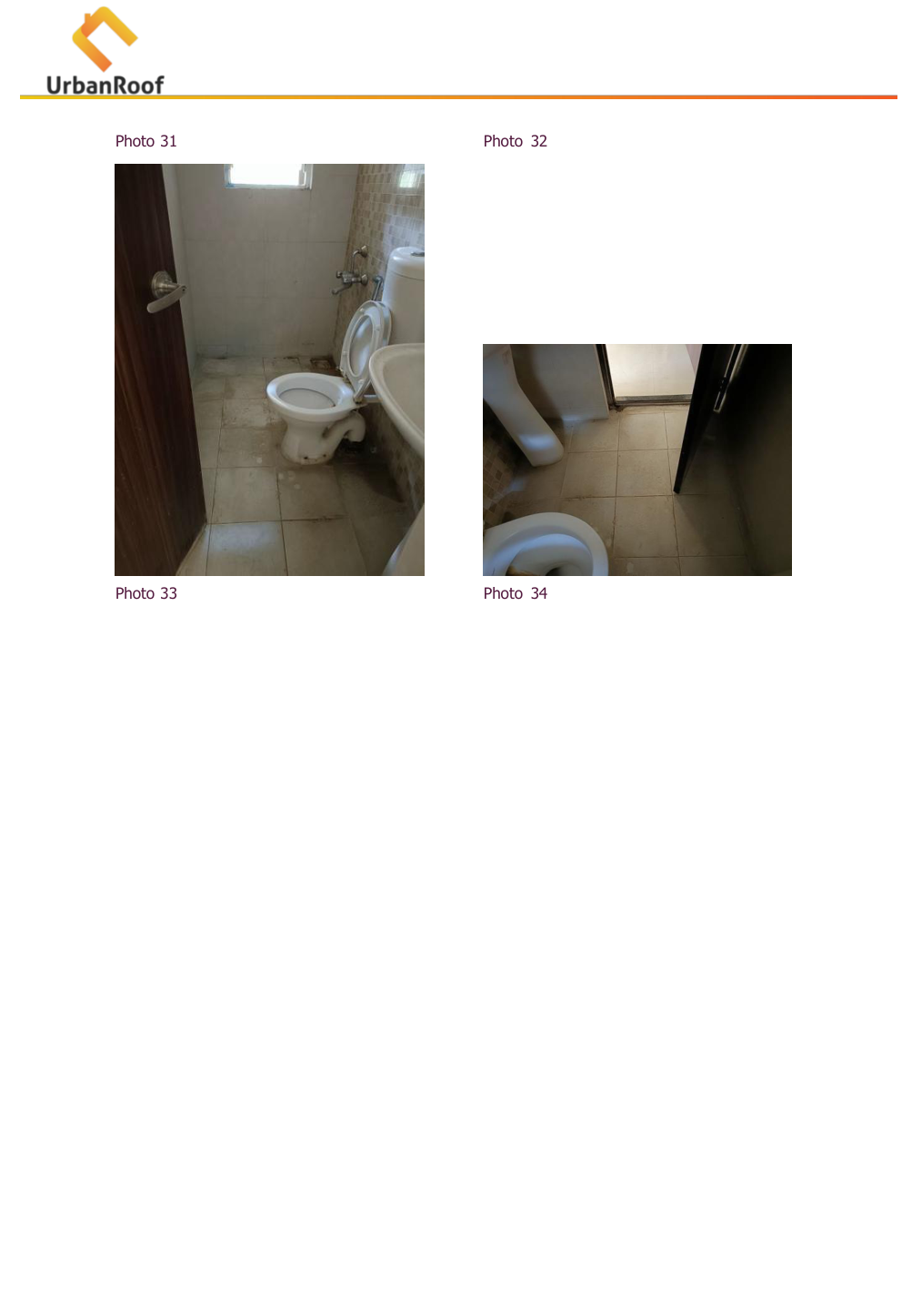
Inspection PDF page 16 - area/photo evidence
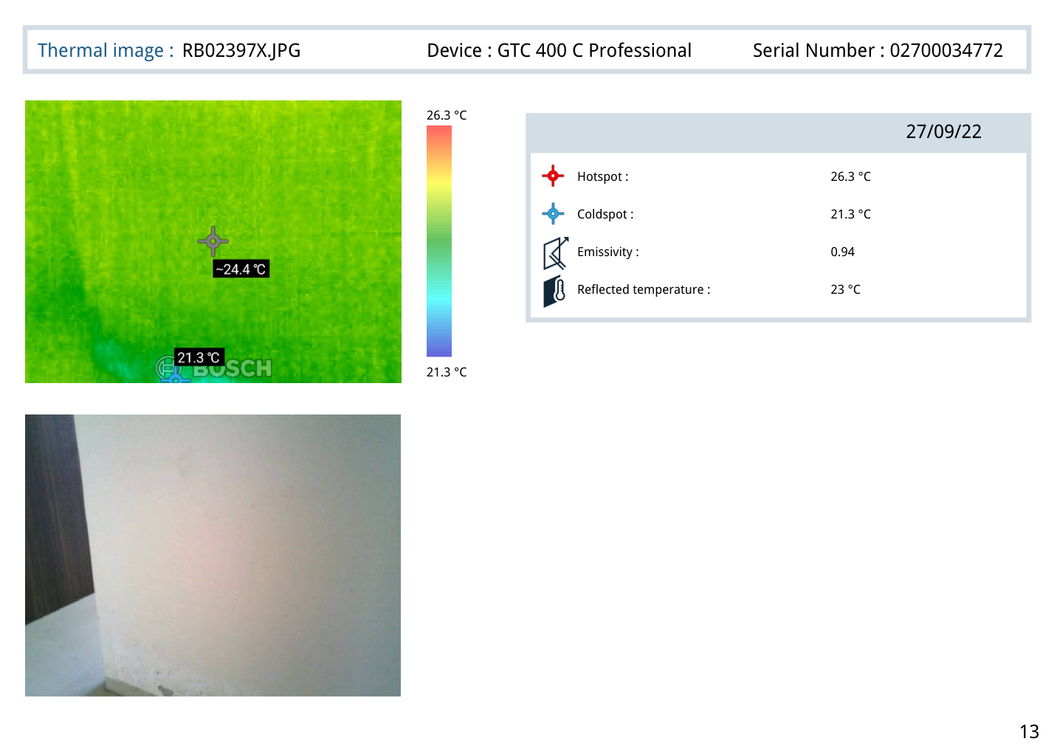
Thermal Images PDF page 13 - thermal evidence
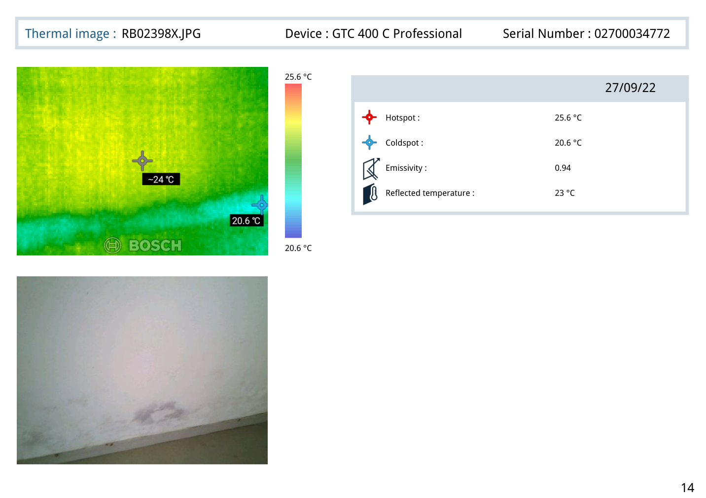
Thermal Images PDF page 14 - thermal evidence

Point 5 - Master Bedroom wall / External wall near Master Bedroom of Flat No. 103
Inspection observation: Observed dampness & efflorescence on the wall surface of Master Bedroom of Flat No. 103
Linked exposed/positive-side observation: Observed cracks on the External wall of building near Master Bedroom of Flat No. 103
Thermal readings from mapped thermal pages: Page 17 (RB02401X.JPG): Hotspot 25.6 °C, Coldspot 20.6 °C; Page 18 (RB02381X.JPG): Hotspot 27 °C, Coldspot 22 °C; Page 19 (RB02382X.JPG): Hotspot 26.7 °C, Coldspot 21.7 °C; Page 20 (RB02383X.JPG): Hotspot 26.5 °C, Coldspot 21.5 °C
Image evidence from provided PDFs:

Inspection PDF page 10 - summary/source evidence
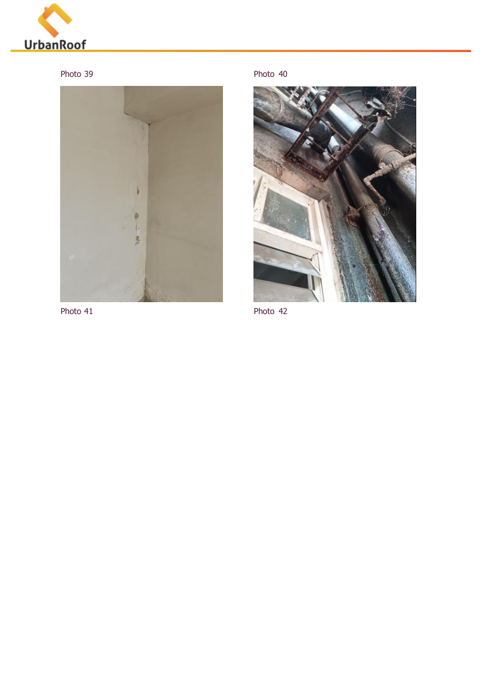
Inspection PDF page 18 - area/photo evidence
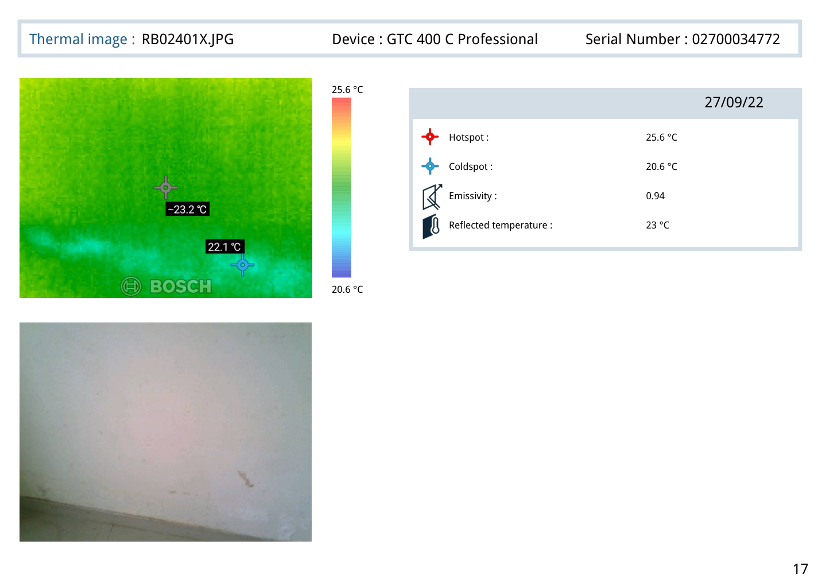
Thermal Images PDF page 17 - thermal evidence
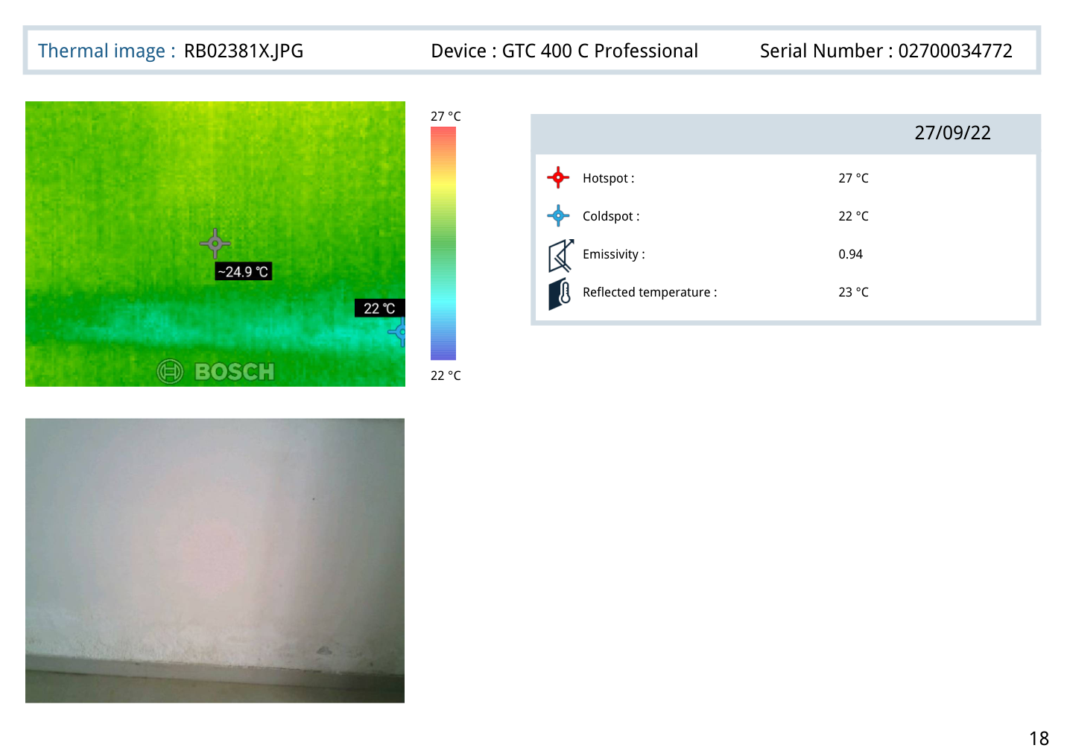
Thermal Images PDF page 18 - thermal evidence

Point 6 - Parking ceiling below Flat No. 103
Inspection observation: Observed leakage at the Parking ceiling below Flat No. 103
Linked exposed/positive-side observation: Observed plumbing issue & gaps between the tile joints of Common Bathroom of Flat No. 103
Thermal readings from mapped thermal pages: Page 21 (RB02384X.JPG): Hotspot 27.3 °C, Coldspot 22.3 °C; Page 22 (RB02385X.JPG): Hotspot 27.3 °C, Coldspot 22.3 °C; Page 23 (RB02387X.JPG): Hotspot 25.2 °C, Coldspot 20.2 °C; Page 24 (RB02388X.JPG): Hotspot 25.1 °C, Coldspot 20.1 °C
Image evidence from provided PDFs:

Inspection PDF page 10 - summary/source evidence
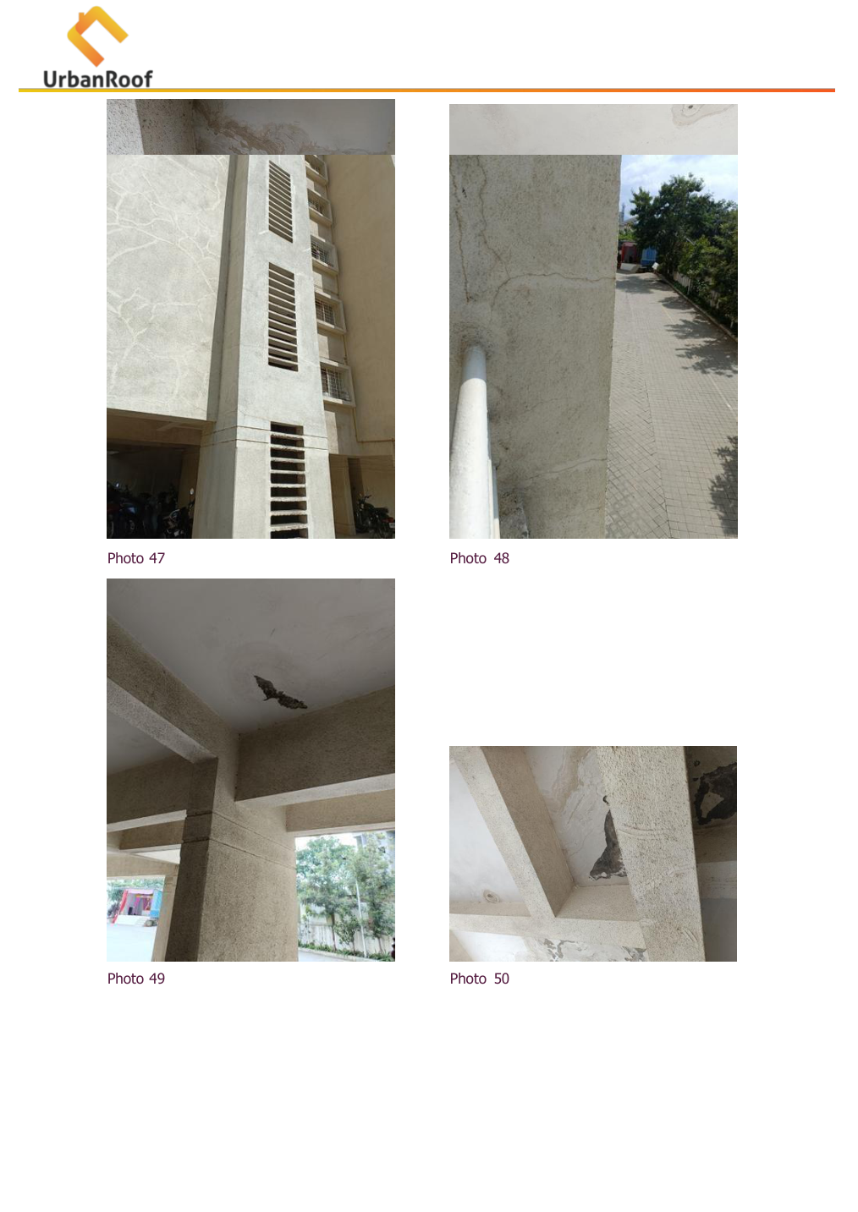
Inspection PDF page 20 - area/photo evidence
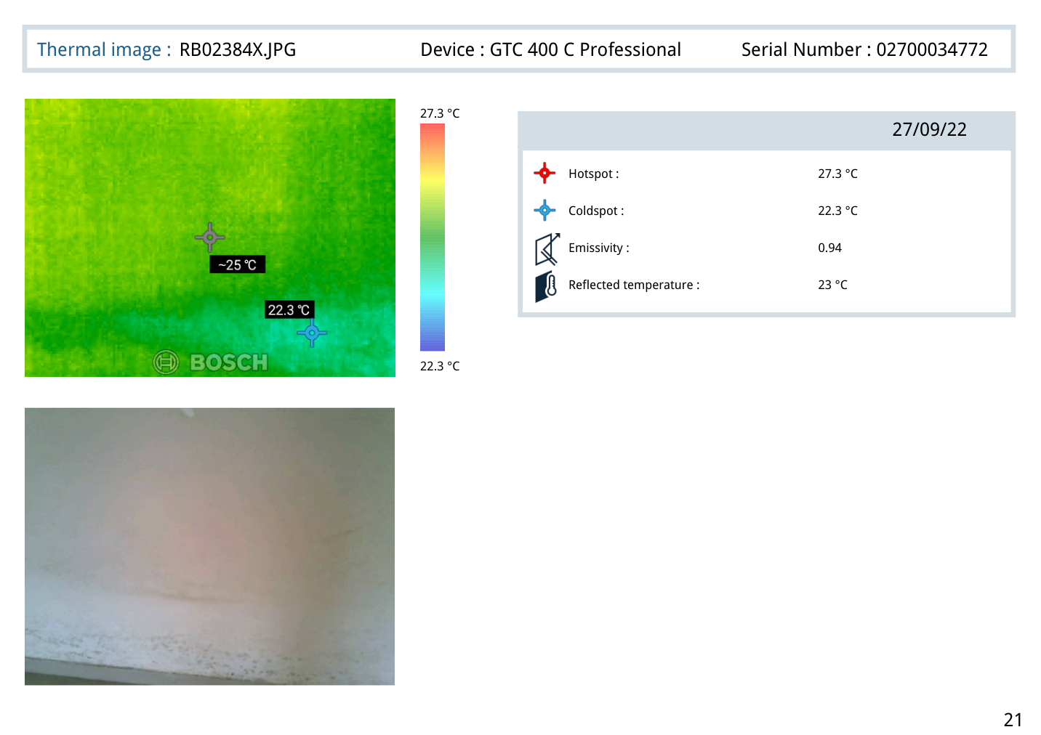
Thermal Images PDF page 21 - thermal evidence
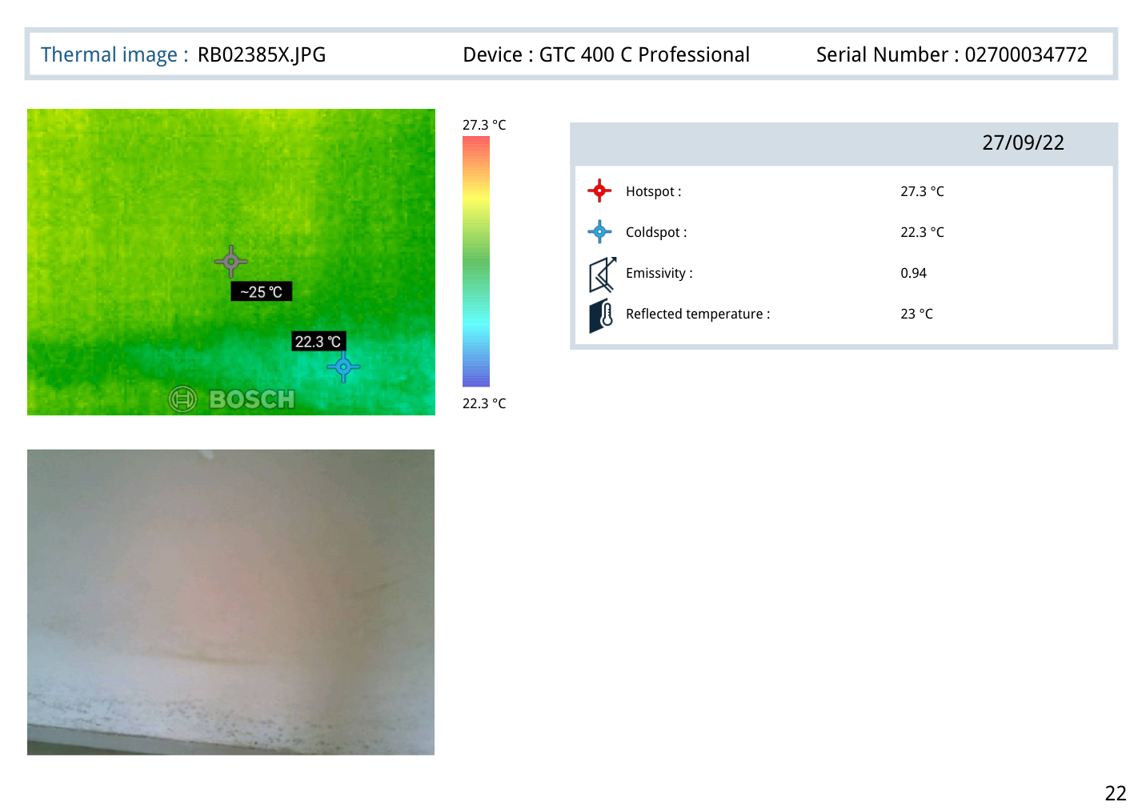
Thermal Images PDF page 22 - thermal evidence

Point 7 - Common Bathroom ceiling of Flat No. 103 / Common & Master Bedroom Bathrooms of Flat No. 203
Inspection observation: Observed mild dampness at the ceiling of Common Bathroom of Flat No. 103
Linked exposed/positive-side observation: Observed gap between tile joints of Common & Master Bedroom Bathrooms of Flat No. 203
Thermal readings from mapped thermal pages: Page 25 (RB02389X.JPG): Hotspot 25.9 °C, Coldspot 20.9 °C; Page 26 (RB02390X.JPG): Hotspot 26.9 °C, Coldspot 21.9 °C; Page 27 (RB02391X.JPG): Hotspot 25.6 °C, Coldspot 20.6 °C; Page 28 (RB02377X.JPG): Hotspot 26.9 °C, Coldspot 21.9 °C; Page 29 (RB02378X.JPG): Hotspot 26.4 °C, Coldspot 21.4 °C; Page 30 (RB02379X.JPG): Hotspot 27.8 °C, Coldspot 22.8 °C
Image evidence from provided PDFs:

Inspection PDF page 10 - summary/source evidence
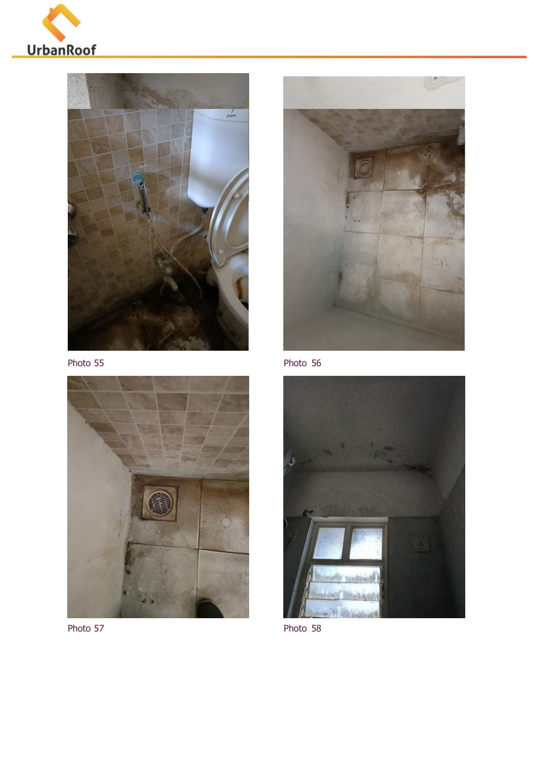
Inspection PDF page 22 - area/photo evidence
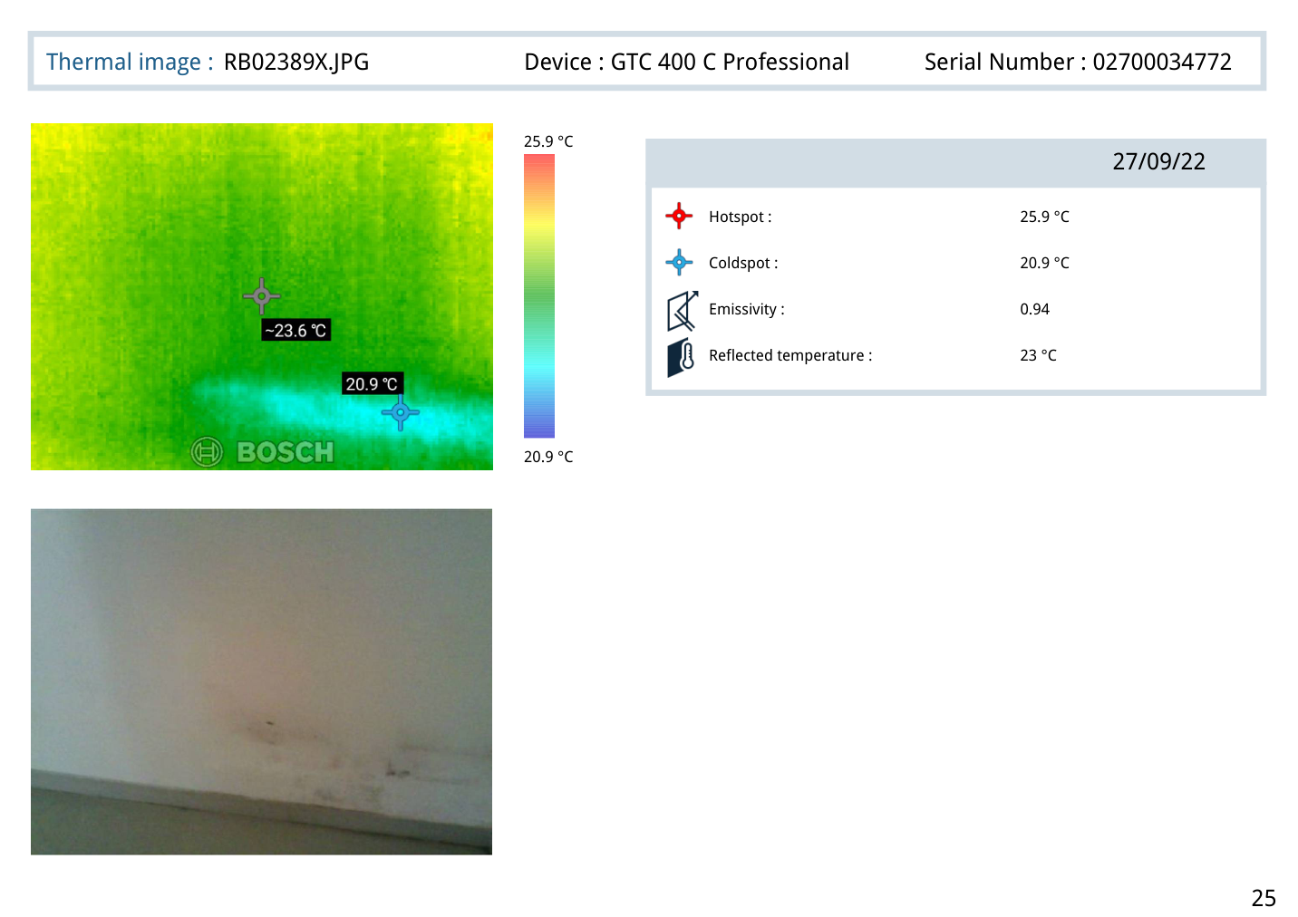
Thermal Images PDF page 25 - thermal evidence
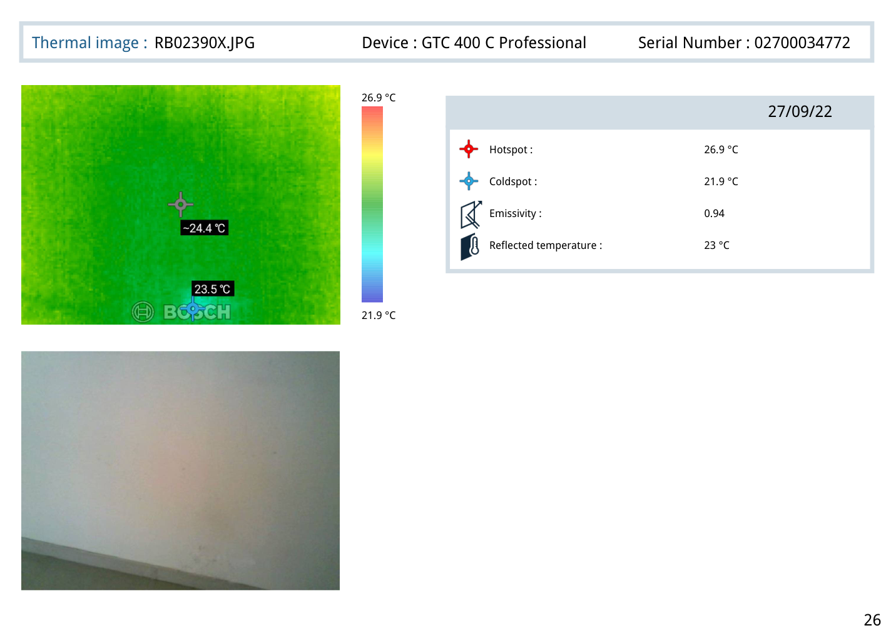
Thermal Images PDF page 26 - thermal evidence

3. Probable Root Cause
- Leakage due to concealed plumbing: Yes
- Leakage due to damage in Nahani trap / Brickbat coba under tile flooring: Yes
- Gaps/Blackish dirt observed in tile joints: Yes
- Gaps around Nahani Trap Joints: Yes
- Loose plumbing joints/rust around joints and edges (Flush Tank/shower/angle cock/bibcock, washbasin, etc): Yes
- Internal WC/Bath/Balcony leakage observed: Yes

4. Severity Assessment (with reasoning)
Overall severity: Moderate.
Reasoning based only on the inspection checklist values:
- Checklist flagged items: 1 flagged
- Condition of cracks observed on RCC Column and Beam: Moderate
- Major or minor cracks observed over external surface: Moderate
- External plumbing pipes cracked and leaked condition: Moderate
- Algae fungus and Moss observed on external wall: Moderate

5. Recommended Actions
- Repair concealed plumbing leakage points mentioned in the inspection checklist.
- Repair the Nahani trap / Brickbat coba related leakage source mentioned in the inspection checklist.
- Seal gaps between tile joints in the Common Bathroom and Master Bedroom Bathroom areas mentioned in the summary table.
- Rectify loose plumbing joints/rust around joints and edges mentioned in the inspection checklist.
- Repair external wall cracks near the Master Bedroom mentioned in the summary table.
- Recheck affected dampness/leakage areas after repair.

6. Additional Notes
The thermal images provide hotspot and coldspot readings, but the thermal PDF text does not provide exact area labels for every thermal page. Therefore, thermal pages are grouped with corresponding observations based on document order and supporting visual evidence only.
The final report avoids duplicate points by using the seven-point summary table as the master issue list.

7. Missing or Unclear Information
- Customer Name: Not Available
- Mobile: Not Available
- Email: Not Available
- Address: Not Available
- Property Age: Not Available
- Exact room/location label for each individual thermal page: Not Available
- Individual thermal images are not labelled area-wise inside Thermal Images.pdf: Not Available

Thermal Reading Appendix
Page | Thermal image | Date | Hotspot °C | Coldspot °C
1 | RB02380X.JPG | 27/09/22 | 28.8 | 23.4
2 | RB02386X.JPG | 27/09/22 | 27.4 | 22.4
3 | RB02395X.JPG | 27/09/22 | 27 | 22
4 | RB02402X.JPG | 27/09/22 | 25.7 | 20.7
5 | RB02403X.JPG | 27/09/22 | 25.5 | 20.5
6 | RB02404X.JPG | 27/09/22 | 25.8 | 20.8
7 | RB02405X.JPG | 27/09/22 | 26.2 | 21.2
8 | RB02406X.JPG | 27/09/22 | 26.5 | 21.5
9 | RB02392X.JPG | 27/09/22 | 25.8 | 20.8
10 | RB02393X.JPG | 27/09/22 | 25.9 | 20.9
11 | RB02394X.JPG | 27/09/22 | 26 | 21
12 | RB02396X.JPG | 27/09/22 | 26.1 | 21.1
13 | RB02397X.JPG | 27/09/22 | 26.3 | 21.3
14 | RB02398X.JPG | 27/09/22 | 25.6 | 20.6
15 | RB02399X.JPG | 27/09/22 | 26.5 | 21.5
16 | RB02400X.JPG | 27/09/22 | 25.2 | 20.2
17 | RB02401X.JPG | 27/09/22 | 25.6 | 20.6
18 | RB02381X.JPG | 27/09/22 | 27 | 22
19 | RB02382X.JPG | 27/09/22 | 26.7 | 21.7
20 | RB02383X.JPG | 27/09/22 | 26.5 | 21.5
21 | RB02384X.JPG | 27/09/22 | 27.3 | 22.3
22 | RB02385X.JPG | 27/09/22 | 27.3 | 22.3
23 | RB02387X.JPG | 27/09/22 | 25.2 | 20.2
24 | RB02388X.JPG | 27/09/22 | 25.1 | 20.1
25 | RB02389X.JPG | 27/09/22 | 25.9 | 20.9
26 | RB02390X.JPG | 27/09/22 | 26.9 | 21.9
27 | RB02391X.JPG | 27/09/22 | 25.6 | 20.6
28 | RB02377X.JPG | 27/09/22 | 26.9 | 21.9
29 | RB02378X.JPG | 27/09/22 | 26.4 | 21.4
30 | RB02379X.JPG | 27/09/22 | 27.8 | 22.8

