Lightweight Hybrid Intrusion Detection System for Local Networks
Jayati Gupta (1RF23IS043), ISE Department, 5th Sem, RVITM
Abstract— The boom in IoT devices makes local, home, and small office networks increasingly vulnerable to attacks. However, traditional IDSs are computationally too expensive for such environments. A lightweight hybrid IDS is presented here that will provide effective security while minimizing the utilization of resources. It consists of a high-speed, rule-based engine for detecting known attack patterns and an anomaly detection engine to flag novel threats. The rule-based engine has been tested against Port Scans, SYN Floods, Traffic Bursts, and ARP Spoofing. An anomaly detector will be implemented using a K-Means clustering algorithm, which will be trained over a dataset of benign traffic and then evaluated. The precision was high at 87.5%, reflecting a low false-positive rate, while the recall was more modest at 50.0%, showing it missed some stealthier attacks. Overall, this result underlines the evident advantage of a hybrid model where the rule-based engine reliably takes care of the first layer of protection, while the anomaly detector adds a second layer against hitherto-unknown deviations from normal behavior.

Introduction
In today's world, abundance of devices has increased the need for heavily interconnected devices. This also opens networks to vulnerabilities. The enhancement in Internet of Things devices, smart homes and small office networks has created a complex ecosystem with exponentially higher vulnerabilities. This remains an issue that isn’t easily diagnosable and doesn’t show any symptoms until a significant security breach has occurred.
Increased reliance on interconnected devices has made local networks a target for intrusions and data theft. While this problem persists, protection is already available in the market. Enterprise level protection is often computationally very expensive and resource intensive while Traditional Intrusion Detection Systems often rely on massive signature databases. Neither of these approaches is suitable for small or home businesses
To address this gap, this paper proposes a lightweight hybrid IDS with anomaly detection. The proposed system combines major components like a high-speed, rule-based engine to identify known threats and a k-means clustering model to detect novel anomalies. This approach aims to provide robust security without the requirement of high computational overhead of traditional systems.

Related Work
Network intrusion detection is a rather popular and well-established field, with solutions falling into two major categories. The first one is Signature-Based IDS. This is the most common approach and is widely used for basic tasks. One very popular and open-source tool, Snort, uses similar logic to operate as an antivirus scanner for the network. These systems maintain a vast database of known attack signatures and check all incoming and outgoing traffic against it. The main strength of this system is its low false-positive rates and high accuracy. The critical weakness, however, is the inability to detect novel attacks for which pre-recognized signatures are not available.
The second category is Anomaly Based IDS. This type addresses the weakness of the Signature Based system by using a machine learning model to identify normal and abnormal network behavior. Any traffic that slightly deviates from the notion of “normal” traffic is flagged as “abnormal”. This approach is powerful as it detects novel attacks. However, these systems come with their own issues like high computation power requirement for model training and intensive data collection for the same. Another major issue with these systems is false alerting. These systems are known to alert false positives and flag benign unusual network activity as malicious.

System Design and Methodology
The proposed system is a lightweight-hybrid IDS that processes packets in real time. The main architecture has two stages to maximize efficiency. All incoming traffic is first checked against the rules by a rule-based engine. If a known attack is detected, alerts are generated, and subsequent data is labelled malicious. The traffic that passes the rule based checkpoint is further analyzed by the k-means anomaly detection engine to identify unknown threats.

3.1 Rule-Based (Signature) Engine
The rule-based engine of implemented as a packet processor that monitors traffic for specific, known threats and attack patterns. The four modules implemented were:
- Port Scan detector: This module keeps a set of destination ports contacted for each source IP. If the number of unique ports contacted for a single source IP exceeds the threshold (N=20) in a certain time duration, it's marked as a port scan.
- TCP SYN Flood detector: This module tracks the number of TCP SYN (connection request) packets coming from each source IP address. If this count is greater than N=30 within the specified time period, 5 seconds, an attempt is considered as a potential SYN flood.
- Traffic Burst Detector: It keeps track of the total bandwidth from every source IP. The system flags all the IPs from which the total bytes sent exceed a certain threshold (N=1,000,000 bytes) within any 2-second window as a potential Denial-of-Service attack.
- ARP Spoof Detector: This module keeps track of a local network's IP-to-MAC address mapping. If an ARP reply is generated with the established mapping-that is, a new MAC address claims an existing IP-an ARP spoofing alert is generated.
3.2. Anomaly-Detection (K-Means) Engine
The anomaly-detection engine acts as the second layer of defense. The purpose is to identify traffic that is not flagged malicious by the rule-based engine but is statistically different from the normal activity.
We selected K-means clustering algorithm for this task due to its simplicity and computational efficiency, making it an ideal solution for a lightweight system. The logic behind this algorithm is that normal traffic will form predictable clusters, while the attack traffic will be a statistical outlier.
The model is currently trained only in normal traffic (packets that are not flagged by the rule-based engine). This enables the model to form a baseline notion of what normal traffic looks like. Once trained, the cluster centroids represent different types of normal activity for example, one cluster for web browsing, another for DNS lookups, etc.

Implementation and Experiment
4.1 Implementation details
The entire system is built and implemented in Python 3. The core packet capture and parsing capabilities were provided by the Scapy library. The machine learning components were built using the Pandas library for data manipulation and visualization and the Scikit-learn library for K-Means modeling.

4.2 Data Collection and Generation
To evaluate the system and to train the models, a custom dataset was generated on a test network. The sniffer script was run on a target machine while logging all traffic to a csv file.
- Normal traffic was generated by performing common activities like browsing websites, streaming audio and performing DNS lookups.
- Malicious traffic was simulated to test the rule-based engine from a separate machine on the network. Port Scan was simulated using Nmap, TCP SYN Flood and UDP Traffic Burst were generated using hping3 and ARP Spoof attack was simulated using arpspoof.
All these packets were logged to generate the final labeled dataset, with each row containing packet details like source IP, destination IP, length of packet, timestamp and a Boolean rule-based alert value (0 for normal, 1 for attack).

4.3 Data Processing for K-Means
The raw csv data needed preprocessing before it could be used for machine learning. We selected 4 key features like source_port, destination_port, protocol and length from each packet. Categorical data like IP addresses were ignored.
The K-Means algorithm is sensitive to feature scale that is influenced by single disproportionate features. To avoid this, the data was normalized using the StandardScaler from scikit-learn. This process scales the data so that all features have a mean of 0 and standard deviation of 1.

Results and Evaluation
5.1. Rule-Based Engine Performance
The rule-based engine was evaluated first. During the live test, it successfully identified and printed real-time alerts for all four simulated attacks, validating the logic of the signature-based component. These alerts were used to label our dataset for the next phase.

5.2 Anomaly Model Training
The anomaly model was trained on only the 18 "normal" packets from our dataset. In order to find the optimal number of clusters, we utilized the "Elbow Method." The plot of inertia versus shown in Fig. 1 contains a distinct "elbow" at k=3, which indicates that our normal traffic can be grouped into three distinct types of activity.
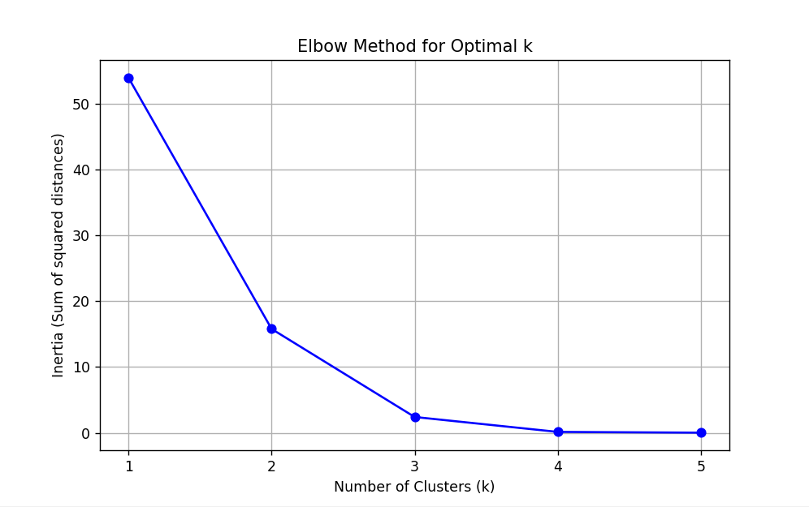
Fig. 1: Elbow Method for determining optimal k.
We then trained the model using k = 3 to develop an appropriate threshold for identifying anomalies. We computed the distance of each normal point to its nearest cluster center and obtained the 95th percentile of the distances. The 95th percentile value, 0.7600, serves as our threshold for anomalies: any new packet whose distance is more than 0.7600 will be considered an anomaly.

5.3 Anomaly Model Performance
The trained model was tested against a 32-packet dataset which contains 14 known attacks. The model’s predictions were compared against ground truth and plotted in a confusion matrix in Fig.2
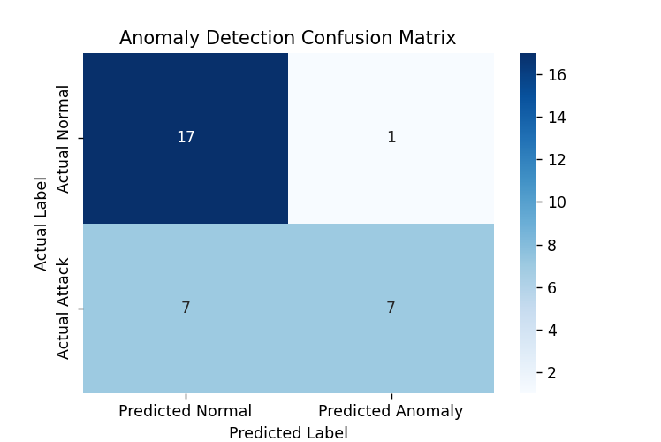
Fig. 2: Anomaly Detection Confusion Matrix

Based on these results, the following performance metrics were calculated:
Accuracy: 75.00%
Precision: 0.8750%
Recall: 0.5000%
F1-Score: 0.6364

Conclusion and Future Work
In this paper, we designed, implemented, and evaluated a lightweight hybrid intrusion detection system. We showed that a two-stage approach based on a simple rule-based engine combined with an efficient k-means anomaly detector can indeed work for resource-constrained local networks. The system was able to identify both known, simulated attacks in real time and detect part of the anomalous traffic with high precision.
- Limiting factors in the performance of the anomaly detector included a small dataset size that we generated. Future work shall focus on three areas:
- Increasing the Size of the Dataset: For building a more robust and accurate model of "normal" behavior, the system has to be trained on a much larger and diverse dataset of benign traffic, captured over days or weeks.
- Benchmarking: This system should be tested on a standardized academic dataset, such as CIC-IDS-2017, in order to formally benchmark its performance against a greater variety of complex attacks.
- Feature Engineering: More complex features could be engineered for the k-means model, such as packet inter-arrival time and flow duration that might offer better discrimination between normal and malicious traffic.
References:
[1] IBM, "What is an intrusion detection system (IDS)?" IBM Think Topics, Oct. 29, 2024. [Online]. Available: https://www.ibm.com/think/topics/intrusion-detection-system. [Accessed: Nov. 10, 2025].
[2] M-A. K. Igbaria, "How to Build a Real-Time Intrusion Detection System with Python," freeCodeCamp, Feb. 15, 2024. [Online]. Available: https://www.freecodecamp.org/news/build-a-real-time-intrusion-detection-system-with-python/. [Accessed: Nov. 10, 2025].
[3] NeuralNine, "Coding an Intrusion Detection System in Python." YouTube, Jan. 26, 2023. [Video]. Available: https://www.youtube.com/watch?v=f0vpwwNAcdI. [Accessed: Nov. 10, 2025].
[4] F. Pedregosa et al., "Scikit-learn: Machine Learning in Python," Journal of Machine Learning Research, vol. 12, pp. 2825-2830, 2011.
[5] The Pandas Development Team, pandas-dev/pandas: Pandas. 2020. [Software]. Available: https://pandas.pydata.org/
6] D. E. Denning, "An Intrusion-Detection Model," IEEE Transactions on Software Engineering, vol. SE-13, no. 2, pp. 222-232, Feb. 1987.
[7] I. Sharafaldin, A. H. Lashkari, and A. A. Ghorbani, "Toward Generating a New Intrusion Detection Dataset and Intrusion Traffic Characterization," in Proc. 4th International Conference on Information Systems Security and Privacy (ICISSP), 2018, pp. 108-116.
[8] M. Tavallaee, E. Bagheri, W. Lu, and A. A. Ghorbani, "A Detailed Analysis of the KDD CUP 99 Data Set," in Proc. 2009 IEEE Symposium on Computational Intelligence for Security and Defense Applications, 2009, pp. 1-6.
[9] Snort, "Snort - Network Intrusion Detection & Prevention System." [Online]. Available: https://www.snort.org/. [Accessed: Nov. 10, 2025].
[10] Scapy, "Scapy: Packet Manipulation and Sniffing." [Online]. Available: https://scapy.net/. [Accessed: Nov. 10, 2025].
[11] M. Ahmad, S. R. R. Q. R. A. M, and J. A. M. (2021). A Survey of Machine Learning for Intrusion Detection Systems: A Review of Models, Datasets, and Challenges. IEEE Access, 9, 134446-134473.
[12] J. F. Kurose and K. W. Ross, Computer Networking: A Top-Down Approach, 8th ed. Hoboken, NJ: Pearson, 2021.
[13] L. Dhanabal and S. P. Shantharajah, "A Study on K-Means Clustering Algorithm for Intrusion Detection," International Journal of Advanced Research in Computer and Communication Engineering, vol. 4, no. 7, pp. 416-420, Jul. 2015.
[14] I. A. Al-Jumaili, "A Hybrid Intrusion Detection System Based on Combining Signature and Anomaly Detection," Journal of Physics: Conference Series, vol. 1804, no. 1, p. 012110, 2021.
[15] A. H. Lashkari, A. Seo, G. Mamun, and A. A. Ghorbani, "A Survey of Intrusion Detection Systems for IoT Networks," IEEE Internet of Things Journal, vol. 8, no. 12, pp. 9639-9657, Jun. 2021.

